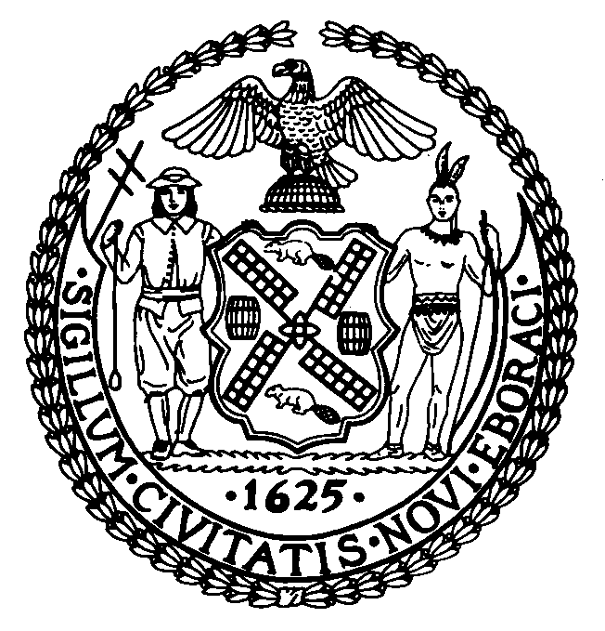 | The Council of the City of New York  Finance Division  Larian Angelo, Director  Fiscal Impact Statement  Intro. No: 364-A  Committee: Public Safety
Title: To amend the administrative code of the city of New York, in relation to increasing the penalties for drag racing. | Sponsors: Council Members Vallone Jr, Liu, Weprin, Addabbo, Avella, Comrie, Fidler, Gerson, Katz, Koppell, Monserrate, Nelson, Palma, Sanders, Sears and Gennaro
Summary of Legislation This legislation would amend the administrative code of the city of New York by adding a new section 10-163 that would: (1) increase the criminal penalty for any person who engages in or participates in any race, exhibition or contest of speed, or aid or abet in such race, exhibition or contest of speed, on any highway, street, alley, sidewalk, or any public or private parking lot or area, except as provided in the vehicle and traffic law; and (2) create a criminal penalty for those who participate as a spectator in any event or gathering held for the purpose of a race, exhibition or contest of speed not authorized pursuant to the vehicle and traffic law.

Effective Date This local law shall take effect immediately.

Fiscal Year In Which Full Fiscal Impact Anticipated:

Fiscal Impact Statement:
 | Effective FY05 | FY Succeeding  Effective FY06 | Full Fiscal  Impact FY05
Revenues (+) | $0 | $0 | $0
Expenditures (-) | $0 | $0 | $0
Net | $0 | $0 | $0

Impact on Revenues: There would be no impact on revenues resulting from the enactment of this legislation.

Impact on Expenditures: There would be no impact on expenditures resulting from the enactment of this legislation.

Source of Funds To Cover Estimated Costs: Not applicable

Source of Information: City Council Finance Division

Estimate Prepared By: Andy Grossman, Assistant Director, City Council Finance Division
Andrew D. Lenney, Assistant Director, City Council Finance Division

FIS History: To be considered by the Committee on September 27, 2004.

Date Submitted to Council: May 5, 2004

