THE COUNCIL OF THE CITY OF NEW YORK
RESOLUTION NO. 1313

Resolution approving the decision of the City Planning Commission on Application No. N 160366 ZRX, for an amendment of the Zoning Resolution of the City of New York, modifying Appendix F for the purpose of establishing a Mandatory Inclusionary Housing area, Community District 6, Borough of the Bronx (L.U. No. 498).

By Council Members Greenfield and Richards

WHEREAS, the City Planning Commission filed with the Council on October 7, 2016 its decision dated October 5, 2016 (the "Decision"), pursuant to Section 201 of the New York City Charter, regarding an application submitted by Second Farms Neighborhood HDFC, for an amendment of the text of the Zoning Resolution of the City of New York, modifying Appendix F for the purpose of establishing a Mandatory Inclusionary Housing area, which in conjunction with other related actions, would facilitate the 1932 Bryant Ave residential development, a mixed-use, affordable housing development within an existing large-scale residential development in the West Farms neighborhood of the Bronx (Application No. N 160366 ZRX), Community District 6, Borough of the Bronx (the "Application");

WHEREAS, the Application is related to applications C 160365 ZMX (L.U. No. 497), a zoning map amendment changing Parcel 9 from an R7-1 district to an R8 district with a 100 foot deep C2-4 overlay along Boston Road and 125 foot long C2-4 overlay along East Tremont Avenue; C 160367 ZSX (L.U. No. 499), a special permit pursuant to Section 74-532 to waive the required accessory off-street parking for existing affordable dwelling units located on Parcels 6, 7 and 8a; and C 160368 ZSX (L.U. No. 500), a special permit pursuant to ZR 78-312 to allow within a Large Scale Residential Development the location of buildings without regard for rear yards and height and setback waivers for the portion of the proposed building’s street wall frontage along the periphery of the Bronx Park South Large Scale Plan (BPSLSP);

WHEREAS, the Decision is subject to review and action by the Council pursuant to Section 197-d(b)(1) of the City Charter;
WHEREAS, upon due notice, the Council held a public hearing on the Decision and Application on November 1, 2016;

WHEREAS, the Council has considered the land use implications and other policy issues relating to the Decision and Application; and

WHEREAS, the Council has considered the relevant environmental issues and analysis (CEQR No. 16DCP155X), including the negative declaration (June 6, 2016), revised environmental assessment statement (October 3, 2016), and the revised negative declaration (October 5, 2016) (together the “Environmental Review”);

RESOLVED:

The Council finds that the action described herein will have no significant impact on the environment as set forth in the Environmental Review.

Pursuant to Sections 197-d and 200 of the City Charter and on the basis of the Decision and Application, and based on the environmental determination and consideration described in the report, N 160366 ZRX, incorporated by reference herein, the Council approves the Decision with the following modifications as follows:

Matter in underline is new, to be added;
Matter in strikeout is to be deleted;
Matter within # # is defined in Section 12-10;
* * * indicates where unchanged text appears in the Zoning Resolution

* * *

APPENDIX F
Inclusionary Housing Designated Areas and Mandatory Inclusionary Housing Areas

* * *
THE BRONX
* * *

Bronx Community District 6

In the R7A, R7D, R7X, R8, R8A and R8X Districts within the areas shown on the following Maps 1, 2, 3, 4, and 5 and 6:

* * *

Map 6 – [date of adoption]

[PROPOSED MAP]

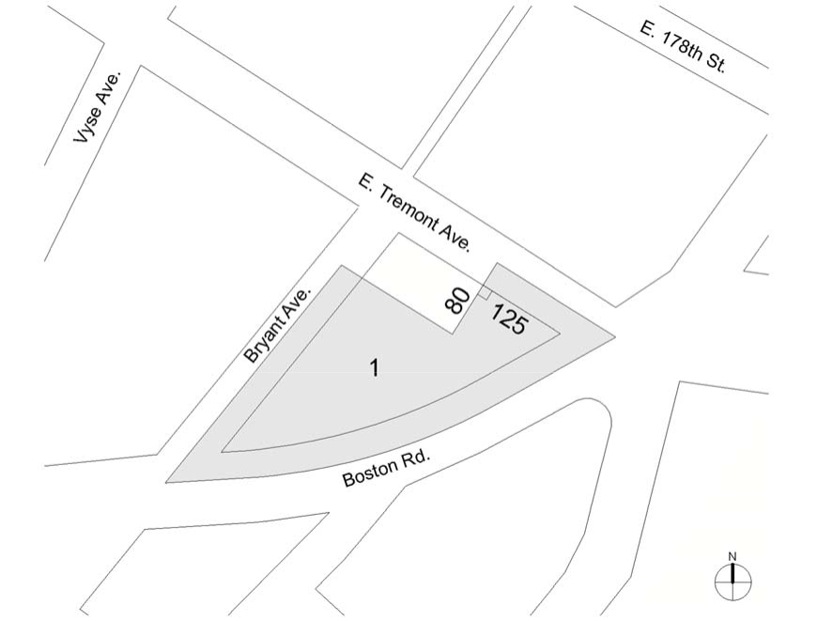

Mandatory Inclusionary Housing area see Section 23-154(d)(3)
Area 1 [date of adoption] ─ MIH Program Option 1 and Option 2

Portion of Community District 6, The Bronx

* * *

Adopted.

Office of the City Clerk, }
The City of New York, } ss.:

I hereby certify that the foregoing is a true copy of a Resolution passed by The Council of The City of New York on November 29, 2016, on file in this office.

.....…….........................................
City Clerk, Clerk of The Council

