THE COUNCIL OF THE CITY OF NEW YORK
RESOLUTION NO. 1648

Resolution approving with modifications the decision of the City Planning Commission on Application No. N 170190 ZRK, for an amendment of the Zoning Resolution of the City of New York, modifying Appendix F for the purpose of establishing a Mandatory Inclusionary Housing area in Community District 16, Borough of Brooklyn (L.U. No. 719).

By Council Members Greenfield and Richards

WHEREAS, the City Planning Commission filed with the Council on July 14, 2017 its decision dated July 12, 2017 (the "Decision"), pursuant to Section 201 of the New York City Charter, regarding an application submitted by Brownsville Linden Plaza, LLC, for an amendment of the text of the Zoning Resolution of the City of New York, modifying Appendix F for the purpose of establishing a Mandatory Inclusionary Housing area, which in conjunction with the related action would facilitate the development of two new 11-story mixed-use buildings containing approximately 531 affordable dwelling units in the Brownsville neighborhood of Brooklyn, (Application No. N 170190 ZRK), Community District 16, Borough of Brooklyn (the "Application");

WHEREAS, the Application is related to application C 170189 ZMK (L.U. No. 718), a zoning map amendment to change an M1-1 zoning district to an R7A/C2-4 District and R7D/C2-4 zoning districts;

WHEREAS, the Decision is subject to review and action by the Council pursuant to Section 197-d(b)(1) of the City Charter;
WHEREAS, upon due notice, the Council held a public hearing on the Decision and Application on July 27, 2017;

WHEREAS, the Council has considered the land use implications and other policy issues relating to the Decision and Application; and

WHEREAS, the Council has considered the relevant environmental issues, including the revised negative declaration issued July 10, 2017 (CEQR No. 17DCP088K), which includes an (E) designations to avoid the potential for significant adverse impacts related to hazardous materials, air quality and noise (E-419) (the “Revised Negative Declaration”);

RESOLVED:

The Council finds that the action described herein will have no significant impact on the environment as set forth in the Revised Negative Declaration.

Page 2 of 5
N 170190 ZRK
Res. No. 1648 (L.U. No. 719)

Pursuant to Sections 197-d and 200 of the City Charter and on the basis of the Decision and Application, and based on the environmental determination and consideration described in the report, N 170190 ZRK, incorporated by reference herein, the Council approves the Decision with the following modifications:

Matter underlined is new, to be added;
Matter struck out is to be deleted;
Matter within # # is defined in Section 12-10;
Matter in double strikeout is old, deleted by the City Council;
Matter in double underline is new, added by the City Council.
- * * indicates where unchanged text appears in the Zoning Resolution

* * *

APPENDIX F
Inclusionary Housing Designated Areas and Mandatory Housing Designated Areas

* * *

Brooklyn

* * *

Brooklyn Community District 16

* * *

In the R7A and R7D Districts within the area shown on the following Map 2: Map 2 – [date of adoption]

Page 3 of 5
N 170190 ZRK
Res. No. 1648 (L.U. No. 719)

[CITY PLANNING COMMISSION PROPOSED MAP]

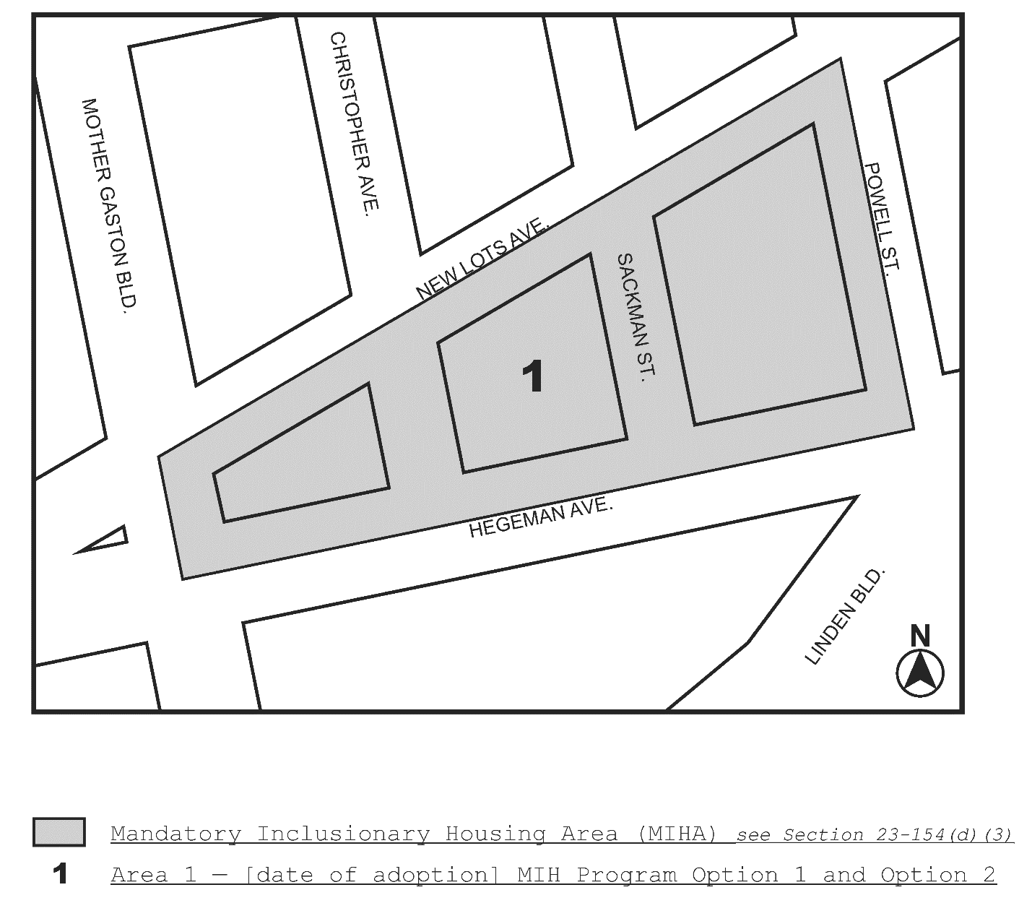

Page 4 of 5
N 170190 ZRK
Res. No. 1648 (L.U. No. 719)

[COUNCIL MODIFIED MAP]

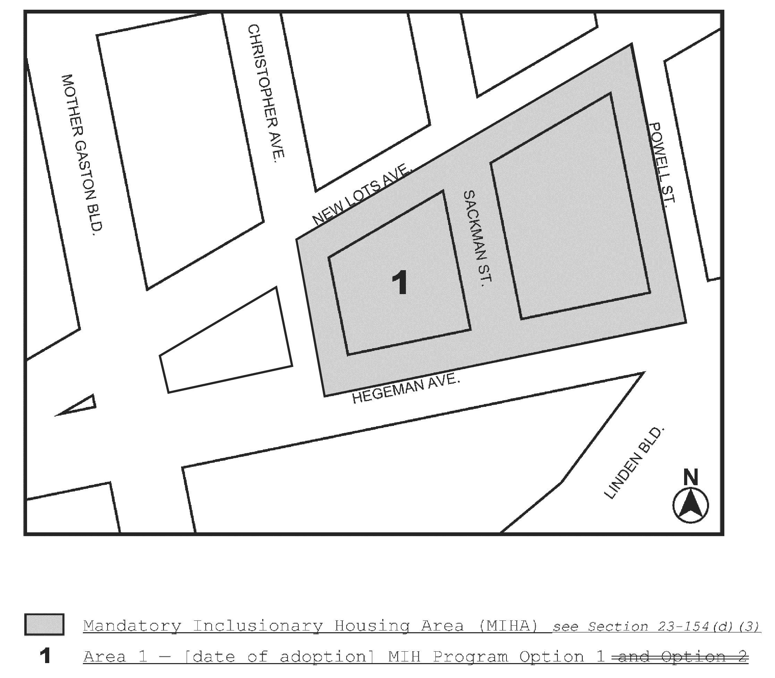

Portion of Community District 16, Brooklyn

* * *

Page 5 of 5
N 170190 ZRK
Res. No. 1648 (L.U. No. 719)

Adopted.

Office of the City Clerk, }
The City of New York, } ss.:

I hereby certify that the foregoing is a true copy of a Resolution passed by The Council of The City of New York on September 7, 2017, on file in this office.

.....…….........................................
City Clerk, Clerk of The Council

