THE COUNCIL OF THE CITY OF NEW YORK
RESOLUTION NO. 925

Resolution approving with modifications the decision of the City Planning Commission on Application No. N 230129 ZRK, for an amendment of the text of the Zoning Resolution (L.U. No. 268).

By Council Members Salamanca and Riley

WHEREAS, 2510 CIA, LLC, filed an application pursuant to Section 201 of the New York City Charter, for an amendment of the text of the Zoning Resolution of the City of New York, modifying APPENDIX F for the purpose of establishing a Mandatory Inclusionary Housing area, which in conjunction with the related action would facilitate the development of a new 11-story, approximately 61,500 square-foot mixed-use building containing approximately 55,100 square feet of residential space, or 60 dwelling units, approximately 15 to 18 of which would be permanently income-restricted, as well as approximately 6,400 square feet of ground floor commercial space located at 2510 Coney Island Avenue in the Sheepshead Bay neighborhood of Brooklyn, Community District 15 (ULURP No. N 230129 ZRK), (the “Application”);
WHEREAS, the City Planning Commission filed with the Council on March 26, 2025, its decision dated March 5, 2025 (the “Decision”) on the Application;
WHEREAS, the Application is related to application C 230128 ZMK (L.U. No. 267), a zoning map amendment to change R4 (OP) and C8-1 (OP) zoning districts to a R7D/C2-4 (OP) zoning district;
WHEREAS, the Decision is subject to review and action by the Council pursuant to Section 197-d of the City Charter;
WHEREAS, upon due notice, the Council held a public hearing on the Decision and Application on April 8, 2025;
WHEREAS, the Council has considered the land use implications and other policy issues relating to the Decision and Application; and
WHEREAS, the Council has considered the relevant environmental issues, including the Negative Declaration issued on November 4, 2024 (CEQR No. 22DCP138K), which includes an (E) designation to avoid the potential for significant adverse impacts related to hazmat, air quality, and noise analyses (E-720) (the “Negative Declaration”).
RESOLVED:
The Council finds that the action described herein will have no significant impact on the environment as set forth in the (E) Designation (E-720) and Negative Declaration.
Pursuant to Sections 197-d and 200 of the City Charter and on the basis of the Decision and Application, and based on the environmental determination and consideration described in the report, N 230129 ZRK, incorporated by reference herein, and the record before the Council, the Council approves the Decision of the City Planning Commission, with the following modifications.
Matter underlined is new, to be added;
Matter struck out is to be deleted;
Matter double struck out is old, deleted by the City Council;
Matter double-underlined is new, added by the City Council;
Matter within # # is defined in Section 12-10;
* * * indicates where unchanged text appears in the Zoning Resolution.
* * *
APPENDIX F
Mandatory Inclusionary Housing Areas and former Inclusionary Housing Designated Areas
* * *
BROOKLYN
* * *
Brooklyn Community District 15
* * *
Map 9 – [date of adoption]

[PROPOSED MAP]
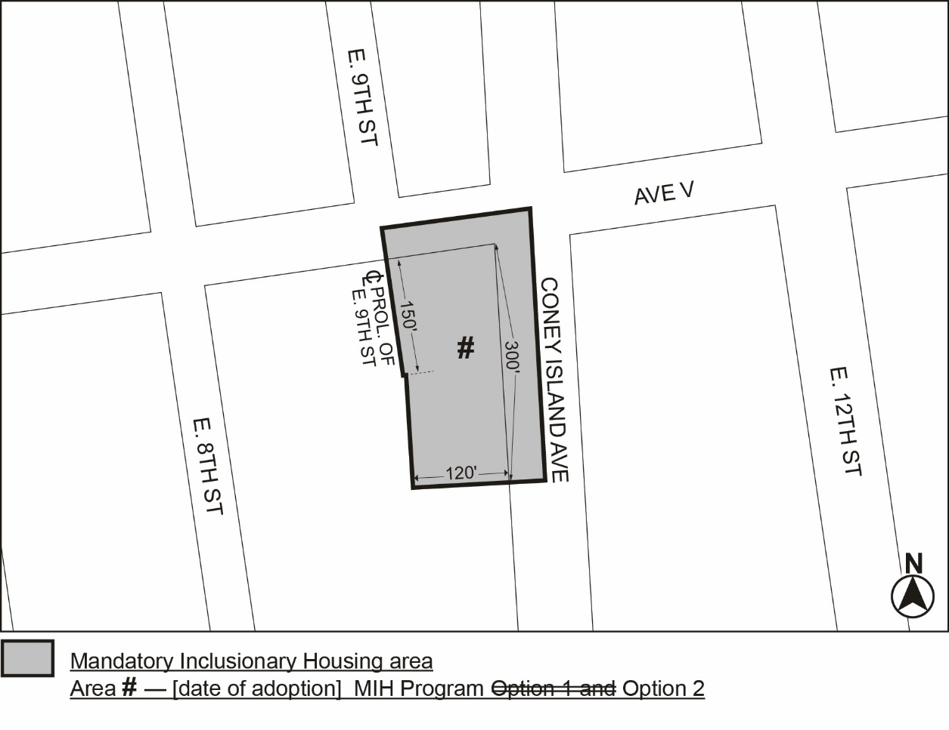
Portion of Community District 15, Brooklyn

* * *
Adopted.

Office of the City Clerk,}
The City of New York,} ss.:

I hereby certify that the foregoing is a true copy of a Resolution passed by The Council of The City of New York on _________, 2025, on file in this office.

.....................................................
City Clerk, Clerk of The Council

