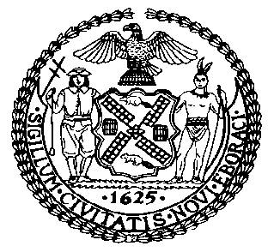 | The Council of the City of New York  Finance Division  Latonia McKinney, Director  Fiscal Impact Statement  Proposed Intro. No: 1431-A  Committee: Housing and Buildings
Title: A Local Law to amend the administrative code of the city of New York, in relation to the registration and duties of lift directors | Sponsors: Council Members Grodenchik, Crowley, Rose, Reynoso, Levin, Espinal, Menchaca, Cornegy, Rodriguez and Kallos (in conjunction with the Mayor)
Summary of Legislation: Proposed Intro. 1431-A would establish a training requirement for lift directors for all cranes that require a certificate of on-site inspection. The requirement for lift directors would take effect 18 months after the Department of Buildings (“DOB”) approves a 32-hour training program for lift directors. The content of such training would include topics related to mobile cranes, tower cranes, and derricks, weather warnings, and other topics to be determined by DOB. The legislation would also set forth the standards by which a lift director qualification would be issued.

Effective Date: This local law would take effect immediately except that this local law would not apply to the use of a mobile crane at a construction site where a certificate of on-site inspection for the use of such crane at such site is issued prior to July 1, 2017; provided that this exception shall not apply to a mobile crane that is a crawler crane.
Fiscal Year In Which Full Fiscal Impact Anticipated: Fiscal 2019
Fiscal Impact Statement:

 | Effective FY18 | FY Succeeding Effective FY19 | Full Fiscal Impact FY19
Revenues | $0 | $0 | $0
Expenditures | $0 | $0 | $0
Net | $0 | $0 | $0

Impact on Revenues: It is estimated that there would be no impact on revenues resulting from the enactment of this legislation. Under the legislation, DOB would be required to establish a procedure for applying for lift director registration, which could include a registration, but these fees are not mandated or set under this legislation, and thus not assumed in this cost estimate.
Impact on Expenditures: It is anticipated that there would be no impact on expenditures resulting from the enactment of this legislation because existing resources would be used by DOB to implement the provisions of this local law. This estimate assumes that non-City entities would bear the costs of providing a training course for lift directing in accordance with the legislation, although at the time of this writing, the structure of such program is not yet known and subject to DOB approval.
Source of Funds To Cover Estimated Costs: Not applicable.

Source of Information: New York City Council Finance Division

Estimate Prepared by: Sarah Gastelum, Principal Financial Analyst
Estimated Reviewed by: Chima Obichere, Unit Head
Rebecca Chasan, Counsel

Legislative History: This legislation was introduced to the full Council on January 18, 2017 as Intro. No. 1431 and was referred to the Committee on Housing and Buildings (Committee). A hearing was held by the Committee on January 31, 2017, and the bill was laid over. The legislation was subsequently amended, and the amended version, Proposed Intro. No. 1431-A, will be considered by the Committee on November 29, 2017. Following a successful Committee vote, the bill will be submitted to the full Council for a vote on November 30, 2017.

Date Prepared: November 28, 2017

