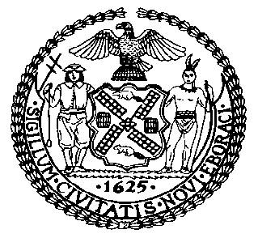 | The Council of the City of New York  Finance Division  Latonia McKinney, Director  Fiscal Impact Statement  Proposed Intro. No: 1482-B  Committee: Housing and Buildings
Title: A Local Law to amend the administrative code of the city of New York and the New York city building code, in relation to bird friendly materials | Sponsors: By Council Members Espinal, the Speaker (Council Member Johnson), Rosenthal, Brannan, Koslowitz, Levin, Perkins, Dromm, Constantinides, Grodenchik, Rivera, Powers, Levine, Van Bramer, Reynoso, Lander, Ayala, Kallos, Chin and the Public Advocate (Mr. Williams)
Summary of Legislation: Proposed Int. No. 1482-B would require that newly constructed or altered buildings be constructed with materials that reduce the likelihood of bird strike fatalities.

Effective Date: This local law would take effect one year after it becomes law and would not apply to applications for construction document approval filed prior to such effective date, except that the Commissioner of the Department of Buildings may take such measures as are necessary for the implementation of this local law, including the promulgation of rules, prior to such effective date.

Fiscal Year In Which Full Fiscal Impact Anticipated: Fiscal 2022
Fiscal Impact Statement:

 | Effective FY21 | FY Succeeding Effective FY22 | Full Fiscal Impact FY22
Revenues | $0 | $0 | $0
Expenditures | $0 | $0 | $0
Net | $0 | $0 | $0

Impact on Revenues: It is estimated that there would be no impact on revenues resulting from the enactment of this legislation.
Impact on Expenditures: It is anticipated that there would be no impact on expenditures resulting from the enactment of this legislation.
Source of Funds To Cover Estimated Costs: N/A.

Source of Information: New York City Council Finance Division
Mayor’s Office of City Legislative Affairs
New York City Department of Buildings

Estimate Prepared by: Luke Zangerle, Financial Analyst

Estimated Reviewed by: Chima Obichere, Unit Head
Stephanie Ruiz, Assistant Counsel

Legislative History: This legislation was introduced to the full council on March 28, 2019 as Int. No. 1482 and was referred to the Committee on Housing and Buildings (Committee). The legislation was amended after introduction and a hearing was held by the Committee on the amended version, Proposed Int. No. 1482-A, on September 10, 2019, and the bill was laid over. The legislation was subsequently amended a second time, and the amended version, Proposed Int. No. 1482-B, will be considered by the Committee on December 9, 2019. Following a successful vote by the Committee, the legislation will be submitted to the full Council for a vote on December 10, 2019.

Date Prepared: December 5, 2019

