THE COUNCIL OF THE CITY OF NEW YORK
RESOLUTION NO. 1754

Resolution approving with modifications the decision of the City Planning Commission on Application No. N 170417 ZRK, for an amendment of the Zoning Resolution of the City of New York, modifying Appendix F for the purpose of establishing a Mandatory Inclusionary Housing area in Community District 9, Borough of Brooklyn (L.U. No. 809).

By Council Members Greenfield and Salamanca

WHEREAS, the City Planning Commission filed with the Council on October 20, 2017 its decision dated October 18, 2017 (the "Decision"), pursuant to Section 201 of the New York City Charter, regarding the application submitted by the NYC Economic Development Corporation , for an amendment of the text of the Zoning Resolution of the City of New York, modifying Appendix F for the purpose of establishing a Mandatory Inclusionary Housing area (Application No. N 170417 ZRK), Community District 9, Borough of Brooklyn (the "Application");

WHEREAS, the Application is related to applications C 170416 ZMK (L.U. No. 808), a zoning map amendment to change the project area from an R6 district to R7-2 and R7-2/C2-4 districts, C 170418 ZSK (L.U. No. 810) a special permit to create a large-scale general development LSGD, C 170419 ZSK (L.U. No. 811) a special permit to modify parking requirements and C 170420 PPK (L.U. No. 812), a disposition of City-owned property;

WHEREAS, the Decision is subject to review and action by the Council pursuant to Section 197-d(b)(1) of the City Charter;
WHEREAS, upon due notice, the Council held a public hearing on the Decision and Application on November 14, 2017;

WHEREAS, the Council has considered the land use implications and other policy issues relating to the Decision and Application; and

WHEREAS, the Council has considered the relevant environmental issues, including the Final Environmental Impact Statement (FEIS) for which a Notice of Completion was issued on October 19, 2017 (CEQR No. 16DME005K), which identified significant adverse impacts with respect to historic and cultural resources – archaeological resources, transportation (traffic, buses, subways, and pedestrians) and construction activities related to noise;

RESOLVED:

Having considered the FEIS with respect to the Decision and Application, the Council finds that:
(1) The FEIS meets the requirements of 6 N.Y.C.R.R. Part 617;

(2) Consistent with social, economic and other essential considerations, from among the reasonable alternatives thereto, the action is one which minimizes or avoids adverse environmental impacts to the maximum extent practicable; and

(3) The adverse environmental impacts disclosed in the FEIS will be minimized or avoided to the maximum extent practicable by incorporating as conditions to the approval, those mitigation measures that were identified as practicable.

The Decision and the FEIS constitute the written statement of facts, and of social, economic and other factors and standards that form the basis of this determination, pursuant to 6 N.Y.C.R.R. §617.11(d).

Pursuant to Sections 197-d and 200 of the City Charter and on the basis of the Decision and Application, and based on the environmental determination and consideration described in the report, N 170417 ZRK, incorporated by reference herein, the Council approves the Decision of the City Planning Commission with the following modification:

Matter underlined is new, to be added;
Matter struck out is to be deleted;
Matter within # # is defined in Section 12-10;
Matter double strike-out is old, deleted by the City Council;
Matter double underlined is new, added by the City Council;
* * * indicates where unchanged text appears in the Zoning Resolution.

* * *

APPENDIX F
Inclusionary Housing Designated Areas and Mandatory Inclusionary Housing Areas

* * *

Brooklyn

* * *

Brooklyn Community District 9

* * *

In the R7-2 District within the areas shown on the following Map 1:

* * *
Map 1 - (date of adoption)

[PROPOSED MAP]

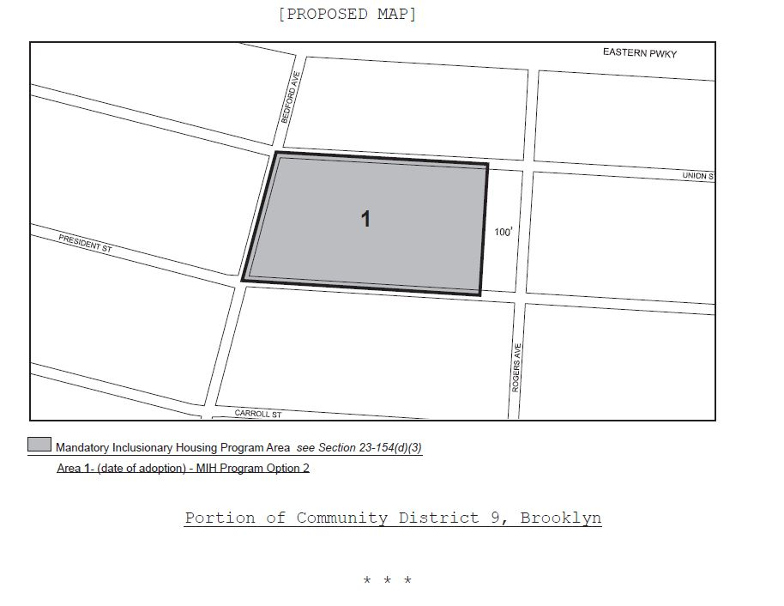

Mandatory Inclusionary Housing Program Area see Section 23-154(d)(3)
Area 1 (date of adoption) - MIH Program Option 2 Option 1

Portion of Community District 9, Brooklyn

* * *

Adopted
Office of the City Clerk, }
The City of New York, } ss.:

I hereby certify that the foregoing is a true copy of a Resolution passed by The Council of The City of New York on November 30, 2017, on file in this office.

.....…….........................................
City Clerk, Clerk of The Council

