THE COUNCIL OF THE CITY OF NEW YORK
RESOLUTION NO. 770

Resolution approving with modifications the decision of the City Planning Commission on Application No. N 240105 ZRX, for an amendment of the text of the Zoning Resolution (L.U. No. 211).

By Council Members Salamanca and Riley

WHEREAS, BronxCo, LLC, filed an application pursuant to Section 201 of the New York City Charter, for an amendment of the text of the Zoning Resolution of the City of New York to amend Article XII, Chapter 3 (Special Mixed Use District) and APPENDIX F to establish a Mandatory Inclusionary Housing area, which in conjunction with the related action would facilitate the development of one new building totaling approximately 174,000 square feet of floor area, including approximately 3,300 square feet of commercial space, 7,600 square feet of light manufacturing, 25,600 square feet of office, 6,600 square feet of community facility, 87 dwelling units and 43 cellar parking spaces at 438 Concord Avenue in the Mott Haven neighborhood of the Bronx, Community District 1 (ULURP No. N 240105 ZRX), (the “Application”);

WHEREAS, the City Planning Commission filed with the Council on December 30, 2024, its decision dated December 4, 2024 (the "Decision") on the Application;

WHEREAS, the Application is related to application C 240104 ZMX (L.U. No. 210), a zoning map amendment to change from an M1-2 zoning district to an M1-4/R7D (MX-18) zoning district;

WHEREAS, the Decision is subject to review and action by the Council pursuant to Section 197-d of the City Charter;

WHEREAS, upon due notice, the Council held a public hearing on the Decision and Application on January 9, 2025;

WHEREAS, the Council has considered the land use implications and other policy issues relating to the Decision and Application; and

WHEREAS, the Council has considered the relevant environmental issues, including the Negative Declaration issued on June 24, 2024 (CEQR No. 23DCP092X), which includes an (E) designation to avoid the potential for significant adverse impacts related to hazardous materials, air quality, and noise (E-756) (the “Negative Declaration”).

RESOLVED:

The Council finds that the action described herein will have no significant impact on the environment as set forth in the (E) Designation (E-756) and Negative Declaration.

Pursuant to Sections 197-d and 200 of the City Charter and on the basis of the Decision and Application, and based on the environmental determination and consideration described in the report, N 240105 ZRX, incorporated by reference herein, and the record before the Council, the Council approves the Decision of the City Planning Commission, with the following modifications.

Matter underlined is new, to be added;
Matter struck out is to be deleted;
Matter double struck out is old, deleted by the City Council;
Matter double-underlined is new, added by the City Council
Matter within # # is defined in Section 12-10;
* * * indicates where unchanged text appears in the Zoning Resolution.

* * *

ARTICLE XII
SPECIAL PURPOSE DISTRICTS

Chapter 3
Special Mixed Use District

* * *

123-63

Maximum Floor Area Ratio and Lot Coverage Requirements for Zoning Lots Containing Only Residential Buildings in R6, R7, R8 and R9 Districts

* * *

#Special Mixed Use District# | Designated #Residence District#
* * *
MX 16 - Community Districts 5 and 16, Brooklyn | R6A R7A R7D R8A
MX 18 - Community District 1, The Bronx | R7D R7X
MX 19 - Community District 16, Brooklyn | R6A R7A
* * *

* * *

APPENDIX F
Inclusionary Housing Designated Areas and Mandatory Inclusionary Housing Areas

The Bronx

Community District 1

* * *

Map 9 — [date of adoption]

[EXISTING MAP]
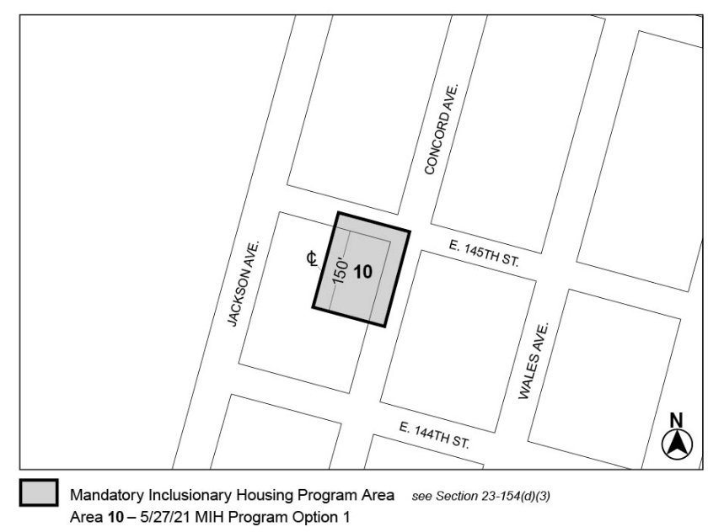
[PROPOSED MAP]
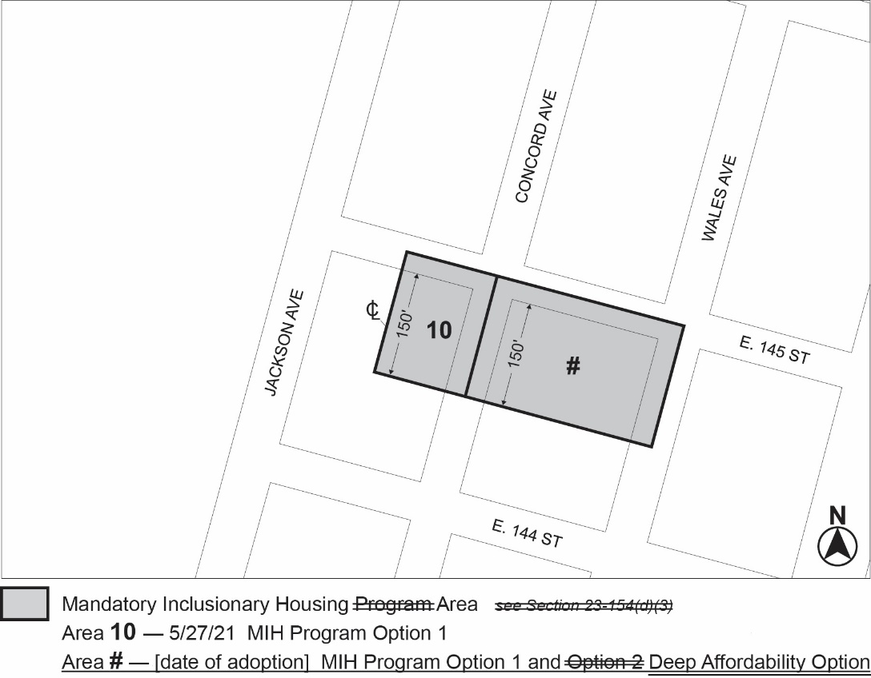
[Non-substantive changes to terminology have been made to reflect the City of Yes for Housing Opportunity text amendment (N 240290 ZRY) adopted on December 5, 2024.]
* * *

Adopted.

Office of the City Clerk,}
The City of New York,} ss.:

I hereby certify that the foregoing is a true copy of a Resolution passed by The Council of The City of New York on _________, 2025, on file in this office.

.....................................................
City Clerk, Clerk of The Council

