THE COUNCIL OF THE CITY OF NEW YORK
RESOLUTION NO. 915

Resolution approving with modifications the decision of the City Planning Commission on Application No. N 250015 ZRK, for an amendment of the text of the Zoning Resolution (L.U. No. 258).

By Council Members Salamanca and Riley

WHEREAS, the New York City Department of City Planning, New York City Department of Citywide Administrative Services, and New York City Department of Housing Preservation and Development, filed an application pursuant to Section 201 of the New York City Charter, for an amendment of the text of the Zoning Resolution of the City of New York, establishing the Special Atlantic Avenue Mixed Use District (Article XIV, Chapter 6) and modifying APPENDIX F for the purpose of establishing a Mandatory Inclusionary Housing area, and related Sections (ULURP No. N 250015 ZRK) (the “Application”);

WHEREAS, the City Planning Commission filed with the Council on March 24, 2025, its decision dated March 19, 2025 (the “Decision”) on the Application;

WHEREAS, the Application is related to applications C 250014 ZMK (L.U. No. 257), a zoning map amendment to change M1-1, C6-2A, C6-3A, C6-3X, M1-4/R7A, R7A/C24, R7D/C2-4, R6B, and R6A districts to R7A, R7D, C6-3A, M1-1A/R6B, M1-2A/R6A, M1-3A/R7D, M1-4A/R9A, C4-3A, C4-5D, R7-2, and M1-3A districts and C2-4 commercial overlays, and establish the Special Atlantic Avenue Mixed Use District; C 250020 PQK (L.U. No. 259), an acquisition of property by the City located at 516 Bergen Street (Block 1143, Lot 25); C 250021 PPK (L.U. No. 260), a disposition of City-owned property located at 1110 Atlantic Avenue (Block 1126, Lot 32); C 250022 PPK (L.U. No. 261), a disposition of City-owned property located at 457 Nostrand Avenue (Block 1844, Lot 1); C 250023 PPK (L.U. No. 262), a disposition of City-owned property located at 1134-1142 Pacific Street (Block 1205, Lots 11, 14, 111); C 250016 HAK (L.U. No. 263), a disposition approval, UDAA and UDAAP designation located at 542 Dean Street (Block 1136, Lot 29, 32, 33, 34, 35); C 250019 PQK (L.U. No. 264), an acquisition of property by the City located at 1134-1142 Pacific Street (Block 1205, Lots 11, 14, 111); C 250017 HAK (L.U. No. 265), a disposition approval, UDAA and UDAAP designation located at 516 Bergen Street (Block 1143, Lot 25); C 250018 PQK (L.U. No. 266), an acquisition of property by the City located at 1110 Atlantic Avenue (Block 1126, Lot 32); G 250073 XAK, an Article XI Disposition approval, for the disposition of city-owned property located at 457 Nostrand Avenue (Block 1844, Lot 1) (L.U. No. 273); and G 250074 XAK, an Article XI Disposition approval, for the disposition of city-owned property located at 1134-1142 Pacific Street (Block 1205, Lots 11, 14, 111) (L.U. No. 274);

WHEREAS, the Decision is subject to review and action by the Council pursuant to Section 197-d of the City Charter;

WHEREAS, upon due notice, the Council held a public hearing on the Decision and Application on March 27, 2025;

WHEREAS, the Council has considered the land use implications and other policy issues relating to the Decision and Application; and

WHEREAS, the Council has considered the relevant environmental issues, including the Positive Declaration issued on September 15, 2023 (CEQR No. 24DCP019K) and a Final Environmental Impact Statement (FEIS) for which a Notice of Completion was issued on March 7, 2025, in which significant adverse impacts related to hazardous materials, air quality, and noise would be avoided through the placement of (E) designations (E-810) on selected projected and potential development sites as specified in Chapters 9, 14 and 16, respectively of the FEIS; and the FEIS determined that the proposed actions would have identified significant adverse impacts with respect to open space, shadows (St. Bartholomew’s Episcopal Church and the Lefferts Place Block Association Garden), historic and cultural resources (architectural and archaeological), transportation (traffic, transit, and pedestrians), and construction activities (transportation, air quality, noise). In addition, the identified significant adverse impacts and proposed mitigation measures under the proposed actions are summarized in Chapter 20, “Mitigation” of the FEIS. The Council has also considered the Technical Memorandum dated [ ], 2025 (“Technical Memorandum”).

RESOLVED:

Having considered the FEIS with respect to the Decision and Application, and the Technical Memorandum, the Council finds that:
- The FEIS meets the requirements of 6 N.Y.C.R.R. Part 617;

- The environmental impacts disclosed in the FEIS were evaluated in relation to the social, economic, and other considerations associated with the actions that are set forth in this report; and

- Consistent with social, economic and other essential considerations from among the reasonable alternatives available, the action is one which avoids or minimizes adverse environmental impacts to the maximum extent practicable;

The Decision, together with the FEIS issued March 7, 2025, and the Technical Memorandum, constitute the written statement of facts, and of social, economic and other factors and standards that form the basis of this determination, pursuant to 6 N.Y.C.R.R. §617.11(d);

Pursuant to Sections 197-d and 200 of the City Charter and on the basis of the Decision and Application, the environmental determination and consideration described in the report, N 250015 ZRK, incorporated by reference herein, and the record before the Council, the Council approves the Decision of the City Planning Commission, with the following modifications:

Matter underlined is new, to be added;
Matter struck out is to be deleted;
Matter double-underlined is new, added by the City Council;
Matter double struck out is old, deleted by the City Council;
Matter within # # is defined in Section 12-10;
* * * indicates where unchanged text appears in the Zoning Resolution.

ARTICLE I
GENERAL PROVISIONS

Chapter 1
Title, Establishment of Controls and Interpretation of Regulations

* * *

11-10
ESTABLISHMENT AND SCOPE OF CONTROLS, ESTABLISHMENT OF DISTRICTS, AND INCORPORATION OF MAPS

* * *

11-12
Establishment of Districts

* * *

11-122
Districts established

In order to carry out the purposes and provisions of this Resolution, the following districts are hereby established:

* * *

Special Purpose Districts

* * *

Establishment of the Special 125th Street District

In order to carry out the special purposes of this Resolution as set forth in Article IX, Chapter 7 the #Special 125th Street District# is hereby established.

Establishment of the Special Atlantic Avenue Mixed Use District

In order to carry out the special purposes of this Resolution as set forth in Article XIV, Chapter 6, the #Special Atlantic Avenue Mixed Use District# is hereby established.

Establishment of the Special Battery Park City District

In order to carry out the special purposes of this Resolution as set forth in Article VIII, Chapter 4, the #Special Battery Park City District# is hereby established.

* * *

Chapter 2
Construction of Language and Definitions

* * *

12-10
DEFINITIONS

* * *

Special 125th Street District

The “Special 125th Street District” is a Special Purpose District designated by the number “125” in which special regulations set forth in Article IX, Chapter 7, apply.

Special Atlantic Avenue Mixed Use District

The “Special Atlantic Avenue Mixed Use District” is a Special Purpose District designated by the letters “AAM” in which special regulations set forth in Article XIV, Chapter 6, apply.

Special Battery Park City District

The “Special Battery Park City District” is a Special Purpose District designated by the letters “BPC” in which special regulations set forth in Article VIII, Chapter 4, apply.

* * *

ARTICLE XII
SPECIAL PURPOSE DISTRICTS

Chapter 3
Special Mixed Use District

* * *

123-90
SPECIAL MIXED USE DISTRICTS SPECIFIED

* * *

#Special Mixed Use District# - 19:
Brownsville, Brooklyn

The #Special Mixed Use District# - 19 is established in Brownsville in Brooklyn as indicated on the #zoning maps#.

#Special Mixed Use District# - 20:
Crown Heights West, Brooklyn

The #Special Mixed Use District# - 20 is established in Crown Heights West in Brooklyn as indicated on the #zoning maps#.

#Special Mixed Use District# - 21:
Arverne, Queens

The #Special Mixed Use District# - 21 is established in Arverne in Queens as indicated on the #zoning maps#.

* * *

ARTICLE XIV
SPECIAL PURPOSE DISTRICTS

* * *

Chapter 6
Special Atlantic Avenue Mixed Use District (AAM)

146-00
GENERAL PURPOSES

The “Special Atlantic Avenue Mixed Use District” established in this Resolution is designed to promote and protect public health, safety and general welfare. These general goals include, among others, the following specific purposes:

(a) to expand local employment opportunities and to promote the opportunity for workers to live in the vicinity of their work;

(b) to create a lively and attractive built environment that will provide amenities and services for the use and enjoyment of area residents, workers and visitors;

(c) to enhance neighborhood economic diversity by broadening the range of housing choices for residents at varied incomes;

(d) to encourage stability and growth in the neighborhood by permitting compatible light manufacturing and residential uses to coexist;

(e) to ensure that the form and use of new buildings relates to and enhances neighborhood character and responds to unique corridors such as Atlantic Avenue; and

(f) to promote the most desirable use of land in the area and thus preserve, protect and enhance the value of land and buildings and thereby protect City tax revenues.

146-01
General Provisions

The provisions of this Chapter shall apply within the #Special Atlantic Avenue Mixed Use District#. The regulations of all other Chapters of this Resolution are applicable, except as superseded, supplemented or modified by the provisions of this Chapter. In the event of a conflict between the provisions of this Chapter and other regulations of this Resolution, the provisions of this Chapter shall control, except where explicitly stated otherwise in this Chapter.

146-02
District Plan and Map

The regulations of this Chapter are designed to implement the #Special Atlantic Avenue Mixed Use District# Plan. The district plan includes the following map in the Appendix to this Chapter:
Map 1 Designated Streetscape Frontages
Such map is hereby incorporated and made part of this Resolution for the purpose of specifying locations where the special regulations and requirements set forth in the text of this Chapter apply.

146-03
Definitions

For the purposes of this Chapter, matter in italics is defined in Sections 12-10 (DEFINITIONS), 32-301 (Definitions) or 123-11 (Definitions).

146-04
Applicability of the Mandatory Inclusionary Housing Program

For the purposes of applying the Mandatory Inclusionary Housing Program provisions set forth in Section 27-10 (ADMINISTRATION OF AFFORDABLE HOUSING), #Mandatory Inclusionary Housing areas# within the #Special Atlantic Avenue Mixed Use District# are shown in APPENDIX F of this Resolution.

146-041
Applicability of Article VI, Chapter 6

For #transit-adjacent sites#, as defined in Section 66-11 (Definitions), in the event of a conflict between the provisions of this Chapter and the provisions of Article VI, Chapter 6 (Special Regulations Applying Around Mass Transit Stations), the provisions of Article VI, Chapter 6 shall control.

146-042
Applicability of Article XII, Chapter 3

In M1 Districts paired with a #Residence District#, the special #use#, #bulk# and parking and loading provisions of Article XII, Chapter 3 (Special Mixed Use District) shall apply, except where modified by the provisions of this Chapter.

146-10
SPECIAL USE REGULATIONS

The #use# regulations of the underlying districts, or of Article XII, Chapter 3 (Special Mixed Use Districts), shall apply, except as modified by the provisions this Section, inclusive.

146-11
Additional Conditions for Certain Uses

In M1 Districts paired with a #Residence District#, all applicable #commercial# and
#manufacturing# #uses# may only locate in the same #building# as, or may only share a
common wall with, a #building# containing a #residence# or a #community facility# #use# with
sleeping accommodations:

(a) where the provisions of paragraph (b)(1) of Section 123-22 (Additional Conditions for Certain Uses) are met; or

(b) where the Chairperson of the City Planning Commission certifies an alternative means of compliance pursuant to Section 146-12, and an (E) designation listed in APPENDIX C of this Resolution applies to all tax lots with such #uses# in accordance with Section 11-15 (Environmental Requirements), establishing specific building design or other environmental requirements in order to protect occupants of the #building# and surrounding properties from any hazardous materials, noise or air quality associated with such #commercial# or #manufacturing# #uses#.

146-12
Certification for an Alternate Means of Compliance for Mixed Buildings

In M1 Districts paired with a #Residence District#, the Chairperson of the City Planning Commission shall allow, by certification, an alternative to the provisions of paragraph (b) of Section 123-22 (Additional Conditions for Certain Uses) where applicable #commercial# and #manufacturing# #uses# are proposed to locate in the same #building# as, or share a common wall with, a #building# containing a #residence# or a #community facility# #use# with sleeping accommodations.

In order for the Chairperson to make such certification, the applicant shall submit a report, from a licensed architect or engineer, demonstrating that specific physical design standards to be implemented in the #building# design, or other environmental requirements, will protect occupants of such #residences# or #community facility# #uses# with sleeping accommodations from any potential hazardous materials, noise or air quality associated with such #commercial# or #manufacturing# #uses#.

An (E) designation shall be listed in APPENDIX C of this Resolution and bind the owners, successors, and assigns to comply with Section 11-15 (Environmental Requirements) and the specific building design or other environmental requirements listed in the report.

146-13
Streetscape Regulations

The underlying #ground floor level# streetscape provisions set forth in Section 32-30 (STREETSCAPE REGULATIONS), inclusive, shall apply, except where Map 1, in the Appendix to this Chapter, designates:

(a) #ground floor level# #street frontages# that shall be considered #Tier C street frontages#; and

(b) #ground floor level# #street frontages# where the alternative provisions for #Tier B street frontages# set forth in Section 32-322 shall not apply.

146-20
SPECIAL BULK REGULATIONS

The #bulk# regulations of the underlying districts or of Article XII, Chapter 3 (Special Mixed Use District) shall apply, except as modified by the provisions of this Section, inclusive.

146-21
Floor Area Regulations

146-211
Floor area modifications for certain paired districts

In M1A Districts paired with #Residence Districts#, for #zoning lots# with #buildings# containing #residential# and non-#residential uses#, notwithstanding the maximum #floor area ratio# for individual #uses# on the #zoning lot#, the total #floor area ratio# shall be as follows:

TOTAL FLOOR AREA RATIO

District | Total #floor area ratio#
M1-1A/R6B | 3.0
M1-2A/R6A | 5.0

146-22
Special Yard Regulations

The #yard# regulations of the underlying districts shall apply, except that for #zoning lots# where the #side lot line# is located within 30 feet of an elevated rail line, the #rear yard# and #rear yard equivalent# provisions of Section 23-34 (Rear Yard and Rear Yard Equivalent Requirements), inclusive, need not apply.

146-23
Special Height and Setback Regulations

146-231
Street wall modifications

For #zoning lots#, or portions thereof, fronting on Atlantic Avenue or Bedford Avenue, the applicable #street wall# location regulations shall be modified as follows:
(a) the #street wall# shall be located at least 20 feet beyond the curb of the sidewalk, except that such depth need not exceed five feet from the #street line#; and
(b) for #developments# with #building# widths exceeding 100 feet, a minimum of 20 percent of the surface area of such #street walls# above the level of the second #story#, or a height of 30 feet, whichever is lower, shall either recess or project a minimum of three feet from the remaining surface of the #street wall#; and

(c) for the purposes of applying the provisions of Section 35-633 (Additional height and setback provisions) on shallow #through lots# with a frontage along Atlantic Avenue, the #street wall# location requirements of this Section shall be required along Atlantic Avenue.

146-232
Other height and setback modifications

The height and setback regulations of the applicable underlying districts shall be modified as follows:

(a) for #zoning lots#, or portions thereof, within 100 feet of a #side lot line# that is located within 30 feet of an elevated rail line, the applicable maximum #building# heights may be increased by 10 feet in M1-2A/R6A Districts, and by 20 feet in C6-3A and M1-4A/R9A Districts; and

(b) in M1A Districts paired with #Residence Districts#, for #zoning lots# with #buildings# containing both #residential# and non-#residential uses#, the following height and setback modifications may be applied:

MAXIMUM BASE HEIGHT AND MAXIMUM BUILDING HEIGHT

District | Maximum base height (in feet) | Maximum height of #buildings or other structures# (in feet)
M1-1A/R6B | 65 | 95
M1-2A/R6A | 95 | 125

In addition, for #zoning lots# with a #lot area# greater than or equal to 20,000 square feet, a #building# may exceed the maximum #building# heights established in such table by 25 percent.

146-30
SPECIAL OFF-STREET PARKING REGULATIONS

The #accessory# off-street parking regulations of the underlying districts are modified by the provisions of this Section, inclusive.

146-31
Accessory Off-street Parking Spaces for Non-residential Uses

In all districts, no #accessory# off-street parking spaces shall be required for #manufacturing#, #commercial#, or #community facility# #uses#.

146-40
SPECIAL APPROVALS

146-41
Authorization for a Public Plaza

In C6-3A, C6-3X and M1-4A/R9A Districts, for #zoning lots# with a #lot area# of at least 25,000 square feet 30,000 square feet, the City Planning Commission may authorize an increase in the maximum #floor area ratio# where a #public plaza# is provided on the #zoning lot# in accordance with the provisions of Section 37-70 (PUBLIC PLAZAS), inclusive.

In conjunction with such #floor area# bonus, the Commission may authorize modifications to the applicable #bulk# regulations of this Resolution, or to the regulations governing #public plazas# in Section 37-70, inclusive.

In order to grant such authorization, the Commission shall determine that the conditions and limitations of paragraph (a) and the findings of paragraph (b) are met.

(a) Conditions and limitations
The following conditions and limitations shall apply:
(1) For the purposes of determining the bonus ratio in #Commercial Districts# with a #residential equivalent# of an R9 District, or in M1 Districts paired with an R9 District, the underlying bonus ratio for a C6-3 District shall apply. The #floor area# bonus resulting from applying such ratio shall not exceed 20 percent of the maximum #floor area ratio# otherwise permitted by the district.

(2) Modifications to the maximum permitted #building# height shall not result in an increase that exceeds 25 percent of the maximum #building# height otherwise permitted by the applicable district regulations; and
(3) Modifications to the regulations governing #public plazas# shall be limited to:
(i) the basic design criteria set forth in Section 37-71, inclusive, other than the area dimensions of Section 37-712;
(ii) the access and circulation provisions set forth in Section 37-72, inclusive, other than hours of access set forth in Section 37-727; and
(iii) the types and standards for amenities, set forth in Section 37-74, inclusive.
(b) Findings
The Commission shall find that:
(1) the public benefit derived from the #public plaza# merits the amount of additional #floor area# being granted pursuant to this Section;

(2) the #public plaza# will be well-integrated with the overall pedestrian circulation network and contribute to an enhanced streetscape;

(3) any modifications to #bulk# are the minimum extent necessary to reasonably accommodate the #public plaza# and the additional #floor area# granted pursuant to this Section and will not unduly obstruct access to light and air to surrounding #streets# and properties; and

(4) any modifications to #public plaza# regulations are the minimum extent necessary, and will better align such #public plaza# regulations with unique site configurations or with the mixed-use character of the neighborhood.

The City Planning Commission may prescribe additional appropriate conditions and safeguards to minimize adverse effects on the character of the surrounding area.

APPENDIX
Special Atlantic Avenue Mixed Use Plan

Map 1 – Designated Streetscape Frontages
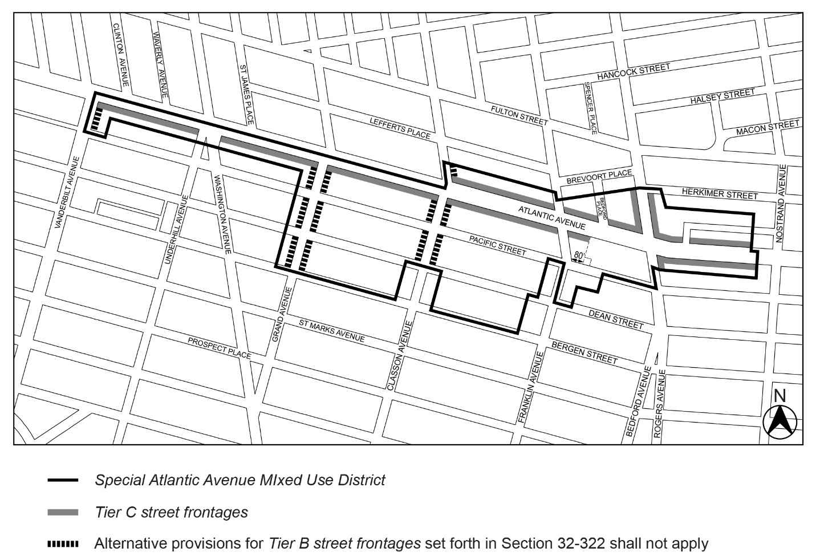

* * *

APPENDIX F
Mandatory Inclusionary Housing Areas and former Inclusionary Housing Designated Areas

BROOKLYN

* * *

Brooklyn Community District 3

Map 1
[EXISTING MAP]
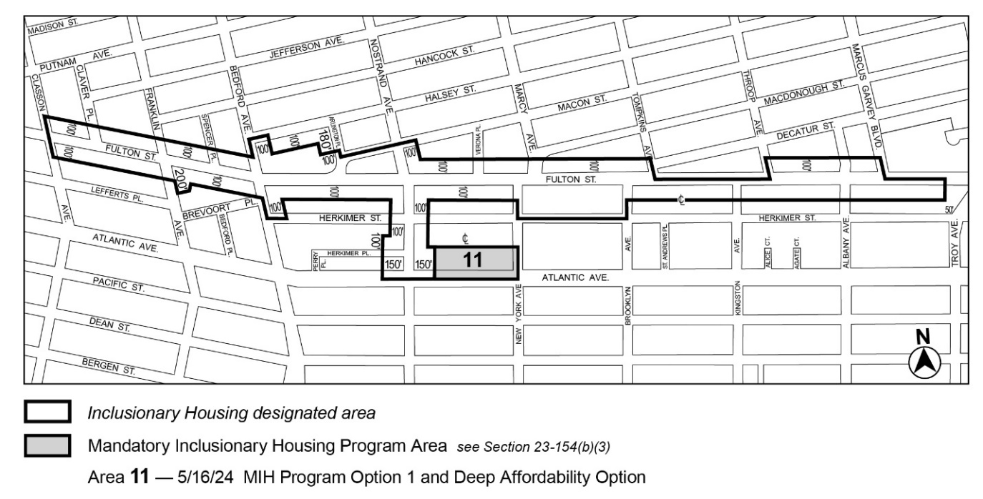

* * *

Map 7
[EXISTING MAP]
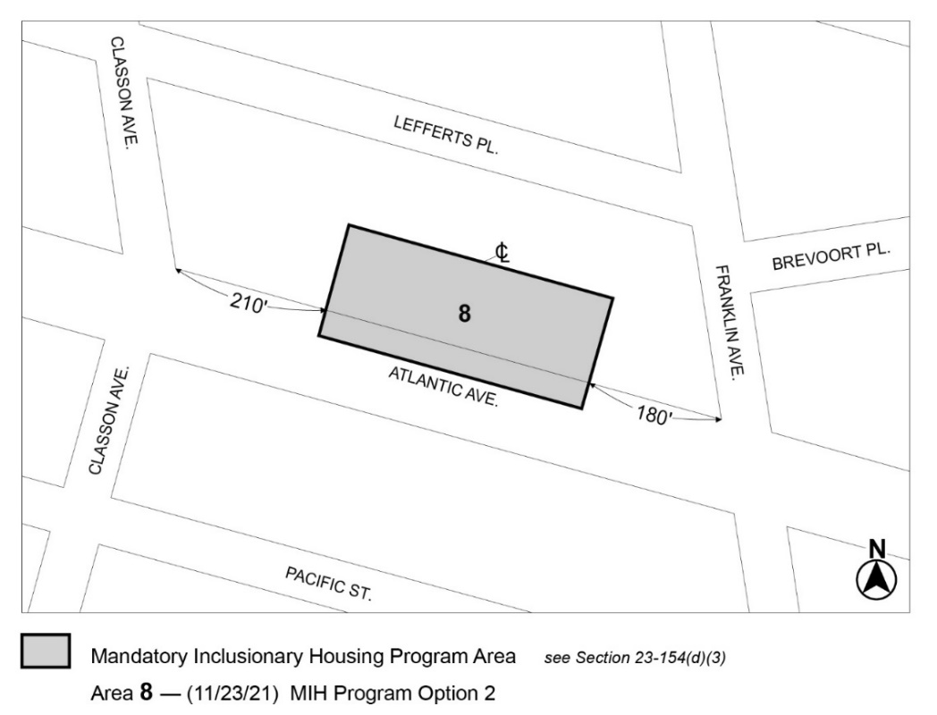

[MAP APPROVED BY CPC]
Map 1 – [date of adoption]
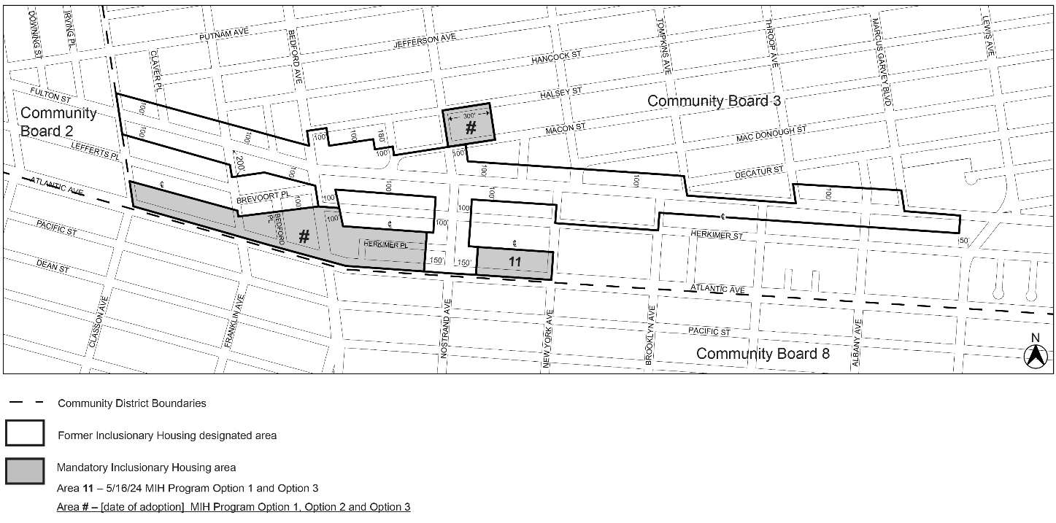
Portion of Community District 3, Brooklyn

[PROPOSED MAP – MODIFIED BY CITY COUNCIL]
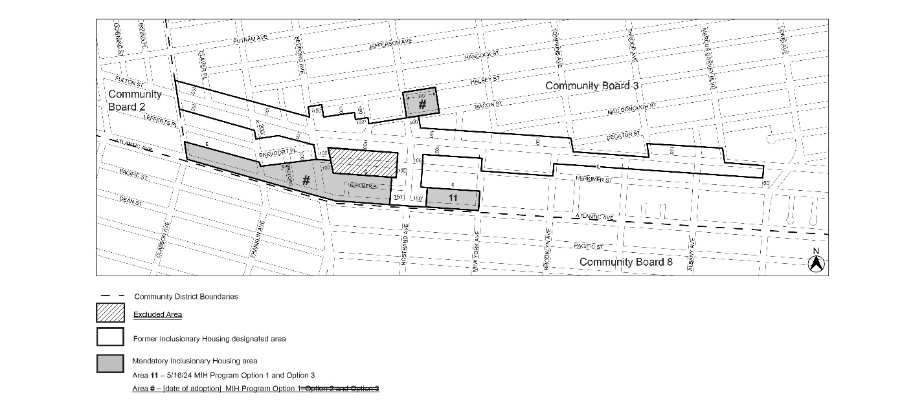
Portion of Community District 3, Brooklyn

[Maps 1 and 7 in Brooklyn CD 3 have been incorporated into composite Map 1 per N 250015 ZRK, [date of adoption]]
* * *
Brooklyn Community District 8
Map 1
[EXISTING MAP]
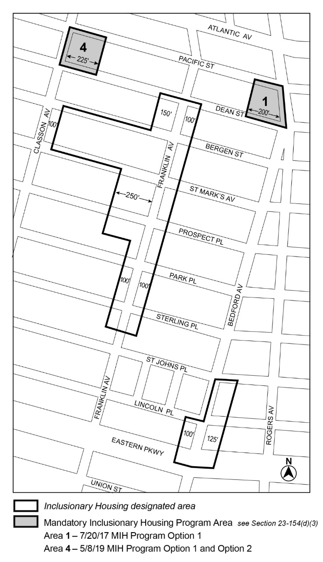

Map 2
[EXISTING MAP]
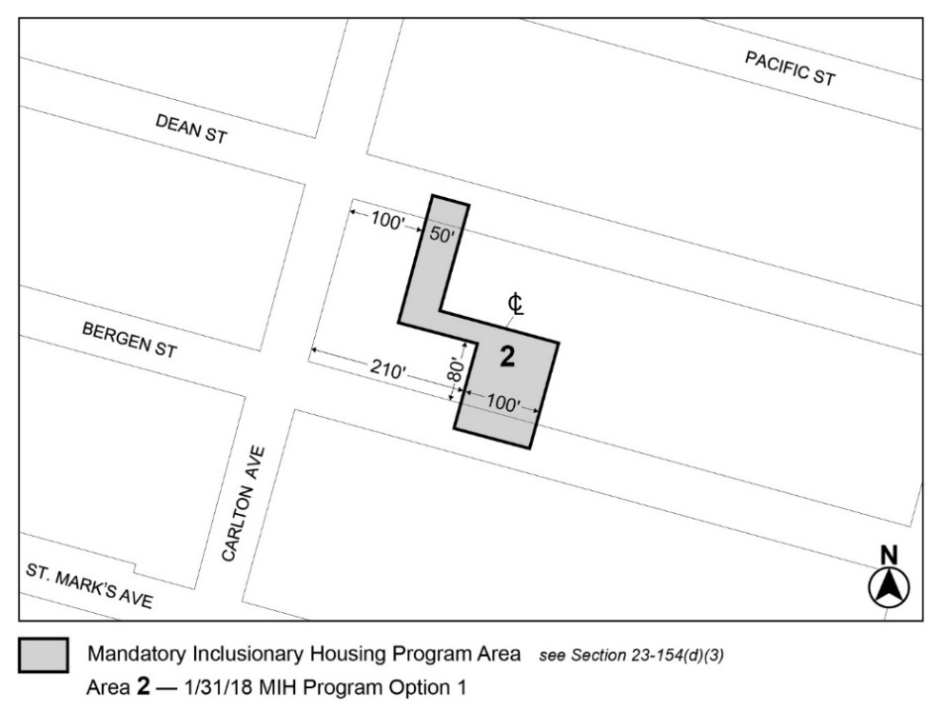

Map 3
[EXISTING MAP]
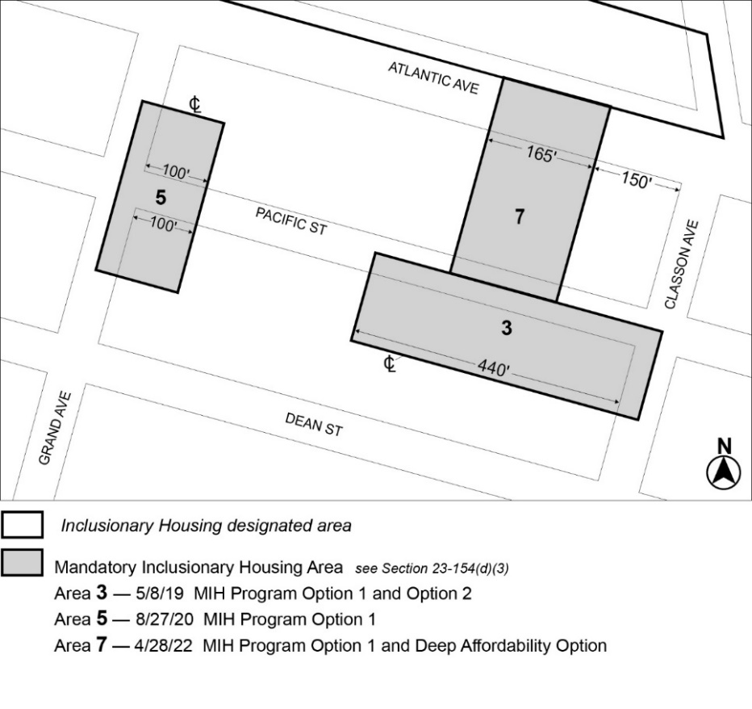

Map 4
[EXISTING MAP]
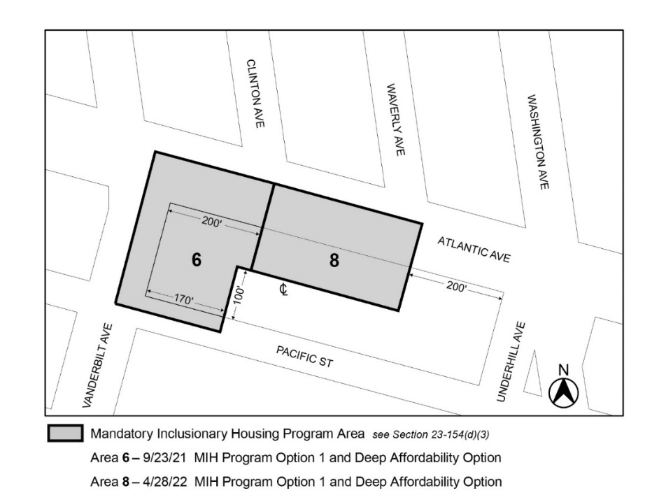

Map 1 – [date of adoption]
[MAP APPROVED BY CPC]
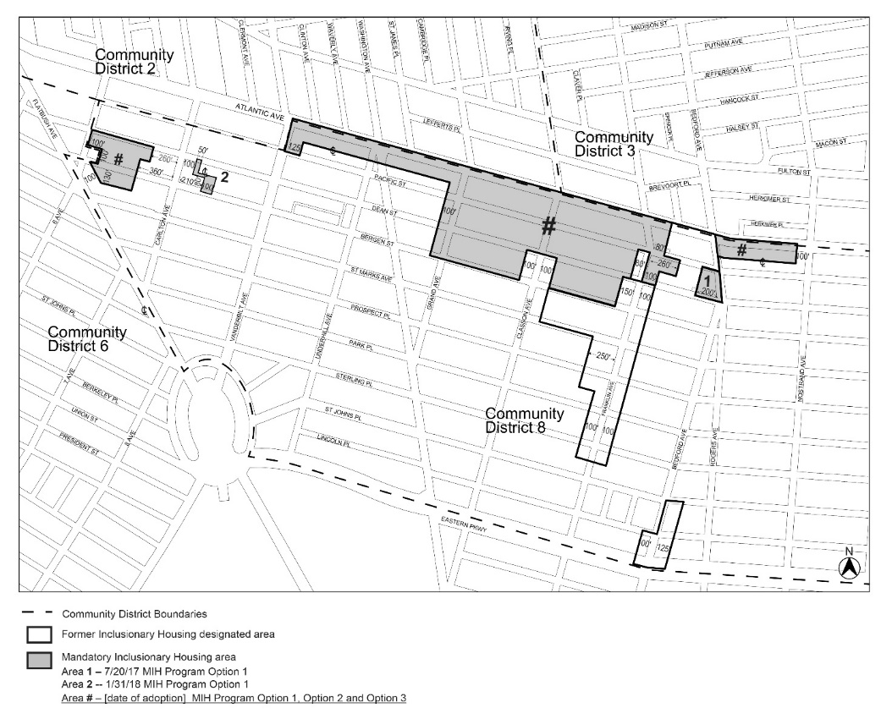
Portion of Community District 8, Brooklyn

[PROPOSED MAP – MODIFIED BY CITY COUNCIL]
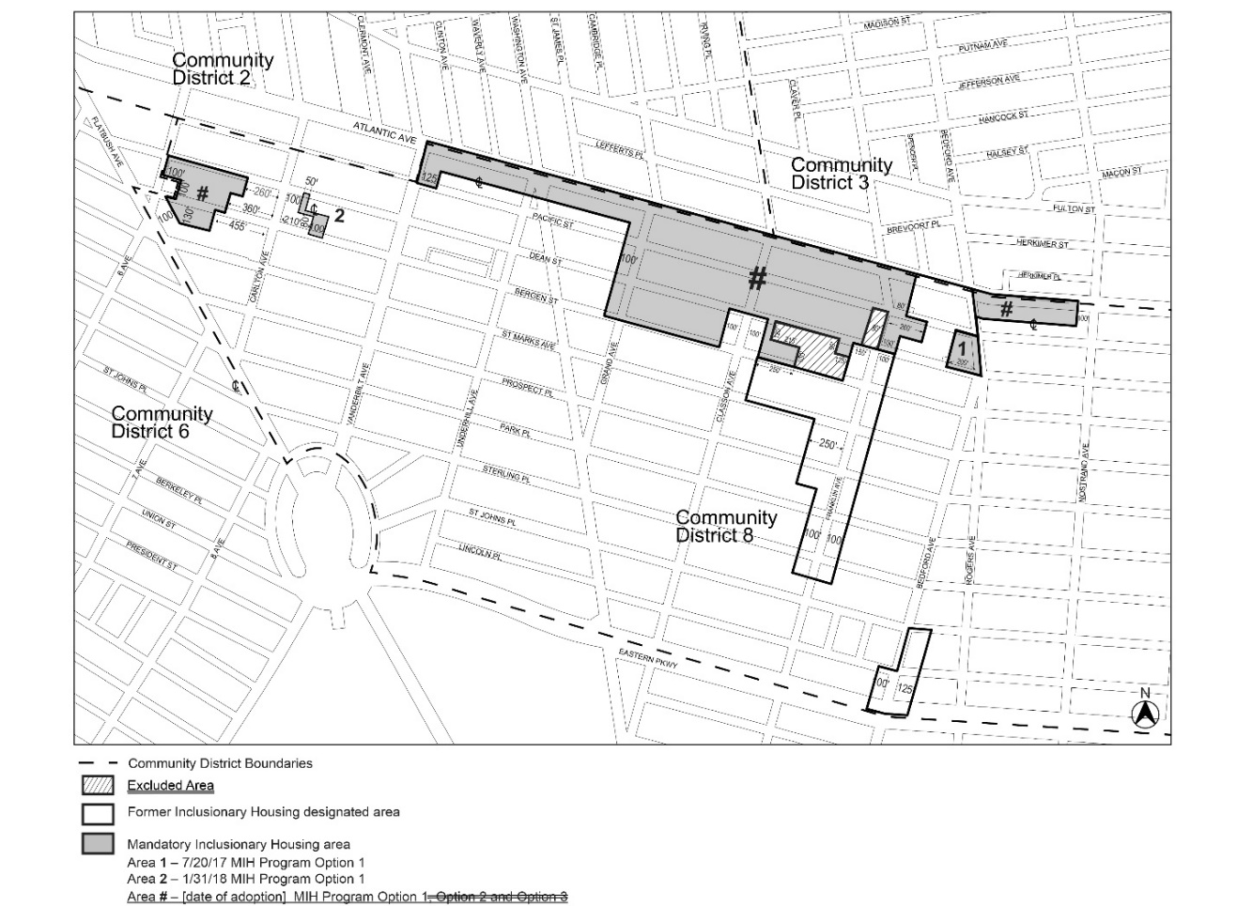

Portion of Community District 8, Brooklyn

[Maps 1, 2, 3 and 4 in Brooklyn CD 8 have been incorporated into composite Map 1 per N 250015 ZRK, [date of adoption]]
* * *
Adopted.

Office of the City Clerk,}
The City of New York, } ss.:

I hereby certify that the foregoing is a true copy of a Resolution passed by The Council of The City of New York on _________, 2025, on file in this office.

.....................................................
City Clerk, Clerk of The Council

