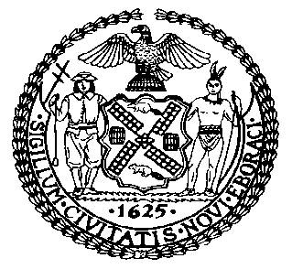 | The Council of the City of New York  Finance Division  Latonia McKinney, Director  Fiscal Impact Statement  Proposed Intro. No: 1436-A  Committee: Housing and Buildings
Title: A Local Law to amend the administrative code of the city of New York, in relation to requiring the department of buildings to report on site safety managers and coordinators | Sponsors: Council Members Matteo, Crowley, Salamanca, Gentile, Rosenthal, Rose, Reynoso, Levin, Espinal, Cornegy, Richards, Menchaca and Chin
Summary of Legislation: Proposed Intro. No. 1436-A would require the Department of Buildings (DOB) to submit an annual report in October of each year to the Council and post the report on its website, that details information on site safety manager and coordinator certificates, including the number of certificates, the number of sites which required a site safety manager or coordinator, the number of certificates issued, the number of applications filed, the average time for approval of an application and the average time for completion of the background check.

Effective Date: This local law would take effect immediately.
Fiscal Year In Which Full Fiscal Impact Anticipated: Fiscal 2019
Fiscal Impact Statement:

 | Effective FY18 | FY Succeeding Effective FY19 | Full Fiscal Impact FY19
Revenues | $0 | $0 | $0
Expenditures | $0 | $0 | $0
Net | $0 | $0 | $0

Impact on Revenues: It is estimated that there would be no impact on revenues resulting from the enactment of this legislation.
Impact on Expenditures: It is anticipated that there would be no impact on expenditures resulting from the enactment of this legislation because existing resources can be used to implement the provisions of this local law.
Source of Funds To Cover Estimated Costs: Not applicable.

Source of Information: New York City Council Finance Division

Estimate Prepared by: Sarah Gastelum, Principal Financial Analyst

Estimated Reviewed by: Eric Bernstein, Counsel
Rebecca Chasan, Counsel

Legislative History: This legislation was introduced to the full Council on January 18, 2017, as Intro. No. 1436 and was referred to the Committee on Housing and Buildings (Committee). A hearing was held by the Committee on January 31, 2017, and the bill was laid over. The legislation was subsequently amended, and the amended version, Proposed Intro. 1436-A, will be considered by the Committee on October 30, 2017. Following a successful Committee vote, the bill will be submitted to the full Council for a vote on October 31, 2017.

Date Prepared: October 24, 2017

