THE COUNCIL OF THE CITY OF NEW YORK
RESOLUTION NO. 1651

Resolution approving with modifications the decision of the City Planning Commission on Application No. N 170244(A) ZRQ, for an amendment of the Zoning Resolution of the City of New York, relating to Article XIII, Chapter 6 (Special Far Rockaway District) to establish the Special Downtown Far Rockaway District and establish a Mandatory Inclusionary Housing area, within Community District 14, Borough of Queens (L.U. No. 722).

By Council Members Greenfield and Richards

WHEREAS, the City Planning Commission filed with the Council on July 10, 2017 its decision dated July 10, 2017 (the "Decision"), pursuant to Section 201 of the New York City Charter, regarding an application submitted by the New York City Economic Development Corporation, for an amendment of the text of the Zoning Resolution of the City of New York, relating to Article XIII, Chapter 6 (Special Far Rockaway District) to establish the Special Downtown Far Rockaway District and establish a Mandatory Inclusionary Housing area. This amendment in conjunction with the related actions would facilitate the Downtown Far Rockaway Development Plan, a comprehensive planning, zoning, and redevelopment strategy aimed at supporting Downtown Far Rockaway’s growth and vitality by fostering a vibrant mix of residential, commercial, and community facility uses on vacant and underutilized sites near mass transit resources and along the area’s primary corridors, (Application No. N 170244(A) ZRQ), Community District 14, Borough of Queens (the "Application");

WHEREAS, the Application is related to applications C 170243 (A) ZMQ (L.U. No. 721), a zoning map amendment, as modified; N 170245 HGQ (L.U. No. 723), designation of the Downtown Far Rockaway Urban Renewal Area; C 170246 HUQ (L.U. No. 724), Downtown Far Rockaway Urban Renewal Plan; C 170247 HDQ (L.U. No. 725), disposition of City-owned property within the Downtown Far Rockaway Urban Renewal Area; and C 170248 PPQ (L.U. No. 726), disposition of City-owned property;

WHEREAS, the Decision is subject to review and action by the Council pursuant to Section 197-d(b)(1) of the City Charter;
WHEREAS, upon due notice, the Council held a public hearing on the Decision and Application on July 27, 2017;

WHEREAS, the Council has considered the land use implications and other policy issues relating to the Decision and Application; and

WHEREAS, the Council has considered the relevant environmental issues, including the Final Environmental Impact Statement (FEIS) for which a Notice of Completion was issued on June 29, 2017 (CEQR No. 16DME010Q), which identified significant adverse impacts with respect to hazardous materials, air quality and noise which would be avoided through the placement of (E) designations (E-415) and the Technical Memoranda dated April 26, 2017, and August 31, 2017, (the “Technical Memoranda”);
RESOLVED:

Having considered the FEIS and the Technical Memoranda with respect to the Decision and Application, the Council finds that:

(1) The FEIS meets the requirements of 6 N.Y.C.R.R. Part 617;

(2) Consistent with social, economic and other essential considerations, from among the reasonable alternatives thereto, the action is one which minimizes or avoids adverse environmental impacts to the maximum extent practicable; and

(3) The adverse environmental impacts disclosed in the FEIS will be minimized or avoided to the maximum extent practicable by incorporating as conditions to the approval, those mitigation measures that were identified as practicable; and

(4) The Decision, together with the FEIS and the Technical Memorandum, constitute the written statement of facts, and of social, economic and other factors and standards that form the basis of this determination, pursuant to 6 N.Y.C.R.R. §617.11(d).

Pursuant to Sections 197-d and 200 of the City Charter and on the basis of the Decision and Application, and based on the environmental determination and consideration described in the report, N 170244(A) ZRQ, incorporated by reference herein, the Council approves the Decision with the following modifications:

Matter in underline is new, to be added;
Matter in strikeout is to be deleted;
Matter with # # is defined in Section 12-10 or 81-613;
Matter in double strikeout is old, deleted by the City Council;
Matter in double underline is new, added by the City Council;
* * * indicates where unchanged text appears in the Zoning Resolution

Article I: General Provisions

Chapter 1 - Title, Establishment of Controls and Interpretation of Regulations

* * *
11-122
Districts established

* * *

Special Purpose Districts

* * *

Establishment of the Special Downtown Brooklyn District

In order to carry out the special purposes of this Resolution as set forth in Article X, Chapter 1, the #Special Downtown Brooklyn District# is hereby established.

Establishment of the Special Downtown Far Rockaway District

In order to carry out the special purposes of this Resolution as set forth in Article XIII, Chapter 6, the #Special Downtown Far Rockaway District# is hereby established.

Establishment of the Special Downtown Jamaica District

* * *

Chapter 2 – Construction of Language and Definitions

* * *

12-10
DEFINITIONS

* * *

Special Downtown Brooklyn District

The “Special Downtown Brooklyn District” is a Special Purpose District designated by the letters “DB” in which special regulations set forth in Article X, Chapter 1, apply.

Special Downtown Far Rockaway District

The “Special Downtown Far Rockaway District” is a Special Purpose District designated by the letters “DFR” in which special regulations set forth in Article XIII, Chapter 6, apply.

Special Downtown Jamaica District

* * *

Chapter 4 – Sidewalk Café Regulations

* * *

14-44
Special Zoning Districts Where Certain Sidewalk Cafes Are Permitted

#Enclosed# or #unenclosed sidewalk cafes# shall be permitted, as indicated, in the following special zoning districts, where allowed by the underlying zoning. #Small sidewalk cafes#, however, may be located on #streets# or portions of #streets# within special zoning districts pursuant to the provisions of Section 14-43 (Locations Where Only Small Sidewalk Cafes Are Permitted).

* * *

Queens | #Enclosed Sidewalk Cafe# | #Unenclosed Sidewalk Cafe#
Downtown Far Rockaway District | No | Yes
Downtown Jamaica District | No | Yes
Forest Hills District¹ | No | Yes
Long Island City Mixed Use District² | No | Yes
Southern Hunters Point District | No | Yes
Willets Point District | No | Yes
-----
¹ #Sidewalk cafes# are not allowed on Austin Street

² See Appendix A in Article XI, Chapter 7

* * *

Article II: RESIDENCE DISTRICT REGULATIONS

Chapter 3 – Residential Bulk Regulations in Residence Districts

* * *

23-011
Quality Housing Program

* * *

- In the districts indicated without a letter suffix, the optional Quality Housing #bulk# regulations permitted as an alternative pursuant to paragraph (b) of this Section, shall not apply to:

* * *

- Special Purpose Districts

However, such optional Quality Housing #bulk# regulations are permitted as an alternative to apply in the following Special Purpose Districts:

* * *

#Special Downtown Brooklyn District#;

#Special Downtown Far Rockaway District#;

#Special Downtown Jamaica District#;

* * *

23-03
Street Tree Planting in Residence Districts

R1 R2 R3 R4 R5 R6 R7 R8 R9 R10

In all districts, as indicated, the following shall provide #street# trees in accordance with Section 26-41 (Street Tree Planting):

(a) #developments#, or #enlargements# that increase the #floor area# on a #zoning lot# by 20 percent or more. However, #street# trees shall not be required for #enlargements# of #single-# or #two-family residences#, except as provided in paragraphs (b) and (c) of this Section;

(b) #enlargements# of #single-# or #two-family residences# by 20 percent or more within the following special purpose districts:

* * *

#Special Downtown Brooklyn District#;

#Special Downtown Far Rockaway District#;

#Special Downtown Jamaica District#;

* * *

23-10
OPEN SPACE AND FLOOR AREA REGULATIONS
R1 R2 R3 R4 R5 R6 R7 R8 R9 R10

* * *

23-15
Open Space and Floor Area Regulations in R6 through R10 Districts
R6 R7 R8 R9 R10

* * *

23-153
For Quality Housing buildings

R6 R7 R8 R9 R10

In the districts indicated, for #Quality Housing buildings#, the maximum #floor area ratio# and maximum #residential lot coverage# for #interior lots# or #through lots# shall be as set forth in the table in this Section. The maximum #residential lot coverage# for a #corner lot# shall be 100 percent.

MAXIMUM LOT COVERAGE AND FLOOR AREA RATIO
FOR QUALITY HOUSING BUILDINGS

District | Maximum #Lot Coverage# for an  #Interior Lot# or #Through Lot#  (in percent) | Maximum #Floor Area Ratio#
R6 | 60 | 2.20
R6 ² | 60 | 2.43
R6 ^{1, 3} R6A  R7B | 65 | 3.00
R6B | 60 | 2.00
R7 | 65 | 3.44
R7 ¹ R7A | 65 | 4.00
* * *
R8 ¹ | 70 | 7.20
* * *
---

¹ for #zoning lots#, or portions thereof, located within 100 feet of a #wide street# in R6, R7 or R8 Districts without a letter suffix outside the #Manhattan Core#

² for #zoning lots# in an R6 District inside the #Manhattan Core# located within 100 feet of a #wide street#

³ for #zoning lots# in an R6 District without a letter suffix the maximum #lot coverage# for any #MIH development# utilizing the height and setback provisions of paragraph (c) of Section 23-664 in: Mandatory Inclusionary Housing Area 1, as of May 24, 2017 in Community District 9 in the Borough of the Bronx and in Mandatory Inclusionary Housing Area 2, as of [date of adoption], in Community District 14 in the Borough of Queens.the maximum #lot coverage# for #zoning lots# in Mandatory Inclusionary Housing Program Area 1, as of May 24, 2017, in an R6 District without a letter suffix in Community District 9 in the Borough of the Bronx, utilizing the height and setback provisions of paragraph (c) of Section 23-664

23-154
Inclusionary Housing

* * *

(d) Special #floor area# provisions for #zoning lots# in #Mandatory Inclusionary Housing areas#

For #zoning lots# in #Mandatory Inclusionary Housing areas#, the following provisions shall apply:

* * *

(2) Maximum #floor area ratio#

The maximum #floor area ratio# for the applicable zoning district in #Inclusionary Housing designated areas# set forth in paragraph (b) of this Section shall apply to any #MIH development#, except:

However, in an R7-3 or R7X District, the maximum #floor area ratio# for any #MIH development# shall be 6.0; and in Mandatory Inclusionary Housing Program Area 1, as of May 24, 2017, in in Community District 9 in the Borough of the Bronx, it shall be 3.6.

- in an R6 District without a letter suffix the maximum #floor area ratio# for any #MIH development# shall be 3.6 in the following areas:

(aa) Mandatory Inclusionary Housing Area 1, as of May 24, 2017, in Community District 9 in the Borough of the Bronx; and

(bb) Mandatory Inclusionary Housing Area 2, as of [date of adoption], in Community District 14 in the Borough of Queens.

- in an R7-1 District the maximum #floor area ratio# for any #MIH development# shall be 4.6;

- in an R7-3 or R7X District, the maximum #floor area ratio# for any #MIH development# shall be 6.0.

In addition, in R6, R7-1, R7-2, R8 and R9 Districts without a letter suffix, where the basic height and setback requirements are utilized pursuant to paragraph (c) of Section 23-952, the maximum #floor area ratio# shall be determined in accordance with the provisions of Section 23-151 (Basic regulations for R6 through R9 Districts).

For any #development#, #enlargement# or #conversion# from non-#residential# to #residential use# that is subject to the provisions of paragraph (d)(4) of this Section, the maximum #floor area ratio# for the applicable district outside of #Inclusionary Housing designated areas# or #Mandatory Inclusionary Housing areas# shall apply.

* * *

33-03
Street Tree Planting in Commercial Districts

C1 C2 C3 C4 C5 C6 C7 C8

In all districts, as indicated, the following shall provide #street# trees in accordance with Section 26-41 (Street Tree Planting):

(a) #developments#, or #enlargements# that increase the #floor area# on a #zoning lot# by 20 percent or more. However, #street# trees shall not be required for #enlargements# of #single-# or #two-family residences#, except as provided in paragraphs (b) and (c) of this Section;

(b) #enlargements# of #single-# or #two-family residences# by 20 percent or more within the following special purpose districts:

* * *

#Special Downtown Brooklyn District#;

#Special Downtown Far Rockaway District#;

#Special Downtown Jamaica District#;

* * *

Article XIII - Special Purpose Districts

Chapter 6
Special Downtown Far Rockaway District

136-00
GENERAL PURPOSES

The “Special Downtown Far Rockaway District” established in this Resolution is designed to promote and protect the public health, safety and general welfare of the Downtown Far Rockaway community. These general goals include, among others, the following specific purposes:

(a) strengthen the commercial core of Downtown Far Rockaway by improving the working and living environments;

(b) support the development of vacant and underutilized parcels in Downtown Far Rockaway with a mix of residential, commercial and community facility uses;

(c) encourage the design of new buildings to blend into the existing neighborhood fabric by providing a transition in height between the downtown commercial core and the lower-scale residential communities;

(d) establish a center to the downtown with lively new gathering and civic spaces along Mott Avenue that complement and strengthen the existing neighborhood;

(e) encourage the development of affordable housing;

(f) expand the retail, entertainment and commercial character of areas around transit nodes to enhance the area’s role as a local transportation hub;

(g) integrate new roadways into an improved pedestrian and vehicular network with key north-south and east-west connections;

(h) ensure the provision of adequate accessory parking that reflects both the automobile ownership patterns of the neighborhood and public transit access;

(i) enhance the pedestrian environment by relieving sidewalk congestion and providing pedestrian amenities; and

(j) promote the most desirable use of land and building development and thus conserve and enhance the value of land and buildings, and thereby protect the City's tax revenues.

136-01
General Provisions

The regulations of this Chapter shall apply within the #Special Downtown Far Rockaway District#. The regulations of all other chapters of this Resolution are applicable except as modified, supplemented or superseded by the provisions of this Chapter. In the event of a conflict between the provisions of this Chapter and other regulations of this Resolution, the provisions of this Chapter shall control.

136-02
Definitions

Definitions specifically applicable to this Chapter are set forth in this Section. The definitions of other defined terms are set forth in Section 12-10 (DEFINITIONS).

Open Space A

“Open Space A” shall be a publicly accessible open space designed and constructed pursuant to the provisions of Section 136-324 (Publicly accessible open space requirements) and located within the area designated as “Flexible Open Space A Location” on Map 7 (Mandatory Street Walls and Public Open Spaces) in the Appendix to this Chapter.

Open Space B

“Open Space B” shall be a publicly accessible open space designed and constructed pursuant to the provisions of Section 136-324 (Publicly accessible open space requirements) and located within the area designated as “Flexible Open Space B Location” on Map 7 (Mandatory Street Walls and Public Open Spaces) in the Appendix to this Chapter.

136-03
District Plan and Maps

The regulations of this Chapter implement the #Special Downtown Far Rockaway District# Plan.

The District Plan includes the following maps in the Appendix to this Chapter:

Map 1 - Special Downtown Far Rockaway District and Subdistrict
Map 2 - Commercial Core
Map 3 - Ground Floor Use and Transparency Requirements
Map 4 - Maximum Building Height
Map 5 - Maximum Building Height Within Subdistrict A
Map 6 - Publicly Accessible Private Streets
Map 7 - Mandatory Street Walls and Public Open Spaces
Map 8 - Sidewalk Widenings

The maps are hereby incorporated and made part of this Resolution for the purpose of specifying locations where the special regulations and requirements set forth in this Chapter apply.

136-04
Subdistricts

In order to carry out the purposes and provisions of this Chapter, Subdistrict A is established. The location of the Subdistrict is shown on Map 1 in the Appendix to this Chapter.

136-05
Applicability of District Regulations

136-051
Applicability of the Quality Housing Program

R6 R7-1

In the districts indicated, and in C2 Commercial Districts mapped within such districts, any #building# containing #residences#, #long-term care facilities# or philanthropic or non-profit institutions with sleeping accommodations that is constructed in accordance with the #bulk# regulations of this Chapter shall be considered a #Quality Housing building#, and shall comply with the provisions of Article II, Chapter 8 (The Quality Housing Program) of this Resolution.

136-052
Applicability of the Mandatory Inclusionary Housing Program

R6 R7-1

In the districts indicated, and in C2 Commercial Districts mapped within such districts, the regulations for a #Mandatory Inclusionary Housing area# shall apply. The locations of such #Mandatory Inclusionary Housing areas# are shown on the maps in Appendix F of this Resolution.

136-06
Private Streets and Publicly Accessible Open Spaces

Except as otherwise provided herein, private streets that are provided in accordance with the provisions of this Chapter within the locations shown on Map 6 (Publicly Accessible Private Streets) in Appendix A of this Chapter, and publicly accessible open spaces that are provided in accordance with the provisions of this Chapter within the locations shown on Map 7 (Mandatory Street Walls and Public Open Spaces) in Appendix A of this Chapter shall be considered #streets# for the purposes of establishing the #use#, #bulk# and parking regulations of this Resolution. However, for the purposes of #floor area# regulations, such private streets and publicly accessible open spaces shall be considered part of a #zoning lot#. Furthermore, for the purpose of determining minimum and maximum base heights and minimum setback depth pursuant to paragraph (a) of Section 136-313 (Minimum and maximum base height), private streets and publicly accessible open spaces shall be distinguished from #streets#.

136-10
SPECIAL USE REGULATIONS

The #use# regulations of the underlying district shall apply except as modified in this Section, inclusive.

136-11
Location Within Buildings

Within locations shown on Map 2 (Commercial Core) in the Appendix to this Chapter, the provisions of Section 32-421 (Limitation on floors occupied by commercial uses) shall not apply. In lieu thereof, the provisions of Section 32-422 (Location of floors occupied by commercial uses) shall apply.

136-12
Use Groups 10A and 12 in C2 Districts

Within locations shown on Map 2 (Commercial Core) in the Appendix to this Chapter, the provisions of Sections 32-19 (Use Group 10) and 32-21 (Use Group 12) shall be modified to allow Use Groups 10A and 12 in C2 Districts.

136-13
Ground Floor Use Regulations

The special ground floor #use# provisions of this Section shall apply to any portion of a #building#:

(a) fronting on a designated #street#, as shown on Map 3 (Ground Floor Use and Transparency Requirements); or

(b) located within 175 feet of Mott Avenue and fronting on #Open Space A#.

#Uses# within #stories# on the ground floor or with a floor level within five feet of the level of the adjoining sidewalk, shall be limited to non-#residential uses#. A #building’s street# frontage shall be allocated exclusively to such #uses#, except for Type 1 lobby space, entrances and exits to #accessory# off-street parking facilities, and entryways or entrances to subway stations in accordance with Section 37-33 (Maximum Width of Certain Uses). Such non-#residential uses# shall comply with the minimum depth provisions of Section 37-32 (Ground Floor Depth Requirements for Certain Uses).

136-14
Transparency and Parking Wrap Requirements

The provisions of this Section shall apply to #buildings developed# or #enlarged# after [date of adoption], where the ground floor of such #development# or #enlarged# portion of the #building# fronts upon designated #streets# as shown on Map 3 (Ground Floor Use and Transparency Requirements) in the Appendix to this Chapter. These provisions shall also apply to the frontage of #buildings# located along #Open Space A#. The ground floor #street wall# of such #building# or portion thereof shall be glazed in accordance with Section 37-34 (Minimum Transparency Requirements).

The provisions of Section 37-35 (Parking Wrap and Screening Requirements) shall apply along designated #streets# as shown on Map 3 and along #Open Space A#. In addition, the screening requirements of paragraph (b) of Section 37-35 shall apply along intersecting #streets# within 50 feet of designated #streets#, and along intersecting #streets# or private streets within 50 feet of #Open Space A#.

136-15
Special Use Regulations Within Subdistrict A

The following additional special #use# provisions of this Section, inclusive, shall apply within Subdistrict A, as shown on Map 1 (Special Downtown Far Rockaway District and Subdistrict) in the Appendix to this Chapter.

136-151
Modification of Supplemental Use Provisions

For #mixed buildings#, the underlying provisions of Section 32-421 (Limitation on floors occupied by non-residential uses) shall not apply. In lieu thereof, Use Groups 6, 7, 8, 9 or 14, other than offices listed in Use Group 6B, shall not be located above the level of the second #story# ceiling. Offices shall be permitted above the level of the second #story#, provided that where any floor space allocated to such offices is located on the same #story# as a #dwelling unit#, no access exists between such #uses#, and further provided that no floor space allocated to such offices is located directly over #dwelling units#.

136-152
Location of entrances

(a) Non-#residential# entrances

Within Subdistrict A, on designated #streets#, as shown on Map 3 (Ground Floor Use and Transparency Requirements) in the Appendix to this Chapter, the requirements of this paragraph (a) shall apply to any #building or other structure# fronting on such #streets#. These provisions shall also apply to the frontage of #buildings# along #Open Space A#. Access to each ground floor #commercial# or #community facility# establishment shall be provided directly from a #street# or from #Open Space A#.

(b) #Residential# entrances

Eighty percent of all ground floor #dwelling units# with frontage only on Redfern Avenue shall have a #primary entrance# directly accessible from Redfern Avenue.

136-20
SPECIAL BULK REGULATIONS

The #bulk# regulations of the underlying district shall apply except as modified in this Section, inclusive.

136-21
Lot Coverage

The #residential# portion of a #building# shall comply with the maximum #lot coverage# provisions of the underlying district applicable to #Quality Housing buildings#.

136-22
Height and Setback Regulations

For #residential buildings#, #mixed buildings# and #commercial buildings#, the height and setback regulations of the underlying district shall be modified by the regulations of this Section, inclusive. The provisions of Section 23-952 (Height and setback in Mandatory Inclusionary Housing areas) and Section 23-664 (Modified height and setback regulations for certain Inclusionary Housing buildings or affordable independent residences for seniors) shall not apply within the #Special Downtown Far Rockaway District#.

All heights shall be measured from the #base plane#.

136-221
Street wall location

In C2 Districts, the #street wall# location regulations of the underlying district shall apply except as modified in this Section.

(a) In C2 Districts mapped within R6 and R7-1 Districts, at least 70 percent of the #aggregate width of street walls# shall be located within eight feet of the #street line# and shall extend to at least the minimum base height specified in Section 136-222 (Minimum and maximum base height), or the height of the #building#, whichever is less. Up to 30 percent of the #aggregate width of street walls# may be recessed beyond eight feet of the #street line#, provided that any such recesses deeper than ten feet along a #wide street# or 15 feet along a #narrow street# are located within an #outer court#. For #zoning lots# bounded by more than one #street line#, these #street wall# location requirements shall be mandatory on only one #street line#.

(b) In C2 Districts mapped within R5 Districts, at least 70 percent of the #aggregate width of street walls# shall be located within eight feet of the #street line# and shall extend to a height of 30 feet, or the height of the #building#, whichever is less. Up to 30 percent of the #aggregate width of street walls# may be recessed beyond eight feet of the #street line#, provided that any such recesses deeper than ten feet along a #wide street# or 15 feet along a #narrow street# are located within an #outer court#. For #zoning lots# bounded by more than one #street line#, these #street wall# location requirements shall be mandatory on only one #street line#.

(c) Below a height of 15 feet or the height of the second #story# floor, whichever is lower, no recesses shall be permitted within 30 feet of the intersection of two #street lines# except recesses that do not exceed a depth of 12 inches.

The underlying allowances for #street wall# articulation, set forth in paragraph (e) of Section 35-651 (Street wall location) shall be permitted to project or recess beyond the #street wall# locations established in paragraphs (a) and (b) of this Section.

Existing #buildings# may be vertically #enlarged# by up to one #story# or 15 feet, without regard to the #street wall# location requirements of this Section.

136-222
Minimum and maximum base height

R6 R7-1

In the districts indicated, and in C2 Commercial Districts mapped within such districts, the minimum and maximum heights before setback of a #street wall# required pursuant to Section 136-221 (Street wall location), shall be as set forth in the following table:

District | Minimum  Base Height  (feet) | Maximum  Base Height  (feet)
R6 | 30 | 55
R7-1 | 40 | 55

At a height not lower than the minimum base height nor higher than the maximum base height specified for the applicable district in this Section, a setback with a depth of at least ten feet shall be provided from any #street wall# fronting on a #wide street#, and a setback with a depth of at least 15 feet shall be provided from any #street wall# fronting on a #narrow street#. The underlying provisions of paragraphs (c)(2) through (c)(4) of Section 23-662 (Maximum height of buildings and setback regulations) shall apply to such setbacks.

136-223
Maximum building height

R6 R7-1

In the districts indicated, and in C2 Commercial Districts mapped within such districts, the height of a #building or other structure# shall not exceed the maximum height or the maximum number of #stories#, whichever is less, as shown for such location on Map 4 (Maximum Building Height) in the Appendix to this Chapter.

136-30
SPECIAL REGULATIONS WITHIN SUBDISTRICT A

The regulations of this Section, inclusive, shall apply within the area labeled “Subdistrict A”, as shown on Map 1 (Special Downtown Far Rockaway District and Subdistrict) in the Appendix to this Chapter. The regulations of the #Special Downtown Far Rockaway District# shall apply, except as modified by the regulations of this Section, inclusive.

136-31
Special Height and Setback Regulations Within Subdistrict A

136-311
Street wall location

The provisions of Section 136-221 (Street wall location) shall apply within Subdistrict A, except as provided in this Section.

(a) For portions of #buildings# or #building segments# with frontage on Redfern Avenue located between the prolongation of the northerly #street line# of Dix Avenue and a line 150 feet south of and parallel to Nameoke Street, the street wall location rules of Section 136-221 shall not apply. In lieu thereof, paragraph (b) of Section 23-661 (Street wall location) shall apply.

(b) For “Street Wall A” and “Street Wall B”, as shown on Map 7 (Mandatory Street Walls and Public Open Spaces) in the Appendix to this Chapter, the provisions of Section 136-231 (Street wall location) shall not apply. In lieu thereof, the provisions of this Section shall apply.

(1) “Street Wall A”

#Buildings# on the west side of #Open Space A# shall have a #street wall# located along the required sidewalk widening on Mott Avenue, shown as a line designated “A1” on Map 7, except that #street wall# articulation set forth in paragraph (e) of Section 35-651 (Street wall location) shall be permitted. Beyond 112 feet of Redfern Avenue, the #street wall# shall be located no closer to Central Avenue than the line designated “A2” as shown on Map 7.

(2) “Street Wall B”

#Street walls# fronting #Open Space A# shall be located no closer to Redfern Avenue than as shown as a line designated “B1” on Map 7. The #street walls# of #buildings# on the east side of #Open Space A# with frontage on Mott Avenue shall be located no closer to Mott Avenue than as shown as lines designated “B2” and “B3” on Map 7 for. Portions of #street walls# with frontage on Mott Avenue, located so that a line drawn perpendicular to the line designated “B3” intersects such #street walls#, shall be located no further than 30 feet from “B3.” #Street walls# fronting Central Avenue shall be located no closer to Central Avenue than as shown for the line designated “B4” on Map 7, and shall be located no further than 30 feet from “B4.”

(c) For #blocks# with a dimension of less than 100 feet between #streets# or private streets that are parallel or do not intersect, the provisions of Section 136-221 shall be modified to require a minimum of 40 percent of the #aggregate width of street walls# to be located within eight feet of the #street line# and to extend to at least the minimum base height specified in Section 136-222 (Minimum and maximum base height), or the height of the #building#, whichever is less.

All #street walls# governed by this Section shall extend to the minimum base height specified in Section 136-313 (Minimum and maximum base height), or the height of the #building#, whichever is less.

136-312
Street wall recesses

For each #building# within Subdistrict A, where the #aggregate width of street walls# is greater than 90 feet, a minimum of 20 percent of the surface area of #street walls# below the maximum base height and above the level of the first #story# shall be recessed beyond three feet of the #street line#. Portions of #street lines# with no #street walls# may be counted towards the recess requirements of this Section. No portion of such minimum recessed area shall be located within 30 feet of the intersection of two #street lines#. However, such minimum recessed area shall be permitted within 30 feet of Redfern Avenue, except at the intersection of Redfern Avenue and Mott Avenue.

136-313
Minimum and maximum base height

Within Subdistrict A, the provisions of Section 136-222 (Minimum and maximum base height) shall not apply. In lieu thereof, for #residential buildings#, #mixed buildings# and #commercial buildings#, the provisions of this Section shall apply. The #street wall# height and setback regulations of the underlying district shall apply except as modified in this Section.

(a) The minimum and maximum heights before setback of a #street wall# required pursuant to Section 136-221 (Street wall location), shall be as set forth in the following table:

Condition | Minimum  Base Height  (feet) | Maximum  Base Height  (feet) | Minimum  Setback Depth  (feet)
Fronting on Redfern  Avenue and greater than 75 feet from an intersecting #street# | 30 | 45 | 10
Fronting on, or within 100 feet of, a #street#, other than a private street or publicly accessible open space | 40*40¹ | 65 | 10
Fronting on a private street or a publicly accessible open space and beyond 100 feet of a #street# that is not a private street or publicly accessible open space | 4040¹ | 85 | 7
* Within 300 feet of Mott Avenue, the minimum base height shall be 20 feet.Fronting on Redfern  Avenue | 30¹ | 45² | 10

¹ Within 300 feet of Mott Avenue, the minimum base height shall be 20 feet.

² The maximum base height for the portion of a building subject to the 65 foot or six story maximum height provisions of 136-314 shall be 65 feet,

(b) Dormers

The provisions of paragraph (c) of Section 23-621 (Permitted obstructions in certain districts) shall be modified to allow dormers as a permitted obstruction within the required front setback distance above a maximum base height, as follows:

(1) Within 75 feet of intersecting #streets#, dormers shall be permitted without limitation on width.

(2) Where dormers are provided pursuant to paragraph (b)(1) of this Section, and such dormers exceed the maximum width permitted pursuant to paragraph (c) of Section 23-621, for any portion of a #building# with an #aggregate width of street walls# greater than 75 feet, a setback shall be provided above the maximum base height between such dormer and any other dormer for a width of at least 20 feet, or the remaining width of such #street wall#, as applicable.

(3) Beyond 75 feet of intersecting #streets#, the provisions of paragraph (c) of Section 23-621 shall apply. The width of any dormers provided pursuant to the provisions of paragraph (b)(1) of this Section shall be included in the aggregate width of all dormers.

However, the provisions of this paragraph (b) shall not apply to portions of #buildings# with frontage on Redfern Avenue, except that these provisions shall apply to portions of #buildings# with frontage on both Redfern Avenue and Mott Avenue.

136-314
Maximum building height

The height of a #building or other structure# shall not exceed the maximum building height or the maximum number of #stories#, whichever is less, as shown on Map 5 (Maximum Building Height Within Subdistrict A) in the Appendix to this Chapter. However, within 75 feet of the intersection of the southerly cross street with Redfern Avenue, and within 75 feet of the intersection of the northerly cross street with Redfern Avenue, the maximum height for #buildings or other structures# shall be not exceed maximum height of six #stories# or 65 feet, whichever is less. Any such 65 foot or six story maximum building height limit falling within 300 feet of Mott Avenue shall only extend to a depth of 25 feet off of Redfern Avenue, after which the maximum building height and number of stories shown on Map 5 shall apply.

136-315
Maximum building height and horizontal dimension for tall buildings

Within the area labeled “Tower Location Area” on Map 5 (Maximum Building Height Within Subdistrict A) in the Appendix to this Chapter, the height of a #building# may exceed the height limits specified in Section 136-314 (Maximum building height) only as set forth in this Section. Any portion of a #building# above a height of 125 feet shall hereinafter be referred to as a “tower.”

(a) Towers shall be located within portions of #zoning lots# bounded by intersecting #street lines# and lines parallel to and 200 feet from each intersecting #street line#.

(b) Towers shall be separated from one another by a minimum distance of 60 feet, measured in all horizontal directions.

(c) The outermost walls of each #story# of a #building# located entirely above a height of 125 feet shall be measured in plan view and inscribed within a rectangle. The maximum length of two sides of such rectangle shall be 170 feet. The maximum length of the two sides any other side of such rectangle shall be 100 feet. For the purposes of this Section, #abutting# portions of #buildings# above a height of 125 feet shall be considered a single tower.

(d) To permit portions of a #building# to rise from grade to a tower portion without setback, the setback provisions of Section 136-313 (Minimum and maximum base height) shall not apply to any portion of a #building# located within 100 feet of intersecting #street lines#.

(e) The maximum height of a tower shall be 155 feet or 15 #stories#, whichever is lower.

(f) No more than two towers shall be permitted within Subdistrict A.

136-316
Maximum length of buildings

The outermost walls of each #story# of a #building# located entirely above a height of 95 feet shall be measured in plan view and inscribed within a rectangle. The maximum length of any side of such rectangle shall be 170 feet. For the purposes of this Section, #abutting # portions of #buildings# on above a single #zoning lot# height of 95 feet shall be considered a single #building#.

136-32
Streets and public open spaces

136-321
Certification

The requirements of this Section shall apply to #zoning lots# containing #developments# or #enlargements# within the current or former Downtown Far Rockaway Urban Renewal Area.
No building permit shall be issued for any #development# or #enlargement# until the Chairperson of the City Planning Commission certifies to the Department of Buildings that such #development# or #enlargement# complies with the provisions of this Section.

The Chairperson shall certify that:

(a) all publicly accessible open spaces adjacent to the proposed #development# or #enlargement# comply with the provisions of Section 136-324 (Publicly accessible open space requirements);

(b) the location of private streets adjacent to the proposed #development# or #enlargement# complies with the provisions of Section 136-323 (Private streets); and

(c) for any portion of Subdistrict A outside the area of the proposed #development# or #enlargement# for which a certification pursuant to this Section has not been obtained, the applicant has submitted sufficient documentation showing that the #development# or #enlargement# that is the subject of this certification, and any associated private streets and publicly accessible open spaces required to be constructed in conjunction with such #development# or #enlargement#, shall not preclude such undeveloped portions of Subdistrict A from complying with the provisions of Sections 136-323 and 136-324 under future certifications pursuant to this Section.

All required private streets and publicly accessible open spaces, once certified in accordance with the provisions of this Section, shall be duly recorded in the form of a signed declaration of restrictions, including provisions for the maintenance and operation of such private streets and publicly accessible open spaces, indexed against the property, binding the owners, successors and assigns to provide and maintain such private streets and publicly accessible open spaces in accordance with the plans certified by the Chairperson. Such declaration, or any maintenance and operation agreement with the City or its designee executed in connection therewith, shall require that adequate security be provided to ensure that the private streets and public access areas are maintained in accordance with the declaration and any related maintenance and operation agreement and are closed only at authorized times. The filing of such declaration in the Borough Office of the Register of the City of New York shall be a precondition for the issuance of a building permit.

In addition, the private streets and publicly accessible open spaces integral to the #development# or #enlargement# of a #building#, as indicated in the plans certified by the Chairperson, shall be recorded on the certificate of occupancy for such #building# by the Department of Buildings. The recording information of the declaration of restrictions shall be included on the certificate of occupancy for any #building#, or portion thereof, issued after the recording date.

The property owner shall be responsible for the construction and maintenance of all required private streets and publicly accessible open spaces on the #zoning lot#. No temporary or final certificate of occupancy shall be issued for any #building# adjacent to such private street or publicly accessible open space until all required improvements are completed, except as set forth in a phasing plan that has been incorporated in a signed and duly recorded declaration of restrictions, and that has provided for interim improvements and access where these do not present conflicts with construction, staging, or public safety.

136-322
Sidewalk widening

For #buildings developed# or #enlarged# after [date of adoption], where the #development# or horizontal #enlargement# fronts upon designated #streets# as shown on Map 8 (Sidewalk Widenings) in the Appendix to this Chapter, the provisions of this Section shall apply.

A sidewalk widening is a continuous, paved open area along the #street line# of a #zoning lot#, located within the #zoning lot#. A sidewalk widening shall be provided along #streets# as shown on Map 8, to the extent necessary, so that a minimum sidewalk width of 13 feet or 18 feet, as applicable, is achieved, including portions within and beyond the #zoning lot#. Such depth shall be measured perpendicular to the #street line#. Sidewalk widenings shall be improved as sidewalks to Department of Transportation standards, at the same level as the adjoining public sidewalk and shall be directly accessible to the public at all times. No #enlargement# shall be permitted to decrease the depth of such sidewalk widening to less than such minimum required depth.

Lighting shall be provided with a minimum level of illumination of not less than two horizontal foot candles throughout the entire mandatory sidewalk widening. Lighting fixtures installed by the Department of Transportation within the #street# adjacent to such sidewalk widening shall be included in the calculation of the required level of illumination.

Where a continuous sidewalk widening is provided on the #zoning lot#, along the entire #block# frontage of a #street#, the boundary of the sidewalk widening within the #zoning lot# shall be considered to be the #street line# for the purposes of Sections 136-22 (Height and Setback Regulations) and 136-31 (Special Height and Setback Regulations Within Subdistrict A).

136-323
Private streets

In Subdistrict A, private streets shall be accessible to the public at all times, except when required to be closed for repairs, and for no more than one day each year in order to preserve the private ownership of such area. Private streets shall have a minimum width of 60 feet. Private streets shall be constructed to Department of Transportation standards for public #streets#. Sidewalks shall have a minimum clear path of seven feet on each side of such private streets along their entire length. Such private streets shall be located as shown on Map 6 (Publicly Accessible Private Streets) in the Appendix to this Chapter. One street tree shall be planted for every 25 feet of curb length of each private street. Fractions equal to or greater than one-half resulting from this calculation shall be considered to be one tree. Such trees shall be planted at approximately equal intervals along the entire length of the curb of the private street.

The private street network shall be established as follows.

(a) A central street shall connect #Open Space A# with Nameoke Ave. as shown on Map 6 (Publicly Accessible Private Streets). However, if the centerline of the new street is not within five feet of the extended centerline of Brunswick Avenue, then the easterly curb of the new street shall be greater than 50 feet from the extended line of the westerly curb of Brunswick Avenue.

(b) A southerly cross street shall connect Redfern Avenue with the central street, intersecting Redfern Avenue within the 170-foot wide area shown on Map 6. However, if the centerline of the new street is not within five feet of the extended centerline of Dix Avenue, then the northerly curb of the new street shall be greater than 50 feet from the extended line of the southerly curb of Dix Avenue.

(c) A northerly cross street shall connect Birdsall Avenue with Bayport Place, intersecting Redfern Avenue so that the centerline of the new street is within five feet of the extended centerline of Birdsall Avenue and within five feet of the centerline of Bayport Place.

136-324
Publicly accessible open space requirements

Publicly accessible open spaces shall be provided within the areas designated “Flexible Open Space A Location” and “Flexible Open Space B Location”, as applicable, as shown on Map 7 (Mandatory Street Walls and Public Open Spaces) in the Appendix to this Chapter. #Open Space A# shall contain a minimum of 23,000 square feet, and #Open Space B# shall contain a minimum of 7,000 square feet.

(a) A portion of the required publicly accessible open space located within #Open Space A# shall have a minimum width of 80 feet within 55 feet of Mott Avenue. #Open Space A# shall extend from Mott Avenue to the nearest private street required pursuant to Section 136-323 (Private streets), and shall maintain a minimum width of 60 feet.

(b) Publicly accessible open spaces shall comply with the provisions of Sections 37-725 (Steps), 37-726 (Permitted obstructions), 37-727 (Hours of access) 37-728 (Standards of accessibility for persons with disabilities), 37-73 (Kiosks and Open Air Cafes), 37-74 (Amenities) and 37-75 (Signs), except for the following modifications:

(1) Section 37-73 (Kiosks and Open Air Cafes) shall be modified as follows:

(i) Paragraph (a) of Section 37-73 shall be modified to permit a kiosk to occupy an area no greater than 400 square feet within #Open Space A#, provided that such kiosk has a maximum width, measured along the same axis as the minimum width of #Open Space A# pursuant to paragraph (a) of this Section, of 20 feet, and provided further that any canopies, awnings or other sun control devices extending from such kiosk shall be limited to a distance of five feet from such kiosk;

(ii) Paragraph (b) of Section 37-73 shall be modified to limit the aggregate area of open air cafes to no more than 40 percent of the publicly accessible open space, to allow open air cafes to occupy up to 50 percent of #street# frontage along Mott Avenue, and to eliminate the requirement that open air cafes be located along the edge of the publicly accessible open space; and

(iii) Paragraphs (c) and (d) of Section 37-73 shall not apply to the certification of open air cafes in the Special District, and the filing of plans for open air cafes in the Borough Office of the City Register shall not be required;

(2) Section 37-741 (Seating) shall be modified as follows:

(i) the requirement for a minimum of one linear foot of required seating for every two linear feet of #street# frontage within 15 feet of the #street line# shall not apply;

(ii) the requirement of one linear foot of seating for each 30 square feet of #public plaza# area shall be modified to one linear foot of seating for each 60 square feet of publicly accessible open space; and

(iii) seating for open air cafes may count toward the seating requirement, in the category of moveable seating, provided that 50 percent of the linear seating capacity is provided through other seating types;

(3) For #Open Space A#, Section 37-742 (Planting and trees) shall be modified to require that at least 15 percent of the area of the publicly accessible open space shall be comprised of planting beds with a minimum dimension of two feet, exclusive of any bounding walls. For #Open Space B#, Section 37-742 (Planting and trees) shall be modified to eliminate the requirement for such planting beds;

(4) Section 37-743 (Lighting) shall be modified to provide that for publicly accessible open spaces fronting on Mott Avenue, the lighting fixtures installed by the Department of Transportation within the #street# shall be included in the calculation of the required level of illumination;

(5) Section 37-744 (Litter receptacles) shall be modified to require a minimum of one litter receptacle per 10,000 5,000 square feet of publicly accessible open space;

(6) Entry plaques for publicly accessible open spaces shall be provided as described in paragraph (a) of Section 37-751 (Public space signage systems), except that the number of such plaques shall be provided so that one such plaque is located at each point of entry from a #street# to such publicly accessible open spacePlaques pursuant to paragraphs (b) and (c) of Section 37-751 shall not be required; and

(7) Section 37-753 (Accessory signs) shall be modified as follows:

(i) paragraphs (a), (c) and (d) shall not apply;

(ii) paragraph (b) shall be modified to permit non-#illuminated# or #illuminated accessory signs#, and the permitted #surface area# of such #signs# shall be as permitted by the underlying district, as if the publicly accessible open space was a #street#; and

(iii) paragraph (e) shall be modified to permit any number of #accessory signs# within the publicly accessible open space, subject to the remaining provisions of such paragraph (e).

136-40
SPECIAL OFF-STREET PARKING REGULATIONS

136-41
Parking Regulations

The off-street parking regulations shall be modified, as follows:

(a) The regulations of Section 25-027 (Applicability of regulations in Community District 14, Queens) shall not apply. In lieu thereof, the regulations of the applicable underlying district shall apply, as modified by the provisions of this Section.

(b) In a C2 Commercial District mapped within an R7-1 District, the regulations of Section 25-251 (Income-restricted housing units) shall be modified to require an #accessory# off-street parking requirement of 25 percent per #income-restricted housing unit#.

(c) For #commercial uses# in Parking Requirement Categories PRC-A, PRC-B, PRC-B1 and PRC-C, the provisions of Section 36-21 (General Provisions) shall be modified to require #accessory# off-street parking spaces at a rate of one parking space per 750 square feet of #floor area#.

For ambulatory diagnostic or treatment health care facilities listed in Use Group 4, the provisions of Sections 25-31 (General Provisions) and 36-21 shall be modified to require #accessory# off-street parking spaces at a rate of one parking space per 750 square feet of #floor area#.

(d) Within Subdistrict A, parking spaces provided on private streets shall count towards the number of #accessory# off-street parking spaces required by the provisions of Sections 36-20 (REQUIRED ACCESSORY OFF-STREET PARKING SPACES FOR COMMERCIAL OR COMMUNITY FACILITY USES) and 36-30 (REQUIRED ACCESSORY OFF-STREET PARKING SPACES FOR RESIDENCES WHEN PERMITTED IN COMMERCIAL DISTRICTS). For such parking spaces located within private streets, the provisions of Section 28-40 (PARKING FOR QUALITY HOUSING) shall not apply.

136-50
AUTHORIZATIONS

136-51
Authorization to Modify Provisions for Publicly Accessible Open Spaces and Private Streets

The City Planning Commission may authorize modification of the provisions of Sections 136-323 (Private streets) and 136-324 (Publicly accessible open space requirements), provided that the Commission shall find that:

(a) the usefulness and attractiveness of the publicly accessible open space will be improved by the proposed design and layout;

(b) such modification to private street provisions will result in a private street network that will ensure pedestrian and vehicular mobility and safety and will be well integrated with the surrounding #streets#; and

(c) such modification will result in a superior urban design relationship with surrounding #buildings# and open areas, including #streets# and private streets.

The Commission may prescribe appropriate conditions and controls to enhance the relationship of such publicly accessible open spaces and private streets to surrounding #buildings# and open areas.

136-52
Authorization to Modify Bulk Regulations for Income-Restricted Housing Units

The For #developments# or #enlargements# containing only #income-restricted housing units#, #affordable independent residences for seniors#, or other government-assisted #dwelling units#, the City Planning Commission may authorize modifications ofheight and setback regulations,:

- #yard# regulations, and

- regulations governing the minimum required distance between #buildings# on the same #zoning lot#, provided that no waiver shall authorize a minimum distance of less than 40 feet, and

- regulations governing the minimum required distance between #legally required windows# and walls or #lot lines#, provided that no waiver shall authorize a minimum of less than 20 feet between #legally required windows# and walls or #lot lines#;

provided that the maximum building heights established in Sections 136-314 (Maximum building height), 136-315 (Maximum building height and horizontal dimension for tall buildings) shall not be modified.

The Commission shall find that such modifications:

- will aid in achieving the general purposes and intent of this Chapter as set forth in Section 136-00 (GENERAL PURPOSES);

- will provide a better distribution of #bulk# on the #zoning lot#, resulting in a superior site plan, in which the #buildings# subject to this authorization and any associated open areas will relate harmoniously with one another and with adjacent #buildings# and open areas; and

- will not unduly increase the #bulk# of any #building# or unduly obstruct access of adequate light and air to the detriment of the occupants or users of #buildings# on the #block# or nearby #blocks#, or of people using the public #streets# and other public spaces.; and

- will not create traffic congestion in the surrounding area.

The City Planning Commission may prescribe appropriate conditions and safeguards to minimize adverse effects on the character of the surrounding area.

Appendix
Special Downtown Far Rockaway District Maps

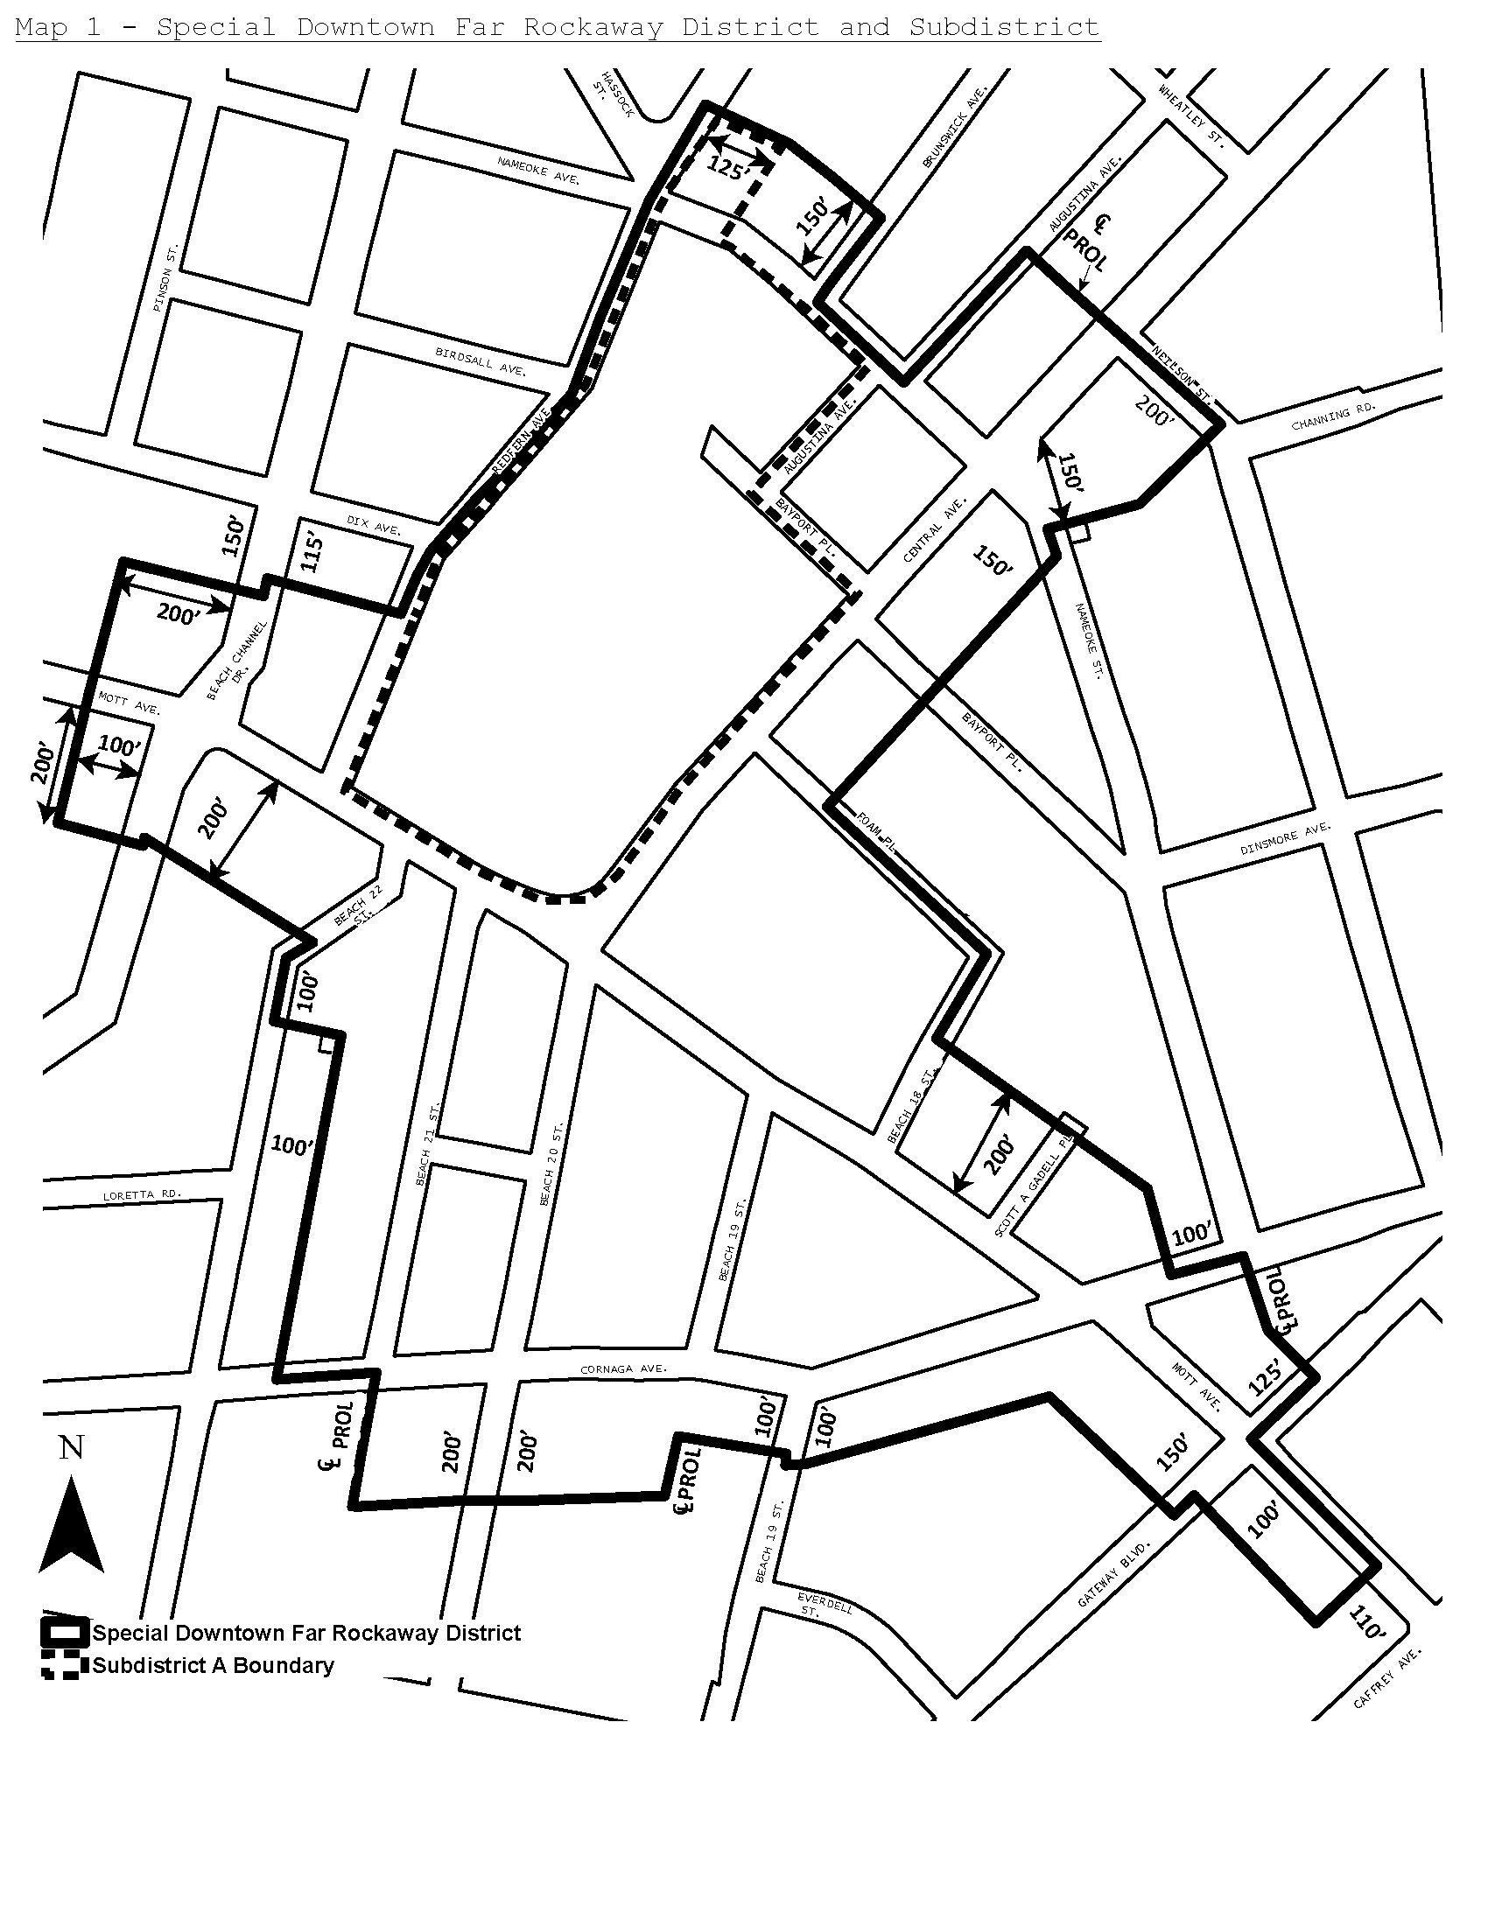

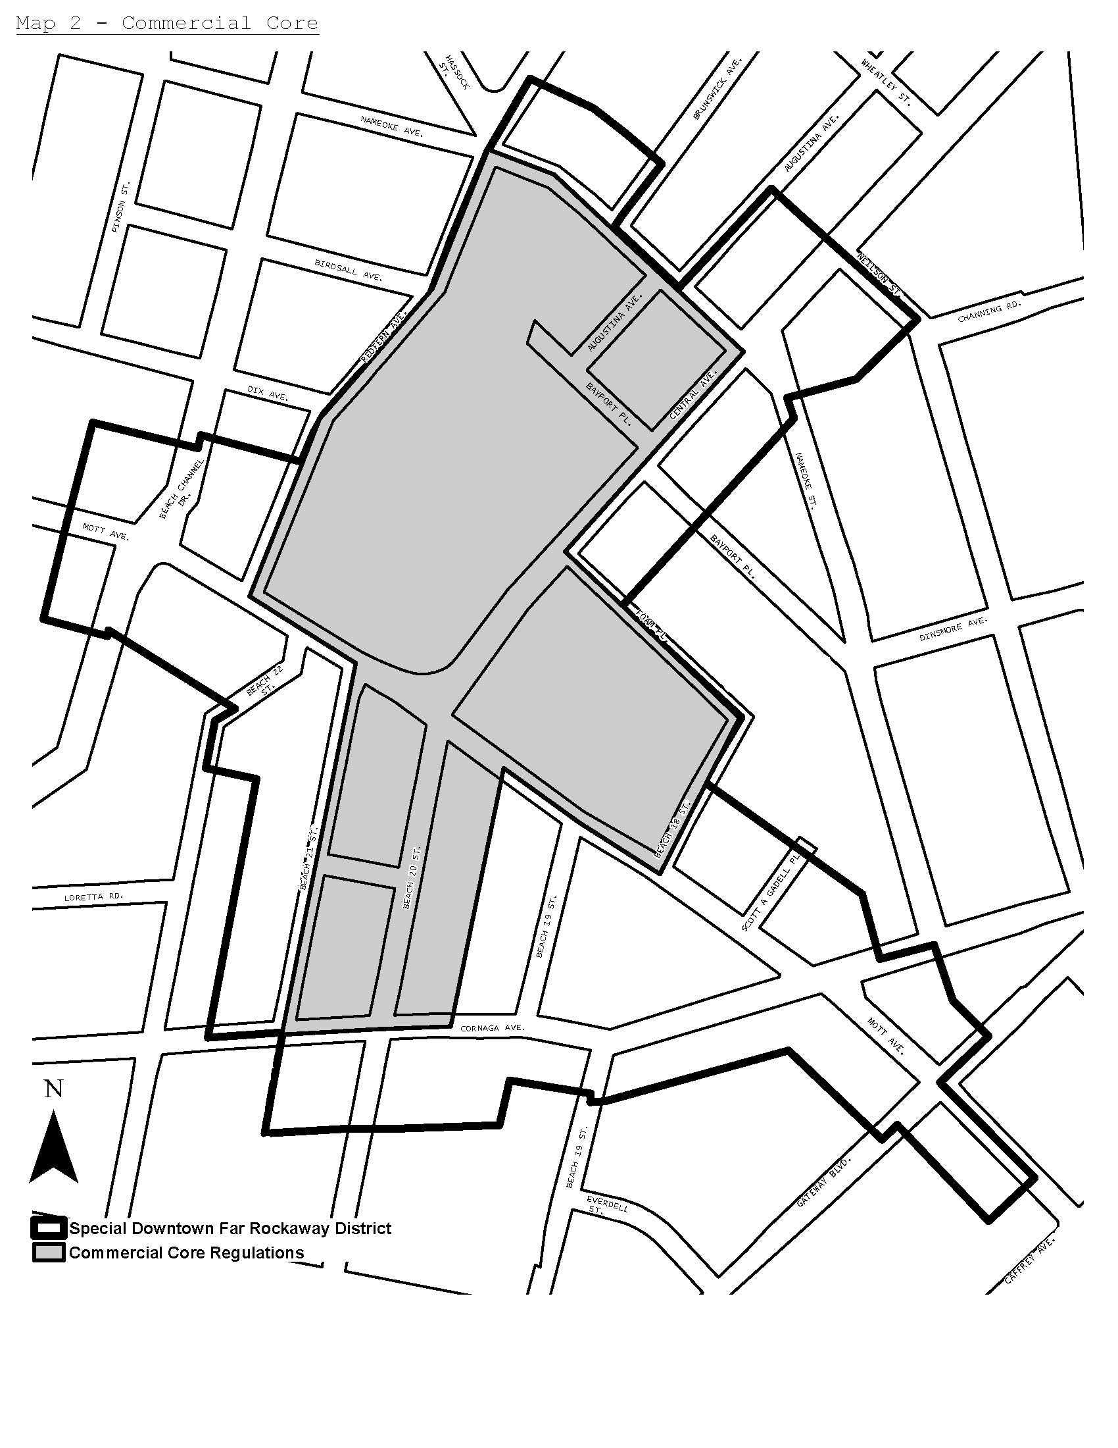

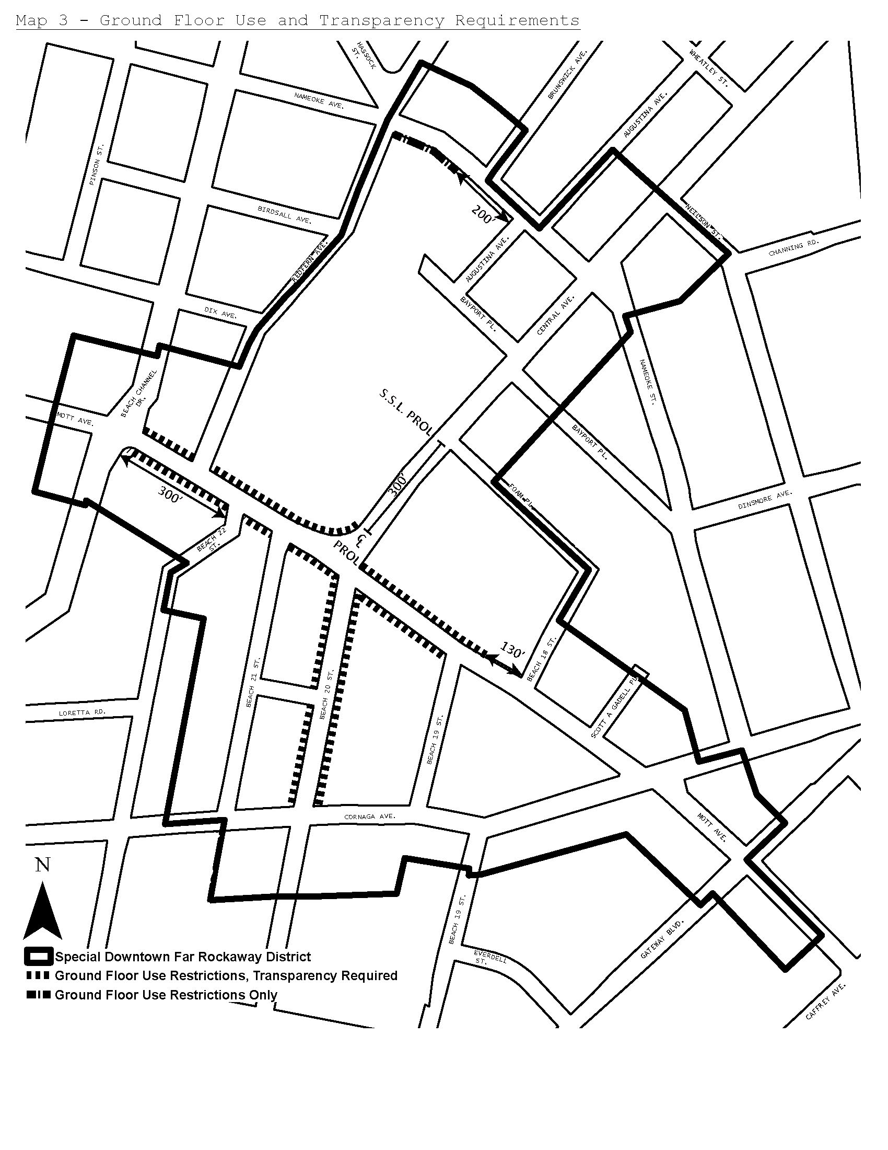

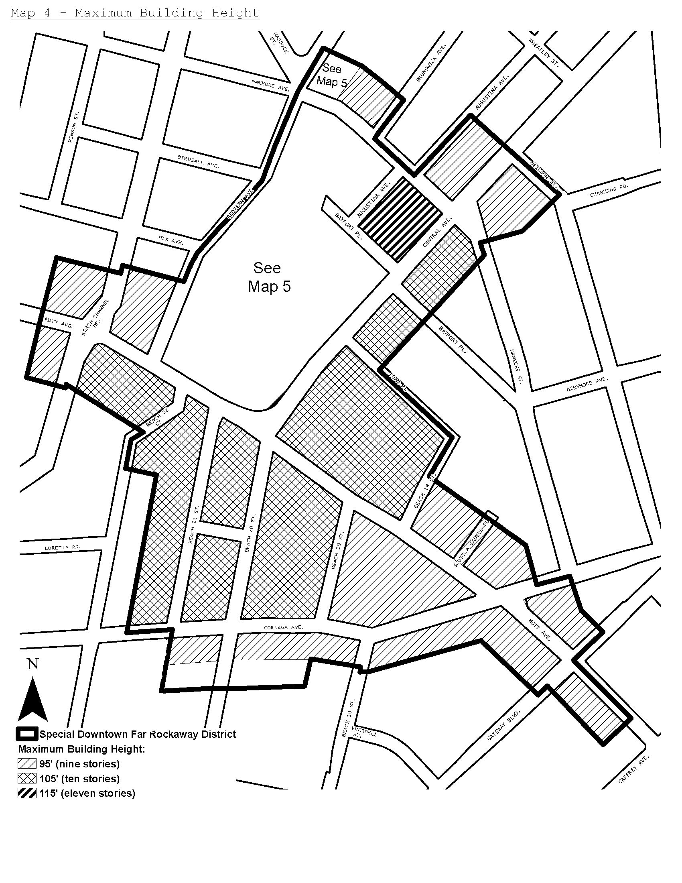
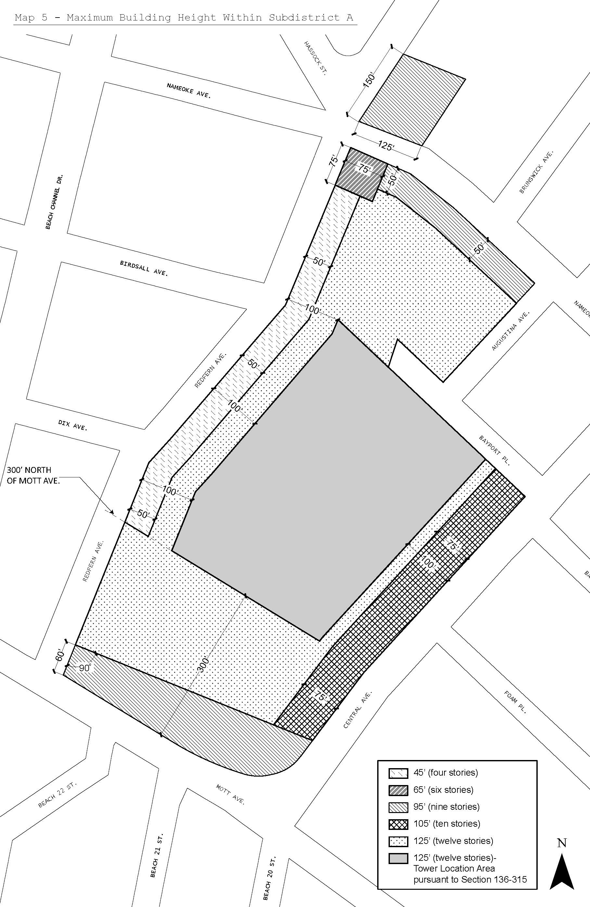
[City Planning Commission Proposed Map 6]

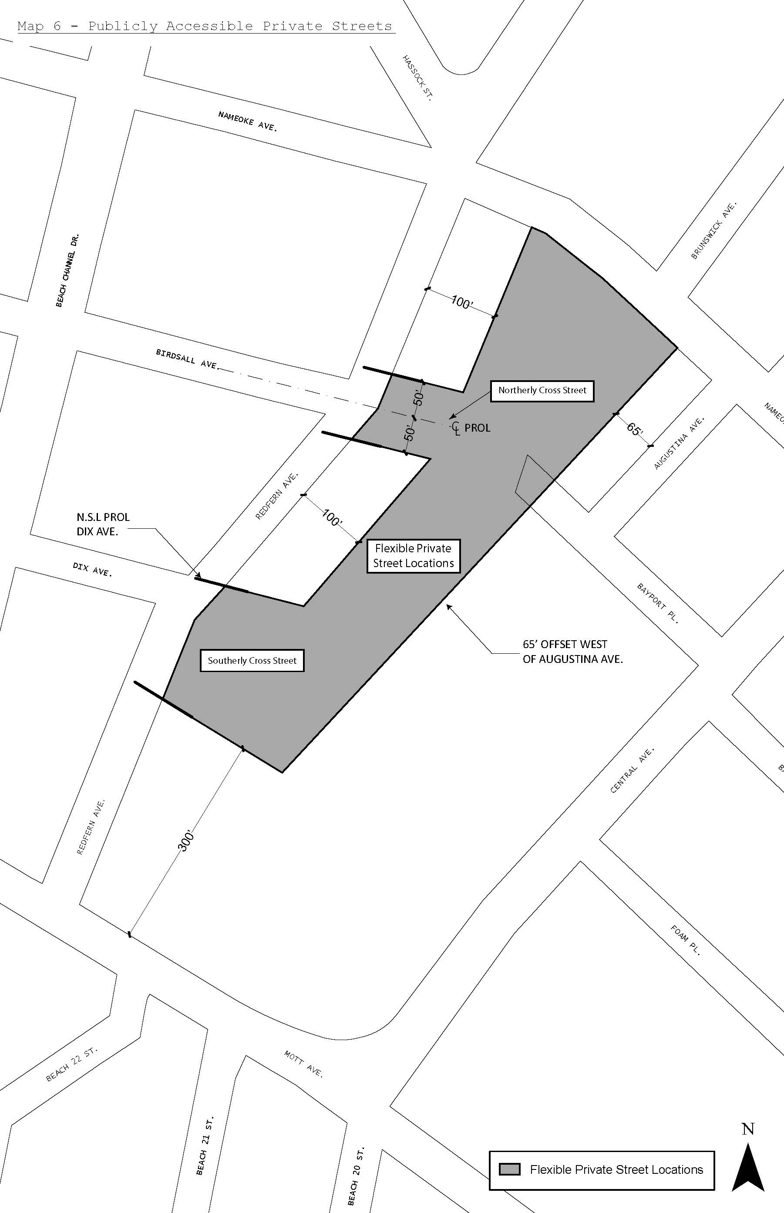
[Map 6 as Modified by City Council]

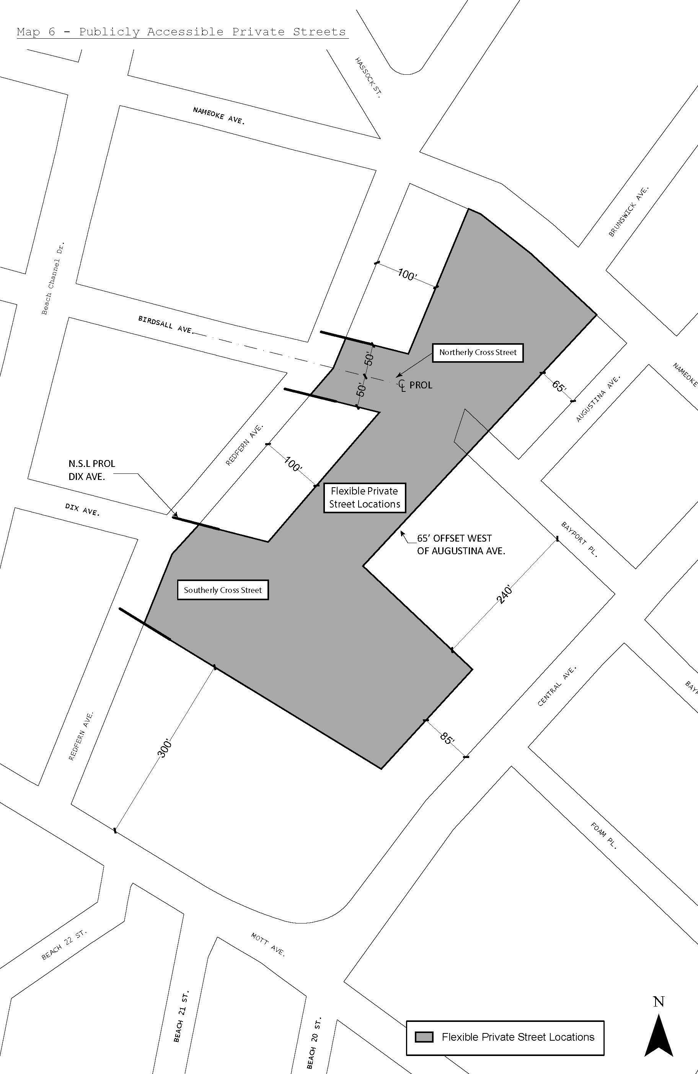

[City Planning Commission Proposed Map 7]

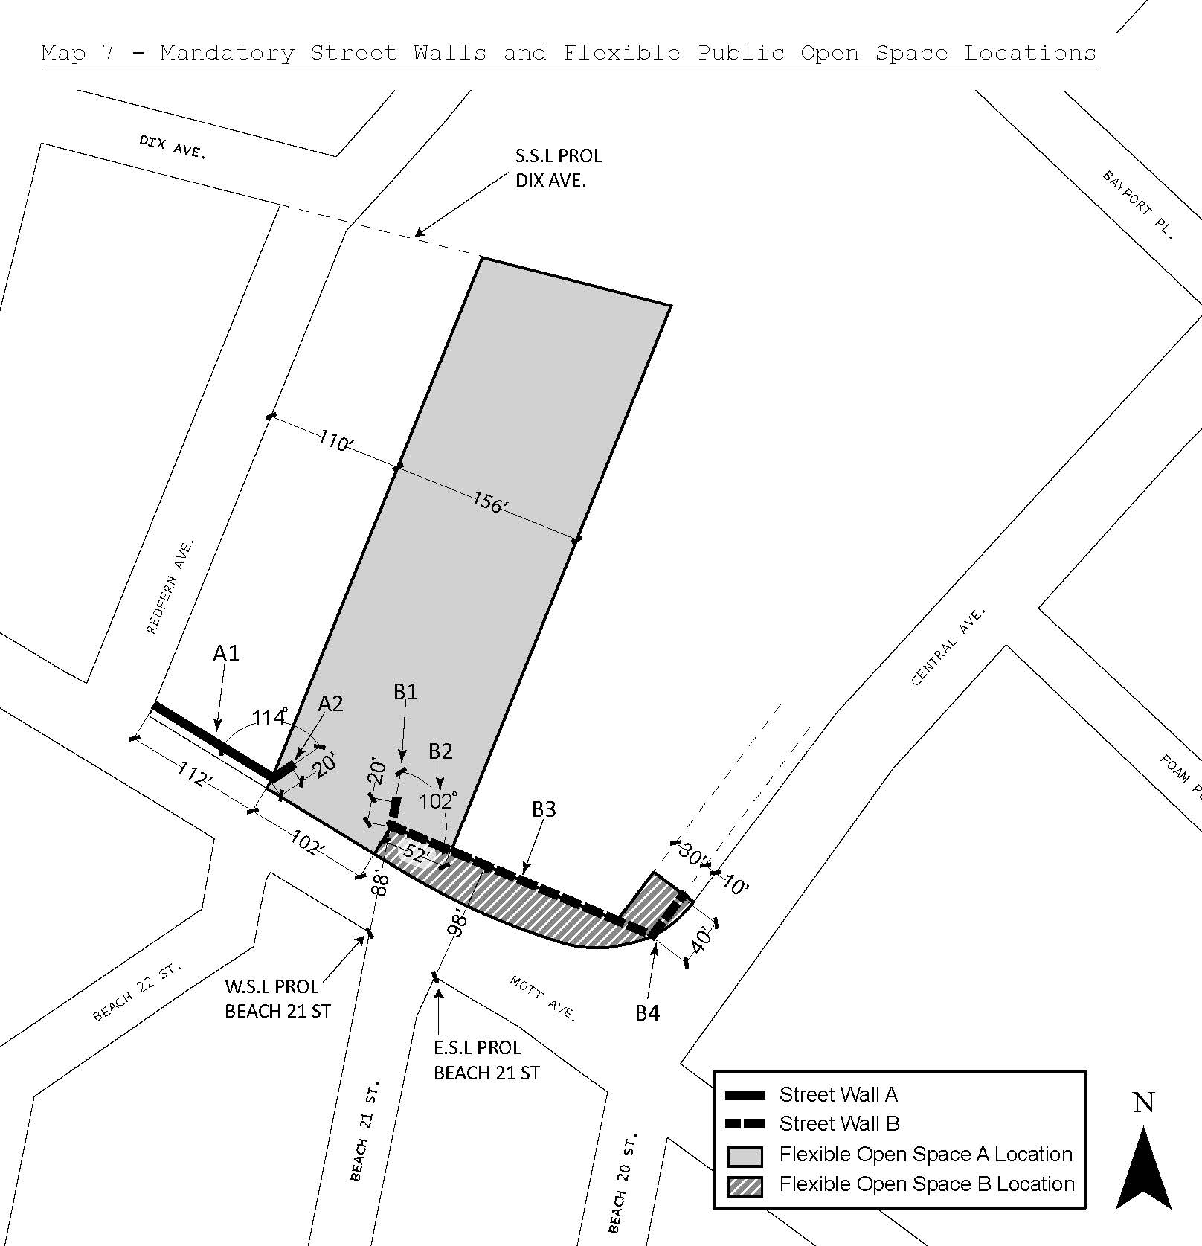

[Map 7 as Modified by City Council]
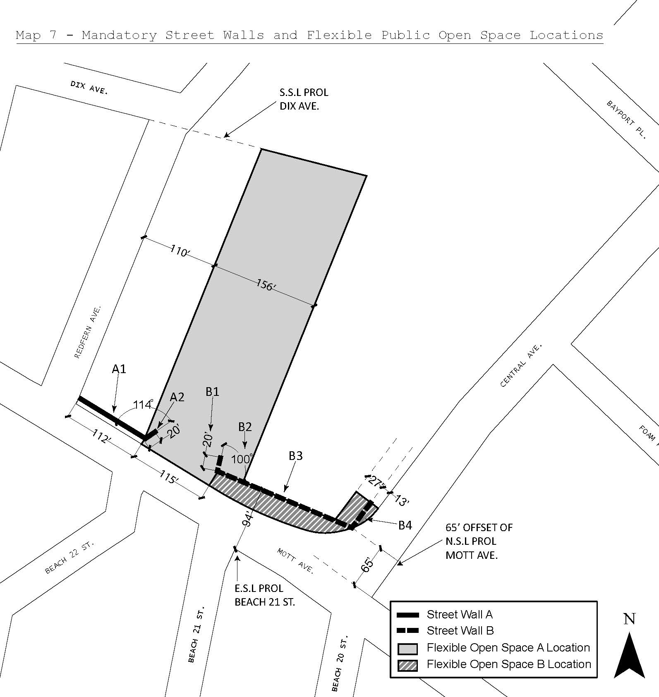
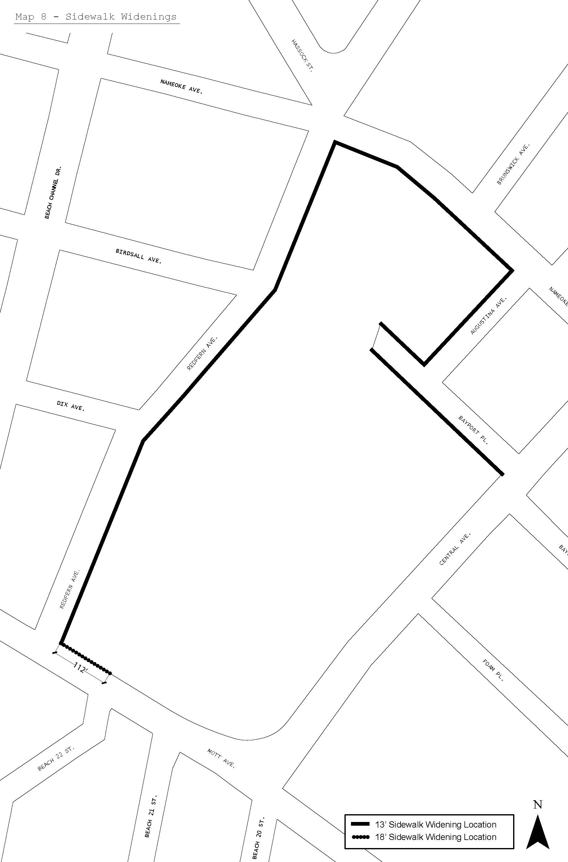

* * *
APPENDIX F
Inclusionary Housing Designated Areas and Mandatory Inclusionary Housing Areas

* * *

Queens
* * *

Queens Community District 14

In portions of the #Special Downtown Far Rockaway District# and in the R6, R6A, and R7-1 Districts within the areas shown on the following Maps 1 and 2:

* * *

Map 2 – [date of adoption]
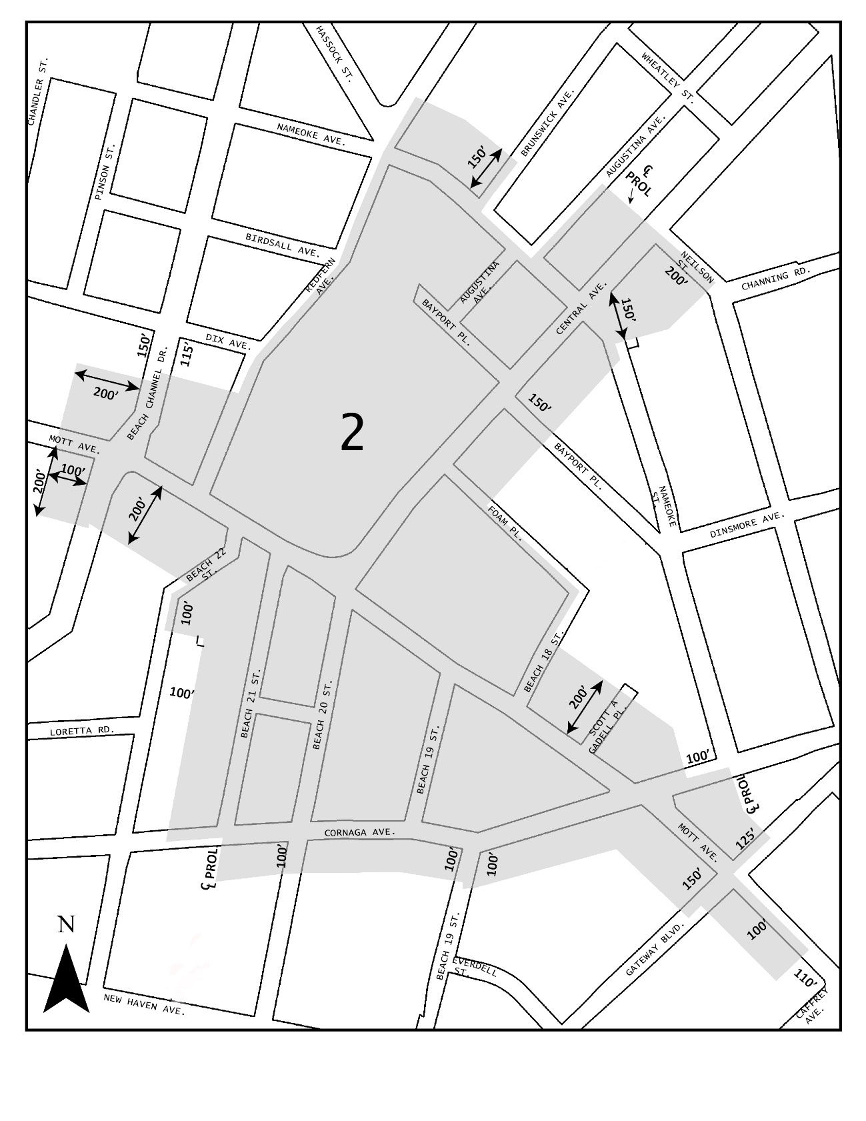
Mandatory Inclusionary Housing area see Section 23-154(d)(3)
Area 2 [date of adoption] ─ MIH Program Option 1, and Option 2, and Deep Affordability Option

Portion of Community District 14, Queens

* * *

Adopted.

Office of the City Clerk, }
The City of New York, } ss.:

I hereby certify that the foregoing is a true copy of a Resolution passed by The Council of The City of New York on September 7, 2017, on file in this office.

.....…….........................................
City Clerk, Clerk of The Council

