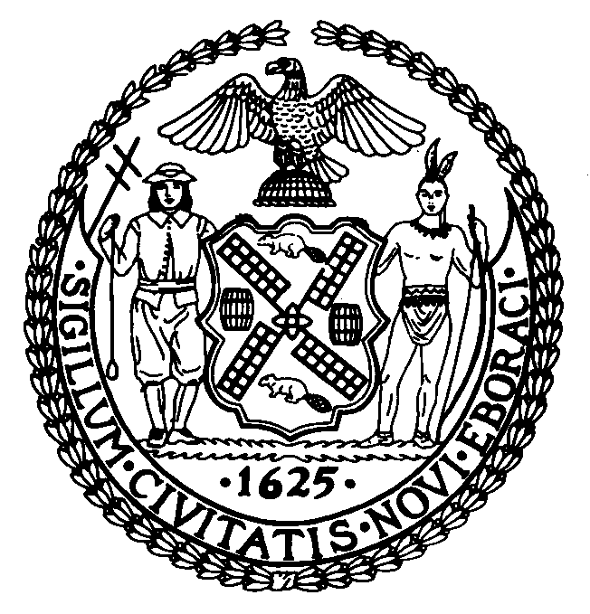 | The Council of the City of New York  Finance Division  Latonia Mckinney, Acting Director  Fiscal Impact Statement  Proposed Intro. No: 167-A  Committee: Transportation
Title: A Local Law to amend the administrative code of the city of New York, in relation to prohibiting certain stunt behavior with vehicles. | Sponsor: By Council Members Rodriguez, Chin, Koo, Levine, Treyger, Levin, Arroyo and Van Bramer
Summary of Legislation: This legislation would amend section 10-163 of the administrative code of the city of New York, as added by local law number 46 for the year 2004 broaden the prohibition speed contests to include “stunt behavior” such as wheelies, donuts, burnouts, and revving. A first violation of the stunt behavior prohibition would be a misdemeanor punishable by up to 60 days in jail and/or a fine of up to $600. A second or subsequent violation committed within ten years would result in up to 120 days in jail and/or a fine up to $1,000.

In addition, existing City law prohibits individuals from participating as a spectator in speed contests or stunt behavior. This bill would extend that prohibition to include stunt behavior and defines participation by a spectator as taking “specific overt actions” encouraging the people engaged in the speed contest or stunt behavior or wagering on the outcome. A violation would result in up to 15 days in jail and/or a fine of up to $250.

The bill would also require motorcycles’ license plates to be clearly visible at all times. A violation would result in up to 15 days in jail and/or a fine of up to $250.

Effective Date: This local law would take effect 90 days after its enactment into law.

Fiscal Year In Which Full Fiscal Impact Anticipated: 2015
Fiscal Impact Statement:
 | Effective FY15 | FY Succeeding  Effective FY16 | Full Fiscal  Impact FY15
Revenues (+) | $0 | $0 | $0
Expenditures (-) | $0 | $0 | $0
Net | $0 | $0 | $0

Impact on Revenues: There would be no impact on revenues resulting from the enactment of this legislation.

Impact on Expenditures: Because the Department will use existing resources to implement this local law, it is anticipated that there would be minimal to no impact on expenditures resulting from the enactment of this legislation.

Source of Funds To Cover Estimated Costs: N/A

Source of Information: NYC Council Finance Division
Mayor’s Office of Legislative Affairs
Estimate Prepared By: Chima Obichere, Unit Head

Estimate Reviewed By: Nathan Toth, Deputy Director
Tanisha Edwards, Finance Counsel
History: Introduced as Intro. 167 by the Council on March 12, 2014 and referred to the Committee on Transportation. A hearing was held and the legislation was laid over by the Committee on April 30, 2014. Intro. 167 has been amended, and the amended version, Proposed Int. 167-A, will be considered by the Committee on Transportation on May 29, 2014 and upon a successful vote, the bill would be submitted to the full Council for a vote.

