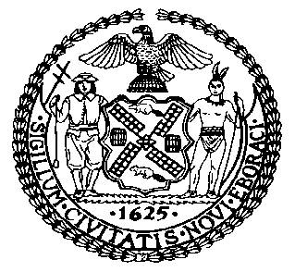 | The Council of the City of New York  Finance Division  Latonia McKinney, Director  Fiscal Impact Statement  Proposed Intro. No: 443-A  Committee: Housing and Buildings
Title: A Local Law to amend the New York city building code, in relation to crane modernization | Sponsors: Council Members Kallos, Rose, Constantinides, Reynoso, Levin, Espinal, Menchaca, Cornegy and Richards
Summary of Legislation: Proposed Intro. 443-A would prohibit the operation of cranes in New York City that are older than 25 years. Under the legislation, cranes with an age of 25 years or older could be used until the completion of a construction project, provided the crane is in use or is approved to be in use as of January 1, 2019 or until it reaches 28 years of age. Additionally, the Department of Buildings (“DOB”) may approve the use of a crane with an age of 25 years or older for up to a maximum of five years, not to exceed 30 years, provided the crane meets the manufacturers standards for use.

Effective Date: This local law would take effect on January 1, 2019, except that the Commissioner of Buildings may take such measures as are necessary for its implementation, including the promulgation of rules, before such effective date.
Fiscal Year In Which Full Fiscal Impact Anticipated: Fiscal 2020
Fiscal Impact Statement:

 | Effective FY19 | FY Succeeding Effective FY20 | Full Fiscal Impact FY20
Revenues | $0 | $0 | $0
Expenditures | $0 | $0 | $0
Net | $0 | $0 | $0

Impact on Revenues: It is estimated that there would be no impact on revenues resulting from the enactment of this legislation.
Impact on Expenditures: It is anticipated that there would be no impact on expenditures resulting from the enactment of this legislation because existing resources would be used by DOB to implement the provisions of this local law.
Source of Funds To Cover Estimated Costs: Not applicable.

Source of Information: New York City Council Finance Division

Estimate Prepared by: Sarah Gastelum, Principal Financial Analyst

Estimated Reviewed by: Chima Obichere, Unit Head
Rebecca Chasan, Counsel

Legislative History: This legislation was introduced to the full Council on August 21, 2014 as Intro. No. 443 and was referred to the Committee on Housing and Buildings (Committee). A hearing was held by the Committee on January 31, 2017, and the bill was laid over. The legislation was subsequently amended, and the amended version, Proposed Intro. No. 443-A, will be considered by the Committee on November 29, 2017. Following a successful Committee vote, the bill will be submitted to the full Council for a vote on November 30, 2017.

Date Prepared: November 28, 2017

