THE COUNCIL OF THE CITY OF NEW YORK
RESOLUTION NO. 754

Resolution approving the decision of the City Planning Commission on Application No. N 240344 ZRM, for an amendment of the text of the Zoning Resolution (L.U. No. 215).

By Council Members Salamanca and Riley

WHEREAS, 455 First Avenue Associates, LLC, and the New York City Economic Development Corporation, filed an application pursuant to Section 201 of the New York City Charter, for an amendment of the text of the Zoning Resolution of the City of New York, modifying APPENDIX F for the purpose of establishing a Mandatory Inclusionary Housing Area, which in conjunction with the related actions would facilitate the development of a new commercial life sciences development at 455 First Avenue in the Kips Bay neighborhood of Manhattan, Community District 6 (ULURP No. N 240344 ZRM), (the “Application”);

WHEREAS, the City Planning Commission filed with the Council on December 30, 2024, its decision dated December 16, 2024 (the "Decision") on the Application;

WHEREAS, the Application is related to applications C 240342 ZMM (L.U. No. 214), a zoning map amendment to change an R8 district and an R8 district with a C2-5 commercial overlay to a C6-4 district; and C 240343 ZSM (L.U. No. 216), a zoning special permit pursuant to Section 74-901 of the Zoning Resolution (ZR) to modify the height and setback requirements of Section 33-432 (In Other Commercial Districts);

WHEREAS, the Decision is subject to review and action by the Council pursuant to Section 197-d of the City Charter;

WHEREAS, upon due notice, the Council held a public hearing on the Decision and Application on January 9, 2025;

WHEREAS, the Council has considered the land use implications and other policy issues relating to the Decision and Application; and

WHEREAS, the Council has considered the relevant environmental issues, including the negative declaration issued June 21, 2024 (CEQR No. 23DME012M) (the “Negative Declaration”).
RESOLVED:
The Council finds that the action described herein will have no significant impact on the environment as set forth in the Negative Declaration.
Pursuant to Sections 197-d and 200 of the City Charter and on the basis of the Decision and Application, and based on the environmental determination and consideration described in the report, N 240344 ZRM, incorporated by reference herein, and the record before the Council, the Council approves the Decision of the City Planning Commission.

Matter underlined is new, to be added;
Matter struck out is to be deleted;
Matter within # # is defined in Section 12-10;
* * * indicates where unchanged text appears in the Zoning Resolution

APPENDIX F
Inclusionary Housing Designated Areas and Mandatory Inclusionary Housing Areas

MANHATTAN

* * *

Manhattan Community District 6

* * *

Map 3 — [date of adoption]

[PROPOSED MAP]
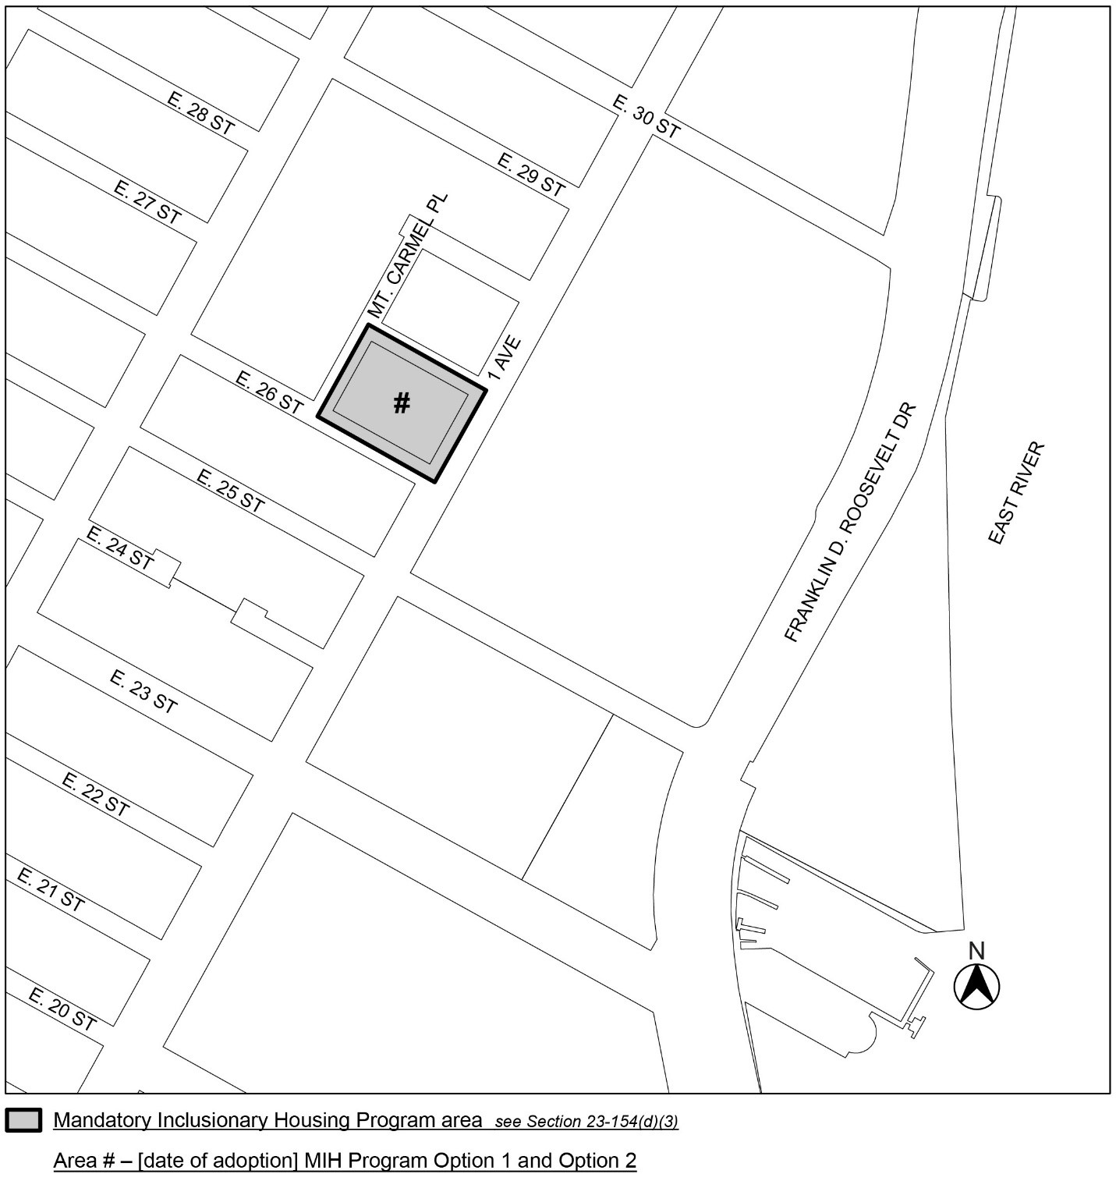

Portion of Community District 6, Manhattan

* * *

Adopted.

Office of the City Clerk,}
The City of New York,} ss.:

I hereby certify that the foregoing is a true copy of a Resolution passed by The Council of The City of New York on _________, 2025, on file in this office.

.....................................................
City Clerk, Clerk of The Council

