THE COUNCIL OF THE CITY OF NEW YORK
RESOLUTION NO. ____

Resolution approving with modifications the decision of the City Planning Commission on Application No. N 250147 ZRM, for an amendment of the text of the Zoning Resolution (L.U. No. 313).

By Council Members Salamanca and Hanks

WHEREAS, the New York City Department of Housing Preservation and Development, Ascendant Neighborhood Development, Urban Builders Collaborative, and Xylem Projects, filed an application pursuant to Section 201 of the New York City Charter, for an amendment of the text of the Zoning Resolution of the City of New York, modifying APPENDIX F for the purpose of establishing a Mandatory Inclusionary Housing area, which in conjunction with the related action would facilitate the development of Carmen Villegas Apartments – Senior Housing, an income-restricted housing complex for seniors at 100 East 111th Street (Block 1638, p/o Lot 1) in East Harlem, Manhattan Community District 11 (ULURP No. N 250147 ZRM), (the “Application”);

WHEREAS, the City Planning Commission filed with the Council on June 6, 2025, its decision dated June 2, 2025 (the "Decision") on the Application;

WHEREAS, the Application is related to applications C 250148 ZMM (L.U. No. 314), a zoning map amendment to change R7-2, R7-2/C2-4, and R7B/C2-4 zoning districts to R9-1 and R9-1/C2-4 zoning districts; C 250149 PPM (L.U. No. 315), a disposition of non-residential City-owned property for a property located at East 110th Street (Block 1638, p/o Lot 1); and C 250150 PQM (L.U. No. 316), an acquisition of property by the City for a property located at East 110th Street (Block 1638, p/o Lot 1);

WHEREAS, the Decision is subject to review and action by the Council pursuant to Section 197-d of the City Charter;

WHEREAS, upon due notice, the Council held a public hearing on the Decision and Application on June 12, 2025;

WHEREAS, the Council has considered the land use implications and other policy issues relating to the Decision and Application; and

WHEREAS, the Council has considered the relevant environmental issues, including the Revised Negative Declaration issued March 18th, 2025 (CEQR No. 24HPD010M), which supersedes the Negative Declaration issued January 8th, 2025. The revised Negative Declaration which include measures to avoid the potential for significant adverse impacts related to hazardous materials through an (E) designation (E-808), and noise through provisions contained in a Land Disposition Agreement and/or Regulatory Agreement between the Project Sponsor and HPD. A Technical Memorandum evaluating potential significant adverse impacts to disadvantaged communities was issued on May 5, 2025. The memorandum concludes that the Proposed Actions would not be expected to cause or increase a disproportionate pollution burden to disadvantaged communities.

RESOLVED:

The Council finds that the action described herein will have no significant impact on the environment as set forth in the (E) Designation (E-808) and Negative Declaration.

Pursuant to Sections 197-d and 200 of the City Charter and on the basis of the Decision and Application, and based on the environmental determination and consideration described in the report, N 250147 ZRM, incorporated by reference herein, and the record before the Council, the Council approves the Decision of the City Planning Commission, with the following modifications.

Matter underlined is new, to be added;
Matter struck out is to be deleted;
Matter double-underlined is new, added by the City Council;
Matter double struck out is old, deleted by the City Council;
Matter within # # is defined in Section 12-10;
* * * indicates where unchanged text appears in the Zoning Resolution

* * *

APPENDIX F
Mandatory Inclusionary Housing Areas and former Inclusionary Housing Designated Areas

MANHATTAN
* * *
Manhattan Community District 11

* * *
Map 5 – [date of adoption]

[EXISTING MAP]

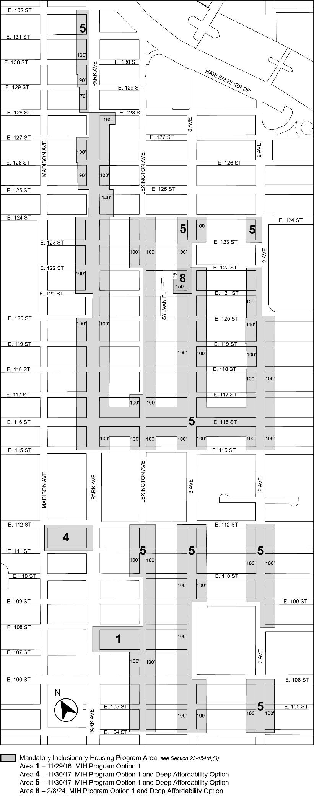

[PROPOSED MAP]

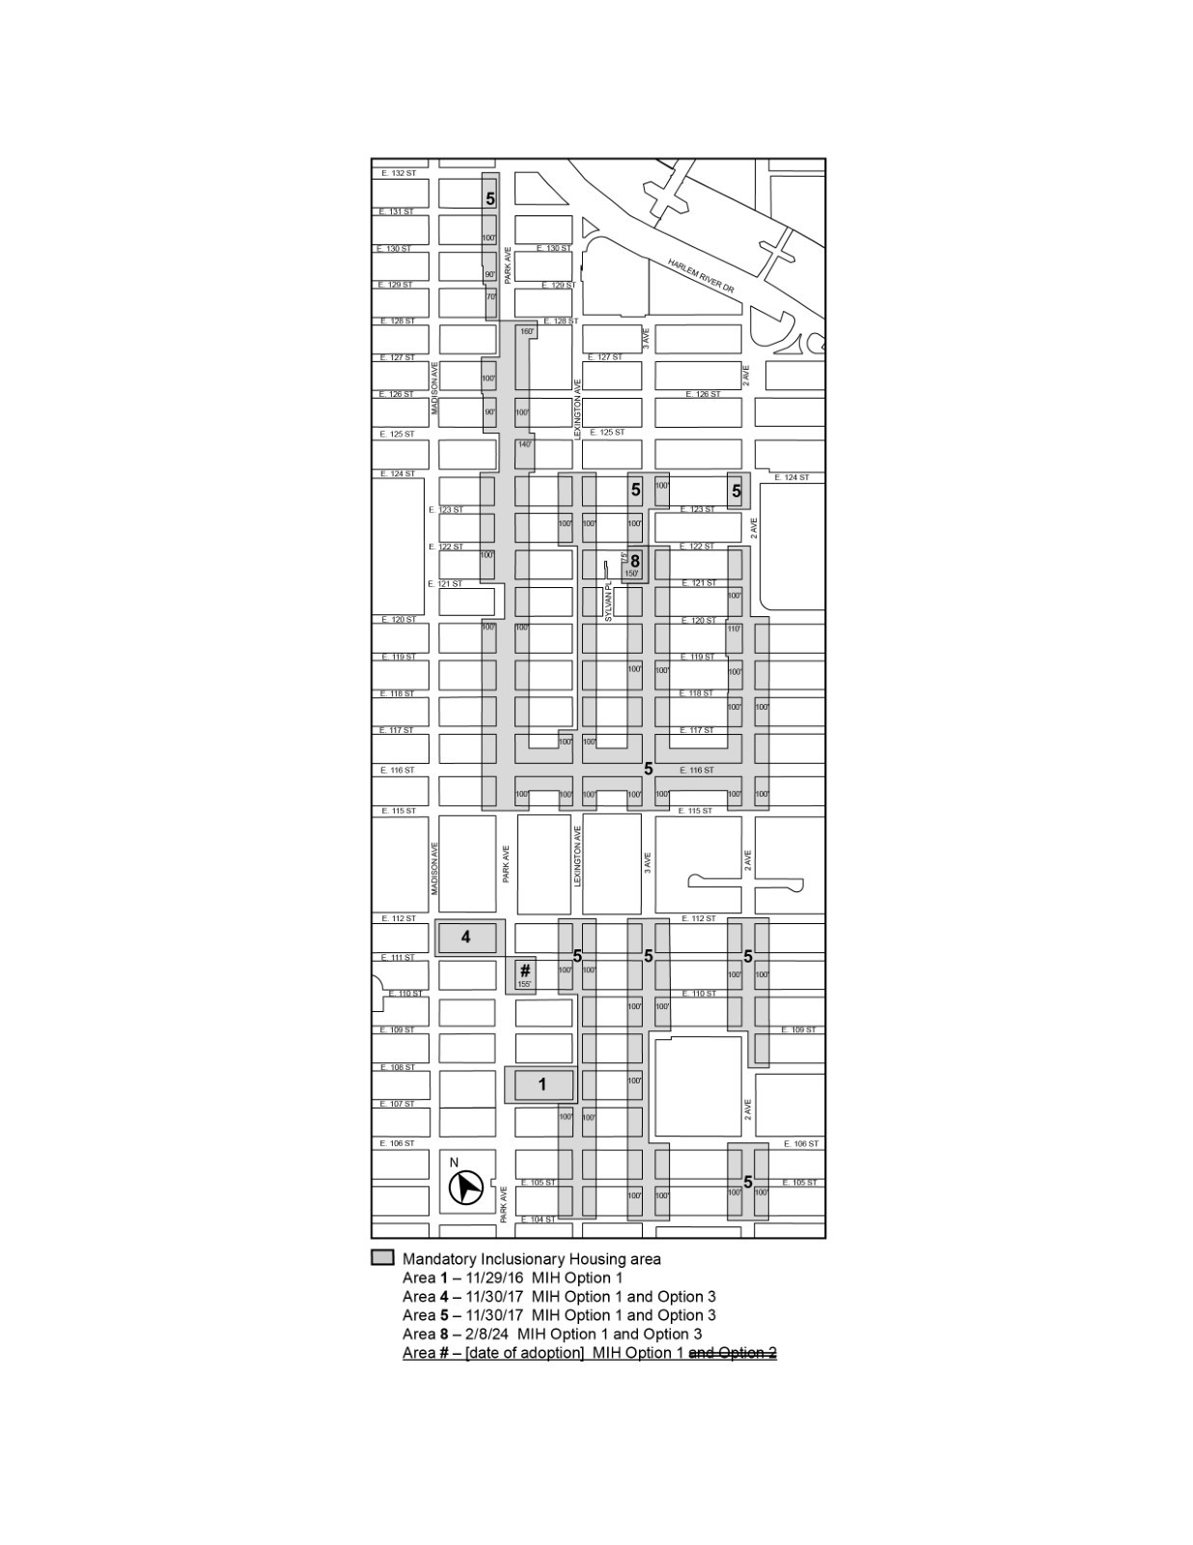
Portion of Community District 11, Manhattan

Adopted.

Office of the City Clerk,}
The City of New York,} ss.:

I hereby certify that the foregoing is a true copy of a Resolution passed by The Council of The City of New York on _________, 2025, on file in this office.

.....................................................
City Clerk, Clerk of The Council

