THE COUNCIL OF THE CITY OF NEW YORK
RESOLUTION NO. 556

Resolution approving with modifications the decision of the City Planning Commission on Application No. N 240132 ZRK, for an amendment of the text of the Zoning Resolution (L.U. No. 118).

By Council Members Salamanca and Riley

WHEREAS, Ford Coyle Properties Inc, filed an application pursuant to Section 201 of the New York City Charter, for an amendment of the Zoning Resolution of the City of New York, modifying APPENDIX F for the purpose of establishing a Mandatory Inclusionary Housing area, which in conjunction with the related action for a zoning map amendment (C 240131 ZMK), would facilitate the development of a nine-story, approximately 112,000 square-foot, mixed-use building with 109 dwelling units (27 to 33 of which would be permanently income-restricted), approximately 13,650 square-feet of ground-floor retail, and 98,350 square-feet of residential floor area located at 3033 Avenue V in the Sheepshead Bay neighborhood of Brooklyn, Community District 15 (ULURP No. N 240132 ZRK), (the “Application”);
WHEREAS, the City Planning Commission filed with the Council on July 12, 2024, its decision dated June 26, 2024 (the “Decision”) on the Application;
WHEREAS, the Application is related to application C 240131 ZMK (L.U. No. 117), a zoning map amendment to change an R4/C1-2 zoning district to an R7D/C2-4 zoning district;
WHEREAS, the Decision is subject to review and action by the Council pursuant to Section 197-d of the City Charter;
WHEREAS, upon due notice, the Council held a public hearing on the Decision and Application on July 24, 2024;
WHEREAS, the Council has considered the land use implications and other policy issues relating to the Decision and Application; and
WHEREAS, the Council has considered the relevant environmental issues, including the Negative Declaration issued on March 18, 2024 (CEQR No. 24DCP052K), which includes an (E) designation to avoid the potential for significant adverse impacts related to hazardous materials and air quality (E-752) (the “Negative Declaration”).
RESOLVED:
The Council finds that the action described herein will have no significant impact on the environment as set forth in the (E) Designation (E-752) and Negative Declaration.
Pursuant to Sections 197-d and 200 of the City Charter and on the basis of the Decision and Application, and based on the environmental determination and consideration described in the report, N 240132 ZRK, incorporated by reference herein, and the record before the Council, the Council approves the Decision of the City Planning Commission with the following modifications.
Matter underlined is new, to be added;
Matter struck out is to be deleted;
Matter double struck out is old, deleted by the City Council;
Matter double-underlined is new, added by the City Council
Matter within # # is defined in Section 12-10;
* * * indicates where unchanged text appears in the Zoning Resolution

* * *
APPENDIX F
Inclusionary Housing Designated Areas and Mandatory Inclusionary Housing Areas
* * *
BROOKLYN
* * *
Brooklyn Community District 15
* * *
Map 4 – [date of adoption]
[EXISTING MAP]
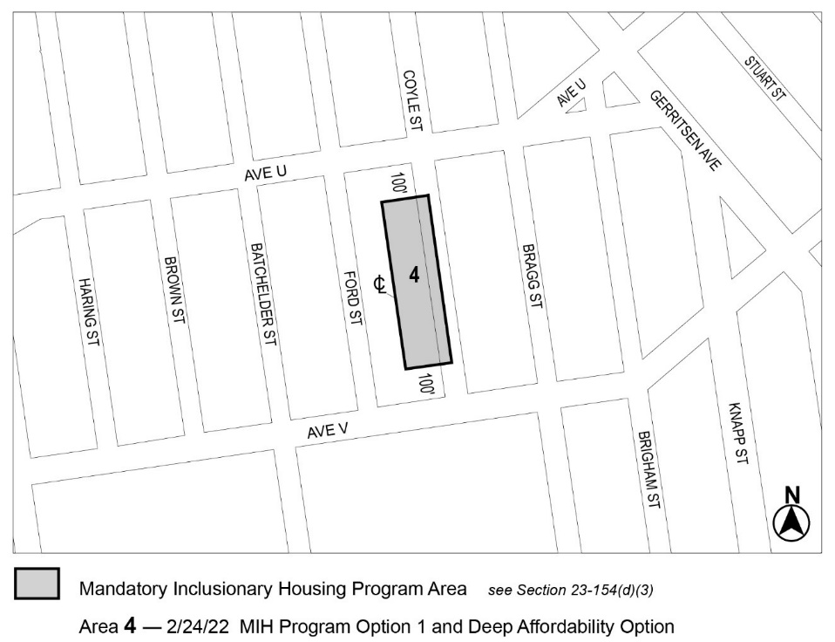

[PROPOSED MAP]
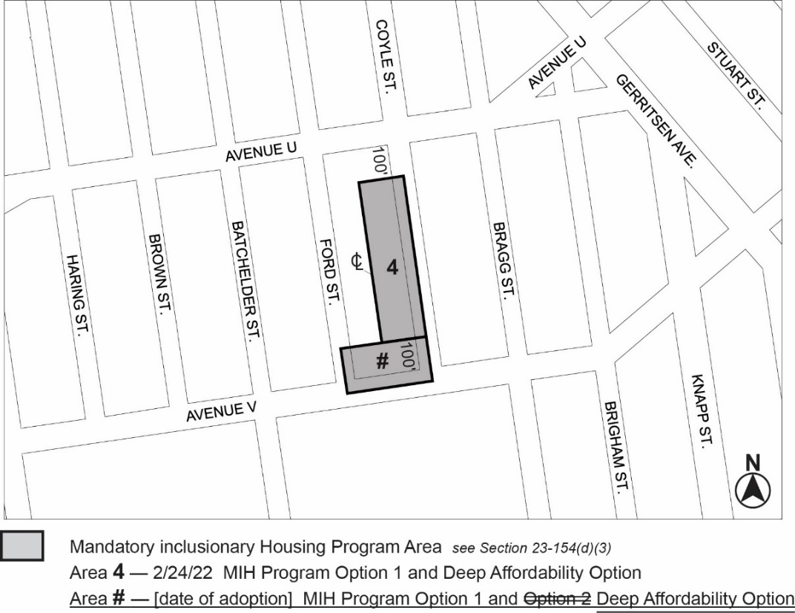
Portion of Community District 15, Brooklyn
* * *

Adopted.

Office of the City Clerk,}
The City of New York,} ss.:

I hereby certify that the foregoing is a true copy of a Resolution passed by The Council of The City of New York on _______, 2024, on file in this office.

.....................................................
City Clerk, Clerk of The Council

