Staff: Committee on Sanitation
Cullen Howe, Counsel
Rachel Harris, Policy Analyst



THE COUNCIL OF THE CITY OF NEW YORK

COMMITTEE REPORT OF THE INFRASTRUCTURE DIVISION
Matthew Gewolb, Legislative Director

COMMITTEE ON SANITATION AND SOLID WASTE MANAGEMENT
Hon. Antonio Reynoso, Chair

September 16, 2015

INT. NO. 204 By Council Members Koslowitz, Constantinides, Wills, Richards, Ferreras-Copeland, Gentile, Johnson, King and Ulrich

TITLE: A Local Law to amend the administrative code of the city of New York, in relation to increasing fines for the depositing of residential or commercial refuse into public litter baskets

INT. NO. 377 By Council Members Chin, Koo, Mendez, Rodriguez, Rose, Dromm and Rosenthal

TITLE A Local Law to amend the administrative code of the city of New York, in relation to requiring the cleaning of liquid on a sidewalk, flagging or curbstone generated by trash placed curbside for collection and allowing the use of a hose to conduct such cleaning during times otherwise proscribed by such code

INT. NO. 857 By Council Members Matteo, Reynoso, Mendez, Richards and Ulrich

TITLE A Local Law to amend the administrative code of the city of New York, in relation to increasing penalties for littering

INT. NO. 879 By Council Members Rosenthal, Koo, Mealy and Rose

TITLE A Local Law to amend the administrative code of the city of New York, in relation to receptacles in a building or dwelling that has a high concentration of rodent infestation

- Introduction
On Wednesday, September 16, 2015 the Committee on Sanitation and Solid Waste Management (the “Committee”), chaired by Council Member Antonio Reynoso, will hold a hearing on Int. No. 204, concerning fine increases for depositing residential or commercial trash in public litter baskets; Int. No. 377, concerning cleaning liquids on sidewalks generated by curbside trash with hoses; Int. No. 857, concerning fine increases for littering; and Int. No. 879, concerning requiring rat proof trash bins for buildings that have received two or more rodent infestation violations within a 12-month period. The Committee expects to hear from sponsors of the bill, Department of Sanitation (DSNY) officials, community members and advocates.

- Background
A 2015 study published in the Proceedings of the National Academy of Sciences examined 27 metropolitan areas with more than 10 million people, including New York City, and how they consume resources and create waste. These 27 cities contain 6.7% of the world’s population but produce 12.6% of the world’s waste. Among these 27 cities, New York City ranks as the top offender in terms of amount of solid waste generated.
To address this issue, New York City’s OneNYC Plan has stated as a goal that the city become zero waste by 2030. However, while aiming to achieve these large reductions in waste, New Yorkers still have to contend with daily nuisances such as litter on NYC streets and sidewalks, liquids from trash bags that leaks onto sidewalks, and rodent infestation in buildings. Therefore, Council Members have introduced four bills that aim to address these quality of life issues.

- Int. No. 204

Int. No. 204 would reduce illegal dumping of household and commercial waste in public waste receptacles by increasing fines related to this illegal activity. A 2005 Waste Characterization Study issued by DSNY reported that up to 20% of all waste deposited in public waste basket consisted of illegally deposited commercial or residential trash. When residents or businesses deposit trash in public waste receptacles, it leaves little to no room for trash placed there by pedestrians, causing the baskets to overflow and creating a dirty area and street.
In 2007, the Council passed Local Law 42, which amended Local Law 1 of 2003 by raising the fines for first-time violations from $25 to $100 and up to $400 for three or more violations within a 12-month period. Local Law 42 also creates a rebuttable presumption that the person whose identifying information appears in illegally dumped household or commercial waste deposited the waste.
Following the enactment of Local Law 42, violations issued for residential/commercial dumping into public waste receptacles were reduced. However, there was a sharp spike in the number of violations issued in 2011, after several public officials complained.
Following Hurricane Sandy, the number of violations for residential/commercial dumping into public waste receptacles decreased significantly, from 4,185 in FY 2012 to 922 in FY 2013. According to DSNY, this was largely because DSNY enforcement agents were temporarily transferred to traffic duty. However, the number of violations did not increase substantially in FY 2014 when the enforcement agents returned to normal duty, and the number of violations for 2015 is approximately 500 thus far.
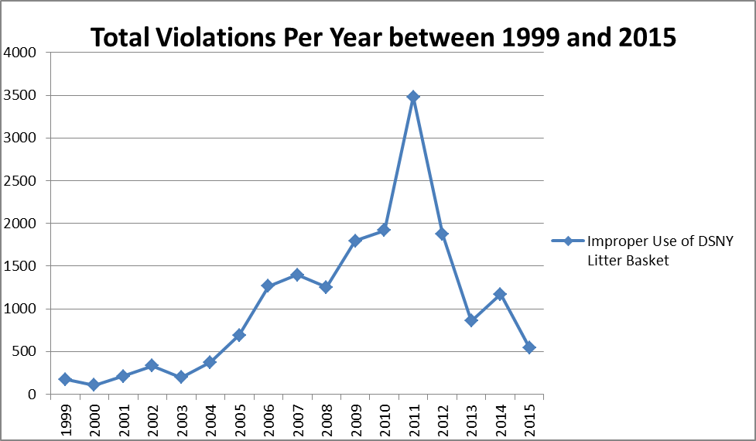
Beginning in 2011, DSNY has addressed this issue by removing some public waste receptacles, with mixed results. While removal of public waste receptacles helped in some locations, other locations continue to complain of overflowing litter baskets with residential and commercial refuse, as well as trash dumped on the ground.
Int. No. 204 would double the $100 fine to $200 for a first-time violation, $500 for a second violation and $600 for a third or subsequent violation within a twelve-month period. A third or subsequent violation is also considered a class a misdemeanor, meaning that an imprisonment of between 15 days and a year can be imposed.

- Int. No. 377

Waste put out by restaurants and other service establishments often contains liquid, which can attract rats and other vermin, as well as lead to sticky, discolored sidewalks and noxious odors, particularly in the summer months. However, section 24-332 of the Administrative Code makes it unlawful to wash any street, sidewalk, areaway, steps, building or other place with a hose between November 1 and March 31, and rules enacted by the City prohibit the use of a hose to wash sidewalks anytime during these months as well as during other months from 11 a.m. to 7 p.m.
Int. No. 377 attempts to address this issue by doing several things. First, it would require owners, lessees, tenants, occupants or persons in charge of service establishments that serve food or beverages to clean liquids that leak onto any sidewalk resulting from the placement of garbage bags or waste receptacles with a hose during certain designated times after waste collection. Second, the bill amends current law to allow for such individuals to clean these liquids from the sidewalk or street with a hose. Third, it imposes fines of between $100-$500 for a first violation for failing to clean liquids from the sidewalk or street, $500-$600 for a second violation, and $700-$900 for a third or subsequent violation within any 12-month period.

- Int. No. 857

In 2003, the Council enacted Local Law 1, which raised the civil penalties for littering. Local Law 1 raised fines for littering to between $50-$250 for a first violation, between $250-$350 for a second violation, and between $350-$450 for a third or subsequent violation in a 12-month period. While fines for littering have not been raised since that time, complaints about sidewalk cleanliness have risen over time. The number of peak monthly litter complaints has roughly doubled since 2010, from approximately 700 complaints in July 2010 to 1,200 complaints in April 2015.
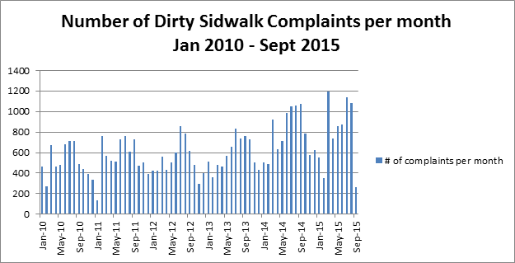
Int. No. 857 would increase these civil penalties in a 12-month period as follows: $250 for a first violation, $350 for a second violation, and $450 for a third or subsequent violation. In addition, the bill would increase the fine for not answering a notice of violation, appearance ticket or summons within the time provided from not more than $450 to not more than $675 for each violation.

- Int. No. 879

New York City residents make on average over 2,500 complaints per year concerning rat infestations. Complaints often peak in the summer months. In July 2015, rat complaints spiked at approximately 3,500, nearly 1,000 more complaints than the same month in any of the previous 4 years. So far in 2015, 331 rat violations have been reported for 259 buildings. Of those buildings, 40 have more than one violation and one building has 9 rat violations, the highest so far this year.
Int. No. 879 would require building owners, lessees, agents, occupants or persons who manage or control buildings or dwellings to provide and maintain rodent-proof bins if the building or dwelling has received two or more rodent violations pursuant to the New York City Health Code or Housing Maintenance Code within a 12-month period. The requirement will apply to such building or dwelling until two years pass without any additional violations.

Int. No. 204
By Council Members Koslowitz, Constantinides, Wills, Richards, Ferreras-Copeland, Gentile, Johnson, King and Ulrich

A LOCAL LAW

To amend the administrative code of the city of New York, in relation to increasing fines for the depositing of residential or commercial refuse into public litter baskets

Section 1. Subdivision f of section 16-120 of the administrative code of the city of New York is amended to read as follows:
f. Any person violating the provisions of this section, except subdivision e, shall be liable for a civil penalty of not less than twenty-five nor more than one hundred dollars for the first violation, not less than one hundred dollars nor more than two hundred dollars for a second violation within any twelve-month period, and not less than two hundred dollars nor more than three hundred dollars for a third or subsequent violation with any twelve-month period. Any person violating the provisions of subdivision e of this section shall be liable for a civil penalty of [not less than one hundred dollars nor more than three hundred] two hundred dollars for the first violation, [not less than two hundred fifty dollars nor more than three hundred fifty] five hundred dollars for a second violation within any twelve-month period, and [not less than three hundred fifty dollars nor more than four hundred] six hundred dollars for a third or subsequent violation within any twelve month period. A third or subsequent violation shall be a class a misdemeanor.
§2. This local law shall take effect ninety days after its enactment.
JCH
LS# 805
Int. 774/2012
3/19/14

Int. No. 377

By Council Members Chin, Koo, Mendez, Rodriguez, Rose, Dromm and Rosenthal

A LOCAL LAW

To amend the administrative code of the city of New York, in relation to requiring the cleaning of liquid on a sidewalk, flagging or curbstone generated by trash placed curbside for collection and allowing the use of a hose to conduct such cleaning during times otherwise proscribed by such code

Section 1. Subdivision 2 of section 16-118 of the administrative code of the city of New York is amended by adding a new paragraph c to read as follows:
(c)(1) Every owner, lessee, tenant, occupant or person in charge of any food or beverage service establishment shall properly clean any liquid found on any sidewalk, flagging or curbstone resulting from the placement of garbage bags or waste receptacles for collection at or near any such location by any such person. Where collection of waste for any such establishment is scheduled to occur during such establishment’s regular hours of operation, the owner, lessee, tenant, occupant or person in charge of such establishment shall properly clean any such liquid within one hour of waste collection. Where collection of waste for any such establishment is not scheduled to occur during such establishment's regular hours of operation, the following cleaning requirements shall apply: (i) where such collection is scheduled to occur before midnight, the owner, lessee, tenant, occupant or person in charge of such establishment shall properly clean any such liquid on the next day of business by the later of 7:00 a.m., or two hours before the time at which such establishment reopens for business; (ii) where such collection is scheduled to occur after midnight, the owner, lessee, tenant, occupant or person in charge of such establishment shall properly clean any such liquid by the later of 7:00 a.m. on the day that collection is scheduled to occur, or two hours before the time at which such establishment reopens for business on such day. If the food or beverage service establishment is not open for business on such day, the cleaning requirements of subparagraph i of this paragraph shall apply.
(2) For purposes of this subdivision, "food or beverage service establishment" shall mean any establishment that serves food or beverages that is required to be permitted pursuant to articles 85, 87, 88, or 89 of the New York city health code or any beverage service establishment required to be licensed pursuant to section 100 of the New York state alcoholic beverage control law that sells beverages for on-premises consumption.
§ 2. Subdivision 9 of section 16-118 of the administrative code of the city of New York is amended to read as follows:
9. (a) [Any] Except for violations of paragraph c of subdivision two of this section, any person violating the provisions of this section shall be liable for a civil penalty of not less than fifty dollars nor more than two hundred fifty dollars, except that for a second violation of subdivision one, three, four, or six of this section within any twelve-month period, such person shall be liable for a civil penalty of not less than two hundred fifty dollars nor more than three hundred fifty dollars and for a third or subsequent violation of subdivision one, three, four or six of this section within any twelve-month period such person shall be liable for a civil penalty of not less than three hundred fifty dollars nor more than four hundred fifty dollars.
(b) Any person who violates paragraph c of subdivision 2 of this section shall be liable for a civil penalty of not less than one hundred dollars nor more than five hundred dollars, except that for a second violation of such subdivision within any twelve-month period, such person shall be liable for a civil penalty of not less than five hundred nor more than six hundred dollars and for a third or subsequent violation of such subdivision within any twelve-month period such person shall be liable for a civil penalty of not less than seven hundred dollars nor more than nine hundred dollars.
§ 3. Section 24-332 of title 24 of the administrative code of the city of New York is amended to read as follows:
§ 24-332 Use of water through hose. [It] Except for the purposes of cleaning liquids by an owner, lessee, tenant, occupant or person in charge of a food or beverage service establishment as provided in paragraph c of subdivision 2 of section 16-118 of this code, it shall be unlawful for any person to wash any street, sidewalk, areaway, steps, building or other place in the city by means of a hose or piping, or to use water through a hose or sprinkler for watering lawns or gardens, or to operate any outside shower where the water runs upon a street, sidewalk, or other public place between the first day of November and the last day of March following.
§ 4. This local law shall take effect immediately.
TBD
Int. 453/2011
LS 440 / 2014
4/3/2014 4:23 PM

Int. No. 857
By Council Members Matteo, Reynoso, Mendez, Richards and Ulrich
A LOCAL LAW

To amend the administrative code of the city of New York, in relation to increasing penalties for littering

Be it enacted by the Council as follows:
Section 1. Subdivision 9 of section 16-118 of the administrative code of the city of New York, as amended by local law number 56 for the year 2013, is amended to read as follows:
9. Any person violating the provisions of this section shall be liable for a civil penalty of [not less than fifty dollars nor more than] two hundred fifty dollars, except that for a second violation of subdivision one, three, four, or six of this section within any twelve-month period, such person shall be liable for a civil penalty of [not less than two hundred fifty dollars nor more than] three hundred fifty dollars and for a third or subsequent violation of subdivision one, three, four or six of this section within any twelve-month period such person shall be liable for a civil penalty of [not less than three hundred fifty dollars nor more than] four hundred fifty dollars.
§ 2. Subdivision 11 of section 16-118 of the administrative code of the city of New York, as amended by local law number 1 for the year 2003, is amended to read as follows:
11. In the event that a violator fails to answer such notice of violation, appearance ticket or summons within the time provided therefor by the rules and regulations of the environmental control board, he or she shall become liable for additional penalties. The additional penalties shall not exceed [four hundred fifty] six hundred seventy-five dollars for each violation.
§ 3. This local law takes effect 120 days after it becomes law.

EAA/GP
LS 4855
7/8/15 2:51 PM

Int. No. 879
By Council Members Rosenthal, Koo, Mealy and Rose

A LOCAL LAW

To amend the administrative code of the city of New York, in relation to receptacles in a building or dwelling that has a high concentration of rodent infestation.

Section 1. Subdivision a of section 16-120 chapter 1 of title 16 of the administrative code of the city of New York is amended to read as follows:
§ 16-120 Receptacles for the removal of waste material. a. 1. The owner, lessee, agent, occupant or other person who manages or controls a building or dwelling shall provide and maintain in accordance with this section separate receptacles for the deposit of incinerator residue and ashes; refuse, and liquid waste. The receptacles shall be provided for the exclusive use of each building or dwelling and shall be of sufficient size and number to contain the wastes accumulated in such building or dwelling during a period of seventy-two hours. The receptacles shall be made of metal or other material of a grade and type acceptable to the department, the department of health and mental hygiene and the department of housing preservation and development. Receptacles used for liquid waste shall be constructed so as to hold their contents without leakage. Metal containers shall be provided with tight fitting metal covers.
2. Where a building or dwelling has received two or more violations pursuant to section 151.02 of the New York city health code or section 27-2018 of the housing maintenance code within a twelve month period, commencing after the effective date of the local law that added this sentence, and such violations are upheld by the environmental control board, the receptacles required pursuant to paragraph one of this subdivision shall be of a material or design approved by the department, department of health and mental hygiene and department of housing preservation and development to minimize rodent access and harborage. This requirement shall apply for such building or dwelling until a two-year period, commencing after initial application of the requirement, has elapsed in which no such violations have been issued to such building or dwelling and upheld by the environmental control board.
§ 2. This local law shall take effect immediately upon enactment.

JCH
LS# 2327
10/1/14

City Lab, New York is the World’s Most Wasteful Megacity, in 3 Charts, May 7, 2015, available at http://www.citylab.com/weather/2015/05/new-york-is-the-worlds-most-wasteful-megacity-in-3-charts/392636/.
Id.
The Zero Waste Initiative of OneNYC is available at http://www1.nyc.gov/html/onenyc/visions/sustainability/goal-2.html.
NYC Waste Characterization Study, Final Report, Volume #1, Sect #5 Street Basket Study, Pages 1-15
§16-120(e) & (f) of Administrative Code of the City of New York.
Id.
See NY Daily News, City Councilman Peter Vallone Jr. goes after illegal dumping of trash in city litter baskets, January 23, 2012, available at http://www.nydailynews.com/news/city-councilman-peter-vallone-jr-illegal-dumping-trash-city-litter-baskets-article-1.1010149.
See NY Daily News, Fewer tickets handed out for home garbage put in city’s litter-collection trash cans, August 26, 2013, available at http://www.nydailynews.com/new-york/tickets-home-garbage-put-city-trash-cans-article-1.1436635.
Id.
ECB, Notice of Violations, Open Data Law, available at https://data.cityofnewyork.us/City-Government/ECB-Notice-of-Violations/y6h5-jvss.
See NY Daily News, Sanitation Dept. fights illegal dumping in city street bins by quietly removing litter baskets, June 16, 2014, available at http://www.nydailynews.com/new-york/brooklyn/garbage-bins-quietly-removed-part-ongoing-experiment-crack-illegal-dumping-article-1.1832051.
See Int. 0204-201,4 available at http://legistar.council.nyc.gov/LegislationDetail.aspx?ID=1687943&GUID=34E48B6A-7353-412B-9EA4-79AABFB0F623&Options=Advanced&Search=.
New York City Adm. Code § 24-332.
See R.C.N.Y. § 20-08: Water Use Restrictions and Fire Hydrant Use, available at http://rules.cityofnewyork.us/content/section-20-08-water-use-restrictions-and-fire-hydrant-use
See Int. No 377 available at http://legistar.council.nyc.gov/LegislationDetail.aspx?ID=1812834&GUID=2B998DE0-4F8D-4181-AD4A-38C507EBCDFF&Options=Advanced&Search=
Id
See §16-118 (9) and (11); §16-120 (f) and (h); §16-123 (j) available at http://legistar.council.nyc.gov/LegislationDetail.aspx?ID=437396&GUID=46CCD2BB-1E6D-451A-90D8-9BF762A5516F&Options=Advanced&Search=
Id
See 311 Service Requests from 2010 to Present, available at https://data.cityofnewyork.us/Social-Services/311-Service-Requests-from-2010-to-Present/erm2-nwe9
See Int. No. 857 available at http://legistar.council.nyc.gov/LegislationDetail.aspx?ID=2386612&GUID=767E9976-6B1F-4C11-B201-3E8127BD2E64&Options=Advanced&Search=
See NYC Open Data Portal, 311 Service Requests from 2010 to present, available at https://data.cityofnewyork.us/Social-Services/311-Service-Requests-from-2010-to-Present/erm2-nwe9
Id
See NYC Open Data Portal, Housing Maintenance Code Violations, available at https://data.cityofnewyork.us/Housing-Development/Housing-Maintenance-Code-Violations/wvxf-dwi5
See Int. No. 879 available at http://legistar.council.nyc.gov/LegislationDetail.aspx?ID=2404421&GUID=DE97F8FB-C2FE-44DB-9314-1A4D1E4BCE73&Options=Advanced&Search=
Id.

