THE COUNCIL OF THE CITY OF NEW YORK
RESOLUTION NO. 1604

Resolution approving with modifications the decision of the City Planning Commission on Application No. N 150401 ZRR, for an amendment of the Zoning Resolution of the City of New York, relating to Article XI, Chapter 6 (Special Stapleton Waterfront District) and related sections, appendix A maps (Stapleton Waterfront District Plan) and modifying Appendix F for the purpose of establishing a Mandatory Inclusionary Housing area in Community District 1, Borough of Staten Island (L.U. No. 655).

By Council Members Greenfield and Richards

WHEREAS, the City Planning Commission filed with the Council on May 19, 2017 its decision and report dated May 10, 2017 (the "Decision"), pursuant to Section 201 of the New York City Charter, regarding an application submitted by Pier 21 Development, LLC, for an amendment of the text of the Zoning Resolution of the City of New York, relating to Article XI, Chapter 6 (Special Stapleton Waterfront District) and related sections, Appendix A maps (Stapleton Waterfront District Plan) and modifying Appendix F for the purpose of establishing a Mandatory Inclusionary Housing area in Community District 1, which in conjunction with the related action would facilitate the development of a mixed-use project that would create approximately 371 residential units and commercial/retail uses within three buildings, as well as a visual corridor/upland connection and a shore public walkway on a waterfront block in the Rosebank neighborhood within an expansion of the existing Special Stapleton Waterfront District of Staten Island, (Application No. N 150401 ZRR), Community District 1, Borough of Staten Island (the "Application");

WHEREAS, the Application is related to application C 150402 ZMR (L.U. No. 654), an amendment to the Zoning Map to change an existing M2-1 district to an R6 district and R6/C2-2 district and to establish a Special Stapleton Waterfront District on portions of four zoning lots;

WHEREAS, the Decision is subject to review and action by the Council pursuant to Section 197-d(b)(1) of the City Charter;
WHEREAS, upon due notice, the Council held a public hearing on the Decision and Application on May 30, 2017;

WHEREAS, the Council has considered the land use implications and other policy issues relating to the Decision and Application; and

WHEREAS, the Council has considered the relevant environmental issues, including the revised conditional negative declaration issued May 5, 2017 (CEQR No. 17DCP069R), which includes an (E) designation to avoid the potential for significant adverse impacts related to air quality and noise (E-401), (the “Revised Conditional Negative Declaration”);

RESOLVED:

The Council finds that the action described herein will have no significant impact on the environment as set forth in the Revised Conditional Negative Declaration.

Pursuant to Sections 197-d and 200 of the City Charter and on the basis of the Decision and Application, and based on the environmental determination and consideration described in the Decision, incorporated by reference herein, the Council approves the Decision with the following modifications:

Matter underlined is new, to be added;
Matter struck out is to be deleted;
Matter within # # is defined in Section 12-10;
Matter in double-strikeout is old, deleted by the City Council;
Matter in double-underline is new, added by the City Council;
* * * indicates where unchanged text appears in the Zoning Resolution

Article XI
SPECIAL PURPOSE DISTRICTS

Chapter 6
Special Stapleton Waterfront District

* * *
116-01
Definitions

For the purposes of this Chapter, matter in italics is defined in Section 12-10 (DEFINITIONS) or in this Section.

Esplanade

The “Esplanade” is a park extending along all portions of the waterfront edges of the #Special Stapleton Waterfront District#. The #Esplanade# is shown in the District Plan, Map 1 (Special Stapleton Waterfront District, Subareas and Public Spaces) in the Appendix to A of this Chapter.

* * *
Mandatory front building wall line

“Mandatory front building wall lines” are imaginary lines extending through Subarea B of the #Special Stapleton Waterfront District# which are shown on Map 3 (Mandatory Front Building Wall Lines) in the Appendix to A of this Chapter, and with which #building# walls must generally coincide, as provided in Section 116-232.

Pier Place, the Cove

“Pier Place” and the “Cove” are designated open spaces accessible to the public, located within the #Special Stapleton Waterfront District# as shown in the District Plan, Map 1, in the Appendix to A of this Chapter.

Shore public walkway

A #shore public walkway# is a linear public access area running alongside the shore or water edges of a #platform# on a #waterfront zoning lot#.

Upland connection

An “upland connection” is a pedestrian way that which provides a public access route from the #Esplanade# or a #shore public walkway# to a public sidewalk within a public #street#. Required #upland connections# are shown in the District Plan, Map 5 (Upland Connections and Visual Corridors), in the Appendix to A of this Chapter.

Visual corridor

A "visual corridor" is a public #street# or tract of land within a #block# that provides a direct and unobstructed view to the water from a vantage point within a public #street#. Required #visual corridors# are shown in the District Plan, Map 5, and Map 6 (Location of Visual Corridor in Subarea E) in the Appendix to A of this Chapter.

116-02
General Provisions

In harmony with the general purposes and content of this Resolution and the general purposes of the #Special Stapleton Waterfront District#, the provisions of this Chapter shall apply to all #developments#, #enlargements# and changes of #use# within the #Special Stapleton Waterfront District#. The regulations of all other Chapters of this Resolution are applicable except as modified, supplemented or superseded by the provisions of this Chapter. In the event of a conflict between the provisions of this Chapter and other regulations of this Resolution, the provisions of this Chapter shall control. However, in #flood zones#, in the event of a conflict between the provisions of this Chapter and the provisions of Article VI, Chapter 4 (Special Regulations Applying in Flood Hazard Areas), the provisions of Article VI, Chapter 4, shall control., except in Subarea E of this Chapter.

Within the #Special Stapleton Waterfront District#, the regulations of the underlying R6, C2-2, C4-2A and M2-1 Districts shall apply, as modified in this Chapter.

116-03
District Plan and Maps

The District Plan for the #Special Stapleton Waterfront District# identifies specific areas comprising the Special District in which special zoning regulations are established in order to carry out the general purposes of the #Special Stapleton Waterfront District#.

These areas shall include the #Esplanade#, Subareas A, B1, B2, B3, B4, B5, C, D and E, the #Esplanade# and two designated public open spaces: #Pier Place# and the #Cove#. In addition, Subareas B and E shall include #upland connections# and Subarea E shall include a #shore public walkway#.

The District Plan includes the following maps in the Appendix to A of this Chapter.

Map 1 Special Stapleton Waterfront District, Subareas and Public Spaces
Map 2 Ground Floor Use and Frontage Requirements
Map 3 Mandatory Front Building Wall Lines
Map 4 Restricted Curb Cut and Off-Street Loading Locations
Map 5 Upland Connections and Visual Corridors
Map 6 Location of Visual Corridor in Subarea E

* * *

116-04
Subareas

In order to carry out the purposes and provisions of this Chapter, the following subareas are established within the #Special Stapleton Waterfront District#: Subarea A, Subarea B, comprised of Subareas B1, B2, B3, B4 and B5, Subareas C, D and E, the #Esplanade#, #Pier Place# and the #Cove#. In each of these subareas, special regulations apply that may not apply in other subareas.

116-05
Applicability

In Subareas A, B and C, the #Esplanade#, #Pier Place# and the #Cove#, Tthe provisions of Article VI, Chapter 2 (Special Regulations Applying in the Waterfront Area), shall not apply in the #Special Stapleton Waterfront District#, except where specifically stated otherwise in this Chapter. In lieu thereof, the special #use#, #bulk#, #accessory# off-street parking, public access and urban design regulations of Sections 116-10 through 116-50 shall apply.

In Subarea D, the provisions of Article VI, Chapter 2 shall apply pursuant to the underlying M2-1 District regulations.

In Subarea E, the underlying provisions of Article VI, Chapter 2 shall apply, except as modified in Section 116-60 (SPECIAL REGULATIONS IN SUBAREA E), inclusive. In addition, the provisions of Article VI, Chapter 4 (Special Regulations Applying in Flood Hazard Areas), shall not apply. In lieu thereof, the provisions of Section 116-623 (Height and setback regulations), shall apply.

#Lower density growth management area# regulations shall not apply in the #Special Stapleton Waterfront District#.

116-10
SPECIAL USE REGULATIONS FOR SUBAREAS A, B AND C, THE ESPLANADE, PIER PLACE AND THE COVE

Within the #Special Stapleton Waterfront District# In Subareas A, B and C, the #Esplanade#, #Pier Place# and the #Cove#, the following special #use# regulations shall apply. The #use# regulations of the underlying C4-2A District shall be modified by Sections 116-101 through 116-13, inclusive.

116-101

Use Groups 12 and 14

The #uses# listed in Section 32-21 (Use Group 12) shall not be permitted in Subarea C.

The #uses# listed in Section 32-23 (Use Group 14) shall be permitted in the #Special Stapleton Waterfront District# Subareas A, B and C, the #Esplanade#, #Pier Place# and the #Cove#; boat storage, repair or painting, however, shall be allowed without restriction relating to boat length.

* * *

116-11

Special Sign Regulations

The #sign# regulations of the underlying C4-2 District in Section 32-60 (Sign Regulations) shall be modified as follows: #flashing signs# shall not be permitted in the #Special Stapleton Waterfront District# Subareas A, B and C, the #Esplanade#, #Pier Place# and the #Cove#.

116-12

Mandatory Ground Floor Use and Frontage Requirements

The provisions of Section 32-433 (Ground floor use in C1, C2 and C4 Districts in the Borough of Staten Island) shall not apply in the #Special Stapleton Waterfront District# Subareas A, B and C. However, on designated #streets# and #mandatory front building wall lines# in Subareas B3 and C, as shown on Map 2 in the Appendix to A of this Chapter, the special ground floor #use# and frontage regulations of this Section shall apply to any #building developed# or #enlarged# after October 25, 2006.

#Uses# located on the ground floor level, or within two feet of the as-built level of the adjoining sidewalk, shall be exclusively limited to the permitted non-#residential uses# as modified by the special #use# provisions of this Chapter. Such ground floor #uses# shall extend along the entire width of the #building#, except for lobbies or entrances to #accessory# parking spaces, and shall have a depth provided in accordance with Section 37-32 (Ground Floor Depth Requirements for Certain Uses).

* * *

116-13

Transparency Requirements

Within the #Special Stapleton Waterfront District# In Subareas A, B and C, the transparency requirements of Section 37-34 (Minimum Transparency Requirements) shall apply to any #development# or an #enlargement# where the #enlarged# portion of the ground floor of the #building# is within eight feet of the #street line# and where non-#residential uses# are located on the ground floor level or within two feet of the as-built level of the adjoining sidewalk.

116-20
SPECIAL BULK REGULATIONS FOR SUBAREAS A, B AND C, THE ESPLANADE, PIER PLACE AND THE COVE

The special #bulk# regulations of this Section shall apply within the #Special Stapleton Waterfront District# to Subareas A, B and C, the #Esplanade#, #Pier Place# and the #Cove#.

* * *

116-231
Special rooftop regulations

The provisions of Section 33-42 (Permitted Obstructions) shall apply to all #buildings or other structures# in the #Special Stapleton Waterfront District# Subareas A, B and C, except that dormers may penetrate a maximum base height in accordance with the provisions of paragraph (c)(1) of Section 23-621 (Permitted obstructions in certain districts).

116-232
Street wall location

In Subarea A, the underlying #street wall# location regulations shall apply.

In Subareas B and C, the underlying #street wall# location regulations of a C4-2A District or an R6B District, as applicable, shall be modified as set forth in this Section. Map 3 (Mandatory Front Building Wall Lines) in the Appendix to A of this Chapter, specifies locations in Subareas B and C where #mandatory front building wall# requirements apply as follows:

* * *

116-233

Maximum building height

Within the #Special Stapleton Waterfront District# In Subareas A, B and C, the maximum height of a #building or other structure# outside of Subarea B2 shall not exceed 50 feet. However, where the ground floor lever of a #building# provides a #qualifying ground floor# in accordance with the supplemental provisions set forth in paragraph (b) of Section 35-652 (Maximum height of buildings and setback regulations), the maximum height of a #building or other structure# may be increased to 55 feet.
Within Subarea B2, the maximum height of a #building or other structure# shall not exceed 60 feet.

116-30

SPECIAL ACCESSORY OFF-STREET PARKING AND LOADING REGULATIONS FOR SUBAREAS A, B AND C

Within the #Special Stapleton Waterfront District# In Subareas A, B and C, the parking and loading regulations of the underlying C4-2A District shall apply, except as modified in this Section.

* * *
116-34
Location and Width of Curb Cuts

Curb cuts are prohibited in the locations shown on Map 4 (Restricted Curb Cut and Off-Street Loading Locations) in the Appendix to A of this Chapter.

In Subarea C, for #zoning lots# with access only to Front Street, only one curb cut shall be permitted along Front Street.

Within the #Special Stapleton Waterfront District# In Subareas A, B and C, the maximum width of curb cuts shall not exceed 25 feet, including splays.

* * *

116-40
UPLAND CONNECTIONS AND VISUAL CORRIDORS FOR SUBAREAS A, B AND C

116-41

Upland Connections

In the locations shown on Map 5 (Upland Connections and Visual Corridors) in the Appendix to A of this Chapter, #upland connections# shall be provided. An #upland connection# traversing a #zoning lot# in Subareas A, B and C shall consist of a single circulation path bordered continuously along both sides by buffer zones.

* * *

(c) Permitted obstructions

The provisions of Section 62-611 (Permitted obstructions) shall apply to #upland connections# within the #Special Stapleton Waterfront District# Subarea B, the #Esplanade#, #Pier Place# and the #Cove#. The permitted obstructions listed in paragraph (b)(2) of Section 62-611 are further subject to the tree and planting requirements of Section 62-655. Water-Dependent (WD) #uses# referenced in paragraph (a)(6) of Section 62-611 shall be as listed in Section 62-211.

116-42
Visual Corridors

#Visual corridors# shall be provided in the locations shown on Map 5 in the Appendix to A of this Chapter. Such #visual corridors# shall be subject to the requirements of Section 116-512 (Design requirements for visual corridors).

116-50
SPECIAL URBAN DESIGN REQUIREMENTS FOR SUBAREAS A, B AND C, THE ESPLANADE, PIER PLACE AND THE COVE

The special urban design requirements of this Section, inclusive, shall apply to all #developments# and #enlargements# within Subareas A, B and C, the #Esplanade#, #Pier Place# and the #Cove# the #Special Stapleton Waterfront District#.

* * *
116-512
Design requirements for visual corridors

The requirements of this Section shall apply to all #visual corridors# within Subarea B, the #Esplanade#, #Pier Place# and the #Cove#. When a #visual corridor# coincides with an #upland connection#, the provisions of Section 116-511 (Design requirements for upland connections) shall also apply.

* * *

116-5352
Waterfront Public Access Signage

The New York City Waterfront Symbol Plaque shall be used to direct the public to waterfront public access areas including the #Esplanade# and #upland connections# within Subarea B, #Pier Place# and the #Cove#, and to identify the entry points of these areas. Such signage shall be provided in accordance with requirements of Section 62-654.

116-5453
Refuse Storage Areas

Refuse shall be stored within a #completely enclosed building#.

116-60
SPECIAL REGULATIONS IN SUBAREA E

The special #use#, #bulk#, #visual corridor# and #waterfront public access area# requirements of this Section, inclusive, shall apply to Subarea E.

116-61
Special Use Regulations

The #use# regulations of Article VI, Chapter 2 (Special Regulations Applying in the Waterfront Area) shall apply, modified as follows:

(a) The provisions of Section 32-433 (Ground floor use in C1, C2 and C4 Districts in the Borough of Staten Island) shall not apply;

(b) The provisions of Section 62-29 (Special Use Regulations for R6, R7, R8, R9 and R10 Districts) are modified to allow #uses# listed in Section 62-212 (Waterfront-Enhancing (WE) uses) to be located anywhere within a #building# existing prior to [date of adoption] provided that no #commercial floor area# is located above a #dwelling unit#; and

(c) #Physical culture or health establishments# shall be permitted as-of-right. The special permit provisions of Section 73-36 shall not apply.

116-62
Special Bulk Regulations

The #bulk# regulations of Article VI, Chapter 2 (Special Regulations Applying in the Waterfront Area) shall apply, except as modified in this Section, inclusive.

116-621
Floor area

Subarea E of the #Special Stapleton Waterfront District# shall be a #Mandatory Inclusionary Housing area# for the purpose of applying the Inclusionary Housing Program provisions of Section 23-90 (INCLUSIONARY HOUSING), inclusive.

The #floor area# regulations of Article VI, Chapter 2, shall not apply. In lieu thereof, the #floor area# regulations of Section 23-154 (Inclusionary Housing), as applicable to #Mandatory Inclusionary Housing areas#, shall apply, except that in R6 Districts:

- for #zoning lots#, or portions thereof, within 100 feet of a #wide street#, the maximum #floor area ratio# shall be 3.6; and

- for #zoning lots#, or portions thereof, beyond 100 feet of a #wide street#, the maximum #floor area ratio# shall be 2.42.

116-622
Required yards

The special #yard# provisions of 62-332 (Rear yards and waterfront yards) shall apply, except that the 40 foot minimum depth requirement for a #waterfront yard# may be reduced by up to five feet, to a minimum depth of 35 feet, along those portions of the landward edge of the stabilized shore, bulkhead or natural #shoreline# where the depth of the landward portions of the #zoning lot# is less than 150 feet, as measured perpendicular and landward from such edge.

116-623
Height and setback regulations

The provisions of Section 62-341 (Developments on land and platforms) shall apply, except as modified in this Section.

(a) #Initial setback distance#

The provisions of paragraph (a)(2) of Section 62-341 shall be modified for #buildings# located on portions of a #zoning lot# where the distance between the edge of the stabilized shore and a landward #zoning lot line# is less than 150 feet. The depth of such #initial setback distance# from the boundary of a #shore public walkway# may be reduced to five feet, provided that at least 40 percent of the width of each #story# required to be set back above the minimum base height is set back no less than ten feet from the boundary of the #shore public walkway#.

(b) Measurement of height

The provisions of paragraph (a)(3) of Section 62-341 shall apply, except that for the purpose of this Section, #base plane# shall refer to an elevation of 16.8 feet above Richmond Datum.

(c) Permitted obstructions

The provisions of paragraphs (a)(4)(i) and (ii) of Section 62-341 shall not apply. Dormers and penthouse portions of a #building# shall not be considered permitted obstructions above a maximum base height.

(d) Maximum base height

The maximum base height provisions of paragraph (c)(1) of Section 62-341 shall apply, except that a #building or other structure#, or a portion thereof, located within an #initial setback distance#, shall rise to a height of at least 25 feet or two #stories#, whichever is less, and may not exceed a maximum base height of 55 feet or five #stories#, whichever is less.

(e) Maximum #building# height and tower size

The maximum #residential# tower size provisions of paragraph (c)(4) of Section 62-341 shall not apply. For the purposes of this paragraph (e), any portion of a #building# that exceeds a height of 55 feet or five #stories#, whichever is less, shall be considered a tower. #Buildings# with tower portions fronting on Edgewater Street shall not exceed a height of 120 feet above the #base plane# or 12 #stories#, whichever is less. The height of any other #building# with tower portions shall not exceed a height of 110 feet above the #base plane#, or 11 #stories#, whichever is less. Each #story# within a tower portion of a #building# shall not exceed a gross area of 10,000 square feet up to a height of 90 feet or nine #stories#, whichever is less, and each #story# above a height of 90 feet or nine #stories#, whichever is less, shall not exceed a gross area of 8,100 square feet. All #stories# within the tower portions of #buildings# shall be bounded on all sides by open areas on the #zoning lot#. For #zoning lots# with three or more #buildings#, no more than two #buildings# shall contain towers.

(f) #Floor area# distribution

The provisions of paragraph (c)(3) of Section 62-341 shall not apply.

(g) #Street wall# articulation facing #shore public walkways#

The provisions of paragraph (c)(5) of Section 62-341 shall apply. In addition, for portions of #buildings# fronting on a #shore public walkway# with an #aggregate width of street wall# greater than 200 feet, such #street walls# shall provide a recess at least five feet deep and 55 feet wide, unobstructed from the lowest level of the #building# to the sky. In no event shall a #street wall# extend along a #shore public walkway# for a distance greater than 130 feet without providing such a recess. Furthermore, above the height of the second #story#, such #street walls# shall provide at least one additional recess with a minimum depth of five feet and a minimum width or, where applicable, an aggregate width, of at least 40 feet.

(h) Streetscape provisions

The streetscape provisions of paragraph (c)(6) of Section 62-341 shall not apply. In lieu thereof, the following provisions shall apply:

(1) Lobbies

A #residential# lobby, extending along at least 30 percent of the #aggregate width of street walls# shall be provided, but need not be wider than 35 feet. Transparent glazing materials shall occupy at least 40 percent of the surface area of the #street wall# of the lobby, measured between a height of two and ten feet above the level of the adjoining grade.

A lobby to a #commercial or community facility use# shall have a minimum width of 20 feet. Transparent glazing materials shall occupy at least 50 percent of the surface area of the #street wall# of the lobby, measured between a height of two feet above the level of the adjoining grade and a height 12 feet above the level of the first finished floor.

In the event of a conflict between the provisions of this paragraph (h)(1) and the construction standards of the Federal government or Appendix G of the New York City Building Code, the requirements of this paragraph shall not apply.

(2) Parking garage wall treatment

For any level within a #building# where #accessory# off-street parking is provided, such parking shall be screened from the #street line# or #waterfront public access area# with a #street wall# that is at least 50 percent opaque. Each one-foot square portion of such #street wall# shall comply individually with this requirement. Such required wall treatment may be interrupted by vehicular or pedestrian entrances. In addition to the wall treatment, the screening requirements of Section 62-655 (Planting and trees) shall apply.

For #buildings# with #street walls# that are more than 50 feet in width and located within 50 feet of a #waterfront public access area# or #street#, at least 70 percent of the width of such #street walls# shall contain #floor area# at the first #story# located completely above the #base plane#.

116-63
Requirements for Visual Corridors and Waterfront Public Access Areas

116-631
Visual corridors

The provisions of 62-51 (Applicability of Visual Corridor Requirements) shall apply, except as modified in this Section. The minimum width of the required #visual corridor# shall be 60 feet. The location of such #visual corridor# shall be as shown on Map 5 (Upland Connections and Visual Corridors) and Map 6 (Location of Visual Corridor in Subarea E) in Appendix A of this Chapter. Such #visual corridor# shall be located such that the northern boundary of the #visual corridor# shall intersect with the easterly #street line# of Edgewater Street at a point 22 feet south of the following intersection: the easterly prolongation of the northerly #street line# of Lynhurst Avenue and the easterly #street line# of Edgewater Street. Such #visual corridor# shall extend to the pierhead line at an angle of 89.35 degrees, as measured between the northern boundary of such #visual corridor# and the portion of the easterly #street line# of Edgewater Street north of such #visual corridor#.

116-632
Waterfront Public Access Area

The provisions of 62-52 (Applicability of Waterfront Public Access Area Requirements) shall apply, except that no #supplemental public access area#, as set forth in 62-57 (Requirements for Supplemental Public Access Areas), shall be required. However, a #shore public walkway# and an #upland connection# must be provided as modified in this Section and shown on Maps 1, 5 and 6 in Appendix A of this Chapter.

(a) #Shore public walkway#

The provisions of paragraph (a)(3) of Section 62-53 (Requirements for Shore Public Walkways) shall apply, except that the minimum width of a #shore public walkway# on shallow portions of a #zoning lot# set forth on such Section shall be modified to be no less than 35 feet.

If there is an existing #building or other structure# to remain on the #zoning lot#, the entire area between such existing #building# and the shoreline shall be entirely occupied by the #shore public walkway#, with a required circulation path of at least eight feet.

(b) #Upland connections#

The requirement for a “transition area” within a Type 2 #upland connection# in paragraph (b)(2) of Section 62‐561 (Types of upland connections) shall not apply. In addition, the minimum width requirement of ten feet for the #upland connection# abutting such turnaround shall be modified to five feet, provided that the entire area of the vehicular turnaround is paved with the same paving material as the #upland connection#.

116-633
Phased development of Waterfront Public Access Area

For the purposes of applying for an authorization for phased #development# of a #waterfront public access area# in paragraph (c)(1) of Section 62-822 (Modification of waterfront public access area and visual corridor requirements), the #lot area# shall be the portion of the #zoning lot# above water.

Appendix A
Stapleton Waterfront District Plan
Map 1. Special Stapleton Waterfront District, Subareas and Public Spaces

[EXISTING]

[PROPOSED]

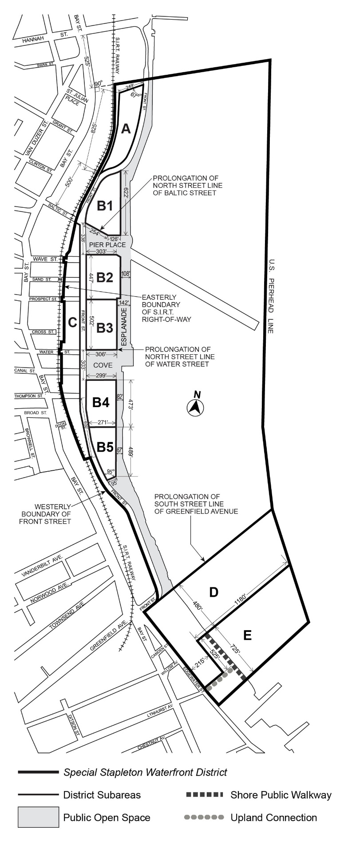
Map 2. Ground Floor Use and Frontage Requirements

[EXISTING]

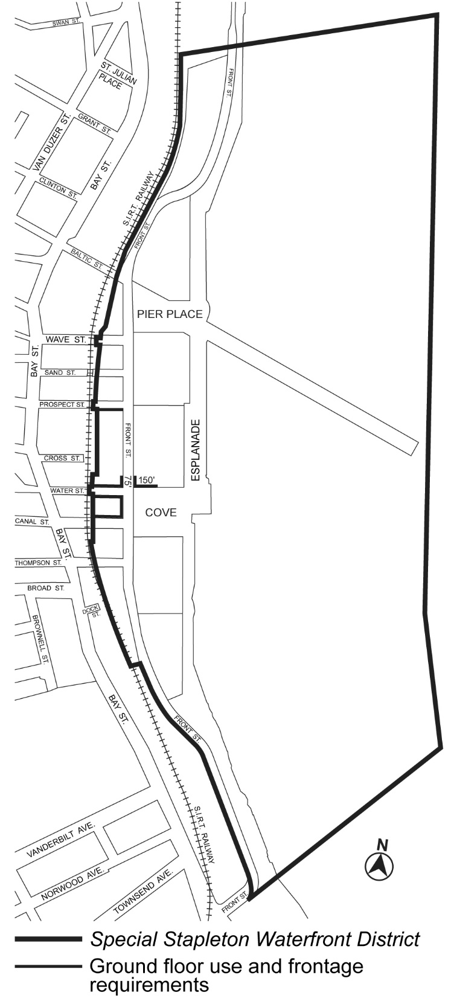

[PROPOSED]

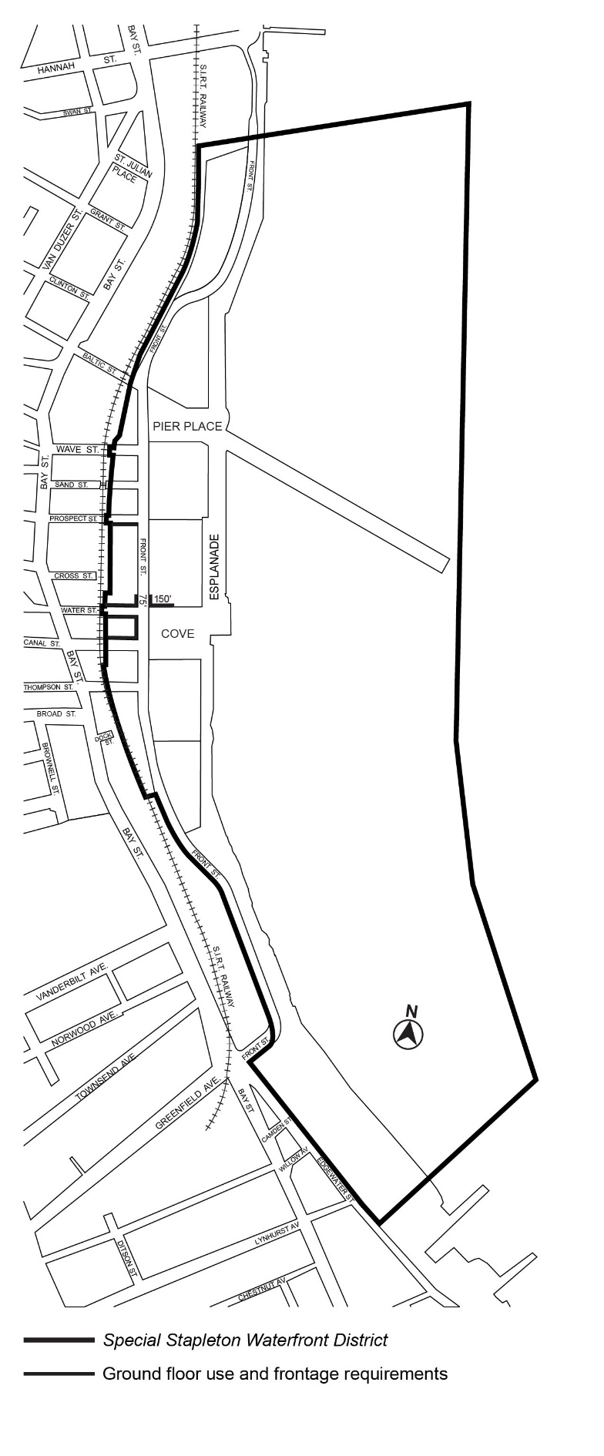
Map 3. Mandatory Front Building Wall Lines

[EXISTING]

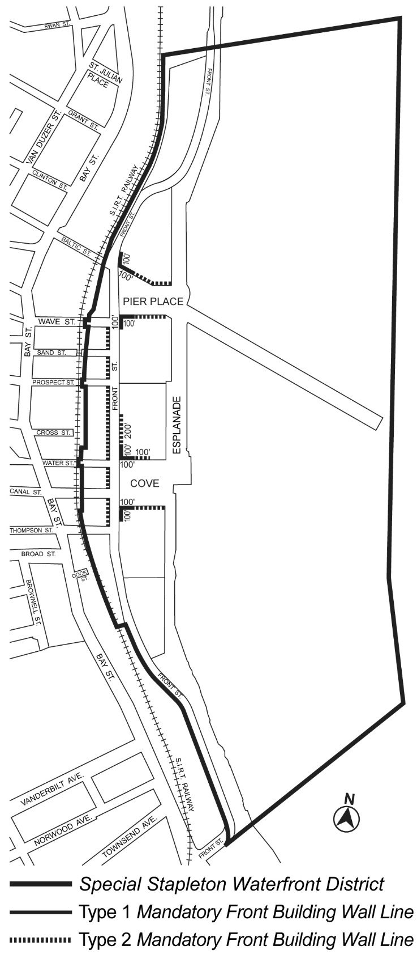

[PROPOSED]

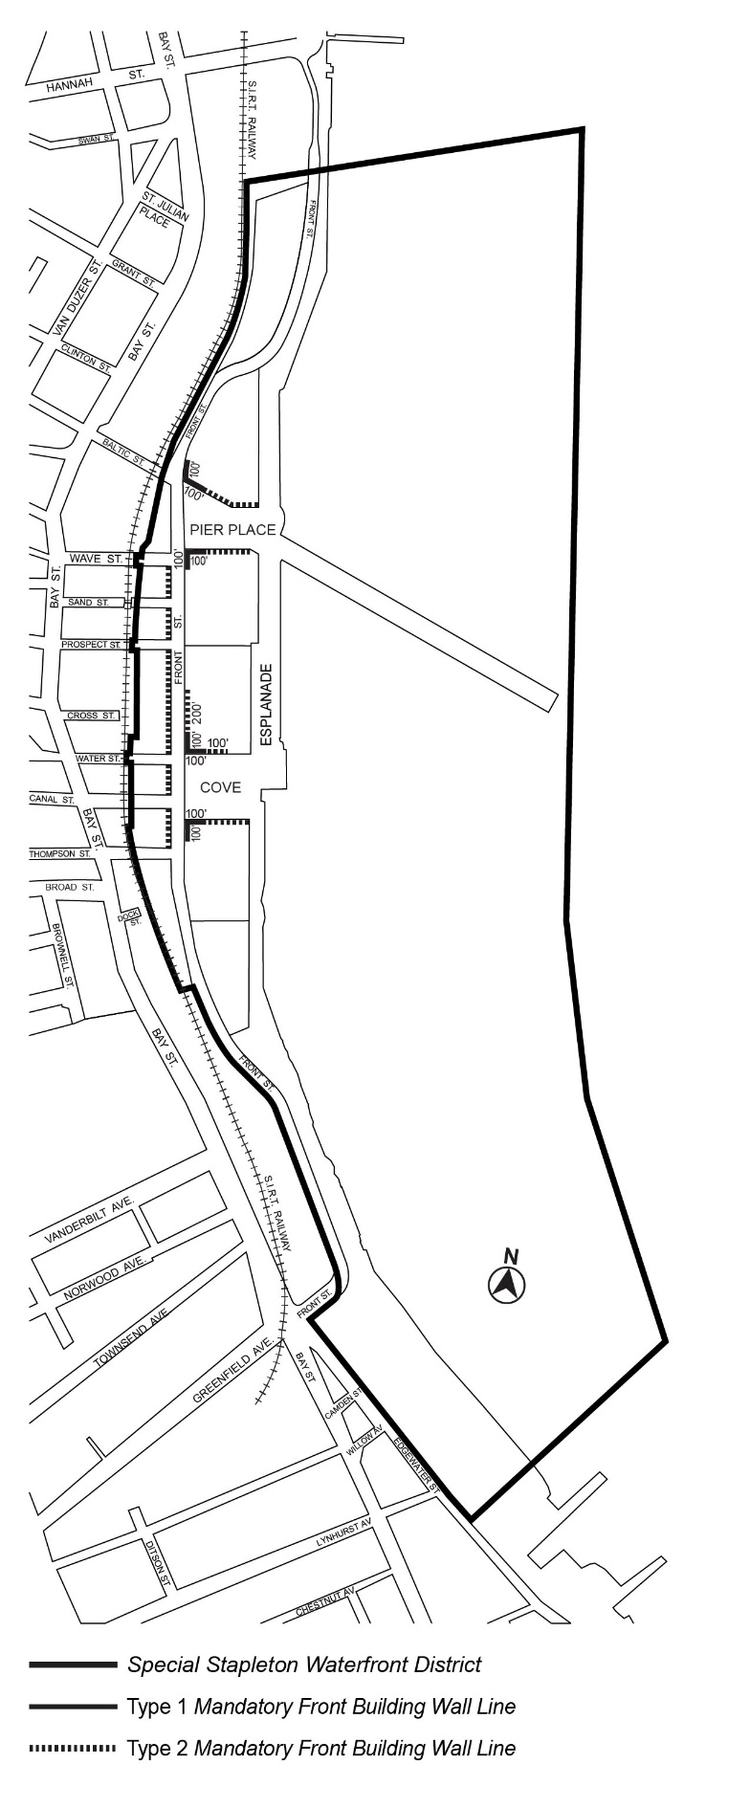

Map 4. Restricted Curb Cut and Off-Street Loading Locations

[EXISTING]

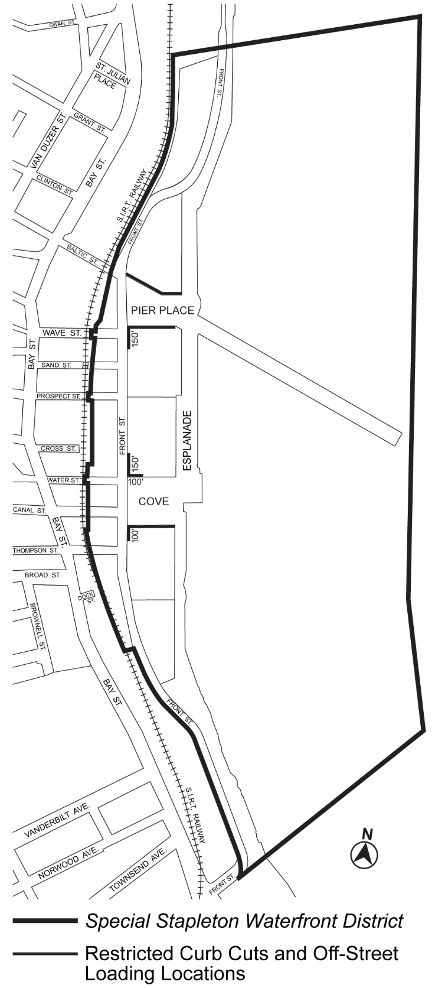

[PROPOSED]

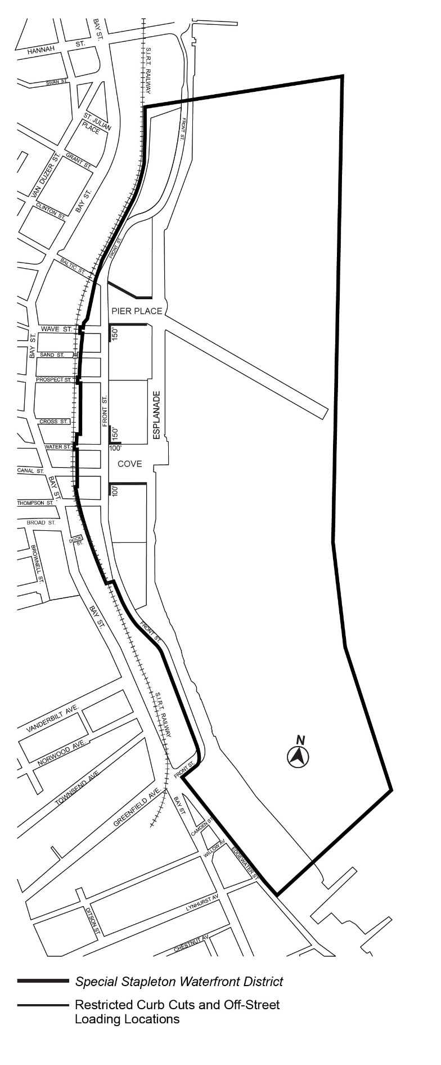

Map 5. Upland Connections and Visual Corridors

[EXISTING]

[PROPOSED]

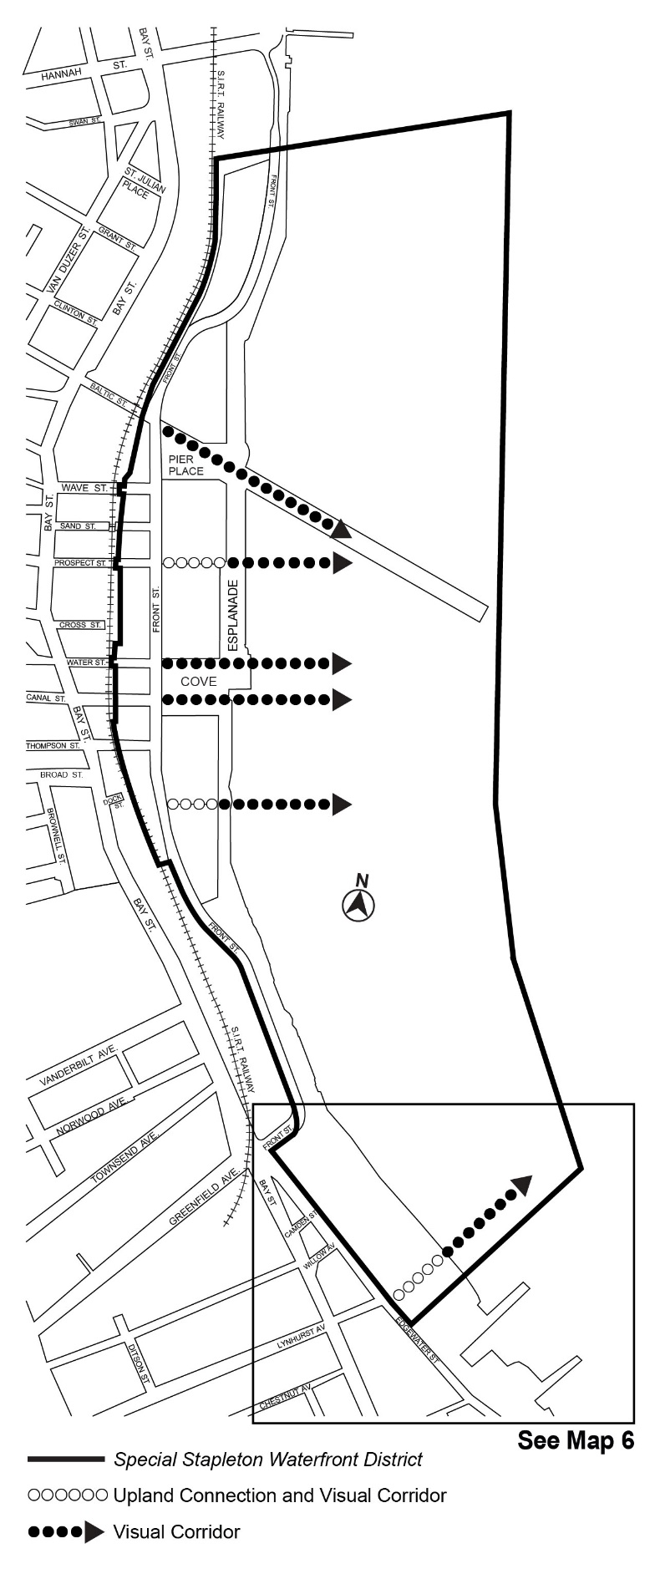

Map 6. Location of Visual Corridor in Subarea E

[NEW MAP: PROPOSED]

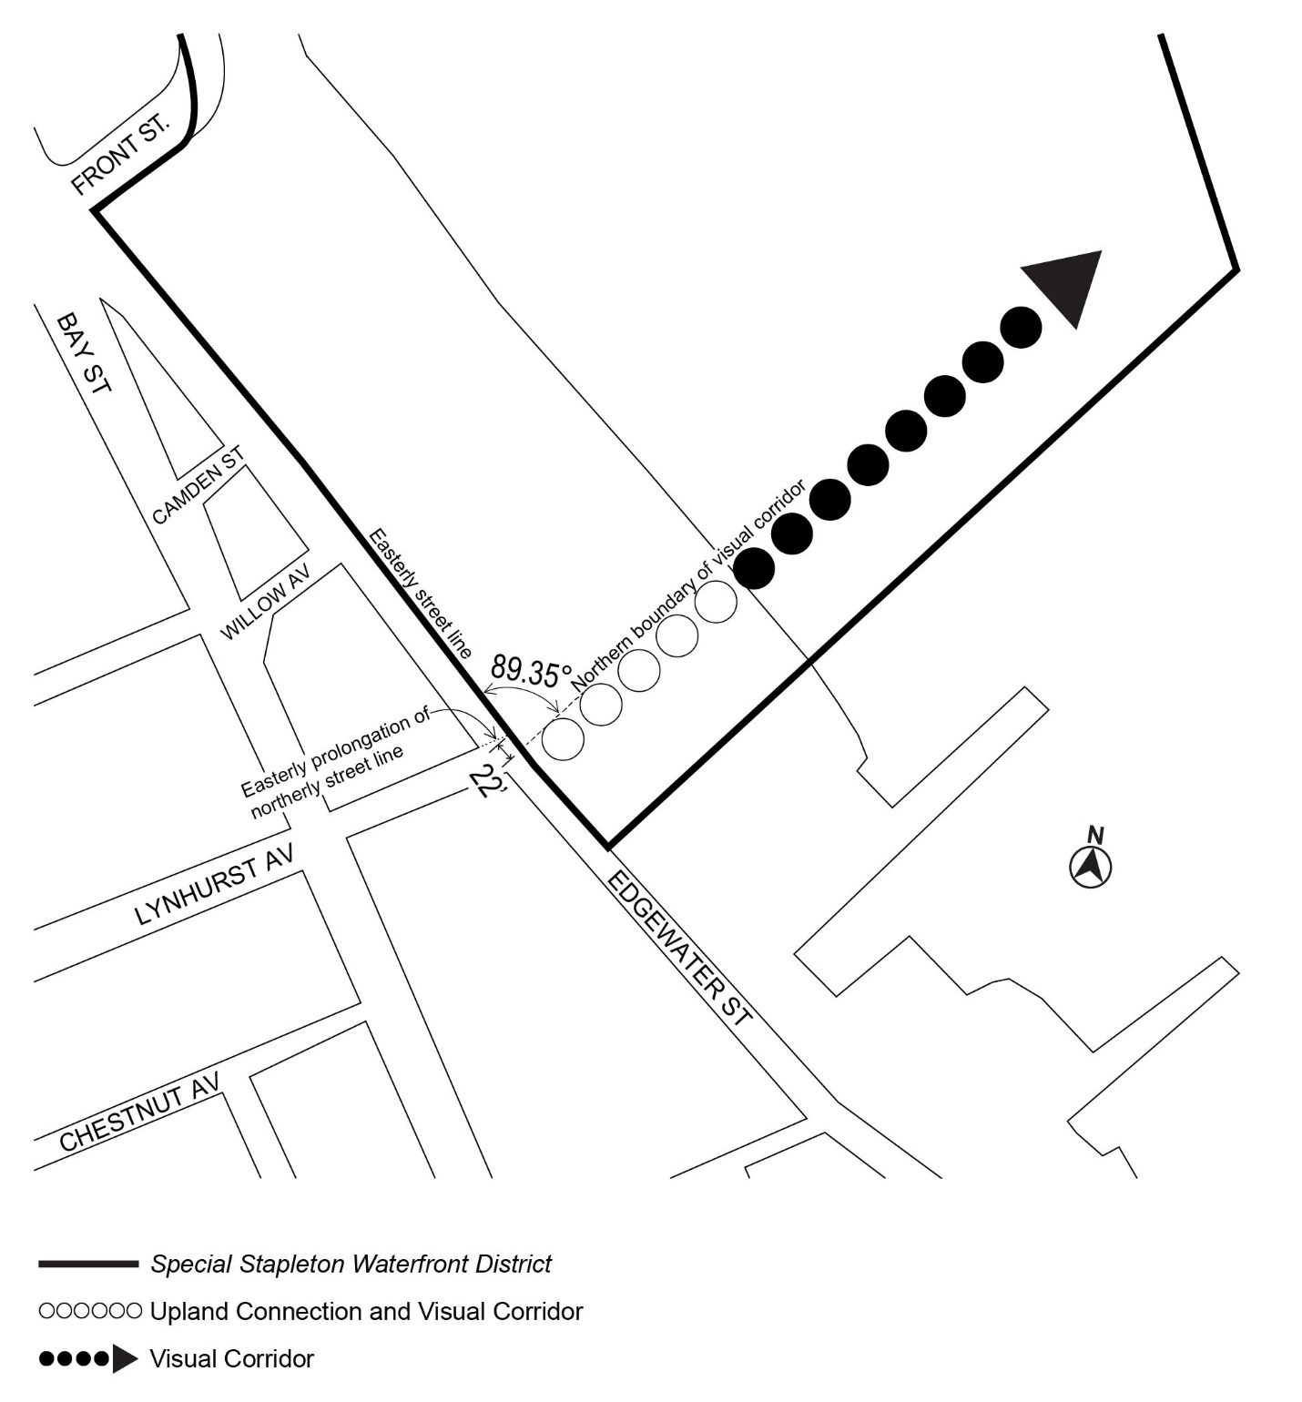

* * *

APPENDIX F
Inclusionary Housing Designated Areas and Mandatory Inclusionary Housing Areas

* * *

Queens

* * *

Staten Island

Staten Island Community District 1

In Subarea E of the #Special Stapleton Waterfront District# (see Section 116-60) and in the R6 District within the areas shown on the following Map 1:

Map 1. (date of adoption)

[NEW MAP: PROPOSED]
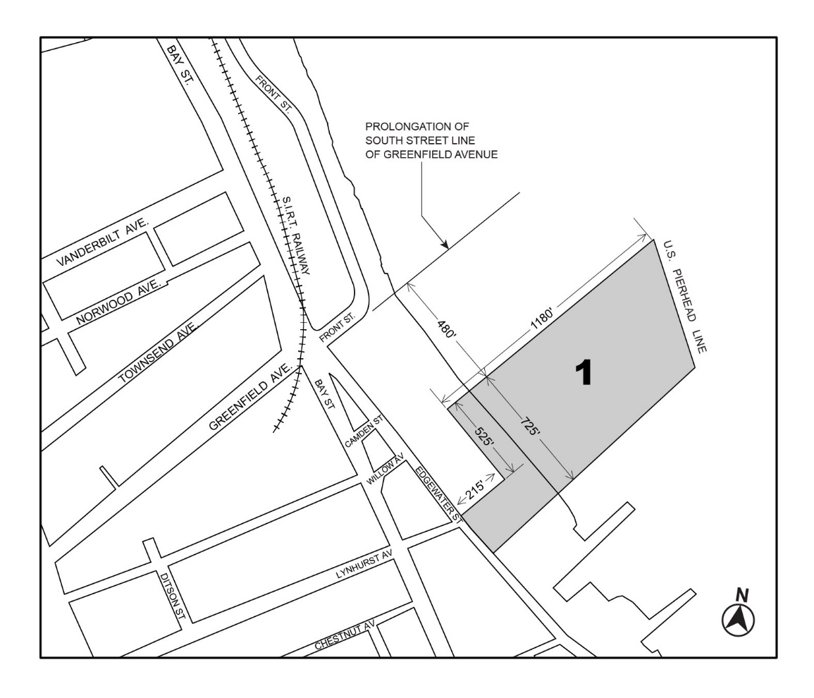
Mandatory Inclusionary Housing area see Section 23-154(d)(3)
Area 1 (date of adoption) ─ MIH Program Option 1, Option 2 and Deep Affordability Option Workforce Option

Portion of Community District 1, Staten Island

* * *
Adopted.

Office of the City Clerk, }
The City of New York, } ss.:

I hereby certify that the foregoing is a true copy of a Resolution passed by The Council of The City of New York on July 20, 2017, on file in this office.

.....…….........................................
City Clerk, Clerk of The Council

