THE COUNCIL OF THE CITY OF NEW YORK
RESOLUTION NO. 250

Resolution approving with modifications the decision of the City Planning Commission on Application No. N 130337 ZRM, for an amendment of the Zoning Resolution of the City of New York, relating to Article IX, Chapter 6 (Special Clinton District) and Appendix F concerning regulations in Northern Subarea C1 and Inclusionary Housing designated areas within Community District 4, Borough of Manhattan (L.U. No. 43).

By Council Members Greenfield and Weprin

WHEREAS, the City Planning Commission filed with the Council on March 17, 2014 its decision dated March 17, 2014 (the "Decision"), pursuant to Section 201 of the New York City Charter, regarding an application submitted by 606 W. 57 LLC c/o TF Cornerstone Inc., for an amendment of the text of the Zoning Resolution of the City of New York, relating to Article IX, Chapter 6 (Special Clinton District) and Appendix F concerning regulations in Northern Subarea C1 and Inclusionary Housing designated areas within Manhattan Community District 4; which in conjunction with its related actions would facilitate construction of a new mixed-use building on a portion of a block bounded by West 56th Street and West 57th Street, between Eleventh Avenue and Twelfth Avenue, in the Clinton neighborhood (Application No. N 130337 ZRM), Community District 4, Borough of Manhattan (the "Application");

WHEREAS, the application is related to Applications C 130336 ZMM (L.U. No. 41), an amendment of the Zoning Map to change M1-5 and M2-3 districts to a C4-7 district; and C 130339 ZSM (L.U. No. 42), a special permit pursuant to Section 13-454, Additional parking spaces for large scale developments, to provide a maximum of 500 public parking spaces or a maximum of 395 public parking spaces;

WHEREAS, the Decision is subject to review and action by the Council pursuant to Section 197-d(b)(1) of the City Charter;
WHEREAS, upon due notice, the Council held a public hearing on the Decision and Application on April 1, 2014;

WHEREAS, the Council has considered the land use implications and other policy issues relating to the Decision and Application; and

WHEREAS, the Council has considered the relevant environmental issues and the Final Environmental Impact Statement (“FEIS”), for which a Notice of Completion was issued on March 7, 2014 (CEQR No. 13DCP080M), and the CEQR Technical Memorandum dated May 1, 2014 (the “CEQR Technical Memorandum”);

RESOLVED:

Having considered the FEIS and the CEQR Technical Memorandum with respect to the Decision and Application, the Council finds that:

(1) The FEIS meets the requirements of 6 N.Y.C.R.R. Part 617;

(2) Consistent with social, economic, and other essential considerations, from among the reasonable alternatives thereto, the Proposed Action adopted herein, with modifications, is one which minimizes or avoids adverse environmental impacts to the maximum extent practicable;

(3) The adverse environmental impacts disclosed in the FEIS and the CEQR Technical Memorandum will be minimized or avoided to the maximum extent practicable by incorporating as conditions to the approval, pursuant to the Restrictive Declaration marked as Exhibit A to the CPC Decision C 130336 ZMM, those project components related to the environment and mitigation measures that were identified as practicable;

(4) No development pursuant to this resolution shall be permitted until the Restrictive Declaration attached as Exhibit A to the CPC Decision C 130336 ZMM, as same may be modified with any necessary administrative or technical changes, all as acceptable to counsel to the Department of City Planning, is executed, and such Restrictive Declaration shall have been recorded and filed in the Office of the Register of the City of New York, County of New York; and

(5) The Decision together with the FEIS constitutes the written statement of facts, and of social, economic and other factors and standards, that form the basis of the decision, pursuant to 6 N.Y.C.R.R. §617.11(d).

Pursuant to Sections 197-d and 200 of the City Charter and on the basis of the Decision and Application, and based on the environmental determination and consideration described in this report, N 130337 ZRM, incorporated by reference herein, the Council approves the Decision with the following modifications:

The Zoning Resolution of the City of New York, effective as of December 15, 1961, and as subsequently amended, is further amended as follows:

Matter in underline is new, to be added;
Matter in strikeout is old, to be deleted;
Matter within # # is defined in Section 12-10;
Matter in bold double-underline is new, added by the City Council
Matter in [brackets] is old, deleted by the City Council
* * * indicates where unchanged text appears in the Zoning Resolution

Article II: Residence District Regulations
Chapter 3
Residential Bulk Regulations in Residence Districts

* * *

Article IX: Special Purpose Districts
Chapter 6
Special Clinton District

* * *

96-30
OTHER AREAS

In Area C, the regulations of the underlying districts shall apply, except as otherwise set forth in this Section, inclusive. The boundaries of Northern Subarea C1 and Western Subarea C2 are shown on the District Map in Appendix A of this Chapter.

* * *
96-34
Special Regulations in Northern Subarea C1

Within Area C1-1, within Northern Subarea C1, as shown on the map in Appendix A of this Chapter, the following special [#use# and] Inclusionary Housing regulations, #use# and special permit regulations shall apply:

(a) Inclusionary Housing Program

The boundaries of the #Inclusionary Housing designated area# within the #Special Clinton District# are shown on Map 2 in Manhattan Community District 4, in Appendix F of this Resolution. Such area shall be an #Inclusionary Housing designated area#, pursuant to Section 12-10 (DEFINITIONS), for the purpose of making the Inclusionary Housing Program regulations of Section 23-90, inclusive, applicable as modified within the Special District.

Within such “Inclusionary Housing designated area# the following special regulations shall apply:

The #residential floor area# of the #zoning lot# may be increased by 1.25 square feet for each square foot of #low income floor area# provided, or by 0.625 square feet for each one square foot of #middle income floor area# provided, up to the maximum #floor area# set forth in Section 23-952 (Floor area compensation in Inclusionary Housing designated areas). However, the amount of #low income floor area# plus half the amount of #middle income floor area# required to receive such #floor area compensation# need not exceed 20 percent of the total #floor area#, exclusive of ground floor non-#residential floor area# on the #compensated zoning lot#, provided that no more than 8,000 square feet of #middle income floor area# may be included within this calculation.

(b) Special #use# regulations

[Within the area shown on the Map entitled Special Use Regulations in Northern Subarea C1 in Appendix A of this Chapter, t]

- The following #uses# shall be permitted below the level of the lowest floor occupied by #dwelling units#:

[(1)] (i) automobile showrooms or sales with preparation of automobiles for delivery; and

[(2)] (ii) automobile repairs.

- #Transient hotels# shall not be permitted in that portion of Area C1-1 which is located between Eleventh Avenue and a line 250 feet west of Eleventh Avenue, and in a portion located between West 57th Street and a line 100 feet south of West 57th Street, except by special permit of the City Planning Commission, pursuant to the provisions of this paragraph (b)(2):

The City Planning Commission may permit #transient hotels#, resulting from a #development#, #enlargement#, #extension# or change of #use#, provided that the Commission shall find that such #transient hotel# is so located as to not impair the essential character of, or the future use or development, of the surrounding area.

The Commission may prescribe appropriate conditions and safeguards to minimize adverse effects on the character of the surrounding area.

* * *

96-80
EXCLUDED AREAS
* * *

96-81
R10 Districts

R10 Districts in Excluded Areas shall be #Inclusionary Housing designated areas# pursuant to Section 12-10 (DEFINITIONS) for the purpose of making the Inclusionary Housing Program regulations of Section 23-90, inclusive, applicable as modified within the Special District. The provisions of paragraph (a) of Section 23- 954 (Additional requirements for compensated developments) shall not apply.

* * *

Appendix A - Special Clinton District Map

* * *

Map to be inserted in Appendix A

C1-1 – Special Use Regulations Area

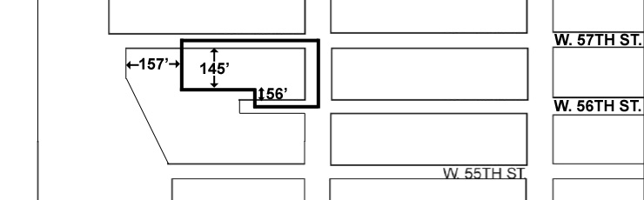

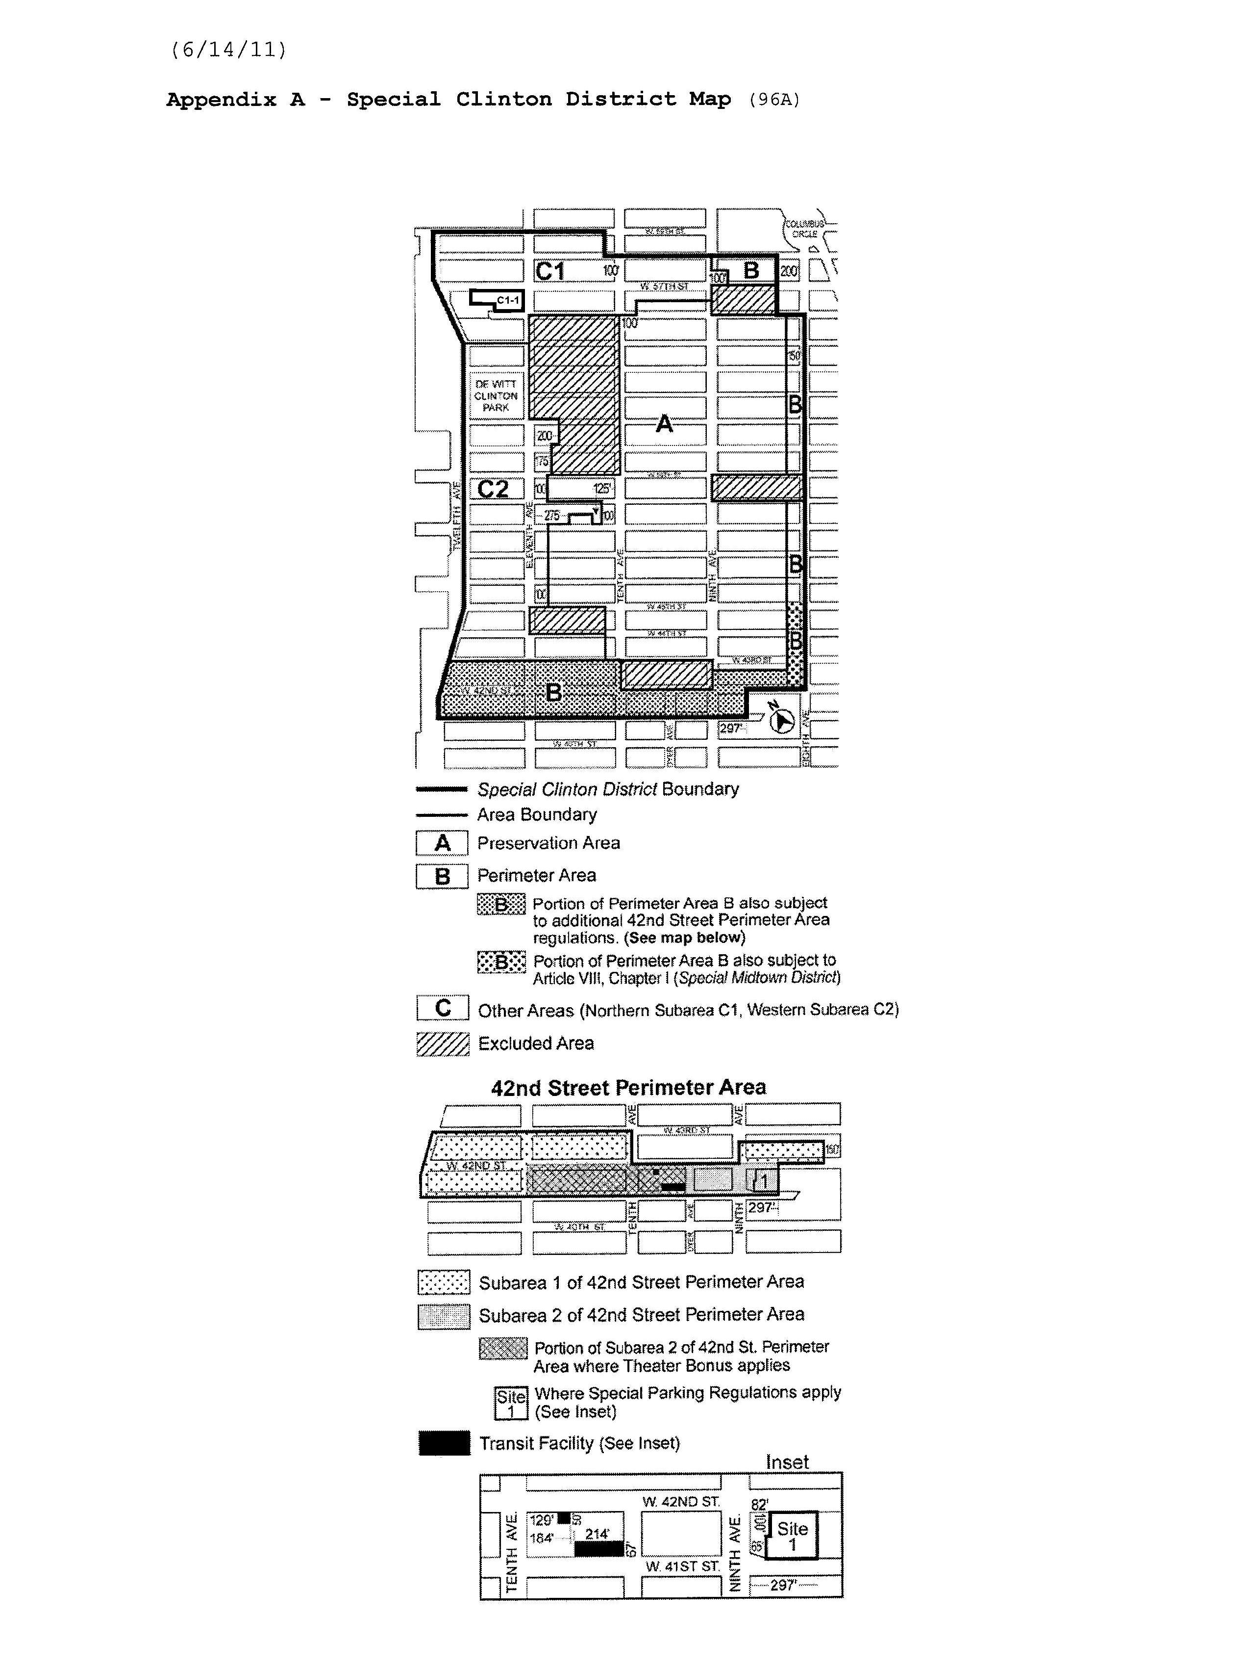
APPENDIX F
Inclusionary Housing Designated Areas

The boundaries of #Inclusionary Housing designated areas# are shown on the maps listed in this Appendix F. The #Residence Districts# listed for such areas shall include #Commercial Districts# where #residential buildings# or the #residential# portion of #mixed buildings# are governed by the #bulk# regulations of such #Residence Districts#. Where #Inclusionary Housing designated areas# are mapped in #Commercial Districts#, the residential district equivalent has instead been specified for each map.

* * *

Map 2
#Special Clinton District# – see Sections 96-31, 96-32, 96-34, 96-81 and 96-82

EXISTING MAP TO BE REPLACED

PROPOSED MAP

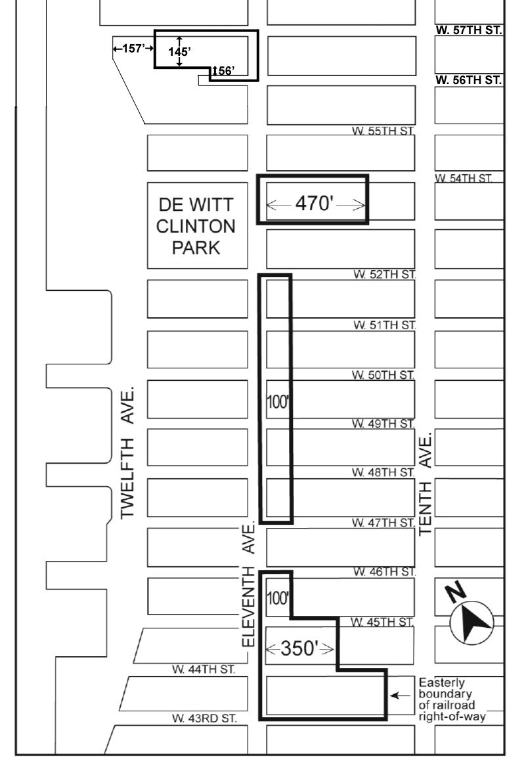
300’

Portion of Community District 4, Manhattan

Adopted.
Office of the City Clerk, }
The City of New York, } ss.:

I hereby certify that the foregoing is a true copy of a Resolution passed by The Council of The City of New York on May 14, 2014, on file in this office.

.....…….........................................
City Clerk, Clerk of The Council

