THE COUNCIL OF THE CITY OF NEW YORK
RESOLUTION NO. 2133

Resolution approving with modifications the decision of the City Planning Commission on Application No. N 090273 (A) ZRK, and proposed for modification pursuant to Section 2-06(c) (1) of the Uniform Land Use Review Procedure, for an amendment of the Zoning Resolution of the City of New York, relating to the creation of the Special Coney Island District (Article XIII, Chapter 1), Borough of Brooklyn (L.U. No. 1137).

By Council Member Katz

WHEREAS, the City Planning Commission filed with the Council on June 18, 2009 its decision dated June 17, 2009 (the "Decision"), on the application submitted by the Department of City Planning pursuant to Section 201 of the New York City Charter, and proposed for modification pursuant to Section 2-06(c) (1) of the Uniform Land Use Review Procedure, for an amendment of the Zoning Resolution of the City of New York, relating to the creation of the Special Coney Island District (Article XIII, Chapter 1), (Application No. N 090273 ZRK), Community District 13, Borough of Brooklyn (the "Application");

WHEREAS, the Application is related to ULURP Applications Numbers C 090272 ZMK (L.U. No. 1136), an amendment to the Zoning Map, Section Nos. 28d, to rezone C7 and R6 districts to R7A, R7X and R7D districts with C2-4 overlays within the proposed Special Coney Island District and to rezone C7 district to R5 outside of the Special Coney Island District; C 090274 PQK (L.U. No. 1138), an acquisition of property located within the Coney East subdistrict; C 090275 PQK (L.U. No. 1139), an acquisition of property located at West 19th Street and Surf Avenue; C 090276 HAK (L.U. No. 1140), an urban development action area project designation, project approval and disposition of city-owned property located between West 19th Street and West 20th Street and between Surf Avenue and Mermaid Avenue; C 090277 PPK (L.U. No. 1141), a disposition of city-owned property within the Coney East subdistrict; and C 090107 MMK (L.U. No. 1142), an amendment of the City Map to eliminate and establish parkland, to eliminate, discontinue and close, establish and extend certain streets and to modify the grades of existing streets;

WHEREAS, the Decision is subject to review and action by the Council pursuant to Section 197-d(b)(1) of the City Charter;
WHEREAS, upon due notice, the Council held a public hearing on the Decision and Application on July 1, 2009;

WHEREAS, the Council has considered the land use implications and other policy issues relating to the Decision and Application; and

WHEREAS, the Council has considered the relevant environmental issues; the Final Environmental Impact Statement (FEIS) for which a Notice of Completion was issued on June 5, 2009 with respect to this application (CEQR No. 08DME007K) and the Technical Memoranda, dated June 15, 2009, in which the City Planning Commission finds that the requirements of the New York State Environmental Quality Review Act and Regulations have been met, and July 22, 2009 in which it was found that the Council modifications would not result in any new significant adverse environmental impacts not already identified in the FEIS;

RESOLVED:

Having considered the FEIS and the Technical Memoranda, with respect to the Application, the Council finds that:

(1) The FEIS meets the requirements of 6 N.Y.C.R.R. Part 617;

(2) Consistent with social, economic and other essential considerations, from among the reasonable alternatives thereto, the action, together with the modifications thereto adopted herein, and as described in the Technical Memoranda, dated June 15, 2009 and July 22, 2009 is one which minimizes or avoids adverse environmental impacts to the maximum extent practicable;

(3) The adverse environmental impacts disclosed in the FEIS will be minimized or avoided to the maximum extent practicable by incorporating as conditions to the approval, those mitigative measures that were identified as practicable; and

(4) The Decision, the FEIS and the Technical Memoranda dated June 15, 2009 and July 22, 2009, constitute the written statement of facts, and of social, economic and other factors and standards, that form the basis of the decision, pursuant to 6 N.Y.C.R.R. §617.11(d).

Pursuant to Sections 197-d and 200 of the City Charter and on the basis of the Decision and Application, and based on the environmental determination and consideration described in this report, N 090273 (A) ZRK, incorporated by reference herein, the Council approves the Decision.

RESOLVED:

Pursuant to Sections 197-d and 200 of the City Charter and on the basis of the Decision and Application the Council approves the Decision with the following modifications:

The Zoning Resolution of the City of New York, effective as of December 15, 1961, and as subsequently amended, is further amended as follows:

PROPOSED SPECIAL
CONEY ISLAND
DISTRICT

“A text “ with CPC Modifications

Matter in underline is new, to be added;
Matter in strikeout is old, to be deleted;
Matter within # # is defined in Section 12-10;
* * * indicate where unchanged text appears in the Zoning Resolution;
Matter in graytone and double underline is new, to be added by the City Council;
Matter in [brackets] is old, to be deleted by the City Council.

11-12
Establishment of Districts

* * *
Establishment of the Special Clinton District

* * *

Establishment of the Special Coney Island District

In order to carry out the special purposes of this Resolution as set forth in Article XIII, Chapter 1, the #Special Coney Island District# is hereby established.

Establishment of the Special Coney Island Mixed Use District

* * *

12-10
Definitions

* * *

Special Coney Island District

The #Special Coney Island District# is a Special Purpose District designated by the letters “CI” in which special regulations set forth in Article XIII, Chapter 1, apply. The #Special Coney Island District# appears on the #zoning maps# superimposed on other districts and, where indicated, its regulations supplement, modify and supersede those of the districts on which it is superimposed, provided that its regulations shall not apply in Parcel 1 of the Coney East Subdistrict, which shall be governed by the provisions of the underlying C7 District.

14-44
Special Zoning Districts Where Certain Sidewalk Cafes are Permitted

#Enclosed# or #unenclosed sidewalk cafes# shall be permitted, as indicated, in the following special zoning districts, where allowed by the underlying zoning. #Small sidewalk cafes#, however, may be located on #streets# or portions of #streets# within special zoning districts pursuant to the provisions of Section 14-43 (Locations Where Only Small Sidewalk Cafes Are Permitted).

* * *

Brooklyn | #Enclosed Sidewalk Cafe# | #Unenclosed Sidewalk Cafe#
Bay Ridge District | Yes | Yes
Coney Island District | No | Yes
Coney Island Mixed Use District | Yes | Yes
Downtown Brooklyn District | Yes | Yes
Mixed Use District-8  (Greenpoint-Williamsburg) | Yes | Yes
Ocean Parkway District* | Yes | Yes
Sheepshead Bay District | No | Yes
-------
* #Sidewalk cafes# are not allowed on Ocean Parkway

* * *

Chapter 5
Residential Conversion of Existing Non-Residential Buildings

* * *

15-011
Applicability within Special Districts

* * *

The provisions of this Chapter shall apply in the #Special St. George District# as modified by Article XII, Chapter 8 (Special St. George District).

The provisions of this Chapter shall apply in the #Special Coney Island District# as modified by Article XIII, Chapter 1 (Special Coney Island District).

* * *

ALL TEXT IN ARTICLE XIII, CHAPTER 1 IS NEW

131-00
GENERAL PURPOSES

The #Special Coney Island District# established in this Resolution is designed to promote and protect public health, safety and general welfare. These general goals include, among others, the following specific purposes, to:

(a) preserve, protect and enhance the character of the existing amusement district as the location of the city’s foremost concentration of amusements and an area of diverse uses of a primarily entertainment and entertainment-related nature;

(b) facilitate and guide the development of a year-round amusement, entertainment and hotel district;

(c) facilitate and guide the development of a residential and retail district;

(d) provide a transition to the neighboring areas to the north and west;

(e) provide flexibility for architectural design that encourages building forms that enhance and enliven the streetscape;

(f) control the impact of development on the access of light and air to streets, the Boardwalk and parks in the district and surrounding neighborhood;

(g) promote development in accordance with the area’s District Plan and thus conserve the value of land and buildings, and thereby protect the City’s tax revenues.

131-01
General Provisions

The provisions of this Chapter shall apply to all #developments#, #enlargements#, #extensions#, alterations and changes of #use# within the #Special Coney Island District#. The regulations of all other Chapters of this Resolution are applicable, except as superseded, supplemented or modified by the provisions of this Chapter. In the event of a conflict between the provisions of this Chapter and other regulations of this Resolution, the provisions of this Chapter shall control.

131-02
District Plan and Maps

The District Plan for the #Special Coney Island District# identifies specific areas comprising the Special District in which special zoning regulations are established in order to carry out the general purposes of the #Special Coney Island District#. The District Plan includes the following maps in the Appendix of this Chapter.

Map 1 Special Coney Island District and Subdistricts
Map 2 Mandatory Ground Floor Use Requirements
Map 3 Coney East Subdistrict Floor Area Ratios
Map 4 Street Wall Location
Map 5 Minimum and Maximum Base Heights
Map 6 Coney West Subdistrict Transition Heights

131-03
Subdistricts

In order to carry out the purposes and provisions of this Chapter, four subdistricts are established as follows:

Coney East Subdistrict
Coney West Subdistrict
Coney North Subdistrict
Mermaid Avenue Subdistrict.

In each of these subdistricts, certain special regulations apply which do not apply within the remainder of the #Special Coney Island District#. The subdistricts are specified on Map 1 in the Appendix of this Chapter.

131-04
Applicability

131-041
Applicability of Article I, Chapter 1

Within the #Special Coney Island District#, Section 11-15 (Environmental Requirements) shall apply, except that prior to issuing a demolition permit, where compliance at time of demolition is required by the (E) designation, or a building permit for any #development#, or for an #enlargement#, #extension# or a change of #use#, on a lot that has an (E) designation for potential hazardous material contamination, noise or air quality impacts, the Department of Buildings shall be furnished with a report from the Department of Environmental Protection of the City of New York stating:

(a) in the case of an (E) designation for hazardous material contamination, that environmental requirements related to the (E) designation have been met for that lot; or

(b) in the case of an (E) designation for noise or air quality impacts, that the plans and drawings for such #development# or #enlargement# will result in compliance with the environmental requirements related to the (E) designation.

131-042
Applicability of Article 1, Chapter 5

The provisions of Article 1, Chapter 5 (Residential Conversion of Existing Non-Residential Buildings), shall apply in the #Special Coney Island District#, as modified in this Section. The conversion to #dwelling units#, or portions thereof, erected prior to January 1, 1977, shall be permitted subject to Sections 15-11 (Bulk Regulations), 15-12 (Open Space Equivalent) and 15-30 Minor Modifications), paragraph (b). Uses in #buildings# erected prior to January 1, 1977, containing both #residential# and non-#residential uses# shall not be subject to the provisions of Section 32-42 (Location within Buildings).

131-043
Applicability of Article 6, Chapter 2

The provisions of Article 6, Chapter 2 (Special Regulations Applying in the Waterfront Area) shall not apply in the #Special Coney Island District#.

131-044
Applicability of Article 7, Chapter 4

The provisions of Section 74-513 (In C7 Districts) shall not apply in the #Special Coney Island District#. In lieu thereof, #public parking lots# shall not be permitted, and #public parking garages# of any size shall be permitted as-of-right, provided such garages comply with the provisions of Section 131-52 (Use and Location of Parking Facilities).

131-045
Physical Culture Establishments

The provisions of Section 73-36 (Physical Culture or Health Establishments) shall not apply in the Coney East, Coney North or Coney West Subdistricts. In lieu thereof, physical culture establishments shall be allowed as-of-right.

131-046
Modification of use and bulk regulations for zoning lots fronting upon the Riegelmann Boardwalk, Keyspan Park and Highland View Park

Where the #lot line# of a #zoning lot# coincides or is within 20 feet of the boundary of the Riegelmann Boardwalk, Keyspan Park or Highland View Park, such #lot line# shall be considered to be a #street line# for the purposes of applying all #use# and #bulk# regulations of this Resolution.

131-10
SPECIAL USE REGULATIONS

The special #use# regulations set forth in this Section, inclusive, shall modify the underlying Commercial Districts, as applicable.

For the purposes of this Chapter, “ground floor level” shall mean the finished floor level within five feet of an adjacent public sidewalk or any other publicly accessible open area.

131-11
Use Group 5

For the purposes of this Chapter, the definition of #transient hotel# shall be modified to allow only such hotels used exclusively for transient occupancy. Such #transient hotels# used exclusively for transient occupancy shall be permitted only in specified locations as set forth in this Chapter.

13-12
Use Groups A, B and C

Special Use Groups are established as set forth in this Section, to promote and strengthen the commercial and entertainment character of the Special District.

131-121
Use Group A: Amusements

Use Group A consists of a group of #uses# selected from Use Groups 12, 13 and 15 as modified in this Section, and may be open or enclosed:

- Amusement arcades
Amusement parks, with no limitation on floor area per establishment
Animal exhibits, circuses, carnivals or fairs of a temporary nature

Camps, overnight or day, commercial beaches or swimming pools

Dark rides, electronic or computer-supported games including interactive entertainment facilities, laser tag and motion simulators

Ferris wheels, flume rides, roller coasters, whips, parachute jumps, dodgem scooters, merry-go-rounds or similar midway attractions

Fortune tellers, freak shows, haunted houses, wax museums, or similar midway attractions

Miniature golf courses and model car hobby centers, including racing
Open booths with games of skill or chance, including shooting galleries

Water parks

(2) Arenas or auditoriums, with capacity limited to 2,000 seats

Billiard parlors or pool halls, bowling alleys or table tennis halls, with no limitation on number of bowling lanes per establishment

Gymnasiums or recreational sports facilities including but not limited to indoor golf driving ranges, batting cages, basketball, volleyball, squash and other courts, without membership requirements

Skateboard parks, roller or ice skating rinks

Theaters, including movie theaters, provided such #use# does not occupy the ground floor level of a #building#, except for lobbies limited to a maximum #street# frontage of 30 feet except that on #corner lots# one #street# frontage may extend up to 100 feet

#Accessory uses# to the amusements listed above, including the display and sale of goods or services, provided:

- such #accessory uses# are limited to not more that 25 percent of the #floor area# of the amusement establishment or, for open #uses#, not more than 25 percent of the #lot area#;

- such #accessory uses# shall be entered only through the principal amusement establishment;

- such #accessory uses# shall share common cash registers with the principal amusement #use#;

- such #accessory uses# shall have the same hours of operation as the principal amusement #use#; and

- the principal amusement #use# shall occupy the entire #street# frontage of the ground floor level of the establishment and shall extend to a depth of at least 30 feet from the #street wall# of the #building# or, for open #uses#, at least 30 feet from the #street line#.

131-122
Use Group B: Amusement and entertainment- enhancing uses

Use Group B consists of a group of #uses# selected from Use Groups 6, 9, 12, 13 and 18, as modified in this Section:

Art gallery, commercial
Banquet halls

Breweries

Eating or drinking establishments of any size, including those with entertainment or dancing

Historical exhibits
Spas and bathhouses

Studios, art, music, dancing or theatrical

Tattoo parlors
Radio or television studios

Wedding chapels

131-123
Use Group C: Retail and service uses

Use Group C consists of a group of retail and service #uses# selected from Use Groups 6, 7, 12 and 14, as modified in this Section:

Arts and crafts production and sales, including but not limited to ceramics, art needlework, hand weaving or tapestries, book binding, fabric painting, glass blowing, jewelry or art metal craft and wood carving

Bicycle sales, rental or repair shops
Bookstores
Candy or ice cream stores
Clothing or clothing accessory
Clothing, custom manufacturing or altering for retail including costume production and hair product manufacturing

Delicatessen stores
Fishing tackle or equipment, rental or sales
Gift shops
Jewelry manufacturing from precious metals

Musical instruments store
Toy stores

Music stores
Newsstands

Patio or beach furniture or equipment

Photographic equipment stores and studios

Sporting goods or equipment, sale or rental, including instruction in skiing, sailing or skin diving

131-13
Special Use Regulations in Subdistricts

131-131
Coney East Subdistrict

The #use# regulations of the underlying C7 District are modified as set forth in this Section. #Transient hotels# and Use Groups A, B and C, as set forth in Sections 131-11 through 131-123, inclusive, and #public parking garages# shall be the only #uses# allowed in the Coney East Subdistrict, and shall comply with the following regulations:

(a) Use Group C

Use Group C #uses# shall be limited to 2,500 square feet of #floor area# and 30 feet of #street# frontage, except that on #corner lots# one #street# frontage may extend up to 100 feet.

(b) Bowery and Wonder Wheel Way

At least 50 percent of Bowery and Wonder Wheel Way #street# frontage of any #zoning lot# shall be occupied by Use Group A1 #uses# at the ground floor level, and not more than 50 percent of the Bowery and Wonder Wheel Way #street# frontage of any #zoning lot# shall be occupied by Use Group C #uses# at the ground floor level.

(c) Surf Avenue

At least 15 percent of the #street# frontage of each #block# front bounding the south side of Surf Avenue between West 16th Street and West 10th Street shall be occupied by Use Group A1 #uses# at the ground floor level.

There shall be separate ground floor establishments fronting upon each #block# front bounding Surf Avenue, as follows:

(1) On the #block# front bounding the southerly #street line# of Surf Avenue between Stillwell Avenue and West 12th Street there shall be at least six establishments;

(2) On the #block# front bounding the southerly #street line# of Surf Avenue between West 12th Street and West 10th Street there shall be at least six establishments;

(3) On all other #block# fronts there shall be at least four establishments;

(4) The provisions of this paragraph (c) shall not apply along the southerly #street line# of Surf Avenue east of West 10th Street.

There may be fewer establishments fronting upon such #block# fronts than required pursuant to this paragraph (c) where the Chairperson of the Department of City Planning certifies to the Department of Buildings that such modification is necessary to accommodate an amusement #use# listed in Use Group A1.

(d) Stillwell Avenue and West 10th Street

At least 15 percent of the Stillwell Avenue and West 10th Street #street# frontage of any #zoning lot# shall be occupied by Use Group A1 #uses# at the ground floor level.

(e) #Transient hotels#

(1) #Transient hotels# shall be permitted only on #blocks# with Surf Avenue frontage, except that no #transient hotels# shall be permitted on that portion of the #block# bounded by West 15th Street and West 16th Street south of the prolongation of the centerline of Bowery;.

(2) #Transient hotel use# shall not be permitted within 50 feet of Bowery on the ground floor level of a #building#, except that where a #zoning lot# has frontage only on Bowery, a #transient hotel# lobby may occupy up to 30 feet of such frontage.

(3) For #transient hotels# located on #zoning lots# with at least 20,000 square feet of #lot area#, an amount of #floor area# or #lot area# of Use Group A1 #uses# equal to at least 20 percent of the total #floor area# permitted on such #zoning lot# shall be provided either onsite or anywhere within the Coney East Subdistrict.

(4) The #street wall# of the ground floor level of a #transient hotel# shall be occupied by active #accessory uses# including, but not limited to, lobbies, retail establishments, eating and drinking establishments and amusements.

(5) #accessory# retail establishments within a #transient hotel# shall be limited to 2,500 square feet of #floor area#.

(f) Depth of ground floor uses

All ground floor #uses# shall have a depth of at least 15 feet measured from the #street wall# of the #building#, as shown on Map 2 (Mandatory Ground Floor Use Requirements).

(g) Parcel 2

On Parcel 2 as shown on Map 2, only #uses# listed in Use Group A, and #public parking garages# of any size, shall be permitted, provided such garages comply with the provisions of Section 131-62 (Use and Location of Parking Facilities).

- Parcel 3

On Parcel 3 as shown on Map 2, the provisions of the underlying C7 District shall apply, except as modified in this paragraph (h). Only open amusement #uses# listed in Use Group 13A and Use Group 15 as set forth in Section 32-22 and Section 32-24, respectively, shall be permitted.

131-132
Coney North and Coney West Subdistricts

In the Coney North and Coney West Subdistricts, #uses# allowed by the underlying district regulations shall apply except as modified in this Section for #uses# fronting upon designated #streets#, as shown on Map 2 (Mandatory Ground Floor Use Requirements). For the purposes of this Section, the “building line” shown on Parcel F shall be considered a #street line# of Ocean Way or Parachute Way, as applicable. Furthermore, an open or enclosed ice skating rink shall be a permitted #use# anywhere within Parcel F in the Coney West Subdistrict.

- Mandatory ground floor level use along designated #streets#

Any #use# listed in Use Groups A, B and C, as set forth in Sections 131-12, inclusive, not otherwise allowed by the underlying district regulations, shall be permitted within 70 feet of the Riegelmann Boardwalk and within 100 feet of all other designated streets, as shown on Map 2.

  - Riegelmann Boardwalk

Only #uses# listed in Use Groups A, B and C and #transient hotels# located above the ground floor level are permitted within 70 feet of the Riegelmann Boardwalk, except that a #transient hotel# lobby may occupy up to 30 feet of frontage along the Riegelmann Boardwalk. Use Group C #uses# shall be limited to 2,500 square feet of #floor area# and 30 feet of #street# frontage for each establishment. All other establishments shall be limited to 60 feet of #street# frontage, except that for any establishment on a corner, one #street# frontage may extend up to 100 feet. All ground floor #uses# shall have a depth of at least 15 feet measured from the #street wall# of the #building#.

  - Designated #streets# other than Riegelmann Boardwalk

At least 20 percent of the designated #street# frontage of a #building# shall be allocated exclusively to #uses# listed in Use Groups A, B or C. The remaining designated #street# frontage of such #buildings# shall be allocated to #commercial uses# permitted by the underlying district regulations or, where permitted, #transient hotels#. In addition, a #residential# lobby may occupy up to 40 feet of frontage along a designated #street#.

There shall be at least four separate ground floor #commercial# establishments fronting upon each #block# front bounding Surf Avenue.

All ground floor #commercial uses# shall have a depth of at least 50 feet measured from the #street wall# of the #building#. Such minimum 50 foot depth requirement may be reduced where necessary in order to accommodate a #residential# lobby and vertical circulation core.

(b) Prohibited ground floor level #uses# along designated #streets# other than Riegelmann Boardwalk

No #use# listed in this paragraph, (b), shall be permitted within 50 feet of a designated #street# on the ground floor level of a #building#. Lobbies or entryways to non-ground floor level #uses# are permitted, provided the length of #street# frontage occupied by such lobbies or entryways does not exceed, in total, 60 feet.

From Use Group 2:
All #uses#.

From Use Groups 3A and 3B:
All #uses#, except for libraries, museums or non-commercial art galleries.

From Use Groups 4A and 4B:
All #uses#, except for houses of worship or playgrounds.

From Use Group 5A:
All #uses#, except that #transient hotels# shall be permitted within 200 feet of
Surf Avenue between Stillwell Avenue and West 16th Street.

From Use Groups 6B, and 6E
Offices, veterinary medicine offices or non-commercial clubs.

From Use Group 6C
Banks (except for automated teller machines, provided the length of #street# frontage allocated for automated teller machines shall be no more than 25 feet or 40 percent of the frontage of the #zoning lot#, whichever is less, except such frontage need not be less than 20 feet), except that this prohibition shall not apply along Stillwell Avenue.

Electrolysis studios, frozen food lockers and loan offices.

From Use Group 6D:
All #uses#.

From Use Group 7:
All #uses#, except for bicycle rental or repair shops.

From Use Groups 8A and 8B:
Automobile driving schools, ice vending machines, lumber stores or pawn shops.

From Use Groups 8C, 8D and 8E:
All #uses#.

From Use Groups 9A, 9B and 9C:
All #uses#, except for gymnasiums, public auction rooms, photographic
developing or printing establishments for the consumer, or art, music, dancing or theatrical studios.

From Use Groups 10A, 10B and 10C:
Depositories for storage, and wholesale offices or showrooms.

Use Group 11:
All #uses#.

Use Groups 12A and 12B:
Trade expositions.

Use Groups 12C and 12D:
All #uses#.

Use Group 14A and 14B:
All #uses#, except for bicycle sales, rental or repair shops.

131-14

Location of Uses within Buildings

The provisions of Section 32-42 (Location within Buildings) are modified to permit:

(a) #residential uses# on the same #story# as a non-#residential use# or directly below a non-#residential use#, provided no access exists between such #uses# at any level containing #residences#, and separate elevators and entrances from the #street# are provided; and

(b) in the Coney North and Coney West Subdistricts, any #commercial use# permitted by this Chapter shall be permitted on the second #story# of a #mixed building#. Furthermore, a #public parking garage# may occupy any #story# of a #mixed building# provided such garage complies with the provisions of Section 131-52 (Use and Location of Parking Facilities).

131-15
Transparency

Each ground floor level #street wall# of a #commercial# or #community facility use# other than a #use# listed in Use Group A, as set forth in Section 131-121, shall be glazed with materials which may include show windows, glazed transoms or glazed portions of doors. Such glazing shall occupy at least 70 percent of the area of each such ground floor level #street wall#, measured to a height of 10 feet above the level of the adjoining sidewalk, public access area or #base plane#, whichever is higher. Not less than 50 percent of the area of each such ground floor level #street wall# shall be glazed with transparent materials and up to 20 percent of such area may be glazed with translucent materials.

However, in the Coney East Subdistrict and along the Riegelmann Boardwalk and boundary of Keyspan Park in the Coney West Subdistrict, in lieu of the transparency requirements of this Section, at least 70 percent of the area of the ground floor level #street wall# of a #commercial use#, measured to a height of 10 feet above the level of the adjoining sidewalk, public access area or #base plane#, whichever is higher, may be designed to be at least 70 percent open during seasonal business hours.

131-16
Security Gates

All security gates installed after (effective date of amendment), that are swung, drawn or lowered to secure commercial or community facility premises shall, when closed, permit visibility of at least 75 percent of the area covered by such gate when viewed from the #street#. However, this provision shall not apply to entrances or exits to parking garages, or to any #use# fronting upon the Riegelmann Boardwalk, provided that security gates at such locations that permit less than 75 percent visibility when closed shall be treated with artwork.

131-17
Authorization for Use Modifications

Along designated #streets# other than the Riegelmann Boardwalk, as shown on Map 2, the City Planning Commission may authorize Use Group A, B or C establishments with a ground floor depth of less than 50 feet upon a finding that the design and operation of such establishments result in an effective and compelling amusement, entertainment or retail space that furthers the goals of the Special District.

131-20
SIGN REGULATIONS

(a) In the Coney East Subdistrict, the underlying C7 #sign# regulations shall apply, except that:

- no #advertising signs# shall be permitted above a height of 40 feet, and

- the provisions of Sections 32-66 (Additional Regulations for Signs Near Certain Parks and Designated Arterial Highways), inclusive, and 32-67 (Special Provisions Applying along District Boundaries) shall not apply.

(b) In the Coney North and Coney West Subdistricts, the underlying C2-4 #sign# regulations shall apply, except that the height restrictions of Section 32-655 shall be modified to allow permitted #signs# at the level of any #story# occupied by a #commercial use#.

131-30
FLOOR AREA REGULATIONS

The #floor area ratio# regulations of the underlying districts shall be modified as set forth in this Section, inclusive.

131-31
Coney East Subdistrict

Except on Parcel 3 as shown on Map 3, t[T]he maximum #floor area ratio# of the underlying C7 District shall not apply. In lieu thereof, the maximum #floor area ratio# is specified for each #block# or portion thereof, as shown on Map 3 (Coney East Subdistrict Floor Area Ratios). On Parcel 2, as shown on Map 3, the maximum #floor area ratio# for a #public parking garage# shall be 4.0.

On Parcel 3, the maximum #floor area ratio# of the underlying C7 District shall apply. Furthermore, #floor area# attributable to Parcel 3 shall be used exclusively within Parcel 3.

131-32
Coney West, Coney North and Mermaid Avenue Subdistricts

131-321
Special floor area regulations for residential uses

R7A R7D R7X

- Applicability of Inclusionary Housing Program

R7A, R7Dand R7X Districts within the #Special Coney Island District# shall be #Inclusionary Housing designated areas#, pursuant to Section 12-10 (DEFINITIONS), for the purpose of making the Inclusionary Housing Program regulations of Section 23-90 (Inclusionary Housing Program), inclusive, applicable as modified within the Special District.

(b) Maximum #floor area ratio#

The base #floor area ratio# for any #zoning lot# containing #residences# shall be as set forth in the following table. Such base #floor area ratio# may be increased to the maximum #floor area ratio# set forth in the table through the provision of #lower income housing#, pursuant to the provisions for #Inclusionary Housing designated area#, as set forth in Section 23-90 (INCLUSIONARY HOUSING), inclusive. Parcels A through F within R7D Districts are shown on Map 1 (Special Coney Island District and Subdistricts).

TABLE FLOOR AREA RATIO FOR BUILDINGS CONTAINING RESIDENCES
Subdistrict  Zoning District | Base #floor area ratio# | Maximum #floor area ratio#
Coney West Parcels: A, B, C, D R7D | 4.35 | 5.8
Coney West Parcels: E, FR7D | 4.12 | 5.5
Coney North  R7X | 3.75 | 5.0
Mermaid Avenue  R7A | 3.45 | 4.6

(c) Coney West floor area distribution rules

In the Coney West Subdistrict, #floor area# attributable to #zoning lots# within the following sets of parcels, as shown on Map 1 in the Appendix to this Chapter, may be distributed anywhere within such sets of parcels:

Parcels A and B
Parcels C and D
Parcels E and F.

In addition, #floor area# attributable to lot 130, #block# 7071 within Parcel B may be distributed anywhere within Parcels C or D.

(d) Height and setback

For all #zoning lots#, or portions thereof, located in the Coney West or Coney North Subdistricts, the height and setback regulations of paragraph (b) of Section 23-942 shall not apply. In lieu thereof, the height and setback regulations of this Chapter shall apply.

131-322
Special floor area regulations for community facility uses

In the Coney West and Coney North Subdistricts, the maximum permitted #floor area ratio# for #community facility uses# shall be 2.0.

131-323
Special floor area ratio regulations for hotel uses

In the Coney North Subdistrict, for #transient hotels# located within 200 feet of Surf Avenue between Stillwell Avenue and West 16th Street, the maximum permitted #floor area ratio# shall be 3.75.

131-324
Special floor area ratio regulations for entrances to stories above the base flood elevation

Up to 300 square feet of an entranceway adjoining the #street wall# of a #building# that contains ramps, stairs or handicap accessible elevators providing access from a public sidewalk to the lowest #story# above the #base flood elevation# shall be exempt from the definition of #floor area#.

131-325
Lot coverage

For #residential uses# in the Coney North and Coney West Subdistricts, no maximum #lot coverage# shall apply to any #corner lot#. For #residential uses# in the Mermaid Avenue Subdistrict, no maximum #lot coverage# shall apply to any #zoning lot# comprising a #corner lot# of 5,000 square feet or less.

Furthermore, in the #Special Coney Island District# the level of any #building# containing #accessory# parking spaces or non-#residential uses# shall be exempt from #lot coverage# regulations.

131-326
Rear Yards

Required #rear yards# or #rear yard equivalents# may be provided at any level not higher than the floor level of the lowest #story# containing #dwelling units# facing onto such #yard#.

131-40
HEIGHT AND SETBACK REGULATIONS

The underlying height and setback regulations shall not apply. In lieu thereof, the height and setback regulations of this Section shall apply. The height of all #buildings or other structures# shall be measured from the #base plane#.

131-41
Rooftop Regulations

(a) Permitted obstructions

The provisions of Section 33-42 (Permitted Obstructions) shall apply to all #buildings# within the #Special Coney Island District#, except that elevator or stair bulkheads, roof water tanks, cooling towers or other mechanical equipment (including enclosures), may penetrate a maximum height limit provided that either the product, in square feet, of the #aggregate width of street walls# of such obstructions facing each #street# frontage, times their average height, in feet, shall not exceed a figure equal to eight times the width, in feet, of the #street wall# of the #building# facing such frontage or, the #lot coverage# of all such obstructions does not exceed 20 percent of the #lot coverage# of the #building#, and the height of all such obstructions does not exceed 40 feet. In addition, dormers may penetrate a maximum base height in accordance with the provisions of paragraph (c) of Section 23-621 (Permitted obstructions in certain districts) only in the Mermaid Avenue Subdistrict.

(b) Screening requirements for mechanical equipment

For all #developments# and #enlargements#, all mechanical equipment located on any roof of a #building or other structure# shall be fully enclosed, except that openings in such enclosure shall be permitted only to the extent necessary for ventilation and exhaust.

131-42
Coney East Subdistrict

The regulations of this Section, inclusive, shall apply to all #buildings or other structures# in the Coney East Subdistrict. For the purposes of applying the height and setback regulations of this Section, Jones Walk shall not be considered a #street#. Map 4 (Street Wall Location) and Map 5 (Minimum and Maximum Base Heights) in the Appendix to this Chapter, illustrate the #street wall# location provisions and minimum and maximum base height provisions of this Section 131-42, inclusive.

131-421
Coney East Subdistrict, south side of Surf Avenue

The following regulations shall apply along the south side of Surf Avenue and along those portions of #streets# intersecting Surf Avenue located north of a line drawn 50 feet north of and parallel to the northern #street# line of Bowery and its westerly prolongation.

(a) #Street wall# location

The #street wall# of a #development# or #enlargement# shall be located within five feet of the #street line# and extend along the entire frontage of the #zoning lot#, except that:

(1) a sidewalk widening shall be required at the intersection of Surf Avenue and West 10th Street, extending from a point on the Surf Avenue #street line# 125 feet west of West 10th Street to a point on the West 10th Street #street line# 20 feet south of Surf Avenue. Such area shall be improved as a sidewalk to Department of Transportation standards, be at the same level as the adjoining sidewalks, and be accessible to the public at all times. Such sidewalk widening line shall be considered a #street line# for the purposes of applying the #use# and height and setback regulations of this Chapter;

(2) ground floor level recesses up to three feet deep shall be permitted for access to building entrances. However, for building entrances providing direct access to the lowest #story# located above the #base flood elevation#, such recesses shall be permitted to have a depth of up to ten feet provided the width of such recesses does not exceed 20 feet and the height of such recessed area is not less than 15 feet at any point as measured from the #base flood elevation#;

(3) to allow for corner articulation, the #street wall# may be located anywhere within an area bounded by intersecting #street lines# and lines 15 feet from and parallel to such #street lines#;

(4) to allow for portions of towers to rise without setback from grade, a portion of a building base below a tower may be set back ten feet from the #street line#, provided the width of such setback area is not greater than 40 percent of the width of the #street wall# of the tower, and provided such setback area complies with the provisions of Section 131-47 (Design Requirements for Ground Level Setbacks).

(b) Building base

- Surf Avenue , west of West 12th Street

West of West 12th Street, the #street wall# of a #development# or #enlargement# shall rise without setback to a minimum base height of 35 feet or the height of the #building#, whichever is less, and a maximum base height of 45feet. If a tower is provided, in accordance with requirements of paragraph (d) of this Section, the maximum base height shall be 65 feet. At a height no lower than the minimum base height and no higher than the maximum base height, a setback shall be required, pursuant to the provisions set forth in paragraph (c) of this Section.

For #developments# or #enlargements# located West of West 12 Street that, provide a tower in accordance with the requirements of paragraph (d) of this Section, not more than 40 percent of the #aggregate width of street walls# facing Surf Avenue shall exceed a height of 45 feet without setback, and at least 40 percent of the #aggregate width of street walls# facing Surf Avenue shall rise without setback to a height of at least 60 feet but not more than 65 feet. Furthermore, any portion of a #street wall# which exceeds a height of 60 feet shall be located within 150 feet of the intersection of two #street lines# and shall coincide with the location of a tower. Towers shall comply with location requirements of paragraphs (d) of this Section.

- Surf Avenue, east of West 12th Street

East of West 12th Street, the #street wall# of a #development# or #enlargement# shall rise without setback to a minimum base height of 35 feet or the height of the #building#, whichever is less, and a maximum base height of 45 feet. At a height no lower than the minimum base height and no higher than the maximum base height, a setback is required that shall comply with the provisions set forth in paragraph (d) of this Section.

For the base of any #building# located on the south side of Surf Avenue, above the level of the second #story#, up to 30 percent of the #aggregate width of street walls# may be recessed, provided no recesses are located within 15 feet of an adjacent #building# or within 30 feet of the intersection of two #street lines#, except where corner articulation is provided as set forth in paragraph (a)(3) of this Section.

(c) Transition height

All portions of a #building# that exceed the applicable maximum base height specified in paragraph (b) of this Section, shall be set back from the #street line# at least 20 feet except that where towers are provided, the minimum setback depth from the #street line# shall be 10 feet.

- East of West 12th Street

The maximum transition height shall be 65 feet, and all portions of #buildings# that exceed such height shall comply with the tower provisions of paragraph (d) of this Section, except that within 100 feet of Jones Walk on the easterly side, the maximum building height after the required setbacks shall be 85 feet.

- West of West 12th Street

All portions of a #building# that exceed the maximum base height as set forth in paragraph (b) (1) of this Section shall comply with the tower provisions of paragraph (d) of this Section.

- Special Regulations for Use Group A

The transition height regulations of paragraphs (c) (1) and (c) (2) of this Section shall not apply to #buildings# that rise to a maximum height of 85 feet to accommodate a Use Group A #use#; or to #buildings# where the Chairperson of the City Planning Department certifies to the Department of Buildings that additional height is necessary to accommodate an amusement #use# listed in Use Group A1.

(d) Towers

All #stories# of a #development# or #enlargement# located partially or wholly above a height of 65 feet shall be considered a ”tower” and shall comply with the provisions of this paragraph.

- Maximum floorplate

Each #story# of a tower shall not exceed a gross area of 8,500 square feet.

- Maximum length and height

The outermost walls of all tower #stories# shall be inscribed within a rectangle, and no side of such rectangle shall exceed a length of 165 feet.
The maximum height of a #building# located between West 12th Street and Jones Walk shall be 150 feet between West 12th Street and Jones Walk. The maximum height of a #building# located between West 12th Street and West 16th Street on #zoning lots# with less than 50,000 square feet of #lot area# shall be 220 feet; on #zoning lots# with50,000 square feet or more of #lot area#, the maximum height of a #building# shall be 270 feet. All towers that exceed a height of 150 feet shall provide articulation in accordance with Section 131-46 (Tower Top Articulation).

- Tower location

All towers shall be located within 25 feet of Surf Avenue and entirely within 100 feet of an intersecting #street#.

131-422
Coney East Subdistrict, north side of Surf Avenue

Any #building or other structure# fronting upon the north side of Surf Avenue shall not exceed a height of 85 feet. Furthermore, in order to protect the view from the elevated subway to the Coney East Subdistrict, no portion of such #building or other structure#, including permitted obstructions or #signs#, shall be located between a height of five feet below the upper level of the elevated subway tracks and a level 25 feet above such level, except for a vertical circulation core, supporting structural elements and related appurtenances. In no event shall more than 30 percent of the Surf Avenue frontage of the #zoning lot# be obstructed with such elements.

131-423
Along all other streets

The following regulations shall apply along Wonder Wheel Way, Bowery, and all other #streets# and portions thereof located south of a line drawn 50 feet north of and parallel to the northern #street# line of Bowery and its westerly prolongation.

(a) #Street wall# location

The #street wall# of the #development# or #enlargement#, or portion thereof, shall be located within five feet of the #street line#. However, for building entrances providing direct access to the lowest #story# located above the #base flood elevation#, a recess shall be permitted to have a depth of up to ten feet as measured from the #street line# provided the width of such recess does not exceed 20 feet and the height of such recessed area is not less than 15 feet at any point as measured from the #base flood elevation#;

(b) Maximum building height

The #street wall# of a #development# or #enlargement#, or portion thereof, shall rise to a minimum height of 20 feet and a maximum height of 40 feet before setback. The maximum height of a #building or other structure# shall be 60 feet, provided any portion of a #building# that exceeds a height of 40 feet shall be set back from the #street wall# of the #building# at least 20 feet.

West of West 12th Street, along the northern #street line# of Bowery, the maximum #building# height shall be 40 feet. If a tower is provided along the Surf Avenue portion of the #block#, 40 percent of the #aggregate width of street walls# may rise above the maximum #street wall# height of 40 feet, and such portion of the #aggregate width of street walls# shall be located within 150 feet of the intersection of two #street lines# and shall coincide with that portion of the #street wall# along Surf Avenue that rises to a height of between 60 to 65 feet, pursuant to the provisions of paragraph (b)(1) of Section 131-421. However, where the portion of the #block# that fronts on Surf Avenue is #developed# or #enlarged# pursuant to the special regulations for Use Group A, in paragraph (c)(3) of Section 131-421 (Coney East Subdistrict, south side of Surf Avenue), the #street wall may rise after a setback of 20 feet to a maximum height of 60 feet for the entire length of the Bowery #street line#, or may extend beyond the 40 percent of the #aggregate width of #street wall# for the length of the #street wall# of such Use Group A #development# or #enlargement# which fronts along Surf Avenue, whichever is less.

Furthermore, a #building# that exceeds a height of 60 feet shall be permitted where the Chairperson of the City Planning Department certifies to the Department of Buildings that such additional height is necessary to accommodate an amusement #use# listed in Use Group A1.

131-43
Coney West Subdistrict

The regulations of this Section shall apply to all #buildings or other structures# in the Coney West Subdistrict. Map 4 (Street Wall Location), Map 5 (Minimum and Maximum Base Heights) and Map 6 (Coney West Subdistrict Transition Heights), in the Appendix to this Chapter, illustrate the #street wall# location provisions, minimum and maximum base height provisions and transition height provisions of this Section, inclusive. For the purposes of this Section, the “building line” shown on Parcel F shall be considered a #street line# of Ocean Way or Parachute Way, as indicated on such maps.

131-431
Coney West District, Surf Avenue

The regulations of this Section shall apply along Surf Avenue. The #street wall# location provisions of paragraph (a) of this Section shall also apply along #streets# intersecting Surf Avenue within 50 feet of Surf Avenue, and the building base regulations of paragraph (b) of this Section shall also apply along #streets# within 100 feet of Surf Avenue.

(a) #Street wall# location

The #street wall# of a building base of a #development# or #enlargement# shall be located on the Surf Avenue #street line# and extend along the entire Surf Avenue frontage of the #zoning lot#, except that:

(1) ground floor level recesses up to three feet deep shall be permitted for access to building entrances; However, for building entrances providing direct access to the lowest #story# located above the #base flood elevation#, such recesses shall be permitted to have a depth of up to ten feet provided the width of such recess does not exceed 20 feet and the height of such recessed area is not less than 15 feet at any point as measured from the #base flood elevation#;

(2) to allow for corner articulation, the #street wall# may be located anywhere within an area bounded by intersecting #street lines# and lines 15 feet from and parallel to such #street lines#; and

(3) to allow for portions of towers to rise without setback from grade, a portion of a building base below a tower may be set back ten feet from a #street line#, provided the width of such setback area is not greater than 40 percent of the width of the #street wall# of the tower and provided such setback area complies with the provisions of Section 131-47 (Design Requirements for Ground Level Setbacks).

(b) Building base

The #street wall# of a #development# or #enlargement# fronting on Surf Avenue shall rise without setback to a minimum height of six #stories# or 65 feet, or the height of the #building#, whichever is less, and a maximum height of eight #stories# or 85 feet, whichever is less, before a setback is required. For #developments# or #enlargements# that exceed a height of eight #stories# or 85 feet, not more than 40 percent of the #aggregate width of street walls# facing Surf Avenue shall exceed a height of six #stories# or 65 feet, whichever is less, and at least 40 percent of the #aggregate width of street walls# facing Surf Avenue shall rise without setback to a height of at least eight #stories# or 80 feet, whichever is less. However, on the blockfront bounded by West 21st Street and West 22nd Street, the minimum height of a #street wall# shall be 40 feet and the maximum height of a #street wall# shall be six #stories# or 65 feet, whichever is less, before a setback is required.

Above the level of the second #story#, up to 30 percent of the #aggregate width of street walls# may be recessed, provided no recesses are located within 15 feet of an adjacent #building# or within 30 feet of the intersection of two #street lines#, except where corner articulation is provided as set forth in paragraph (a)(2) of this Section.

All portions of a #building# that exceed the maximum heights set forth in this paragraph, (b), shall be set back from the #street line# at least ten feet.

(c) Transition height

Above the maximum base height, a #street wall# may rise to a maximum transition height of nine #stories# or 95 feet, whichever is less, provided that up to 60 percent of the #aggregate width of street walls# facing Surf Avenue shall be set back a minimum distance of 10 feet from the Surf Avenue #street line#. The remaining portion of such #aggregate width of street walls# facing Surf Avenue shall be set back a minimum distance of 15 feet. All portions of #buildings# that exceed a transition height of 95 feet shall comply with the tower provisions of Section 131-434 (Coney West Towers).

131-432
Along all other Streets, other than the Riegelmann Boardwalk

The following regulations shall apply along all other #streets# in the Coney West Subdistrict, except within 70 feet of the Riegelmann Boardwalk.

(a) #Street wall# location

The #street wall# of a building base of a #development# or #enlargement#, or portion thereof, beyond 50 feet of Surf Avenue shall be located within eight feet of the #street line#, except that, to allow portions of towers to rise without setback from grade, a portion of a building base below a tower may be set back ten feet from the #street line#, provided the width of such setback area is not greater than 40 percent of the width of the #street wall# of the tower. In addition, for #street walls# facing Ocean Way, building entrances providing direct access to the lowest #story# located above the #base flood elevation# may be recessed up to a depth of ten feet as measured from the #street line# provided the width of such recess does not exceed 20 feet and the height of such recessed area is not less than 15 feet at any point as measured from the #base flood elevation#;

For #buildings# where the ground floor level is occupied by #residential uses#, any area between the #street wall# and the #street line# shall be planted except for sidewalks, steps and handicap accessible elevators that provide access to building entrances.

(b) Building base

The #street wall# of a building base of a #development# or #enlargement#, or portion thereof, located beyond 100 feet of Surf Avenue, shall rise without setback to a minimum height of 40 feet or the height of the #building#, whichever is less, and a maximum height of six #stories# or 65 feet, whichever is less. Up to 30 percent of the #aggregate width of street walls# may be recessed for #outer courts# or balconies, provided no recesses are located within 15 feet of an adjacent #building# or within 30 feet of the intersection of two #street lines#, and provided the maximum depth of such recesses is 15 feet, as measured from the #street line#. All portions of a #building# that exceed a height of 65 feet shall be set back from the #street wall# of the #building# at least ten feet, except such setback distance may include the depth of any permitted recesses.
(c) Transition heights

Beyond 100 feet of Surf Avenue, a #street wall# may rise to a maximum transition height of nine #stories# or 95 feet, whichever is less, provided that:

(1) above the maximum base height, up to 60 percent of the #aggregate width of street walls# facing Ocean Way, and along all other #streets#, other than the Riegelmann Boardwalk, shall be set back a minimum distance of 10 feet from the #street line#. The remaining portion of such #aggregate width of street walls# facing Ocean Way, and along all other #streets# other than the Riegelmann Boardwalk, shall be set back a minimum distance of 15 feet from the #street line#, except that for #blocks# north of the Ocean Way #street line#, along a minimum of one #street line# bounding the #block# (except for Surf Avenue), the remaining portion of such #aggregate width of street walls# shall remain open to the sky for a minimum depth of 100 feet from the #street line#;

(2) for #blocks# bounding the southern #street line# of Ocean Way, any portion of a #building or other structure# that exceeds a height of six #stories# or 65 feet, whichever is less, shall be located within 80 or 100 feet of a #street line#, as indicated on Map 6 in the Appendix to this Chapter;

(3) for portions of #buildings# higher than six #stories# or 65 feet that are within 100 feet of the Riegelmann Boardwalk, each #story# within such portion shall provide a setback with a depth of at least ten feet, measured from the south facing wall of the #story# directly below.

A #building# may exceed such transition heights only in accordance with the tower provisions of Section 131-434.

131-433
Riegelmann Boardwalk and Building Line of Parcel F

The #street wall# of the #development# or #enlargement# shall be located on the Riegelman Boardwalk #street line# and extend along the entire Riegelmann Boardwalk frontage of the #zoning lot# to a minimum height of 20 feet, as shown on Map 2 (Mandatory Ground Floor Use Requirements). Any #building or other structure# within 70 feet of the Riegelmann Boardwalk shall not exceed a height of 40 feet above the level of the Riegelmann Boardwalk.

In addition, on Parcel F, the #street wall# of the #development# or #enlargement# shall be located on the Parachute Way building line and the portion of the Ocean Way building line that is within 100 feet of the Parachute Way building line, as shown on Map 2. Such #street walls# shall extend along such entire frontages of Parcel F to a minimum height of 20 feet.

131-434
Coney West District towers

All #stories# of a #development# or #enlargement# located partially or wholly above an applicable transition height shall be considered a ‘tower” and shall comply with the provisions of this Section.

- Maximum floorplate

Each #story# of a tower shall not exceed a gross area of 8,500 square feet.

- Maximum length and height

On #blocks# bounding Surf Avenue, the maximum height of a #building# shall be 220 feet, and on #blocks# bounding the southerly #street line# of Ocean Way, the maximum #building# height shall be 170 feet. Furthermore, the outermost walls of all tower #stories# shall be inscribed within a rectangle, and no side of such rectangle shall exceed a length of 165 feet.

For #developments# that provide #lower income housing# pursuant to Section 131-321 (Special residential floor area regulations), the maximum height of a #building# shall be increased to 270 feet, provided that the tower complies with either paragraph (b) (1) or (b)(2) of this Section.

(1) The outermost wall of all tower #stories# shall be inscribed within a rectangle where no side of such rectangle exceeds a length of 100 feet; or

(2) The outermost wall of all tower #stories# below a height of 120 feet shall be inscribed within a rectangle where no side of such rectangle exceeds a length of 130 feet; above a height of 120 feet, no side of such rectangle shall exceed a length of 100 feet.

Above a height of 120 feet, the maximum floor plate shall be 80 percent of the #story# immediately below such height, or 6,800 square feet, whichever is greater. Such reduced #lot coverage# shall be achieved by one or more setbacks on each face of the tower, where at least one setback on each tower face has a depth of at least five feet and a width that, individually or in the aggregate, is equal to at least 10 percent of the width of each respective tower face.

All #buildings# that exceed a height of 170 feet shall provide articulation in accordance with Section 131-46 (Tower Top Articulation).

(c) Tower location

All towers shall be located entirely within 100 feet of Parachute Way, West 20th Street, West 21st Street or West 22nd Street and within 25 feet of the intersection of two #street lines#. When a #zoning lot# bounding Surf Avenue contains a tower, such tower shall be located within 25 feet of Surf Avenue. No more than one tower shall be permitted on any #zoning lot#, except that for #developments# that provide #lower income housing# pursuant to Section 131-321, no more than two towers shall be permitted on any #zoning lot#, and the second tower shall be located within 25 feet of Ocean Way. However, on Parcel E, any #development# may include two towers and, for #developments# that provide #low income housing# pursuant to Section 131-321, a third tower shall be permitted to be located anywhere on such parcel along Parachute Way.

131-44
Coney North Subdistrict

The regulations of this Section shall apply to all #buildings or other structures# in the Coney North Subdistrict. Map 4 (Street Wall Location) and Map 5 (Minimum and Maximum Base Heights), in the Appendix to this Chapter, illustrate the #street wall# location provisions, minimum and maximum base height provisions and maximum building height provisions of this Section, inclusive.

131-441
Coney North Subdistrict, Surf Avenue

The regulations of this Section shall apply along Surf Avenue. The #street wall# location provisions of paragraph (a) of this Section shall also apply along #streets# intersecting Surf Avenue within 50 feet of Surf Avenue, and the building base regulations of paragraph (b) of this Section shall also apply along #streets# within 100 feet of Surf Avenue.

(a) #Street wall# location

The #street wall# of a building base of a #development# or #enlargement# shall be located on the Surf Avenue #street line# and extend along the entire Surf Avenue frontage of the #zoning lot#, except that:

(1) ground floor level recesses up to three feet deep shall be permitted for access to building entrances. However, for building entrances providing direct access to the lowest #story# located above the #base flood elevation#, such recesses shall be permitted to have a depth of up to ten feet provided the width of such recess does not exceed 20 feet and the height of such recessed area is not less than 15 feet at any point as measured from the #base flood elevation#;

(2) to allow for corner articulation, the #street wall# may be located anywhere within an area bounded by intersecting #street lines# and lines 15 feet from and parallel to such #street lines#; and

(3) to allow for portions of towers to rise without setback from grade, a portion of a building base below a tower may be set back ten feet from a #street line#, provided the width of such setback area is not greater than 40 percent of the width of the #street wall# of the tower and provided such setback area complies with the provisions of Section 131-47 (Design Requirements for Ground Level Setbacks).

(b) Building base

The #street wall# of a building base of a #development# or #enlargement# fronting on Surf Avenue shall rise without setback to a minimum height of six #stories# or 65 feet, or the height of the #building#, whichever is less, and a maximum height of eight #stories# or 85 feet, whichever is less, before a setback is required.

For #developments# or #enlargements# that exceed a height of eight #stories# or 85 feet, not more than 40 percent of the #aggregate width of street walls# facing Surf Avenue shall exceed a height of 65 feet without setback, and at least 40 percent of the #aggregate width of street walls# facing Surf Avenue shall rise without setback to a height of at least 80 feet, but not more than 85 feet. However, on the blockfront bounded by Stillwell Avenue and West 15th Street, for #buildings# that exceed a height of 85 feet, all #street walls# of such #building# facing Surf Avenue shall rise without setback to a height of 85 feet.

Above the level of the second #story#, up to 30 percent of the #aggregate width of street walls# may be recessed, provided no recesses are located within 15 feet of an adjacent #building# or within 30 feet of the intersection of two #street lines#, except where corner articulation is provided, as set forth in paragraph (a)(2) of this Section.

All portions of a #building# that exceed a height of 85 feet shall be set back from the #street line# at least ten feet, and comply with the tower provisions of Section 131-444 (Coney North Towers).

(c) Transition height

Above the maximum base height, a #street wall# may rise to a maximum transition height of nine #stories# or 95 feet, whichever is less, provided that up to 60 percent of the #aggregate width of street walls# facing Surf Avenue shall be set back a minimum distance of 10 feet from the Surf Avenue #street line#. The remaining portion of such #aggregate width of street walls# facing Surf Avenue shall be set back a minimum distance of 15 feet. All portions of #buildings# that exceed a transition height of 95 feet shall comply with the tower provisions of Section 131-444 (Coney North Towers).

131-442
Along all other Streets, other than Stillwell Avenue

The following regulations shall apply along all other #streets# in the Coney North Subdistrict, other than Stillwell Avenue.

(a) #Street wall# location

The #street wall# of a building base of a #development# or #enlargement#, or portion thereof ,beyond 50 feet of Surf Avenue, shall be located within eight feet of the #street line#, except that, to allow portions of towers to rise without setback from grade, a portion of a building base below a tower may be recessed ten feet from the #street line#, provided the width of such recess area is not greater than 40 percent of the width of the #street wall# of the tower.

For #buildings# where the ground floor level is occupied by #residential uses#, any area between the #street wall# and the #street line# shall be planted except for sidewalks, steps and handicap accessible elevators that provide access to building entrances.

(b) Building base

The #street wall# of a building base of a #development# or #enlargement#, or portion thereof, located beyond 100 feet of Surf Avenue, shall rise without setback to a minimum height of 40 feet, or the height of the #building#, whichever is less, and a maximum height of six #stories# or 65 feet, whichever is less. Up to 30 percent of the #aggregate width of street walls# may be recessed for #outer courts# or balconies, provided no recesses are located within 15 feet of an adjacent #building# or within 30 feet of the intersection of two #street lines#, and provided the maximum depth of such recesses is 15 feet, as measured from the #street line#.

All portions of a #building# that exceed a height of 65 feet shall be set back from the #street wall# of the #building# at least ten feet, except such setback distance may include the depth of any permitted recesses.

(c) Transition height

In all portions of #blocks# located beyond 100 feet of Surf Avenue, a #street wall# may rise above the maximum base height to a maximum transition height of eight #stories# or 85 feet, whichever is less, provided that up to 60 percent of the #aggregate width of street walls# facing Surf Avenue shall be set back a minimum distance of 10 feet from the Surf Avenue #street line#. The remaining portion of such #aggregate width of street walls# facing Surf Avenue shall be set back a minimum distance of 15 feet. All portions of #buildings# that exceed a transition height of 85 feet shall comply with the tower provisions of Section 131-444 (Coney North Subdistrict towers).

131-443
Stillwell and Mermaid Avenues

Within 100 feet of Stillwell and Mermaid Avenues, except within 100 feet of Surf Avenue, all portions of a #building or other structure# shall comply with the height and setback regulations of a C2 District mapped within an R7A District, except that the #street wall# of a #building# shall be located on the #street line# and rise without setback to a minimum height of 40 feet or the height of the #building#, whichever is less, except as follows:

(a) ground floor level recesses up to three feet deep shall be permitted for access to building entrances. However, for building entrances providing direct access to the lowest #story# located above the #base flood elevation#, such recesses shall be permitted to have a depth of up to ten feet provided the width of such recess does not exceed 20 feet and the height of such recessed area is not less than 15 feet at any point as measured from the #base flood elevation#;

(b) to allow for corner articulation, the #street wall# may be located anywhere within an area bounded by intersecting #street lines# and lines 15 feet from and parallel to such #street lines#; and

(c) above the level of the second #story#, up to 30 percent of the #aggregate width of street walls# may be recessed, provided no recesses are located within 15 feet of an adjacent #building# or within 30 feet of the intersection of two #street lines#, except where corner articulation is provided as set forth in paragraph (b) of this Section.

131-444
Coney North Subdistrict towers

All #stories# of a #development# or #enlargement# located partially or wholly above a height of 85 feet within 175 feet of Surf Avenue and above a height of 65 feet beyond 175 feet of Surf Avenue shall be considered a ‘tower” and shall comply with the provisions of this Section 131-444.

(a) Maximum floorplate

Each #story# of a tower shall not exceed a gross area of 8,500 square feet.

(b) Maximum length and height

On #blocks# bounding Surf Avenue, the maximum height of a #building# shall be 220 feet and beyond 175 feet of Surf Avenue the maximum height of a #building# shall be 170 feet. Furthermore, the outermost walls of all tower #stories# shall be inscribed within a rectangle and no side of such rectangle shall exceed a length of 165 feet.

For #developments# that provide #lower income housing# pursuant to Section 131-321 (Special residential floor area regulations), the maximum height of a #building# shall be increased to 270 feet, provided that the tower portion of such #building# complies with either paragraph (b)(1) or (b)(2) of this Section.

(1) The outermost wall of all tower #stories# shall be inscribed within a rectangle, where no side of such rectangle shall exceed a length of 100 feet; or

(2) The outermost wall of all tower #stories#, below a height of 120 feet, shall be inscribed within a rectangle, where no side of such rectangle shall exceed a length of 130 feet; above a height of 120 feet, no side of such rectangle shall exceed a length of 100 feet.

Above a height of 120 feet, the maximum floor plate shall be 80 percent of the #story# immediately below such height, or 6,800 square feet, whichever is greater. Such reduced #lot coverage# shall be achieved by one or more setbacks on each face of the tower, where at least one setback on each tower face has a depth of at least five feet and a width that, individually or in the aggregate, is equal to at least 10 percent of the width of each respective tower face

All #buildings# that exceed a height of 170 feet shall provide articulation in accordance with Section 131-46 (Tower Top Articulation).

(c) Tower location

Towers shall be located within 25 feet of Surf Avenue and entirely within 100 feet of an intersecting #street#. No more than one tower shall be permitted on any #zoning lot#, except that for #developments# that provide #lower income housing#, pursuant to Section 131-321, a second tower shall be permitted anywhere on the #zoning lot# that is entirely beyond 175 feet of Surf Avenue and ten feet from any other #street#. All towers shall be located at least ten feet from a #side lot line#.

131-45
Mermaid Avenue Subdistrict

All portions of a #building or other structure# shall comply with the height and setback regulations of a C2 District mapped within a R7A District, except that on Mermaid Avenue, and on intersecting #streets# within 50 feet of Mermaid Avenue, the #street wall# of a #building# shall be located on the #street line# and rise without setback to a minimum base height of 40 feet or the height of the #building#, whichever is less, except that:

(a) ground floor level recesses up to three feet deep shall be permitted for access to building entrances. However, for building entrances providing direct access to the lowest #story# located above the #base flood elevation#, such recesses shall be permitted to have a depth of up to ten feet provided the width of such recess does not exceed 20 feet and the height of such recessed area is not less than 15 feet at any point as measured from the #base flood elevation#;

(b) to allow for corner articulation, the #street wall# may be located anywhere within an area bounded by intersecting #street lines# and lines 15 feet from and parallel to such #street lines#; and

(c) above the level of the second #story#, up to 30 percent of the #aggregate width of street walls# may be recessed, provided no recesses are located within 15 feet of an adjacent #building# or within 30 feet of the intersection of two #street lines#, except where corner articulation is provided as set forth in paragraph (b) of this Section.

131-46
Tower Top Articulation

All #buildings# that exceed a height of 170 feet shall provide articulation in accordance with at least one of following provisions:

(a) Setbacks on each tower face

The highest three #stories#, or as many #stories# as are located entirely above a height of 170 feet, whichever is less, shall have a #lot coverage# of at least 50 percent of the #story# immediately below such #stories#, and a maximum #lot coverage# of 80 percent of the #story# immediately below such #stories#. Such reduced #lot coverage# shall be achieved by one or more setbacks on each face of the tower, where at least one setback on each tower face has a depth of at least four feet, and a width that, individually or in the aggregate, is equal to at least 10 percent of the width of such respective tower face. For the purposes of this paragraph, (a), each tower shall have four tower faces, with each face being the side of a rectangle within which the outermost walls of the highest #story# not subject to the reduced #lot coverage# provisions have been inscribed. The required setbacks shall be measured from the outermost walls of the #building# facing each tower face. Required setback areas may overlap.

(b) Three setbacks

Setbacks shall be provided at the level of three different #stories#, or as many #stories# as are located entirely above a height of 170 feet, whichever is less. Such setbacks shall be located on either the north- facing or south-facing side of the #building#, but not both. Such setbacks shall have a minimum depth of 15 feet measured, as applicable, from the north or south-facing wall of the #story# immediately below. For towers with at least six #stories# located entirely above a height of 170 feet, the lowest level at which such setbacks may be provided is 170 feet, and the highest #story#, therefore, shall be located entirely within the northern or southern half of the tower, as applicable.

(c) Reverse setbacks

A minimum of 15 percent of the area of the plane surface of #street walls# enclosing #floor area# of the tower and a maximum of 50 percent of the area of the plane surface of the #street walls# enclosing #floor area# of the tower shall project at least eighteen inches but not more than five feet from the remaining plane surface of the #street walls# enclosing any #floor area# of the tower. No projections, including balconies, shall be permitted from the lowest two #stories# of the tower.

131-47
Design Requirements for Ground Level Setbacks

Wherever a building base below a tower is set back from the #street line#, and the building walls bounding such setback area are occupied by non-#residential uses#, such setback area shall comply with the provisions of this Section. Where two such setback areas adjoin one another at the intersection of two #streets#, the combined area of such spaces shall determine the applicability of such provisions.

- Minimum and maximum areas

No such setback area shall be less than 240 square feet nor greater than 1,000 square feet.

- Pavement

The setback area shall be paved with materials distinctive from the adjoining public sidewalk.

- Wall treatments

All ground floor level building walls bounding such setback area not otherwise subject to the transparency requirements of Section 131-15 shall comply with the provisions of either paragraphs (c)(1) or (c)(2) of this Section.

  - If such building wall is a #street wall# wider than 10 feet, such #street wall# shall comply with the provisions of Section 131-15.

  - All other building walls shall comply with one of the following provisions:

(i) Such building walls shall be glazed with transparent materials which may include show windows, glazed transoms or glazed portions of doors. Such glazing shall occupy at least 50 percent of the area of each such ground floor level building wall, measured to a height of 10 feet above the level of the adjoining sidewalk, public access area or #base plane#, whichever is higher; or

(ii) Such building walls shall be articulated with artwork or landscaping to a height of at least ten feet.

(d) Building entrances

A public entrance to a #building# shall front upon such setback area. No ramps shall be permitted within the setback area.

(e) Landscaping

A minimum of 20 percent of such setback area shall be planted with, at a minimum, evergreen ground cover or shrubs in planting beds, with a minimum of six inches in height and a maximum height of four feet. Such planting beds may not occupy more than 50 percent of the width of the setback area, as measured along the #street line#.

(f) For setback areas of 500 square feet or more, there shall be the following additional amenities:

(1) an additional public entrance to the #building# that fronts upon such setback area; and

(2) a minimum of one linear feet of seating for every 20 square feet of setback area shall be provided. At least 40 percent of such seating shall be fixed, of which at least half shall have backs with a minimum height of 14 inches. All fixed seating shall have a minimum depth of 18 inches and a maximum depth of 24 inches, and a minimum seat height of 16 inches and a maximum seat height of 20 inches. At least 50 percent of required seating shall be moveable chairs.

131-48
Street Trees

The provisions of Section 33-03 (Street Tree Planting in Commercial Districts) shall not apply in the Coney East Subdistrict.
131-49
Authorization for Exterior Ramps

The City Planning Commission may authorize modifications of the #street wall# location provisions of this Chapter to allow exterior ramps for access from the public sidewalk to the lowest #story# above the #base flood elevation# provided the Commission finds that the design of such ramps:

- maximizes visibility of interior ground floor space within the #building# from the public sidewalk;

- incorporates amenities such as seating and planting as the Commission may find appropriate; and

(c) relates harmoniously with the design and materials of the adjacent #building# and the surrounding streetscape.

The City Planning Commission may prescribe appropriate conditions and safeguards to minimize adverse effects on the character of the surrounding area.

131-50
OFF-STREET PARKING AND LOADING REGULATIONS

The special provisions of this Section shall apply to all off-#street# parking spaces and loading facilities within the #Special Coney Island District#.

131-51
Amount of Required and Permitted Parking

- Residential and Community Facility Parking

The underlying regulations shall apply, except that the number of #accessory# off-#street# parking spaces required pursuant to [provisions of] Section 36-331 [are modified] shall be modified to require off-#street# parking spaces for at least 60 percent of #residences# #developed# under single ownership or control where group parking facilities are provided [all new #dwelling units#].

- Commercial parking

The underlying regulations shall apply, except as modified below:

- For Use Group A #uses#:
one off-#street# parking space shall be provided for every 2,000 square feet of #floor area# or #lot area# for open #uses#, except that for a water park, two off-#street# parking spaces per 1,000 square feet of #floor area# shall be provided

(2) For #transient hotels#:
one off-#street# parking space shall be provided for every six guest rooms or suites.

- Public parking facilities

In accordance with the provisions of Section 131-043 (Applicability of Article 7, Chapter 4), #public parking lots# shall not be permitted, and #public parking garages# of any size shall be permitted as-of-right, provided such garages comply with the provisions of Section 131-52 (Use and Location of Parking Facilities).

131-52
Use and Location of Parking Facilities

The following provisions shall apply to all parking facilities:

- All #accessory# off-street parking spaces may be made available for public use. However, any such space shall be made available to the occupant of a #residence# to which it is accessory within 30 days after written request therefore is made to the landlord. Furthermore, if #accessory# parking spaces and spaces within a #public parking garage# are provided on the same #zoning lot#, all such spaces may be provided within the same parking facility.

(b) The off-site parking space provisions of Sections 36-42 and 36-43 shall not apply. In lieu thereof, all permitted or required off-#street# parking spaces may be provided on a #zoning lot# other than the same #zoning lot# to which such spaces are #accessory#, provided that:

  - In the Coney East Subdistrict, such spaces are located anywhere within an area bounded on the east by Ocean Parkway, on the south by the Riegelmann Boardwalk, on the west by West 27th Street and on the north by Coney Island Creek and the Belt Parkway, in accordance with all applicable underlying parking regulations.

(2) In the Coney West Subdistrict, such parking spaces #accessory# to the following sets of parcels, as shown on Map 1 in the Appendix to this Chapter, shall be located anywhere on such sets of parcels:

Parcels A and B
Parcels C and D
Parcels E and F.

(3) In the Coney North and Mermaid Avenue Subdistricts, such spaces shall be located anywhere on the same #block#.

(c) All off-#street# parking facilities shall be located within facilities that, except for entrances and exits, are:

(1) entirely below the level of any #street# or publicly accessible open area upon which such facility, or portion thereof, fronts; or

  - located, at every level above-grade, behind #commercial#, #community facility# or #residential floor area# with a minimum depth of 15 feet as measured from the #street wall# of the #building# so that no portion of such parking facility is visible from adjoining #streets# or publicly accessible open areas. All such parking facilities shall be exempt from the definition of #floor area#.

However, in the Coney East Subdistrict, the provisions of this paragraph (c)(2) need not apply on the north side of Surf Avenue above the level of the ground floor, on Parcel 2 beyond 70 feet of the Riegelmann Boardwalk, or on the east side of that portion of West 16th Street beyond 50 feet of Surf Avenue and Wonder Wheel Way, provided that:

  - any non-horizontal parking deck structures shall not be visible from the exterior of the #building# in elevation view;

  - opaque materials are located on the exterior #building# wall between the bottom of the floor of each parking deck and no less than three feet above such deck; and

  - a total of at least 50 percent of such exterior building wall with adjacent parking spaces consists of opaque materials which may include #signs#, graphic or sculptural art, or living plant material.

(d) Any roof of a facility containing off-street parking spaces not otherwise covered by a #building#, which is larger than 400 square feet, shall be landscaped. Up to five percent of such roof area may be used for mechanical equipment, provided that such mechanical equipment is screened from view by a fence which is at least 75 percent opaque or by at least three feet of dense planting. Up to 25 percent of such roof area may be accessible solely from an adjacent #dwelling unit# and the remaining roof area shall be accessible for the recreational use of the occupants of the building in which it is located. Hard surfaced areas shall not cover more than 60 percent of such roof area.

131-53
Curb Cuts

No curb cuts shall be permitted on Surf Avenue, Wonder Way or New Bowery except on a #zoning lot# with no frontage on any other #street#. The curb cut provisions of paragraph (c) of Section 36-58 shall apply to all #developments# and #enlargements#.

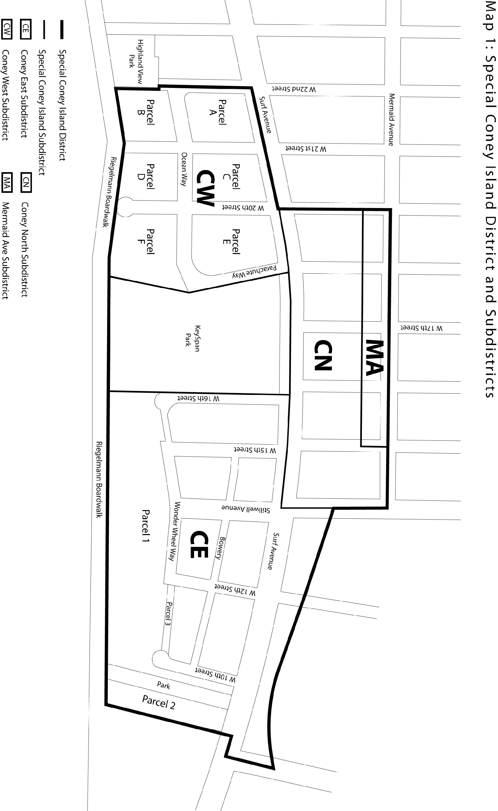
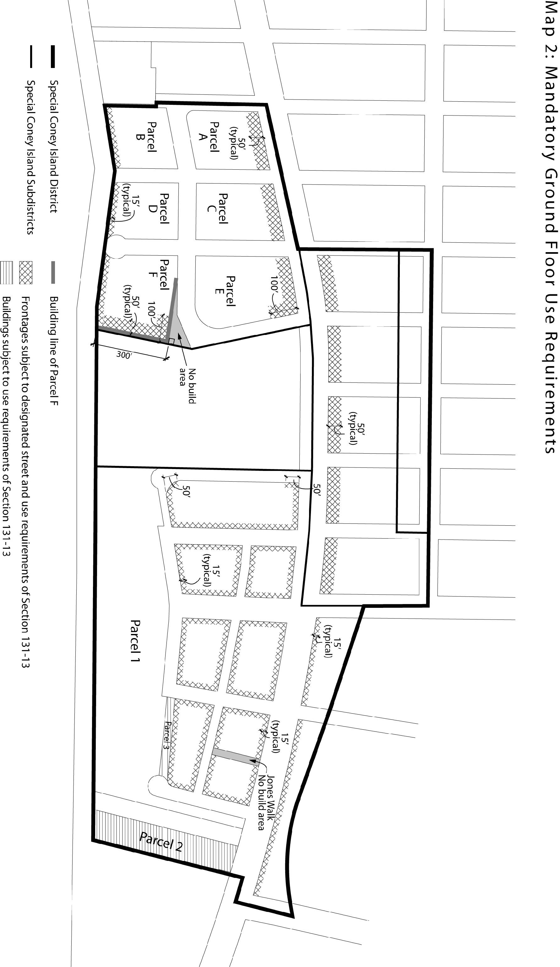
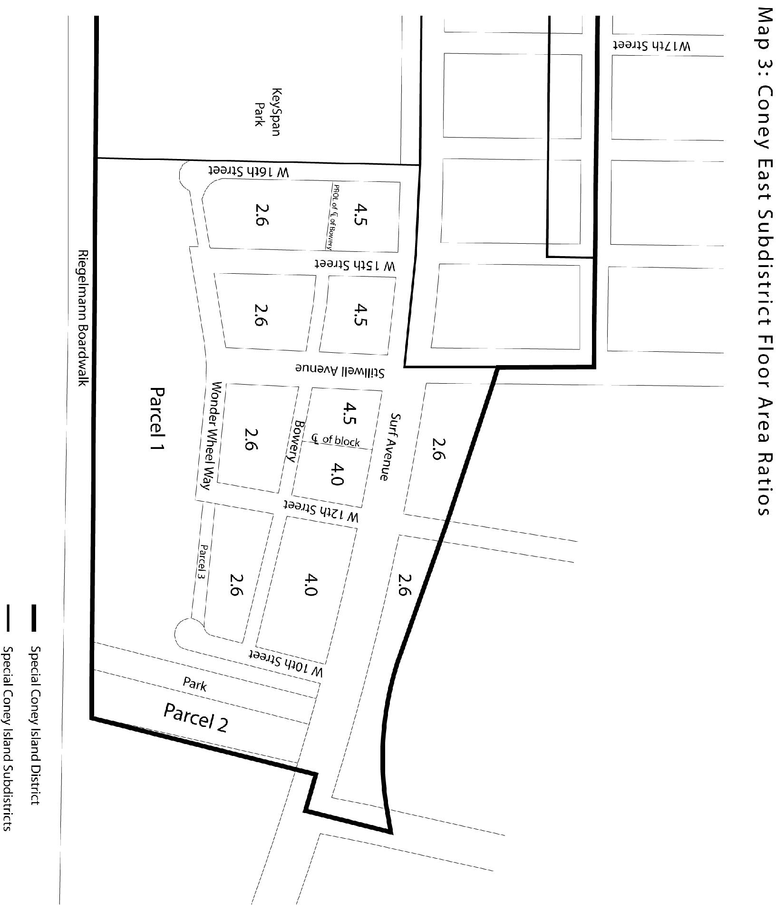

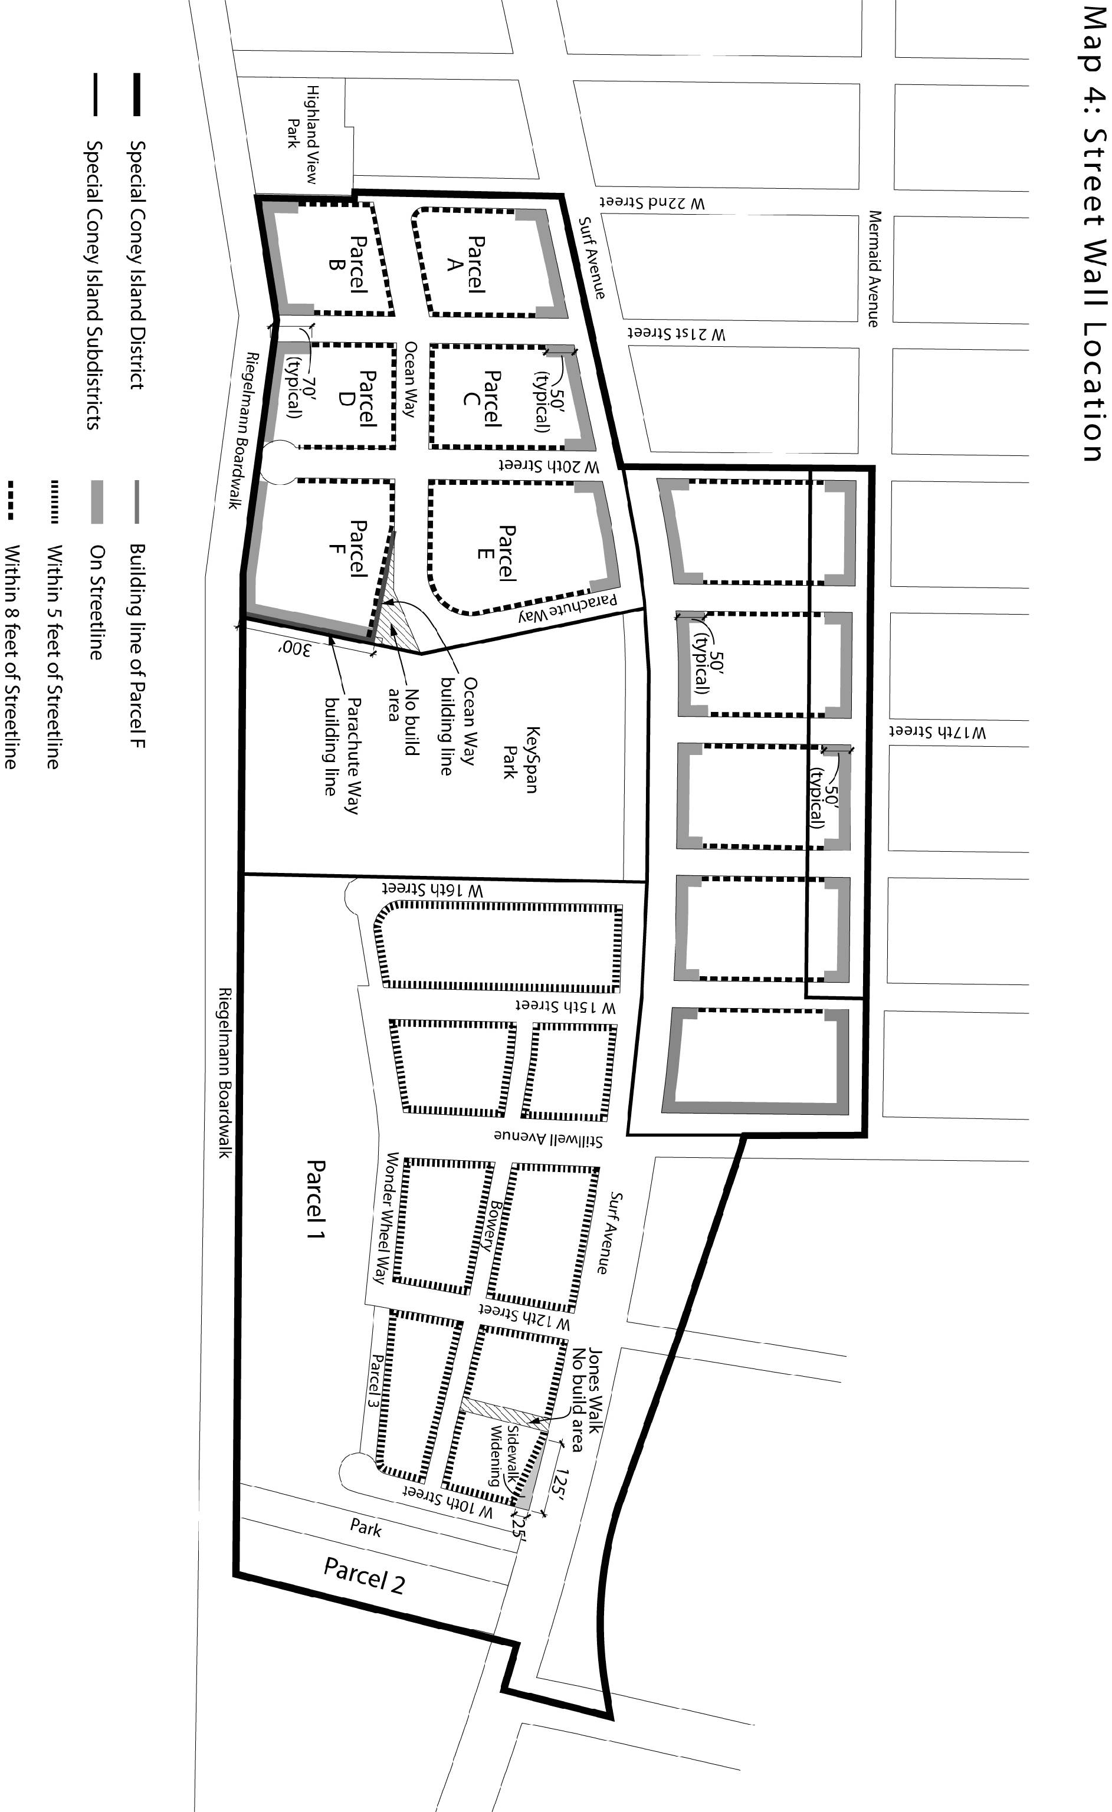
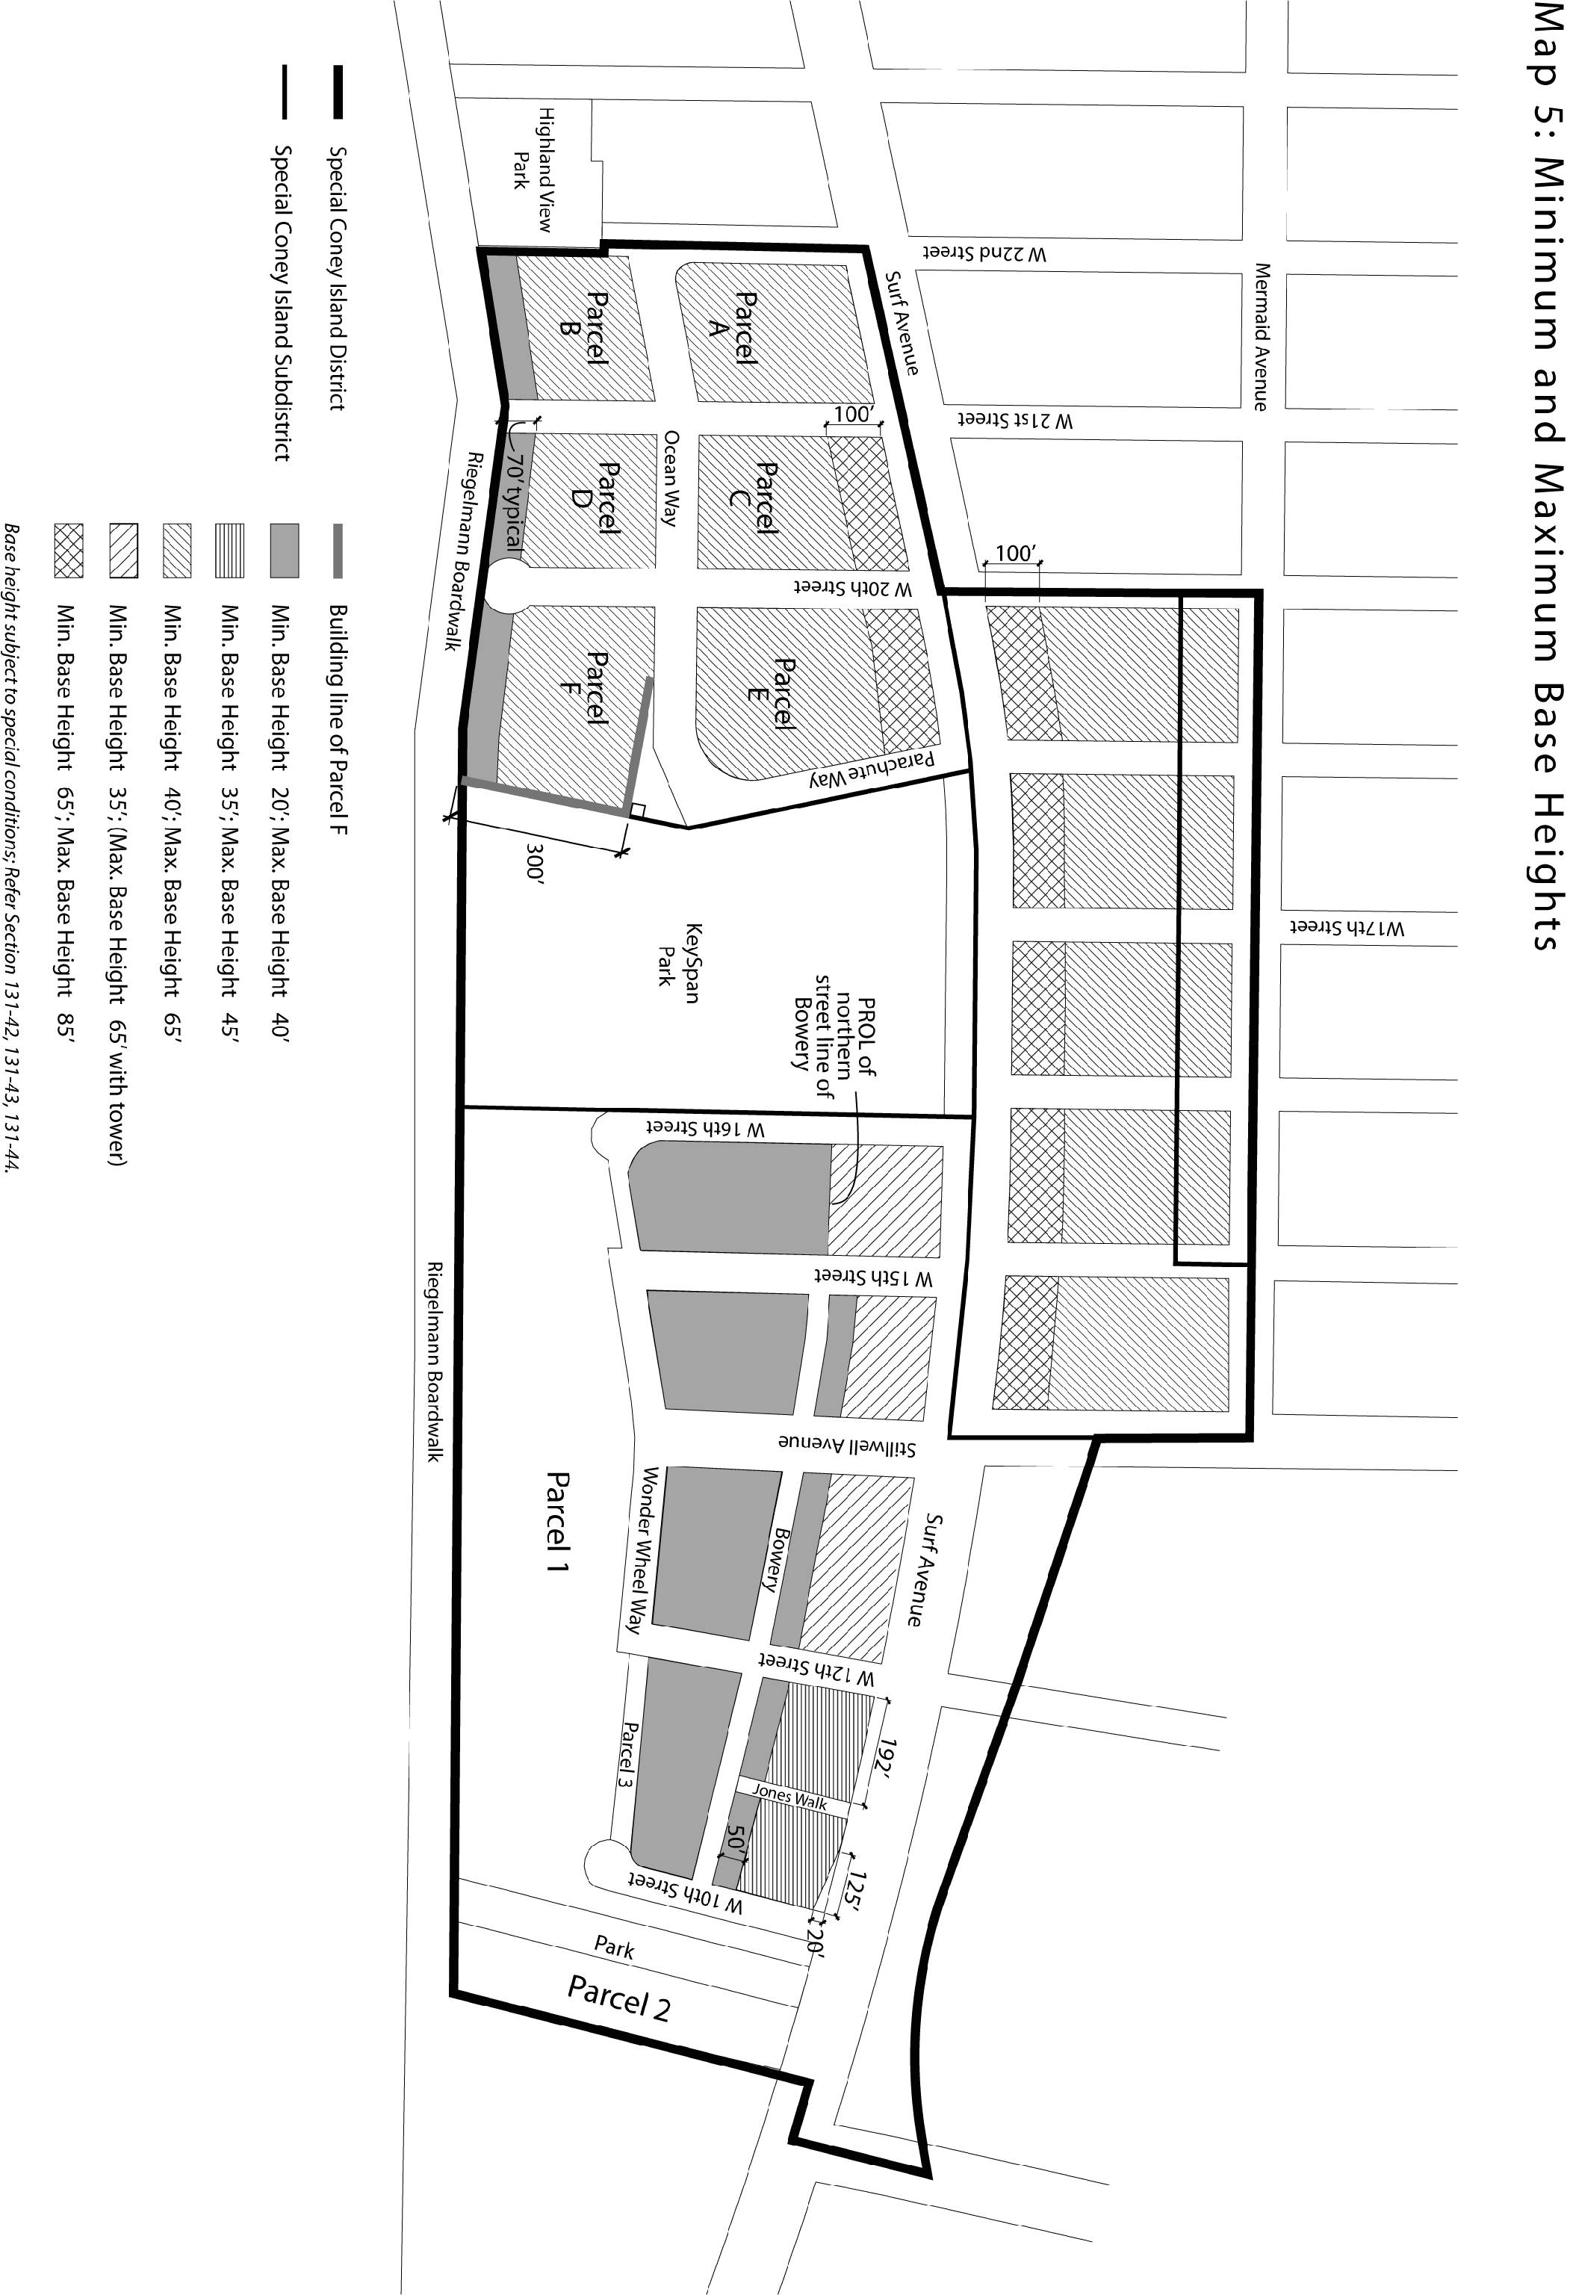
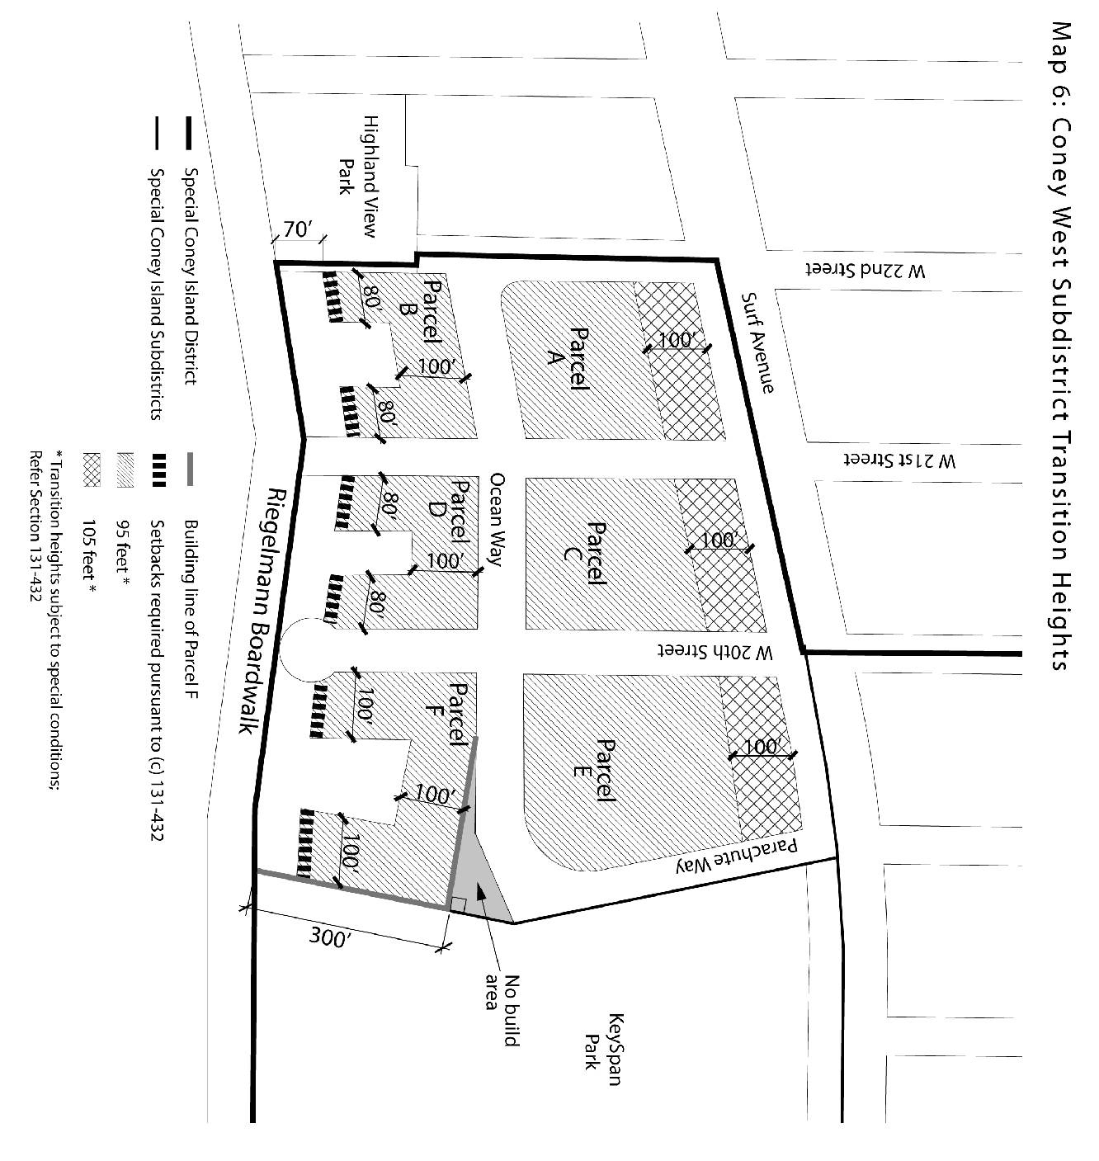

Adopted.

Office of the City Clerk, }
The City of New York, } ss.:

I hereby certify that the foregoing is a true copy of a Resolution passed by The Council of The City of New York on July 29, 2009, on file in this office.

...…….........................................
City Clerk, Clerk of The Council

