THE COUNCIL OF THE CITY OF NEW YORK
RESOLUTION NO. 905

Resolution approving the decision of the City Planning Commission on Application No.
N 240407 ZRK, for an amendment of the text of the Zoning Resolution (L.U. No. 280).

By Council Members Salamanca and Riley
WWHEREAS, Capscar III, LLC, filed an application pursuant to Section 201 of the New York City Charter, for an amendment of the text of the Zoning Resolution of the City of New York, modifying APPENDIX F for the purpose of establishing a Mandatory Inclusionary Housing area, which in conjunction with the related action would facilitate the development of a six-story, 16,607-square-foot mixed-use building containing 15 dwelling units, approximately 4 of which would be permanently income-restricted, as well as 2,342 square feet of commercial ground-floor area at 19 Maspeth Avenue in the Williamsburg neighborhood of Community District 1, Brooklyn
(ULURP No. N 240407 ZRK), (the “Application”);

WHEREAS, the City Planning Commission filed with the Council on April 21, 2025, its decision dated April 9, 2025 (the "Decision") on the Application;

WHEREAS, the Application is related to application C 240406 ZMK (L.U. No. 279), a zoning map amendment to change a C8-2 zoning district to a R7D/C2-4 zoning district;

WHEREAS, the Decision is subject to review and action by the Council pursuant to Section 197-d of the City Charter;

WHEREAS, upon due notice, the Council held a public hearing on the Decision and Application on April 23, 2025;

WHEREAS, the Council has considered the land use implications and other policy issues relating to the Decision and Application; and

WHEREAS, the Council has considered the relevant environmental issues, including the Negative Declaration issued on November 18, 2024 (CEQR No. 24DCP063K), which includes an (E) designation to avoid the potential for significant adverse impacts related to hazardous materials, air quality and noise (E-782) (the “Negative Declaration”).

RESOLVED:

The Council finds that the action described herein will have no significant impact on the environment as set forth in the (E) Designation (E-782) and Negative Declaration.

Pursuant to Sections 197-d and 200 of the City Charter and on the basis of the Decision and Application, and based on the environmental determination and consideration described in the report, N 240407 ZRK, incorporated by reference herein, and the record before the Council, the Council approves the Decision of the City Planning Commission.

Matter underlined is new, to be added;
Matter struck out is to be deleted;
Matter within # # is defined in Section 12-10;
* * * indicates where unchanged text appears in the Zoning Resolution
* * *

APPENDIX F
Mandatory Inclusionary Housing Areas and former Inclusionary Housing Designated Areas
* * *

BROOKLYN

* * *

Brooklyn Community District 1

* * *

Map 2 – [date of adoption]

[EXISTING MAP]

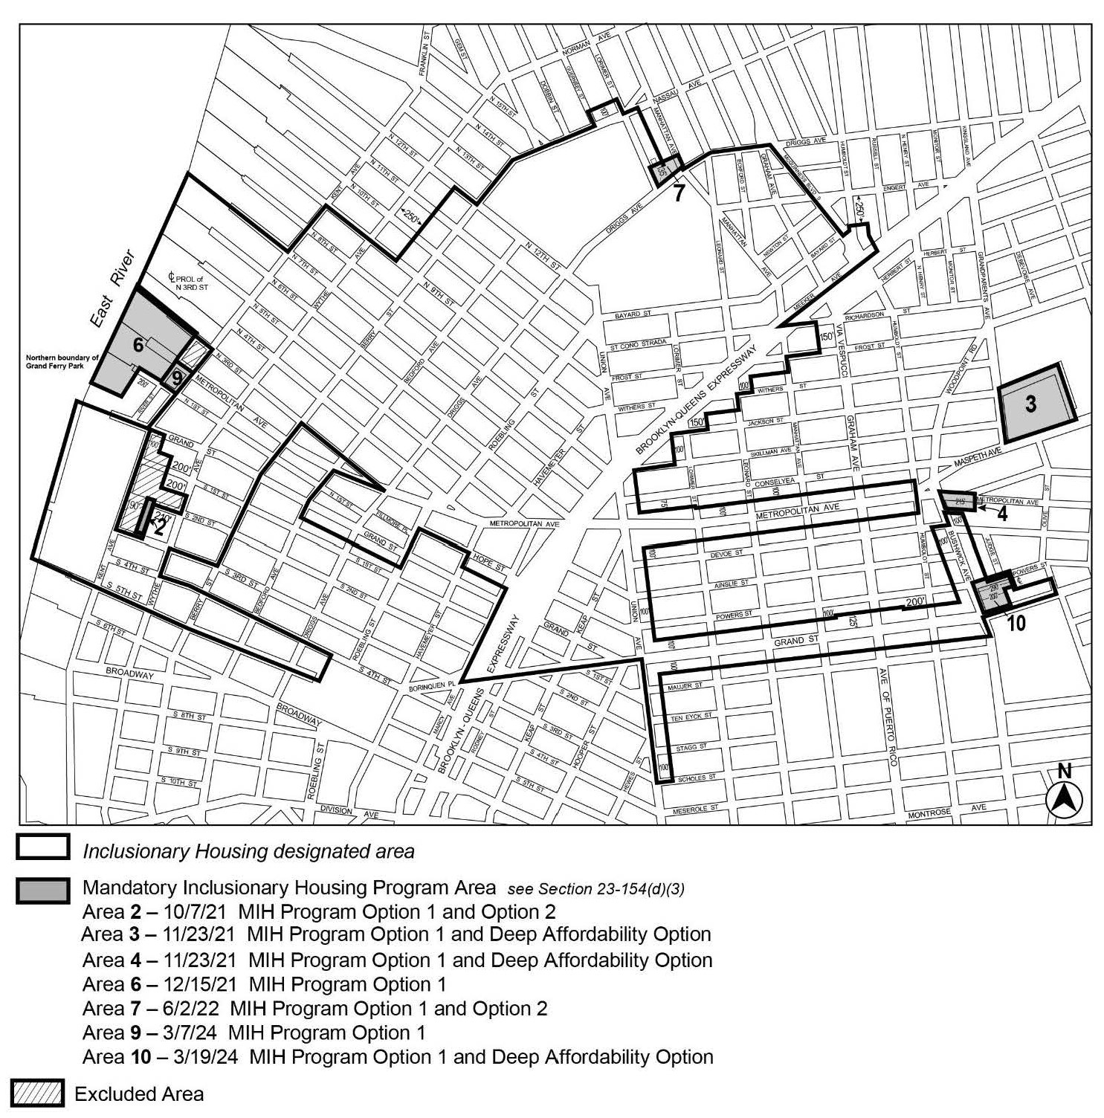

[PROPOSED MAP]

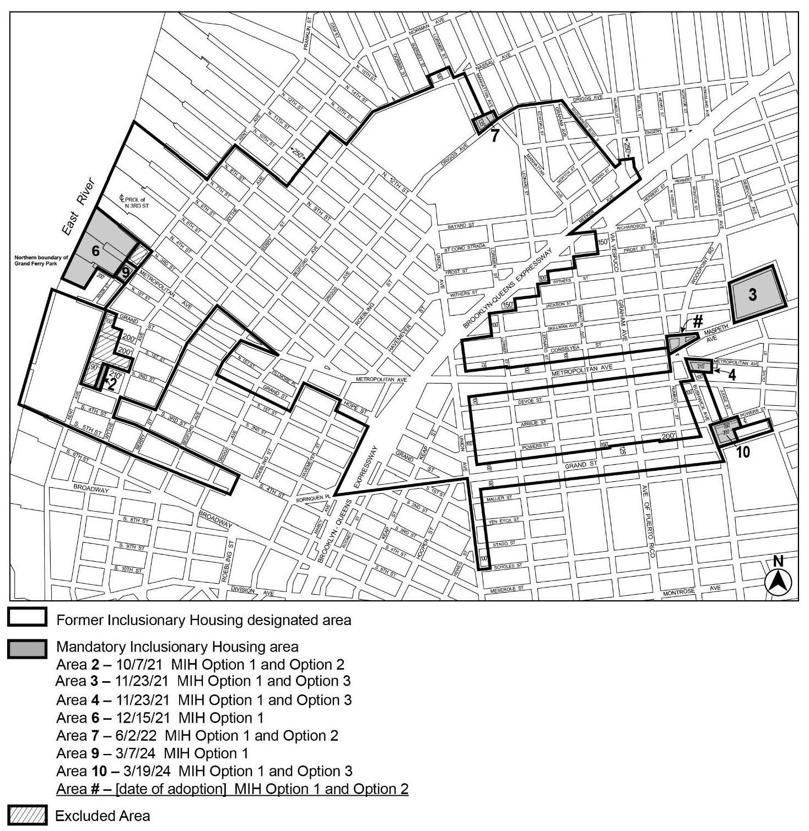

Portion of Community District 1, Brooklyn
* * *

Adopted.

Office of the City Clerk,}
The City of New York,} ss.:

I hereby certify that the foregoing is a true copy of a Resolution passed by The Council of The City of New York on _________, 2025, on file in this office.

.....................................................
City Clerk, Clerk of The Council

