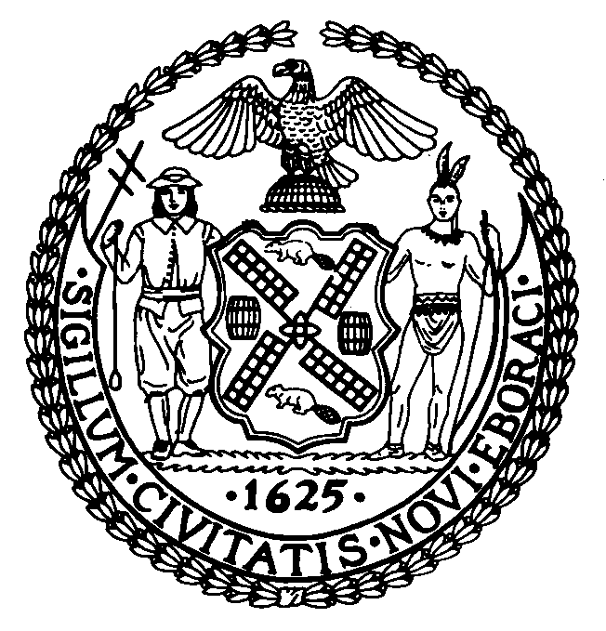

The Council of the City of New York
Finance Division
Larian Angelo, Director
Fiscal Impact Statement

Intro. No: 243-A

Committee: Public Safety

Title: A Local Law to amend the administrative code of the city of New York, in relation to the possession, sale, and display of etching acid.

Sponsor: Council Members Brewer, Addabbo, Avella, Comrie, Felder, Fidler, Gennaro, Gerson, Gioia, Jackson, Lopez, McMahon, Moskowitz, Provenzano, Recchia, Reed, Reyna, Stewart, and Vallone; also Council Members Quinn and Oddo.

Summary of Legislation: The proposed legislation amends Section 10-117 of the administrative code of the city of New York to include/recognize etching acid with regards to defacement of property, possession, sale, and display.

Effective Date: This local law would take effect 120 days after enactment.

Fiscal Year In Which Full Fiscal Impact Anticipated: Fiscal 2004

Fiscal Impact Statement:
 | Effective FY03 | FY Succeeding  Effective FY04 | Full Fiscal  Impact FY04
Revenues (+) | $0 | $0 | $0
Expenditures (-) | $0 | $0 | $0
Net | $0 | $0 | $0

Impact on Revenues: There would be no impact on revenues resulting from the enactment of this legislation.

Impact on Expenditures: This legislation will not result in additional expenses.

Source of Funds To Cover Estimated Costs: General Fund

Source of Information: City Council Finance Division

Estimate Prepared By: Andy Grossman, Assistant Director
Andrew D. Lenney, City Council Finance Division

FIS History: Introduced on July 24, 2002.
Considered by the Committee on Public Safety on November 13, 2002

