Tanisha Edwards, Counsel



THE COUNCIL

COMMITTEE REPORT OF THE FINANCE DIVISION
Preston Niblack, Director

COMMITTEE ON FINANCE
Council Member Domenic M. Recchia, Jr., Chair

January 23, 2012

PROPOSED INT NO. 729-A: By Council Members Mealy, Wills, Barron, Chin, Fidler, Gentile, James, Koppell, Lander, Palma, Recchia, Rose, Sanders Jr., Vacca, Vann, Williams, Rodriguez and Koo

TITLE: To amend the administrative code of the city of New York, in relation to the posting of material terms of contracts entered into by the city on a newly created public, online searchable database.

- Introduction
On January 23, 2012, the Committee on Finance, chaired by Council Member Domenic M. Recchia, Jr. will meet to consider Proposed Int. No. 729-A, a bill to amend the administrative code of the city of New York, in relation to the posting of material terms of contracts entered into by the city on a newly created public, online searchable database.

Background
In Fiscal 2011, New York City procured over $15 billion worth of supplies, services and construction, through more than 50,000 transactions. New York City employs procurement as one of its essential tools to serve the public and accomplish critical governmental functions. Agencies procure the goods and services they need to fulfill their missions— from trucks to sweep the streets, to architectural designs for new firehouses, from biodiesel fuel for City vehicles, to nonprofit service providers working in communities throughout the City. The breadth and variety of City contracts reflect the breadth and variety of City services themselves.
The City’s procurement process is governed by Chapter 13 of the New York City Charter and the Rules of the Procurement Policy Board. The Mayor’s Office of Contracts (“MOCs”) handles the administration of contracts, and the New York City Comptroller is responsible for contract registration. According to MOCs, the procurement process is designed to achieve three main goals: 1) provide necessary goods and services on time and at the best value for the taxpayer; 2) operate fairly and transparently; and 3) ensure the responsibility of vendors, including their business integrity.
MOCs tracks procurements according to six major industry categories: 1) architecture

and engineering; 2) construction services; 3) goods; 4) human services; 5) professional

services; and 6) standardized services.

Chart 1
MOCS Industry Type | No. of Contracts | Value of Contracts (millions) | Pct. of Contracts ≥$100,000 | Pct. of Value ≥$100,000
Architecture/Engineering | 310 | $518 | 70.3% | 99.4%
Construction Services | 2,831 | $2,214 | 41.0% | 97.6%
Goods | 19,512 | $1,532 | 3.0% | 91.8%
Human Services | 5,710 | $7,203 | 41.5% | 98.9%
Professional Services | 1,935 | $2,148 | 14.5% | 99.1%
Standardized Services | 23,239 | $1,846 | 1.9% | 95.3%
TOTAL | 53,537 | $15,461 | 9.5% | 97.6%
Source: Council Finance Division
Many of the City’s contracts support major initiatives that affect the lives of millions of New Yorkers. The City regularly enters into individual contracts that are valued in the hundreds of millions of dollars, occasionally even billions. The table below shows the 25 largest contracts ranked by dollar value. Together, these contracts equal nearly 29% of the overall citywide procurement dollar volume during Fiscal 2011.
Source: Annual Procurement Indicator Reports for Fiscal 2011 at 2.
- Agency Tracking of City Contracts (Source: OMB and MOCS)
The Financial Management System (“FMS”) is the suite of integrated computer applications that New York City uses for its accounting, budgeting and procurement functions. FMS is managed by the Financial Information Systems Agency (FISA) with oversight from the Office of Management and Budget (OMB) and the Office of the New York City Comptroller. The major components of FMS include accounting, budget, interfund agreement, VENDEX, and payee information portal. For purposes of relevancy, the next two paragraphs of this paper will only focus on the accounting and VENDEX functions of FMS.
Accounting manages the chain of events for all the City’s expenditures and revenues in accordance with internal controls and directives issued by the Comptroller. For expenses, the chain can include the requests of agencies for purchases, purchase orders or contracts with vendors and finally the disbursement of payments. All expense transactions are validated against the budget to ensure that there are funds available. The revenue chain records the receipt or anticipated receipt of revenue and the status of the revenue’s collection.
The Vendor Information Exchange System (VENDEX) is a database that provides information about vendors who do business with the City. This database is maintained by MOCs. City agencies, city-affiliated and other government entities use VENDEX to research vendors, principals and related entities and to communicate requests for background checks, tax status and agency requests. The public can access VENDEX through a public access terminal located at MOCs.
All city agencies use FMS to track all contracts between vendors and city agencies. All 3 agencies have access to FMS which allows them to enter information required by section 1064 of the Charter, as will be explained below, and other relevant contract information, such as comptroller registration status, service location, change orders, modification or amendments to contract amounts, and contract purpose.

- Public Access to Contract Information
- Charter Mandates
Pursuant to section 334 (c) of the New York City Charter, “The mayor shall ensure that copies of city contracts and other standard information regarding city contracts and contractors are reasonably available for public inspection in accordance with provisions of section one thousand sixty-four of this charter.”
Section 1064 (a) provides that: “The mayor shall maintain, in a central place which is accessible to the public, standard information regarding each city contract and contractor. Such information shall include: (1) a copy of the contract; (2) information regarding the method by which the contract was let; (3) such standard documents as the contractor is required to submit, which documents shall be updated regularly in accordance with rules of the procurement policy board; (4) information regarding the contractor's qualifications and performance; (5) any evaluations of the contractor and any contractor responses to such evaluations; (6) any audits of the contract and any contractor responses to such audits; and (7) any decisions regarding the suspension or debarment of the contractor.”
Pursuant to section 1064(c) of the New York City Charter, a computer terminal is available at the offices of MOCS to access computerized contract information, which allows the public “meaningful read-only access to such information by the agency name, contractor name, contract category, and contract number…”

- Annual Procurement Indicator Report
Each year, MOCs publishes the Annual Procurement Indicator Report, which provides information on the procurement process and a general overview of the contracts letted in the previous fiscal year. Information provided in this report include:
- Purchase and Procurement Methods
- Competitiveness of letting contracts
- Procurement Timeliness
- Contract Administration
- Vendor responsibility; and
- Business opportunities with the City
This report is available on-line on MOCs website located at: http://www.nyc.gov/html/mocs/html/research/indicator_reports.shtml.
- ClearViewNYC
ClearView is an online database established by the NYC Comptroller that provides the public with access to general information regarding approximately 90,000 contracts that City agencies have with businesses, nonprofits, and other government entities. This database allows contract information to be searched for using a variety of different criteria, including:
- A City agency’s or vendor’s name;
- The nature of the services being provided;
- The contract’s amount;
- The contract’s number;
- The vendor’s Tax ID number; or
- The date the Comptroller’s Office received the contract.

**Snapshot of ClearView screen when researching information on CEMUSA, a vendor doing business with the city to provide, among other things, bus shelters and snow removal services.
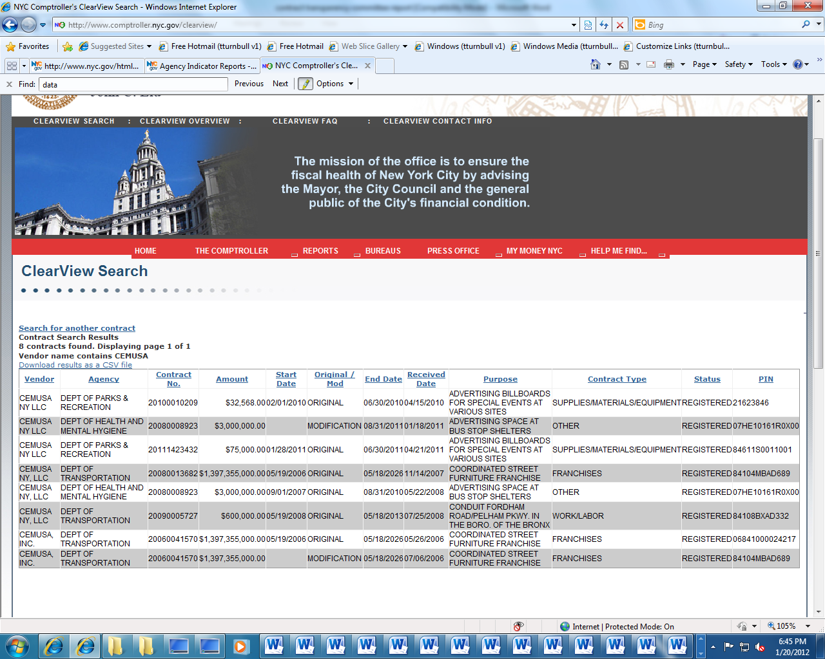

- Lack of Transparency in City Contracts
While MOCs’ Annual Procurement Indicator Report provides statistics on city contracts, and VENDEX offers information regarding vendors who contract with the city, there is no centralized and easily accessible public database that allows public access to meaningful information relating to the city’s contracts. Currently, in order for the public to obtain a city contract, a request must be made to MOCS. Further, oftentimes city contracts are thousands of pages long, with dozens of appendices and exhibits, which make the contract difficult to navigate. Further, the language provided in the contracts are often replete with legal jargon or esoteric language, thereby rendering a complete and thorough understanding of a city contract nearly impossible.
While ClearView on the Comptroller’s Office’s website has key terms that make searching for contracts and specific provisions within such contracts easier, the information provided on ClearView is limited as it does not provide detailed summaries; the dollar amount of the revised maximum expenditure authorized under each contract; a description in plain language of the scope of services to be provided pursuant to the contract; the date and reason for any modification or amendment of the contract; the percentage change from original contract amount; the award method; nor the category, as defined by MOCS, in which the contract applies.

- Proposed Int. 729-A
- Legislative Intent
The lack of clear, concise, and meaningful information available to the public regarding contracts between city agencies and vendors not only impedes the public’s knowledge about the type of services for which the City contracts, but also impairs the Council from fully exercising its duties and responsibilities under the New York City Charter with respect to the contract budget.
In the 2011 State of the City Address by New York City Council Speaker Christine C. Quinn, she noted that she wanted the Council to fully exercise its duties and responsibilities under the New York City Charter with respect to the contract budget. She emphasized that fully exercising this role requires greater transparency of the procurement process, and she further emphasized that given the scope of City procurement and the reliance on contracts for the provision of goods and services in many areas of the budget, the Council and the public need and deserve easier access to information about City contracts and their terms than is currently available.
The legislation under consideration today, Proposed Int. 729-A, seeks to address the Speaker’s concerns and the public’s concerns regarding contract transparency, and would require the posting of material terms of contracts entered into by the city on a newly created public, online searchable database established by the mayor. The purpose of the legislation is to facilitate the access of contract information, and present such information in a way that allows the public at large to understand the services let by the City.
- Legislative Provisions of Proposed Int. 729-A
  - Requires the mayor to establish by July 1, 2012, a searchable online database that would information on the material terms of city contracts. The website would be located on an official website of the city.
    - Material terms that would be summarized in the database include: (1) the legal name of the contractor, franchisee or concessionaire where available; (2) the dollar amount of the revised maximum expenditure authorized under each contract; (3) the dollar amount of the original maximum expenditure authorized under each contract; (4) a description in plain language of the scope of services to be provided pursuant to the contract; (5) the starting and scheduled completion date of the contract; (6) the name of the agency, elected official or the council that awarded the contract; (7) the contract, franchise or concession and the contract registration number, if any, assigned by the comptroller; (8) the date and reason for any modification or amendment of the contract; (9) the percentage change from original contract amount; (10) the award method; (11) the contract type; and (12) the contract category.

  - The bill would only apply to contracts between contractors and city agencies, as defined in the Charter. The bill would not apply to affiliated agencies, such as the Department of Education, NYCHA, the public libraries, or other non-city agencies.

  - The bill would only apply to contracts between city agencies and contractors with a value that exceeds the small purchase limit, currently set at $100,000. As illustrated in Chart 1 on page 3 of this document, contracts that exceed $100,000 account for over 97% of the value of contracted services by New York City.

  - The bill takes effect immediately, with the exception of the following provisions:
    - With respect to the categories of information of the searchable database relating to the dollar amount of the original maximum expenditure authorized under each contract; the date and reason for any modification or amendment of the contract; the percentage change from original contract amount; the contract type; and the contract category, the effective date will be on September 1, 2012, during which time DOITT must certify to the mayor and the city council either that the searchable database established is substantially complete with respect to the categories of information required by such paragraphs, or that such database is not yet substantially complete with respect to such categories, detailing the reasons therefor.
    - No later than July 1, 2013, DOITT must certify to the mayor and council, on an annual basis, that the searchable database is substantially complete with respect to all of the categories of information required by such section.
    - Prior to the dates cited above, DOITT may certify to the council and the mayor that the provisions required to be included in the searchable database are complete when DOITT has determined that each category has been established with reasonable completeness and accuracy.
    - Upon DOTT’s certification of completeness, DOITT must also submit to the mayor and the council an analysis of the steps taken to establish the category of information of the database and of the steps taken to ensure and test for reasonable completeness and accuracy. Such report shall also explain the process by which, and how often, the department of information technology and telecommunications will update the searchable database.
- Difference between Int. 729 and Proposed Int. 729-A
On December 8, 2011, the Council introduced Int. 729. Since the bill’s introduction, the legislation has since been amended for implementation purposes.
Proposed Int. 729-A reflects the following changes from Int. 729:
- Implementation Date: The amended bill changes the date of implementation of the online database from March 1, 2012 to July 1, 2012.
- Database location: The bill changes the location of where the online database will be located. The amended bill requires the database to be located on an official website of a city agency, rather than on the city’s official website (nyc.gov) or the MOCS website.
- Information included in the database: The prior bill required the following information: (1) the name, address, and federal taxpayer's identification number of the contractor, franchisee or concessionaire; (2) the dollar amount of each contract including original maximum and revised maximum expenditure authorized, current encumbrance and actual expenditures; (3) the type of goods or services to be provided pursuant to the contract; (4) a detailed narrative in plain language of the purpose of the contract; (5) the term of the contract, or in the case of a construction contract the starting and scheduled completion date of the contract and the date final payment is authorized; (6) the agency, New York city affiliated agency, elected official or the council that awarded the contract, franchise or concession and the contract registration number, if any, assigned by the comptroller; (7) the manner in which the contractor, franchisee or concessionaire was selected; (8) price adjustment trigger, if any, whether automatic or periodic; (9) milestones or deliverables, if any; (10) payment schedule, and triggers, if any; (11) non-performance penalties, if any; and (12) bonus payments, if any. The amended bill requires: (1) the legal name of the contractor, franchisee or concessionaire where available; (2) the dollar amount of the revised maximum expenditure authorized under each contract; (3) the dollar amount of the original maximum expenditure authorized under each contract; (4) a description in plain language of the scope of services to be provided pursuant to the contract; (5) the starting and scheduled completion date of the contract; (6) the name of the agency, elected official or the council that awarded the contract; (7) the contract, franchise or concession and the contract registration number, if any, assigned by the comptroller; (8) the date and reason for any modification or amendment of the contract; (9) the percentage change from original contract amount; (10) the award method; (11) the contract type; and (12) the contract category.
- Agency coverage: The amended bill changes the scope of agency contracts to be included in the newly established database. The bill now only applies to city agencies, as defined in the charter, and does not apply to affiliated agencies, such as public authorities and state created entities, such as the department of education, and the economic development corporation.
- Contractor definition: The amended bill narrows the definition of contractor to exclude subcontractors.
- Contracts definition: The amended bill changes the definition of contracts to:
  - Apply to all city contracts, rather than specifying contracts that fall within the six contract categories specified by MOCS.
  - Agreements between an agency, elected official or the council and a contractor, rather than also taking into consideration contracts between contractors and subcontractors, when aggregated, total more than the small purchase limit.
- Effective date: The language of the previous bill required all provisions of the legislation to take immediately. The amended version requires the bill to take effect immediately, with the exception of several provisions, noted in paragraph 4 of Part III of this report.
- Certification: Adds provisions to require DOITT to certify, at various times, to the mayor and the council on the status of completion of each category specified in this legislation, and provide an analysis of the steps taken to establish the categories, and tests used to determine accuracy of information.
- January 23, 2012 hearing on Proposed Int. 729-A
Today’s hearing will discuss Proposed Int. 729-A and determine whether the provisions of the bill reflect the Council’s intent: transparency in city contracts. MOCS, along with members of the public, have been invited to testify.

See Annual Procurement Indicator Reports for Fiscal 2011 Executive Summary, p. vi. available at http://www.nyc.gov/html/mocs/downloads/pdf/procurement_indicators_2011.pdf (last accessed on January 20, 2012).
See id.
See id.
Pursuant to section 311 of the New York City Charter, the Procurement Policy Board (“PPB”) establishes the rules that govern the methods of selecting procurement types, soliciting bids and proposals, awarding and administering contracts, determining responsibility, retaining records and resolving contract disputes. The PPB must review its rules, policies and procedures on an annual basis and submit a report to the Mayor, Comptroller, and City Council with recommendations on agency organization and personnel qualifications in order to facilitate efficient procurement. The PPB consists of five members, three of whom are appointed by the Mayor and two of whom are appointed by the Comptroller.
See supra n.1.
Architecture/Engineering: A class of services specifically related to the preparation of plans and specifications for construction projects. This category does not include construction management or construction management and build contracts, nor the preparation of environmental studies. Contracts to hire licensed architects or professional engineers are included. See id. at 61.
Construction Services: Construction services provide construction, rehabilitation and/or renovation of physical structures. This category includes Construction Management and Build contracts as well as other construction related services such as: painting, carpentry, plumbing and electrical installation, asbestos and lead abatement, carpet installation and removal, and demolition. See id. at 62.
Goods: This category includes all purchases of physical items. Most purchases of goods above the small purchase limit of $100,000 are made by the Department of Citywide Administrative Services (DCAS). See id. at 64.
Human Services: A class of services that are provided directly to clients in various at-need groups. This category includes homeless shelters, counseling services, youth programs, after-school programs, homes for the aged, home care and other similar services. Vendors in this category are primarily nonprofit; some services, such as home care, also have for-profit providers. See id.
Professional Services: Professional services are a class of services that require an individual to hold an advanced degree or have experience in a specialized field. Professional services are usually procured through a Request for Proposals, where emphasis is placed on the quality of the vendor's approach as the service is likely to be highly individualized. Services of this type include: legal, management consulting, information technology, accounting, auditing, actuarial, advertising, health, architecture, pure construction management (without including construction) and environmental analysis. See Annual Procurement Indicator Reports for Fiscal 2009 at. 70 available at http://www.nyc.gov/html/mocs/downloads/pdf/procurement_indicators_2009.pdf (last accessed January 20, 2012).
Standardized Services: Standardized services typically do not require the provider to have experience in a specialized field or hold an advanced degree. A standardized service is clearly defined and highly commoditized; procurements for these services are generally awarded based on the lowest price. Examples include: security, janitorial, secretarial, transportation, collection and food related services. Contracts for services such as plumbing, electrical and HVAC for maintenance and repair not related to new construction also fall into this category. See id. at 68.
See Mayor’s Office of Contract Services’ website, available at http://www.nyc.gov/html/mocs/html/research/indicator_reports.shtml (last accessed January 20, 2012)
See Office of the New York City Comptroller website, ClearView Overview, available at http://www.comptroller.nyc.gov/Clearview/overview.shtm (last accessed January 20, 2012).
Section 334(c) of the New York City Charter provides that: “The mayor shall ensure that copies of city contracts and other standard information regarding city contracts and contractors are reasonably available for public inspection in accordance with provisions of section one thousand sixty-four of this charter.”

