L Staff:


Dylan Casey, Deputy General Counsel

James Lloyd, Project Manager

THE COUNCIL

COMMITTEE REPORT OF THE LAND USE DIVISION

Raju Mann, Director of Land Use

Amy Levitan, Deputy Director of Land Use

COMMITTEE ON LAND USE

Hon. David Greenfield, Chair

June 7, 2016

Int. No. 775-A: By Council Members Koo, Greenfield, Williams, Lancman, Richards, Vallone, Crowley, King, Ferreras-Copeland, Torres, Espinal, Gentile, Treyger, Maisel, Cornegy, Koslowitz, Rose, Palma, Eugene, Cabrera, Salamanca, Cumbo, Rodriguez, Gibson, Dickens, Miller, Cohen, Deutsch, Constantinides, Borelli, Ulrich, and Matteo

Title: A Local Law to amend the Administrative Code of the city of New York, in relation to establishing a time period for the landmarks preservation commission to take action on an item upon a motion to calendar such item for consideration of landmark status.

Administrative Code: Amends section 25-303 of chapter 3 of title 25 of the Administrative Code of the City of New York.

I. Introduction

On Wednesday September 9, 2015, the Committee on Land Use, chaired by Council Member David Greenfield, held a hearing on legislation relating to the designation of landmarks and operations of the Landmarks Preservation Commission (LPC). In the City of New York, LPC is the agency responsible for designating and regulating “landmarks, portions of landmarks, landmark sites, interior landmarks, scenic landmarks and historic districts.”
Introduction Number 775-A (“Int. No. 775-A”) is a local law that would amend the Administrative Code of the City of New York in relation to establishing a maximum period of time for the Landmarks Preservation Commission to take action on any item calendared for consideration of landmark status.
II. Proposed Int. No. 775-A
A. Background
This proposed legislation, Int. No. 775-A, would amend the Landmarks Law to implement mandatory timelines for the process for designating landmarks, interior landmarks, scenic landmarks, and historic districts. The bill is intended to help inform landowners and the public about the prospects and timelines for designations of individual landmarks and historic districts. The timelines would cover the period from when an item is calendared for consideration through designation. Currently, LPC can vote to calendar an item as a way of establishing the property or neighborhood as under consideration for designation. The date for the public hearing on the item can be set at the time of calendaring, or at some later date. The practice of calendaring an item prior to a public hearing was established through agency rulemaking, and is not currently required by the Landmarks Law. This bill would codify the practice of calendaring as part of the Landmarks Law, and require properties to be calendared prior to the public hearing. Lastly, Int. No. 775-A would also require LPC to act within 18 months on all items that are on the calendar at the time the bill takes effect.
Over the last 15 years, LPC was able to designate individual landmarks within 360 days of the date of calendaring 80 percent of the time. For historic districts, LPC was able to move from calendaring to designation in less than 720 days for 94% of districts. These data were taken from the New York City Open Data Portal.
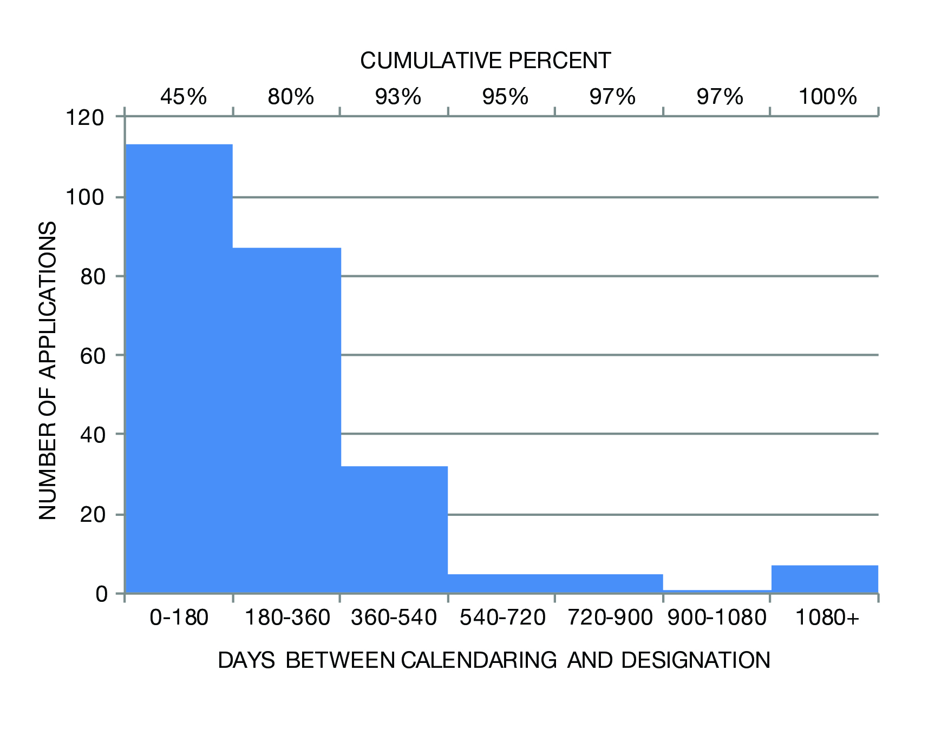
Figure 1: Analysis of Individual Landmarks

When calendaring dates are available for individual landmarks (most designated landmarks after 1998):
- Average time from calendaring to designation: 290 days
- Median time from calendaring to designation: 189 days
- 80% of items were designated within 360 days of calendaring
- 93% of items were designated within 540 days of calendaring
- Very few items took greater than 540 days to be designated.

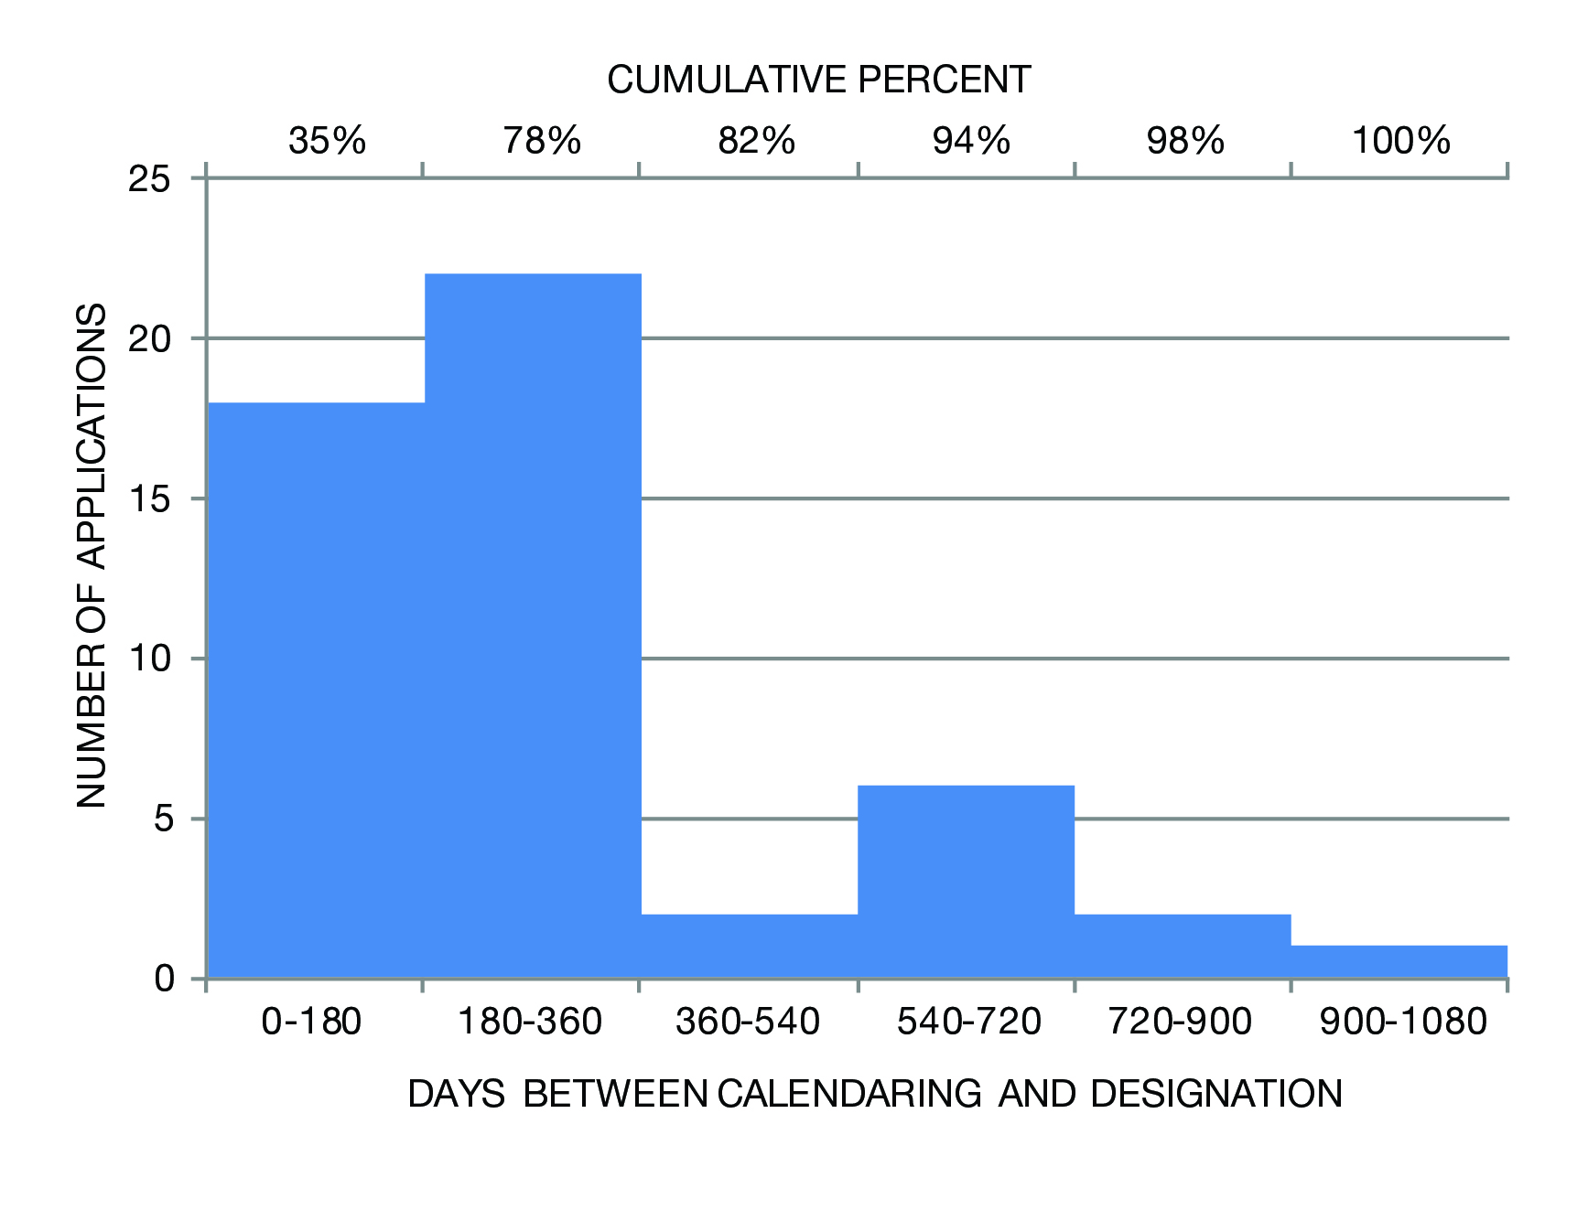
Figure 2: Analysis of Historic Districts

When calendaring dates are available for districts (almost all districts after 1999):
- Average time from calendaring to designation: 286 days
- Median time from calendaring to designation is 224 days
- Most items (78%) were designated within 360 days of calendaring
- 94% of items were designated within 720 days

B. Summary of Proposed Law
Section One of Int. No. 775-A would add a new subdivision l to Section 25-303 of chapter 3 of title 25 of the New York City Administrative Code. Chapter 3 governs the Landmarks Preservation Commission and Section 25-303 governs the procedures for the establishment of landmarks, landmark sites, interior landmarks, scenic landmarks and historic districts.
Paragraph (1) of the proposed subdivision l would require LPC to vote to calendar any potential landmark, interior landmark, scenic landmark, or historic district prior to holding a public hearing on that item.
Paragraph (2) of the proposed subdivision l would establish a timeframe for designating a property as an historic landmark after calendaring the property for consideration. The legislation would require that LPC designate the property within 12 months of calendaring, with another 12 month extension permitted with written consent of the property owner. If LPC failed to designate an item within the allotted timeframe, the item would be removed from the calendar.
Paragraph (3) of the proposed subdivision l would establish a timeframe for designating a property as an historic district after calendaring the property for consideration. The legislation would require that LPC designate the property within 24 months of calendaring. If LPC failed to designate an item within the allotted timeframe, the item would be removed from the calendar.
Section 2 of Int. No. 775-A would establish a timeframe for designating landmarks, scenic landmarks, interior landmarks, and historic districts that are calendared prior to the effective date of the proposed local law. LPC would have 18 months to designate any such item. If LPC did not designate the item within 18 months, the item would be removed from the calendar. The section would also allow for a one-year extension with the written consent of the owner. This section contains the enactment clause and provides that the local law would take effect on the date of enactment.
C. Proposed Amendment to Int. No. 775
A series of amendments have been proposed to the original bill that had a public hearing on September 9th, 2015. The amendments were developed in response to the public testimony received at the public hearing and feedback from the Landmarks Preservation Commission (LPC). In the public hearing, testimony in opposition of the proposed legislation was concentrated on the inflexibility of the timelines imposed and the inappropriateness of the five year prohibition on reconsideration. The five year prohibition, in particular, was a point of contention. Numerous members of the public testified that although timelines for designation may be acceptable, they could not support timelines when coupled with a prohibition on reconsideration. There were concerns expressed about the opportunity for landowners to destroy buildings worthy of landmarking if the building fell off the calendar due to oversight rather than lack of merit. In response to these concerns, and similar concerns voices by LPC, the proposed amendments have removed the prohibition on reconsideration from the legislation.
In addition to this criticism, many members of the public and LPC expressed a need for more flexibility in the timeline for the situation where a landowner needs more time to complete work on her property prior to designation. In response to this feedback, the proposed amendments have allowed for a one year extension for individual landmarks where the property owner consents to the extension in writing. This compromise allows for more time to consider in special circumstances while protecting the property owners’ interests.
Lastly, LPC asked for the bill to be amended so that they would have more flexibility on when to hold the public hearing during the timeline. Based on this feedback, the amended bill allows for increased flexibility with the timing of the public hearing. For individual landmarks, the amended bill would allow for one year total. For historic districts, the amended bill would allow for two years total. In both cases, the LPC public hearing on the item could take place at any time during the time period.
 | Timeline for individual Landmarks | Timeline for Historic Districts | Extension of Timeline? | Consequences of failing to designate within timeline
Int. 775 | 6 months from date of calendaring to have public hearing, 6 months from public hearing to designate | One year from date of calendaring to hold public hearing, One year from public hearing to designate historic district | None | Item is removed from the calendar, and LPC is prohibited from calendaring the item for 5 years
Proposed Int. 775-A | One year from date of calendaring to designate, public hearing can take place at any time within that year | Two years from date of calendaring to designate historic district, public hearing can take place at any time within two year period | Timeline for Individual landmarks can be extended for up to one additional year is property owner consents | Item is removed from the calendar, no moratorium

Proposed Int. No. 775-A

By Council Members Koo, Greenfield, Williams, Lancman, Richards, Vallone, Crowley, King, Ferreras-Copeland, Torres, Espinal, Gentile, Treyger, Maisel, Cornegy, Koslowitz, Rose, Palma, Eugene, Cabrera, Salamanca, Cumbo, Rodriguez, Gibson, Dickens, Miller, Cohen, Deutsch, Constantinides, Borelli, Ulrich, and Matteo

A LOCAL LAW

To amend the administrative code of the city of New York, in relation to establishing a time period for the landmarks preservation commission to take action on an item upon a motion to calendar such item for consideration of landmark status

Be it enacted by the Council as follows:

Section 1. Section 25-303 of the administrative code of the city of New York is amended by adding a new subdivision l to read as follows:
l. (1) Subject to subdivisions a through k of this section, the commission shall, upon the adoption of a motion, calendar an item to be considered for designation as a landmark, interior landmark, scenic landmark or historic district prior to holding a public hearing on such item.
(2) The commission shall, after a public hearing, act to designate an item under consideration for designation as a landmark, interior landmark, or scenic landmark within 12 months after the date that the motion to calendar such item has been adopted by the commission. In the event the commission fails to designate the item within such 12 month period, the item shall be removed from the commission’s calendar, except that the commission or the chair acting upon delegation by the commission may, upon a determination that there is a need and with the written concurrence of the owner, extend the time to designate such item for no more than 12 additional months.
(3) The commission shall, after a public hearing, act to designate an item under consideration for designation as an historic district within 24 months after the date that the motion to calendar such item has been adopted by the commission. In the event the commission fails to designate the item within such 24 month period, the item shall be removed from the commission’s calendar.
§ 2. This local law shall take effect immediately, provided, however, that for any item under consideration for designation as a landmark, interior landmark, scenic landmark or historic district for which the commission has adopted a motion to calendar such item prior to the effective date of this local law but that has not been so designated, the commission may make such designation within 18 months after such effective date, and provided further that if the commission fails to designate any such item within such 18 months, such item shall be removed from the commission’s calendar, except that the commission or the chair acting upon delegation by the commission may, upon a determination that there is a need and with the written concurrence of the owner, extend the time to designate an item under consideration as a landmark, interior landmark or scenic landmark for no more than 12 additional months.

DSC
LS #2381
5/25/16

Section 3020 of the New York City Charter.

