Committee on Technology
Irene Byhovsky, Legislative Counsel
Erik Brown, Legislative Policy Analyst
Florentine Kabore, Finance Unit Head
Amaan Mahadevan, Financial Analyst



THE NEW YORK CITY COUNCIL
Andrea Vazquez, Legislative Director

COMMITTEE REPORT OF THE INFRASTRUCTURE DIVISION
Bradley Reid, Deputy Director, Infrastructure

COMMITTEE ON TECHNOLOGY
Hon. Jennifer Gutiérrez, Chair

August 14, 2025

Proposed Int. No. 422-A: By Council Members Rivera, Brewer, Louis, Banks, Feliz, Gutiérrez, and Schulman

Title: A Local Law to amend the administrative code of the city of New York, in relation to requiring the commissioner of information technology and telecommunications to create a separate 311 category for rooftop activity complaints and to require the commissioner of buildings to report annually regarding certain rooftop spaces

Administrative Code: Adds a new section 23-313 and a new section 28-103.38

- Introduction
On August 14, 2025, the Committee on Technology, chaired by Council Member Jennifer Gutiérrez, will hold a hearing to vote on Proposed Int. No. 422-A, sponsored by Council Member Carlina Rivera, in relation to requiring the commissioner of information technology and telecommunications to create a separate 311 category for rooftop activity complaints, and to require the commissioner of buildings to report annually regarding certain rooftop spaces.
The Committee heard a previous version of the bill on April 25, 2024. Those that submitted testimony included representatives from the New York City (“NYC” or “City”) Office of Technology and Innovation (“OTI”), formerly known as the Department of Information Technology and Telecommunications, (“DoITT”).
- Background
  - 311 Overview
The 311 Customer Service Center (“311”) is a citywide customer service program that provides NYC residents, businesses, and visitors with access to non-emergency government services and information. OTI oversees 311’s operations and technology. 311 is available 24 hours per day, 7 days per week, 365 days per year, and can be accessed through multiple channels, including via telephone, text message, the web, mobile application, and social media.
In Fiscal Year 2024 (“FY24”), 311 handled approximately 17.5 million calls. Use of digital platforms continued to be a primary way for New Yorkers to interact with 311, with online site visits reaching 18.2 million and mobile app contacts totaling 2.2 million. When a customer contacts 311, the interaction generally results in either a “service request” (when the customer is seeking a city agency to take an action) or an “informational request” (when the customer has a question regarding a city service). In total, In total, 311 processed 3.6 million service requests in FY24, up from 3.4 million in FY23.
According to OTI’s Office of Data Analytics (“ODA”), the Top 10 Service Requests for FY20 to FY24, as well as their responsible agencies, were as follows. The Top 10 Service Requests remained largely the same year over year, with the main complaints being Noise Complaints, Illegal Parking, Heat/Hot Water, and Unsanitary Condition. Consequently, the main agencies handling the Top 10 Service Requests were the New York City Police Department (“NYPD”), the Department of Sanitation (“DSNY”), and the Department of Housing Preservation and Development (“HPD”):
FY 2020 Rank | Complaint Type | # of Complaints | Agency
1 | Noise - Residential | 285573 | NYPD
2 | Request Large Bulky Item Collection | 235109 | DSNY
3 | Illegal Parking | 184392 | NYPD
4 | Heat/Hot Water | 174005 | HPD
5 | Noise - Street/Sidewalk | 138708 | NYPD
6 | Blocked Driveway | 116120 | NYPD
7 | Non-Emergency Police Matter | 79658 | NYPD
8 | Street Light Condition | 66340 | DOT
9 | Street Condition | 65779 | DOT
10 | Water System | 53703 | DEP
FY 2021 Rank | Complaint Type | # of Complaints | Agency
1 | Noise - Residential | 411721 | NYPD
2 | Request Large Bulky Item Collection | 314697 | DSNY
3 | Illegal Parking | 259353 | NYPD
4 | Noise - Street/Sidewalk | 210531 | NYPD
5 | Heat/Hot Water | 187078 | HPD
6 | Blocked Driveway | 142254 | NYPD
7 | Noise - Vehicle | 94381 | NYPD
8 | Unsanitary Condition | 77351 | HPD
9 | Damaged Tree | 70857 | Department of Parks and Recreation
10 | Street Condition | 64761 | DOT
FY 2022 Rank | Complaint Type | # of Complaints | Agency
1 | Illegal Parking | 371848 | NYPD
2 | Noise - Residential | 367101 | NYPD
3 | Heat/Hot Water | 235940 | HPD
4 | Request Large Bulky Item Collection | 195771 | DSNY
5 | Noise - Street/Sidewalk | 166135 | NYPD
6 | Blocked Driveway | 158515 | NYPD
7 | Unsanitary Condition | 98904 | HPD
8 | Street Condition | 78568 | DOT
9 | Noise - Vehicle | 77106 | NYPD
10 | Noise - Commercial | 61830 | NYPD
FY 2023 Rank | Complaint Type | # of Complaints | Agency
1 | Illegal Parking | 441528 | NYPD
2 | Noise - Residential | 346910 | NYPD
3 | Heat/Hot Water | 236470 | HPD
4 | Blocked Driveway | 158095 | NYPD
5 | Noise - Street/Sidewalk | 147195 | NYPD
6 | Unsanitary Condition | 103836 | HPD
7 | Street Condition | 69198 | DOT
8 | Abandoned Vehicle | 63915 | NYPD
9 | Noise - Commercial | 62949 | NYPD
10 | Water System | 60216 | DEP
FY 2024 Rank | Complaint Type | # of Complaints | Agency
1 | Illegal Parking | 503115 | NYPD
2 | Noise - Residential | 304524 | NYPD
3 | Heat/Hot Water | 247885 | HPD
4 | Blocked Driveway | 171594 | NYPD
5 | Noise - Street/Sidewalk | 151716 | NYPD
6 | Unsanitary Condition | 122721 | HPD
7 | Noise - Commercial | 70248 | NYPD
8 | Street Condition | 69739 | DOT
9 | Abandoned Vehicle | 69414 | NYPD
10 | Paint/Plaster | 65502 | HPD
Figure No. 1, showing the ten most frequent 311 service requests and their responding agencies for FY2021-FY2024.
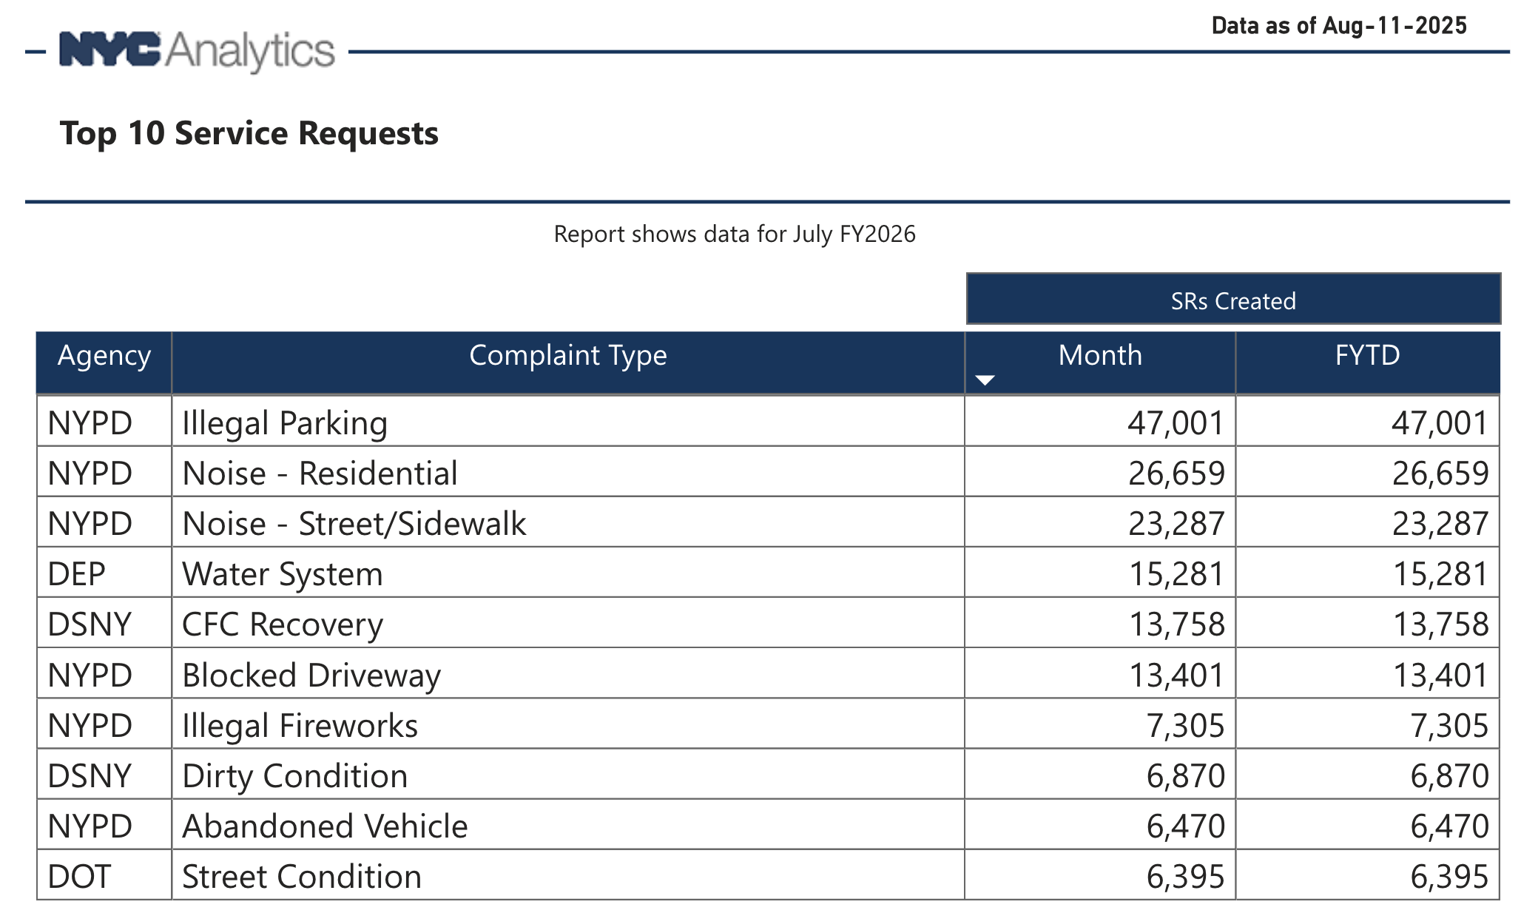
Figure No. 2, showing the ten most frequent 311 service requests and their responding agencies for August of FY2025 as well as the total number of complaints in FY2025 as of August 12, 2025.
  - 311 Noise and Rooftop Complaints
Noise is consistently one of the most frequent complaints registered through the City’s 311 system. As indicated by data from OTI’s Office of Data Analytics, “Noise - Residential” was the top service request in Fiscal Year 2021 and the second most common in Fiscal Years 2020, 2022, 2023, and 2024. Currently, 311 categorizes noise complaints into several broad types, including “Noise - Residential,” “Noise - Commercial,” and “Noise - Street/Sidewalk,” which are then routed to the NYPD.
In recent years, media reports have highlighted resident frustrations with recurring loud music and large crowds at gatherings on residential rooftops, which can last late into the night. According to these reports, rooftop gatherings are particularly prevalent in denser neighborhoods like the East Village. While other agencies such as the New York City Department of Health and Mental Hygiene (“ DOHMH”) specify when 311 incidents occur on a roof, NYPD does not provide specific data on the prevalence of noise complaints originating from rooftop activities. The lack of a specific 311 complaint category for rooftop noise makes it difficult to quantify the full scope of the problem citywide.
Beyond the noise disturbances, these gatherings often pose serious safety risks. Overcrowding on rooftops not designed for assembly can lead to structural dangers and an increased risk of falls. There have been several tragic incidents in recent years where individuals have fallen to their deaths from rooftop parties underscoring the potential dangers of unregulated rooftop gatherings.
The legality of using a rooftop for parties or events is determined by the building’s Certificate of Occupancy (“CO”) which specifies the legal use and occupancy of a building and is issued by the Department of Buildings (“DOB”). Furthermore, any space intended to accommodate 75 or more people requires a Place of Assembly Certificate of Operation (“PACO”) from the DOB. This certificate is only granted after the space has been deemed safe for large gatherings, with adequate exits and fire protection systems. It is unclear how many of the residential rooftops currently being used for parties possess the required CO designation or a PACO, suggesting that many of these events may be operating outside of legal requirements.
- Legislative Analysis
Int. No. 422
This bill would require the Department of Information Technology and Telecommunications (“DoITT”) to create a separate category for rooftop activity complaints on the 311 website and mobile app. The bill would further require the Department of Buildings to report annually on the number of City rooftops with recreational spaces indicated on a Certificate of Occupancy or indicated on a Place of Assembly Certificate of Operation.
This bill would take effect 1 year after becoming law.

Proposed Int. No. 422-A

By Council Members Rivera, Brewer, Louis, Banks, Feliz, Gutiérrez and Schulman

A Local Law to amend the administrative code of the city of New York, in relation to requiring the commissioner of information technology and telecommunications to create a separate 311 category for rooftop activity complaints and to require the commissioner of buildings to report annually regarding certain rooftop spaces

Be it enacted by the Council as follows:

Section 1. Chapter 3 of title 23 of the administrative code of the city of New York is amended by adding a new section 23-313 to read as follows:
§ 23-313 Rooftop activity complaints. a. The department of information technology and telecommunications shall implement and maintain on its 311 citizen center website and mobile device platforms the capability for the public to file a complaint under the category of “rooftop activity complaint.” This complaint category shall contain subcategories for “rooftop occupancy without proper certificate or permit complaints” and “exceeding authorized rooftop occupancy complaints” in order that each such complaint may be referred to the appropriate agency to take action as necessary to address the complaint.
b. The department of information technology and telecommunications shall implement and maintain on its 311 citizen center website and mobile device platforms the capability for the public to file a noise complaint from rooftop activity under the category “noise” with the subcategory “rooftop activity.”
c. With respect to complaints filed pursuant to subdivisions a and b, the public shall have the ability to submit photographic evidence or recordings supporting such complaints.
§ 2. Article 103 of chapter 1 of title 28 of the administrative code of the city of New York is amended by adding a new section § 28-103.38 to read as follows:
§ 28-103.38 Reporting regarding certain rooftop spaces. No later than March 31 of each year, the commissioner shall submit to the mayor and the speaker of the council and shall post on the department’s website a report on rooftop occupancy in the city. The report shall contain the following information for certificates of occupancy and place of assembly certificates of operation issued in the preceding year, disaggregated by community board:
1. The number of buildings with a roof deck, roof terrace, or other rooftop recreational space indicated on the certificate of occupancy for such building, and the building address;
2. The number of rooftops that have been issued a place of assembly certificate of operation, and the building address for each such rooftop; and
3. Any other information that the commissioner deems relevant.
§ 3. This local law takes effect 1 year after it becomes law.

Session 13
IB
LS #6119/6193
8/6/25 7:56 pm

Session 12
JB
LS #6119/6193
2/17/22 10:17am

See NYC311, https://portal.311.nyc.gov.
See About: Who We Are: NYC311, NYC Office of Technology and Innovation, https://www.nyc.gov/content/oti/pages/meet-the-team/nyc311.
See Mayor’s Management Report, City of New York, p. 185, September 2024, https://www.nyc.gov/assets/operations/downloads/pdf/mmr2024/2024_mmr.pdf.
Joe Morrisroe, Mayor’s Management Report, Office of Technology and Innovation, 311 Customer Service Center, p.3, https://www.nyc.gov/assets/operations/downloads/pdf/mmr2024/311.pdf.
Id.
See id.
The New York City Council Data Team consolidated the data and analysis for the top ten service requests by agency for FY20-23 using data from the Office of Data Analytics, https://www.nyc.gov/site/311reporting/311-reports/service-requests.page.
Id; Office of Data Analytics, https://www.nyc.gov/site/311reporting/311-reports/service-requests.page.
See Figure No. 1.
Valeria Ricciulli, East Village Rooftop Parties Are Out of Control — Can a New Bill Change That?, CURBED, https://www.curbed.com/2021/06/east-village-rooftop-parties-law-nyc.html.
Id.
DOB Urges New Yorkers to Stay Safe This Fourth Of July, DOB, https://www.nyc.gov/site/buildings/dob/pr-fourth-of-july-2025.page.
Kevin Rincon, 24-Year-Old Cameron Perrelli Falls To Her Death at East Village Rooftop Party, CBS2, https://www.cbsnews.com/newyork/news/woman-falls-east-village-rooftop/.
Certificate of Occupancy, DOB, https://www.nyc.gov/site/buildings/property-or-business-owner/certificate-of-occupancy.page.
Place of Assembly Certificate of Operation, DOB, https://www.nyc.gov/site/buildings/property-or-business-owner/place-of-assembly-certificate-of-operation.page.
Id.

