THE COUNCIL OF THE CITY OF NEW YORK
RESOLUTION NO. 765

Resolution approving the decision of the City Planning Commission on Application No.
N 240312 ZRQ, for an amendment of the text of the Zoning Resolution (L.U. No. 230).

By Council Members Salamanca and Riley

WHEREAS, Northern 167 Property, LLC, filed an application pursuant to Section 201 of the New York City Charter, for an amendment of the text of the Zoning Resolution of the City of New York, modifying APPENDIX F for the purpose of establishing a Mandatory Inclusionary Housing area, which in conjunction with the related action would facilitate the development of a new six-story mixed-use building containing commercial uses on the ground floor and approximately 94 dwelling units, of which an estimated 28 would be qualifying affordable units, located at 122-03 14th Avenue in the College Point neighborhood of Queens, Community District 7 (ULURP No. N 240312 ZRQ), (the “Application”);

WHEREAS, the City Planning Commission filed with the Council on January 10, 2025, its decision dated January 8, 2025 (the "Decision") on the Application;

WHEREAS, the Application is related to application C 240311 ZMQ (L.U. No. 229), a zoning map amendment to change from an R4A/C1-3 zoning district to an R6A/C2-4 zoning district;

WHEREAS, the Decision is subject to review and action by the Council pursuant to Section 197-d of the City Charter;

WHEREAS, upon due notice, the Council held a public hearing on the Decision and Application on January 29, 2025;

WHEREAS, the Council has considered the land use implications and other policy issues relating to the Decision and Application; and

WHEREAS, the Council has considered the relevant environmental issues, including the Negative Declaration issued on September 9th, 2024 (CEQR No. 24DCP130Q), which includes an (E) designation to avoid the potential for significant adverse impacts related to air quality and noise (E-801) (the “Negative Declaration”).

RESOLVED:

The Council finds that the action described herein will have no significant impact on the environment as set forth in the Negative Declaration.

Pursuant to Sections 197-d and 201 of the City Charter and on the basis of the Decision and Application, the environmental determination and consideration described in the report, N 240312 ZRQ, incorporated by reference herein, and the record before the Council, the Council approves the Decision of the City Planning Commission as set forth below.

Matter underlined is new, to be added;
Matter struck out is to be deleted;
Matter within # # is defined in Section 12-10;
* * * indicates where unchanged text appears in the Zoning Resolution

* * *

APPENDIX F

Mandatory Inclusionary Housing Areas and former Inclusionary Housing Designated Areas
* * *

QUEENS
* * *

Queens Community District 7
* * *
Map 5 – [date of adoption]

[PROPOSED MAP]

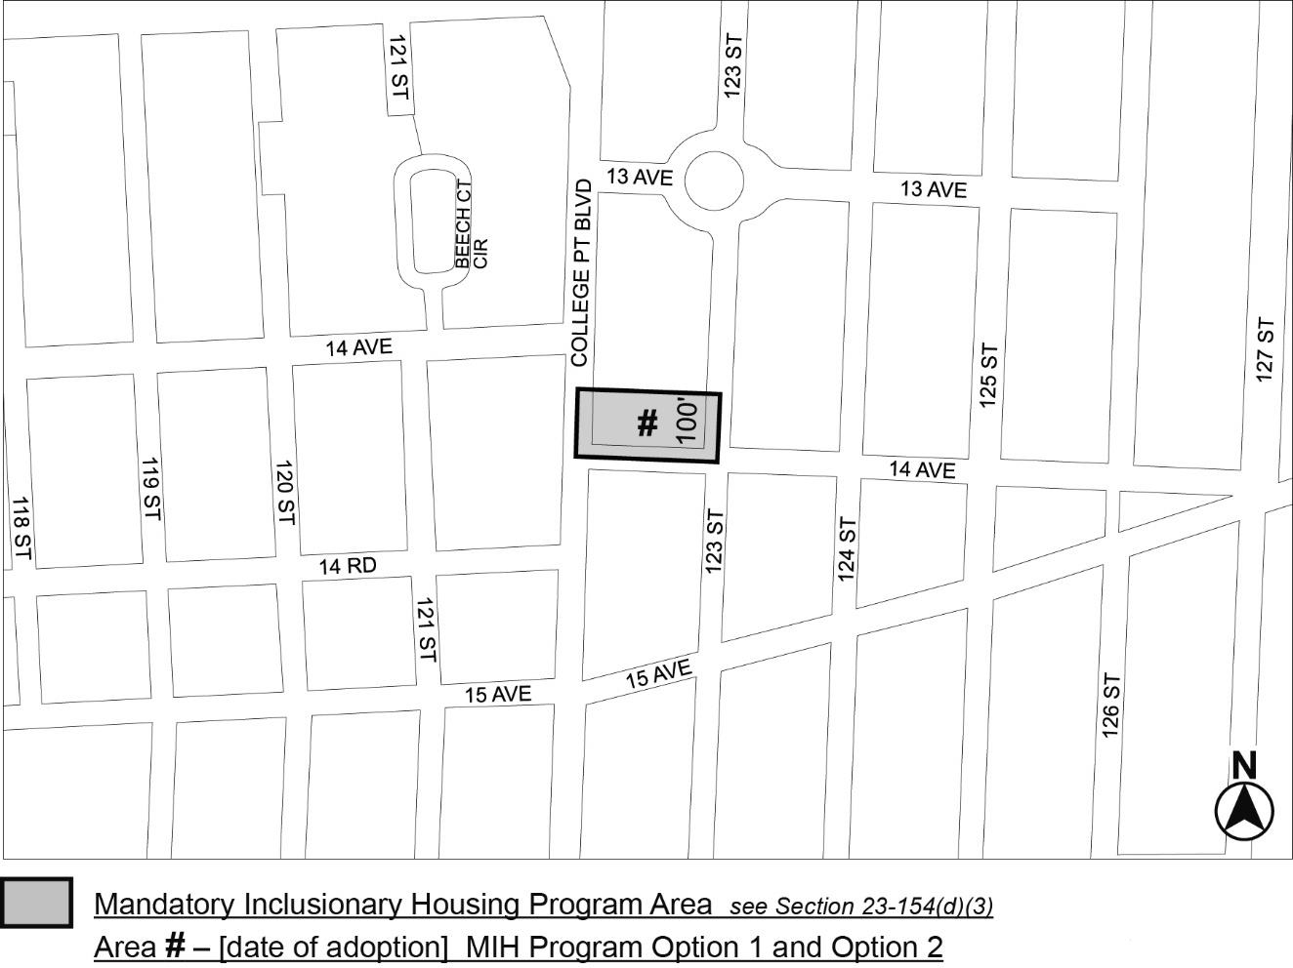

Portion of Community District 7, Queens
* * *

Adopted.

Office of the City Clerk,}
The City of New York, } ss.:

I hereby certify that the foregoing is a true copy of a Resolution passed by The Council of The City of New York on _________, 2025, on file in this office.

.....................................................
City Clerk, Clerk of The Council

