THE COUNCIL OF THE CITY OF NEW YORK
RESOLUTION NO. 511

Resolution approving the decision of the City Planning Commission on Application No. N 230352 ZRK, for an amendment of the text of the Zoning Resolution (L.U. No. 91).

By Council Members Salamanca and Riley

WHEREAS, 2118 Avenue U LLC, filed an application pursuant to Section 201 of the New York City Charter, for an amendment of the text of the Zoning Resolution of the City of New York, modifying APPENDIX F for the purpose of establishing a Mandatory Inclusionary Housing area which in conjunction with the related action for a zoning map amendment (C 230351 ZMK), would facilitate the development of a five-story, approximately 20,450-square-foot mixed-use development containing 15,650 square feet of residential space with 10 dwelling units, approximately three of which would be income restricted, as well as approximately 4,800 square feet of ground-floor commercial space at 2118 Avenue U (Block 7354, Lot 8) in the Sheepshead Bay neighborhood of Brooklyn, Community District 15 (ULURP No. N 230352 ZRK) (the “Application”);

WHEREAS, the City Planning Commission filed with the Council on May 31, 2024, its decision dated May 15, 2024 (the "Decision") on the Application;

WHEREAS, the Application is related to application C 230351 ZMK (L.U. No. 90), a zoning map amendment to change an R4/C1-3 zoning district to R6A/C2-4 and R4 zoning districts;

WHEREAS, the Decision is subject to review and action by the Council pursuant to Section 197-d of the City Charter;

WHEREAS, upon due notice, the Council held a public hearing on the Decision and Application on June 11, 2024;

WHEREAS, the Council has considered the land use implications and other policy issues relating to the Decision and Application; and

WHEREAS, the Council has considered the relevant environmental issues, including the Negative Declaration issued February 2, 2024 (CEQR No. 24DCP013K), which includes an (E) designation to avoid the potential for significant adverse impacts related to hazardous materials and air quality (E-746) (the “Negative Declaration”).

RESOLVED:

The Council finds that the action described herein will have no significant impact on the environment as set forth in the (E) Designation (E-746) and Negative Declaration.

Pursuant to Sections 197-d and 200 of the City Charter and on the basis of the Decision and Application, and based on the environmental determination and consideration described in the City Planning Commission report, N 230352 ZRK, incorporated by reference herein, and the record before the Council, the Council approves the Decision of the City Planning Commission.

Matter underlined is new, to be added;
Matter struck out is to be deleted;
Matter within # # is defined in Section 12-10;
* * * indicates where unchanged text appears in the Zoning Resolution

* * *
APPENDIX F
Inclusionary Housing Designated Areas and Mandatory Inclusionary Housing Areas

* * *
BROOKLYN
* * *
Brooklyn Community District 15
* * *

[PROPOSED MAP]
Map 6 – [date of adoption]

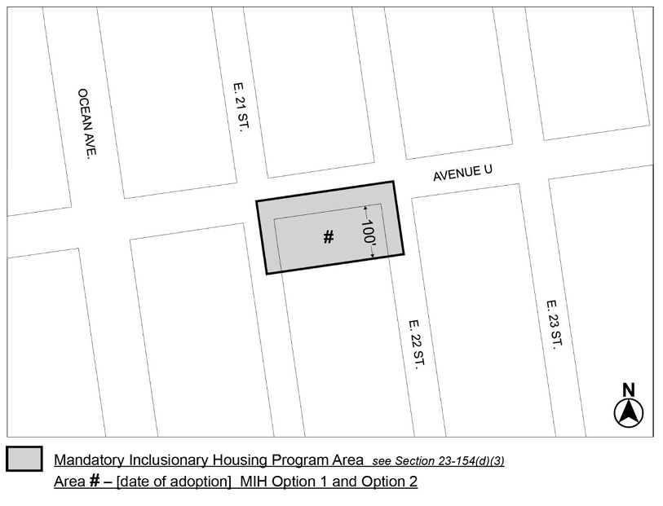
Portion of Community District 15, Brooklyn

* * *

Adopted.

Office of the City Clerk,}
The City of New York,} ss.:

I hereby certify that the foregoing is a true copy of a Resolution passed by The Council of The City of New York on July 18, 2024, on file in this office.

.....................................................
City Clerk, Clerk of The Council

