THE COUNCIL OF THE CITY OF NEW YORK
RESOLUTION NO. 607

Resolution approving with modifications the decision of the City Planning Commission on Application No. N 180187 ZRK (L.U. No. 249), for an amendment of the Zoning Resolution of the City of New York, modifying Appendix F for the purpose of establishing a Mandatory Inclusionary Housing area, Community District 12, Borough of Brooklyn.

By Council Members Salamanca and Moya

WHEREAS, the City Planning Commission filed with the Council on September 28, 2018 its decision dated September 26, 2018 (the "Decision"), pursuant to Section 201 of the New York City Charter, regarding an application submitted by 39 Group, Inc., for an amendment of the text of the Zoning Resolution of the City of New York, modifying Appendix F for the purpose of establishing a Mandatory Inclusionary Housing area, which in conjunction with the related action would facilitate the development of a new six-story mixed-use building containing approximately 40 residential units, including 10 permanently affordable units, and ground floor retail in the Borough Park neighborhood of Brooklyn Community District 12, (Application No. N 180187 ZRK), Community District 12, Borough of Brooklyn (the "Application");

WHEREAS, the Application is related to application C 180186 ZMK (Pre. L.U. No. 248), a zoning map amendment to change an M1-2 zoning district to an R7A/C2-4 zoning district;

WHEREAS, the Decision is subject to review and action by the Council pursuant to Section 197-d(b)(1) of the City Charter;
WHEREAS, upon due notice, the Council held a public hearing on the Decision and Application on October 3, 2018;

WHEREAS, the Council has considered the land use implications and other policy issues relating to the Decision and Application; and

WHEREAS, the Council has considered the relevant environmental issues, including the negative declaration issued May 7, 2018 (CEQR No. 18DCP107K), which includes an (E) designation to avoid the potential for significant adverse impacts related to hazardous materials, air quality and noise and would apply to the sites Block 5583, Lot 6 (Projected Development Site 1), Block 5583, Lots 12, 13, and 15 (Projected Development Site 2), and Block 5583, Lots 16 and 17 (Projected Development Site 3) (E-479) (the “Negative Declaration”).

RESOLVED:

The Council finds that the action described herein will have no significant impact on the environment as set forth in the Negative Declaration.

Pursuant to Section 200 of the City Charter and on the basis of the Decision and Application, and based on the environmental determination and consideration described in the report, N 180187 ZRK, incorporated by reference herein, and the record before the Council, the Council approves the Decision of the City Planning Commission with the following modifications.

Matter underlined is new, to be added;
Matter struck out is to be deleted;
Matter within # # is defined in Section 12-10;
Matter double struck out is old, deleted by the City Council;
Matter double-underlined is new, added by the City Council;

* * * indicates where unchanged text appears in the Zoning Resolution

* * *

APPENDIX F
Inclusionary Housing Designated Areas and Mandatory Inclusionary Housing Areas

* * *

BROOKLYN

* * *
Brooklyn Community District 12

* * *

Map 1 - [date of adoption]

[PROPOSED MAP]

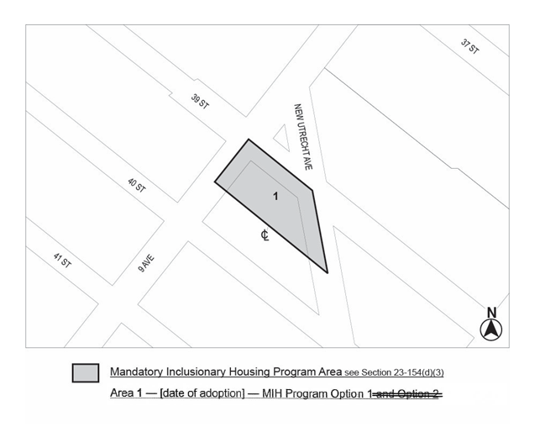
Portion of Community District 12, Brooklyn

* * *

Adopted.

Office of the City Clerk, }
The City of New York, } ss.:

I hereby certify that the foregoing is a true copy of a Resolution passed by The Council of The City of New York on October 31, 2018, on file in this office.

.....……......................................... City Clerk, Clerk of The Council

