THE COUNCIL OF THE CITY OF NEW YORK
RESOLUTION NO. 1745

Resolution approving the decision of the City Planning Commission on Application No. N 170362 ZRM, for an amendment of the Zoning Resolution of the City of New York, modifying Appendix F for the purpose of establishing a Mandatory Inclusionary Housing area in Community District 11, Borough of Manhattan (L.U. No. 777).

By Council Members Greenfield and Richards

WHEREAS, the City Planning Commission filed with the Council on October 2, 2017 its decision dated October 2, 2017 (the "Decision"), pursuant to Section 201 of the New York City Charter, regarding an application submitted by the New York City Department of Housing Preservation and Development, for an amendment of the text of the Zoning Resolution of the City of New York, modifying Appendix F for the purpose of establishing a Mandatory Inclusionary Housing area, which in conjunction with the related actions would facilitate the development of three predominately residential mixed-use buildings containing approximately 655 affordable dwelling units, commercial and community facility floor area, community gardens, and publicly accessible open space in Manhattan Community District 11, (Application No. N 170455 ZRK), Community District 11, Borough of Manhattan (the "Application");

WHEREAS, the Application is related to applications C 170361 ZMM (L.U. No. 776), a zoning map amendment to change existing R7-2 and R7-2/C1-4 districts to R9 and R9/C2-5 districts; C 170363 HAM (L.U. No. 778), an Urban Development Action Area Project (UDAAP) designation and project approval and the disposition of City-owned property; C 170364 PQM (L.U. No.779), an acquisition of a portion of the disposition area by the City for community garden use; C 170365 ZSM (L.U. No. 780), a special permit to modify the height and setback and yard requirements within a Large-Scale General Development; C 170366 ZSM (L.U. No. 781), a special permit to allow commercial use above the second story within a mixed-use building within a Large-Scale General Development; C 170367 ZSM (L.U. No. 782) a special permit to modify parking requirements within a Large Scale General Development; and 20185083 (L.U. No. 790), a real property tax exemption;

WHEREAS, the Decision is subject to review and action by the Council pursuant to Section 197-d(b)(1) of the City Charter;
WHEREAS, upon due notice, the Council held a public hearing on the Decision and Application on October 11, 2017;

WHEREAS, the Council has considered the land use implications and other policy issues relating to the Decision and Application; and

WHEREAS, the Council has considered the relevant environmental issues, including the Final Environmental Impact Statement (FEIS) for which a Notice of Completion was issued on September 19, 2017 (CEQR No. 17DCP048M), and the Technical Memoranda dated September 29, 2017, (the “Technical Memoranda”);

RESOLVED:

Having considered the FEIS and the Technical Memoranda with respect to the Decision and Application, the Council finds that:

(1) The FEIS meets the requirements of 6 N.Y.C.R.R. Part 617;

(2) Consistent with social, economic and other essential considerations from among the reasonable alternatives available, the action is one which avoids or minimizes adverse environmental impacts to the maximum extent practicable; and

(3) The adverse environmental impacts identified in the Sendero Verde Development Alternative of the FEIS will be minimized or avoided to the maximum extent practicable by incorporating as conditions to the approval, pursuant to the Land Disposition Agreement(s) with the City, those project components related to the environment and mitigation measures determined to be practicable.

The Decision, together with the FEIS and the Memoranda constitute the written statement of facts, and of social, economic and other factors and standards that form the basis of this determination, pursuant to 6 N.Y.C.R.R. §617.11(d).

Pursuant to Sections 197-d and 200 of the City Charter and on the basis of the Decision and Application, and based on the environmental determination and consideration described in the report, N 170362 ZRM, incorporated by reference herein, the Council approves the Decision of the City Planning Commission.

Matter underlined is new, to be added; Matter struck out is to be deleted;
Matter within # # is defined in Section 12-10;
* * * indicates where unchanged text appears in the Zoning Resolution

* * *

APPENDIX F
Inclusionary Housing Designated Areas and Mandatory Inclusionary Housing Areas

* * *

MANHATTAN

* * *

Manhattan Community District 11

* * *

In the R9 District within the areas shown on the following Map 2:

* * *
Map 2 - (date of adoption)

[PROPOSED MAP]
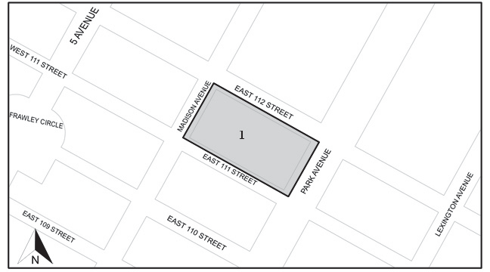

Mandatory Inclusionary Housing Program Area see Section 23-154(d)(3)
Area 1 (date of adoption) - MIH Program Option 1 and Deep Affordability Option

Portion of Community District 11, Manhattan

* * *

Adopted
Office of the City Clerk, }
The City of New York, } ss.:

I hereby certify that the foregoing is a true copy of a Resolution passed by The Council of The City of New York on November 30, 2017, on file in this office.

.....…….........................................
City Clerk, Clerk of The Council

