THE COUNCIL OF THE CITY OF NEW YORK
RESOLUTION NO. 1092

Resolution approving the decision of the City Planning Commission on Application No. N 250222 ZRX, for an amendment of the text of the Zoning Resolution (L.U. No. 367).

By Council Members Salamanca and Riley

WHEREAS, the New York City Department of Housing Preservation and Development (HPD), filed an application pursuant to Section 201 of the New York City Charter, for an amendment of the text of the Zoning Resolution of the City of New York, modifying APPENDIX F for the purpose of establishing a Mandatory Inclusionary Housing area (ULURP No. N 250222 ZRX) (the “Application”);

WHEREAS, the City Planning Commission filed with the Council on September 2, 2025, its decision dated August 13, 2025 (the “Decision”) on the Application;

WHEREAS, the Application is related to applications C 250220 HAX (L.U. No. 365), an Urban Development Action Area designation (UDAA), Urban Development Action Area Project (UDAAP), and disposition of city-owned property; and C 250221 ZMX (L.U. No. 366), a zoning map amendment to change an R7-1 zoning district to R8; and G 250083 XAX (L.U. 382), requesting approval for an exemption from real property taxation pursuant to Article XI of the Private Housing Finance Law;

WHEREAS, the Decision is subject to review and action by the Council pursuant to Section 197-d of the City Charter;

WHEREAS, upon due notice, the Council held a public hearing on the Decision and Application on September 30, 2025;

WHEREAS, the Council has considered the land use implications and other policy issues relating to the Decision and Application; and

WHEREAS, the Council has considered the relevant environmental issues, including the Negative Declaration issued on March 26, 2025 (CEQR No. 23HPD093X), which includes measures to avoid the potential for significant adverse impacts related to hazardous materials through an (E) designation (E-809) and noise through provisions contained in a Land Disposition Agreement and Regulatory Agreement between the Project Sponsor and HPD (the “Negative Declaration”) and a technical memorandum evaluating potential significant adverse impacts to disadvantaged communities was issued on May 1, 2025 (the “Technical Memorandum”), which concluded that the proposed actions are not expected to cause or increase a disproportionate pollution burden to disadvantaged communities.

RESOLVED:

The Council finds that the action described herein will have no significant impact on the environment as set forth in the Negative Declaration, the (E) Designation (E-809) and the Technical Memorandum.

Pursuant to Sections 197-d and 200 of the City Charter and on the basis of the Decision and Application, the environmental determination and consideration described in the report, N 250222 ZRX, incorporated by reference herein, and the record before the Council, the Council approves the Decision of the City Planning Commission.

Matter underlined is new, to be added;
Matter struck out is to be deleted;
Matter within # # is defined in Section 12-10;
* * * indicates where unchanged text appears in the Zoning Resolution.

* * *

APPENDIX F

Mandatory Inclusionary Housing Areas and former Inclusionary Housing Designated Areas

THE BRONX

* * *

The Bronx Community District 4

* * *

Map 4 - [date of adoption]

[PROPOSED MAP]
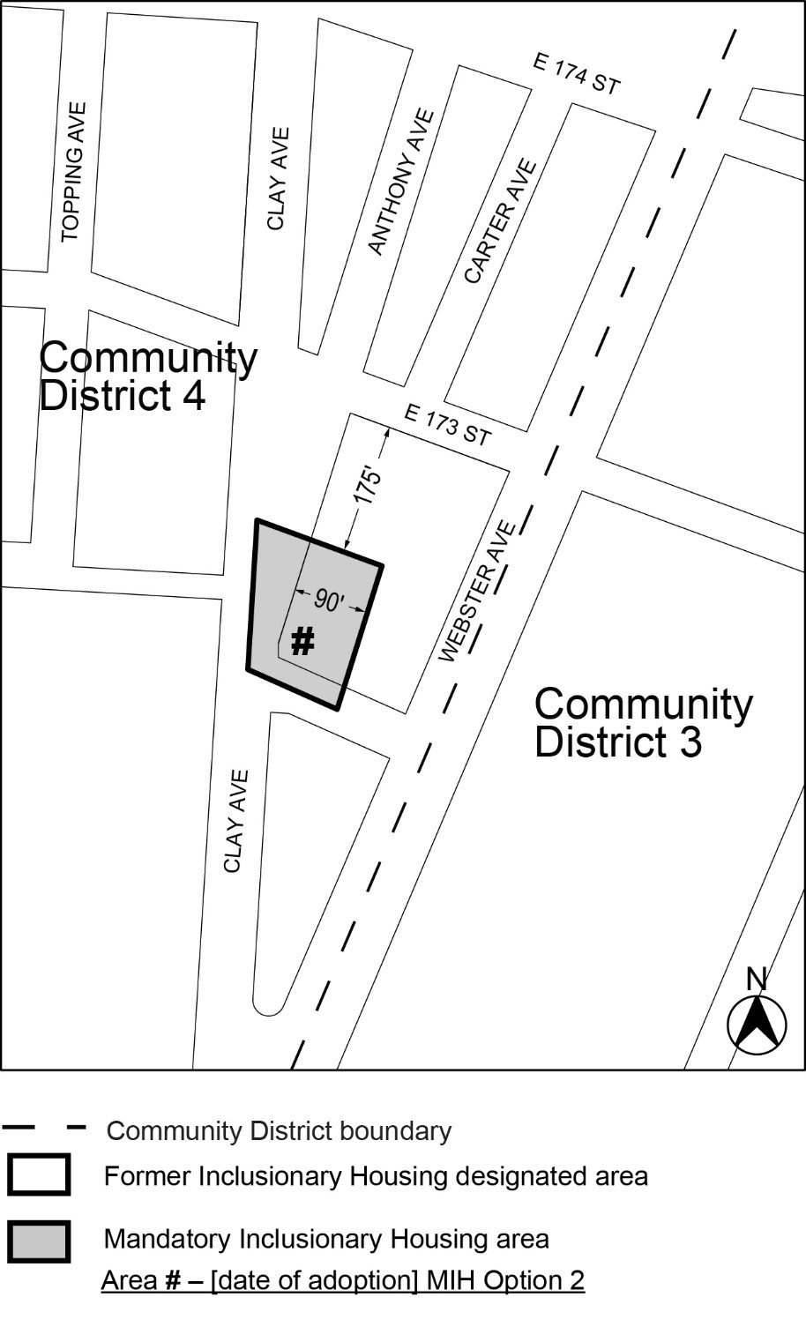
Portion of Community District 4, The Bronx.

* * *

Adopted.

Office of the City Clerk,}
The City of New York, } ss.:

I hereby certify that the foregoing is a true copy of a Resolution passed by The Council of The City of New York on _________, 2025, on file in this office.

.....................................................
City Clerk, Clerk of The Council

