THE COUNCIL OF THE CITY OF NEW YORK
RESOLUTION NO. 881

Resolution approving the decision of the City Planning Commission on Application No. N 160176 ZRK, for an amendment of the text of the Zoning Resolution (L.U. No. 392).

By Council Members Salamanca, Jr. and Moya

WHEREAS, the City Planning Commission filed with the Council on April 8, 2019 its decision dated April 8, 2019 (the "Decision"), on the application submitted by 1050 Pacific Street, LLC, pursuant to Section 201 of the New York City Charter, for an amendment of the text of the Zoning Resolution of the City of New York, modifying Article XII, Chapter 3 (Special Mixed Use District) for the purpose of establishing a Special Mixed Use District (MX-20) and modifying APPENDIX F for the purpose of establishing a Mandatory Inclusionary Housing area utilizing Options 1 and 2 on Block 1134, Lots 2, 4, 5, 7, 8, 9, 11, 12, 96, and 97, and portions of Lots 81 and 17, which in conjunction with the related action would facilitate an eight-story mixed-use development with 105,670 square feet of floor area; 103 dwelling units, 33 of which would be permanently affordable; 15,790 square feet of commercial space on the ground floor; and 42 below-grade accessory parking at 1050 Pacific Street in the Crown Heights neighborhood of Brooklyn, Community District 8, (Application No. N 160176 ZRK), (the "Application");

WHEREAS, the Application is related to application C 160175 ZMK (L.U. No. 391), a zoning map amendment to rezone an M1-1 district to an M1-4/R7A district;

WHEREAS, the Decision is subject to review and action by the Council pursuant to Section 197-d(b)(1) of the City Charter;

WHEREAS, upon due notice, the Council held a public hearing on the Decision and Application on April 16, 2019;

WHEREAS, the Council has considered the land use implications and other policy issues relating to the Decision and Application; and

WHEREAS, the Council has considered the relevant environmental issues, including the Negative Declaration issued October 29th, 2018 (CEQR No. 17DCP205K) which include an (E) designation to avoid the potential for significant adverse impacts related to hazardous materials, air quality, and noise (the “E” Designation (E-510)).

RESOLVED:

The Council finds that the action described herein will have no significant impact on the environment as set forth in the (E) Designation (E-510) and Negative Declaration.

Pursuant to Sections 197-d and 200 of the City Charter and on the basis of the Decision and Application, and based on the environmental determination and consideration described in the report, N 160176 ZRK, incorporated by reference herein, and the record before the Council, the Council approves the Decision of the City Planning Commission.

Matter underlined is new, to be added;
Matter struck out is to be deleted;
Matter within # # is defined in Section 12-10;
* * * indicates where unchanged text appears in the Zoning Resolution

ARTICLE XII
SPECIAL PURPOSE DISTRICTS

Chapter 3
Special Mixed Use District

* * *

123-63
Maximum Floor Area Ratio and Lot Coverage Requirements for Zoning Lots Containing Only Residential Buildings in R6, R7, R8 and R9 Districts

* * *

#Special Mixed Use District# | Designated #Residence District#
MX-1 – Community District 1, The Bronx | R6A R7D
MX 2 - Community District 2, Brooklyn | R7A R8A
MX 4 – Community District 3, Brooklyn | R6A
MX 8 - Community District 1, Brooklyn | R6 R6A R6B R7A
MX 11 - Community District 6, Brooklyn | R7-2
MX 13 – Community District 1, The Bronx | R6A R7A R7X R8A
MX 14 - Community District 6, The Bronx | R7A R7X
MX 16 - Community Districts 5 and 16, Brooklyn | R6A R7A R7D R8A
MX 20 – Community District 8, Brooklyn | R7A

* * *

123-90
SPECIAL MIXED USE DISTRICTS SPECIFIED

The #Special Mixed Use District# is mapped in the following areas:

* * *

#Special Mixed Use District# - 17: (3/22/18)
Hunts Point, the Bronx

The #Special Mixed Use District# - 17 is established in Hunts Point in The Bronx as indicated on the #zoning maps#.

#Special Mixed Use District# - 20: [date of adoption]
Crown Heights West, Brooklyn

The #Special Mixed Use District# - 20 is established in Crown Heights West in Brooklyn
as indicated on the #zoning maps#.

* * *

APPENDIX F

Inclusionary Housing Designated Areas and Mandatory Inclusionary Housing Areas

* * *

BROOKLYN
* * *

Brooklyn Community District 8

Map 1 - (date of adoption)
[EXISTING MAP]

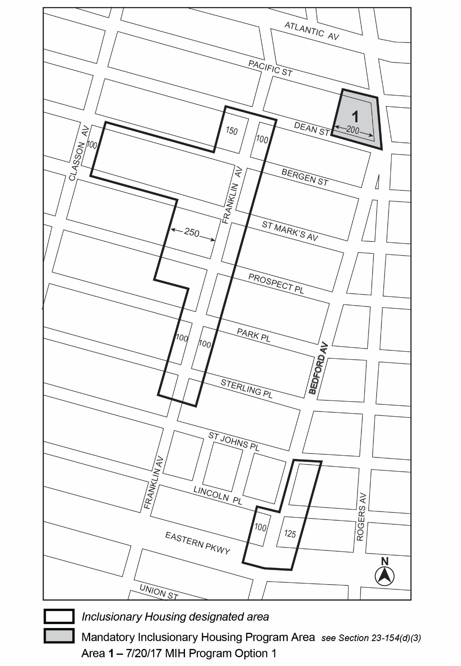

[PROPOSED MAP]
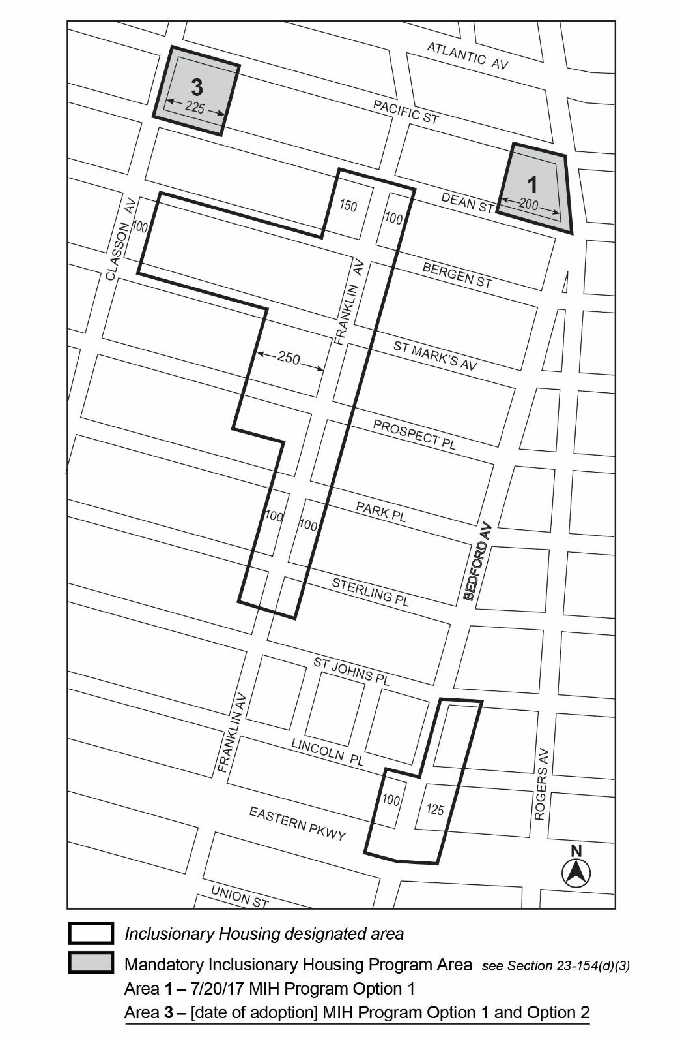

Portion of Community District 8, Brooklyn

* * *

Adopted.

Office of the City Clerk, }
The City of New York, } ss.:

I hereby certify that the foregoing is a true copy of a Resolution passed by The Council of The City of New York on May 8, 2019, on file in this office.

.....…….........................................
City Clerk, Clerk of The Council

