THE COUNCIL OF THE CITY OF NEW YORK
RESOLUTION NO. 273

Resolution approving with modifications the decision of the City Planning Commission on Application No. N 220233 ZRQ, for an amendment of the text of the Zoning Resolution (L.U. No. 68).

By Council Members Salamanca and Louis

WHEREAS, the New York City Department of Housing Preservation and Development (HPD), filed an application pursuant to Section 201 of the New York City Charter, for an amendment of the text of the Zoning Resolution of the City of New York, modifying Article XIII, Chapter 7 (Special Coastal Risk District) to establish the Special Coastal Risk District in Edgemere, Queens, and modifying APPENDIX F to establish Mandatory Inclusionary Housing areas, which in conjunction with the related actions would facilitate a long-term land-use, development, and neighborhood strategy responding to the area’s flood risk on 166 acres of property generally bounded by Beach 35th Street, Rockaway Freeway, Rockaway Beach Boulevard, Beach 51st Street, and Jamaica Bay in the Edgemere neighborhood of Queens, Community District 14 (ULURP No. N 220233 ZRQ) (the “Application”);

WHEREAS, the City Planning Commission filed with the Council on May 20, 2022, its decision dated May 11, 2022 (the “Decision”), on the Application;

WHEREAS, the Application is related to application C 220232 ZMQ (L.U. No. 67), a zoning map amendment to eliminate C1-2 and C2-2 districts, change R4, R4-1, R5, C3 and C8-1 Districts to R3A, R4-1, R6A, and C3A Districts and establish C2-4 Districts and a Special Coastal Risk District (CR); C 220235 PPQ (L.U. No. 69), a disposition of city-owned property; C 220236 HAQ (L.U. No. 70), an Urban Development Action Area (UDAA) designation, project approval (UDAAP) and disposition of city-owned property; and C 220237 HUQ (L.U. No. 71), an amendment to the Edgemere Urban Renewal Plan (URP);

WHEREAS, the Decision is subject to review and action by the Council pursuant to Section 197-d of the City Charter;

WHEREAS, upon due notice, the Council held a public hearing on the Decision and Application on June 7, 2022;

WHEREAS, the Council has considered the land use implications and other policy issues relating to the Decision and Application; and

WHEREAS, the Council has considered the relevant environmental issues, including the Positive Declaration issued December 18th, 2020 (CEQR No. 21HPD009Q) and a Final Environmental Impact Statement (FEIS) for which a Notice of Completion was issued on April 29, 2022, in which potential significant adverse impacts related to hazardous materials, air quality, and noise would be avoided through the placement of (E) designations (E-655) on the project site. The original application as analyzed in the FEIS identified significant adverse impacts related to community facilities (early childhood programs), open space (active recreation), transportation (traffic, transit, and safety), air quality (mobile sources), and construction (noise) at certain locations, and the identified significant adverse impacts and proposed mitigation measures are summarized in Chapter 19, “Mitigation” and Chapter 20, “Alternatives” of the FEIS. The Council has also considered the Technical Memorandum dated [__________].

RESOLVED:

Having considered the FEIS with respect to the Decision and Application, the Council finds that:

- The FEIS meets the requirements of 6 N.Y.C.R.R. Part 617;

- Consistent with social, economic and other essential considerations, from among the reasonable alternatives thereto, the action is one which minimizes or avoids adverse environmental impacts to the maximum extent practicable; and

- The adverse environmental impacts disclosed in the FEIS will be minimized or avoided to the maximum extent practicable by incorporating, as conditions to the approval, those mitigation measures that were identified as practicable.

The Decision, together with the FEIS constitute the written statement of facts, and of social, economic and other factors and standards that form the basis of this determination, pursuant to 6 N.Y.C.R.R. §617.11(d).

Pursuant to Sections 197-d and 200 of the City Charter and on the basis of the Decision and Application, and based on the environmental determination and consideration described in the report, N 220233 ZRQ, incorporated by reference herein, and the record before the Council, the Council approves the Decision of the City Planning Commission with the following modifications:

Matter underlined is new, to be added;
Matter struck out is to be deleted;
Matter within # # is defined in Section 12-10;
* * * indicates where unchanged text appears in the Zoning Resolution
Matter double struck out is old, deleted by the City Council;
Matter double-underlined is new, added by the City Council

* * *

ARTICLE XIII
SPECIAL PURPOSE DISTRICTS

* * *

Chapter 7
Special Coastal Risk District (CR)

* * *

137-10
GENERAL PROVISIONS

* * *

137-11
District Plan and Maps

The District Maps are located in the Appendix to this Chapter and are hereby incorporated and made part of this Resolution. They are incorporated for the purpose of specifying locations where special regulations and requirements set forth in this Chapter apply.

Map 1 #Special Coastal Risk District# 1 (CR-1), in Broad Channel, Community District 14, Borough of Queens

Map 2 #Special Coastal Risk District# 2 (CR-2), in Hamilton Beach, Community District 10, Borough of Queens

Map 3 #Special Coastal Risk District# 3 (CR-3), encompassing New York State Enhanced Buyout Areas in Graham Beach and Ocean Breeze, Community District 2, Borough of Staten Island

Map 4 #Special Coastal Risk District# 3 (CR-3), encompassing New York State Enhanced Buyout Areas in Oakwood Beach, Community District 3, Borough of Staten Island

Map 5 #Special Coastal Risk District# 4 (CR-4), in Gerritsen Beach, Community District 15, Borough of Brooklyn.

Map 6 #Special Coastal Risk District# 5 (CR-5), in Edgemere, Community District 14, Borough of Queens.

137-12
Applicability of Special Regulations

The special #use# and #bulk# regulations of this Chapter shall apply in the #Special Coastal Risk District# as set forth in the following table:

SPECIAL REGULATIONS

#Special Coastal Risk District# | #Residential Use# (137-21) | #Community Facility Use# (137-22) | Modified #Bulk# Requirements (137-31) | Modifications to Article V (137-40) | Special Requirements (137-50)
CR–1 (Broad Channel, Queens) | x | x
CR–2 (Hamilton Beach, Queens) | x | x | x
CR–3 (buyout areas, Staten Island) | x | x |  | x | x
CR–4 (Gerritsen Beach, Brooklyn) | x | x | x
CR–5 (Edgemere, Queens) | x | x

137-20
SPECIAL USE REGULATIONS

The special #use# regulations of this Section 137-20, inclusive, shall apply in the #Special Coastal Risk Districts# as set forth in the table in Section 137-12 (Applicability of Special Regulations).

137-21
Residential Use

In #Special Coastal Risk Districts#, #residential uses# shall be permitted as follows:

(a) In #Special Coastal Risk Districts# 1 and 3, #residential uses# shall be limited to #single-family detached residences#.

(b) In #Special Coastal Risk District# 2, #residential uses# shall be limited to #single-# or #two-family detached residences#.

(c) In #Special Coastal Risk District# 4, #residential uses# shall be permitted as follows:

(a) (1) for #zoning lots# with a #lot area# of less than 3,000 square feet, #residential uses#
shall be limited to #detached# or #semi-detached single-family residences#; and

(b) (2) for #zoning lots# with a #lot area# of 3,000 square feet or more, #residential uses#
shall be limited to #detached# or #semi-detached# #single-# or #two-family
residences#.

(d) In #Special Coastal Risk District# 5, #residential uses# shall be permitted as follows:

(1) in R3A and C3A Districts, #residential uses# shall be limited to #single-family detached residences#; and

(2) in R4-1 Districts:

(i) for #zoning lots# with a #lot width# of less than 25 feet, #residential uses# shall be limited to #single-family detached residences#; and

(ii) for #zoning lots# with a #lot width# of 25 feet or more, #residential uses# shall be limited to #single-# or #two-family detached residences#.

The inclusion of #accessory# #residential uses# shall not be precluded by the provisions of this Section.

137-22
Community Facility Use

* * *

APPENDIX
Special Coastal Risk District Plan

* * *

Map 6 – Special Coastal Risk District 5, in Edgemere, Community District 14, Borough of Queens [date of adoption]

[PROPOSED MAP]

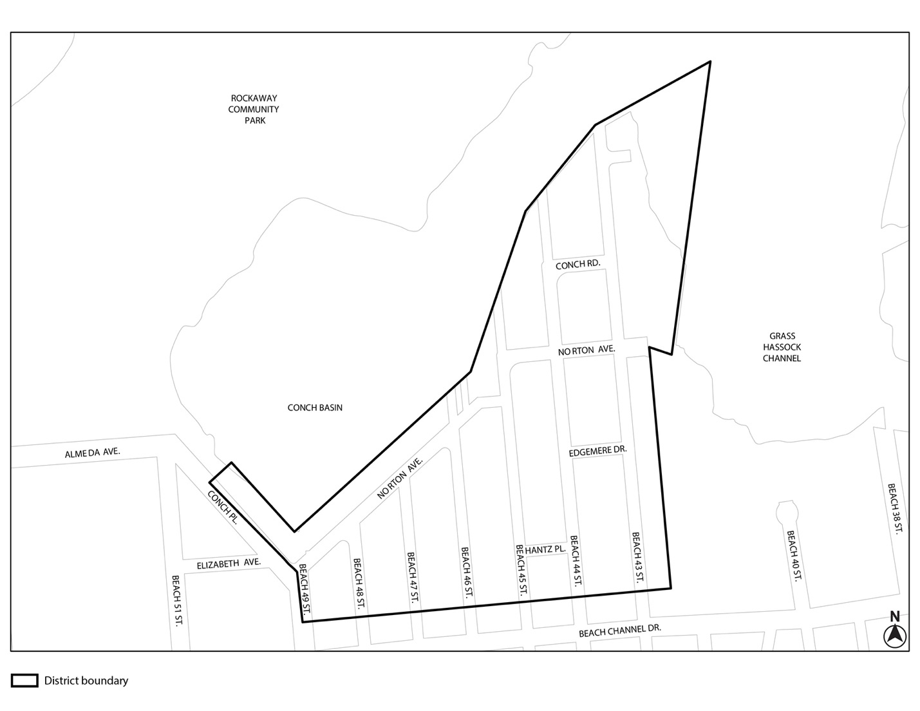
* * *

APPENDIX F – Inclusionary Housing Designated Areas and Mandatory Inclusionary Housing Areas

* * *

APPENDIX F

QUEENS

* * *

Queens Community District 14

* * *

Map 3 – (11/14/19) [date of adoption]

[EXISTING MAP]

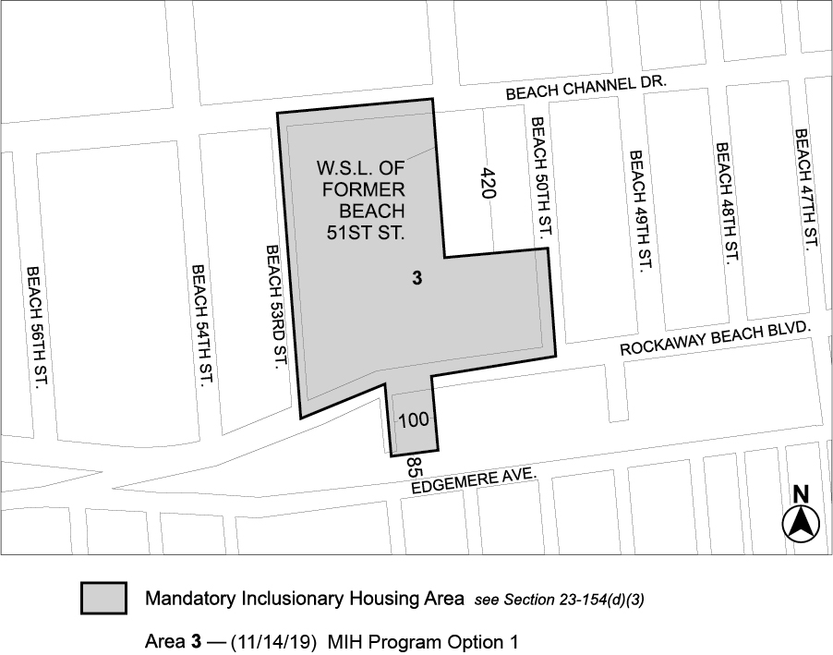

[PROPOSED MAP]

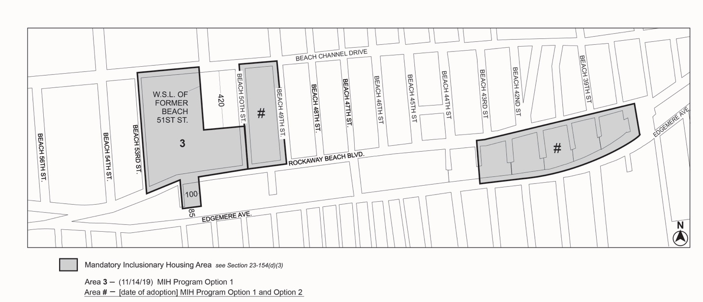

[PROPOSED MAP]

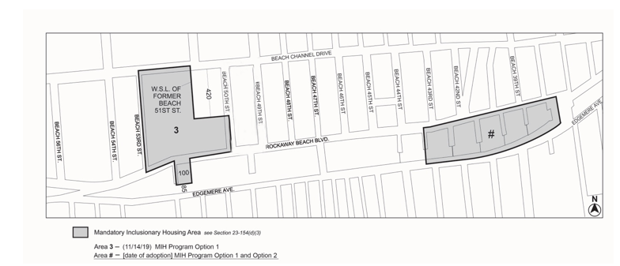

Portion of Community District 14, Queens

* * *
Adopted.

Office of the City Clerk, }
The City of New York, } ss.:

I hereby certify that the foregoing is a true copy of a Resolution passed by The Council of The City of New York on ____________, 2022, on file in this office.

.....................................................
City Clerk, Clerk of The Council

