THE COUNCIL OF THE CITY OF NEW YORK
RESOLUTION NO. 1795

Resolution approving with modifications the decision of the City Planning Commission on Application No. N 170446 ZRX, for an amendment of the Zoning Resolution of the City of New York, to modify the text of the special permit for non-profit hospital staff dwellings in Article VII, Chapter 4, and to modify Appendix F for the purpose of establishing a Mandatory Inclusionary Housing area in Community District 11, Borough of the Bronx (L.U. No. 803).

By Council Members Greenfield and Richards

WHEREAS, the City Planning Commission filed with the Council on October 20, 2017 its decision dated October 18, 2017 (the "Decision"), pursuant to Section 201 of the New York City Charter, regarding the application submitted by 1776 Eastchester Realty LLC, Hutch 34 Industrial Street, LLC and Hutch 35 LLC, for an amendment of the text of the Zoning Resolution of the City of New York, to modify the text of the special permit for non-profit hospital staff dwellings in Article VII, Chapter 4, and to modify Appendix F for the purpose of establishing a Mandatory Inclusionary Housing area. This zoning text amendment in conjunction with the related actions would facilitate the development of 182 units of non-profit hospital staff housing above an existing parking garage (Application No. N 170446 ZRX), Community District 11, Borough of the Bronx (the "Application");

WHEREAS, the Application is related to applications C 170445 ZMX (L.U. No. 802), zoning map amendment to change an M1-1 district to R5, C4-2, and C4-2A districts; and C 170447 ZSX (L.U. No. 804), zoning special permit to allow for construction of non-profit hospital staff dwellings;

WHEREAS, the Decision is subject to review and action by the Council pursuant to Section 197-d(b)(1) of the City Charter;
WHEREAS, upon due notice, the Council held a public hearing on the Decision and Application on November 14, 2017;

WHEREAS, the Council has considered the land use implications and other policy issues relating to the Decision and Application; and

WHEREAS, the Council has considered the relevant environmental issues, including the revised environmental assessment statement and negative declaration issued October 13, 2017 (CEQR No. 17DCP165X), which includes an (E) designation to avoid the potential for significant adverse impacts related to hazardous materials, air quality and noise (E-436) (the “Revised Environmental Assessment Statement” and the “Revised Negative Declaration”);

RESOLVED:

The Council finds that the action described herein will have no significant impact on the environment as set forth in the Revised Environmental Assessment Statement and the Revised Negative Declaration.

Pursuant to Sections 197-d and 200 of the City Charter and on the basis of the Decision and Application, and based on the environmental determination and consideration described in the report, N 170446 ZRX, incorporated by reference herein, the Council approves the Decision of the City Planning Commission with the following modifications:

Matter underlined is new, to be added;
Matter struck out is to be deleted;
Matter within # # is defined in Section 12-10;
Matter double strike-out is old, deleted by the City Council;
Matter double underlined is new, added by the City Council;
* * * indicates where unchanged text appears in the Zoning Resolution.

* * *

ARTICLE VII
ADMINISTRATION

Chapter 4
Special Permits by the City Planning Commission

* * *

74-70
NON-PROFIT HOSPITAL STAFF DWELLINGS

The City Planning Commission may permit #non-profit hospital staff dwellings# in accordance with the conditions of paragraph (a) of this Section, provided that the findings of paragraph (b) are met.

- The Commission may permit:

  - In in all #Residence Districts#, or in C1, C2, C3, C4, C5, C6 or C7 Districts, the City Planning Commission may permit #non-profit hospital staff dwellings# located on a #zoning lot#, no portion of which is located more than 1,500 feet from the non-profit or voluntary hospital and related facilities, provided that the following findings are made:; or

  - in C4-2 Districts without a letter suffix, in Community District 11 in the Borough of the Bronx, #non-profit hospital staff dwellings# on #zoning lots# located not more than 1,500 feet from the non-profit or voluntary hospital and related facilities.

- To permit such #non-profit hospital staff dwellings#, the Commission shall find:

(a)(1) that the #bulk# of such #non-profit hospital staff dwelling# and the density of population housed on the site will not impair the essential character or the future use or development of the surrounding area; and
(b)(2) that the number of #accessory# off-street parking spaces provided for such #use# will be sufficient to prevent undue congestion of #streets# by such #use#.

The Commission may prescribe appropriate conditions and safeguards to minimize adverse effects on the character of the surrounding area.

* * *

APPENDIX F

Inclusionary Housing Designated Areas and Mandatory Inclusionary Housing Areas

THE BRONX

* * *

The Bronx Community District 11
Map 1- [date of adoption]

[PROPOSED MAP]
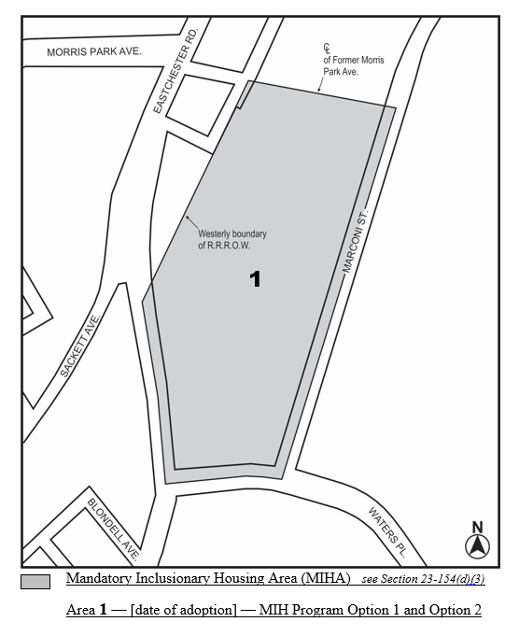
Portion of Community District 11, The Bronx

* * *
[City Council Modified Map]

Adopted
Office of the City Clerk, }
The City of New York, } ss.:

I hereby certify that the foregoing is a true copy of a Resolution passed by The Council of The City of New York on December 19, 2017, on file in this office.

.....…….........................................
City Clerk, Clerk of The Council

