THE COUNCIL OF THE CITY OF NEW YORK
RESOLUTION NO. 783

Resolution approving with modifications the decision of the City Planning Commission on Application No. N 040500 (A) ZRM, an amendment to the text of the Zoning Resolution relating to Article VIII, Chapter 1 (Special Midtown District), Article IX, Chapter 6 (Special Clinton District), Article XII, Chapter 1 (Special Garment Center District) and the elimination of the Special Jacob K. Javits Convention Center District and the Creation of the Special Hudson Yards District in Article IX, Chapter 3 (L.U. No. 324).

By Council Members Katz and Avella

WHEREAS, the City Planning Commission filed with the Council on November 22, 2004 its decision dated November 22, 2004 (the "Decision"), on the application submitted by the Department of City Planning, pursuant to Section 201 of the New York City Charter, for an amendment to the text of the Zoning Resolution (Application No. N 040500 (A) ZRM) (the "Application");

WHEREAS, the Application is related to Applications Numbers C 040499 (A) ZMM (L.U. No. 323), an amendment to the Zoning Map; C 040501 PCM (L.U. No. 325), site selection and acquisition of property for use as a sanitation garage and tow pound facility; C 040502 PCM (L.U. No. 326), site selection and acquisition of property for use as a public parking garage; C 040503 PQM (L.U. No. 327), acquisition of aerial easements for a pedestrian bridge; C 040504 PQM (L.U. No. 334), acquisition of property and easements for construction of a subway extension; C 040505 PQM (L.U. No. 335), an acquisition of property; C040506 PPM (L.U. No.328), disposition of thirty-six city-owned properties; C 040507 MMM (L.U. No. 329), an amendment to the City Map involving the establishment and the elimination, discontinuance and closing of streets; C 040508 MMM (L.U. No. 336), amendment to the City Map establishing a park; and 20055114 TAM (L.U. No. 357), proposed transfer of real property for construction of a subway extension;

WHEREAS, the Decision is subject to review and action by the Council pursuant to Section 197-d(b)(1) of the City Charter;

WHEREAS, upon due notice, the Council held a public hearing on the Decision and Application on December 13, 2004;

WHEREAS, modification to the zoning text prohibits the use of revenue from the Hudson Yards District Improvement Fund for certain uses including New York Sports and Convention Center (“NYSCC”) improvements, a pedestrian tunnel connecting the NYSCC to the Javits Center, the game porch between 33rd and 34th Streets and a platform over 12th Avenue connecting the stadium to the waterfront, and

WHEREAS, the Council has considered the land use implications and other policy issues relating to the Decision and Application; and

WHEREAS, the Council has considered the relevant environmental issues; and

WHEREAS, a positive declaration was issued on April 21, 2003 and distributed, published and filed, and the applicant was asked to prepare or have prepared a Draft Generic Environmental Impact Statement (“DGEIS”). A public meeting for the Draft Scope of Work for the DGEIS was held on June 6, 2003 and the Final Scope of Work for the DGEIS was issued on May 28, 2004;

The co-lead agencies prepared a DGEIS and a Notice of Completion for the DGEIS was issued on June 21, 2004. Pursuant to the SEQRA regulations and CEQR procedures, a joint public hearing was held on the DGEIS on September 23, 2004 in conjunction with the public hearing on this application (N 040500 (A) ZRM) and related items (C 040499 (A) ZMM, N 040500 ZRM, C 040501 PCM, C 040502 PCM, C 040503 PQM, C 040504 PQM, C 040505 PQM, C 040506 PPM, C 040507 MMM, C 040508 MMM); and

WHEREAS, a Final Generic Environmental Impact Statement (“FGEIS”) was completed and Notices of Completion for the FGEIS were issued by the co-lead agencies on November 8, 2004.

WHEREAS, the FGEIS identified significant adverse impacts and proposed mitigation measures that are summarized in the Co-Lead Agency Findings Statement set forth in Exhibit A to the Reports of the City Planning Commission approving said application and such summary is incorporated by reference herein; and

WHEREAS, modifications of the applications adopted by the City Planning Commission in the form of changes to ULURP Applications Nos. N 040500 (A) ZRM and C 040507 MMM were considered in a Technical Memorandum of the Co-Lead Agencies, dated November 17, 2004; and

WHEREAS, modifications of ULURP Applications Nos. C 040499 (A) ZMM and N 040500 (A) ZRM adopted by the City Council are considered in a Technical Memorandum of the Co-Lead Agencies, dated January 14, 2005;

Now, therefore be it

RESOLVED:

Having considered the FGEIS, with respect to the Application, the Council finds that:

(1) The FGEIS meets the requirements of 6 N.Y.C.R.R. Part 617;

- Consistent with the social, economic and other essential considerations, from among the reasonable alternatives thereto, the actions to be approved are ones which minimize or avoid adverse environmental impacts to the maximum extent practicable; and

- The adverse environmental impacts revealed in the FGEIS will be minimized or avoided to the maximum extent practicable by incorporating as conditions to the approval those mitigative measures that were identified as practicable;

- The Decision and the FGEIS and the Technical Memoranda described above constitute the written statement of facts, and of social, economic and other factors and standards that form the basis of the decision, pursuant to 6 N.Y.C.R.R. §617.11(d).

Pursuant to Sections 197-d and 200 of the City Charter and on the basis of the Decision and Application the Council approves the Decision with modifications; and

The Zoning Resolution of the City of New York, effective as of December 15, 1961, and as subsequently amended, is further amended as follows:

Matter in underline is new, to be added by City Planning Commission;
Matter in strikeout is old, to be deleted by City Planning Commission;
Matter in bold double underline is new, to be added by City Council
Matter in [brackets] to be deleted by City Council
Matter within # # is defined in Section 12-10;
* * * indicates where unchanged text appears in the Zoning Resolution

* * *

11-12

Establishment of Districts

* * *

Establishment of the Jacob K. Javits Convention Center District

In order to carry out the special purposes as set forth in Article IX, Chapter 3, the #Special Jacob K. Javits Convention Center District# is hereby established.

Special Hudson Yards District

In order to carry out the special purposes as set forth in Article IX, Chapter 3, the #Special Hudson Yards District# is hereby established.

* * *

12-10

Definitions

* * *

The “Special Jacob K. Javits Convention Center District” is a Special Purpose District designated by the letters “CC” in which special regulations set forth in Article IX, Chapter 3 apply to all #developments#. The #Special Jacob K. Javits Convention Center District# appears on the #zoning maps# superimposed on other districts and, where indicated, its regulations supplement and supersede those of the districts on which it is superimposed.

The “Special Hudson Yards District” is a Special Purpose District designated by the letters “HY” in which special regulations set forth in Article IX, Chapter 3 apply to all #developments#. The #Special Hudson Yards District# appears on the #zoning maps# superimposed on other districts and its regulations supplement and supersede those of the districts on which it is superimposed.

* * *

ARTICLE 1

GENERAL PROVISIONS

CHAPTER 3
COMPREHENSIVE OFF-STREET PARKING REGULATIONS IN COMMUNITY DISTRICTS 1 THROUGH 8 IN MANHATTAN AND A PORTION OF COMMUNITY DISTRICTS 1 AND 2 IN THE BOROUGH OF QUEENS

* * *

13-224

Jacob K. Javits Convention Center study area

No public parking lots are permitted in the area bounded by Eighth Avenue, 30th Street, the Hudson River and 42nd Street, except as provided in Section 13-552 (Public parking lots).

13-225 13-224

Manufacturing Districts

* * *

13-226 13-225

Long Island City subject area

* * *

ARTICLE VIII SPECIAL PURPOSE DISTRICTS

CHAPTER 1 SPECIAL MIDTOWN DISTRICT

* * *

APPENDIX A

Midtown District Plan Maps

Map 1. Special Midtown District and Subdistricts

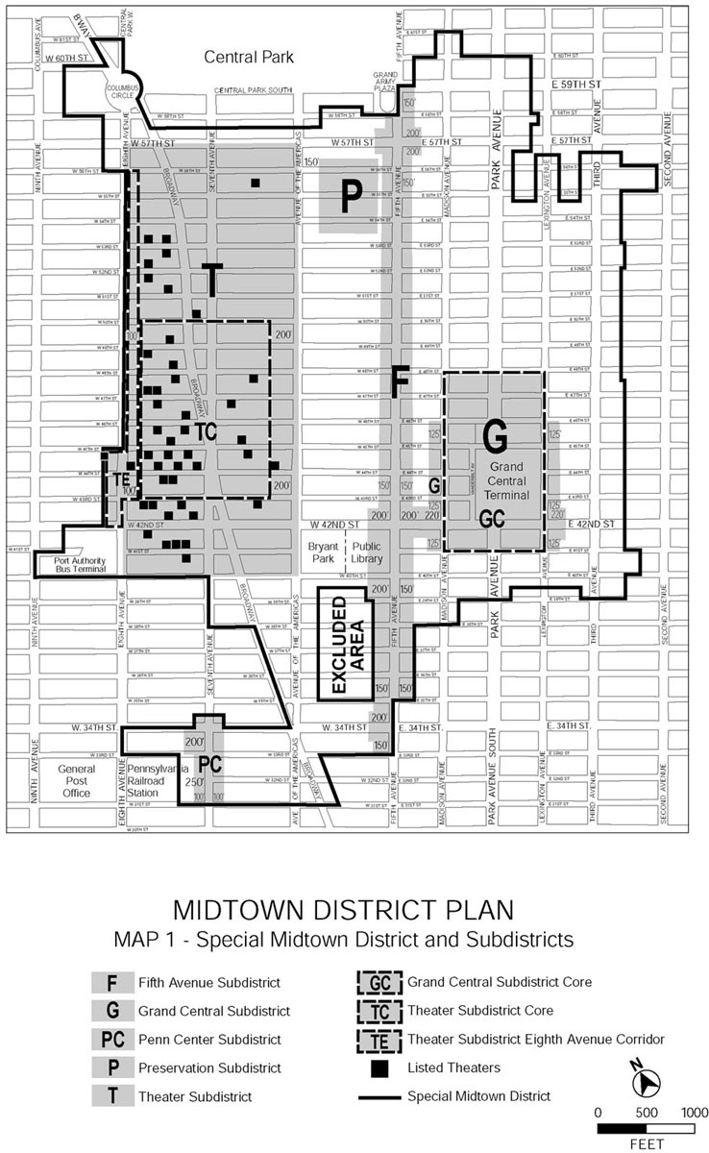
APPENDIX A

Midtown District Plan Maps

Map 2. Retail & Street Wall Continuity

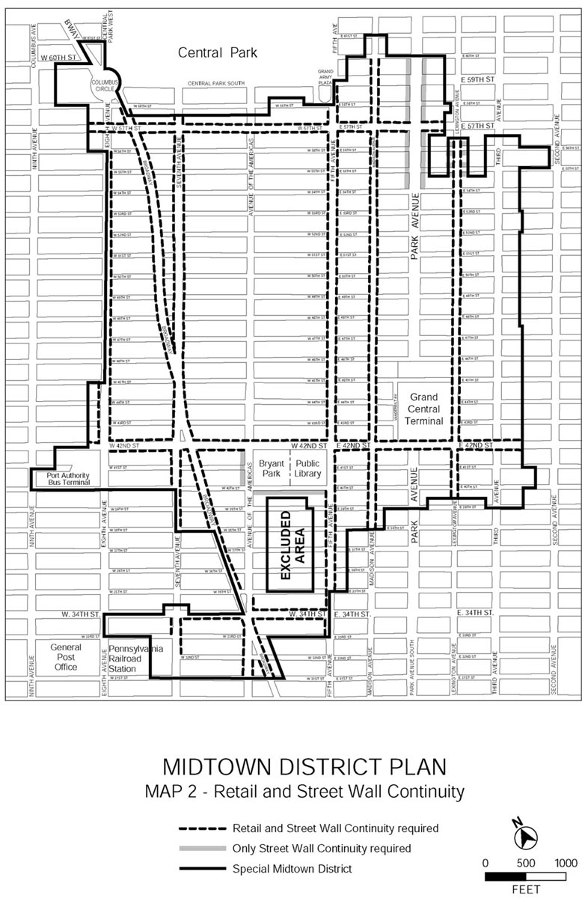

APPENDIX A

Midtown District Plan Maps

Map 3. Subway Station and Retail Mass Transit Facility Improvement Areas

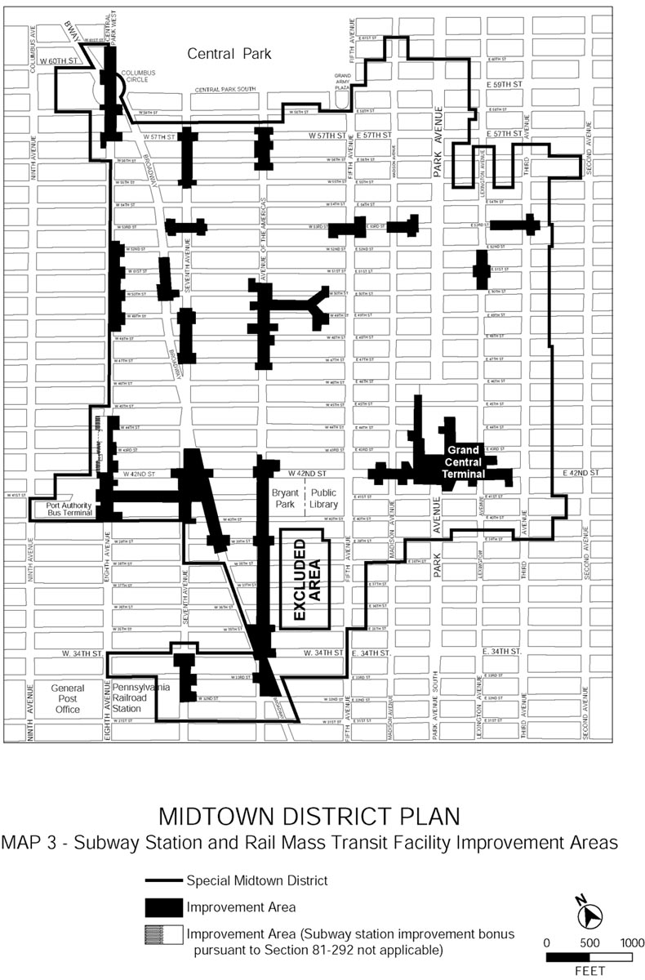

ARTICLE IX

SPECIAL PURPOSE DISTRICTSCHAPTER 3SPECIAL HUDSON YARDS DISTRICT

(delete entire Special Jacob K. Javits Convention Center District. All text in Chapter 3 is new)

93-00

GENERAL PURPOSES

The “Special Hudson Yards District” established in this Resolution is designed to promote and protect public health, safety and general welfare. These general goals include, among others, the following specific purposes:

(a) to facilitate and guide the development of an environmentally beneficial, transit oriented business and residence district by coordinating high density development with expanded mass transit facilities, extended and improved subway lines, improved pedestrian access to mass transit facilities, improved pedestrian circulation, and avoidance of conflicts with vehicular traffic;

(b) to control the impact of buildings on the access of light and air to the streets and avenues of the Hudson Yards area and the surrounding neighborhoods;

(c) to provide an open space network comprised of public parks, public open space and public access areas through the establishment of a large-scale plan and other controls and incentives;

(d) to preserve the pedestrian orientation of ground floor uses, and thus safeguard a traditional quality of the City;

(e) to preserve the low-and medium scale residential character of the Hell’s Kitchen area;

(f) to provide a transition between the Hudson Yards District and the Clinton community to the north;

(g) to provide a transition between the Hudson Yards District and the Garment Center to the east;

(h) to provide a transition between the Hudson Yards District and the West Chelsea area to the south;

(i) to promote the use of the Jacob K. Javits Convention Center to the west by creating an active and attractive business district that facilitates pedestrian access to the Center;

(j) to provide flexibility of architectural design within limits established to assure adequate access of light and air to the street, and thus to encourage more attractive and economic building forms;

(k) to promote the most desirable use of land and building development in accordance with the District Plan for the Hudson Yards and thus conserve the value of land and buildings and thereby protect the City’s tax revenues.

93-01

Definitions

Hudson Yards District Improvement Fund

The Hudson Yards District Improvement Fund (the “Fund”), shall be an account of the Hudson Yards Infrastructure Corporation (the “Corporation”). The Fund shall be owned for all purposes by the Corporation, and may be used for any corporate purpose of the Corporation, including its pledge, assignment or sale in furtherance of any financing by the Corporation in support of district improvements in the #Hudson Yards Redevelopment Area#. The Corporation, as owner for all purposes of the Fund, will manage the Fund in furtherance of the purposes of the Corporation.

Hudson Yards Redevelopment Area

The “Hudson Yards Redevelopment Area” shall be the areas within the #Special Hudson Yards District#, Area P-2 of the #Special Garment Center District#, the 42nd Street Perimeter Area of the #Special Clinton District#, and the area bounded by the centerline of Eleventh Avenue, the northern #street line# of West 43rd Street, the westerly prolongation of the northern #street line# of West 43rd Street to the U.S. Pierhead Line, the U.S. Pierhead Line, the westerly prolongation of the southern #street line# of West 29th Street to the U.S. Pierhead Line, and the southern #street line# of West 29th Street. However, [all #blocks# within] the area bounded by the westerly side of Eleventh Avenue, the southerly side of West 43rd Street, the westerly side of Twelfth Avenue and the northerly side of West 30th Street shall not be included in the #Hudson Yards Redevelopment Area#, except for any portion of such #blocks# containing a transit easement for subway-related use. Furthermore, the #Hudson Yards Redevelopment Area# shall not include any underground connections from a subway station to any #use# located on such excluded #blocks# or between any such #uses#.

Phase 2 Hudson Boulevard and Park

The “Phase 2 Hudson Boulevard and Park” is the area within the #Special Hudson Yards District# bounded on the north by the centerline of West 39th Street, on the east by the eastern boundary of the #park# located between West 38th and West 39th Streets and the eastern #street line# of Hudson Boulevard East, on the south by the centerline of West 36th Street, and on the west by the western #street line# of Hudson Boulevard West and the western boundary of the #park# located between West 38th and West 39th Streets, as shown on Map 1.

Special Hudson Yards District

The “Special Hudson Yards District” is a Special Purpose District designated by the letters “HY” in which special regulations set forth in Article IX, Chapter 3, apply.

93-02

General Provisions

The provisions of this Chapter shall apply to all #developments#, #enlargements#, #extensions#, alterations and changes of #uses# within the #Special Hudson Yards District#. The regulations of all other Chapters of this Resolution are applicable, except as superseded, supplemented or modified by the provisions of this Chapter. In the event of a conflict between the provisions of this Chapter and other regulations of this Resolution, the provisions of this Chapter shall control.

93-03

District Plan and Maps

The regulations of this Chapter are designed to implement the #Special Hudson Yards District Plan#.

The District Plan includes the following four maps:

Map 1. Special Hudson Yards District, Subdistricts and Subareas

Map 2. Mandatory Ground Floor Retail

Map 3. Mandatory Street Wall Requirements

Map 4. Mandatory Sidewalk Widenings

Map 5. Transit Easements and Subway Entrances

The Maps are located within Appendix A of this Chapter and are hereby incorporated and made part of this Resolution. They are incorporated for the purpose of specifying locations where special regulations and requirements set forth in the text of this Chapter apply.

93-04

Subdistricts and Subareas

In order to carry out the provisions of this Chapter, six subdistricts are established, as follows:

The Large-Scale Plan (Subdistrict A),

The Farley Corridor (Subdistrict B)

The 34th Street Corridor (Subdistrict C)

[The Tenth Avenue Corridor] Hell’s Kitchen (Subdistrict D)

South of Port Authority (Subdistrict E)

[Hell’s Kitchen (Subdistrict F)]

In each of these subdistricts, certain special regulations apply which do not apply within the remainder of the #Special Hudson Yards District#. Within certain subdistricts, subareas are established, as follows:

Within the Large-Scale Plan (Subdistrict A):

Eastern Rail Yards Subarea (A1)

Four Corners Subarea (A2)

[Northern Blocks Subarea (A3)] Subarea A3

Subarea A4

Subarea A5

Within the Farley Corridor (Subdistrict B):

Western Blocks Subarea (B1)

Central Blocks Subarea (B2)

Farley Post Office Subarea (B3)

Pennsylvania Station Subarea (B4)

Within [the Tenth Avenue Corridor] Hell’s Kitchen (Subdistrict D):

Subarea D1

Subarea D2

Subarea D3

Subarea D4

Subarea D5

[Within Hell’s Kitchen (Subdistrict F):

Midblocks Subarea (F1)

Ninth Avenue Corridor Subarea (F2)]

Within these subareas, certain special regulations apply which do not apply within the remainder of the subdistrict.

The subdistricts and subareas are outlined on Map 1 (Special Hudson Yards District, Subdistricts and Subareas) in Appendix A of this Chapter.

93-05

Applicability of District Regulations

93-051

Applicability of Chapter 1 of Article 1

(a) Within the #Hudson Yards Redevelopment Area#, Section 11-15 (Environmental Requirements) shall apply, except that prior to issuing a building permit for any #development#, or for an #enlargement#, #extension# or a change of #use#, on a lot that has an (E) designation for hazardous material contamination, noise or air quality, the Department of Buildings shall be furnished with a report from the Department of Environmental Protection (DEP) of the City of New York stating:

(1) in the case of an (E) designation for hazardous material contamination, that environmental requirements related to the (E) designation have been met for that lot; or

(2) in the case of an (E) designation for noise or air quality, that the plans and drawings for such #development# or #enlargement# will result in compliance with the environmental requirements related to the (E) designation.

(b) Section 11-332 (Extension of period to complete construction) shall apply, except that not withstanding the provisions of paragraph (a) of such Section, in the event that other construction for which a building permit has been lawfully issued and for which construction has been commenced but not completed on (effective date of amendment), such other construction may be continued provided that the construction is completed and a temporary or permanent certificate of occupancy is obtained not later than (one year after effective date of amendment).

93-052

Applicability of Chapter 3 of Article I

#Public parking lots# authorized pursuant to Section 13-552 (Public parking lots) prior to (effective date of amendment) and #accessory# off-street parking facilities for which a special permit has been granted pursuant to Section 13-561 prior to (effective date of amendment) may be renewed subject to the terms of such authorization or special permit.

93-053

Applicability of Chapter 3 of Article VII

The following special permits by the Board of Standards and Appeals shall not be applicable:

Section 73-16 (Public Transit, Railroad or Electric Utility Substations) shall not apply to electrical utility substations. In lieu thereof, such #uses# shall be allowed within the #Special Hudson Yards District# upon authorization of the City Planning Commission pursuant to Section 93-19 (Authorization for Electrical Utility Substations).

Section 73-62 (Modification of Bulk Regulations for Residential Buildings)

Section 73-63 (Enlargement of Non-Residential Buildings)

Section 73-64 (Modifications for Community Facility Uses)

93-054

Applicability of Chapter 4 of Article VII

(a) The following special permits by the City Planning Commission shall not be applicable:

Section 74-61 (Public Transit, Railroad or Electric Utility Substations) shall not apply to electrical utility substations. In lieu thereof, such #uses# shall be allowed within the #Special Hudson Yards District# upon authorization of the City Planning Commission pursuant to Section 93-19 (Authorization for Electrical Utility Substations).

Section 74-68 (Development Within or Over a Right-of-Way or Yards).

Section 74-72 (Bulk Modification)

Section 74-74 (General Large-Scale Development) shall be inapplicable in the Large-Scale Plan Subdistrict

[Section 74-82 (Through Block Arcades)]

Section 74-83 (Court Houses)

Section 74-841 (Developments in Certain Commercial Districts)

Section 74-852 (Height and setback regulations for developments on lots divided by district boundaries)

Section 74-87 (Covered Pedestrian Space)

Section 74-91 (Modifications of Urban Plazas)

Section 74-95 (Modifications of Housing Quality Special Permits)

(b) The following provisions regarding special permits by the City Planning Commission shall be applicable as modified:

(1) Section 74-52 (Parking Garages or Public Parking Lots in High Density Central Areas) shall be applicable to #public parking lots# of any capacity, and, to #public parking garages# or portions thereof located above grade subject to the findings of Section 93-821 (Special permit for above-grade parking). However, the findings of Section 93-821 shall not apply to any public parking facility in existence prior to (effective date of amendment) that is the subject of a renewal or new special permit.

(2) Section 74-79 (Transfer of Development Rights from Landmark Sites) shall apply, except that within the Pennsylvania Station Subarea of the Farley Corridor Subdistrict, such Section shall be applicable only for a #development# or #enlargement# that has increased its permitted #floor area ratio# to 15.0 pursuant to Section 93-35 (Transit Bonus in Pennsylvania Station Subarea). Furthermore, the maximum amount of #floor area# that may be transferred from the #zoning lot# occupied by a landmark building may increase the maximum allowable #floor area ratio# within the Pennsylvania Station Subarea to19.5.

(3) Section 74-82 (Through Block Arcades) shall apply to any #development# or #enlargement# for which a #through block arcade# would not otherwise be permitted pursuant to this Chapter, except that no #floor area# bonus shall be permitted.

93-10

USE REGULATIONS

The #use# regulations of the underlying districts are modified as set forth in this Section 93-10, inclusive.

93-11

Air Space over a Railroad or Transit Right-of-way or Yard

The provisions for the use of air space over railroad or transit right-of-ways or yards set forth in Sections 22-41, 32-44 and 42-462 shall not apply. In lieu thereof, all #developments# or #enlargements# within such air space shall comply with the provisions of this Chapter.

93-12

Special Residential Use Regulations

93-121

Restrictions on residential use

No #residential use# shall be permitted within the Pennsylvania Station Subarea (Subarea B4) of the Farley Corridor Subdistrict.

93-122

Certification for residential use in Subdistricts A, B and E

Within the Large-Scale Plan Subdistrict, Subareas B1 and B2 of the Farley Corridor Subdistrict, and the South of Port Authority Subdistrict, #residential use# shall be permitted only upon certification of the Chairperson of the City Planning Commission that the #zoning lot# on which such #residential use# is located contains the minimum amount of #commercial floor area# required before #residential use# is allowed, as specified in Section 93-21 or 93-22, as applicable, and that for #zoning lots# in [the Four Corners and Northern Blocks Subareas,] Subareas 2 through 5 of the Large Scale Plan Subdistrict, a certification pursuant to Section 93-34 (Distribution of Floor Area from Eastern Rail Yard Subarea) has been made.

However, special regulations shall apply to #zoning lots# with phased #development#, as follows:

(a) For #zoning lots# with less than 69,000 square feet of #lot area#, the Chairperson shall allow for phased #development#, upon certification that a plan has been submitted whereby the ratio of #commercial floor area# to #residential floor area#, in #buildings# in each phase, is no smaller than the ratio of the minimum amount of #commercial floor area# required on the #zoning lot# before #residential use# is allowed, to the maximum #residential floor area# permitted on the #zoning lot# as specified in Section 93-21 or 93-22, as applicable, and

(b) For #zoning lots# with at least 69,000 square feet of #lot area#, the Chairperson shall allow for a #residential building# or #buildings# to be #developed# without the minimum amount of #commercial floor area# required before #residential use# is allowed, as specified in Section 93-21 or 93-22, as applicable, upon certification that a plan has been submitted whereby one or more regularly-shaped portions of the #zoning lot# with a minimum area of 50,000 square feet are reserved for future #development# of not more than 2 million square feet of #commercial floor area# on each such portion, and that, upon full #development# of such #zoning lot#, the ratio of #commercial floor area# to #residential floor area# shall be no smaller than the ratio of the minimum amount of #commercial floor area# required on the #zoning lot# before #residential use# is allowed, to the maximum #residential floor area# permitted on the #zoning lot#, as specified in Section 93-21 or 93-22, as applicable.

All #developments# or #enlargements# so certified shall be permitted only in accordance with the provisions of this Chapter.

93-123

Location of residential use within buildings

The provisions of Section 32-422 (Location of floors occupied by non-residential uses) are modified to permit #residential uses# on the same #story# as a non-#residential use# provided no access exists between such #uses# at any level containing #residences# and provided any non-#residential uses# are not located directly over any #residential uses#. However, such non-#residential uses# may be located over a #residential use# by authorization of the City Planning Commission upon a finding that sufficient separation of #residential uses# from non-#residential uses# exists within the #building#.

93-13

Special Office Use Regulations

93-131

Certification for office use

(a) No temporary certificate of occupancy from the Department of Buildings may be issued for any portion of a #development# or #enlargement# in the #Hudson Yards Redevelopment Area# that includes Use Group 6B offices constructed after (the effective date of amendment) until the Chairperson of the Department of City Planning certifies to the Commissioner of Buildings that:

(1) such #development# or #enlargement# does not utilize any #floor area# increases pursuant to Sections 23-90 (INCLUSIONARY HOUSING), Section 93-30 (SPECIAL FLOOR AREA REGULATIONS), inclusive, or Section 96-25 (Floor Area Bonus for New Legitimate Theater Use); or

(2) such #development# or #enlargement# utilizes #floor area# increases pursuant to Sections 23-90 (INCLUSIONARY HOUSING), Section 93-30 (SPECIAL FLOOR AREA REGULATIONS), inclusive, or Section 96-25 (Floor Area Bonus for New Legitimate Theater Use), and will not result in a total amount of Use Group 6B office #floor area# #developed# or #enlarged# after (the effective date of amendment) within the #Hudson Yards Redevelopment Area# of over 20 million square feet.

All #developments# or #enlargements# so certified shall be permitted in accordance with the provisions of this Chapter, or the provisions of the #Special Clinton District# or the #Special Garment Center District#, as applicable.

(b) Where the Chairperson of the Department of City Planning determines that the amount of office #floor area# in any #development# or #enlargement# will result in a total amount of Use Group 6B office #floor area developed# or #enlarged# after (the effective date of amendment) within the #Hudson Yards Redevelopment Area# of over 20 million square feet, no building permit from the Department of Buildings shall be issued for any #development# or #enlargement# that includes Use Group 6B offices constructed after (the effective date of amendment) until the Chairperson certifies to the Commissioner of Buildings that:

(1) such #development# or #enlargement# does not utilize any #floor area# increases pursuant to Sections 23-90 (INCLUSIONARY HOUSING), Section 93-30 (SPECIAL FLOOR AREA REGULATIONS), inclusive, or Section 96-25 (Floor Area Bonus for New Legitimate Theater Use); or

(2) such #development# or #enlargement# utilizes #floor area# increases pursuant to Sections 23-90 (INCLUSIONARY HOUSING), Section 93-30 (SPECIAL FLOOR AREA REGULATIONS), inclusive, or Section 96-25 (Floor Area Bonus for New Legitimate Theater Use), and will not result in a total amount of Use Group 6B office #floor area# #developed# or #enlarged# after (the effective date of amendment) within the #Hudson Yards Redevelopment Area# of over 25 million square feet.

All #developments# or #enlargements# so certified shall be permitted in accordance with the provisions of this Chapter, or the provisions of the #Special Clinton District# or the #Special Garment Center District#, as applicable.

However, if such #developments# or #enlargements# fail to comply with the provisions of Section 11-331 with respect to completion of foundations within one year of the date of certification pursuant to this Section, such building permit shall lapse, and any new building permit will require a new Chairperson’s certification pursuant to this Section.

(c) Where the Chairperson of the Department of City Planning determines that the amount of office #floor area# in any #development# or #enlargement# will result in a total amount of Use Group 6B office #floor area developed# or #enlarged# after (the effective date of amendment) within the #Hudson Yards Redevelopment Area# of over 25 million square feet, and where such #development# or #enlargement# utilizes #floor area# increases pursuant to Section 23-90 (INCLUSIONARY HOUSING), Section 93-30 (SPECIAL FLOOR AREA REGULATIONS), inclusive, or Section 96-25 (Floor Area Bonus for New Legitimate Theater Use), such #development# or #enlargement# shall be permitted only upon authorization of the City Planning Commission pursuant to Section 93-132.

However, no such authorization shall be required for #developments# or #enlargements# utilizing the Inclusionary Housing Program within the area bounded by West 35th Street, Eighth Avenue, West 33rd Street, and a line 100 feet east of and parallel to Ninth Avenue, or in the 42 Street Perimeter Area of the #Special Clinton District#, where the total #floor area ratio# for such #developments# or #enlargements# does not exceed 12.0.

93-132

Authorization for office use

Where the amount of Use Group 6B office #floor area# in a #development# or #enlargement# will result in over 25 million square feet of such #use developed# or #enlarged# after (the effective date of amendment) within the #Hudson Yards Redevelopment Area#, and that such #development# or #enlargement# utilizes increased #floor area# pursuant to Section 23-90 (INCLUSIONARY HOUSING), Section 93-30 (SPECIAL FLOOR AREA INCREASES), inclusive, or Section 96-25 ((Floor Area Bonus for New Legitimate Theater Use), such #development# or #enlargement# shall be permitted only upon authorization of the City Planning Commission that:

(a) such #development# or #enlargement# will not require any significant additions to the supporting services of the neighborhood or that provisions for adequate supporting services have been made;

(b) the #streets# providing access to the #development# or #enlargement# are adequate to handle the traffic generated thereby or provisions have been made to handle such traffic; and

(c) such #development# or #enlargement# is consistent with the goals of the applicable special district.

93-14

Retail Continuity Along Designated Streets

Map 2 in Appendix A (Mandatory Ground Floor Retail) specifies locations where the special ground floor #use# and transparency requirements of this section apply. Such regulations shall apply along either 100 percent or 50 percent of the building’s #street# frontage, as indicated on Map 2.

#Uses# located on the ground floor level or within five feet of #curb level#, and within 50 feet of the #street line# shall be limited to #commercial uses# permitted by the underlying district, but not including #uses# listed in Use Groups 6B, 6E, 7C, 7D, 8C, 8D, 9B, 10B, 11 or 12D. A building’s #street# frontage shall be allocated exclusively to such #uses#, except for lobby space, entryways or entrances to subway stations. In no event shall the length of #street# frontage occupied by lobby space or entryways exceed, in total, 40 feet or 25 percent of the building’s total #street# frontage, whichever is less, except that the width of a lobby need not be less than 20 feet.

For any new #development# or #enlargement# on such designated retail #streets#, each ground floor #street wall# shall be glazed with materials which may include show windows, glazed transoms or glazed portions of doors. Such glazed area shall occupy at least 70 percent of the area of each such ground floor #street wall#, measured to a height of 10 feet above the level of the adjoining sidewalk or public access area. Not less than 50 percent of such area shall be glazed with transparent materials, and up to 20 percent of such area may be glazed with translucent materials.

The provisions of this Section 93-14 shall not apply along the northern #street# frontage of West 35th through West 39th Streets within 100 feet of Eleventh Avenue, as shown on Map 2. However, any #zoning lot# fronting on such #streets# and partially within 100 feet of Eleventh Avenue may, as an alternative, apply the provisions of this Section to the entire West 35th, West 36th, West 37th, West 38th or West 39th #Street# frontage of the #zoning lot#.

93-15

Security Gates

All security gates installed after (effective date of amendment) that are swung, drawn or lowered to secure #commercial# or #community facility# premises shall, when closed, permit visibility of at least 75 percent of the area covered by such gate when viewed from the #street#, except that this provision shall not apply to entrances or exits to parking garages.

93-16

Public Parking Facilities

In C2-5, C2-8 and C6 Districts, the provisions of Use Groups 8 and 12 of Section 32-17 are modified to require a special permit pursuant to Section 74-52 (Parking Garages or Public Parking Lots in High Density Central Areas) for #public parking lots# of any capacity, and in
C2-8 and C6 Districts, to allow, as-of-right, #public parking garages#, provided such garages are entirely below grade and contain not more than 0.30 parking spaces for each 1,000 square feet of #floor area# on the #zoning lot#. However, no #public parking garages# shall be permitted within the #Phase 2 Hudson Boulevard and Park#, as shown on Map 1.

93-17

Modification of Sign Regulations

The underlying #sign# regulations shall apply, except that #flashing signs# shall not be allowed within 100 feet of Hudson Boulevard, its northerly prolongation to West 39th Street, and its
southerly prolongation to West 33rd Street. Furthermore, #flashing signs# shall not be allowed on any portion of a #building# fronting upon the outdoor plaza required in the Eastern Rail Yards Subarea pursuant to Section 93-71.

93-18

Non-Conforming Uses in Large Scale Plan Subdistict

In the Large-Scale Plan Subdistrict, for a period of not more than ten years after (effective date of amendment), existing automobile repair establishments listed in Use Group 16 of Section 32-25 that were #conforming# prior to (effective date of amendment) may be #enlarged#, provided that the #floor area ratio# of any such establishment, including any #enlargement# pursuant to this Section, does not exceed 5.0.

93-19

Authorization for Electrical Utility Substations

Electrical utility substations shall be allowed in the #Special Hudson Yards District# in order to serve the needs of the District, and the regulations thereof shall be modified as necessary to accommodate the operational needs of the substation, upon authorization of the City Planning Commission which shall be issued upon finding, with respect to a proposed site, that:

(a) to the extent reasonably permitted by the operational needs of the substation, the architectural and landscaping treatment of such #use# will blend harmoniously with the abutting area; and

(b) if the site proposed for such #use# is within [Subdistrict F (Hell’s Kitchen)] Subareas D4 or D5 of the Hell’s Kitchen Subdistrict of the #Special Hudson Yards District#, that there are difficulties in locating such #use# in other Subdistricts of the #Special Hudson Yards District#.

The City Planning Commission may, consistent with cost-effective operations and capital planning, and the operational needs of the substation, prescribe appropriate conditions and safeguards on matters necessary to effectuate the provisions of paragraph (a) of this Section which are not regulated by other applicable codes, laws, rules or regulations. The applicant shall provide the Department of City Planning with a general description of such codes, laws, rules or regulations and a certification that the proposed substations shall comply therewith.

93-20

FLOOR AREA REGULATIONS

93-21

Floor Area Regulations in the Large-Scale Plan Subdistrict

In the Large-Scale Plan Subdistrict, the #floor area# provisions of this Section shall apply.

(a) [Four Corners and Northern Blocks Subarea] Subareas 2 through 5

In [the Four Corners and Northern BlocksSubarea] Subareas 2 through 5, the basic maximum permitted #floor area ratio# shall be as specified in row A in the table below. Such #floor area ratio# may be increased to the maximum amount specified in row B in the table below pursuant to Section 93-31 (District Improvement Fund Bonus) or the transfer of #floor area# or increase in the amount of #floor area# from the #Phase 2 Hudson Boulevard and Park# pursuant to Sections 93-32 or 93-33. For #developments# or #enlargements# that have maximized their permitted #floor area# through such #floor area# bonus or transfer provisions, the permitted #floor area# may be further increased to the maximum amount specified in row C in the table below through the distribution of #floor area# from the Eastern Rail Yards Subarea pursuant to Section 93-34. #Residential use# shall only be permitted as part of a #development# or #enlargement# with a non-#residential floor area ratio# of [18 or more]:

(1) 18.0 or more in Subareas 2 and 3,

(2) 15.6 or more in Subarea 4,

(3) 14.0 or more in Subarea 5,

or as provided for phased developments pursuant to Section 93-122 (Certification for residential use in Subdistricts A, B and E).

Maximum Permitted Floor Area Ratio
within [the Four Corners and Northern Blocks] Subareas 2 through 5

Subarea | [Four Corners] Subarea 2 | [Northern Blocks]  Subarea 3 | Subarea 4 | Subarea 5
ROW A  Basic maximum #floor area ratio# | 10 total  10C  2CF | 10 total  10C  2CF | 10 total  10C  2CF | 10 total  10C  2CF
ROW B  Maximum #floor area ratio# through bonus pursuant to Section 93-31 or transfer or increase pursuant to Sections 93-32 or 93-33. | 18 total  18C  2CF | 18 total  18C  2CF | 18 total  18C  2.4R  2CF | 18 total  18C  4R  2CF
ROW C  Maximum #floor area ratio# through distribution pursuant to Section 93-34 | [No limit]  33 total  [No limit C] 33 C  6R  2CF | 24 total  24 C  6R  2CF | 21.6 total  21.6C  6R  2CF | 20 total  20C  6R  2CF

C commercial FAR
CF community facility FAR
R residential FAR

(b) Eastern Rail Yards Subarea

The Eastern Rail Yard Subarea shall generate a maximum #floor area ratio# of 19.0. The maximum #floor area ratio# for #commercial use# shall be 19.0, the maximum #floor area ratio# for #residential use# shall be 3.0, and the maximum #floor area ratio# for #community facility use# shall be 2.0. In order to promote a superior site plan, the amount of #floor area# permitted to be #developed# or #enlarged# in the subarea shall be limited, and unused #floor area# may be distributed as set forth below:

(1) The maximum #floor area ratio# for any #development# or #enlargement# in the subarea shall be 11.0. The maximum #floor area ratio# for #commercial use# shall be 9.0, the maximum #floor area ratio# for #community facility use# shall be 2.0, and the maximum #floor area ratio# for #residential use# shall be 3.0. #Residential use# shall only be permitted as part of a #development# or #enlargement# with a non-#residential floor area ratio# of 8.0 or more, or as provided for phased developments pursuant to Section 93-122 (Certification for residential use in Subdistricts A, B and E).

(2) Unused #floor area# may be distributed to #zoning lots# in [the Four Corners and Northern Blocks] Subareas 2 through 5 pursuant to Section 93-34, provided the total amount of distributed #floor area# does not exceed an amount equal to the #lot area# of the Eastern Rail Yards Subarea multiplied by 10.0. Furthermore, the total #floor area# distributed to Subarea 2 shall not exceed 3,238,000 square feet.

(c) #Phase 2 Hudson Boulevard and Park#

For #zoning lots# or portions of #zoning lots# in the #Phase 2 Hudson Boulevard and Park#, the provisions of Section 93-32 (Floor Area Regulations in the Phase 2 Hudson Boulevard and Park) and 93-33 (Special Regulations for Residual Portions of Zoning Lots Partially Within the Phase 2 Hudson Boulevard and Park) shall apply.

Notwithstanding the provisions of this Section, the basic maximum permitted #floor area ratio# may be increased on an “adjacent lot” pursuant to Section 74-79 (Transfer of Development Rights from Landmark Sites), provided that the maximum #floor area# transferred from the landmark lot does not exceed the basic maximum permitted #floor area ratio# less the total #floor area# of all #buildings# on the landmark lot.

93-22

Floor Area Regulations in Subdistricts B, C, D and E

In Subdistricts B, C, D and E, the basic maximum #floor area ratio# is determined by the subdistrict and, where applicable, subarea, as specified in the table below. The basic maximum #floor area ratios# for non-#residential buildings# are set forth in Row A, and the basic maximum #floor area ratios# for #buildings# containing #residences# are set forth in Row B. Such basic maximum #floor area ratios# may be increased to the amount specified in Row C only pursuant to Section 93-31 (District Improvement Fund Bonus), or as otherwise specified in [paragraphs (a) through (e) below.] Sections 93-221 through 93-224.

Notwithstanding the provisions of this Section, the basic maximum permitted #floor area ratio# may be increased on an “adjacent lot” pursuant to Section 74-79 (Transfer of Development Rights from Landmark Sites), provided that the maximum #floor area# transferred from the landmark lot does not exceed the basic maximum permitted #floor area ratio# less the total #floor area# of all #buildings# on the landmark lot.

[In Subdistricts B and E, #residences# are not permitted except as set forth in paragraph (a) below.

In Subdistricts C and D, the basic maximum #floor area ratios# for #buildings# containing #residences# are set forth in Row B. The #floor area ratio# of any #building# containing #residences# may be increased to the amount specified in Row C as specified in paragraphs (b) and (c) below.]

Maximum Permitted Floor Area Ratio within Subdistricts B through E

Subdistrict | Farley Corridor  (Subdistrict B) |  |  |  | 34th St Corr. (Sub. C) | [Tenth Ave Corridor]  Hell’s Kitchen |  |  | South of PA  (Sub. E)
Subarea | Western  Blocks | Central Blocks | Farley  Post Office | Penn.  Station |  | D1 | D2 | D3
ROW A  Basic maximum #FAR# for non-#residential buildings# | 10 total  10C  2CF | 12 total  12C  2CF | 10 total  10C  6R  2CF | 10 total  10C  2CF | 10 total  10C  10CF | 7.5 total  2C  7.5 CF | 7.5 total  2C  7.5 CF | 7.5 total  6C  7.5 CF | 10 total  10C  2CF
ROW B  Basic maximum #FAR# for  # buildings# containing #residences# | NA | NA | NA | NA | 6.5 total  6.5C  6.5R  6.5CF | 6.5 total  2C  6.5R  6.5 CF | 6.5 total  2C  6.5R  6.5CF | 7.5 total  6C  7.5R  7.5CF | NA
ROW C  Maximum #FAR# through special #floor area# increases pursuant to Section 93-30, inclusive, Inclusionary Housing, or Section 74-79, as applicable. | 21.6 total  21.6C  6R  2CF | 19 total  19C  4R  2CF | 10 total  10C  6R  2CF | 19.5 total  19.5C  2CF | 13 total  13C  12R  12CF | 15 total  3C  12R  12CF | 13 total  3C  12R  12CF | 12 total  7.5R  7.2C  12CF | 18 total  18C  3R  2CF

#FAR# #floor area ratio#
C commercial FAR
CF community facility FAR
R residential FAR
M manufacturing FAR
PA Port Authority Bus Terminal

[93-23

Floor Area Regulations in Hell’s Kitchen (Subdistrict F)

The underlying district #floor area ratio# regulations shall apply within the Hell’s Kitchen Subdistrict, except as provided below:

(a) In the Midblock Subarea (Subarea F1), the #residential floor area ratio# shall be 6.0, and may be increased to 7.5 pursuant to Section 23-90 (INCLUSIONARY HOUSING), as modified by Section 93-24.

(b) For #developments# or #enlargements# on #zoning lots# divided by district boundaries that are wholly or partially within the Hell’s Kitchen Subdistrict and provide publicly accessible open areas contiguous to or over the Lincoln Tunnel Approaches or Dyer Avenue, the City Planning Commission may authorize the distribution of #floor area# across such district boundaries pursuant to Section 93-431 (Authorization for the provision of public open areas). ]

[(a) Subdistricts B and E]

93-221

Maximum #floor area ratio# in Subdistrict B

[(1)](a) Subarea B1

In the Western Blocks Subarea (Subarea B1) of Subdistrict B, #residential use# shall only be permitted as part of a #development# or #enlargement# with a #commercial floor area ratio# of 12.0 or more, or as provided for phased developments in Section 93-122

[(2)](b) Subarea B2

In the Central Blocks Subarea (Subarea B2) of Subdistrict B and the South of Port Authority Subdistrict (Subdistrict E), #residential use# shall only be permitted as part of a #development# or #enlargement# with a #commercial floor area ratio# of 15.0 or more, or as provided for phased developments in Section 93-122.

[(3)](c Subarea B3

In the Farley Post Office Subarea (Subarea B3) of Subdistrict B, no #floor area# increases shall be permitted.

[(4)](d) Subarea B4

In the Pennsylvania Station Subarea (Subarea B4) of Subdistrict B, any increase in the #floor area ratio# specified in Row A in the table in Section 93-22 shall be permitted only pursuant to Section 93-35 (Transit Bonus in Pennsylvania Station Subarea) and Section 74-79 (Transfer of Development Rights from Landmark Sites), as modified by paragraph (b) of 93-054.

[(b) Subdistrict C]

93-222

Maximum #floor area ratio# in Subdistrict C

In Subdistrict C, the basic maximum #floor area ratios# of non-#residential buildings# are set forth in Row A in the table in Section 93-22 and may be increased to the amount specified in Row C pursuant to Section 93-31 (District Improvement Fund). The basic maximum #floor area ratios# of any #building# containing #residences# are set forth in Row B. [The #floor area ratio# of any #building# containing #residences# may be increased from 6.5 to 9.0 only pursuant to Section 93-31, and may be further increased from 9.0 to 12 only pursuant to Section 23-90 (INCLUSIONARY HOUSING), as modified by Section 93-24. Any #floor area# increase above a #floor area ratio# of 12.0 shall be pursuant to Section 93-31. However, notwithstanding the table below, for any #zoning lot# or portion thereof located within the area bounded by West 35th Street, Eighth Avenue, West 33rd Street, and a line 100 feet east of and parallel to Ninth Avenue, the basic maximum #residential floor area ratio# shall be 7.5. and may be increased from 7.5 to 10.0 only pursuant to Section 93-31, and may be further increased from 10.0 to 12 only pursuant to Section 23-90.]

The #floor area ratio# of any #building# containing #residences# may be increased from 6.5 pursuant to Sections 93-31 or 93-32, and pursuant to Section 23-90 (INCLUSIONARY HOUSING), as modified by Section 93-23, as follows:

(a) The #residential floor area ratio# may be increased from 6.5 to a maximum of 12.0 only if for every five square feet of #floor area# increase pursuant to Sections 93-31 or 93-32 there is a #floor area# increase of six square feet pursuant to Section 23-90 as modified by Section 93-23.

(b) Any #floor area# increase above a #floor area ratio# of 12.0 shall be only pursuant to Sections 93-31 or 93-32.

However, notwithstanding the table in Section 93-22, for any #zoning lot# or portion thereof located within the area bounded by West 35th Street, Eighth Avenue, West 33rd Street, and a line 100 feet east of and parallel to Ninth Avenue, the basic maximum #residential floor area ratio# shall be 7.5 and may be increased from 7.5 to 10.0 only pursuant to Section 93-31, and may be further increased from 10.0 to 12.0 only pursuant to Section 23-90.

[(c) Subareas D1 and D2 of Subdistrict D]

93-223

Maximum #floor area ratio# in Subdistrict D

(a) Subareas D1 and D2

In Subareas D1 and D2 of Subdistrict D, the basic maximum #floor area ratios# of non-#residential buildings# are set forth in Row A in the table in Section 93-22 and may be increased to the amount specified in Row C pursuant to Section 93-31 (District Improvement Fund) or through the transfer of #floor area# from the #Phase 2 Hudson Boulevard and Park# as set forth in Section 93-32. The basic maximum #floor area ratios# of any #building# containing #residences# are set forth in Row B. [The #floor area ratio# of any #building# containing #residences# may be increased from 6.5 to 9.0 only pursuant to Sections 93-31 or 93-32, and may be further increased from 9.0 to 12 only pursuant to Section 23-90 (INCLUSIONARY HOUSING), as modified by Section 93-24. Any #floor area# increase above a #floor area ratio# of 12.0 shall be pursuant to Sections 93-31 or 93-32.

However, notwithstanding the table below, for any #zoning lot# or portion thereof located in that portion of Subarea D1 between West 41st Street and the centerline of the #blocks# between West 41st and West 40th Streets, the basic maximum #residential floor area ratio# shall be 7.5, and may be increased from 7.5 to 9.0 only pursuant to Section 93-31 (District Improvement Fund) or through the transfer of #floor area# from the #Phase 2 Hudson Boulevard and Park# as set forth in Section 93-32, and may be further increased from 9.0 to 12 only pursuant to Section 23-90 (INCLUSIONARY HOUSING), as modified by Section 93-24 . Any #floor area# increase above a #floor area ratio# of 12.0 shall be pursuant to Sections 93-31 or 93-32.]

The #floor area ratio# of any #building# containing #residences# may be increased from 6.5 pursuant to Section 93-31 or 93-32, and pursuant to Section 23-90 (INCLUSIONARY HOUSING), as modified by Section 93-23, as follows:

(1) The #residential floor area ratio# may be increased from 6.5 to a maximum of 12.0 only if for every five square feet of #floor area# increase pursuant to Section 93-31 or 93-32 there is a #floor area# increase of six square feet pursuant to Section 23-90 as modified by Section 93-23.

(2) Any #floor area# increase above a #floor area ratio# of 12.0 shall be only pursuant to Sections 93-31 or 93-32.

However, notwithstanding the table in Section 93-22, for any #zoning lot# or portion thereof located in that portion of Subarea D1 between West 41st Street and the centerline of the #blocks# between West 41st and West 40th Streets, the basic maximum #residential floor area ratio# shall be 7.5 and may be increased from 7.5 pursuant to Section 93-31 or 93-32, and pursuant to Section 23-90 (INCLUSIONARY HOUSING), as modified by Section 93-23, as follows:

(1) The #residential floor area ratio# may be increased from 7.5 to a maximum of 12.0 only if for every five square feet of #floor area# increase pursuant to Section 93-31 or 93-32 there is a #floor area# increase of six square feet pursuant to Section 23-90 as modified by Section 93-23.

(2) Any #floor area# increase above a #floor area ratio# of 12.0 shall be only pursuant to Sections 93-31 or 93-32.

Furthermore, in Subarea D1, the #floor area ratio# on a #zoning lot# may exceed 13.0 only where the #community facility floor area ratio# is not less than the excess of such #floor area ratio# above 13.0.

(b) Subarea D5

In Subareas D4 and D5, the underlying #floor area ratio# regulations shall apply.

(c) Authorization for transfer of #floor area# for public facilities

For any #zoning lot# located partially in Subarea D2 and partially in Subarea [F1] D4, where such #zoning lot# is occupied by a #development# or #enlargement# that includes a public facility, the City Planning Commission may authorize modifications to the #street wall# requirements of Subarea [F1] D4 and authorize modifications to the provisions of Section 77-22 (Floor Area Ratio) in order to allow the transfer of #floor area# from that portion of the #zoning lot# located in Subarea [F1] D4 to that portion located in Subarea D2, provided the #floor area ratio# for the #zoning lot# does not exceed the adjusted maximum #floor area ratio# for the #zoning lot# as specified in Section 77-22. In order to authorize such modifications, the Commission shall find that:

[(1)](a) such public facility provides a necessary service to the surrounding area;

[(2)](b) such transfer of #floor area# is necessary in order for the #development# or #enlargement# to achieve an adequate separation of #uses# on the #zoning lot#, and

[(3)](c) such transfer of #floor area# will not unduly increase the #bulk# of any new #development# or #enlargement#, density of population or intensity of #use# to the detriment of occupants of #buildings# on the #block# or surrounding #blocks#, and that any disadvantages to the surrounding area caused by reduced access of light and air will be more than offset by the advantages of the public facility to the local community and the City as a whole.

(d) Authorization for transfer of floor area for public open areas

For #developments# or #enlargements# on #zoning lots# divided by district boundaries that are wholly or partially within the Hell’s Kitchen Subdistrict and provide publicly accessible open areas contiguous to or over the Lincoln Tunnel Approaches or Dyer Avenue, the City Planning Commission may authorize the distribution of #floor area# across such district boundaries pursuant to Section 93-431 (Authorization for the provision of public open areas).

93-224

Maximum #floor area ratio# in Subdistrict E

In the South of Port Authority Subdistrict (Subdistrict E), #residential use# shall only be permitted as part of a #development# or #enlargement# with a #commercial floor area ratio# of 15.0 or more, or as provided for phased developments in Section 93-122..

[93-24] 93-23

Modifications of Inclusionary Housing Program

The provisions of Section 23-90 (INCLUSIONARY HOUSING) [are modified] shall be applicable within the #Special Hudson Yards District# and Area P2 of the #Special Garment Center District#, except as [set forth] modified in this Section. However, the modifications set forth in this Section shall not be applicable in the area bounded by West 35th Street, Eighth Avenue, West 33rd Street, and a line 100 feet east of and parallel to Ninth Avenue, where the underlying provisions of Section 23-90 shall apply.

93-231

Definitions

For the purposes of [Section 23-943 (Preservation option)] this Chapter, the following definitions in Section 23-92 shall be modified:

Fair Rent

[“Fair rent” shall include, in addition to that rent permitted pursuant to Section 23-92, the payment of principal and interest on mortgage debt, and #lower income housing# may secure such debt, provided that, as of the date of the approval of the #lower income housing plan#, the Commissioner of Housing Preservation and Development finds that the total annual rent, when such interest and principal payments are deducted, is in compliance with the requirements of Section 23-94(c) of this Resolution.]

“Fair rent” shall be as defined in Section 23-92 with respect to #standard units# occupied by #lower income households#. The following definition of “fair rent” shall apply to #moderate income households# and #middle income households#: At initial occupancy of #lower income housing# that is occupied by a #moderate income household# or a #middle income household# as defined in this Section 93-231, “fair rent” shall include an annual rent for each such housing unit equal to not more than 30 percent of the annual income of the tenant of such housing (the “30 Percent Standard”).

Upon renewal of a lease for such an existing tenant in #lower income housing#, #fair rent# (the "Rent Stabilization Standard") is not more than the then-current #fair rent# for such housing plus a percentage increase equal to the percentage increase for a renewal lease of the same term permitted by the Rent Guidelines Board for units subject to the rent stabilization law.

After initial occupancy, upon rental of #lower income housing# to a new tenant, #fair rent# is not more than the higher of

(a) the then-currently applicable "30 Percent Standard"; or

(b) the Rent Stabilization Standard.

In order for rent to be #fair rent#, the following must also apply:

There shall be no additional charge to the tenant for the provision of heat and electric service, except that the Commissioner of Housing Preservation and Development may approve a #lower income housing plan# making a #lower income, #moderate income# or #middle income household# responsible for the payment of utilities as long as the sum of:

(1) the initial #fair rent#; and

(2) the monthly costs of a reasonable compensation for these utilities, by an energy conservative household of modest circumstances consistent with the requirements of a safe, sanitary and healthful living environment do not exceed 30 percent of said #lower income#, #moderate income# or #middle income household's# income.

At initial occupancy of any #lower income housing# occupied by a #moderate income# or #middle income household#, a portion of the #fair rents# may be for the payment of the principal or interest on debt, and such housing may secure debt, provided that, as of the date of the approval of the #lower income housing plan#, the Commissioner of Housing Preservation and Development finds that the total annual rent, when such interest and principal payments are deducted, is in compliance with the requirements of Section 23-94(c) of this Resolution, and provided that the lender agrees to enter into a written agreement which subordinates such debt to the provisions of the #lower income housing plan#.

Lower Income Household

[A “lower income household” is a #family# having an income equal to or less than the following proportion:

125
80

of the income limits (the “80 Percent of SMSA Limits”) for New York City residents established by the U. S. Department of Housing and Urban Development pursuant to Section 3(b)(2) of the United States Housing Act of 1937, as amended, for lower income families receiving housing assistance payments.]

#Lower income households# shall also include all existing households in tenancy, provided such households occupy units that are within a #building# in which rents for all occupied units are regulated by City [and] or State law, and the aggregate maximum permitted annual rent roll for such occupied units, divided by the number of occupied units, is less than 30 percent of the applicable income limit for a #lower income household# as provided in this Section. In determining the applicable income limit for such #lower income households#, the Commissioner of Housing Preservation and Development may make adjustments, consistent with the U.S. Department of Housing and Urban Development regulations, for the number of persons residing in each unit.

[Section 23-93 shall be modified so that the applicable ratio for Preservation in Column B shall be 1.5:1.]

Lower income housing

For the purposes of this Section 93-23, #lower income housing#, as defined in Section 23-92, shall include #standard units# assisted under city, state or federal programs. “Lower income housing” shall also include #standard units# occupied or to be occupied by #lower income households#, as defined in Section 23-92, and #moderate income# or #middle income households#, as defined in this Section 93-231.

Moderate income household

For the purposes of this Section 93-23, a “moderate income household” is a #family# having an income equal to or less than the following proportion:

125
80

of the income limits (the “80 Percent of SMSA Limits”) for New York City residents established by the U. S. Department of Housing and Urban Development pursuant to Section 3(b)(2) of the United States Housing Act of 1937, as amended, for lower income families receiving housing assistance payments.

Middle income household

For the purposes of this Section 93-23, a “middle income household” is a #family# having an income equal to or less than the following proportion:

175
80

of the income limits (the “80 Percent of SMSA Limits”) for New York City residents established by the U. S. Department of Housing and Urban Development pursuant to Section 3(b)(2) of the United States Housing Act of 1937, as amended, for lower income families receiving housing assistance payments.

93-232

Floor area increase

The provisions of Section 23-93 (Floor Area Compensation) shall not apply. In lieu thereof, the #floor area# compensation provisions of this Section shall apply. In accordance with the provisions set forth in Section 93-22 (Floor Area Regulations in Subdistricts B, C, D and E) or 121-31 (Maximum Permitted Floor Area), the maximum permitted #residential floor area ratio# for #developments# or #enlargements# that provide Inclusionary Housing may be increased as follows:

(a) The permitted #floor area ratio# may be increased from 6.5, or as otherwise specified in Section 93-22, to a maximum of 9.0 provided that:

(1) at least 10 percent of the #residential floor area# on the #zoning lot#, inclusive of #floor area# bonused pursuant to this Section, shall be occupied by #lower income households#, or

(2) at least 5 percent of the #residential floor area# on the #zoning lot#, inclusive of #floor area# bonused pursuant to this Section, shall be occupied by #lower income households#, and at least 7.5 percent of the #residential floor area# on the #zoning lot#, inclusive of #floor area# bonused pursuant to this Section, shall be occupied by #moderate income households#, or

(3) at least 5 percent of the #residential floor area# on the #zoning lot#, inclusive of #floor area# bonused pursuant to this Section, shall be occupied by #lower income households#, and at least 10 percent of the total #residential floor area# on the #zoning lot# , inclusive of #floor area# bonused pursuant to this Section, shall be occupied by #middle income households#.

(b) The permitted #floor area ratio# may be increased from 9.0 to a maximum of 12.0 provided that:

(1) at least 20 percent of the #residential floor area# on the #zoning lot#, inclusive of #floor area# bonused pursuant to this Section, shall be occupied by #lower income households#, or

(2) at least 10 percent of the #residential floor area# on the #zoning lot#, inclusive of #floor area# bonused pursuant to this Section, shall be occupied by #lower income households#, and at least 15 percent of the #residential floor area# on the #zoning lot#, inclusive of #floor area# bonused pursuant to this Section, shall be occupied by #moderate income households#, or

- at least 10 percent of the #residential floor area# on the #zoning lot#, inclusive of #floor area# bonused pursuant to this Section, shall be occupied by #lower income households#, and at least 20 percent of the total #residential floor area# on the #zoning lot# , inclusive of #floor area# bonused pursuant to this Section, shall be occupied by #middle income households#.

Where #lower#, #moderate# or #middle income housing# is provided on a #zoning lot# other than the #zoning lot# occupied by the compensated #development#, the percentage of #residential floor area# required to be occupied by such households pursuant to this Section shall be determined as a percentage of the #residential floor area# on the #zoning lot# of such compensated #development#, inclusive of #floor area# bonused pursuant to this Section.

93-233

Lower Income Housing Requirements

#Developments# that increase #floor area# in accordance with the provisions of this Section shall comply with the lower income housing requirements of Section 23-94, except as modified in this Section 93-233.

(a) The provisions of Section 23-94(b) shall apply, except that in addition, incoming households of #standard units# in #lower income housing# may be #moderate# and #middle income households#, and sublessees of a #moderate# or #middle income household# may also be a #moderate# or #middle income household#.
Furthermore, on and after the issuance of a certificate of occupancy for #lower income housing#, the #administering agent# shall have a duty to rent such housing to #lower#, #moderate# or #middle income households#, as provided in this Section and in the approved #lower income housing plan#.

This duty to rent shall be satisfied by the #administering agent#, if such agent has in fact rented all such units to #lower#, #moderate# or #middle income households#, as provided in this Section and in the approved #lower income housing plan#, or has, in good faith, made a continuing public offer to rent such units at rents no greater than the rents authorized by this program or otherwise at law.

(b) The provisions of Section 23-94(d) shall apply, except that prior to renting #lower income housing#, the #administering agent# shall verify the income of each household to occupy such housing, to assure that the households are #lower#, #moderate# or #middle income households# as provided by this Section and in the approved #lower income housing plan#. The #administering agent# shall submit an affidavit to the Commissioner of Housing Preservation and Development upon initial occupancy and annually thereafter attesting that all incoming occupants of #lower income housing# are #lower#, #moderate# or #middle income households# as required by the provisions of this Section and in the approved #lower income housing plan#.

(c) The provisions of Sections 23-941, 23-942 and 23-943 shall apply, except that with respect to Sections 23-941(a), 23-942(b), and 23-943(a), #lower income housing# shall be maintained and leased to #lower#, #moderate# or #middle income households#, as provided in this Section, for the life of the increased #floor area#, and in accordance with the approved #lower income housing plan#. Furthermore, Section 23-943(a) shall be modified to provide that the #administering agent# shall not be required to verify the income of households in tenancy as of the date upon which the Commissioner of Housing Preservation and Development approves the #lower income housing plan#.

93-30

SPECIAL FLOOR AREA REGULATIONS

93-31

District Improvement Fund Bonus

In the #Special Hudson Yards District# and Area P-2 of the #Special Garment Center District#, the Chairperson of the City Planning Commission shall allow, by certification, the applicable basic maximum #floor area ratio# to be increased up to the maximum amount specified in Section 93-21, 93-22, or 121-31, as applicable, provided that instruments in a form acceptable to the City are executed ensuring that a contribution be deposited in the #Hudson Yards District Improvement Fund#. The execution of such instruments shall be a precondition to the filing for or issuing of any building permit for such #development# or #enlargement#. Such contribution amount shall be $100 per square foot of #floor area# as of (effective date of amendment) and shall be adjusted by the Chairperson on July 1 of the following year and each year thereafter, based on the percentage change in the Consumer Price Index for all urban consumers as defined by the U.S. Bureau of Labor Statistics.

The Commission may, by rule, adjust the contribution amount specified in the preceding paragraph to reflect changes in market conditions within the #Hudson Yards Redevelopment Area# if in its judgement, the adjusted amount will facilitate the district-wide improvements that are consistent with the purposes of this Chapter and the purposes of the #Special Garment Center District#. The City Planning Commission may make such an adjustment by rule, not more than once a year.

For any such adjustment by rule decreasing the contribution amount, or increasing the contribution amount by more than the percentage change in the Consumer Price Index for all urban consumers, the following shall apply:

(a) Such rule shall be effective for not more than two years, and

(b) The Commission shall not publish the proposed rule pursuant to the City Administrative Procedure Act unless the City Council Land Use Committee and the Department of City Planning have jointly filed an application for a zoning text amendment under Section 201 of the New York City Charter, which would make such adjustment of the contribution amount permanently effective. The contribution amount established under such rule as finally adopted shall continue in effect with further adjustments based upon the Consumer Price Index for all urban consumers, until the next adjustment of the contribution amount pursuant to this Section.

Such contribution amount shall be payable or secured at the time foundation work has been completed and the Commissioner of Buildings shall not authorize any additional construction until the Chairperson has certified that payment has been made or adequate security therefore has been provided.

For the conversion to #dwelling units# of non-#residential buildings# or portions thereof, where the total #floor area# on the #zoning lot# to be converted to #residential use# exceeds a #floor area ratio# of 12.0, such excess #floor area# shall be permitted only pursuant to the provisions of this Section 93-31.

93-32

Floor Area Regulations in the Phase 2 Hudson Boulevard and Park

In the #Phase 2 Hudson Boulevard and Park#, no new #development# shall be permitted, and, except as provided in Section 93-051, no existing #development# shall be #enlarged#. However, #floor area# from a granting site within the #Phase 2 Hudson Boulevard and #Park# may be transferred to a receiving site in accordance with the provisions of paragraph (a) of this Section 93-32.

For the purposes of this Section, a “granting site” shall mean a #zoning lot#, or portion thereof, within the #Phase 2 Hudson Boulevard and Park# and the #lot area# of such granting site shall include any area on such site designated on the City Map as Hudson Boulevard or #public park#,
and a “receiving site’ shall mean a #zoning lot#, or portion thereof, within [the Four Corners or Northern Blocks Subareas] Subareas 2 through 5 of the Large-Scale Plan Subdistrict or Subareas D1 or D2 of the [Tenth Avenue Corridor] Hell’s Kitchen Subdistrict, to which #floor area# from a “granting site” has been transferred.

Special regulations for certain #zoning lots# partially within the #Phase 2 Hudson Boulevard and Park# are set forth in Section 93-33.

(a) Transfer of floor area by certification

The Chairperson of the City Planning Commission shall allow, by certification, the applicable basic maximum #floor area ratio# of a receiving site to be increased up to the maximum amount specified in Section 93-21 or 93-22, as applicable, through the transfer of #floor area# from a granting site, provided that:

(1) the maximum amount of #floor area# transferred from a granting site shall not exceed the #floor area ratio# permitted on the granting site, as listed below, less any existing #floor area# to remain on the granting site:

District Maximum #floor area ratio#
C2-8 7.5
C6-2 6.02
C6-4 10.0
M1-5 5.0

(2) each transfer, once completed, irrevocably reduces the amount of #floor area# that may be transferred from the granting site by the amount of #floor area# transferred;

(3) the maximum amount of #floor area# transferred to a receiving site shall be based on an amount not to exceed the #floor area ratio# permitted on a #zoning lot# through such transfer pursuant to Section 93-21 or 93-22, as applicable. In the event a #granting site# generates more #floor area# than is permitted on a #receiving site#, the Chairperson shall certify that such excess #floor area# be credited towards future #floor area# transfers pursuant to this Section, and

(4) where all #floor area# shall be transferred from a granting site pursuant to one or more such certifications, all certificates of occupancy have been surrendered for such granting site, all structures on such granting site have been demolished, and such granting site has been conveyed to the City for improvement, where applicable, as a #public park# or #street#, as provided for on the City Map.

Where, as a result of the transfer of #floor area# pursuant to this paragraph (a), the amount of #floor area# on a receiving site is less than the maximum allowable as specified for the applicable subarea in row B in the table in Section 93-21 and row C in the table in Section 93-22, any additional #floor area#, up to the maximum #floor area ratio# permitted on the receiving site as specified in such rows, may be achieved only through contributions to the #Hudson Yards District Improvement Fund# pursuant to Section 93-31, an increase in #floor area# pursuant to paragraph (b) of this Section 93-32 or Section 93-33, or the Inclusionary Housing Program pursuant to Section 23-90, as modified by Section [93-24] 93-23.

(b) Authorization for contribution-in-kind

The Chairperson of the City Planning Commission may authorize a contribution-in-kind to the #Hudson Yards District Improvement Fund# for a receiving site provided that:

(1) the conditions for transferring #floor area# set forth in paragraph (a) above have been met;

(2) the #granting site# will be improved, at the applicant’s expense, as a #public park# or #street#, as provided for on the City Map, prior to conveyance to the City,

(3) the applicant has entered into an agreement or provided instruments in a form satisfactory to the City, providing for the improvement of the granting site as a #public park# or #street# pursuant to an agreed upon construction schedule.

In order to grant such authorization, the Commission shall find that the #public park# or #street# has been designed in accordance with the approved plan for the Hudson Boulevard and Park, or as an appropriate interim design, in consultation with the Department of Parks and Recreation or Department of Transportation.

The amount of increased #floor area# generated by the contribution-in-kind shall be as determined by the Commission, which shall determine the reasonable cost of such improvement, including any acquisition and site preparation costs, and shall permit a #floor area# bonus in relation thereto. In making such determination, the Commission may consult with an engineer at the applicant’s expense. In the event the contribution-in-kind results in an amount of #floor area# in excess of what is permitted on the #receiving site#, the Commission shall authorize that such excess #floor area# be credited towards future #floor area# increases pursuant to Section 93-31 (District Improvement Fund Bonus).

The owner shall not apply for or accept a temporary certificate of occupancy for that portion of the #development# or #enlargement# identified as utilizing the increased #floor area# permitted pursuant to this paragraph (b), and the Department of Buildings shall not issue a temporary certificate of occupancy for such portion, until the Chairperson has certified that the improvements are substantially complete and usable by the public. The owner shall not apply for or accept a permanent certificate of occupancy for such portion of the #development# or #enlargement#, nor shall the Department of Buildings issue a permanent certificate of occupancy for such portion until the improvements have been finally completed in accordance with the approved plans and such final completion has been certified by the Chairperson.

An application filed with the Chairperson of the City Planning Commission for the transfer of #floor area# pursuant to this Section shall be made jointly by the owners of the granting site and receiving site and shall include a site plan and #floor area# zoning calculations for the granting site and the receiving site, and a copy of the transfer instrument legally sufficient in both form and content to effect such a transfer, together with notice of the restrictions upon further #development# of the granting site and the receiving site.

Notice of restrictions shall be filed by the owners of the respective sites in the Borough Office of the Register of the City of New York, indexed against the granting site and the receiving site, a certified copy of which shall be submitted to the Chairperson of the City Planning Commission. Receipt of certified copies thereof shall be a pre-condition to issuance of any building permit, including any foundation or alteration permit, for any #development# or #enlargement# on the receiving site.

93-33
Special Regulations for Residual Portions of Zoning Lots Partially Within the Phase 2 Hudson Boulevard and Park

Where all of the #lot area# within the following parcels, as they existed on (effective date of amendment):

Block 708, Lots 20 and 46;
Block 709, Lot 17, and
Block 710, Lot 20

that is also within the #Phase 2 Hudson Boulevard and Park#, has been conveyed to the city pursuant to the provisions of Section 93-32, the owner of the residual portion of one of these parcels may convey to the city such residual portion, with all #development# rights appurtenant thereto, provided that all certificates of occupancy have been surrendered and all structures on such parcel have been demolished.

When such conveyance is made, the Chair of the City Planning Commission may certify that such owner is entitled to an increase in #floor area# on any “receiving site” as specified in Section 93-32, in lieu of a permitted floor area increase in exchange for contributions to the #Hudson Yards District Improvement Fund#. The amount of increase certified shall not exceed the #lot area# of the residual portion, times the #floor area ratio# of the applicable zoning district, as specified in Section 93-32(a)(1).

The maximum amount of #floor area# increase on a receiving site shall be based on an amount not to exceed the #floor area ratio# increase permitted on a #zoning lot# through such contribution pursuant to Section 93-21 or 93-22, as applicable. In the event the certified permissible #floor area# increase is greater than that permitted on a #receiving site#, the Chairperson shall certify that such excess #floor area# be credited towards future #floor area# increases on receiving sites pursuant to this Section.

Once certified by the Chair, the entitlement to an increase in #floor area# pursuant to this Section shall be the property of the former owner of the residual property conveyed to the city, and such owner may assign, sell or otherwise transfer such entitlement without restriction.

Where certification is made pursuant to this Section, the site plan and #floor area# calculations for the receiving site, together with the notice of restrictions upon further #development# of the receiving site, included in the application submitted pursuant to Section 93-32, shall set forth the increase in #floor area# for such receiving site certified hereunder.

93-34

Distribution of Floor Area in the Large-Scale Plan Subdistrict

In order to promote a superior site plan in the Eastern Rail Yards Subarea of the Large-Scale Plan Subdistrict, the Chairperson of the City Planning Commission shall allow, by certification, the distribution of #floor area# from the Eastern Rail Yard Subarea to #zoning lots# in [the Four Corners and Northern Blocks Subareas] Subareas 2 through 5 of the Large-Scale Plan Subdistrict. Such distribution shall only be permitted for receiving sites that have maximized their permitted #floor area# through contributions to the #Hudson Yards District Improvement Fund# pursuant to Section 93-31 or the transfer of #floor area# or increase in the amount of #floor area# from the #Phase 2 Hudson Boulevard and Park# pursuant to Sections 93-32 or 93-33. For the purposes of this Section 93-34, a “receiving site’ shall mean a #zoning lot# within [the Four Corners or Northen Blocks Subareas] Subareas 2 through 5 to which #floor area# from the Eastern Rail Yard Subarea has been distributed.

(a) Distribution of #floor area# by certification

The Chairperson of the City Planning Commission shall allow, by certification, a distribution of #floor area# from the Eastern Rail Yard Subarea to a receiving site provided that:

(1) The amount of #floor area# distributed does not result in distributions in excess of the maximum amount specified for the applicable #use# that may be distributed from the Eastern Rail Yard Subarea, as set forth in paragraph (b)(2) of Section 93-21;

(2) Each distribution, once completed, irrevocably reduces the amount of #floor area# that may be distributed from the Eastern Rail Yard Subarea by the amount of #floor area# distributed, and

(3) The amount of #floor area# on the receiving site which results from such distribution does not exceed the maximum #floor area ratio# permitted on a #zoning lot# through distribution of #floor area# from the Eastern Rail Yard Subarea, as specified in row C of the table in Section 93-21.

(b) Requirements for Application

An application filed with the Chairperson of the City Planning Commission for the distribution of #floor area# by certification pursuant to paragraph (a) of this Section shall be made jointly by the owner of the #development# rights of the Eastern Rail Yard Subarea and the receiving site and shall include:

(1) a site plan and #floor area# zoning calculations for the receiving site, and

(2) a copy of the distribution instrument legally sufficient in both form and content to effect such a distribution, together with a notice of the restrictions limiting further development of the Eastern Rail Yard Subarea.

Notice of restrictions shall be filed by the owners of the respective sites in the Borough Office of the Register of the City of New York, indexed against the Eastern Rail Yard Subarea and the receiving site, a certified copy of which shall be submitted to the Chairperson of the City Planning Commission. Receipt of certified copies thereof shall be a pre-condition to issuance of any building permit, including any foundation or alteration permit, for any #development# or #enlargement# on the receiving site.

93-35

Special Permit for Transit Bonus in Pennsylvania Station Subarea

In the Pennsylvania Station Subarea, for #developments# or #enlargements# that significantly enhance the pedestrian environment and provide improvements to access to public transit facilities, the City Planning Commission may permit a commensurate #floor area# increase for #commercial use# above a #floor area ratio# of 10.0 to a maximum #floor area ratio# of 19.5.

(a) The following conditions shall apply:

(1) The applicant shall submit a plan acceptable to the Commission identifying that portion of the #development# or #enlargement# utilizing such increased floor area.

(2) All transit facility improvements shall comply with applicable design standards or the current guidelines of the Metropolitan Transit Authority, New Jersey Transit, or Amtrak as applicable.

(3) The applicant shall submit schematic or concept plans for all proposed improvements to the applicable transportation agency and the Commission, and any further documentation deemed necessary by the reviewing agencies.

(4) The Commission shall receive a letter from the applicable transportation agency stating the drawings and other documents submitted by the applicant have been determined to be of sufficient scope and detail to fix and describe the size and character of the transit improvement as to architectural, structural, mechanical and electrical systems; materials; relationship to existing site conditions; and other such elements as may be appropriate.

(5) The owner shall sign a legally-enforceable instrument in a form acceptable to the reviewing agencies containing complete drawings of the improvement and setting forth the obligations of owner and developer, their successors and assigns, to construct and maintain all parts of the improvement, whether on-site or off, pursuant to an agreed-upon construction schedule. Such instrument shall be recorded against the #zoning lot# in the Office of the Register of the City of New York for New York County and a certified copy of the instrument shall be submitted to the Chairperson of the City Planning Commission and the applicable transportation agencies.

The owner shall not apply for or accept a temporary certificate of occupancy for that portion of the #development# or #enlargement# identified as utilizing the increased #floor area# permitted pursuant to this Section, and the Department of Buildings shall not issue a temporary certificate of occupancy for such portion, until the applicable transportation agencies have certified that the transit facility improvement is substantially complete and usable by the public. The owner shall not apply for or accept a permanent certificate of occupancy for such portion of the #development# or #enlargement#, nor shall the Department of Buildings issue a permanent certificate of occupancy for such portion until the transit improvement has been finally completed in accordance with the approved plans and such final completion has been certified by the applicable transportation agencies.

(b) In order to grant such special permit, the Commission shall find:

(1) That the transit improvements significantly enhance the surface and subsurface pedestrian circulation network into and around the #development# or #enlargement# and to and from public transit facilities;

(2) That the streetscape, the site design and the location of building entrances for the #development# or #enlargement# contribute to the overall improvement of pedestrian circulation within the #Special Hudson Yards District# and minimize congestion on surrounding streets, and

(3) That the increased #floor area# will not unduly increase the #bulk# of the #development# or #enlargement# , density of population or intensity of #use# to the detriment of the occupants of #buildings# in the surrounding area.

In determining the amount of #floor area# bonus, the Commission shall consider the extent to which the transit improvements address each of the above findings.

The City Planning Commission may prescribe appropriate additional conditions and safeguards in order to enhance the character of the #development# or #enlargement# and to minimize adverse effects on the character of the surrounding area.

93-40

HEIGHT AND SETBACK REGULATIONS

In the #Special Hudson Yards District#, height and setback regulations shall be as set forth in this Section 93-40, inclusive.

93-41

Rooftop Regulations

(a) Permitted Obstructions

The provisions of Section 33-42 (Permitted Obstructions) shall apply to all #buildings# within the #Special Hudson Yards District#, except that elevator or stair bulkheads, roof water tanks, cooling towers or other mechanical equipment (including enclosures), may penetrate a maximum height limit provided that either the product, in square feet, of the #aggregate width of street walls# of such obstructions facing each #street# frontage, times their average height, in feet, shall not exceed a figure equal to eight times the width, in feet, of the #street wall# of the #building# facing such frontage or, the #lot coverage# of all such obstructions does not exceed 20 percent of the #lot coverage# of the #building#, and the height of all such obstructions does not exceed 40 feet. In addition, dormers may penetrate a maximum base height in accordance with the provisions of paragraph (c) of Section 23-621 (Permitted obstructions in certain districts)

(b) Screening Requirements for Mechanical Equipment

For all #developments# and #enlargements#, all mechanical equipment located on any roof of a #building or other structure# shall be fully enclosed, except that openings in such enclosure shall be permitted only to the extent necessary for ventilation and exhaust.

93-42

Height and Setback in Subdistricts A through E

In Subdistricts A through E, the underlying height and setback regulations shall not apply, except as set forth in Section 93-542 (Height and setback in Subareas D4 and D5). In lieu thereof, the provisions of this Section 93-42 shall apply. These regulations are further modified in certain locations as set forth in Section 93-50 (Special Height and Setback Regulations in Subdistricts A through E). The rooftop regulations set forth in Section 93-41 shall apply.

(a) Maximum base heights

The maximum height of a #building or other structure# before setback shall be 150 feet along a #wide street# and along a #narrow# street within 100 feet of its intersection with a #wide street#, and 90 feet along a #narrow street# beyond 100 feet of its intersection with a #wide street#. For #corner lots# with #wide street# frontage and more than 100 feet of #narrow street# frontage, the maximum building height before setback along the #narrow street# may, as an alternative, be the weighted average of 150 feet for the first 100 feet from the corner, and 90 feet for the remainder of the #narrow street# frontage. Such allowable maximum heights before required setbacks are hereinafter referred to as “maximum base heights”.

(b) Required setbacks

For #buildings or other structures# that contain only #residential use# above the applicable maximum base height, the required minimum setback for portions of #buildings# that exceed such maximum base height shall be 10 feet from a #wide street# and 15 feet from a #narrow street#.

For #buildings or other structures# that contain #commercial# or #community facility use# above the applicable maximum base height, the required minimum setback for portions of #buildings# that exceed such maximum base height shall be 15 feet from a #wide street# and 20 feet from a #narrow street#.

(c) Tower #lot coverage#

The portion of any #building# or #buildings# located above a height of 150 feet are hereinafter referred to as “towers”.

(1) Towers containing #residences# shall occupy, in the aggregate, a minimum of 30 percent of the #lot area# of the #zoning lot#, except that this requirement shall not apply to the highest 40 feet of such tower or towers. Furthermore, towers containing #residences# shall occupy not more than 40 percent of the #lot area# of the #zoning lot# or, for #zoning lots# less than 20,000 square feet, the percentage set forth in the following table:

LOT COVERAGE OF TOWERS ON SMALL ZONING LOTS

Area of #Zoning Lot# (in sq ft) | Maximum Percentage of #Lot Coverage#
10,500 or less | 50
10,501 to 11,500 | 49
11,501 to 12,500 | 48
12,501 to 13,500 | 47
13,501 to 14,500 | 46
14,501 to 15,500 | 45
15,501 to 16,500 | 44
16,501 to 17,500 | 43
17,501 to 18,500 | 42
18,501 to 19,999 | 41

(2) Towers that contain only #commercial# or #community facility use#, or a combination thereof, shall occupy not more than 60 percent of the #lot area# of the #zoning lot#, or, for #zoning lots# less than 30,000 square feet, the percentage set forth in the following table:

LOT COVERAGE OF TOWERS ON SMALL ZONING LOTS

Area of #Zoning Lot# (in sq ft) | Maximum Percentage of #Lot Coverage#
20,500 or less | 70
20,501 to 21,500 | 69
21,501 to 22,500 | 68
22,501 to 23,500 | 67
23,501 to 24,500 | 66
24,501 to 25,500 | 65
25,501 to 26,500 | 64
26,501 to 27,500 | 63
27,501 to 28,500 | 62
28,501 to 29,999 | 61

(d) Length of building wall

The maximum length of any #story# located above a height of 500 feet shall not exceed 250 feet. Such length shall be measured by inscribing within a rectangle the outermost walls at the level of each #story# entirely above a height of 500 feet. No side of such rectangle shall exceed a width of 250 feet.

93-50

SPECIAL HEIGHT AND SETBACK REGULATIONS IN SUBDISTRICTS A - E

In Subdistricts A through E, the height and setback regulations set forth in Section 93-42 shall apply, except that such regulations are modified in certain locations as set forth in this Section. Such modifications include the establishment of #street wall# location regulations, minimum base heights and maximum length of building walls for towers, and modifications of maximum base heights, depths of required setbacks, and tower #lot coverage#. Where #street walls# are required to be located on #street lines# or sidewalk widening lines, ground floor recesses up to three feet deep shall be permitted for access to #building# entrances, and deeper recesses shall be permitted only where necessary to comply with the pedestrian circulation space provisions of Section 93-63. Where a #street wall# is required to extend along the entire #street# frontage of a #zoning lot#, and such #street# is intersected by a #street# with a mandatory sidewalk widening, no #street wall# shall be required within such sidewalk widening. Where corner articulation rules apply, the inner boundary of any required sidewalk widening may be considered to be the #street line#. The mandatory #street wall# requirements are illustrated on Map 3 (Mandatory Street Wall Requirements). Where sidewalk widening lines are specified, such lines shall be parallel to and 5 or 10 feet from the #street line#, as required pursuant to Section 93-61 and illustrated on Map 4 (Mandatory Sidewalk Widenings).

93-51

Special Height and Setback Regulations in the Large-Scale Plan Subdistrict

93-511

Tower lot coverage

The tower #lot coverage# requirements of paragraph (c) of Section 93-42 shall not apply to any #development# or #enlargement# within the Large-Scale Plan Subdistrict.

93-512
[Northern Blocks Subarea] Subareas 3, 4 and 5 of the Large Scale Plan Subdistrict

(a) Hudson Boulevard

For the purposes of this paragraph (a), Hudson Boulevard shall be considered to be a #wide street#. The #street wall# of the #development# or #enlargement# shall be located on the Hudson Boulevard sidewalk widening line and extend along at least 70 percent of the length of the Hudson Boulevard frontage of the #zoning lot#, and shall rise without setback to a minimum base height of 90 feet and a maximum base height of 120 feet. On #corner lots#, the maximum base height may apply along intersecting #narrow street lines# for a distance of 100 feet from its intersection with Hudson Boulevard. Above a height of 120 feet, a setback at least 25 feet in depth is required from the Hudson Boulevard #street line#, and setbacks from intersecting #narrow streets# shall comply with the provisions of paragraph (b) of Section 93-42.

Alternatively, for #zoning lots# that occupy the entire Hudson Boulevard #block# front, the Hudson Boulevard #street wall# may rise above a height of 120 feet without setback at the Hudson Boulevard sidewalk widening line provided:

(1) the aggregate width of such #street wall# facing Hudson Boulevard does not exceed 100 feet;
(2) all other portions of the #building# that exceed a height of 120 feet are set back at least 25 feet from the Hudson Boulevard #street line# at a height not lower than 90 feet , and
(3) all portions of the #building# that exceed a height of 120 feet are set back from a #narrow street# in compliance with the provisions of paragraph (b) of Section 93-42.

For the purposes of applying the #street wall# location and setback provisions of this paragraph to #developments# and #enlargements# fronting on the #public park# between West 38th and West 39th Streets, the #street lines# and sidewalk widening lines of Hudson Boulevard shall be prolonged northward to West 39th Street.

(b) Tenth Avenue

The #street wall# of the #development# or #enlargement# shall be located within 10 feet of the Tenth Avenue #street line# and extend along at least 70 percent of the Tenth Avenue frontage of the #zoning lot#, and shall rise without setback to a minimum base height of 90 feet and a maximum base height of 150 feet. On #corner lots#, the maximum base height may apply along intersecting #narrow street lines# for a distance of 100 feet from its intersection with Tenth Avenue. Above a height of 150 feet, the setback provisions of paragraph (b) of Section 93-42 shall apply.

Alternatively, for #zoning lots# that occupy the entire Tenth Avenue #block# front and no portion of the #building# is within 10 feet of the Tenth Avenue #street line#, the Tenth Avenue #street wall# may rise above a height of 150 feet without setback provided:

(1) the aggregate width of such #street wall# does not exceed 100 feet;
(2) all other portions of the #building# that exceed a height of 150 feet are set back at least 10 feet from the Tenth Avenue #street wall# of the #building# at a height not lower than 90 feet, and
(3) all portions of the #building# that exceed a height of 150 feet are set back from a #narrow street# in compliance with the provisions of paragraph (b) of Section 93-42.

(c) Midblocks

For all #zoning lots# with frontage along the northerly #street lines# of West 35th through West 40th Streets, the #street wall# of any #development# or #enlargement# shall be located on and extend along at least 50 percent of the length of the sidewalk widening line of the #zoning lot# and shall rise without setback to a minimum base height of 60 feet and a maximum base height of 120 feet. Above a height of 120 feet, the setback provisions of paragraph (b) of Section 93-42 shall apply. Alternatively, the #street wall# of a #building# may rise without setback at the sidewalk widening line provided the aggregate width of such #street wall# does not exceed 100 feet or 50 percent of the width of such northerly #street line# frontage of the #zoning lot#, whichever is less, and provided all other portions of the #building# that exceed a height of 120 feet comply with the setback provisions of Section 93-42. The provisions of this paragraph shall not apply within 100 feet of Eleventh Avenue. However, any #zoning lot# partially within 100 feet of Eleventh Avenue may, as an alternative, apply the provisions of this paragraph (c) to the entire West 35th, West 36th, West 37th, West 38th, West 39th or West 40th Street #street# frontage of the #zoning lot# .

For all #zoning lots# with frontage along the southerly #street lines# of West 36th through West 41st Streets, the #street wall# of any #development# or #enlargement# shall not exceed a maximum base height of 120 feet. Above a height of 120 feet, the setback provisions of paragraph (b) of Section 93-42 shall apply

(d) Rear setback

No #yard# requirements shall apply to any #commercial building# or #commercial# portion of a #building#. However, above a height of 120 feet, no portion of any #development# or #enlargement# shall be nearer to a #rear lot line# than 20 feet.

93-513
[Four Corners Subarea] Subarea 2

(a) Hudson Boulevard

The provisions of paragraph (a) of Section 93-512 shall apply, except that the maximum base height shall be 150 feet, and, for the purposes of applying such #street wall# location and setback provisions to #developments# and #enlargements# fronting upon the #public park# between West 33rd and West 35th Streets, the westerly #street line# and sidewalk widening lines of Hudson Boulevard West shall be prolonged southward to West 33rd Street.

(b) West 34th Street

The #street wall# of any #development# or #enlargement# shall be located on the West 34th Street sidewalk widening line and extend along at least 70 percent of the West 34th Street frontage of the #zoning lot#, and shall rise without setback to a minimum base height of 90 feet and a maximum base height of 150 feet. For portions of #buildings# exceeding a height of 150 feet, a setback of 20 feet from the #street line# of West 34th Street shall be required. However, a #street wall# may rise without setback along the sidewalk widening line provided the aggregate width of such #street wall# does not exceed 50 percent of the width of the West 34th Street frontage of the #zoning lot# and provided all other portions of the #building# that exceed a height of 150 feet are set back at least 20 feet from the #street line# of West 34th Street.

(c) Tenth Avenue

The regulations set forth in paragraph (b) of Section 93-512 shall apply.

(d) Rear setback

The provisions of paragraph (d) of Section 93-512 shall apply.

93-514

Eastern Rail Yard Subarea

(a) Location of Buildings

#Buildings# shall be located only in the following areas:

(1) East of the southerly prolongation of the eastern sidewalk widening line of Hudson Boulevard East;

(2) West of the southerly prolongation of the western sidewalk widening line of Hudson Boulevard West and within 220 feet of West 33rd Street, and

(3) For #buildings# containing only uses in Use Group 3 or 4, the footprint of such #buildings# at the level of the outdoor plaza required pursuant to paragraph (b) of Section 93-71 shall be west of the southerly prolongation of the eastern sidewalk widening line of Hudson Boulevard East and within 250 feet of West 30th Street.

(b) Height and Setback

No setbacks shall be required for any building wall facing Eleventh Avenue, West 30th Street or West 33rd Street. Along Tenth Avenue, a #street wall# with a minimum height of 60 feet is required to extend along at least 70 percent of the Tenth Avenue frontage of the #zoning lot# not occupied by the urban plaza required pursuant to Section 93-71. Such #street wall# shall align with any existing #street wall# facing Tenth Avenue. Existing #street walls# shall be treated in a manner that provides for visual articulation.

(c) Length of building walls

The provisions of paragraph (d) of Section 93-42 limiting the length of building walls above a height of 500 feet shall not apply.

93-52

Special Height and Setback Regulations in the Farley Corridor (Subdistrict B)

93-521

450 West 33rd Street

The provisions of this Section shall apply to any #development# or #enlargement# on the #zoning lot# bounded by Tenth Ave, West 31st Street, the Lincoln Tunnel Approach and West 33rd Street.

No #building# shall exceed a height of 150 feet within 10 feet of West 33rd Street, 15 feet of Tenth Avenue and 20 feet of West 31st Street, except as provided below:

(a). Along West 31st Street, a #building# may rise without setback provided no part of such #building# is within 15 feet of West 31st Street, and

(b) Along West 33rd Street, a #building# may rise without setback provided that the #aggregate width of street walls# above a height of 150 feet and within 10 feet of the West 33rd Street #street line# does not exceed 50 percent of the length of the West 33rd Street frontage of the #zoning lot#.

However, if more than 75 percent of the total #floor area# existing on the #zoning lot# on (effective date of amendment) is demolished, the reconstructed #development# or #enlargement# shall not exceed a height of 150 feet within 15 feet of a #wide street line# and 20 feet of a #narrow street line#.

93-522

Ninth Avenue Rail Yard

The provisions of this Section shall apply, where applicable, to any #development# or #enlargement# within the area bounded by Ninth Ave, West 31st Street, the Lincoln Tunnel Approach and West 33rd Street.

No #building or other structure# shall exceed a height of 150 feet within 15 feet of a #wide street line# and 20 feet of a #narrow street line#. However, on a #narrow street#, a #building# may rise without setback provided no part of such #building# is within 15 feet of the #narrow street line#.

93-523

Pennsylvania Station Subarea

Along Eighth Avenue, #street walls# shall be provided as follows:

(a) A #street wall# shall be provided for the mandatory public space required pursuant to paragraph (a) of Section 93-74. Such #street wall# shall extend for at least 100 feet along the Eighth Avenue sidewalk widening line and rise without setback to a minimum height of 60 feet. No portion of such #street wall# shall exceed a height of 150 feet within 15 feet of the Eighth Avenue #street line#. However, such #street wall# may encroach upon the mandatory sidewalk widening provided the height of such #street wall# within the sidewalk widening does not exceed 90 feet.
(b) In addition to the #street wall# required pursuant to paragraph (a) above, #street walls# shall be provided along at least 35 percent of the Eighth Avenue frontage of the #zoning lot#. Such #street walls# shall be located within 10 feet of the Eighth Avenue #street line# and rise without setback to a minimum height of 90 feet and a maximum height of 150 feet, except that no setbacks shall be required where such #street walls are located 10 feet from the Eighth Avenue #street line#.

(c) No #street walls# shall be located further than 10 feet from the Eighth Avenue #street line# unless they front upon a public plaza provided pursuant to paragraph (c) of Section 93-74. Along West 31st and West 33rd Streets, any portion of a #development# or #enlargement# that exceeds a height of 150 feet shall be set back at least 15 feet from the West 31st and West 33rd Street #street lines#, as applicable. As an alternative, if the entire #building# is set back at least 10 feet from the West 31st or West 33rd Street #street line#, such #building# may rise without setback along such #street#.

93-53

Special Height and Setback Regulations in the 34th Street Corridor (Subdistrict C)

(a) 34th Street

For #zoning lots# with frontage on 34th Street, the #street wall# of any #development# or #enlargement# shall be located on and extend along the entire West 34th Street #street line#, except that to allow for corner articulation, the #street wall# may be located anywhere within an area bounded by intersecting #street lines# and lines 15 feet from and parallel to such #street lines#. Such #street walls# shall rise without setback to a minimum base height of 120 feet and a maximum base height of 150 feet. For #corner lots#, these provisions shall also apply along any intersecting #street line# for a minimum distance of 50 feet and a maximum distance of 100 feet from its intersection with West 34th Street. Above a height of 150 feet, the setback provisions of paragraph (b) of Section 93-42 shall apply

(b) Tenth Avenue

For #zoning lots# with frontage on Tenth Avenue, the provisions of paragraph (a) of Section 93-54 shall apply.

93-54

Special Height and Setback Regulations in the [Tenth Avenue Corridor (Subdistrict D)]

Hell’s Kitchen Subdistrict

93-541

Height and setback in Subareas D1 and D2

(a) Tenth Avenue

For #zoning lots# that do not occupy the entire Tenth Avenue #block# front, the #street wall# of any #development# or #enlargement# shall be located on and extend along the entire Tenth Avenue #street line#, except that to allow for corner articulation, the #street wall# may be located anywhere within an area bounded by intersecting #street lines# and lines 15 feet from and parallel to such lines. Such #street wall# shall rise without setback to a minimum base height of 90 feet and a maximum base height of 150 feet. Where such #zoning lots# also front upon a #narrow# street#, these provisions shall apply along such #narrow street# frontage for a minimum distance of 50 feet and a maximum distance of 100 feet from the intersection of Tenth Avenue. Above a height of 150 feet, the setback provisions of paragraph (b) of Section 93-42 shall apply

For #zoning lots# that occupy the entire Tenth Avenue #block# front, the #street wall# of the #development# or #enlargement# shall be located within 10 feet of the Tenth Avenue #street line# and extend along the entire Tenth Avenue frontage of the #zoning lot# and shall rise without setback to a minimum base height of 90 feet and a maximum base height of 150 feet. These provisions shall apply for a minimum distance of 50 feet and a maximum distance of 100 feet from the intersection of Tenth Avenue. Above a height of 150 feet, the setback provisions of paragraph (b) of Section 93-42 shall apply.

Alternatively, for #zoning lots# that occupy the entire Tenth Avenue #block# front and no portion of a #building# is within 10 feet of the Tenth Avenue #street line#, the Tenth Avenue #street wall# may rise above 150 feet without setback provided:

(1) the aggregate width of such #street wall# does not exceed 100 feet;
(2) all other portions of the #building# that exceed a height of 150 feet are set back at least 10 feet from the Tenth Avenue #street wall# of the #building# at a height not lower than 90 feet, and
(3) all portions of the #building# that exceed a height of 150 feet are set back from a #narrow street# in compliance with the provisions of paragraph (b) of Section 93-42.

(b) Hudson Boulevard

The regulations set forth in paragraph (a) of Section 93-512 shall apply, except that wherever a setback from the Hudson Boulevard #street line# is required to be at least 25 feet deep, such setback depth may be reduced to 15 feet.

(c) Midblocks between Tenth Avenue and Hudson Boulevard

The regulations set forth in paragraph (c) of Section 93-512 shall apply.

(d) Length of building wall

The maximum length of any #story# located above a height of 150 feet that faces north or south shall not exceed 100 feet. Such length shall be measured by inscribing within a rectangle the outermost walls at the level of each #story# entirely above a height of 150 feet. Any side of such rectangle from which perpendicular lines may be drawn to the nearest #narrow street line# shall not exceed 100 feet.

(e) Tower #lot coverage#

Where more than one tower on a #zoning lot# contains #residences#, the minimum #lot area# requirement of paragraph (c)(1) of Section 93-42 shall not apply to the highest 80 feet of not more than 50 percent of such towers.

[93-43] 93-542

Height and setback in Subareas D4 and D5 [Hell’s Kitchen (Subdistrict F)]

In Subareas D4 and D5 of the Hell’s Kitchen Subdistrict, the underlying height and setback regulations shall apply, except that:

(a) the rooftop regulations set forth in Section 93-41 shall apply to all #developments# or #enlargements#, and

(b) within the C2-5 District of [the Midblocks Subarea, (F1)] Subarea D4, #commercial uses# shall be limited to two #stories# or a height of 30 feet, whichever is less.

[93-431] 93-543

Authorization for the provision of public open areas

For #developments# or #enlargements# on #zoning lots# that are wholly or partially within the Hell’s Kitchen Subdistrict and provide publicly accessible open areas adjacent to or over the Lincoln Tunnel Approaches or Dyer Avenue, the City Planning Commission may authorize height and setback modifications within C2-5 Districts mapped within [R9A] R8A Districts and the distribution of #floor area# without regard to district boundaries provided the Commission finds that:

(a) such publicly accessible open area provides an appropriate amenity to the surrounding area;

(b) such publicly accessible open area has appropriate access, circulation, landscaping, seating, paving and lighting, and

(c) modifications to the height and setback regulations of C2-5 Districts mapped within [R9A] R8A Districts result in a #building# that does not exceed a height of [200] 180 feet and is compatible with the scale and character of the surrounding area.

(d) all necessary approvals have been granted by the Port Authority, or adequate provision has been made for the receipt of such approvals prior to the issuance of any building permit

In granting such authorization, the Commission may prescribe additional conditions and safeguards to minimize adverse effects on the character of the surrounding area.

Publicly accessible open areas authorized by this Section shall be accessible to the public at all times, except where the Commission has authorized a nighttime closing pursuant to Section 37-06. Furthermore, such open areas shall comply with the requirements for #urban plazas# set forth in the following paragraphs of Section 37-04:(o, Public space signage system); (p, Signs); (q, Maintenance), and (r, Penalties for violations).

All plans for publicly accessible open areas, once authorized, shall be filed and duly recorded in the Borough Office of the City Register of the City of New York, indexed against the property in the form of a legal instrument providing notice of the certification of the publicly accessible open areas and setting further such provisions as necessary to ensure compliance with the requirements of this Section. Such filing and recording of the instrument, together with the grant of all necessary approvals by the Port Authority, shall be a precondition for the filing for or issuance of any building permit for any #development# or #enlargement# on the #zoning lot#. The recording information shall be included on the certificate of occupancy for any #building#, or portion thereof, on the #zoning lot# issued after the recording date.

No temporary certificate of occupancy from the Department of Buildings may be issued for any portion of any #development# or #enlargement# subject to the provisions of this Section 93-431 until the Chairperson of the City Planning Commission certifies to the Department of Buildings that the public access area is substantially complete and that the public access area is open to and useable by the public. No permanent certificate of occupancy from the Department of Buildings may be issued for any portion of such #development# or #enlargement# until the Chairperson of the City Planning Commission certifies to the Department of Buildings that the public access area is complete and that all public access requirements of this Section have been met in accordance with the plans for such public access area.

93-55

Special Permit for Modification of Height and Setback Regulations

Within the #Special Hudson Yards District#, except within C1-7A Districts or C2-5 Districts mapped within [R9A] R8A Districts, for #developments# or #enlargements# on #zoning lots# with at least 20,000 square feet of #lot area# or #developments# or #enlargements# on any size #zoning lot# that occupy the entire #block# front along a #wide street# , the City Planning Commission may modify the regulations set forth in Sections 93-40 (HEIGHT AND SETBACK REGULATIONS), inclusive, and 93-50 (SPECIAL HEIGHT AND SETBACK REGULATIONS IN SUBDISTRICTS A - E), inclusive, provided the Commission finds that:

(a) such modifications will result in a better distribution of #bulk# on the #zoning lot# and will not adversely effect access to light and air for surrounding public access areas, #streets# and properties;

(b) where the #development# or #enlargement# is subject to the requirements of Sections 93-60 (MANDATORY IMPROVEMENTS), inclusive, or 93-70 (PUBLIC ACCESS REQUIREMENTS FOR SPECIAL SITES), inclusive, such modifications will not impair the quality of such public access areas on the #zoning lot#,

(c) such modifications are consistent with the goal of the special district to provide flexibility of architectural design and encourage more attractive buildings forms, and

(d) such modifications will result in a #development# or #enlargement# that enhances the streetscape and is compatible with #development# in the surrounding area.

The Commission may prescribe additional conditions and safeguards to minimize adverse effects of the #development# or #enlargement# on the character of the surrounding area.

93-60

MANDATORY IMPROVEMENTS

93-61

Sidewalk Widenings

Map 4 (Mandatory Sidewalk Widenings) in Appendix A specifies locations of mandatory sidewalk widenings. The depth of such sidewalk widenings shall be as indicated on Map 4 and shall be measured perpendicular to the #street line# . All sidewalk widenings shall be improved as sidewalks to Department of Transportation standards, at the same level as the adjoining public sidewalks, and shall be accessible to the public at all times.

93-62

Street Tree Planting

All new #developments# or #enlargements# shall provide and maintain trees of not less than four inch caliper at the time of planting in the sidewalk adjacent to the #zoning lot#. In [the Four Corners Subarea], Subarea 2 of the Large Scale Subdistrict, trees shall also be provided along the #street# edge of the mandatory sidewalk widening. All such trees shall be provided for the entire length of the #street# frontage of the #zoning lot#, at maximum intervals of 25 feet. Trees shall be planted in gratings flush to grade in at least 200 cubic feet of soil per tree with a depth of soil at least 3 feet, six inches. Species shall be selected, installed and maintained in accordance with specifications established by the Department of Parks and Recreation. The provisions of this Section shall not apply where the Department of Parks and Recreation determines that such tree planting would be infeasible.

93-63

Pedestrian Circulation Space

In C2-8 and C6-4 Districts, all new #developments# or #enlargements# on #zoning lots# of 5,000 square feet or larger with more than 70,000 square feet of new #floor area# shall provide pedestrian circulation space in accordance with the provisions of Section 37-07 (Requirements for Pedestrian Circulation Space).

Pedestrian circulation space shall not be required if any of the following conditions exist:

(a) the #zoning lot# is entirely occupied by a #building# of no more than one #story# in height;

(b) the #zoning lot# is an #interior lot# fronting on a #wide street# with less than 80 feet of #street# frontage, or
(c) the #zoning lot# is a #through lot# and both #street# frontages are less than 25 feet in length.

93-64

Major Building Entrances

Any #development# or #enlargement# with a #commercial floor area ratio# of 5.0 or greater and located on a #zoning lot# with frontage upon Hudson Boulevard shall provide a major entranceway to the #commercial# portion of the #building# on Hudson Boulevard.

Any #residential development# or #enlargement# located on #zoning lots# with frontage upon Tenth Avenue north of West 33rd Street shall provide a major entrance to the #residential# portion of the #building# on or within 100 feet of Tenth Avenue.

The #street wall# of any #building# facing east towards Ninth Avenue south of West 33rd Street shall contain either a major building entrance or have at least 70 percent of its ground floor frontage occupied by retail uses.

93-65

Transit Easements

Any #development# or #enlargement# on a #zoning lot# that includes the locations listed below shall provide an easement for subway-related use and public access to the subway mezzanine or station:

(a) The area bounded by Tenth Avenue, West 41st Street, a line 190 feet east of and parallel to Tenth Avenue, and a line 55 feet south of and parallel to West 41st Street. The entrance shall be accessed from Tenth Avenue;

(b) The area bounded by the western boundary of the #park# between West 34th and West 35th Streets, West 34th Street, a line 40 feet west of and parallel to the western boundary of the #park# between West 34th and West 35th Streets, and a line 75 feet north of and parallel to West 34th Street. The entrance shall be accessed from the #park# between West 34th and West 35th Streets;

(c) The area bounded by Eleventh Avenue, West 36th Street, a line 90 feet east of and parallel to Eleventh Avenue, a line 50 feet south of and parallel to West 36th Street, a line 50 feet east of and parallel to 11th Avenue, and West 34th Street. The entrance shall be accessed from West 36th Street or 11th Avenue within 50 feet of West 36th Street; and

(d) For any #development# or #enlargement# on a #zoning lot# that includes the southwest corner of West 40th Street and Eighth Avenue, the transit easement shall accommodate a relocated subway entrance from the adjoining sidewalk to a location within the #development# or #enlargement#.

These locations are illustrated on Map 5 (Transit Easements and Subway Entrances).

The Chairperson of the City Planning Commission shall certify that a plan has been submitted indicating the volume of the easement necessary for future construction of a subway entrance. Such plan shall be developed in consultation with and the approval of the Transit Authority. The Chairperson may alternately certify that a plan has been submitted whereby the applicant agrees to provide the required easement, at the applicant’s expense, within two years of request by the Transit Authority or by its designee.

An instrument establishing such transit easement, or agreement to provide one within two years of request by the Transit Authority, one certified, shall be filed and duly recorded in the Borough Office of the City Register of the City of New York, indexed against the property in the form of a legal instrument providing notice of such certification. Such filing and recording of the instrument shall be a precondition for the filing for or issuance of any building permit for any #development# or #enlargement# on the #zoning lot#. The recording information shall be included on the certificate of occupancy for any #building#, or portion thereof, on the #zoning lot# issued after the recording date.

Floor space within any required transit easement shall be excluded from the definition of #floor area#, and may be temporarily used by the owner of the #zoning lot# for any permitted #uses# until such time as required by the Transit Authority or by its designee for subway purposes. Improvements or construction of a temporary nature within the easement volume for such temporary #uses# shall be removed by the owner of the #zoning lot# prior to the time at which public #use# of the easement area is required. A minimum notice of six months in writing shall be given by the Transit Authority to the owner of the #zoning lot# in order to vacate the tenants of such temporary #uses#.

93-66

Open Area Requirements in the Large-Scale Plan Subdistrict

In [the Four Corners and Northern Blocks Subareas] Subareas 2 through 5 of the Large-Scale Plan Subdistrict, the provisions of this Section shall apply to all open areas between the #street wall# of any #development# or #enlargement# and the #street line#.

(a) Where such open areas are sidewalk widenings required pursuant to Section 93-61, or where a sidewalk widening is not required but an open area extends along the entire #street line# of the #zoning lot#, no obstructions shall be permitted within such open areas within five feet of the #street line#. Beyond five feet of the #street line#, up to a distance of ten feet from the #street line#, obstructions shall be limited to seating, tables, and trees planted flush to grade. Any open area provided beyond ten feet of the #street line# shall comply with the provisions of paragraphs (b) through (d) below, as applicable.

(b) All open areas less than 1,200 square feet in area, or open areas of any size but with a width or depth of less than 30 feet shall be paved or contain landscaping. Paved areas shall be at the same elevation as the adjoining sidewalk or any adjoining public access area required pursuant to this Chapter.

(c) All open areas at least 1,200 square feet in area, and with a width and depth of at least 30 feet shall be paved and contain landscaping. Paved areas shall not be more than two feet six inches above or below the level of the adjoining sidewalk or any adjoining public access area required pursuant to this Chapter.

(d) Open areas described in paragraphs (b) and (c) above may be occupied by features, equipment and appurtenances normally found in #public parks# and playgrounds, as listed in paragraph (g) of Section 37-04 (Requirements for Urban Plazas). In addition, gates or fences shall be permitted for open areas described in paragraph (c) above provided such gates are fully open during business hours, such gates or fences are not higher than five feet, and are a minimum of 65 percent open to permit visibility of the open area. No parking areas shall be permitted in any open area. Driveways in any open area shall lead directly to an enclosed parking or loading facility, except that portes-cocheres are allowed in any open area on #zoning lots# with at least 80,000 square feet of #lot area#. Building trash storage facilities and mechanical equipment shall be screened by a wall or planted area sufficient to visually conceal these facilities from the #street# or any public access area. All paved areas shall be accessible to the public during business hours and have lighting with a minimum level of two foot candles. Edges of planters in all landscaped areas shall not be higher than two feet six inches above the level of any adjacent paved area. .

93-70

PUBLIC ACCESS REQUIREMENTS FOR SPECIAL SITES

Public access shall be provided for special sites as specified in this Section 93-70, inclusive. In the event of a conflict between the provisions of this Section 93-70 inclusive and any underlying regulation, the provisions of this Section shall govern.

No building permit shall be issued for any #development# or #enlargement# on such sites until the Chairperson of the City Planning Commission certifies to the Department of Buildings that the provisions of this Section have been met.

An application for such certification shall be filed with the Chairperson showing the plan of the #zoning lot#; a site plan indicating the area and dimensions of all required public access areas and the location of all proposed #buildings#, and a detailed plan or plans demonstrating compliance with the provisions of this Section.

Plans for public access areas shall be set forth in an instrument in a form acceptable to the City, and setting forth such provisions as necessary to ensure compliance with the provisions of this Section. Such instrument shall be filed and duly recorded in the Borough Office of the City Register of the City of New York and indexed against the property. Such filing and recording of the instrument shall be a precondition for the Chairperson’s certification under this Section. The recording information shall be included on the certificate of occupancy for any #building#, or portion thereof, on the #zoning lot# issued after the recording date.

The Chairperson shall allow for the phased #development# of public access areas upon certification to the Commissioner of Buildings that a plan has been submitted that provides for the completion of any public access area that is integral to the #development# of a #building# or #buildings# within each phase. Where the public use and enjoyment of a public access area is contingent upon #development# on an adjacent #zoning lot# that has not yet occurred, the Chairperson may allow for the future #development# of such public access area at the time that the adjacent #zoning lot# is #developed#.

No temporary certificate of occupancy from the Department of Buildings may be issued for any portion of any #development# or #enlargement# with a #floor area ratio# of 10.0 or more until the Chairperson of the City Planning Commission certifies to the Department of Buildings that the public access area is substantially complete, and the public access area is open to and useable by the public. No permanent certificate of occupancy from the Department of Buildings may be issued for any portion of such #development# or #enlargement# with a #floor area ratio# of 10.0 or more until the Chairperson of the City Planning Commission certifies to the Department of Buildings that the public access area is complete and that all public access requirements of this Section have been met in accordance with the plans for such public access areas. Notwithstanding the foregoing, for #zoning lots# with multiple #buildings# for which the Chairperson has certified that a plan has been submitted that provides for the phased #development# of public access areas through completion of any public access area that is integral to the #development# of a #building# or #buildings# within each phase, such certifications shall be made with respect to substantial completion or completion of the public access areas integral to each such phase.

93-71

Public Access Areas in the Eastern Rail Yard Subarea

Any #development# in the Eastern Rail Yard Subarea shall provide public access areas in accordance with the following requirements:

(a) Amount of public access areas

Public access areas shall be provided in an amount not less than 55 percent of the #lot area# of the #zoning lot#. At least 40 percent of the #lot area# of the #zoning lot# shall be publicly accessible and open to the sky. At least an additional 15 percent of the #lot area# of the #zoning lot# shall be publicly accessible and may be either open or enclosed.
Such open or enclosed areas shall be comprised of the types of public access areas listed in paragraphs (b) through (f) of this Section. Open areas may also include the area of the sidewalk widening along Eleventh Avenue required pursuant to Section 93-61.

(b) Outdoor plaza

A publicly accessible space, open to the sky (hereinafter referred to as the “outdoor plaza”), shall be located within the area bounded by West 33rd Street, the southerly prolongation of the eastern sidewalk widening line of Hudson Boulevard East, a line 250 feet north of and parallel to West 30th Street, Eleventh Avenue, a line 220 feet south of and parallel to West 33rd Street, and the southerly prolongation of the western sidewalk widening line of Hudson Boulevard West. Such open area may extend beyond such boundaries and have necessary grade changes, and up to ten percent of the area of such outdoor plaza may be covered by a #building or other structure#.

No building location or setback requirements shall apply to any building walls facing the northern, eastern or southern boundaries of the outdoor plaza.

Building walls fronting upon the western boundary of the outdoor plaza shall extend along at least 70 percent of the length of the southerly prolongation of the western sidewalk widening line of Hudson Boulevard West and shall rise to a minimum height of 90 feet and a maximum height of 120 feet. Above a height of 120 feet, a setback at least 20 feet in depth is required from such prolongation line. However, such building wall may rise without setback at such prolongation line provided the aggregate width of such building wall does not exceed 50 percent of the width of such line and provided all other portions of the #building# that exceed a height of 120 feet are set back at least 20 feet from such prolongation line at a height not lower than 90 feet.

The retail and glazing requirements of Section 93-14 shall apply to at least 70 percent of the length of all building walls facing each side of the outdoor plaza.

(c) Urban plaza

A publicly accessible space, (hereinafter referred to as an “urban plaza”), shall be provided at the intersection of Tenth Avenue and West 30th Street. Such urban plaza shall have a minimum area of 12,000 square feet with a minimum frontage of 200 feet along Tenth Avenue and a minimum frontage of 60 feet along West 30th Street, and be #developed# to the standards of an #urban plaza# set forth in Section 37-04 (Requirements for Urban Plazas). Such urban plaza shall be open to the sky except that such space may be covered by the existing or reconstructed High Line structure.

The retail and glazing requirements of Section 93-14 shall apply to at least 70 percent of the length of all building walls facing each side of the urban plaza.

(d) Through block connection

A publicly accessible through-block connection shall be provided connecting the outdoor plaza with the Tenth Avenue pedestrian bridge required pursuant to paragraph (g) below. Public access shall also be provided between such through-block connection and the Tenth Avenue sidewalk within 50 feet of the centerline of West 32nd Street. Such through-block connection may be open to the sky or enclosed, need not be linear, and may have necessary grade changes. Such through-block connection shall have a minimum width of 30 feet. If such through block connection is enclosed, it shall have a minimum height of 30 feet. The retail and glazing requirements of Section 93-14 shall apply to at least 50 percent of the length of all building walls facing each side of the through block-connection.

(e) Connection to urban plaza

A public way, open or enclosed, shall be provided connecting the outdoor plaza or the through block connection with the urban plaza. The retail and glazing requirements of Section 93-14 shall apply to at least 50 percent of the length of all building walls facing each side of such connection. The minimum clear width of such public way shall be 20 feet. If enclosed, the minimum clear height shall be 30 feet.

(f) Connection to High Line

A publicly accessible connection between the High Line and the outdoor plaza shall be provided that has a minimum width, measured parallel to the High Line, of 80 feet. If covered, the average clear height of such connection shall be 60 feet. The retail and glazing requirements of Section 93-14 shall apply to at least 50 percent of the length of all building walls facing each side of such connection.

(g) Tenth Avenue Bridge

A publicly accessible pedestrian bridge shall be provided over Tenth Avenue linking the through-block connections required pursuant to paragraph (d) above and paragraph (a) of Section 93-72. Such bridge may be open or enclosed, have a minimum clear width of 30 feet, and if enclosed have a minimum clear height of 15 feet. Such bridge shall be located within 10 feet of the centerline of West 32nd Street and be at the same elevation as the through block connection required pursuant to paragraph (a) of Section 93-72.

93-72

Public Access Areas at 450 West 33rd Street

The provisions of this Section shall apply to any #development# or #enlargement# in the area bounded by Tenth Avenue, West 31st Street, the Lincoln Tunnel Approach and West 33rd Street. However, if a special permit has been granted for the #development# of an arena pursuant to Section 74-41 in the area bounded by Ninth Avenue, West 31st Street, the Lincoln Tunnel Approach and West 33rd Street the provisions of this Section may be waived or modified in conjunction with such special permit.

(a) Through-block connection

A publicly accessible through-block connection shall be provided within 10 feet of the prolonged centerline of West 32nd Street, at an elevation that connects the Tenth Avenue pedestrian bridge required pursuant to paragraph (g) in Section 93-71 with the Lincoln Tunnel Approach bridge required pursuant to paragraph (b) below. Public access shall also be provided between such through-block connection and the Tenth Avenue sidewalk.

For #developments# or #enlargements# where 75 percent or less of the total #floor area# existing on the #zoning lot# on (effective date of amendment) has been demolished, such through block connection shall be open or enclosed and have a minimum clear width of 30 feet. If enclosed, at least 75 percent of such through-block connection shall have a minimum clear height of 30 feet, and the remainder shall have a minimum clear height of 20 feet.

For #developments# or #enlargements# where more than 75 percent of the total #floor area# existing on the #zoning lot# on (effective date of amendment) is demolished, such through block connection shall have a minimum width of 60 feet and a minimum clear path of 20 feet, and have retail uses fronting upon at least 50 percent of its northern and southern boundaries. At least 60 percent of such through block connection shall be enclosed, with an average clear height of 60 feet and a roof of transparent material that allows for natural daylight to enter. Direct access shall be provided to any #building# adjacent to such through block connection. The maximum height of a building wall along the southern boundary of the through block connection shall not exceed the average height of the enclosed portion, or the height at which an arched or angled ceiling of the enclosed through block connection begins, whichever is less. Any portion of a #building# that exceeds such height shall be set back at least 20 feet in depth from the southern boundary of the through block connection. Any portion of such through block connection that is open to the sky shall comply with the provisions for #urban plazas# set forth in paragraphs (g) through (q) of Section 37-04.

(b) Lincoln Tunnel Approach bridge

A publicly accessible pedestrian bridge shall be provided over the Lincoln Tunnel Approach linking the through-block connection required pursuant to paragraph (a) above with the through-block passageway required pursuant to Section 93-73 or the covered pedestrian space required pursuant to Section 93-731. Such bridge may be open or enclosed, and have a minimum width of 30 feet. If enclosed, such bridge shall have a minimum clear height of 15 feet.

93-73

Public Access Areas on Ninth Avenue Rail Yard

The provisions of this Section shall apply to any #development# or #enlargement# in the area bounded by Ninth Avenue, West 31st Street, the western boundary of the Lincoln Tunnel Approach and West 33rd Street. For such #developments# with a #floor area ratio# greater than 2.0, or #enlargements# that result in a total #floor area ratio# greater than 2.0, the following easements shall be required:

(a) a permanent easement shall be provided within 10 feet of and over the Lincoln Tunnel Approach for the purposes of facilitating the construction of the Lincoln Tunnel Approach bridge required pursuant to paragraph (b) of Section 93-72, and

(b) a permanent easement with a minimum width of 60 feet shall be provided within 10 feet of the prolonged centerline of West 32nd Street connecting the Lincoln Tunnel Approach bridge required pursuant to paragraph (b) of Section 93-72 with Ninth Avenue.

Where the #floor area ratio# on the #zoning lot# exceeds 4.0 but is not greater than 10.0, a publicly-accessible through-block passageway with a minimum width of 60 feet shall be provided within 10 feet of the prolonged centerline of West 32nd Street. Such passageway shall be structurally designed to accommodate and connect the Lincoln Tunnel Approach bridge required pursuant to paragraph (b) of Section 93-72 with Ninth Avenue.

No #rear yard# regulations shall apply to any #building developed# or #enlarged# pursuant to this Section. Furthermore, the provisions of this Section may be waived or modified in conjunction with the granting of a special permit pursuant to Section 74-41 for the #development# of an arena in the area bounded by Ninth Avenue, West 31st Street, the Lincoln Tunnel Approach and West 33rd Street.

93-731

Special requirements for zoning lots with floor area ratios greater than 10

The provisions of this Section shall apply to any #development# or #enlargement# in the area bounded by Ninth Avenue, West 31st Street, the western boundary of the Lincoln Tunnel Approach and West 33rd Street. Where the #floor area ratio# for any such #development# or #enlargement# exceeds 10.0, the following paragraphs (a) through (d) shall apply:

(a) Covered Pedestrian Space

A publicly accessible covered pedestrian space shall be provided within 10 feet of the prolonged centerline of West 32nd Street. Such pedestrian space shall be structurally designed to accommodate and connect the Lincoln Tunnel Approach bridge required pursuant to paragraph (b) of Section 93-72 with Ninth Avenue. Such covered pedestrian space shall:

(1) be enclosed, with an average clear height of 60 feet, a minimum width of 60 feet, and a minimum clear path of 20 feet;

(2) have a roof of transparent material that allows for natural daylight to enter;

(3) provide direct access to any #building# adjacent to such covered space,

(4) have retail uses fronting upon at least 50 percent of its northern and southern walls.

The maximum height of a building wall along the southern boundary of the covered pedestrian space shall not exceed the average height of the covered pedestrian space, or the height at which an arched or angled ceiling of the covered pedestrian space begins, whichever is less. Any portion of a #building# that exceeds such height shall be set back at least 20 feet in depth from the southern boundary of the covered pedestrian space.

Notwithstanding the above, up to 40 percent of the area required to be #developed# as a covered pedestrian space pursuant to this paragraph (a) may be open, provided such open area fronts upon Ninth Avenue and is directly accessible to the plaza required pursuant to paragraph (c) of this Section. Such open area shall be #developed# in accordance with the standards of an #urban plaza# set forth in Section 37-04.

In the event that such covered pedestrian space is not provided pursuant to this paragraph (a) concurrently with a #development# or #enlargement# north of such covered pedestrian space, both shall be designed to allow for compliance with the provision of this Section upon completion.

(b) Through block connection

A publicly accessible through block connection, open to the sky, shall be provided along the eastern edge of the Lincoln Tunnel Approach. Such connection shall have a minimum width of 20 feet and provide a direct connection with the covered pedestrian space required pursuant to paragraph (a) above.

(c) Plaza

A publicly accessible plaza, open to the sky, shall be provided at the intersection of Ninth Avenue and West 33rd Street. Such plaza shall have a minimum area of 11,280 square feet with a minimum frontage of 60 feet along West 33rd Street, and provide a direct connection to the covered pedestrian space or open area required pursuant to paragraph (a) above. Such plaza shall be #developed# to the standards of an #urban plaza# set forth in Section 37-04 (Requirements for Urban Plazas).

(d) Connection to below grade passage

Where a pedestrian passage extending from the Eighth Avenue Subway beneath West 33rd Street to the west side of Ninth Avenue has been constructed, an entrance within the #development# or #enlargement# shall be constructed that connects with such passage.

No #rear yard# regulations shall apply to any #building developed# or #enlarged# pursuant to this Section. Furthermore, the provisions of this Section may be waived or modified in conjunction with the granting of a special permit pursuant to Section 74-41 for the #development# of an arena in the area bounded by Ninth Avenue, West 31st Street, the Lincoln Tunnel Approach and West 33rd Street.

93-74

Public Access Areas in Pennsylvania Station Subarea

The provisions of this Section shall apply to any #development# in the Pennsylvania Station Subarea of the Farley Corridor Subdistrict.

(a) Public Space

A publicly-accessible enclosed space with a minimum area of 32,500 square feet shall be provided. Such space shall have at least 100 feet of frontage along the Eighth Avenue #street line#, and have a minimum clear height of 60 feet. The length of such space shall not exceed four times its narrowest width. Up to one-half of such space may be below grade, but shall be visually connected to the at-grade space. Furthermore, such below-grade space shall be connected to the at-grade space by escalators on at least two sides. The retail and glazing requirements of Section 93-14 shall apply to least 70 percent of the length of all building walls facing each side of such space. Such space shall provide direct access to the through block connection required pursuant to paragraph (b) of this Section, adjacent building lobbies and transit facilities.

(b) Through-block Connection

A through-block connection shall be provided linking West 31st Street and West 33rd Street, at least 300 feet from Eighth Avenue and with direct access to the public space required pursuant to paragraph (a) of this Section. Such through-block connection shall have a minimum clear width of 20 feet and may be open or enclosed. If enclosed, such through-block connection shall have a minimum clear height of 30 feet.

(c) Plaza

A publicly accessible plaza, open to the sky, may be provided at the intersection of Eighth Avenue and West 31st Street. Such plaza shall have a minimum area of 12,000 square feet with a minimum frontage of 60 feet along West 31st Street, and be #developed# to the standards of an #urban plaza# set forth in Section 37-04 (Requirements for Urban Plazas).

(d) Corner Circulation Space

Corner circulation spaces shall be provided at the corners of Eighth Avenue and West 31st Street and Eighth Avenue and West 33rd Street. Such spaces shall comply with the requirements for corner circulation spaces of paragraph (d) of Section 37-073. Such spaces shall count towards meeting the pedestrian circulation space requirements of Section 93-63. However, no corner circulation space shall be required at the corner of Eighth Avenue and West 31st Street if such corner is #developed# with a plaza in accordance with paragraph (c) of this Section.

93-80

OFF-STREET PARKING REGULATIONS

The regulations governing permitted and required #accessory# off-street parking spaces of Article 1, Chapter 3 (Comprehensive Off-Street Parking Regulations in Community Districts 1, 2, 3, 4, 5, 6 and 7 in the Borough of Manhattan and a Portion of Community Districts 1 and 2 in the Borough of Queens ), Article 2, Chapter 5 (Accessory Off-Street Parking and Loading Regulations), Article 3, Chapter 6 (Accessory Off-Street Parking and Loading), and Article 4, Chapter 4 (Accessory Off-Street Parking and Loading Regulations) shall not apply. In lieu thereof, the provisions of this Section 93-80, inclusive, shall apply.

93-81

Required and Permitted Parking

All #developments# or #enlargements# on #zoning lots# greater than 15,000 square feet shall provide #accessory# parking spaces in accordance with the provisions of this Section 93-81. For #zoning lots# of 15,000 square feet or less, #accessory# parking spaces are permitted up to the maximum number allowed for required spaces as set forth in this Section.

(a) For #residences#, #accessory# off-street parking spaces shall be provided for at least 33 percent of the total number of #dwelling units#, except that where such #dwelling units# are government assisted pursuant to paragraph (e) of Section 25-25, #accessory# off-street parking spaces shall be provided for at least 25 percent of the total number of such #dwelling units#. The total number of off-street parking spaces #accessory# to #residences# shall not exceed [50] 40 percent of the total number of #dwelling units#. However, if the total number of #accessory# off-street parking spaces required for such #use# on the #zoning lot# is less than 15, no such spaces shall be required.

(b) For #commercial# and #community facility uses#, a minimum of 0.30 #accessory# off-street parking spaces shall be provided for each 1,000 square feet of #floor area#, and not more than [0.35] 0.325 off-street parking spaces shall be provided for every 1,000 square feet of #floor area#. However, if the total number of #accessory# off-street parking spaces required for such #uses# on the #zoning lot# is less than 40, no such spaces shall be required. No parking shall be required for houses of worship or #schools#.

(c) The required and permitted amounts of #accessory# off-street parking spaces shall be determined separately for #residential#, #commercial# and #community facility uses# .

93-82

Use and Location of Parking Facilities

The provisions of this Section shall apply to all off-street parking spaces within the #Special Hudson Yards District#.

(a) In Subdistricts A through E, all #accessory# off-street parking spaces may be made available for public use. However, any such space shall be made available to the occupant of a #residence# to which it is #accessory# within 30 days after written request therefore is made to the landlord. Furthermore, if #accessory# and public parking spaces are provided on the same #zoning lot#, all such spaces shall be located within the same parking facility.

(b) All #accessory# off-street parking spaces may be provided within parking facilities on #zoning lots# other than the same #zoning lot# as the #uses# to which they are #accessory#, provided:

(1) such parking facilities are located within a C2-8 or C6-4 District within the #Special Hudson Yards District#, or within the 42nd Street Perimeter Area of the #Special Clinton District#, or within Area P-2 of the Special Garment Center District#;

(2) the off-street parking space within such facility is counted only once in meeting the parking requirements for a specific #zoning lot#; and

(3) the number of parking spaces within such facility shall not exceed the combined maximum number of spaces permitted on each #zoning lot# using such facility, less the number of any spaces provided on such #zoning lots#.

(c) All off-street parking spaces shall be located within facilities that, except for entrances and exits, are:

(1) entirely below the level of any #street# or publicly accessible open area upon which such facility, or portion thereof, fronts, or,

(2) located, at every level above grade, behind #commercial#, #community facility# or #residential floor area# so that no portion of such parking facility is visible from adjoining #streets# or publicly accessible open areas.

93-821

Authorization for above-grade parking

The City Planning Commission may authorize parking facilities that do not comply with the provisions of paragraph (c) of Section 93-82 above, and may authorize floor space used for parking and located above a height of 23 feet to be exempt from the definition of #floor area#, provided that:

(a) Below-grade parking has been provided to the fullest extent feasible, and such above-grade facility is necessary due to subsurface conditions such as the presence of bedrock, railroad rights-of-ways or other conditions that impose practical difficulties for the construction of below-grade parking facilities;

(b) The scale of the parking facility is compatible with the scale of #buildings# in the surrounding area;

(c) The materials and articulation of the #street wall# of the parking facility is compatible with #buildings# in the surrounding area;

(d) The ground floor level of such parking facilities that front upon #streets# is occupied by #commercial#, #community facility# or #residential uses# that activate all such adjoining #streets#, except at the entrances and exits to the parking facility. Where site planning constraints make such #uses# infeasible, the parking facility shall be screened from adjoining #streets# or public access areas with a densely planted buffer strip at least 10 feet deep. Where such screening is not desirable, such ground floor wall of the parking facility shall be articulated in a manner that provides visual interest;

(e) Any floor space above the ground floor level utilized for parking is located, to the greatest extent feasible, behind #commercial#, #community facility# or #residential floor area# so as to minimize the visibility of the parking facility from adjoining #streets# or public access areas. Any exterior wall of the parking facility visible from an adjoining #street# or public access area shall be articulated in a manner that is compatible with #buildings# in the surrounding area;

(f) For portions of parking facilities that are visible from #streets#, publicly accessible open areas or nearby properties, interior lighting and vehicular headlights are shielded to minimize glare on such #streets#, public access areas or properties, and

(g) The location of vehicular entrances and exits will not unduly inhibit surface traffic and pedestrian flow.

The Commission may prescribe appropriate conditions and safeguards to minimize adverse effects on the character of the surrounding area.

93-83

Curb Cut Restrictions

Along all avenues in the Special Hudson Yards District, and along Hudson Boulevard and West 34th Street, and along the north side of West 35th, West 36th, West 37th and West 38th Streets between Tenth and Eleventh Avenues, no driveway curb cuts for parking facilities or loading berths shall be permitted except:

(a) for entrances or exits to a public parking garage located beneath Hudson Boulevard and the adjacent #public parks#, or

(b) where the Commissioner of Buildings determines there is no alternative means of access to required off-#street# parking spaces or required loading berths from other #streets# bounding the #zoning lot#. However, in no event shall curb cuts be permitted on or within 40 feet of Hudson Boulevard.

93-831

Curb Cut Restrictions in the Large-Scale Plan Subdistrict

In [the Four Corners Subarea,] Subarea 2 of the Large Scale Plan Subdistrict, curb cuts for parking and loading facilities shall be prohibited on West 34th Street, Tenth Avenue, Hudson Boulevard and Eleventh Avenue except where the City Planning Commission certifies there is no frontage available on West 33rd Street or West 35th Street to access a required parking or loading facility.

93-832

Curb cut restrictions in the Farley Corridor Subdistrict

No curb cuts shall be permitted on Eighth or Ninth Avenues between West 31st and West 33rd Streets. In the Pennsylvania Station Subarea, the maximum aggregate width of curb cuts on West 33rd Street shall be 90 feet. On the south side of West 33rd Street between the Lincoln Tunnel Approach and Ninth Avenue, the maximum aggregate width of curb cuts shall be 90 feet.

93-84

Authorization for Additional Curb Cuts

Along the north side of West 35th, West 36th, West 37th, and West 38th Streets between Tenth and Eleventh Avenues, for #zoning lots# greater than 20,000 square feet, the City Planning Commission may authorize curb cuts provided the Commission finds that such curb cuts are needed for required loading berths, such loading berths are arranged so as to permit head-in and head-out truck movements to and from the #zoning lot# and thereby permit a more efficient loading operation, such curb cuts do not unduly inhibit surface traffic or pedestrian flow, and such curb cuts do not impair the essential character of the surrounding area.

93-85

Indoor Bicycle Parking

Within the #Special Hudson Yards District#, a designated area for bicycle parking shall be provided for #developments# or #enlargements# with a minimum #commercial floor area ratio# of 5.0. Such designated area shall be provided at a ratio of one square foot per 1,000 square feet of #floor area#, but in no event shall more than 400 square feet be required. Such facility shall be enclosed, accessible and secure. Up to 25 percent of the designated bicycle parking area may be used for facilities #accessory# to the bicycle parking area.
* * *

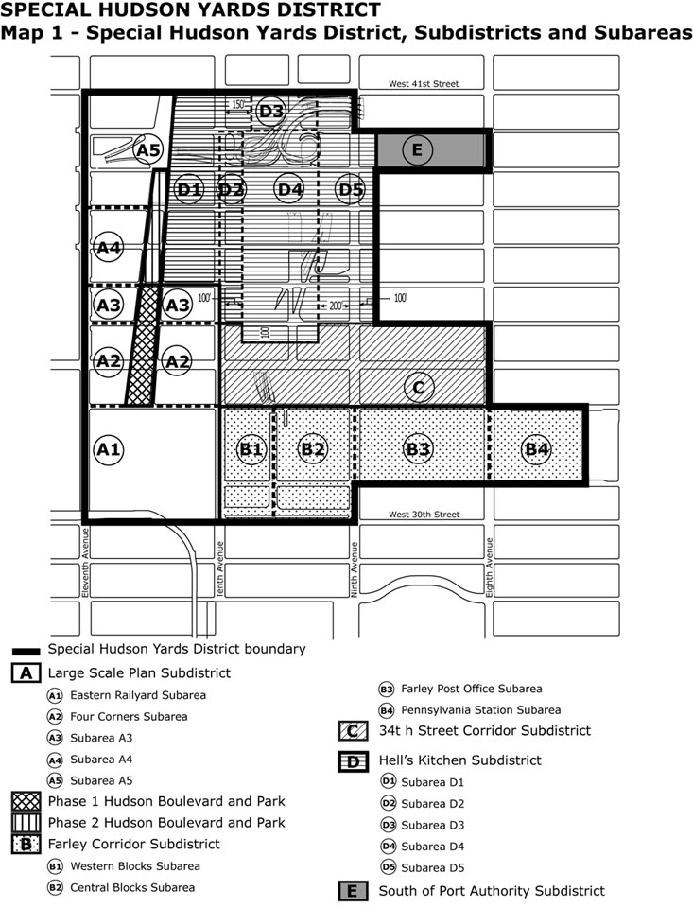

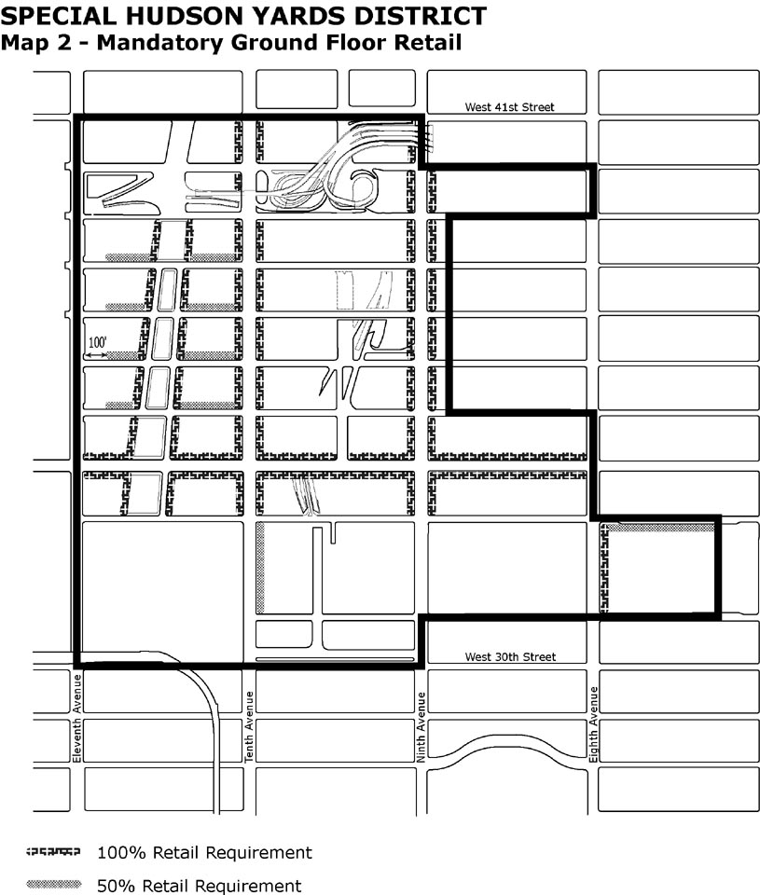

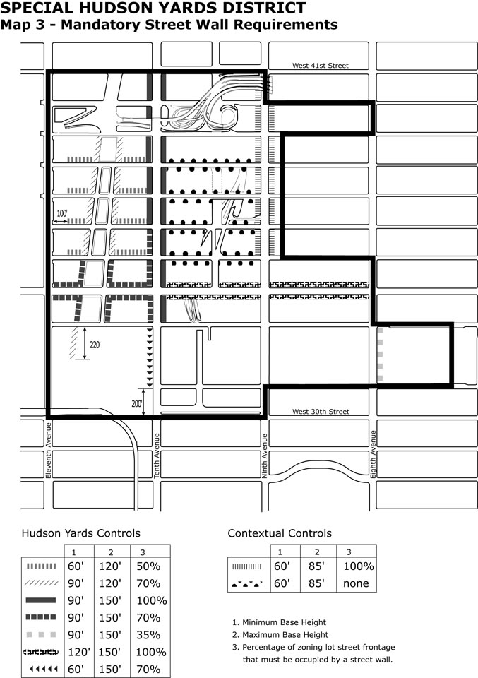

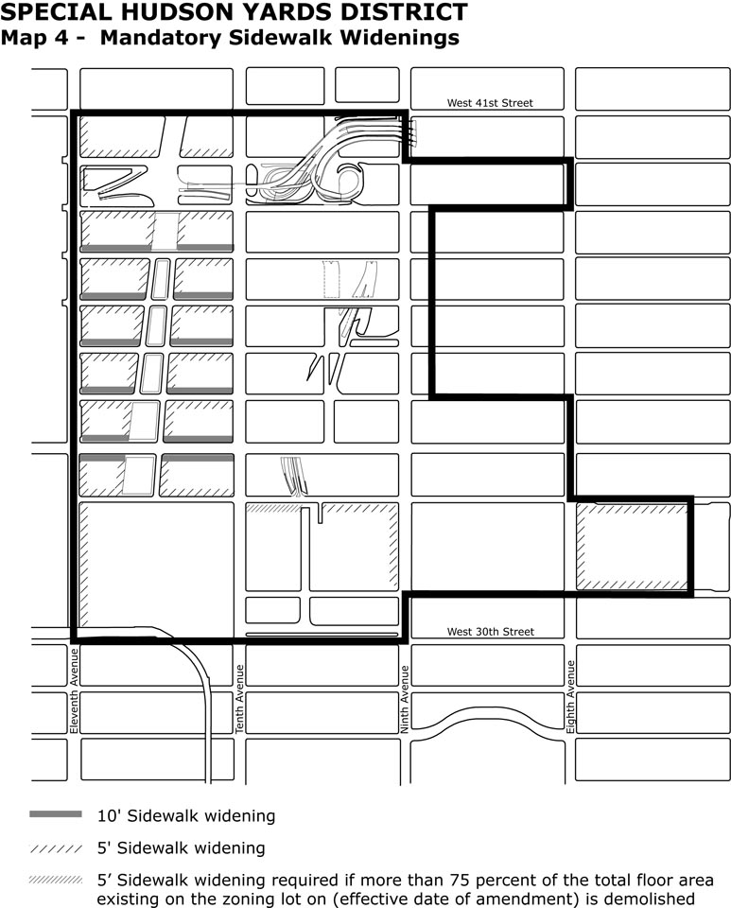

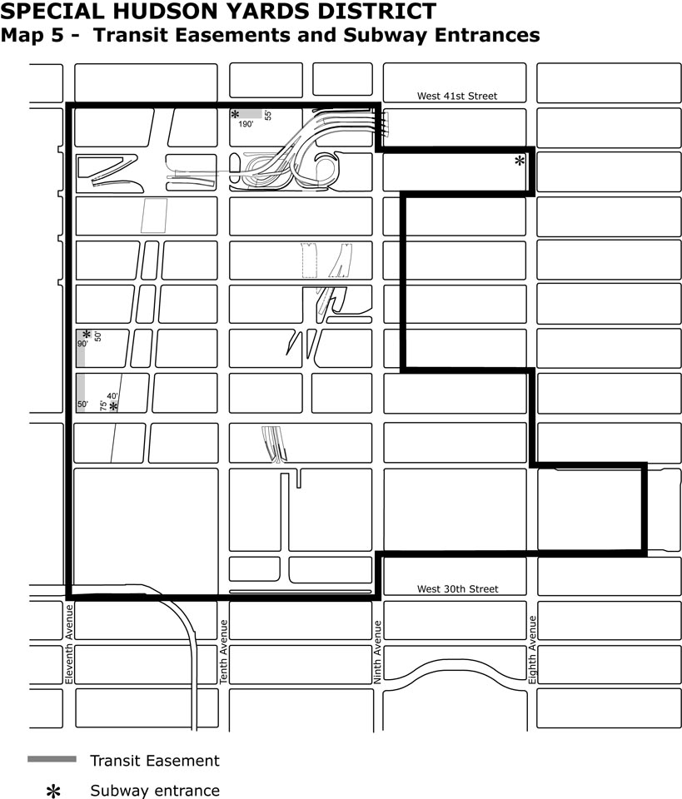

Chapter 6

Special Clinton District

96-00

GENERAL PURPOSES

* * *

These goals include, among others, the following:

* * *

(e) to provide an appropriate transition from the mixed-use character along Eighth Avenue to the lower-scale residential character of the Clinton community on the narrow streets;

(f) to relate the unique character of the 42nd Street Perimeter Area to the adjacent Special Hudson Yards District;

(f)(g) to provide physical amenities, such as street trees, to improve the physical environment;

(g)(h) to restrict demolition of buildings that are suitable for rehabilitation and continued residential use; and

(h)(i) to promote the most desirable use of land in the area and thus conserve the value of land and buildings, and thereby protect the City’s tax revenues, consistent with the foregoing purposes.

* * *

96-20

PERIMETER AREA

#Developments# within the Perimeter Area shall be eligible for increased #floor area# pursuant to Section 96-21 (Floor Area Bonus) 96-21 (Special Regulations for 42nd Street Perimeter Area) or Section 96-22 (Special Regulations for Eighth Avenue Perimeter Area)...

* * *

96-201 96-21

Special rRegulations for 42nd Street Perimeter Area

* * *

(a) Special regulations for office use

In the 42nd Street Perimeter Area as shown in Appendix B, any #development# or #enlargement# that includes Use Group 6B offices constructed after (the effective date of amendment) shall be permitted only pursuant to Section 93-13 (Special Office Use Regulations)

(b) Floor area regulations

(1) Floor area regulations in Subarea 1

In Subarea 1 of the 42nd Street Perimeter Area as shown in Appendix B, the basic #floor area ratio# of any #development# or #enlargement# shall be 10.0, and may be increased to a maximum of 12.0 only in accordance with the provisions of Section 23-90 (INCLUSIONARY HOUSING), except that any units for which a #floor area# increase has been earned pursuant to Section 23-90 shall be within the #Special Clinton District#.

(2) Floor area regulations in Subarea 2

In Subarea 2 of the 42nd Street Perimeter Area as shown in Appendix B, the basic #floor area ratio# of any #development# or #enlargement# shall be 10.0. However, the #floor area ratio# of any #development# or #enlargement# containing #residential use# may exceed 10.0 to a maximum of 12.0 only in accordance with the provisions of Section 23-90 (INCLUSIONARY HOUSING), except that any units for which a #floor area# increase has been earned pursuant to Section 23-90 shall be within the #Special Clinton District#. For #developments# or #enlargements# that have fully utilized the Inclusionary Housing Program, the maximum permitted #floor area ratio# may be increased from 12.0 to 15.0 for new legitimate theater use in accordance with the provisions of Section 96-25 (Floor Area Bonus for New Legitimate Theater Use)

(a)(c) Retail continuity requirements

* * *

(b)(d) Street wall continuity requirements

* * *

(e) Pedestrian circulation space

Within Subarea 2 of the 42nd Street Perimeter Area, as shown in Appendix B, pedestrian circulation space shall be provided in accordance with the provisions of Section 37-07 (Requirements for Pedestrian Circulation Space).

(f) Special curb cut and parking requirements

No curb cuts shall be permitted on 42nd Street. The parking requirements of the #Special Hudson Yards District# shall apply within the 42nd Street Perimeter Area, as set forth in Section 93-80 (OFF-STREET PARKING), except that such parking requirements shall not apply to any #development# or #enlargement# for which a special permit was granted prior to (effective date of amendment).

The provisions of this Section 96-21 shall not apply to any #development# or #enlargement# for which a building permit has been lawfully issued prior to December 31, 2004. In lieu thereof, the regulations in effect at the time such permit was issued shall apply.

96-202 96-22

Special rRegulations for Eighth Avenue Perimeter Area

For #developments# or #enlargements# located in an area bounded by a line 150 feet west of Eighth Avenue, West 56th Street, Eighth Avenue and West 45th Street, excluding such area between West 49th and West 50th Streets, the floor area ratio permitted by the underlying district may be increased from 10.0 to 12.0 only pursuant to Section 23-90 (INCLUSIONARY HOUSING), except that any units for which a #floor area# increase has been earned pursuant to Section 23-90 shall be within the #Special Clinton District#.

All #developments# or #enlargements# located in an area bounded by a line 150 feet west of Eighth Avenue, West 45th Street, Eighth Avenue and West 42nd Street shall comply with special regulations set forth in Article VIII, Chapter 1 (Special Midtown District), including Section 81-21 (Floor Area Regulations), and Section 81-70 (SPECIAL REGULATIONS FOR THEATER SUBDISTRICT). For #developments# or #enlargements# that utilize a #floor area# increase pursuant to the Inclusionary Housing Program of Section 23-90, any units for which a #floor area# increase has been earned shall be within the #Special Clinton District#.

96-21

Floor Area Increase

(a) Except as specified in paragraph (b) of this Section, for any #development#, the #floor area ratio# permitted by the underlying district may be increased from 10.0 to 12.0 only by complying with the provisions of Section 23-90 (INCLUSIONARY HOUSING). A permanent certificate of occupancy for any #building# incorporating a #floor area# increase pursuant to this Section shall not be issued by the Department of Buildings until the issuance of a permanent certificate of occupancy for lower income housing. In addition to the requirements of Section 23-90, any units for which a #floor area# increase has been earned pursuant to Section 23-90 shall be within the #Special Clinton District#.

(b) For any #development# located within the Eighth Avenue Perimeter Area set forth in Section 96-202 (Special regulations for Eighth Avenue Perimeter Area), the #floor area ratio# permitted by the underlying district may be increased pursuant to the provisions of Section 81-21 (Floor Area Regulations) as set forth in Article VIII, Chapter 1 (Special Midtown District).

96-22 96-23

Special Permit for Modification of Height and Setback Regulations

Except within the Eighth Avenue Perimeter Area set forth in Section 96-202 (Special Regulations for Eighth Avenue Perimeter Area), the City Planning Commission, by special permit, may permit modification of height and setback regulations for #developments# which have generated an increase in the #floor area ratio# of not more than 2.0 under the provisions of Section 96-21 (Special Regulations for 42nd Street Perimeter Area), provided that such modification is necessary to achieve better site planning.

The Commission may prescribe additional conditions and safeguards to minimize adverse effects on the character of the surrounding area.

* * *

96-23 96-24

Relocation and Demolition of Buildings in the Perimeter Area

* * *

96-25

Floor Area Bonus for New Legitimate Theater Use

Within Subarea 2 of the 42nd Street Perimeter Area as shown in Appendix B, for #developments# or #enlargements# located within the area bounded by West 42nd Street, Dyer Avenue, West 41st Street and Eleventh Avenue that have fully utilized a #floor area# increase pursuant to Section 23-90 (INCLUSIONARY HOUSING PROGRAM), three additional square feet of #floor area# may be provided for each square foot of new legitimate theater #use#, upon certification by the Chairperson of the City Planning Commission to the Commissioner of Buildings that the following conditions shall exist:

(a) the total #floor area ratio# on the #zoning lot# shall not exceed 15.0;
(b) all #floor area# for which a bonus is received pursuant to this Section shall be limited to floor space exclusively associated with legitimate theater #use#, including auditorium, orchestra, balconies, stage and theater equipment space, wings, dressing rooms, lobbies, lounges, ticket offices, rest rooms and circulation space;

(c) the theater shall be designed, arranged and used exclusively for live performances of drama, music or dance and shall have at least 99 fixed seats;

(d) a signed lease shall be provided from a prospective theater operator, or a written commitment from the owner of the theater if such owner is also the operator, for occupancy of the theater and its operation as a legitimate theater for a period of not less than five years;

(e) A plan and program shall be accompanied by written commitment from such owner of the financial resources available to ensure timely completion of the identified scope of work;

(f) a legal commitment shall be provided for inspection and ongoing maintenance of the theater to ensure its continued availability for theater use. Such inspection shall be conducted every five years by a licensed engineer or architect, and a report issued to the Chairperson of the City Planning Commission and notice of such report shall be published in the City Record. Such report shall describe the condition of the theater and identify any maintenance or repair work necessary to ensure the physical and operational soundness of the theater and establish a plan and program for such work, including providing that adequate resources be made available to ensure timely completion of such maintenance or repair work; and

(g) a legal commitment shall be provided for continuance of the #use# of all #floor area# for which a bonus has been received pursuant to this Section as a legitimate theater for the life of the related #development#.

Such legal commitments shall be in the form of a declaration of restrictions, filed and duly recorded in the Borough Office of the Register of the City of New York, binding upon the owner, lessee of the theater and their successors and assigns, a certified copy of which shall be submitted to the City Planning Commission. The filing of such declaration and the posting of any bond or other security required by the declaration and receipt of such certified copy shall be preconditions to issuance of any building permit, including any foundation or alteration permit, for any #development# or #enlargement#.

The owner shall not apply for or accept a temporary certificate of occupancy for that portion of the #development# or #enlargement# identified as utilizing the increased #floor area# permitted pursuant to this Section, and the Department of Buildings shall not issue a temporary certificate of occupancy for such portion, until the Chairperson has certified that the theater is substantially complete, which shall, for this purpose, mean that such theater is usable by the public. The owner shall not apply for or accept a permanent certificate of occupancy for such portion of the #development# or #enlargement#, nor shall the Department of Buildings issue a permanent certificate of occupancy for such portion until the theater has been finally completed in accordance with the approved plans and such final completion has been certified by the Chairperson.

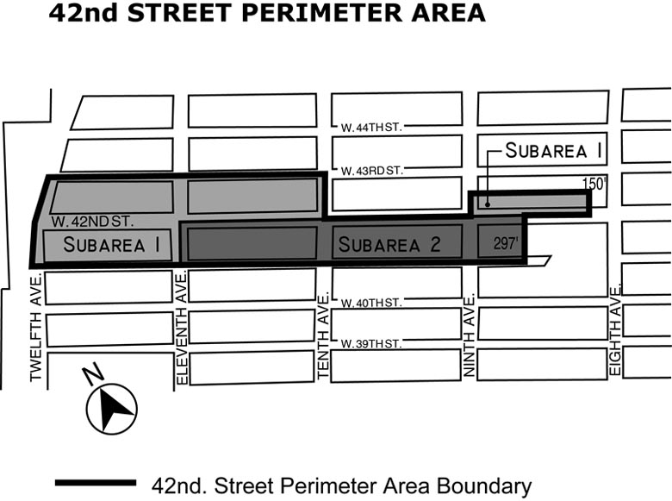

Article XII - Special Purpose Districts

Chapter 1

Special Garment Center District

121-00

GENERAL PURPOSES

The "Special Garment Center District" established in this Resolution is designed to promote and protect public health, safety, and general welfare. These general goals include, among others, the following specific purposes:

* * *

(d) to recognize the unique character of the western edge of the District as integral to the adjacent Special Hudson Yards District;

(d)(e) to establish an appropriate visual character for wide streets within the Garment Center; and

(e)(f) to promote the most desirable use of land within the district, to conserve the value of land and buildings, and thereby protect the City's tax revenues.

* * *

121-03

District Plan (Appendix A)

The District Plan (Appendix A) for the #Special Garment Center District# shows the Preservation Areas, indicated by a "P-1" and “P-2". Appendix A is hereby incorporated as an integral part of the provisions of this Chapter.

121-10

PRESERVATION AREA

121-11Special Use Regulations

(a) Use Groups A and B list the #uses# which are permitted in the Preservation Area. In Preservation Area P-1, permitted uses are listed in Use Groups A and B, as set forth in Sections 121-111 and 121-112. In addition, conversion to Use Group 6B #use# is permitted subject to the #floor area# preservation requirements of Section 121-113 (Floor area preservation).

(b) In Preservation Area P-2, for #buildings# with less than 70,000 square feet of #floor area# on (effective date of amendment), the underlying #use# regulations shall apply, except that the provisions of Section 15-20 through 15-215, inclusive, shall not apply. In lieu thereof, the provisions of Section 15-10 through15-13, inclusive, shall apply to the conversion to #dwelling units# of non-#residential buildings#.

(c) In Preservation Area P-2, for #buildings# with 70,000 square feet or more of #floor area# existing on (effective date of amendment), permitted #uses# are listed in Use Groups A and B as set forth in Sections 121-111 and 121-112. In addition, conversion to any #use# permitted by the underlying #use# regulations is permitted subject to the #floor area# preservation requirements of Section 121-113 (Floor area preservation). For portions of such #buildings# converted to #dwelling units#, the provisions of Section 15-20 through 15-215, inclusive, shall not apply. In lieu thereof, the provisions of Section 15-10 through15-13, inclusive, shall apply to such conversions. Such #floor area# preservation requirements may be waived by authorization of the City Planning Commission pursuant to Section 121-13.

(d) In Preservation Area P-2, any #development# or #enlargement# that includes Use Group 6B offices constructed after (the effective date of amendment) shall be permitted only pursuant to Section 93-13 (Special Office Use Regulations)

121-111

Use Group A

Conversion to Use Group A #uses# are exempt from the #floor area# preservation requirements of Section 121-113 (Floor area preservation). In Preservation Area P-1, Iin the case of conversion of #floor area# to Use Group 6B #use#, Use Group A #uses# may not be used to satisfy the preservation requirement. In Preservation Area P-2, in the case of conversion of #floor area# to any #use# permitted by the underlying #use# regulations, Use Group A #uses# may not be used to satisfy the preservation requirement.

* * *

121-112

Use Group B

Conversion to Use Group B #uses# are exempt from the #floor area# preservation requirements of Section 121-113 (Floor area preservation). In Preservation Area P-1, Iin the case of conversion of #floor area# to Use Group 6B #use#, only Use Group B #uses# may be used to satisfy the preservation requirement. In Preservation Area P-2, in the case of conversion of #floor area# to any #use# permitted by the underlying #use# regulations, only Use Group B #uses#, and #uses# in Use Group 6A and 6C may be used to satisfy the preservation requirement.

* * *

121-113

Floor area preservation

In the Preservation Area P-1, the conversion of #floor area# to Use Group 6B #use# after March 26, 1987, and, in Preservation Area P-2, for #buildings# with 70,000 square feet or more of #floor area# existing on (effective date of amendment), the conversion of #floor area# to any #use# permitted by the underlying #use# regulations is permitted only by certification of the Chairperson of the City Planning Commission that #floor area# has been preserved subject to the provisions of Section 121-115 (Certification and other requirements of preservation and conversion) for #uses# specified in Section 121-112 (Use Group B).

The amount of #floor area# to be preserved shall be equal to the amount of #floor area# converted. Such #floor area# may be preserved in the same #building# or in any other comparable #building# in the Preservation Areas P1 or P2, subject to the provisions of Section 121-114 (Comparability).

* * *

121-115

Certification and other requirements of preservation and conversion

(a) Prior to the issuance of an alteration permit for the conversion of #floor area# to Use Group 6B use in Preservation Area P-1, or the conversion of #floor area# to any #use# permitted by the underlying #use# regulations in Preservation Area P-2, the Chairperson of the City Planning Commission shall certify....

* * *

121-13

Authorization for Waiver of Floor Area Preservation Requirements

In Preservation Area P-2, for #buildings# with 70,000 square feet or more of #floor area# existing on (effective date of amendment), the City Planning Commission may authorize the conversion of #floor area# to any #use# permitted by the underlying #use# regulations without complying with the #floor area# preservation requirements set forth in Section 121-113, provided the Commission finds that:

(a) The #floor area# to be converted has not been occupied by any #manufacturing#, wholesale or showroom #use# for a period of at least three years prior to (date of
complete application filed with the Department of City Planning);

(b) the conversion will not harm the commercial and manufacturing sectors of the City’s economy;

(c) the conversion will not harm the commercial and manufacturing character of the surrounding area;

(d) the process of conversion will not unduly burden #commercial# and #manufacturing uses# in the #building#; and

(e) the neighborhood in which the conversion is taking place will not be excessively burdened by increased #residential# activity.

* * *

121-30

SPECIAL BULK REGULATIONS WITHIN PRESERVATION AREA P-2

The following special #bulk# regulations shall apply within Preservation Area P-2, as shown in Appendix A:

121-31

Maximum Permitted Floor Area

The basic maximum #floor area ratio# of a non-#residential building# shall be 10.0 and may be increased to a maximum #floor area ratio# of 12.0 only pursuant to Section 93-31 (District Improvement Fund). For #buildings# containing #residences#, the basic maximum #floor area ratio# shall be 6.5. The #floor area ratio# of any #building# containing #residences# may be increased from 6.5 [to 9.0 only pursuant to Section 93-31, and may be further increased from 9.0 to 12.0 only pursuant to Section 23-90 (INCLUSIONARY HOUSING), as modified by Section 93-24 .] pursuant to Sections 93-31, and pursuant to Section 23-90 (INCLUSIONARY HOUSING), as modified by Section 93-23, provided that for every five square foot of #floor area# increase pursuant to Section 93-31 or 93-32 there is a #floor area# increase of six square feet pursuant to Section 23-90 as modified by Section 93-23. The maximum #residential floor area ratio# shall be 12.0.

For the conversion to #dwelling units# of non-#residential buildings# or portions thereof, where the total #floor area# on the #zoning lot# to be converted to #residential use# exceeds a #floor area ratio# of 12.0, such excess #floor area# shall be permitted only pursuant to Section 93-31 (District Improvement Fund Bonus).

121-32

Height of Street Walls and Maximum Building Height

The #street wall# of any #development# or #enlargement# shall be located on the #street line# and extend along the entire #street# frontage of the #zoning lot# not occupied by existing #buildings# to remain. Such #street wall# shall rise without setback to a maximum height of 90 feet or the height of the #building#, whichever is less. However, if the height of an adjacent #street wall# fronting on the same #street line# is higher than 90 feet before setback, the #street wall# of the new or #enlarged building# may rise without setback to the height of such adjacent #street wall#, up to a maximum height of 120 feet. Above a height of 90 feet or the height of the adjacent #street wall# if higher than 90 feet, no portion of the #development# or #enlargement# shall penetrate a #sky exposure plane# that begins at a height of 90 feet above the #street line# or the height of the adjacent #street wall# if higher than 90 feet and rises over the #zoning lot# at a slope of four feet of vertical distance for each foot of horizontal distance to a maximum height limit of 250 feet, except as provided below:

(a) any portion of the #building or other structure developed# or #enlarged# pursuant to the tower regulations of Sections 33-45 or 35-63, as applicable, may penetrate the #sky exposure plane# provided no portion of such #building or other structure# exceeds the height limit of 250 feet; and

(b) permitted obstructions, as listed in Section 93-41(a) may penetrate the #sky exposure plane# and the height limit of 250 feet. In addition, a dormer, as listed in paragraph (c) of Section 23-62 may penetrate the #sky exposure plane#.

121-40

PARKING REQUIREMENTS IN PRESERVATION AREA P-2

Within Preservation Area P-2, as shown in Appendix B, the underlying parking requirements shall not apply. In lieu thereof, the parking regulations of the Special Hudson Yards District, as set forth in Section 93-80 (OFF-STREET PARKING) shall apply.

* * *

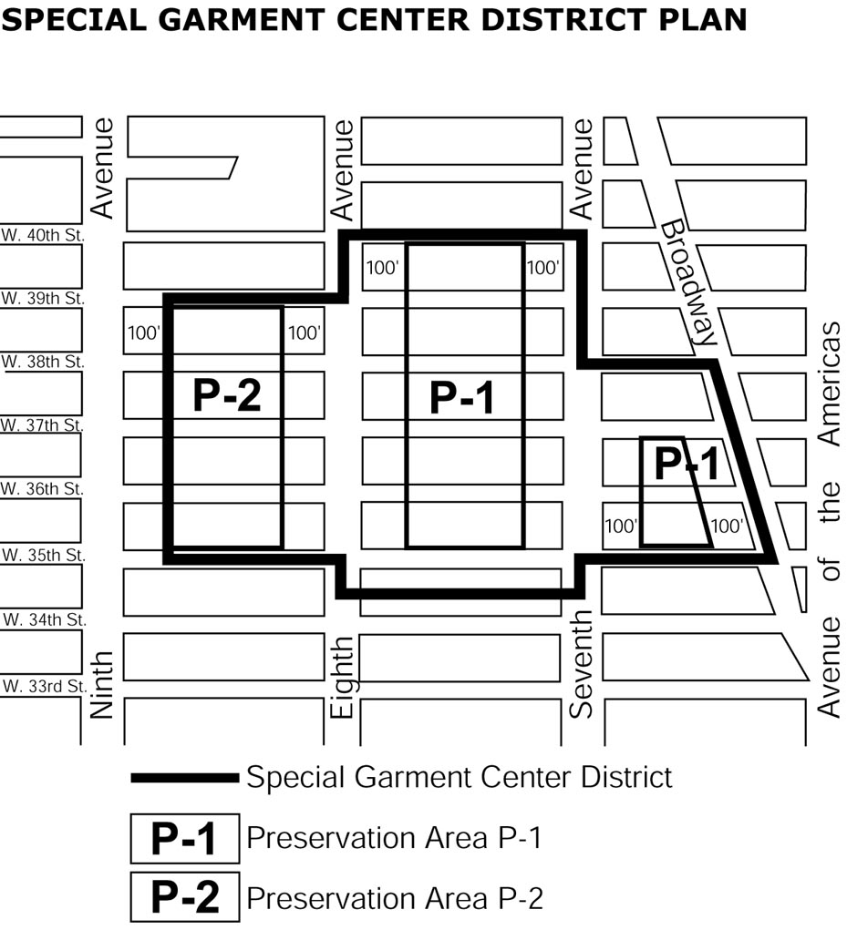

Adopted.

Office of the City Clerk, }
The City of New York, } ss.:

I hereby certify that the foregoing is a true copy of a Resolution passed by The Council of The City of New York on January 19, 2005, on file in this office.

…...............................................
City Clerk, Clerk of The Council

