THE COUNCIL OF THE CITY OF NEW YORK
RESOLUTION NO. 1742

Resolution approving with modifications the decision of the City Planning Commission on Application No. N 170359 ZRM, for an amendment of the Zoning Resolution of the City of New York, establishing the Special East Harlem Corridors District (Article XIII, Chapter 8) and modifying Appendix F, for the purpose of establishing a Mandatory Inclusionary Housing area, and modifying related sections, Community District 11, Borough of Manhattan (L.U. No. 774).

By Council Members Greenfield and Richards

WHEREAS, the City Planning Commission filed with the Council on October 2, 2017 its decision dated October 2, 2017 (the "Decision"), pursuant to Section 201 of the New York City Charter, regarding an application submitted by the New York City Department of City Planning, establishing the Special East Harlem Corridors District (Article XIII, Chapter 8) and modifying Appendix F, for the purpose of establishing a Mandatory Inclusionary Housing area, and modifying related sections. This action, in conjunction with the related actions would facilitate the East Harlem Neighborhood Initiative, a comprehensive, community-focused effort aimed at identifying opportunities for the creation of new mixed-income housing and the preservation of existing affordable housing units (Application No. N 170359 ZRM), Community District 11, Borough of Manhattan (the "Application");

WHEREAS, the Application is related to applications C 170358 ZMM (L.U. No. 773), an amendment to the Zoning Map; and C 170360 HUM (L.U. No. 775), amendment to the bulk and use regulations, and the expiration date, of the Milbank Frawley Circle-East Urban Renewal Plan;

WHEREAS, the Decision is subject to review and action by the Council pursuant to Section 197-d(b)(1) of the City Charter;
WHEREAS, upon due notice, the Council held a public hearing on the Decision and Application on October 11, 2017;

WHEREAS, the Council has considered the land use implications and other policy issues relating to the Decision and Application; and

WHEREAS, the Council has considered the relevant environmental issues, including the Final Environmental Impact Statement (FEIS) for which a Notice of Completion was issued on September 19, 2017 (CEQR No. 17DCP048M), which identified significant adverse impacts with respect to hazardous materials, air quality and noise which would be avoided through the placement of (E) designations (E-422), and additional significant adverse impacts with respect to shadows, historic and cultural resources (architectural and archeological), transportation (traffic, transit and pedestrians), and construction activities related to noise, and the Technical Memoranda dated September 29, 2017, (the “Technical Memoranda”);

RESOLVED:

Having considered the FEIS and the Technical Memoranda with respect to the Decision and Application, the Council finds that:

(1) The FEIS meets the requirements of 6 N.Y.C.R.R. Part 617;

(2) Consistent with social, economic and other essential considerations, from among the reasonable alternatives thereto, the Proposed Actions, as modified with the modifications adopted herein and in the Technical Memorandum 002, is one which minimizes or avoids adverse environmental impacts to the maximum extent practicable; and

(3) The adverse environmental impacts identified in the FEIS will be minimized or avoided to the maximum extent practicable by the placement of (E) designations for Hazardous Materials, Air Quality, and Noise, which form part of the Proposed Actions, or the specification of required mitigation measures, as appropriate; and

(4) The Decision, together with the FEIS and the Technical Memoranda, constitute the written statement of facts, and of social, economic and other factors and standards that form the basis of this determination, pursuant to 6 N.Y.C.R.R. §617.11(d).

Pursuant to Sections 197-d and 200 of the City Charter and on the basis of the Decision and Application, and based on the environmental determination and consideration described in the report, N 170359 ZRM, incorporated by reference herein, the Council approves the Decision of the City Planning Commission with the following modifications:

Matter underlined is new, to be added;
Matter struck out is to be deleted;
Matter within # # is defined in Section 12-10;
Matter double strike-out is old, deleted by the City Council;
Matter double underlined is new, added by the City Council;
* * * indicates where unchanged text appears in the Zoning Resolution.

ARTICLE I
GENERAL PROVISIONS

Chapter 1
Title, Establishment of Controls and Interpretation of Regulations

* * *

11-122
Districts established
In order to carry out the purposes and provisions of this Resolution, the following districts are hereby established:

* * *
Special Purpose Districts

* * *

Establishment of the Special Downtown Jamaica District

In order to carry out the special purposes of this Resolution as set forth in Article XI, Chapter 5, the #Special Downtown Jamaica District# is hereby established.

Establishment of the Special East Harlem Corridors District

In order to carry out the special purposes of this Resolution as set forth in Article XIII, Chapter 8, the #Special East Harlem Corridors District# is hereby established.

Establishment of the Special Enhanced Commercial District

In order to carry out the special purposes of this Resolution as set forth in Article XIII, Chapter 2, the #Special Enhanced Commercial District# is hereby established.

* * *

Chapter 2
Construction of Language and Definitions

* * *

12-10
DEFINITIONS

* * *

Special Downtown Jamaica District

The “Special Downtown Jamaica District” is a Special Purpose District designated by the letters “DJ” in which special regulations set forth in Article XI, Chapter 5, apply.

Special East Harlem Corridors District

The “Special East Harlem Corridors District” is a Special Purpose District designated by the letters “EHC” in which special regulations set forth in Article XIII, Chapter 8, apply.

Special Enhanced Commercial District

The “Special Enhanced Commercial District” is a Special Purpose District designated by the letters “EC” in which special regulations set forth in Article XIII, Chapter 2, apply.

* * *

Chapter 4
Sidewalk Cafe Regulations

* * *

14-40
AREA ELIGIBILITY FOR SIDEWALK CAFES

* * *

14-44
Special Zoning Districts Where Certain Sidewalk Cafes Are Permitted

* * *

Manhattan | #Enclosed Sidewalk Cafe# | #Unenclosed Sidewalk Cafe#
Clinton District | No | Yes
East Harlem Corridors District | No | Yes
Enhanced Commercial District 2  (Columbus and Amsterdam Avenues) | Yes | Yes

* * *

ARTICLE II
RESIDENCE BULK REGULATIONS

Chapter 3
Residential Bulk Regulations in Residence Districts

* * *

23-011
Quality Housing Program

* * *
R6 R7 R8 R9 R10

- In the districts indicated without a letter suffix, the optional Quality Housing #bulk# regulations permitted as an alternative pursuant to paragraph (b) of this Section, shall not apply to:
* * *

- Special Purpose Districts
However, such optional Quality Housing #bulk# regulations are permitted as an alternative to apply in the following Special Purpose Districts:

#Special 125th Street District#;
#Special Downtown Brooklyn District#;
#Special Downtown Jamaica District#;
#Special East Harlem Corridors District#;
#Special Grand Concourse Preservation District#;

* * *

23-03
Street Tree Planting in Residence Districts

R1 R2 R3 R4 R5 R6 R7 R8 R9 R10

In all districts, as indicated, the following shall provide #street# trees in accordance with Section 26-41 (Street Tree Planting):

* * *

(b) #enlargements# of #single-# or #two-family residences# by 20 percent or more within the following special purpose districts:

#Special Bay Ridge District#;

#Special Clinton District#;

#Special Downtown Brooklyn District#

#Special Downtown Jamaica District#

#Special East Harlem Corridors District#;

#Special Grand Concourse Preservation District#;

* * *

ARTICLE III
COMMERCIAL DISTRICT REGULATIONS

Chapter 3
Bulk Regulations for Commercial or Community Facility Buildings in Commercial Districts

* * *

33-03
Street Tree Planting in Commercial Districts

C1 C2 C3 C4 C5 C6 C7 C8

In all districts, as indicated, the following shall provide #street# trees in accordance with Section 26-41 (Street Tree Planting):

* * *

(b) #enlargements# of #single-# or #two-family residences# by 20 percent or more within the following special purpose districts:

#Special Bay Ridge District#;

#Special Clinton District#;

#Special Downtown Brooklyn District#

#Special Downtown Jamaica District#

#Special East Harlem Corridors District#;

#Special Grand Concourse Preservation District#;

* * *

ARTICLE IX

SPECIAL PURPOSE DISTRICTS

Chapter 5
Special Transit Land Use District

95-00
GENERAL PURPOSES

* * *

95-03
Transit Easement

Any #development# or #enlargement# involving ground level construction within the #Special Transit Land Use District# shall provide an easement on the #zoning lot# for subway-related use and public access to the subway mezzanine or station when required pursuant to the provisions of Section 95-04.

The issuance by the Department of Buildings of an excavation permit for any #zoning lot# located within the Special District shall be dependent upon prior compliance with the provisions of this Chapter.

The transit easement required on a #zoning lot# shall permit the realization of one or more of the following planning objectives:

(a) the integration and relating of subway station design to surrounding development;

(b) the introduction of light and air to: stations; and mezzanines; and other related facilities constructed pursuant to the provisions of Section 95-032 (Determination of transit easements at other stations);

* * *

95-031
Selection of transit easement at certain stations

At the stations specified below, Tthe transit easement required on a #zoning lot# shall constitute a volume whose dimensions above and below #curb level# shall comply with the requirements as set forth in Table A or Table B of this Section, depending on the depth of the proposed subway mezzanine below #curb level#, as established by the Metropolitan Transportation Authority.

* * *

TABLE B
MINIMUM DIMENSIONS FOR TRANSIT EASEMENT VOLUME
(in feet)

Stations: Chatham Square, Grand St., 14th St., 23rd St., UN Plaza, East Midtown, and Yorkville, Franklin Plaza, and Triboro Plaza

* * *

95-032
Determination of transit easements at other stations

At the 106th Street, 116th Street and 125th Street stations, a transit easement shall be provided to accommodate, whether singly or in any combination, light wells, stairs, ramps, escalators, elevators, passageways, or ancillary facilities required to support the functioning of subway station or rail mass transit facilities, including, but not limited to, emergency egress or ventilation structures, the Metropolitan Transportation Authority shall, in consultation with the owner of the #zoning lot# and the City Planning Commission, determine the appropriate type of transit easement and reasonable dimensions for such transit easement volume.

95-0323
Location of transit easements

* * *

95-05
Terms and Conditions for Permitted Uses and Construction within Transit Easement Volume

The transit easement volume shall be used as an entrance/exit for public access to the subway and/or to provide better access of light and air to the subway station mezzanine, and for related uses. Illustrative of such purposes are light wells, stairs, ramps, escalators, or elevators, or, for #zoning lots# subject to the provisions of Section 95-032 (Determination of transit easements at other stations), ancillary facilities required to support the functioning of subways, including, but not limited to, emergency egress or ventilation structures.

No #floor area# bonus shall be allowed for any transit easement provided on a #zoning lot#. When a transit easement volume required on a #zoning lot# is located within a #building#, any floor spaces occupied by such transit easement volume shall not count as #floor area#. Any portion of the #lot area# of a #zoning lot# occupied by a transit easement and weather protected by an overhang or roofed area, shall be considered as a #public plaza# in the districts that allow such #public plaza# bonuses.

* * *

95-051
Development of transit access facilities

All access facilities, including any light wells or sky lights required within a transit easement volume established pursuant to the provisions of Section 95-031 (Selection of transit easement at certain stations), or access and ancillary facilities required pursuant to the provisions of Section 95-032 (Determination of transit easement at other stations), shall be constructed and maintained by the Metropolitan Transportation Authority except for any #building# columns, footings or any other permitted obstructions allowed therein.

* * *

95-052
Special access facilities for persons with disabilities at certain stations

For #zoning lots# subject to the provisions of Section 95-031 (Selection of transit easement at certain stations), Sspecial elevators for persons with disabilities may locate within a transit easement volume, provided stair and/or escalator access to the subway mezzanine are located within the same easement and in no event located within the public sidewalk adjacent to the #zoning lot#.

* * *

Article IX
Special Purpose Districts

Chapter 7
Special 125th Street District

97-00
GENERAL PURPOSES

The “Special 125th Street District” established in this Resolution is designed to promote and protect the public health, safety, general welfare and amenity. The general goals include, among others, the following specific purposes:

(a) to preserve, protect and promote the special character of 125th Street as Harlem’s “Main Street” and the role of 125th Street as Upper Manhattan’s premier mixed use corridor;

(b) to guide development on the 125th Street corridor;

(c) to expand the retail and commercial character of 125th Street;

(d) to provide incentives for the creation of visual and performing arts space and enhance the area’s role as a major arts, entertainment and cultural destination in the City;

(e) to support mixed use development throughout the 125th Street corridor, including residential uses, and to provide incentives for the production of affordable housing;

(f) to ensure that the form of new buildings is compatible and relates to the built character of the 125th Street corridor;

(g) to enhance the pedestrian environment through appropriate ground floor uses and regulations;

(h) to ensure, in the Park Avenue Hub Subdistrict, compatibility with the purposes of the #Special East Harlem Corridors District#; and

(h)(i) to promote the most desirable use of land and thus conserve and enhance the value of land and buildings, and thereby protect the City’s revenue.

* * *

97-03
District Plan and Maps

The regulations of this Chapter are designed to implement the #Special 125th Street District# Plan. The District Plan, including Map 1 (Special 125th Street District and Core Subdistricts) and Map 2 (Permitted Small Sidewalk Cafe Locations), is set forth in Appendix A of this Chapter and is hereby incorporated as part of this Resolution for the purpose of specifying locations where the special regulations and requirements set forth in this Chapter apply.

97-04
Establishment of Core Subdistricts

In order to carry out the purposes and provisions of this Chapter, the Core two subdistricts is are established within the #Special 125th Street District# and: the Core Subdistrict and the Park Avenue Hub Subdistrict. Each subdistrict includes specific regulations designed to support an arts and entertainment environment and other relevant planning objectives along 125th Street. The boundaries of the Core Ssubdistricts are shown on Map 1 in Appendix A of this Chapter.

* * *

97-06
Applicability of Special Transit Land Use District Regulations
Applicability of District Regulations

[Note: existing provisions moved to Section 97-061]

97-061
Applicability of Special Transit Land Use District Regulations

[Note: existing provisions moved from Section 97-06 and updated a cross reference. The specification of the #Special Transit Land Use District# was eliminated since they are specified in Zoning Maps.]

Wherever the #Special 125th Street District# includes an area which also lies within the #Special Transit Land Use District#, the requirements of the #Special Transit Land Use District#, as set forth in Article IX, Chapter 5, shall apply, subject to the modifications described in paragraphs (e) (a)(4) and (f) (a)(5) of Section 97-433 (Street wall location) 442 (Height and setback regulations within the Core Subdistrict and areas outside of a subdistrict).

The #Special Transit Land Use District# includes the area within the #Special 125th Street District# bounded by a line 50 feet west of Second Avenue from 124th Street midway to 125th Street where such area widens to a line 100 feet west of Second Avenue.

97-062
Applicability of the Quality Housing Program

[Note: existing provisions moved from 97-40 (SPECIAL BULK REGULATIONS)]

In the #Special 125th Street District#, #buildings# containing #residences# shall be #developed# or #enlarged# in accordance with the Quality Housing Program, and the regulations of Article II, Chapter 8 shall apply. The #bulk# regulations of this Chapter shall be considered the applicable #bulk# regulations for #Quality Housing buildings#.

97-063
Applicability of Inclusionary Housing Program

[Note: existing provision moved from Section 97-421 (Inclusionary Housing) and changed to include Mandatory Inclusionary Housing applicability]

For the purposes of applying the Inclusionary Housing Program provisions set forth in Section 23-154 (Inclusionary Housing) and in Section 23-90 (INCLUSIONARY HOUSING), inclusive, #Inclusionary Housing designated areas# and #Mandatory Inclusionary Housing areas# within the #Special 125th Street Districts# are shown on the maps in APPENDIX F of this Resolution.

97-10
SPECIAL USE AND LOCATION REGULATIONS

* * *

97-14
Transient Hotels Within the Park Avenue Hub Subdistrict

Within the Park Avenue Hub Subdistrict, as shown on Map 1 in Appendix A of this Chapter, the #development# or #enlargement# of a #building# containing a #transient hotel#, as listed in Section 32-14 (Use Group 5), or the #conversion# or change of #use# within an existing #building# to a #transient hotel#, shall only be allowed:

(a) upon certification by the Chairperson of the City Planning Commission to the Commissioner of Buildings that the residential development goal, as set forth in this Section, has been met, or

(b) where such residential development goal, has not been met, by special permit by the City Planning Commission. To permit such a #transient hotel#, the Commission shall find that:

(1) sufficient sites are available in the area to meet the #residential development# goal; or

(2) a harmonious mix of #residential# and non-#residential uses# has been established in the area, and such #transient hotel# is consistent with the character of the surrounding area.

The Commission may prescribe additional conditions and safeguards to minimize adverse effects on the character of the surrounding area.

For the purpose of applying the provisions of this Section, the #residential development# goal shall be met when at least 4,470 3,865 #dwelling units# within the combined areas of the #Special East Harlem Corridors District#, and the Park Avenue Hub Subdistrict, as shown on Map 1 in Appendix A of this Chapter, have received temporary or final certificates of occupancy subsequent to [date of adoption].

97-20
LOCATION AND ACCESS REGULATIONS

[Note: applicability of Article II, Chapter 8 has been moved to Section 97-062]

Within the Core Subdistrict, as shown on Map 1 in Appendix A of this Chapter, and areas outside of a subdistrict, the provisions of Section 97-21 (Location and Access Requirements in Certain Areas), inclusive, shall apply.

Within the Park Avenue Hub Subdistrict, as shown on Map 1 in Appendix A of this Chapter, the provisions of Section 97-21, inclusive, shall apply to any #zoning lot#, or portion thereof, specified in Section 97-21, and the provisions of Section 97-22 (Use Location Regulations in the Park Avenue Hub Subdistrict), inclusive, shall apply to all other #zoning lots#, or portion thereof.

For the purposes of applying the provisions of this Section, defined terms shall include those set forth in Sections 12-10 (DEFINITIONS) and 37-311 (Definitions).

97-21
Location of and Access to Arts and Entertainment Uses
Supplemental Use and Streetscape Regulations along 125th Street

[Note: existing 97-21 provisions moved to Section 97-211]

[Note: existing provisions, moved from Section 97-20]

Within the #Special 125th Street District#, Ffor any #zoning lot# that fronts upon 125th Street, the #use# regulations of the underlying districts shall be modified by the locational and access requirements of this Section, inclusive. However, Oon #through lots# or #corner lots# with frontage along 125th Street, such requirements shall apply within the first 100 feet of the 125th Street #street line#.

97-211
Location and Access to Art and Entertainment Uses

[Note: existing provisions, moved from Section 97-21]

Any arts and entertainment #uses# listed in Section 97-11 that are provided in order to comply with the requirements of Section 97-12 (Arts and Entertainment Use Requirement) or Section 97-422 (Floor area bonus for visual or performing arts uses) shall be subject to the following location and access requirements:

* * *

97-212
Uses not permitted on the ground floor of buildings
[Note: existing provisions moved from Section 97-22 and modified]
The following #uses# are not permitted within #stories# that have a floor level within five feet of #curb level# in #buildings developed# after April 30, 2008, or within #stories# that have a floor level within five feet of #curb level# within portions of #buildings enlarged# after April 30, 2008, where such #building# or portion of a #building# fronts upon 125th Street, or is within 100 feet from 125th Street. Entranceways and lobby space for access to such #uses# shall be permitted at the ground floor level, pursuant to the provisions of Section 97-221 213 (Access to non-ground floor uses).

* * *

97-213
Access to non-ground floor uses

[Note: existing provisions, moved from Section 97-221]
The maximum ground floor #street# frontage on 125th Street allocated to entranceways or lobby space for non-ground floor #uses# listed in Section 97-22 shall be as set forth for Type 1 lobbies in Section 37-33 (Maximum Width of Certain Uses), except that for #developments# or #enlargements# with at least 200 linear feet fronting on 125th Street, the Type 2 lobby regulations shall apply.

Additionally, within the Core Subdistrict the #residential# portion of a #development# or #enlargement# may be accessed from an entrance on 125th Street only if such #development# or #enlargement# does not front upon a #street# other than 125th Street.

97-214
Transparency requirements along 125th Street

[Note: existing provisions, moved from 97-23]

For all #uses#, other than houses of worship, libraries and primary rehearsal spaces, located on the ground floor of #developments# and #enlargements# that front upon that portion of 125th Street located within the #Special 125th Street District#, the ground floor #street wall# shall be glazed in accordance with the provisions set forth in Section 37-34 (Minimum Transparency Requirements).

97-22
Uses Not Permitted on the Ground Floor of Buildings
Supplemental Use and Streetscape Regulations within the Park Avenue Hub Subdistrict

[Note: existing 97-22 provisions moved to Section 97-212]

Within the Park Avenue Hub Subdistrict, as shown on Map 1 in Appendix A of this Chapter, for #zoning lots#, or portion thereof, that are not subject to the provisions of Section 97-21 (Location and Access Regulations along 125th Street), inclusive, the provisions of this Section, inclusive, shall apply.

97-221
Access to non-ground floor uses
Modification of supplemental use location regulations

[Note: existing 97-221 provisions moved to Section 97-213]

The supplementary #commercial use# regulations of Section 32-421 (Limitation on floors occupied by commercial uses) shall be modified to permit #commercial uses# on any #story#, provided that at any level containing #residences#, no access exists between such #commercial# and #residential uses# and provided that such #commercial uses# are not located directly over any #residential use#.

97-222
Ground floor use and streetscape regulations

The provisions of this Section, inclusive, shall apply to #developments# or #ground floor level enlargements#. Any portion of a #ground floor level# allocated to a transit easement required by the MTA pursuant to the provisions of Article IX, Chapter 5 need not comply with the streetscape requirements of this Section.

For the purposes of applying the special #ground floor level# streetscape provisions set forth in Section 37-30 to this Chapter, any portion of a #ground floor level street# frontage along Park Avenue that is not subject to the provisions of Section 97-21 (Location and Access Regulations along 125th Street), inclusive, as well as any #narrow street# frontage within 50 feet of Park Avenue, shall be considered #primary street frontages#. A #ground floor level street# frontage along any other #street# shall be considered a #secondary street frontage#.

(a) Along #primary street frontages#

For #buildings#, or portions thereof, with #primary street frontage#, #uses# on the #ground floor level#, to the minimum depth set forth in Section 37-32 (Ground Floor Depth Requirements for Certain Uses), shall be limited to non-#residential uses#, except for Type 2 lobbies and entrances and exits to #accessory# parking spaces provided in accordance with the applicable provisions of Section 37-33 (Maximum Width of Certain Uses). #Group parking facilities# located on the #ground floor level# shall be wrapped by #floor area# in accordance with the provisions of paragraph (a) of Section 37-35 (Parking Wrap and Screening Requirements). #Ground floor level street walls# shall be glazed in accordance with the provisions set forth in Section 37-34 (Minimum Transparency Requirements).

(b) Along #secondary street frontages#

For #buildings#, or portions thereof, with #secondary street frontage#, all #uses# permitted by the underlying district shall be permitted on the #ground floor level#, provided that any #group parking facilities# on the #ground floor level# shall be wrapped or screened in accordance with the provisions of Section 37-35.

The level of the finished floor of such ground floor shall be located not higher than five feet above nor lower than five feet below the as-built level of the adjoining #street#.

97-23
Transparency Requirements

[Note: existing 97-23 provisions moved to Section 97-214]

* * *

97-40
SPECIAL BULK REGULATIONS

[Note: the applicability of Article II, Chapter 8 moved to Section97-062]

Within the #Special 125th Street District#, all #developments# or #enlargements# containing #residences# shall comply with the requirements of Article II, Chapter 8 (Quality Housing), and the applicable #bulk# regulations of the underlying districts shall apply, except as modified in by the provisions of this Section, inclusive.

97-41
Special Floor Area Regulations

The maximum #floor area ratio#, #open space ratio# and #lot coverage# requirements of the applicable underlying district shall apply within the #Special 125th Street District#, unless modified by the following regulations.

97-411
Maximum floor area ratio in C4-4D, C4-7 and C6-3 Districts within the Core Subdistrict and areas outside of a subdistrict

In C4-4D, C4-7 or C6-3 Districts in the Core Subdistrict, as shown on Map 1 in Appendix A of this Chapter and areas outside of a subdistrict, the maximum permitted #floor area ratios# shall be as listed in the following table for #residential#, #commercial# and #community facility uses#, and may only be increased pursuant to Section 97-42 (Additional Floor Area Bonuses Regulations), inclusive.

* * *

97-412
Maximum floor area ratio in the Park Avenue Hub Subdistrict

Within the Park Avenue Hub Subdistrict, as shown on Map 1 in Appendix A of this Chapter, the maximum #floor area ratio# for #zoning lots# is set forth in paragraph (a) of this Section, and is modified for certain #zoning lots# in accordance with paragraph (b) of this Section.

(a) Maximum #floor area ratio#

The maximum #floor area ratio# shall be 12.0. Where a #development# or #enlargement# contains #residential floor area#, such #zoning lot# shall satisfy the provisions of either:

(1) a minimum non-#residential floor area ratio# of 2.0 shall be provided on such #zoning lot#. Such #floor area# shall not include any #floor area# containing a #transient hotel# pursuant to the provisions of Section 97-14 (Transient Hotels Within the Park Avenue Hub Subdistrict); or

(2) a minimum #floor area ratio# of 0.5, or a minimum amount of floor space equivalent to such 0.5 #floor area ratio#, shall be provided on such #zoning lot#. Such #floor area# or equivalent floor space shall be exclusively used for those visual or performing arts #uses#, designated in paragraph (b) of Section 97-11 (Special Arts and Entertainment Uses), and shall be certified by the Chairperson of the City Planning Commission to the Commissioner of Buildings that the conditions set forth in Section 97-423 (Certification for floor area bonus for visual or performing arts uses) have been met.

(b) Modified maximum #floor area ratio# for certain #zoning lots#

For #zoning lots# existing on or before [date of adoption] with a #lot area# of less than 5,000 square feet, or for #zoning lots# subject to the provisions of paragraph (d)(4) of Section 23-154 (Inclusionary Housing), the maximum #floor area ratios# set forth in paragraph (a) of this Section shall be modified, as follows:

(1) the minimum non-#residential floor area# requirements set forth in paragraph (a) of this Section shall be optional for #zoning lots# existing on or before [date of adoption] with a #lot area# of less than 5,000 square feet. For #zoning lots# utilizing the provisions of this paragraph, the minimum non-#residential floor area# or visual or performing arts space requirements set forth in paragraph (a) of this Section shall not apply;

(2) for #zoning lots#, subject to the provisions of paragraph (d)(4)(i) or (d)(4)(iii) of Section 23-154, the maximum #residential floor area# provision of the underlying district as specified in Section 23-153 (For Quality Housing buildings) shall apply; and

(3) for #zoning lots# utilizing the provisions of paragraph (b)(1) or (b)(2) of this Section, the maximum overall #floor area ratio# shall be 10.0, except that such maximum #floor area ratio# may be increased pursuant to the provisions of paragraph (b) of Section 97-422 (Floor area bonus for visual or performing arts uses).

97-42
Additional Floor Area Bonuses Regulations

Within #Inclusionary Housing designated areas#, as specified in APPENDIX F of this Resolution, Tthe maximum #floor area ratio# may be increased by a pursuant to the #floor area# bonus, pursuant to provisions of Sections 23-154 (Inclusionary Housing) 97-421 (Inclusionary Housing) or 97-422 (Floor area bonus for visual or performing arts uses), which may be used concurrently.

Within #Mandatory Inclusionary Housing areas#, as specified in APPENDIX F of this Resolution, the maximum #floor area ratio# may be increased for certain #zoning lots# specified in paragraph (b) of Section 97-412 (Maximum floor area ratio in the Park Avenue Hub Subdistrict) by the provisions of Section 97-422.

97-421
Inclusionary Housing

[Note: the Inclusionary Housing Program applicability provision moved to 97-063 (Applicability of Inclusionary Housing Program)]

Within the #Special 125th Street District#, In #Inclusionary Housing designated areas# within C4-4D, C4-7 and C6-3 Districts in the Core Subdistrict or areas outside of a subdistrict, shall be #Inclusionary Housing designated areas#, pursuant to Section 12-10 (DEFINITIONS), for the purpose of making the Inclusionary Housing Program regulations of Section 23-90(INCLUSIONARY HOUSING), inclusive, and this Section, applicable within the Special District. Within such #Inclusionary Housing designated areas#, the #residential floor area ratio# may be increased by an Inclusionary Housing bonus, pursuant to the provisions of Section 23-154 (Inclusionary Housing).

97-422
Floor area bonus for visual or performing arts uses

(a) In C4-4D, C4-7 or C6-3 Districts within the #Special 125th Street District# Core Subdistrict or areas outside of a subdistrict, for a #development# or #enlargement# with frontage on 125th Street, the maximum #floor area ratio# otherwise permitted for #residential# or #commercial uses# listed in Section 97-411 may be increased up to the maximum #floor area ratio# specified in the table in this Section, provided that for every four square feet of bonused #floor area#, an amount of space equivalent to one square foot of such bonused #floor area# shall be used for those visual or performing arts #uses# designated in paragraph (b) of Section 97-11 (Special Arts and Entertainment Uses). Such bonused #floor area# shall be permitted only upon certification by the Chairperson of the City Planning Commission to the Commissioner of Buildings that the conditions set forth in Section 97-423 have been met.

MAXIMUM PERMITTED FLOOR AREA RATIO (FAR)
FOR RESIDENTIAL AND COMMERCIAL USES WITH
FLOOR AREA BONUS FOR VISUAL OR PERFORMING ARTS USES

 | Outside the Core District  Within areas  outside of a subdistrict |  | Within the Core Subdistrict
 | #Residential  Floor Area Ratio# | #Commercial  Floor Area  Ratio# | #Residential  Floor Area Ratio# | #Commercial  Floor Area  Ratio#

* * *

(b) In C6-4 Districts within the Park Avenue Hub Subdistrict, for a #development# or #enlargement#, the maximum #floor area ratio# permitted in paragraph (b) of Section 97-412 (Maximum floor area ratio in the Park Avenue Hub Subdistrict) may be increased up to a maximum #floor area ratio# of 12.0, provided that for every four square feet of bonused #floor area#, an amount of space equivalent to one square foot of #floor area# shall be used for those visual or performing arts #uses# designated in paragraph (b) of Section 97-11 (Special Arts and Entertainment Uses). Such bonused #floor area# shall be permitted only upon certification by the Chairperson of the City Planning Commission to the Commissioner of Buildings that the conditions set forth in Section 97-423 have been met.

97-423
Certification for floor area bonus for visual or performing arts uses

The minimum non-#residential floor area# or equivalent floor space provisions of paragraph (a)(2) of Section 97-412 (Maximum floor area ratio in the Park Avenue Hub Subdistrict) or the #floor area# bonus provisions of Section 97-422 shall apply only upon certification by the Chairperson of the City Planning Commission to the Commissioner of Buildings that the following conditions have been met:

(a) Drawings have been provided that clearly designate all #floor area# permitted pursuant to the provisions of paragraph (a)(2) of Section 97-412, or all #floor area# that will result from the permitted increase in #floor area ratio# pursuant to Section 97-422, including the location of such #floor area#.

(b) Drawings also have been provided that clearly designate all #floor area# and/or below grade floor space for any new visual or performing arts #uses# provided for the purposes of satisfying the provisions of paragraph (a)(2) of Section 97-412, or for which a bonus is to be received pursuant to Section 97-422.

Such drawings shall be of sufficient detail to show that such designated space shall be designed, arranged and used for the new visual arts or performing arts #uses#, and shall also show that:

(1) all such visual or performing arts #uses# are located at or above the ground floor level of the #building#, except that performance space meeting the requirements of paragraph (b)(4) of this Section may be located below grade, and #accessory uses# may be located below grade, subject to the requirements of paragraph (b)(5) of this Section;

(2) all bonused #floor area# or below grade space occupied by visual or performing arts #uses# is primarily accessed from 125th Street, except where such visual or performing arts #floor area# or floor space is provided pursuant to paragraphs (a)(2) of Section 97-412 or (b)(2) of Section 97-422;

(3) in the case of primary rehearsal space, where such space does not consist of #accessory uses# subject to the requirements of paragraph (b)(4), such space:

* * *

(iii) has a #street wall# with at least 50 feet of frontage along 125th Street, except that where such primary rehearsal space is provided pursuant to paragraphs (a)(2) of Section 97-412 or (b)(2) of Section 97-422 such #street wall# with 50 feet of frontage need not be along 125th Street, and has a minimum area of 2,000 square feet, with a floor-to-ceiling height of not less than nine feet six inches; and

* * *

(5) #Accessory# space

(i) For primary rehearsal spaces, no more than 25 percent of such minimum required #floor area# or equivalent below grade floor space, or such the bonused #floor area# or below grade floor space, shall be occupied by #uses accessory# to such primary rehearsal spaces. #Accessory uses# shall include but are not limited to educational and classroom space, administrative offices, circulation space, restrooms and equipment space;

(ii) For visual or performing arts #uses# other than a primary rehearsal space, no more than 40 percent of such minimum required #floor area# or equivalent below grade floor space, or such bonused #floor area# or below grade floor space, shall be occupied by #uses accessory# to such visual or performing arts #uses#, provided no single #accessory use# occupies more than 25 percent of the such total minimum required #floor area# or equivalent below grade floor space, or bonused #floor area# or below grade floor space. #Accessory uses# shall include but are not limited to educational and classroom space, non-primary rehearsal space, administrative offices, lobbies, circulation space, ticket offices, restrooms, dressing rooms, other backstage areas and equipment space; and

* * *
(6) Signage

(i) Signage that identifies the visual or performing arts facility shall be provided at the 125th Street entrance of the visual or performing arts facility, subject to the requirements of Section 97-30, inclusive, except where such visual or performing arts facility is provided pursuant to paragraphs (a)(2) of Section 97-412 or (b)(2) of Section 97-422; and

* * *

(e) A legal commitment by the owner has been provided for continued occupancy of all #floor area# or equivalent floor space provided for the purposes of satisfying minimum equivalent non-#residential# floor space provisions of paragraph (a)(2) of Section 97-412, or for which a bonus has been received, pursuant to this Section 97-422, as a visual or performing arts space only in accordance with the drawings and design plans provided pursuant to paragraphs (b) and (c)(5) of this Section, and providing further that in the event of a change of operator, the owner or operator shall obtain a new certification pursuant to this Section. An #adult establishment use# shall be prohibited for the life of the #development# or #enlargement#.

* * *

(g) A legal commitment by the owner has been provided that, in the event of an adjudicated violation of the provisions of paragraph (e) of this Section, requiring the continued occupancy of all #floor area# or equivalent floor space provided for the purposes of satisfying minimum equivalent non-#residential# floor space provisions of paragraph (a)(2) of Section 97-412, or for which a bonus has been received, pursuant to Section 97-422, as a visual and performing arts space only, the owner shall not permit the occupancy of any #floor area# in the #development# or #enlargement# which is vacant as of the date of such adjudication or thereafter, or up to the amount of the increased #floor area# permitted under Section 97-422, as applicable, until such time as the Chairperson of the City Planning Commission has determined that the visual or performing arts space is occupied in accordance with the provisions of this Section.

* * *

The owner shall not apply for or accept a temporary certificate of occupancy for such portion of the #development# or #enlargement# identified under the terms of the declaration of restrictions as utilizing the #floor area# permitted pursuant to the provisions of paragraph (a)(2) of Section 97-412 or the increased #floor area# permitted pursuant to Section 97-422, and the Department of Buildings shall not issue a temporary certificate of occupancy for such portion of the #development# or #enlargement#, until the Commissioner of the Department of Cultural Affairs has certified that the visual or performing arts space is substantially complete. The owner shall not apply for or accept a permanent certificate of occupancy for such portion of the #development# or #enlargement#, nor shall the Department of Buildings issue a permanent certificate of occupancy for such portion of the #development# or #enlargement#, until the visual or performing arts space has been finally completed in accordance with the approved plans and such final completion has been certified by the Commissioner of the Department of Cultural Affairs. The declaration of restrictions shall be noted on any temporary or final certificate of occupancy for the #building#. The temporary or final certificate of occupancy for any portion of the #development# or #enlargement# identified under the terms of the declaration of restrictions as utilizing the #floor area# permitted pursuant to the provisions of paragraph (a)(2) of Section 97-412 or the increased #floor area# permitted pursuant to Section 97-422 shall include the provisions of paragraph (e) of this Section, requiring the continued occupancy of all #floor area# for which a bonus has been received as a visual or performing arts space only, as a condition of occupancy of such portion of the #development# or #enlargement#.

* * *

97-44 43
Special Height and Setback Regulations

Within the #Special 125th Street District#, the underlying height and setback regulations shall be modified in accordance with the provisions of this Section, inclusive.

97-441 431
Permitted obstructions

The provisions of Section 33-42 (Permitted Obstructions) shall apply, except that dormers may penetrate a maximum base height in accordance with the provisions of paragraph (c)(1) of Section 23-621 (Permitted obstructions in certain districts).

97-442 432
Height and setback regulations for C4-7 and C6-3 Districts in the Core Subdistrict and areas outside of a subdistrict

[Note: provisions of paragraph (a) moved from Section 97-443 and modified]

(a) Street wall location

In all #Commercial Districts# within the Core Subdistrict and areas outside of a subdistrict, the #street wall# shall be located on the #street line# of 125th Street and extend along the entire #street# frontage of the #zoning lot# up to at least the applicable minimum base height of the underlying district, or the height of the #building#, whichever is less.

The #street wall# location provisions of such #Commercial Districts# shall be modified, as follows:

(a)(1) On Park Avenue, within 10 feet of its intersection with any #street#, the #street wall# may be located anywhere within 10 feet of the Park Avenue #street line#. However, to allow articulation of the #street walls# pursuant to the provisions of paragraph (b) of this Section, the #street walls# may be located anywhere within an area bounded by a #street line#, the #street wall# on Park Avenue and a line connecting these two lines 15 feet from their intersection.

(b)(2) To allow articulation of #street walls# at the intersection of any two #streets# within the Special District, the #street wall# may be located anywhere within an area bounded by the two #street lines# and a line connecting such #street lines# at points 15 feet from their intersection.

(c)(3) Recesses, not to exceed three feet in depth from the #street line#, shall be permitted on the ground floor where required to provide access to the #building#. Above a height of the second #story# and up to the applicable maximum base height, recesses are permitted for #outer courts# or balconies, provided that the aggregate width of such recesses does not exceed 30 percent of the width of the #street wall# at any level, and the depth of such recesses does not exceed five feet. No recesses shall be permitted within 20 feet of an adjacent #building# or within 30 feet of the intersection of two #street lines#, except in compliance with corner articulation rules.

(d)(4) The #street wall# location and minimum #street wall# height provisions of this Section shall not apply to any existing #buildings# that are to remain on the #zoning lot#.

(e)(5) For any #development# or #enlargement# within the #Special 125th Street District# that is partially within the #Special Transit Land Use District# and located directly over the planned Second Avenue subway line tunnel, the #residential# portion of such #development# or #enlargement# may be constructed pursuant to the R8A #street wall# requirements and the #commercial# portion of such #development# or #enlargement# may be constructed pursuant to the C4-4D #street wall# requirements in lieu of the requirements of this Section.

(f)(6) The requirements of this Section shall apply within the #Special Transit Land Use District# except that, for the area of the #Special Transit Land Use District# that is also within the #Special 125th Street District#, a #street wall# of a #development# or #enlargement# located on the #street line# of a #zoning lot# need not exceed 15 feet if that portion of the #development# or #enlargement# is located directly over the planned Second Avenue subway line tunnel.

(b) Maximum height of building and setback

The following modifications of the underlying district regulations shall apply for C4-7 and C6-3 Districts within the Special District the Core Subdistrict and areas outside of a subdistrict:

(a)(1) The minimum and maximum base height of the #street wall# and the maximum height of a #building or other structure# shall be as set forth in the following table:

* * *

(b)(2) Special regulations for certain C4-7 Districts

(1)(i) For the area located within 50 feet of the 126th Street frontage and between 200 feet east of Adam Clayton Powell Boulevard and 150 feet west of Lenox Avenue/Malcolm X Boulevard, the height of any portion of a #building or other structure# shall be limited to 80 feet.

(2)(ii) For #zoning lots# bounded by 125th Street, Park Avenue and 124th Street, the maximum height of a #building or other structure# shall be 330 feet.

(3)(iii) For Lots 1 and 7501 on Block 1910, the requirements of City Environmental Quality Review (CEQR) Environmental Designation Number (E-102) have been modified, as set forth in the Technical Memorandum to the Final Environmental Impact Statement for CEQR Number 07DCP030M, dated July 18, 2008.

(c)(3) In C6-3 Districts, the maximum length of any #story# located above a height of 85 feet shall not exceed 150 feet. Such length shall be measured by inscribing within a rectangle the outermost walls at the level of each #story# entirely above a height of 85 feet. No side of such rectangle shall exceed a width of 150 feet.

97-44 43
Special Height and Setback Regulations

Within the #Special 125th Street District#, the underlying height and setback regulations shall be modified in accordance with the provisions of this Section, inclusive.

97-441 431
Permitted obstructions

The provisions of Section 33-42 (Permitted Obstructions) shall apply, except that dormers may penetrate a maximum base height in accordance with the provisions of paragraph (c)(1) of Section 23-621 (Permitted obstructions in certain districts).

97-442 432
Height and setback regulations for C4-7 and C6-3 Districts in the Core Subdistrict and areas outside of a subdistrict

* * *

97-443 433
Street wall location
Height and setback regulations in the Park Avenue Hub Subdistrict

[Note: existing provisions of Section 97-443 moved to paragraph (a) of Section 97-432]

In C6-4 Districts within the Park Avenue Hub Subdistrict, as shown on Map 1 in Appendix A of this Chapter, the following provisions shall apply.

(a) #Street wall# location

The applicable provisions of Section 35-651 shall be modified as follows:

(1) Along 125th Street

Along 125th Street, the minimum base height shall be 60 feet, or the height of the #building#, whichever is less, except that for #buildings# or portions thereof within 50 feet of Park Avenue, the minimum base height shall be 40 feet, or the height of the #building#, whichever is less. The street wall location provisions of this paragraph shall be modified to allow a sidewalk widening pursuant to the provisions of paragraph (a)(2) of this Section; and

(2) Along Park Avenue and #narrow streets#

Along Park Avenue and any #narrow streets#, the provisions of paragraph (a) of Section 35-651 shall apply, except that the minimum base height shall be 40 feet, or the height of the #building#, whichever is less.

In addition, for #zoning lots# with frontage along Park Avenue between 124th Street and 125th Street, any #development# or horizontal #enlargement# shall provide a sidewalk widening along the #street line# of Park Avenue. Such sidewalk widening shall have a depth of 10 feet, be improved to Department of Transportation standards for sidewalks, and be at the same level as the adjoining public sidewalk.

(b) Basic maximum #building# height and setback regulations

The maximum height of #buildings or other structures# shall be as set forth in Sections 35-652 (Maximum height of buildings and setback regulations) or 35-654 (Modified height and setback regulations for certain Inclusionary Housing buildings or affordable independent residences for seniors), as applicable, except that the minimum base height shall be as set forth in paragraph (a) of this Section, and the maximum base height for #buildings or other structures# along the #street line# of 125th Street and within 50 feet of such #street line# shall be 85 feet.

For the purposes of applying the provisions for #qualifying ground floors#, the provisions of Section 97-20 (LOCATION AND ACCESS REGULATIONS), inclusive, shall apply in lieu of the applicable provisions of paragraph (b)(2) of Section 35-652.

(c) Optional height and setback regulations

As an alternative to the provisions of paragraph (b) of this Section, the provisions of this paragraph (c) may be applied to #zoning lots# meeting the criteria set forth in paragraph (a) of Section 23-664 (Modified height and setback regulations for certain Inclusionary Housing buildings or affordable independent residences for seniors), or #zoning lots# where 50 percent or more of the #floor area# is allocated to non-#residential uses#.

(1) Setbacks

At a height not lower than the minimum base height specified in paragraph (a) of this Section, nor higher than a maximum base height of 85 feet, a setback shall be provided in accordance with paragraph (c) of Section 23-662 (Maximum height of buildings and setback regulations). Above such required setback, any portion of a #building# or #buildings# on the #zoning lot# shall be considered a “tower.”

(2) #Lot coverage# requirements for towers

Each #story# of a tower containing #residential floor area# shall not exceed a maximum #lot coverage# of 40 percent, except that, for #zoning lots# less than 20,000 square feet, such #lot coverage# may be increased in accordance with the table in Section 23-65 (Tower Regulations). Each #story# of a tower allocated exclusively to non-#residential floor area# shall not exceed a maximum #lot coverage# of 50 percent. However, where dormers are provided within the required setback, such portions of #buildings# shall not count toward the maximum allowable #lot coverage# set forth in this paragraph.

(3) Maximum #building# height

No height limit shall apply to towers.

97-45 44
Special Provisions for Zoning Lots Divided by District Boundaries

* * *

97-50
SPECIAL OFF-STREET PARKING AND OFF-STREET LOADING REGULATIONS

* * *

97-51
Required Accessory Off-Street Residential Parking Within the Core Subdistrict and areas outside of a subdistrict

[Note: existing provisions moved to Section 97-511]

97-511
Required Accessory Off-Street Residential Parking

[Note: existing provisions moved from Section 97-51]

#Accessory# off-street parking spaces, open or enclosed, shall be provided for all #developments# or #enlargements# within the #Special 125th Street District# that contain #residences#, according to the provisions of the underlying district, as modified by the provisions of Section 97-50 (SPECIAL OFF-STREET PARKING AND OFF-STREET LOADING REGULATIONS), inclusive.

97-512
Required Accessory Off-Street Commercial Parking

[Note: existing provisions moved from Section 97-52]

In #Commercial Districts# within the #Special 125th Street District# Core Subdistrict, as shown on Map 1 in Appendix A of this Chapter, and areas outside of a subdistrict, #accessory# off-street parking spaces shall be provided if required by Section 36-21, as modified by the provisions of Section 97-50 (SPECIAL OFF-STREET PARKING AND OFF-STREET LOADING REGULATIONS), inclusive, except that no #accessory# parking spaces shall be required for #commercial uses# in C4-4D Districts.

97-52
Required Accessory Off-Street Commercial Parking Within the Park Avenue Hub Subdistrict

[Note: existing provisions moved to Section 97-512]

In the Park Avenue Hub Subdistrict, as shown on Map 1 in Appendix A of this Chapter, no #accessory# off-street parking shall be required for #residences#. Off-street parking shall be permitted in accordance with the regulations of the underlying district.

* * *

Appendix A
Special 125th Street District Plan

Map 1: Special 125th Street District and Core Subdistricts

[EXISTING MAP]
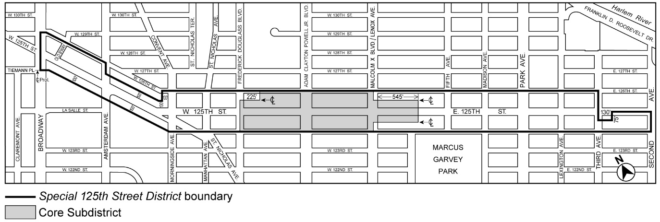

[PROPOSED MAP]
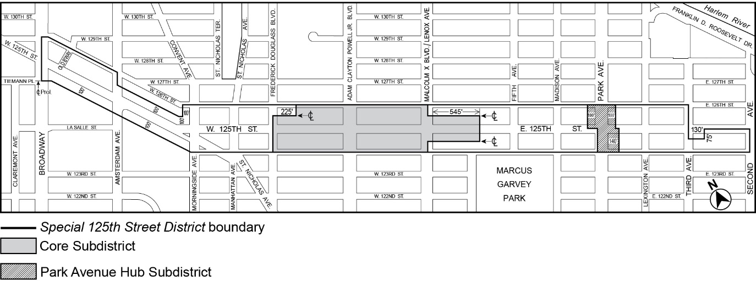
* * *

Article XIII
SPECIAL PURPOSE DISTRICTS

* * *

Chapter 8
Special East Harlem Corridors District

138-00
GENERAL PURPOSES

The “Special East Harlem Corridors District” established in this Resolution is designed to promote and protect public health, safety and general welfare. These general goals include, among others, the following specific purposes:

(a) encourage and guide the development of East Harlem as a dynamic mixed-use neighborhood by permitting the expansion and development of residential, commercial, community facility and light manufacturing uses in appropriate areas;

(b) encourage the development of residential uses along appropriate corridors ;

(c) encourage the development of permanently-affordable housing;

(d) facilitate the development of high-density commercial and manufacturing uses in order to locate jobs near transit connections in ;

(e) enhance the vitality of both existing and emerging commercial corridors by ensuring that ground floor frontages are occupied by active uses that enliven the pedestrian experience along the street;

(f) ensure that the form and use of new buildings relates to and enhances neighborhood character and responds to unique neighborhood conditions such as the Park Avenue viaduct; and

(g) promote the most desirable use of land in the area and thus preserve, protect and enhance the value of land and buildings and thereby protect City tax revenues.

138-01
General Provisions

The provisions of this Chapter shall apply within the #Special East Harlem Corridors District#. The regulations of all other Chapters of this Resolution are applicable, except as superseded, supplemented or modified by the provisions of this Chapter. In the event of a conflict between the provisions of this Chapter and other regulations of this Resolution, the provisions of this Chapter shall control.

138-02
District Plan and Maps

The regulations of this Chapter are designed to implement the #Special East Harlem Corridors District# Plan. The District Plan includes the map, “Special East Harlem Corridors District and Subdistrict,” in the Appendix to this Chapter which is hereby incorporated and made part of this Resolution for the purpose of specifying locations where the special regulations and requirements set forth in this Chapter apply.

138-03
Subdistrict

In order to carry out the provisions of this Chapter, the Park Avenue Subdistrict is established within the #Special East Harlem Corridors District#. The location of the Subdistrict is shown in the Appendix to this Chapter.

138-04
Applicability

138-041
Applicability of Article IX, Chapter 5

In the event of a conflict between the provisions of this Chapter and Article IX, Chapter 5 (Special Transit Land Use District), the provisions of Article IX, Chapter 5 shall control.

138-042
Applicability of Article XII, Chapter 3

In M1 Districts paired with a Residence District, the special #use#, #bulk# and parking and loading provisions of Article XII, Chapter 3 (Special Mixed Use Districts) shall apply, except where modified by the provisions of this Chapter, and shall supplement or supersede the provisions of the designated #Residence# or M1 District, as applicable.

138-043
Applicability of the Quality Housing Program

In the #Special East Harlem Corridors District#, #buildings# containing #residences# shall be #developed# or #enlarged# in accordance with the Quality Housing Program and the regulations of Article II, Chapter 8 shall apply. The #bulk# regulations of this Chapter shall be considered the applicable #bulk# regulations for #Quality Housing buildings#.

138-044
Applicability of the Inclusionary Housing Program

For the purposes of applying the Inclusionary Housing Program set forth in Section 23-90 (INCLUSIONARY HOUSING), the #Special East Harlem Corridors District# shall be a #Mandatory Inclusionary Housing area#.

138-10
SPECIAL USE REGULATIONS

The #use# regulations of the underlying districts, or Article XII, Chapter 3 (Special Mixed Use Districts), as applicable, are modified by the provisions of this Section, inclusive.

138-11
Location of Residential Use Within Buildings

In C4 or C6 Districts, the underlying provisions of Section 32-422 (Location of floors occupied by commercial uses) shall be modified, for #mixed buildings# that are #developed# or #enlarged#, to permit #dwelling units# on the same #story# as a #commercial use# provided no access exists between such #uses# at any level containing #dwelling units# and provided no #commercial uses# are located directly over any #dwelling units#. However, such #commercial uses# may be located over #dwelling units# by authorization of the City Planning Commission upon a finding that sufficient separation of #residential uses# from #commercial uses# exists within the #building#.

138-12
Transient Hotels

C1-5 C2-5 C4-6 C6-4 M1-6/R9 M1-6/R10

In the districts indicated, the #development# or #enlargement# of a #building# containing a #transient hotel#, as listed in Section 32-14 (Use Group 5), or the #conversion# or change of #use# within an existing #building# to a #transient hotel#, shall only be allowed:

(a) upon certification by the Chairperson of the City Planning Commission to the Commissioner of Buildings that the residential development goal, as set forth in this Section, has been met, or

(b) where such residential development goal, has not been met, by special permit by the City Planning Commission. To permit such a #transient hotel#, the Commission shall find that:

(1) sufficient sites are available in the area to meet the #residential development# goal; or

(2) a harmonious mix of #residential# and non-#residential uses# has been established in the area, and such #transient hotel# is consistent with the character of the surrounding area.

The Commission may prescribe additional conditions and safeguards to minimize adverse effects on the character of the surrounding area.

For the purpose of applying the provisions of this Section, the #residential development# goal shall be met when at least 4,470 3,865 #dwelling units# within the combined areas of #Special East Harlem Corridors District#, and the Park Avenue Hub Subdistrict, as shown on Map 1 in Appendix A of Article IX, Chapter 7 (Special 125th Street District), have received temporary or final certificates of occupancy subsequent to [date of adoption].

138-13
Physical Culture or Health Establishments

Within the #Special East Harlem Corridors District#, the provisions of Section 73-36 (Physical Culture or Health Establishments) shall not apply. In lieu thereof, #physical culture or health establishments# shall be permitted as-of-right in C2-5, C4-6, and C6-4 Districts, and in M1 Districts paired with an R9 or R10 District.

138-14
Public Parking Garages

C1-5 C2-5 C4-6 C6-4 M1-6/R9 M1-6/R10

In the districts indicated, for the purpose of applying regulations applicable to #public parking garages# set forth in Article III, Chapter 2 (Use Regulations) and Article III, Chapter 6 (Accessory Off-Street Parking and Loading Regulations), the regulations set forth for C1-4 Districts shall apply to C1-5 Districts, and the regulations set forth for C2-4 Districts shall apply to all other districts. In an M1 District paired with an R9 or R10 District, the regulations of #public parking garages# in Article XII, Chapter 3 (Special Mixed Use Districts) shall not apply. In lieu thereof, the regulations set forth for C2-4 Districts shall apply.

138-20
SPECIAL BULK REGULATIONS

In the #Special East Harlem Corridors District#, all #developments# and #enlargements# shall comply with the #bulk# regulations for #Quality Housing buildings#, as modified by the provisions of this Section, inclusive.

In all districts, the #floor area# provisions of Section 138-21 (Floor Area Regulations), inclusive, and the #street wall# location provisions of Section 138-22 (Street Wall Regulations), shall apply. In #Commercial Districts#, the height and setback provisions of Section 138-23 (Height and Setback Regulations in Commercial Districts) shall apply. In M1 Districts paired with an R9 or R10 Districts, the height and setback provisions set forth in Section 138-24 (Height and Setback Regulations in M1 Districts Paired With an R9 or R10 District) shall apply.

138-21

Floor Area Regulations

Within the #Special East Harlem Corridors District#, the underlying #floor area# regulations shall apply as modified in this Section, inclusive.

138-211
Special floor area regulations

(a) In certain #Commercial Districts# and #Manufacturing Districts# paired with a #Residence District#, shown on Map 2 of the Appendix to this Chapter, for any #zoning lot# containing #residential floor area#, the maximum #residential floor area ratio# shall be modified as follows:

(1) for #zoning lots# complying with the applicable provisions of paragraph (d)(3) of Section 23-154 (Inclusionary Housing) or, for #affordable independent residences for seniors#, the maximum #residential floor area ratio# set forth on Map 2 shall apply;

(2) for #zoning lots# utilizing the provisions of paragraphs (d)(4)(i) or (d)(4)(iii) of Section 23-154, the maximum #residential floor area ratio# shall apply as modified in the table below:

MODIFIED MAXIMUM #RESIDENTIAL
FLOOR AREA RATIO#

Maximum #residential floor area ratio# shown on Map 2 | Modified maximum #residential floor area ratio#
8.5 | 7.52
9.0 | 7.52
10.0 | 9.0

(3) except in C2 Districts subject to the provision of paragraph (b) of this Section, the maximum #floor area ratio# for any combination of #uses# shall be the maximum #floor area ratio# specified in paragraphs (a)(1) or (a)(2) of this Section, whichever is applicable; and

(4) in C4-6 Districts and in C2 Districts mapped within an R9 or R10 District, the #floor area# provisions of Sections 33-13 (Floor Area Bonus for a Public Plaza) or 33-14 (Floor Area Bonus for Arcades) shall not apply.

(b) In C2 Districts mapped within an R7D District that is also located within 100 feet of Park Avenue, the maximum #community facility floor area ratio# shall be 6.5, except that the applicable provisions of paragraph (d) of Section 33-121 shall apply to #zoning lots# containing philanthropic or non-profit institutions with sleeping accomodations or #long-term care facilities#.

138-211 212
Additional Ffloor area regulations in the Park Avenue Subdistrict

The maximum #floor area ratio# for #zoning lots# within the Park Avenue Subdistrict, as shown in the Appendix to this Chapter, is set forth in paragraph (a) of this Section. Such provisions are modified for certain #zoning lots# in accordance with paragraph (b).

Within the Park Avenue Subdistrict, as shown on Map 1 of the Appendix to this Chapter, the #floor area ratio# regulations of Section 138-211 are further modified in this Section.

(a) Maximum Required non-#residential# #floor area ratio#

Where a #development# or #enlargement# of a #building# on a #zoning lot#, or portion thereof, located within the Park Avenue Subdistrict contains #residential floor area#, such #zoning lot# shall provide a minimum non-#residential floor area ratio# as set forth below:

(1) Iin M1-6 Districts paired with an R9 District, the maximum #floor area ratio# shall be 8.5. Where a #development# or #enlargement# of a #building# on a #zoning lot# contains #residential floor area#, such #zoning lot# shall provide a minimum non-#residential floor area ratio# of 1.5. 1.0 shall be provided;

(2) Iin C6-4 Districts, and in M1-6 Districts paired with an R10 District, whose maximum #residential floor area ratio# is 10.0, the maximum #floor area ratio# shall be 12.0. Where a #development# or #enlargement# of a #building# on a #zoning lot# contains #residential floor area#, such #zoning lot# shall provide a minimum non-#residential floor area ratio# of 2.0. 1.5 shall be provided; and

(3) in M1-6 Districts paired with an R10 District whose maximum #residential floor area ratio# is 12.0, a minimum non-#residential floor area ratio# of 1.5 shall be provided.

Where a #development# or #enlargement# of a #building# on a #zoning lot# contains #residential floor area#, such #zoning lot# shall provide a minimum non-#residential floor area ratio# of 1.5 in M1-6 Districts paired with an R9 District, and 2.0 in C6-4 Districts and M1-6 Districts paired with an R10 District.

(b) Modified maximum #floor area ratio# for certain #zoning lots#

The maximum #floor area ratios# set forth in paragraph (a) of this Section and Section 138-211 shall be modified, as follows:

(1) the minimum non-#residential floor area# requirements set forth in paragraph (a) of this Section shall be optional for #zoning lots# existing on or before [date of adoption] with a #lot area# of less than 5,000 square feet. For #zoning lots# utilizing the provisions of this paragraph (b)(1), the minimum non-#residential floor area# requirements set forth in paragraph (a) of this Section shall not apply;

(2) for #zoning lots# subject to the provisions of paragraph (d)(4)(i) or (d)(4)(iii) of Section 23-154 (Inclusionary Housing), the maximum #residential floor area ratio# of the underlying district as specified in Section 23-153 (For Quality Housing buildings) shall apply; and

(3)(2) for #zoning lots# subject to paragraphs (b)(1) or (b)(2) of this Section, the maximum #floor area ratio# for all #uses# shall be 7.52 in M1-6 Districts paired with an R9 District, and 10.0 in C6-4 Districts and M1-6 Districts paired with an R10 District. set forth as follows:

MODIFIED MAXIMUM
#FLOOR AREA RATIO#

Maximum #floor area ratio# shown on Map 2 | Modified maximum  #floor area ratio#
8.5 | 7.52
10.0 | 9.0

138-212
Floor area regulations outside of the Park Avenue Subdistrict

For #zoning lots#, or portions thereof, outside of the Park Avenue Subdistrict, as shown in the Appendix to this Chapter, the underlying #floor area# regulations shall apply, except that:

(a) in C2 Districts mapped within an R9 District, for any #zoning lot# containing #residential floor area#, the maximum #residential floor area ratio# for #zoning lots# complying with the applicable provisions of paragraph (d)(3) of Section 23-154 (Inclusionary housing), or, for #affordable independent residences for seniors#, shall be 8.5, the maximum #residential floor area ratio# for #zoning lots# utilizing the provisions of paragraphs (d)(4)(i) or (d)(4)(iii) of Section 23-154 shall be 7.52, and the maximum #floor area ratio# for any combination of #uses# shall be 8.5; and

(b) in C4-6 Districts and in C2 Districts mapped within an R9 or R10 District, the #floor area# provisions of Sections 33-13 (Floor Area Bonus for a Public Plaza) or 33-14 (Floor Area Bonus for Arcades) shall not apply.

138-22
Street Wall Regulations

All #developments# and #enlargements# within the #Special East Harlem Corridors District# shall comply with the #street wall# regulations of Section 35-651 (Street wall location), as specified and modified in this Section. Where M1 Districts are paired with R9 or R10 Districts, #developments# and #enlargements# within such districts shall comply with the provisions of paragraph (b) of this Section. The applicable provisions of Section 35-651 are specified and modified as follows:

(a) Along #wide streets# other than Park Avenue

Along all #wide streets# other than Park Avenue, and along #narrow streets# within 50 feet of an intersection with such #wide street#, the provisions of paragraph (b) of Section 35-651 shall apply, except that the minimum base height shall be 60 feet, or the height of the #building#, whichever is less.

(b) Along Park Avenue

Along Park Avenue and along #narrow streets# located within 100 feet of Park Avenue, the provisions of paragraph (a) of Section 35-651 shall apply, except that the minimum base height shall be 40 feet, or the height of the #building#, whichever is less.

(c) Along all other #streets#

Along all #streets# not subject to the provisions of paragraph (a) or (b) of this Section, the provisions of paragraph (a) of Section 35-651 shall apply, except that the minimum base height shall be 60 feet, or the height of the #building#, whichever is less.

(d) Within #flood zones#

For #buildings# within the #flood zone#, the provisions of paragraphs (a), (b) and (c) of this Section, as applicable, shall be modified as follows:

(1) for #developments# or horizontal #enlargements#, or portions thereof, where no transparent materials are provided on the #ground floor level street wall# below a height of four feet above the level of the adjoining sidewalk pursuant to the provisions of Section 37-34 (Minimum Transparency Requirements), for a continuous distance of more than 25 feet, such #street wall# shall be located at least three feet beyond the #street line#;

(2) for portions of #developments# and #enlargements# where the provisions of paragraph (a) of this Section apply, such #street wall# shall not be located beyond five feet of the #street line#, except that such #street wall# may be located beyond such distance pursuant to the applicable provisions of paragraph (b) of Section 35-651 or of Section 64-333 (Street wall location in certain districts); and

(3) the area between such #street wall# and the sidewalk, or portions thereof, that do not contain any planting pursuant to the provisions of paragraph (a) of Section 138-32 (Special Streetscape Provisions for Blank Walls), shall be improved to Department of Transportation standards for sidewalks, be at the same level as the adjoining public sidewalk and be accessible to the public at all times. In addition, such area shall provide visual mitigation elements in accordance with the provisions of Section 138-32.

138-23
Height and Setback Regulations in Commercial Districts

In #Commercial Districts#, the underlying height and setback provisions are modified as follows:

- Basic Height and Setback Regulations

Except as provided in paragraph (b) and (c) below, iIn #Commercial Districts#, the maximum height of #buildings or other structures# shall be as set forth in Sections 35-652 (Maximum height of buildings and setback regulations) or 35-654 (Modified height and setback regulations for certain Inclusionary Housing buildings or affordable independent residences for seniors), as applicable, except that:

(1) the minimum base heights shall be modified by the provisions of Section 138-22 (Street Wall Regulations).;

(2) in C2 Districts mapped within an R9 District that is also located within 100 feet of Third Avenue, the maximum #building height# for #buildings# utilizing the provisions of Section 35-654 shall be modified to 215 feet;

(3) in C4-6 Districts whose maximum #residential floor area ratio# is 9.0, as set forth on Map 2 of the Appendix to this Chapter, the applicable provisions of Sections 35-652 or 35-654 for R9 Districts shall apply, except that the minimum base height of Section 138-22 shall apply and the maximum #building height# for #buildings# utilizing the provisions of Section 35-654 shall be modified to 215 feet; and

(4) where applicable, in lieu of the provisions of this paragraph, the provisions of paragraph (b) of this Section may be applied.

The regulations of paragraph (b)(2) of Section 36-652 relating to requirements for #qualifying ground floors#, where otherwise applicable, shall not apply. In lieu thereof, the provisions of Section 138-30 (STREETSCAPE REQUIREMENTS), inclusive, shall apply.

- Alternate Height and Setback Regulations in Certain Districts

Except as provided in paragraph (c) below, iIn C2 Districts mapped within an R9 or R10 District, or in C4-6 or C6-4 Districts, or in C2 Districts mapped within an R7D or R8A District that are also located within 100 feet of Park Avenue, as an alternative to the provisions of paragraph (a) of this Section, the provisions of this paragraph may be applied to #zoning lots# meeting the applicable criteria set forth in paragraph (a) of Section 23-664 (Modified height and setback regulations for certain Inclusionary Housing buildings or affordable independent residences for seniors), or to #zoning lots# where 50 percent or more of the #floor area# is occupied by non-#residential uses#.

(1) Setbacks

At a height not lower than the minimum base height specified in Section 138-22 (Street Wall Regulations), nor higher than a maximum base height of 85 feet, a setback shall be provided in accordance with paragraph (c) of Section 23-662 (Maximum height of buildings and setback regulations). Above such required setback, any portion of such #building# shall be considered a “tower.”

(2) #Lot coverage# requirements for towers

Each #story# of a tower containing #residential floor area# shall not exceed a maximum #lot coverage# of 40 percent, except that, for #zoning lots# of less than 20,000 square feet, such #lot coverage# may be increased in accordance with the table in Section 23-65 (Tower Regulations). Each #story# of a tower containing exclusively non-#residential floor area# shall not exceed a maximum #lot coverage# of 50 percent. However, where dormers are provided within the required setback, such portions of #buildings# shall not count toward the maximum allowable tower #lot coverage# set forth in this paragraph.

(3) Maximum #building# tower height in certain districts

(i) In C2 Districts mapped within R9 Districts, the maximum #building# height shall be 285 feet. The maximum tower height shall be set forth on Map 3 of the Appendix to this Chapter.

(ii) However, iIn C2 Districts mapped within R9 Districts that are also located within the #Special Transit Land Use District#, for #zoning lots# which include a transit easement in accordance with the applicable provisions of Article IX, Chapter 5 (Special Transit Land Use District), the maximum building tower height shall be:

(a) 325 feet for #zoning lots# which include ancillary facilities with emergency egress and/or ventilation structures as specified in Section 95-032 (Determination of transit easements at other stations); and

(b) 215 feet for #zoning lots# which include only transit facilities specified in Section 95-032 other than ancillary facilities with emergency egress and/or ventilation structures.

(ii) In C2 Districts mapped within R10 Districts, and in C4-6 Districts, the maximum building height shall be 325 feet.

(iii) In C6-4 Districts, no height limit shall apply to towers.

138-24
Height and Setback Regulations in M1 Districts Paired With an R9 or R10 District

In M1 Districts paired with an R9 or R10 District, the applicable #street wall# location and minimum base height provisions of paragraph (c) of Section 138-22 (Street Wall Regulations) shall apply, and the applicable maximum height of #buildings or other structures# and setback provisions set forth in Section 123-66 (Height and Setback Regulations), inclusive, shall apply as modified in this Section.

(a) In M1 Districts paired with an R9 District, at a height not lower than the minimum base height set forth in Section 138-22, nor higher than a maximum base height of 105 feet, a setback shall be provided in accordance with paragraph (c) of Section 23-662 (Maximum height of buildings and setback regulations). The maximum #building# height shall be 285 215 feet; and

(b) in M1 Districts paired with an R10 District whose maximum #floor area ratio# is 10.0, at a height not lower than the minimum base height set forth in Section 138-22, nor higher than a maximum base height of 155 feet, a setback shall be provided in accordance with paragraph (c) of Section 23-662. The maximum #building# height shall be 350 275 feet.; and

(c) in M1 Districts paired with an R10 District whose maximum #floor area ratio# is 12.0, at a height not lower than the minimum base height set forth in Section 138-22, nor higher than a maximum base height of 155 feet, a setback shall be provided in accordance with paragraph (c) of Section 23-662. The maximum #building# height shall be 295 feet.

138-30
STREETSCAPE REQUIREMENTS

The provisions of this Section, inclusive, shall apply to #developments# or #ground floor level enlargements# in all districts. In #Commercial Districts# mapped within R7D Districts, the underlying provisions of Section 32-434 (Ground floor use in C4-5D and C6-3D Districts and in certain C2 Districts) shall not apply. Any portion of a ground floor level that is within a transit easement required pursuant to the provisions of Article IX, Chapter 5 need not comply with the streetscape requirements of this Section, inclusive.

138-31
Ground Floor Use Regulations

The special #ground floor level# streetscape provisions set forth in Section 37-30, shall apply to Second Avenue, Third Avenue, Lexington Avenue, Park Avenue and East 116th Street, within the #Special East Harlem Corridors District# which, for the purposes of applying such provisions, shall be considered designated retail streets, and any portion of a #ground floor level street# frontage along the designated retail streets, as well as any #narrow street# frontage within 50 feet of such #streets#, shall be considered #primary street frontages#. A #ground floor level street# frontage along any other #street# shall be considered a #secondary street frontage#. For the purposes of this Section, defined terms shall also include those defined in Section 37-311 (Definitions).

(a) Along #primary street frontages#

For #buildings#, or portions thereof, with #primary street frontage#, #uses# on the #ground floor level#, to the minimum depth set forth in Section 37-32 (Ground Floor Depth Requirements for Certain Uses), shall be limited to non-#residential uses#, except for Type 2 lobbies and entrances and exits to #accessory# parking spaces provided in accordance with the applicable provisions of Section 37-33 (Maximum Width of Certain Uses). #Group parking facilities# located on the #ground floor level# shall be wrapped by #floor area# in accordance with the provisions of paragraph (a) of Section 37-35 (Parking Wrap and Screening Requirements). #Ground floor level street walls# shall be glazed in accordance with the provisions set forth in Section 37-34 (Minimum Transparency Requirements), except that:

(1) in M1-6 Districts paired with an R9 or R10 District, where the #ground floor level# is occupied by #uses# in Use Groups 16, 17 and 18, up to 50 percent of the #ground floor level street wall# width may be exempt from such regulations, provided that any #street wall# width exceeding 50 feet with no transparent elements on the #ground floor level# shall provide planting or screening in accordance with the provisions of paragraphs (a) or (e) of Section 138-32 (Special Streetscape Provisions for Blank Walls) for at least 75 percent of such blank wall; and

(2) in #flood zones#, where no transparent materials or #building# entrances or exits are provided on the #ground floor level street wall# below a height of four feet above the level of the adjoining sidewalk for a continuous width of at least 15 feet, visual mitigation elements shall be provided in accordance with Section 138-32 for such blank wall.

(b) Along #secondary street frontages#

For #buildings#, or portions thereof, with #secondary street frontage#, all #uses# permitted by the underlying district shall be permitted on the #ground floor level#, provided that any #group parking facilities# on the #ground floor level# shall be wrapped or screened in accordance with Section 37-35.

The level of the finished floor of such ground floor shall be located not higher than five feet above nor lower than five feet below the as-built level of the adjoining #street#.

138-32
Special Streetscape Provisions for Blank Walls

Where visual mitigation elements are required on a blank wall along the #ground floor level street wall# pursuant to the provisions of Section 138-31 (Ground Floor Use Regulations), at least 75 percent of the linear footage of any such blank wall shall be treated by one or more of the following visual mitigation elements which shall be provided on the #zoning lot#, except where such elements are permitted within the #street# under other applicable laws or regulations. Such features when utilized as visual mitigation elements shall include:

(a) Planting
Any combination of perennials, annuals, decorative grasses or shrubs shall be provided in planting beds, raised planting beds or planter boxes in front of the #street wall#. Each foot in width of a planting bed, raised planting bed or planter box, as measured parallel to the #street wall#, shall satisfy one linear foot of frontage mitigation requirement. Such planting bed shall extend to a depth of at least three feet, inclusive of any structure containing the planted material. Any individual planted area shall have a width of at least five feet, and the height of such planting, inclusive of any structure containing the planted materials, shall be at least three feet.

Where a blank wall exceeds a #street wall# width of 50 feet, at least 25 percent of such #street wall# width shall be planted in accordance with the provisions of this paragraph.

(b) Benches
Fixed benches with or without backs shall be provided in front of the #street wall#. Unobstructed access shall be provided between such benches and an adjoining sidewalk or required circulation paths. Each linear foot of bench, as measured parallel to the #street wall#, shall satisfy one linear foot of frontage mitigation requirement. Any individual bench shall have a width of at least five feet, and no more than 20 feet of benches may be used to fulfill such requirement per 50 feet of frontage.

(c) Bicycle racks
Bicycle racks, sufficient to accommodate at least two bicycles, shall be provided in front of the #street wall#, and oriented so that the bicycles are placed parallel to the #street wall#. Each bicycle rack so provided shall satisfy five linear feet of frontage mitigation requirement. No more than three bicycle racks may be used to fulfill such requirement per 50 feet of frontage.

(d) Tables and chairs
Fixed tables and chairs shall be provided in front of the #street wall#. Each table shall have a minimum diameter of two feet, and have a minimum of two chairs associated with it. Each table and chair set so provided shall satisfy five linear feet of frontage mitigation requirement.

(e) Wall treatment
Wall treatment, in the form of permitted #signs#, graphic or sculptural art, rustication, decorative screening or latticework, or living plant material, shall be provided along the #street wall#. Each linear foot of wall treatment shall constitute one linear foot of frontage mitigation requirement. Such wall treatment shall extend to a height of at least 10 feet, as measured from the level of the adjoining sidewalk or grade, and have a minimum width of 10 feet, as measured parallel to the #street wall#.

138-40
OFF-STREET PARKING AND LOADING REGULATIONS

The applicable parking and loading regulations of Article II, Chapter 5, Article III, Chapter 6, Article IV, Chapter 4 (ACCESSORY OFF-STREET PARKING AND LOADING REGULATIONS) or Section 123-70 (PARKING AND LOADING), inclusive, shall be modified in this Section, inclusive.

138-41
Required Accessory Off-street Parking Spaces for Residences

In the #Special East Harlem Corridors District#, no #accessory# off-street parking shall be required for #residences#. Off-street parking shall be permitted in accordance with the underlying district regulations.

APPENDIX: SPECIAL EAST HARLEM CORRIDORS DISTRICT PLAN

Map 1: Special East Harlem Corridors District and Subdistrict

[CPC APPROVED MAP]
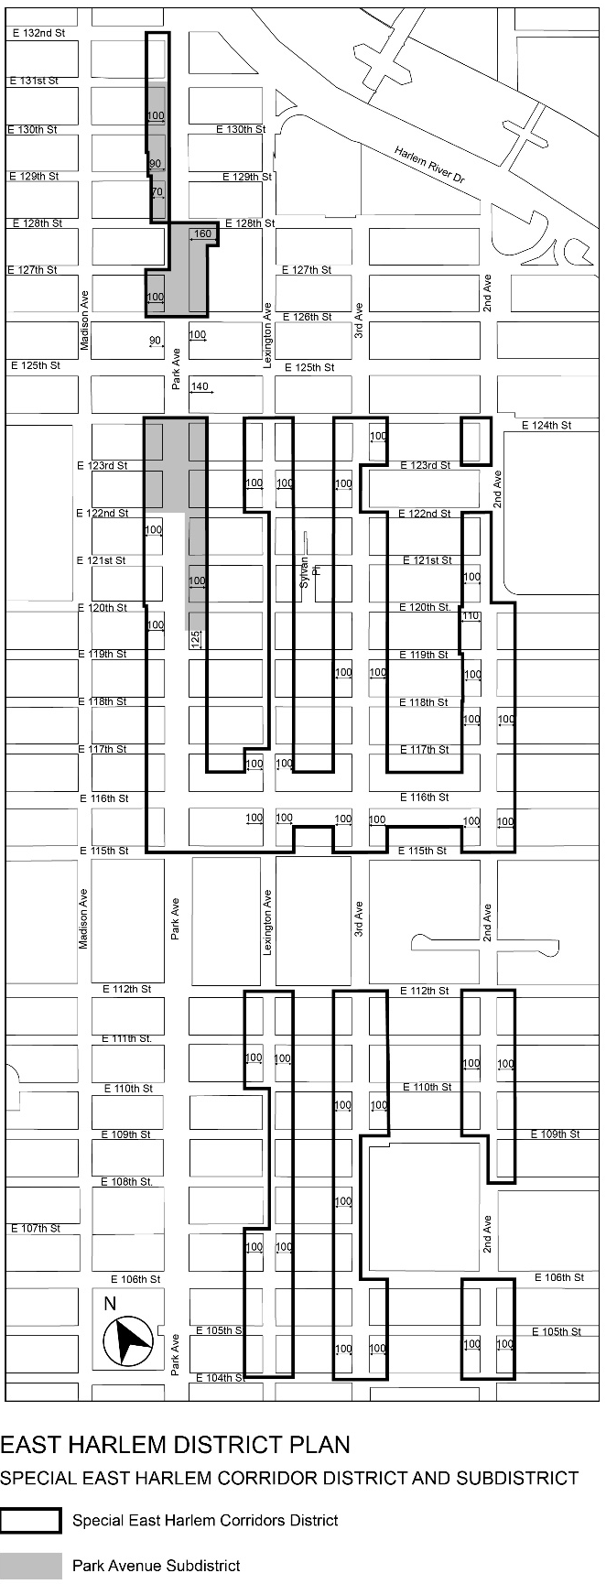
[CITY COUNCIL MODIFIED MAP]
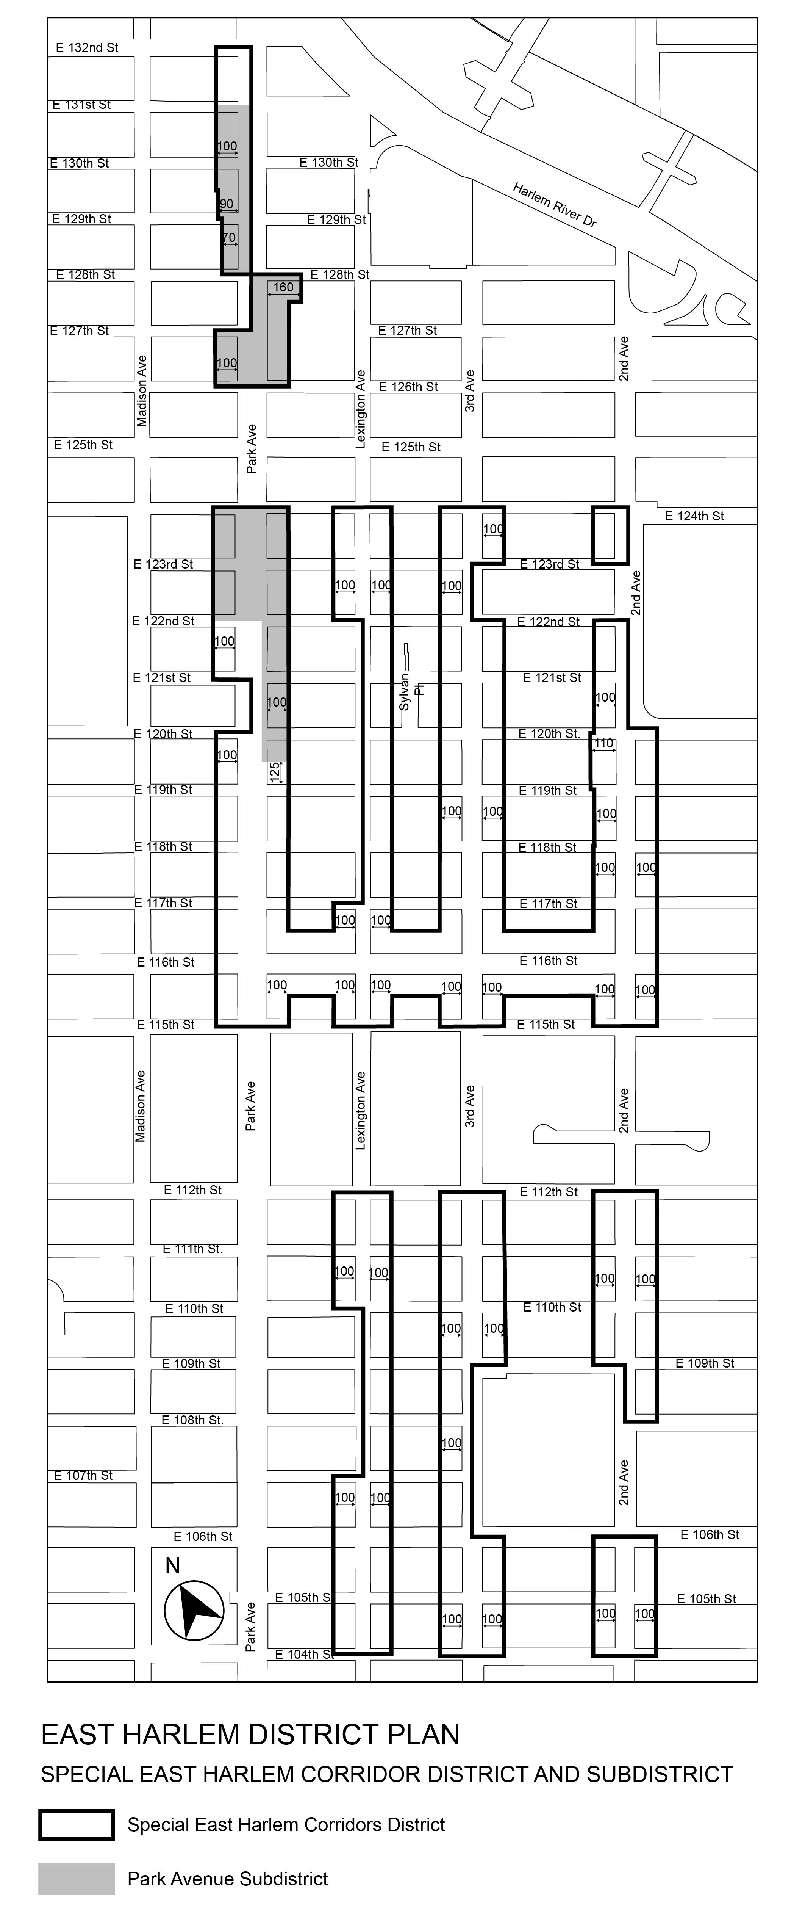

Map 2: Maximum Residential Floor Area Ratio
[CITY COUNCIL MODIFICATION]

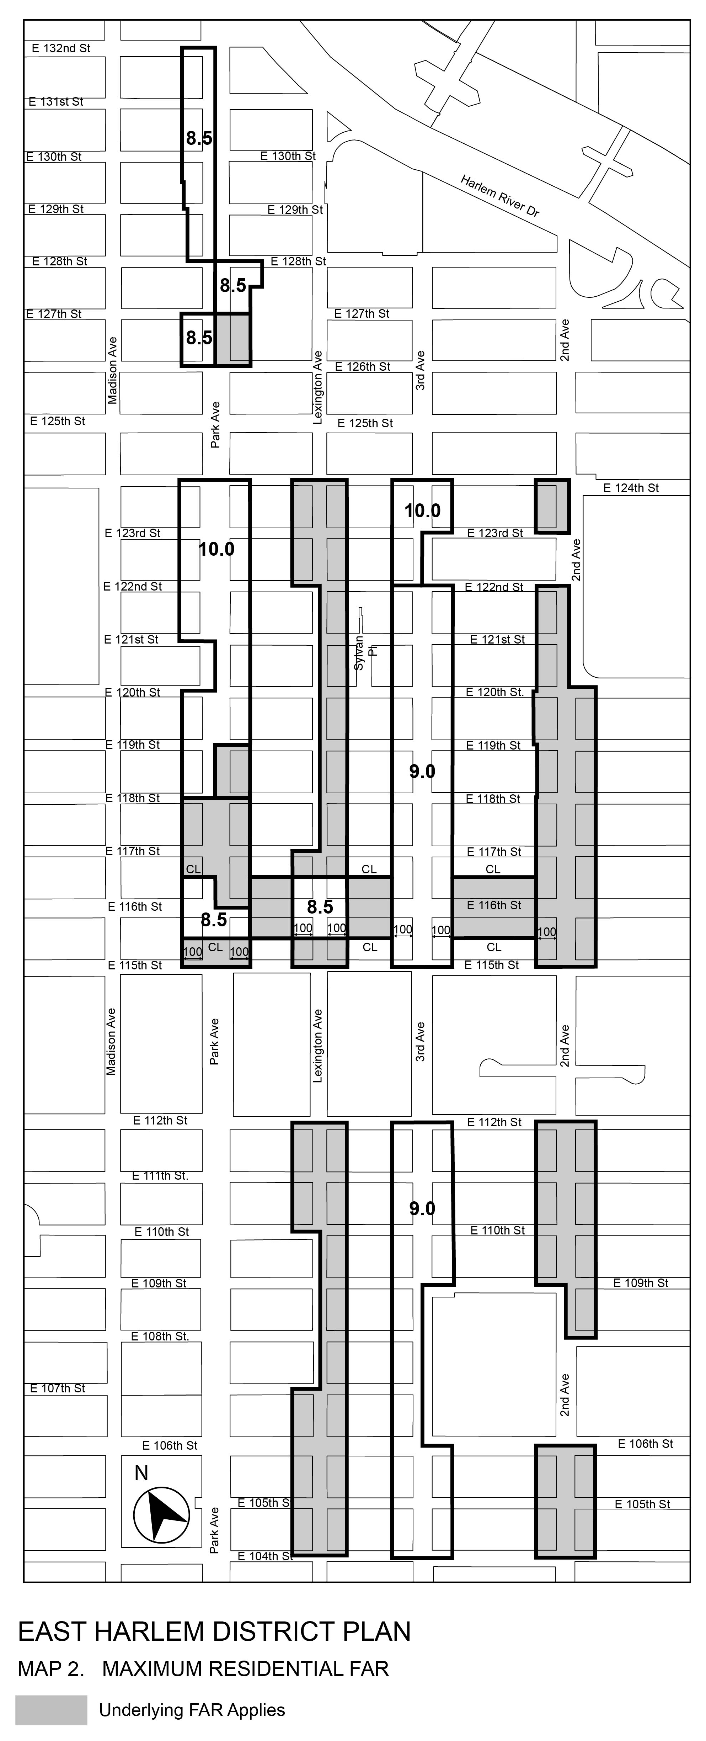
Map 3: Maximum Height
[CITY COUNCIL MODIFICATION]

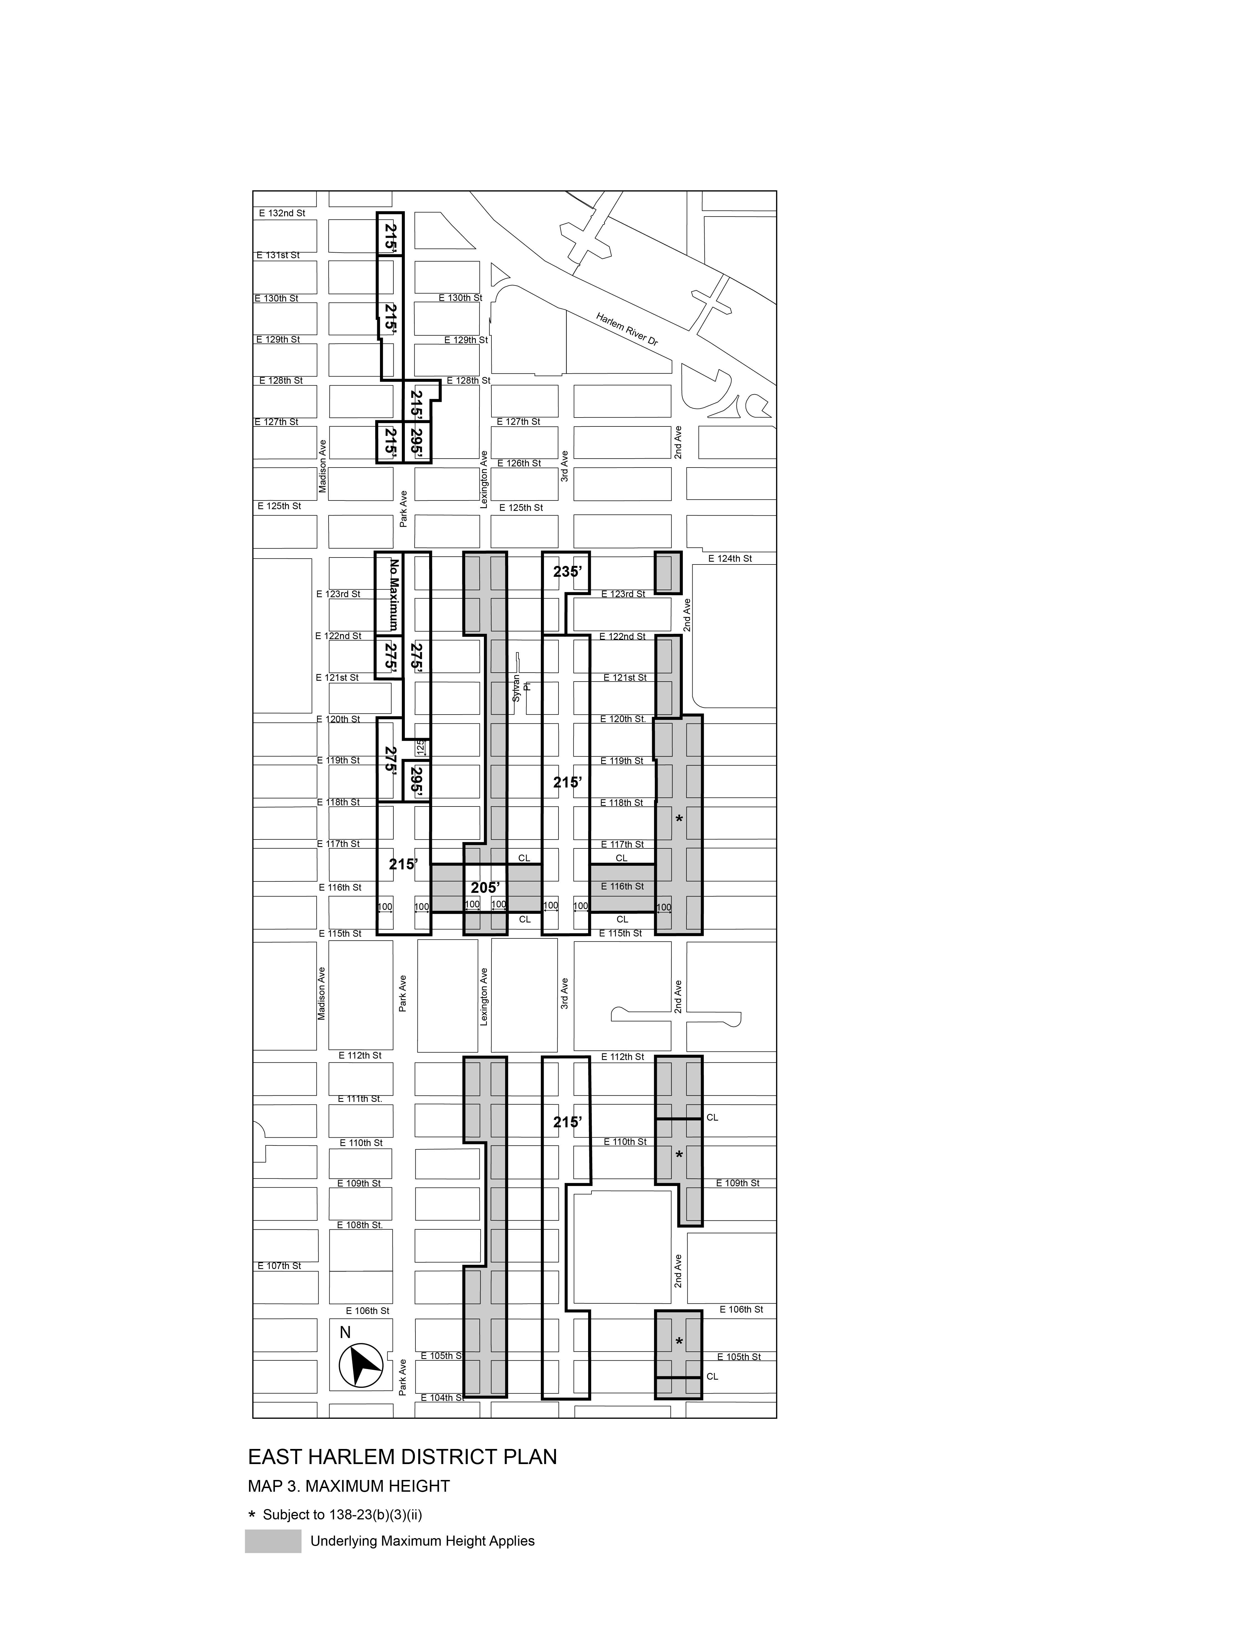

* * *
APPENDIX F
Inclusionary Housing Designated Areas and Mandatory Inclusionary Housing Areas

* * *
MANHATTAN

* * *

Manhattan Community District 11

In the R7D, R8A, R9A, R9 and R10 Districts within the areas shown on the following Map 1 and Map 2:

* * *
Map 2 – [date of adoption]
[CPC APPROVED MAP]
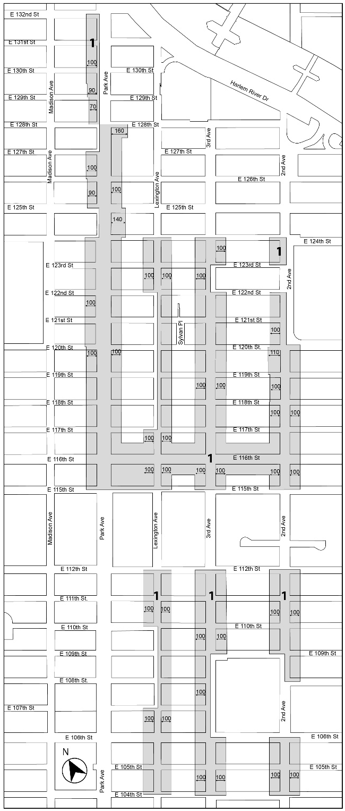

[CITY COUNCIL MODIFIED MAP]
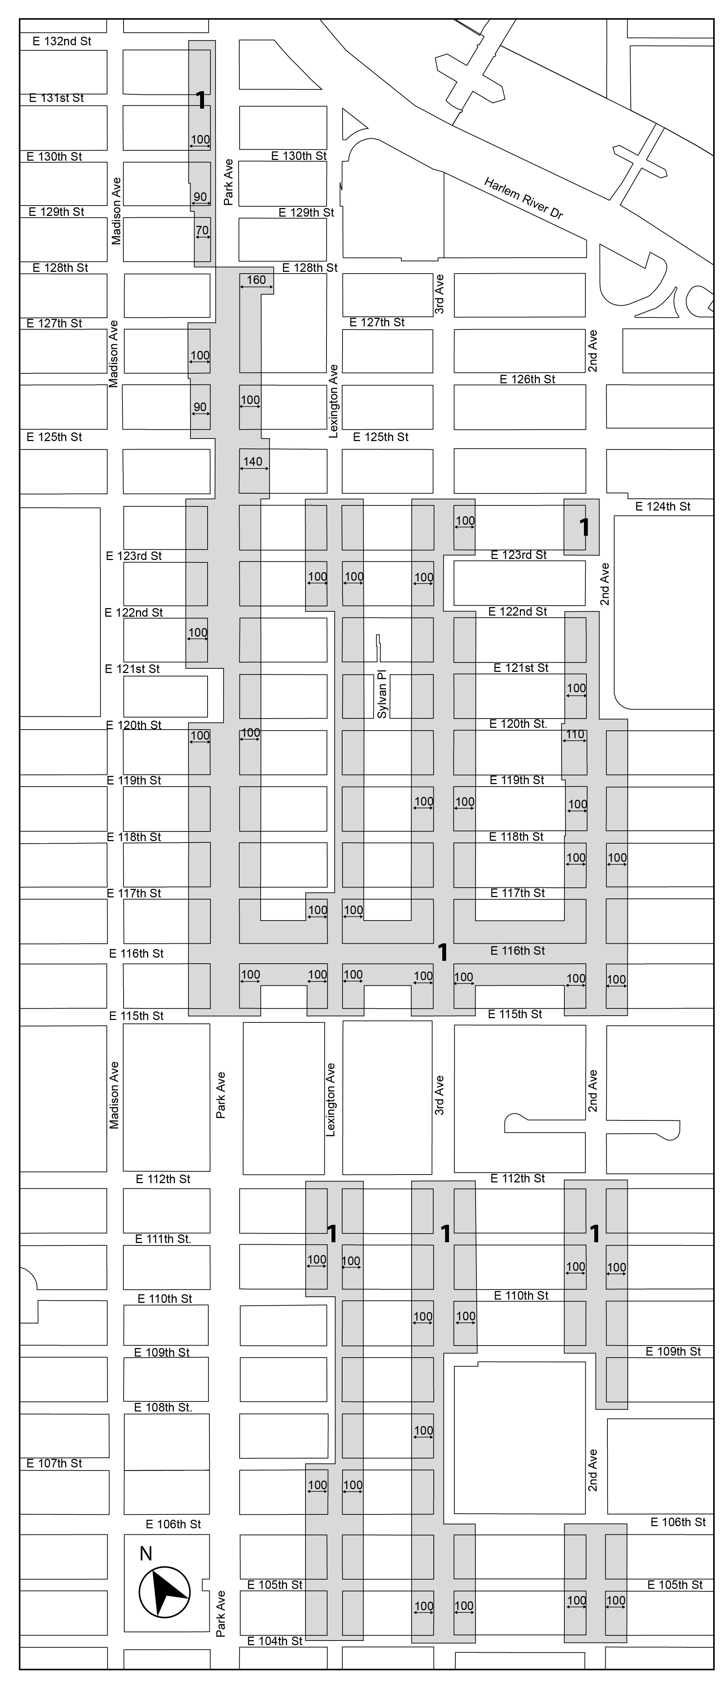

Mandatory Inclusionary Housing Program area see Section 23-154(d)(3)
Area 1 [date of adoption] — MIH Program Option 1 and and the Deep Affordability Option 2

Portion of Community District 11, Manhattan

* * *

Adopted
Office of the City Clerk, }
The City of New York, } ss.:

I hereby certify that the foregoing is a true copy of a Resolution passed by The Council of The City of New York on November 30, 2017, on file in this office.

.....…….........................................
City Clerk, Clerk of The Council

