THE COUNCIL OF THE CITY OF NEW YORK
RESOLUTION NO. 1493

Resolution approving the decision of the City Planning Commission on Application No. N 170141 ZRX, for an amendment of the Zoning Resolution of the City of New York, modifying Appendix F for the purpose of establishing a Mandatory Inclusionary Housing area in Community District 1, Borough of the Bronx (L.U. No. 609).

By Council Members Greenfield and Richards

WHEREAS, the City Planning Commission filed with the Council on April 7, 2017 its decision and report dated April 5, 2017 (the "Decision"), pursuant to Section 201 of the New York City Charter, regarding an application submitted by 600 Associates, LLC, for an amendment of the text of the Zoning Resolution of the City of New York, modifying Appendix F for the purpose of establishing a Mandatory Inclusionary Housing area on property located at 600 East 156th Street (Block 2624, Lot 41), which in conjunction with the related action would facilitate development of a new mixed-use development, comprising of residential and community facility uses in the Melrose neighborhood the Bronx, (Application No. N 170141 ZRX), Community District 1, Borough of the Bronx (the "Application");

WHEREAS, the Application is related to application C 170140 ZMX (L.U. No. 608), an amendment to the Zoning Map changing an M1-1 District to an R8A District; and Preconsidered L.U. 645), a real property tax exemption pursuant to Article XI of the Private Housing Finance Law for property located Block 2624, Lot 41;

WHEREAS, the Decision is subject to review and action by the Council pursuant to Section 197-d(b)(1) of the City Charter;
WHEREAS, upon due notice, the Council held a public hearing on the Decision and Application on May 2, 2017;

WHEREAS, the Council has considered the land use implications and other policy issues relating to the Decision and Application; and

WHEREAS, the Council has considered the relevant environmental issues, including the negative declaration issued November 14, 2016 (CEQR No. 17DCP025X) (the “Negative Declaration”);

RESOLVED:

The Council finds that the action described herein will have no significant impact on the environment as set forth in the Negative Declaration.

Pursuant to Sections 197-d and 200 of the City Charter and on the basis of the Decision and Application, and based on the environmental determination and consideration described in the Decision, incorporated by reference herein, the Council approves the Decision.

Matter underlined is new, to be added;
Matter struck out is to be deleted;
Matter within # # is defined in Section 12-10;
* * * indicates where unchanged text appears in the Zoning Resolution

* * *

APPENDIX F

Inclusionary Housing Designated Areas and Mandatory Inclusionary Housing Areas

* * *

THE BRONX

The Bronx Community District 1

In the #Special Harlem River Waterfront District# (see Section 87-20) and in the R7A, R7X, R8 and R8A Districts within the areas shown on the following Maps 1, 2 and 3:

* * *

Map 2 – [date of adoption]

[EXISTING MAP]
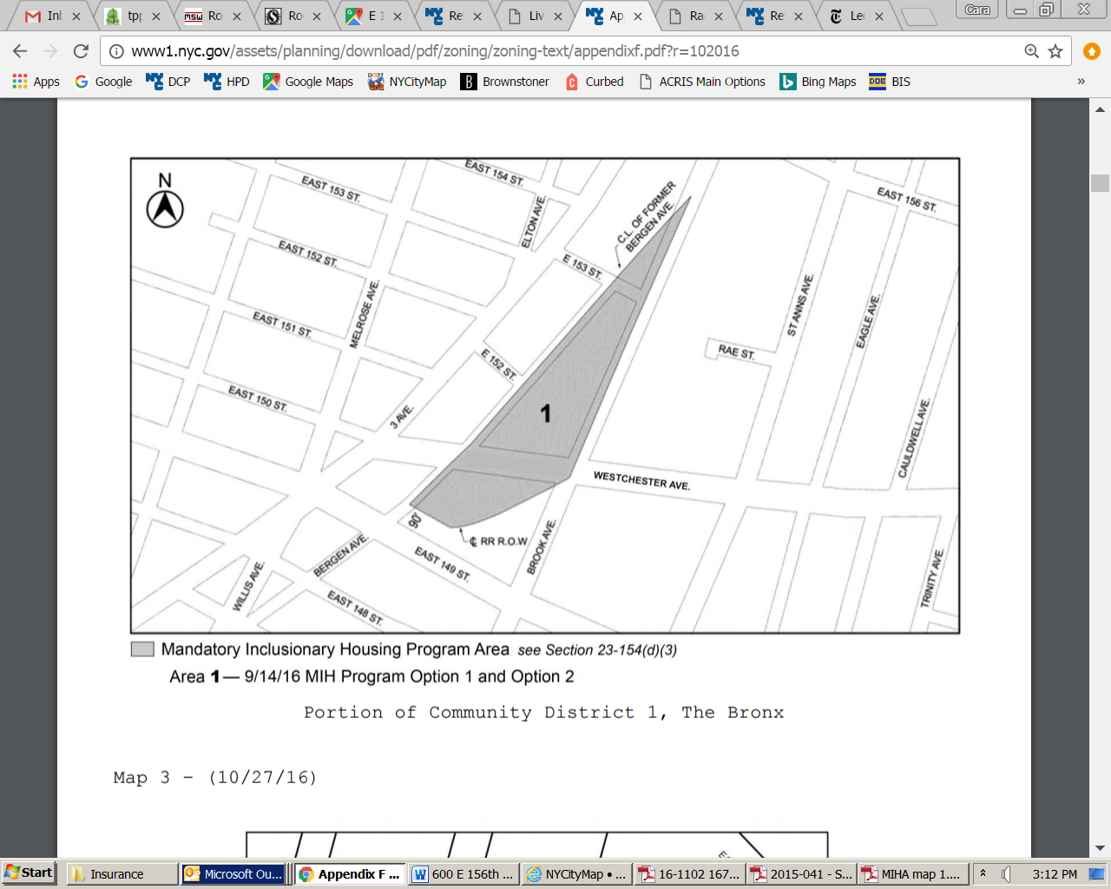

[PROPOSED MAP]

Portion of Community District 1, The Bronx

* * *

Adopted.

Office of the City Clerk, }
The City of New York, } ss.:

I hereby certify that the foregoing is a true copy of a Resolution passed by The Council of The City of New York on May 24, 2017, on file in this office.

.....…….........................................
City Clerk, Clerk of The Council

