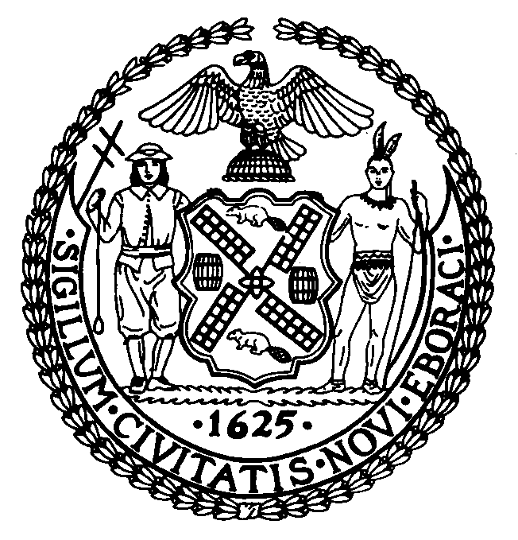 | The Council of the City of New York  Finance Division  Michael Keogh, Director  Fiscal Impact Statement  Intro. No: 110-A  Committee: Sanitation and Solid Waste Management
Title: A Local Law to amend the administrative code of the city of New York, in relation to increasing fines for dumping household and commercial refuse into public litter baskets | Sponsors: Council Members McMahon, Addabbo Jr., Fidler, Gentile, Koppell, Mark-Viverito, Martinez, Mendez, Nelson, Recchia Jr., Sanders Jr., Weprin, Liu, Jackson and Gonzalez
Summary of Legislation: This bill would amend subdivision (e) of section 16-120 of the Administrative Code to change the term open mesh basket to public litter basket. It would also amend subdivision (f) of section 16-120 of the Administrative Code to increase penalties for a violation of paragraph (e) to $100-$300 for a first offense, $250-$350 for a second offense within any twelve-month period and $350-$450 for a third or subsequent violation within any twelve-month period. Lastly, this bill would create a rebuttable presumption that the person whose name or other identifying information is found on the commercial or household waste deposited it in the public litter basket is responsible for it.

Effective Date: This local law shall take effect thirty days after it is enacted.

Fiscal Year In Which Full Fiscal Impact Anticipated: Fiscal 2008
Fiscal Impact Statement:

 | Effective FY08 | FY Succeeding  Effective FY08 | Full Fiscal  Impact FY09
Revenues | $0 | $0 | $0
Expenditures | $0 | $0 | $0
Net | $0 | $0 | $0

Impact on Revenues: There would be minimal impact on revenues resulting from the enactment of this legislation.

Impact on Expenditures: There would be no impact on expenditures resulting from the enactment of this legislation.

Source of Funds To Cover Estimated Costs: N/A
Estimate Prepared By: Latonia McKinney, Assistant Director
New York City Council Finance Division

History: Considered by the Committee on August 22, 2007.
Date Submitted to Council: August 22, 2007

