Environmental Protection:
Donna De Costanzo, Counsel
Richard Colón, Policy Analyst
Veronica McNeil
Joshua Wojcik
Eldin Villafane

THE COUNCIL

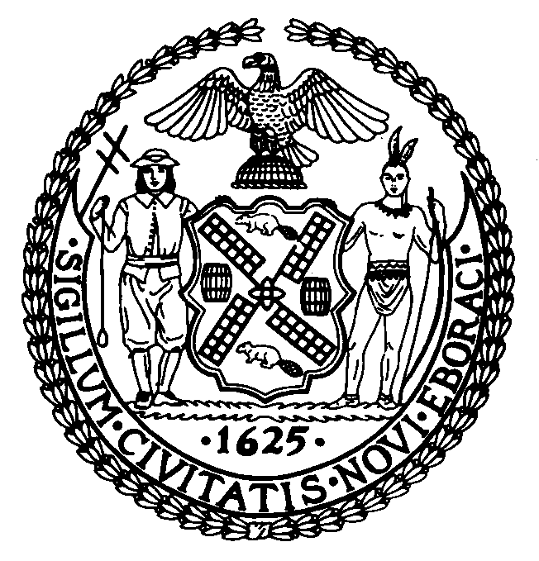

INFRASTRUCTURE DIVISION

Marcel Van Ooyen, Deputy Chief-of-Staff

COMMITTEE ON ENVIRONMENTAL PROTECTION

Council Member James F. Gennaro - Chair, Committee on Environmental Protection

April 30, 2003

Res. No. 794: By Council Members Gennaro, Avella, Barron, Brewer, Clarke, Comrie, Fidler, Gentile, Jennings, Koppell, Liu, Lopez, Martinez, Monserrate, Nelson, Recchia, Stewart, Weprin, Yassky, Gallagher and Lanza

Title: Resolution calling upon the New York City Water Board to reestablish a six-year timeframe within which customers may challenge the fees, rates, rents and other service charges established by the New York City Water Board for water and wastewater services.

On April 28, 2003, the Committee on Finance jointly with the Committee on Environmental Protection held a hearing on Res. No. 794, which calls upon the New York City Water Board to reestablish a six-year timeframe within which customers may challenge the fees, rates, rents and other service charges established by the New York City Water Board for water and wastewater services.
A. Background - Water and Sewer Systems
“New York City’s ability to provide a reliable source of water for its citizens has allowed it to grow and develop into a great urban center.” The City’s drinking water supply enjoys the reputation of being one of the most pristine public supplies in the world. This supply is a critical resource for eight million New York City residents, approximately one million residents of Westchester, Putnam, Ulster, and Orange counties, and a multitude of others who work in and visit the City throughout the year.
The water system has a storage capacity of 550 billion gallons, consisting of a distribution system that is made up of an extensive grid of water mains stretching approximately 6,600 miles in total length. Approximately 1.4 billion gallons of drinking water is delivered each day from the City’s upstate surface water systems and an average of 33 million gallons per day from wells located in southeast Queens. The City’s surface (reservoir) water supply is primarily delivered from nineteen reservoirs (19) and three (3) controlled lakes within a 1,972 square-mile watershed, approximately the size of the State of Delaware, that extends 125 miles north and west of the City. This large watershed is comprised of two distinct sections - “West of Hudson”, also known as the Catskill/Delaware Watershed, and “East of Hudson”, also known as the Croton Watershed. The Catskill/Delaware System, located in Delaware, Greene, Schoharie, Sullivan, and Ulster counties, west of the Hudson River, provides approximately 90% of the City’s surface water supply, while the Croton System, which includes twelve (12) reservoir basins in Putnam, Westchester, and Dutchess counties, east of the Hudson River, supplies the remaining 10%. Unlike other public water systems, “the City’s Water System is both economical and flexible.” “The water flows to New York City through aqueducts, and 97 percent reaches homes and businesses through gravity alone; only 3 percent must be pumped to its final destination.” Due to this fact, operating costs are relatively independent of power costs.
“The City's sewage is collected through an equally extensive grid of sewer pipes of various sizes and over 6,600 miles. Virtually all of the City's dry-weather sewage is collected through this system and processed by one of 14 sewage treatment plants. The plants currently in operation treat about 1.2 billion gallons of sewage per day. The operation of these plants ensures that New York City's surrounding waterways are clean and safe for transportation, shipping and recreation.”

B. DEP, the Municipal Water Finance Authority and the Water Board
The three entities that ensure the physical and fiscal integrity of the water and sewer systems are the New York City Department of Environmental Protection (“DEP”), the New York City Municipal Water Finance Authority (“Finance Authority”) and the New York City Water Board (“Water Board”). The DEP is charged with operating and maintaining the City’s critical water and sewer systems. Approximately 95% of the DEP’s revenue stream is obtained through water and sewer rates incurred by consumers of the City’s drinking water supply, while the remaining 5% is tax levied. The revenue collected by the DEP covers the operation, maintenance and other costs associated with the day-to-day workings of the City’s water and sewer systems. The day-to-day workings include, among other things, the costs associated with security, property taxes on watershed lands, operating expenses, Federal and State mandates, interest payments on bonds, capital plans, water delivery and wastewater management.
The Water Board and the Finance Authority were created in 1984 by a special act of the State legislature (known as the “New York City Municipal Finance Authority Act”). This Act governs the operating and financing relationship between the City, the Water Board and the Finance Authority. Pursuant to the Act, the Water Board has the power to fix, revise, charge and collect and enforce the payment of all fees, rates, rents and other service charges for services furnished by the water and sewer systems to produce cash sufficient to pay debt service on the Finance Authority's bonds and to place the water and sewer systems on a self-sustaining basis. The Water Board consists of seven members appointed by the Mayor who serve a two-year term, with at least one member having experience in the science of water resource development.
The Finance Authority is responsible for issuing bonds to fund the capital needs of the City’s water system. Pursuant to agreements between the City, the Water Board and the Finance Authority, the Water Board leases the water system from the City, sets the water rates and deposits the water rate revenue in a “lock box” for the benefit of the Finance Authority. The DEP operates and maintains the water system for the Water Board and bills the water system customers on behalf of the Board. The Water Board has covenanted to establish water rates sufficient to pay, among other obligations, debt service on all outstanding Finance Authority bonds. The proceeds of the Finance Authority’s bonds are used to fund the capital needs of the City’s water system.
Every odd-numbered year, in accordance with Section 248 of the City Charter, the Mayor develops and publishes a ten-year capital strategy. Included in this strategy are the capital expenditures anticipated for the DEP. Almost all of these expenditures are related to the City’s water and sewer system. The Mayor’s Executive Capital Budget includes the Mayor’s proposed capital expenditures for the ensuing fiscal year and the three years following. When the Council adopts the Capital Budget in June, it is appropriating capital funds for the following fiscal year and approving the four-year capital program that includes the three years thereafter. The Charter-mandated four- and ten-year planning processes recognize the need to plan on a long-term basis to provide funds for capital projects that are rarely completed within one fiscal year. Because capital projects take years to complete, the annual appropriation represents only a portion of their cost. While, legally, the Council appropriation of capital funds encompasses only one year, in effect appropriating funds for one year of a multi-year project represents a level of commitment to complete the project and appropriate addition funds in future years.
Once contracts for capital projects related to the water system have been registered, the Finance Authority issues bonds and the proceeds of the bonds pay for the costs of these contracts. The Water Board is required to set water rates at a level that is sufficient to pay all the principal and interest on the Finance Authority’s outstanding bonds. As bonds for projects that are included in the annually adopted capital plan are not issued until projects are already underway, the current year capital program has little effect on the current level of water rates. However, significant increases in capital spending on water projects over the course of the ten-year capital strategy will require additional bond issuances and - all other factors remaining equal -- will increase the Finance Authority’s debt service costs. As debt service costs increase, so must the water rates to cover these costs. Any significant increase in capital spending over time will therefore increase water rates not just over the course of the ten-year strategy but for the life of the bonds - generally a period of 30 years.

C. Summary of Res. No. 794
In calling upon the Water Board to reestablish a six-year timeframe within which customers may challenge the fees, rates, rents and other service charges established by the Water Board for water and wastewater services, the Resolution describes the timeframe, both past and present, by which a customer can challenge a water or wastewater bill and recommends a change to that period of time.
In April 1999, the Water Board proposed for Fiscal Year 2000 a period of eighteen months within which a customer could file a complaint that challenged a water or wastewater bill. The practice at that time allowed a period of six years within which a customer could challenge a water or wastewater bill. After public hearings were held on April 22, 23, 26 and 27, 1999, pursuant to section 1045-j(3) of the Law, the Water Board adopted a resolution on May 4, 1999, limiting the opportunity for a customer to challenge a water or wastewater bill to two years from the date of such bill for bills issued after July 1, 1999. On October 23, 2001, Chapter 375 of the Laws of 2001 was adopted, which established a minimum six-year period within which a customer could challenge any fee, rate, rent or other service charges for the use of or services furnished by the City’s water and/or wastewater systems. Less than a month later, on November 13, 2001, Chapter 467 of the Laws of 2001 was adopted, which changed the minimum period within which a customer could challenge any fee, rate, rent or other service charges for the use of or services furnished by the City’s water and/or wastewater systems from six to four years.
Res. No. 794 states that a six-year period within which customers could file complaints regarding erroneous water or wastewater bills is consistent with the New York State Public Service Commission (PSC) practice regarding bill challenges for the utility companies it regulates. Although the Water Board is not regulated by the PSC, the State Consumer Protection Board, in an April 21, 1999 letter to the Water Board, recommended that the Water Board adopt the PSC’s practice of permitting a six-year period for consumer refunds. Res. No. 794 further notes that many of the City’s water and wastewater customers do not necessarily have the knowledge and expertise to determine whether they are being overcharged, since these customers typically possess limited knowledge regarding Water Board rates and policies. Therefore, Res. No. 794 recommends that the Water Board reestablish a six-year timeframe within which customers may challenge the fees, rates, rents and other service charges established by the Water Board for water and wastewater services.

Res. No. 794

Resolution calling upon the New York City Water Board to reestablish a six-year timeframe within which customers may challenge the fees, rates, rents and other service charges established by the New York City Water Board for water and wastewater services.

By Council Members Gennaro, Avella, Barron, Brewer, Clarke, Comrie, Fidler, Gentile, Jennings, Koppell, Liu, Lopez, Martinez, Monserrate, Nelson, Recchia, Stewart, Weprin, Yassky, Gallagher and Lanza

Whereas, The New York City Water Board (“Water Board”) is authorized, pursuant to section 1045-g(4) of the New York State Public Authorities Law (the “Law”), to establish, in accordance with section 1045-j of the Law, fees, rates, rents or other charges for the use of, or services furnished, by the City’s water and wastewater systems; and

Whereas, In April 1999, the Water Board proposed for Fiscal Year 2000 a period of eighteen months within which a customer could file a complaint that challenged a water or wastewater bill; and

Whereas, The practice at that time allowed a period of six years within which a customer could challenge a water or wastewater bill; and

Whereas, After public hearings were held on April 22, 23, 26 and 27, 1999, pursuant to section 1045-j(3) of the Law, the Water Board adopted a resolution on May 4, 1999, limiting the opportunity for a customer to challenge a water or wastewater bill to two years from the date of such bill for bills issued after July 1, 1999; and

Whereas, On October 23, 2001, Chapter 375 of the Laws of 2001 was adopted, which established a minimum six-year period within which a customer could challenge any fee, rate, rent or other service charges for the use of or services furnished by the City’s water and/or wastewater systems; and

Whereas, On November 13, 2001, Chapter 467 of the Laws of 2001 was adopted, which changed the minimum period within which a customer could challenge any fee, rate, rent or other service charges for the use of or services furnished by the City’s water and/or wastewater systems from six to four years; and

Whereas, A six-year period within which customers could file complaints regarding erroneous water or wastewater bills is consistent with the New York State Public Service Commission (PSC) practice regarding bill challenges for the utility companies it regulates; and

Whereas, Although the Water Board is not regulated by the PSC, the State Consumer Protection Board, in an April 21, 1999 letter to the Water Board, recommended that the Water Board adopt the PSC’s practice of permitting a six-year period for consumer refunds; and

Whereas, Many of the City’s water and wastewater customers do not necessarily have the knowledge and expertise to determine whether they are being overcharged, since these customers typically possess limited knowledge regarding Water Board rates and policies; now, therefore, be it

Resolved, That the Council of the City of New York calls upon the New York City Water Board to reestablish a six-year timeframe within which customers may challenge the fees, rates, rents and other service charges established by the New York City Water Board for water and wastewater services.

DD LS#2221
4/3/03 1:58 p.m.

The City of New York – Department of Environmental Protection, Education Information, “Celebrating New York City’s Clean Drinking Water” (“Celebrating Clean Drinking Water”), p.1 at http://www.ci.nyc.ny.us/html/celebrate.html
2001 Annual Water Quality Report”, Report by the New York City Department of Environmental Protection (“2001 Water Quality Report”), p. 2; http://www.nyc.gov/html/dep/pdf/wsstato1a.pdf
Alan L. Anders, Executive Director of the NYC Municipal Water Finance Authority, at http://www.ci.nyc.ny.us/html/aboutus.html (“MWFA website”).
New York City Water Board “Public Information Regarding Water and Wastewater Rates”, April 2003 (“April 2003 Booklet”), p. 29.
Celebrating Clean Drinking Water at 3.
2001 Water Quality Report at 2.
Id.
April 2003 Booklet at 29.
Celebrating Clean Drinking Water at 3.
MWFA website.
New York Public Authorities Law § 1045-g(4).
“The Authority is administered by a seven-member Board of Directors. Four of the members are ex officio members: the Commissioner of Environmental Protection of the City, the Director of Management and Budget of the City, the Commissioner of Finance of the City and the Commissioner of Environmental Conservation of the State. The remaining three members are public appointments: two by the Mayor, and one by the Governor.” http://www.nyc.gov/html/nyw/html/aboutus.html

