Committee on Small Business
Stephanie Jones, Senior Legislative Counsel
Noah Meixler, Senior Legislative Policy Analyst
Aliya Ali, Principal Fiscal Policy Analyst



THE COUNCIL OF THE CITY OF NEW YORK

Committee Report of the Governmental Affairs Division
Andrea Vazquez, Legislative Director
Rachel Cordero, Deputy Director, Governmental Affairs Division

COMMITTEE ON SMALL BUSINESS
Hon. Julie Menin, Chair

SBS’s Response to COVID-19

March 7, 2022

- Introduction

On March 7, 2022, the Committee on Small Business, chaired by Council Member Julie Menin, will hold a remote hearing on “SBS’ Response to COVID-19.” Those invited to testify include the Department of Small Business Services (SBS), small business advocates, chambers of commerce, business improvement districts and other members of the public.
- Background
In late December 2019, a new virus, SARS-CoV-2, was detected in Wuhan, China and by January 30, 2020, the World Health Organization (WHO) declared that COVID-19, the disease caused by the SARS-CoV-2 virus, was now a Public Health Emergency of International Concern (PHEIC).
The progressive nature by which the virus spreads caused governments across the globe to shutdown businesses, schools, religious and cultural institutions, and mandate various levels of social isolation. While these measures have helped to limit the spread of the virus, stay-at-home orders have had a catastrophic impact on economic markets, particularly small businesses that thrive from regular contact with their community and neighbors.
Impact of Limitations on City Businesses in Response to COVID-19
As businesses were subject to operational restrictions and New Yorkers stayed home to stop the spread of the virus, consumer spending declined in the City. In late March 2020, consumer spending dropped 44 percent year-over-year, according to Mastercard. The Manhattan Chamber of Commerce reported that foot traffic in Manhattan at the end of August 2020 was down nearly 40 percent compared to pre-COVID times. According to the research firm Opportunity Insights, small business revenues dropped over 70 percent in NYC in early April 2020 in comparison to January 2020. As of December 30, 2020, small business revenues were down over 53 percent in comparison to January 2020.
The drastic drop in consumer spending in the City and resulting loss in revenue for businesses during the initial waves of the pandemic made it difficult for business owners to continue paying rent. The Hospitality Alliance surveyed over 400 restaurants, bars, nightclubs and event venues in NYC about their rent obligations in December 2020. The resulting report found that approximately 92 percent of respondents could not pay their full rent in December, while around 60 percent of landlords did not waive rent payments for restaurants, bars and night clubs.
The spread of the Omicron variant, which led to a dramatic increase in COVID-19 infections in New York City, further hampered small businesses’ recovery from the pandemic. According to a January 2022 survey from Goldman Sachs, over 70 percent of businesses reported that the rise in COVID-19 cases due to the Omicron variant negatively impacted their business. Nearly 80 percent of small business owners surveyed are concerned about the ongoing impacts of COVID-19 on their businesses. A December 2021 survey from the Brooklyn Chamber of Commerce found that 77 percent of respondents reported a reduction in holiday sales, 59 percent of businesses had employees calling in sick, and 20 percent of businesses reported closing for some days during the holiday season due to spread of Omicron.
As small businesses have struggled due to the spread of Omicron, the City’s labor market has lagged behind the nationwide recovery. The City’s unemployment rate in December 2021 was 8.8 percent, compared to 3.9 percent nationally. The NYC Independent Budget Office predicts that New York City will not recover all of the jobs lost in 2020 until 2025, while the national economy is projected to pass pre-pandemic employment by the middle of 2022. A recent report from New York State Comptroller DiNapoli similarly found that employment in the restaurant, recreation, and retail have continued to struggle. The report found that the restaurant, recreation, and retail industries employ 30 percent, 24 percent, and 14 percent fewer workers respectively than they did in 2019. Nationally, these sectors are only 3.4 percent smaller than they were in 2019.
- SBS’ Response to COVID-19
Since the start of the pandemic, SBS has launched numerous financial relief programs and business education services to help small businesses survive the economic impact of the pandemic. In total, SBS disbursed over $175 million in grants to businesses suffering economic losses due to the pandemic. Nearly 57,000 business owners attended the over 860 small business education webinars SBS hosted throughout the pandemic, and over 75,000 businesses contacted SBS’s small business hotline. In total, SBS delivered over 337,000 services for New Yorkers during the pandemic. While many of the programs SBS developed during the pandemic were successful in delivering necessary services to struggling small businesses, some of SBS’s efforts encountered challenges that hampered their ability to equitably serve small businesses across the City.
Small Business Continuity Loan Fund and Employee Retention Grant Program
In response to the economic devastation caused by the pandemic, City, State, and Federal financial relief programs were developed to distribute money to small business owners in need. Prior to the announcement of the Small Business Administration’s Paycheck Protection Program (PPP), SBS announced the Employee Retention Grant Program and Small Business Continuity Loan Fund to provide immediate financial relief to small businesses during the COVID-19 crisis. To qualify for either program, businesses were required to provide documentation proving that over a two-month period in 2020 their revenues decreased by 25 percent due to COVID-19. Businesses with fewer than five employees were eligible for the Employee Retention Grant Program, which provided a grant covering up to 40 percent of a business's payroll for two months, with a maximum amount of $27,000. Total funding for the Employee Retention Grant Program was nearly $25 million, all of which was from Federal funding. On April 3, 2020, SBS stopped accepting applications to the grant program.
The Small Business Continuity Loan Fund provided a zero-interest loan to businesses with fewer than 100 employees for up to $75,000. Of the nearly $23 million allocated to the Continuity Loan Fund, $5 million was from Federal funding and the remainder came from private funding. On April 8, 2020, SBS paused application intake for the loan fund due to an overwhelming number of applications. While the programs were successful in providing money to business owners in need quickly, the disbursement of City funds did not equitably provide relief to businesses across the five boroughs, with Manhattan businesses receiving the majority of funds. On November 27, 2020, SBS submitted a breakdown of the loans and grants issued by Council District (CD), zip code, and industry type to the City Council pursuant to Local Law 94 of 2020.
The results of the report reflect how certain neighborhoods in the City benefitted more from available resources than others. The three CDs that received the most money from the Employee Retention Grant Program are all in Manhattan, while the three CDs that received the least amount of grant money were in the Bronx (See Appendix A). Businesses in Council District 11 qualified for more total grant money than businesses in any other Bronx Council District, but CD11 still received the 37th lowest amount of grant money. In addition to being geographically inequitable, SBS’s disbursement of grant money predominantly benefitted more professional and technical small businesses. During his press conference on March 8, 2020, then-Mayor de Blasio described the purpose of the Employee Retention Grant Program of providing money to “our smallest small businesses [with] under five employees, a lot of mom and pop stores, neighborhood-based stores.” However, attorney’s offices, physicians and dentists were the three professional groups that received the most amount of money through the program (See Appendix B).
The Small Business Continuity Loan Fund similarly failed to disburse loans equitably across the five boroughs. Seven Council Districts, five of which are from the Bronx, received zero money through the program. The top three Council Districts that received the most money from the loan program were the same Districts that received the most money from the grant program as well (See Appendix C). It is important to note that certain Council Districts in the City, such as CD 1, were perhaps able to qualify for a high number of grants and loans because they have a greater concentration of businesses than do other neighborhoods in the City. Overall, however, the outer boroughs qualified for less City-funded aid through these programs than did businesses in Manhattan. Small business owners who were not conversant in English may have had difficulty understanding the terms and conditions and how to apply to the programs, without materials available in other languages. SBS took weeks to translate application materials on their website, and even then only translated certain materials, with text on the website translated by browser tools.
Unlike SBS’s grant program, the Small Business Continuity Loan Fund did not primarily benefit more professional and technical businesses. Restaurants, bars and nightclubs, and nail salons were among the business sectors that qualified for the most loans from the program (See Appendix F).
Support for Hard-Hit Low and Moderate Income (LMI) Communities
On November 25, 2020, then-Mayor de Blasio announced three financial relief programs to benefit small businesses in low-to-moderate (LMI) income neighborhoods. The NYC LMI Storefront Loan, Interest Rate Reduction Grant, and Strategic Impact COVID-19 Commercial District Support Grant disbursed $37 million exclusively to small businesses located in LMI neighborhoods. According to then-SBS Commissioner Jonnel Doris, “The launch of these programs is a targeted approach to provide relief efforts in communities that need it most.”
SBS partnered with the New York City Economic Development Corporation (NYCEDC) and Pursuit BDC to develop the NYC LMI Storefront Loan, a $35 million loan program. Of the $35 million, $4 million came from federal funding and $31 million came from private capital. Businesses with at least two and less than 100 employees located in LMI neighborhoods are eligible under the program for a zero-interest loan for up to $100,000. To determine which businesses could qualify for the program, SBS used the Department of Housing and Urban Development’s 2020 area median income for the NYC region to determine low-to-moderate income zip codes. On November 30, 2020, applications for the loan program opened exclusively for small businesses located in the lowest income zip codes. The program then expanded to accepting applications from moderate-income neighborhoods on December 15, 2020. As of May 7, 2021, 142 businesses received the loan with an average size of $91,007. Of the recipients thus far, 60 businesses are located in Queens, 37 in Brooklyn, 23 in Manhattan, 17 in Bronx and five in Staten Island.
SBS’s Interest Rate Reduction Grant Program was created to help business owners reduce the interest they owe on existing loans from certain Community Development Financial Institutions (CDFI). SBS partnered with 11 CDFI’s to provide the grant, which enabled business owners to increase their cash flow by helping them pay off these existing financial obligations. The total budget for the grant program was $2 million, all of which came from Federal funds. So far, 560 businesses have received the grant with an average grant amount of $1,984. The recipients include 151 in Manhattan, 145 in the Bronx, 141 in Queens, 120 in Brooklyn, and three in Staten Island.
SBS’s Strategic Impact COVID-19 Commercial District Support Grant provided grants to community-based development organizations (CBDOs) to run local COVID-19 recovery support programs for small businesses. CBDOs must use the grants from SBS to fund outreach efforts, provide technical support, and increase awareness of new City and State rules for local small businesses. A total of $906,000 was available in the program, and the program was City funded. The recipients of this grant include nine organizations in Brooklyn, eight in Manhattan, six in Bronx, five in Queens, one in Staten Island and one City-wide.
Advocate Concerns with SBS’s LMI Programs
As previously mentioned, to determine which neighborhoods qualify as LMI, SBS used the Department of Housing and Urban Development’s 2020 area median income for the NYC region. This dataset overlooked certain lower-income neighborhoods in the City, however, that are part of the same zip codes as neighborhoods with more affluent residents. The zip code 10013, which includes parts of Chinatown including Mott Street, Pell Street, and Doyers Street, was excluded from the LMI Storefront Loan program, as it includes parts of SoHo and Tribeca, which have higher median incomes. One census tract within zip code 10013-census tract 29-has a median household income of around $27,000, and over 40 percent of families rely on social security. SBS’s use of area median incomes to determine which zip codes qualify as LMI has therefore overlooked income diversity that can exist within a certain zip code.
The failure of the LMI Storefront Loan program to include certain areas of Chinatown angered Chinatown advocates. According to Yin Kong, director of Think! Chinatown, "My first initial reaction was that I'm sure this is some sort of administrative oversight. They didn't realize that 10013 is also a part of Chinatown." Jan Lee, a member of the Chinatown Core Block Association, commented, “The loan is designed for minority communities and minority businesses. I don't understand how [SBS] can leave out Chinatown because you're using us in your publicity for your office.” Then-Manhattan Borough President Brewer called on SBS to explain why they choose to use zip codes to determine which areas qualify as LMI, and for the agency to include zip code 10013 in the LMI Storefront Loan.
To qualify for the LMI Storefront Loan, businesses are also required to provide a personal guarantee on the loan. Personal guarantees reduce the lender’s risk in issuing the loan because it provides the lender the right to pursue the business owner’s personal assets if the business fails to repay the debt owed. As small businesses in the City were experiencing drastically decreased revenues without a clear idea of when the City will resume its normal economic activity, requiring all applicants to agree to a personal guarantee on the LMI Storefront Loan may depress applications to the program. As the purpose of the loan program is to benefit businesses in low-income neighborhoods, the possibility of low-income business owners losing their personal assets may cause further harm in certain communities in the future.
Small Business Resilience Grant
On December 8, 2021, then-Mayor de Blasio announced the creation of a $100 million Small Business Resilience Grant to provide further funding to small businesses in the arts, entertainment, recreation, accommodation, and food sectors, and to businesses in LMI communities. The resilience grant program, unlike the LMI storefront loan program, used census tract data to determine whether a business is located in an LMI neighborhood. Businesses under the program are eligible to receive a $10,000 grant, that can be used for payroll and benefits, mortgage, rent, utilities, and other operating costs. Businesses that qualified for a federal grant under the Shuttered Venues Operators Grant program or Restaurant Revitalization Fund are not eligible to receive a small business resilience grant. As of February 2022, applications for the Small Business Resilience Grant were paused until further notice due to an overwhelming number of businesses applying for grants.
Connecting Businesses to Federal Support
In addition to disbursing financial relief to small businesses, SBS established the Fair Share NYC program to help connect small businesses with Federal relief funds. SBS provided technical assistance to businesses seeking PPP loans, including helping businesses review and put together loan documents, calculate loan repayment terms, help prepare SBA loan forgiveness documents and help businesses connect with PPP lenders. Under the program, SBS helped over 4,600 businesses apply for over $400 million in loans from the Paycheck Protection Program and Economic Injury Disaster Loan Program.
SBS also administered Fair Share NYC: Restaurants to help restaurants apply for the Federal Restaurant Revitalization Fund (RRF), and Curtains Up NYC to help businesses and nonprofits apply for the Shuttered Venue Operators Grant Program. According to a report from Comptroller DiNapoli, however, only 35 percent of restaurants in New York State that applied for RRF funding received it before the program ran out of money. Additionally, LMI neighborhoods had greater difficulty accessing RRF funding. For example, in Manhattan’s Chinatown and the Lower East Side, only 30 percent of RRF dollars disbursed to Chinatown businesses went to the 60 percent of businesses located in LMI communities, whereas the remaining 70 percent of RRF dollars disbursed to Chinatown businesses went to businesses in more affluent parts of the neighborhood.
Educating Businesses
SBS launched a number of programs to equip business owners with new skills and to update businesses with information on changing COVID-19 regulations. SBS launched “training your employees”, a free program to provide businesses with online marketing, e-commerce, and computer skills. SBS also led webinars and produced educational documents to update business owners on the Key to NYC mandate. SBS developed industry-specific documents and conducted tours across the City to share resources with small business owners on how to comply with the mandate. SBS’s small business hotline fielded over 75,000 calls during the pandemic on reopening, financing, business operations, and legal assistance. Mayor Adams announced on March 7, 2022, that the City will be lifting the Key to NYC mandate.
PPE Supplies
During the peak of the pandemic, businesses had difficulty obtaining face masks due to shortages and supply chain issues. SBS distributed over 8.5 million face coverings to businesses across the City for free. SBS also launched PPE+ Reopening Supplies Marketplace, a one-stop-shop for businesses to find PPE from local suppliers, including face masks and shields, gloves, disinfectant products, and other supplies business owners needed for reopening.
Marketing Campaigns
In November 2020, SBS launched Shop Your City, a $550,000 marketing campaign to urge New Yorkers to support local small businesses during the holiday season. The campaign included advertising in community and ethnic media platforms, subways, NYC media, and a digital billboard in Times Square. In May 2021, SBS announced a Shop Your City Challenge, offering small incentives to New Yorkers to shop local.
Other Services
SBS administered a number of other services to help small businesses succeed during the pandemic. SBS launched NYC Business Quick Start, an $11 million service where businesses have a single point of contact to navigate City regulations. The service is a collaboration between SBS, Department of Buildings (DOB), Department of Environmental Protection (DEP), Department of Health and Mental Hygiene (DOHMH), and the New York City Fire Department (FDNY).
SBS also developed Small Business Mentors NYC, a mentorship program connecting storefront business owners in underrepresented communities seeking to grow with more established businesses. Participants in the program are given specialized guidance to improve their business operations. SBS also established M/WBE Mentors, a peer mentorship program to help Minority and Women-owned Business Enterprises (M/WBEs) build their professional networks and expand their access to resources and contracting opportunities. Overall, over 1,500 businesses participated in SBS’s mentorship programs throughout the pandemic.
- Conclusion
While the City’s past and current financial relief programs have been successful in disbursing necessary relief to small business owners, SBS’s programs have encountered numerous equity-based problems. This hearing will provide an opportunity for SBS to offer a retrospective on the challenges the agency faced last session, and what different approaches the new Administration will be taking this session. The hearing will also provide the Administration an opportunity to detail its current plans to help small businesses recover from the pandemic.

Appendix A

Council District | Grant Amount
4 | $5,432,819.81
3 | $3,950,686.04
1 | $3,197,655.96
14 | $28,328.93
12 | $27,103.58
16 | $11,833.39

Appendix B

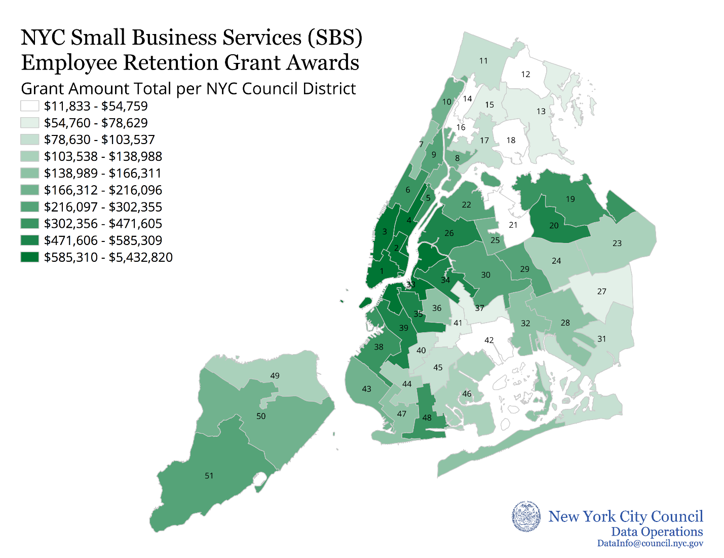

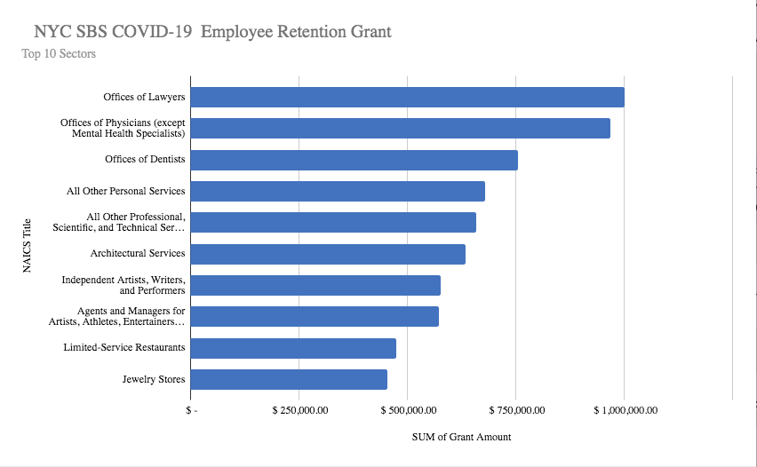
Appendix C

Appendix D

Council District | Loan Amount
4 | $4,274,250
3 | $3,588,083.34
1 | $3,079,466
12 | $53,000
21 | $38,000
16 | $3,000

Appendix E

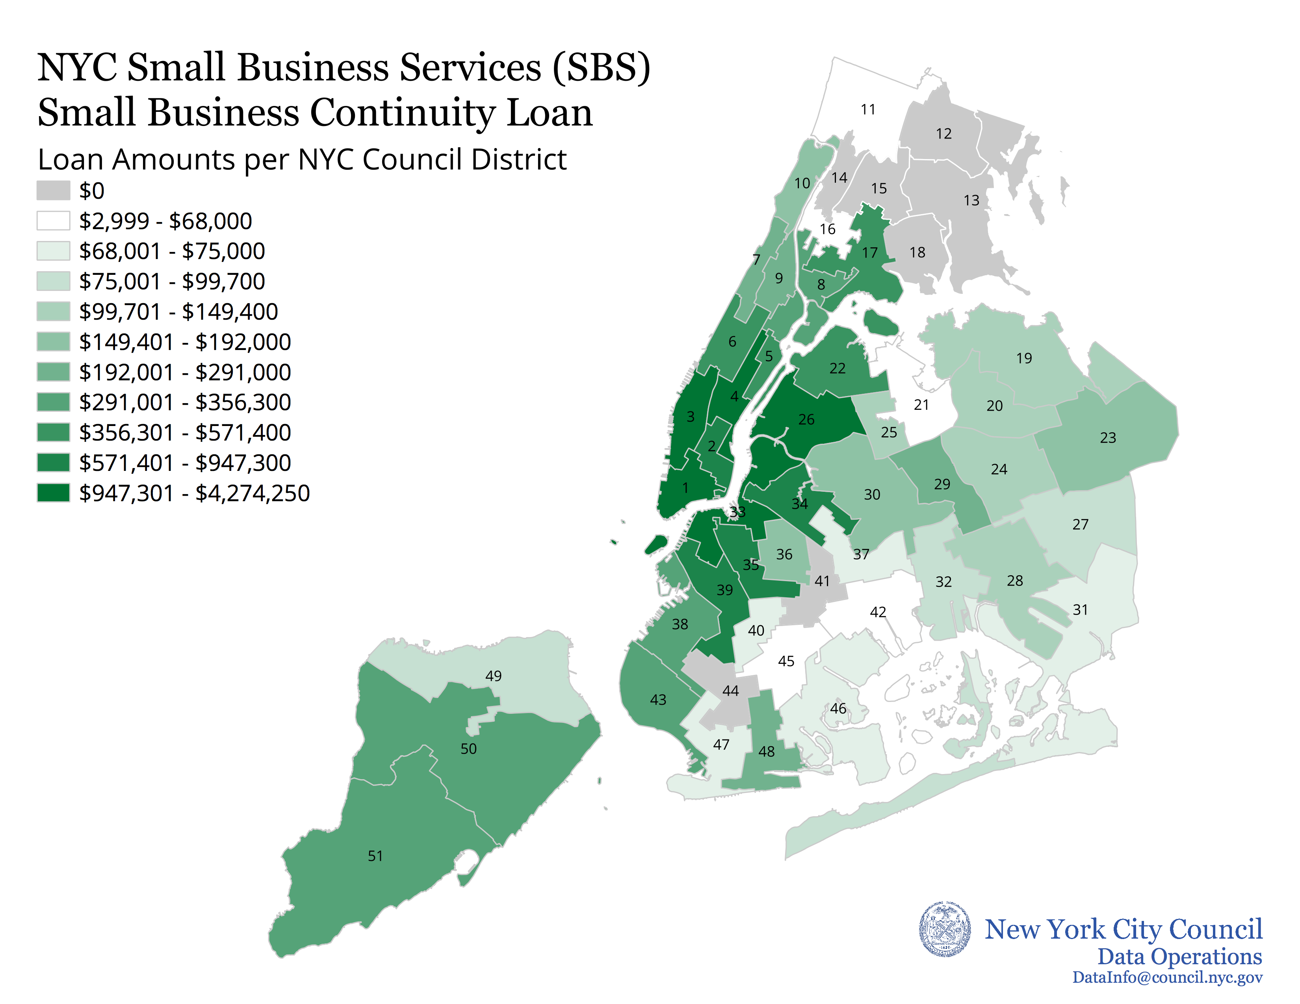

Appendix F

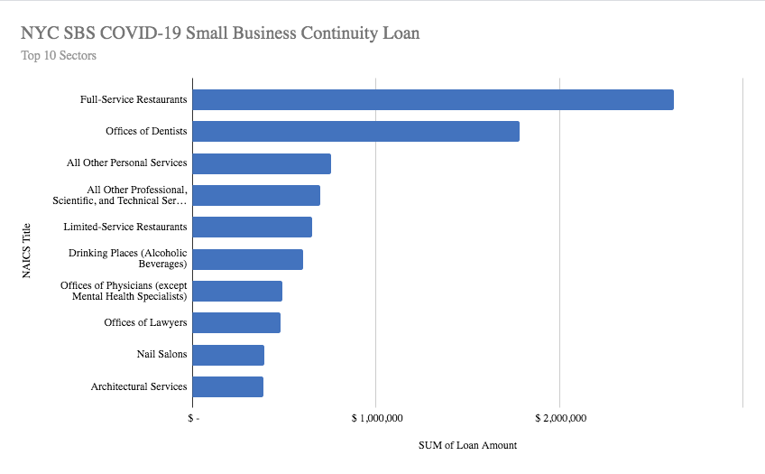

World Health Organization “Rolling updates on coronavirus disease (COVID-19)”, Updated April 18, 2020, available at: https://www.who.int/emergencies/diseases/novel-coronavirus-2019/events-as-they-happen
“A Call for Action and Collaboration”, Partnership for New York City, July 2020, pg. 14 https://pfnyc.org/research/a-call-for-action-and-collaboration/.
“Indicators of Progress,” Manhattan Chamber of Commerce, https://www.nycindicators.com/.
“Percent Change in Small Business Revenue” available at: https://tracktherecovery.org/
Id.
“December 2020 Rent Survey”, NYC Hospitality Alliance, available at: https://www.thenycalliance.org/industry-statistics/
“Survey: Small Businesses on the Brink - New Survey Data Shows Omicron Hurting Main Street, Leading Small Business Owners to Overwhelmingly Support Congress Passing Additional Aid”, Goldman Sachs, January 24, 2022, available at: https://www.goldmansachs.com/citizenship/10000-small-businesses/US/infographics/small-businesses-on-the-brink/index.html
Id.
“Brooklyn Small Businesses in Omicron era: down but not out” Brooklyn Daily Eagle, December 29, 2021, available at: https://brooklyneagle.com/articles/2021/12/29/brooklyn-small-businesses-in-omicron-era-down-but-not-out/
Greg David, “Omicron Afflicts Already Ailing NYC Economy, Pushing Projected Jobs Recovery Back to 2025” The City, January 5, 2022, available at: https://www.thecity.nyc/economy/2022/1/5/22869184/omicron-afflicts-ailing-nyc-economy
Nicole Hong, Matthew Haag and Patrick McGeehan, “ New York’s Recovery Took 2 Steps Forward. Omicron Sent It One Step Back.” The New York Times, January 28, 2022, available at: https://www.nytimes.com/2022/01/28/nyregion/nyc-omicron-covid.html
“A Forecast in Uncertain Times: Modest Budget Shortfalls Projected, But Risks To Outlook Increase as Infections Surge”, New York City Independent Budget Office, January 2022, available at: https://ibo.nyc.ny.us/iboreports/a-forecast-in-uncertain-times-modest-budget-shortfalls-projected-but-risks-to-outlook-increase-as-infections-surge-jamuary-2022.pdf
Comptroller Thomas P. DiNapoli, “New York City Restaurant, Retail and Recreation Sectors Still Face Uphill Recovery,” Office of the New York State Comptroller, January 2022, available at: https://www.osc.state.ny.us/files/reports/osdc/pdf/report-17-2022.pdf
Id.
“Supporting NYC Small Business: Recovery & Growth”, NYC Small Business Services, available at: https://www1.nyc.gov/assets/sbs/downloads/pdf/about/reports/supporting-nyc-recovery-growth.pdf
Id.
Id.
Office of the Mayor, Mayor de Blasio Provides Updates on New York City's COVID-19 Response, March 8, 2020, available at: https://www1.nyc.gov/office-of-the-mayor/news/124-20/mayor-de-blasio-provides-on-new-yorkcity-scovid-19-response.
Id.
NYC Department of Small Business Services “NYC Employee Retention Grant Program”, (as of April 2, 2020), available at: https://www1.nyc.gov/nycbusiness/article/nyc-employee-retention-grant-program. Program information is still available at: https://www.paulweiss.com/media/3979874/nyc2-employee-retention-grant-program-summary_4-6.pdf.
“Report to the Committee on Finance and the Committee on Small Business Services on the Fiscal 2022 Executive Plan for: Department of Small Business services” Available at: SBS.pdf (nyc.gov)
NYC Department of Small Business Services “NYC Employee Retention Grant Program”, (as of April 2, 2020), available at: https://www1.nyc.gov/nycbusiness/article/nyc-employee-retention-grant-program. Program information is still available at: https://www.paulweiss.com/media/3979874/nyc2-employee-retention-grant-program-summary_4-6.pdf.
NYC Department of Small Business Services “NYC Small Business Continuity Loan Program”, (as of April 7, 2020) available at: https://www1.nyc.gov/nycbusiness/article/nyc-small-business-continuity-loan-program. Program Information still available at: https://www.natlawreview.com/article/nyc-financial-assistance-businesses-impacted-covid-19
“Report to the Committee on Finance and the Committee on Small Business Services on the Fiscal 2022 Executive Plan for: Department of Small Business services” Available at: SBS.pdf (nyc.gov)
Angelica Acevedo, “New Small Business Services Commissioner Says Equitable Distribution of Resources is Main Priority”, amNY, May 19, 2020, https://www.amny.com/business/new-small-business-services-commissionersays-equitable-distribution-of-resources-is-main-priority/.
The City Council’s data operations unit produced a map of total grants issued by Council District (Appendix B)
“Transcript: Mayor de Blasio Holds Media Availability on COVID-19” The City of New York, https://www1.nyc.gov/office-of-the-mayor/news/125-20/transcript-mayor-de-blasio-holds-media-availability-covid-19
Businesses from Council Districts 12, 13, 14, 15, 18, 41 and 44 all received no money from the program.
The City Council’s data operations unit produced a map of total loans issued by Council District (Appendix E)
See NYC Department of Small Business Services “Assistance & Guidance for Businesses Impacted Due to Novel Coronavirus”, available at: https://www1.nyc.gov/site/sbs/businesses/covid19-business-financial-assistance.page (last viewed on April 24, 2020). Page has since been updated to reflect the fact that the programs are no longer being offered, but materials had not been translated as of March 20, 2020. See also a tweet publicizing an SBS guide in languages other than English from NYC Mayor’s Office of Immigrant Affairs, March 24, 2020, available at: https://twitter.com/NYCImmigrants/status/1242484476057354240 . Re-tweeted by NYC Department of Small Business Services on March 24, 2020, available at: https://twitter.com/nyc_sbs.
“Recovery Agenda: City Launches Small Business Supports for Hard-Hit Low and Moderate Income (LMI) Communities”, City of New York, November 25, 2020, https://www1.nyc.gov/office-of-the-mayor/news/812-20/recovery-agenda-city-launches-small-business-supports-hard-hit-low-moderate-income-lmi-
Id.
Report to the Committee on Finance and the Committee on Small Business Services on the Fiscal 2022 Executive Plan for: Department of Small Business services” Available at: SBS.pdf (nyc.gov)
Id.
“NYC LMI Storefront Loan Eligible Zip Codes”, City of New York, https://www1.nyc.gov/assets/sbs/downloads/pdf/businesses/COVID19_LMI_Storefront_Loan_eligible_zipcodes.pdf
Id.
Id.
Report to the Committee on Finance and the Committee on Small Business Services on the Fiscal 2022 Executive Plan for: Department of Small Business services” Available at: SBS.pdf (nyc.gov)
Report to the Committee on Finance and the Committee on Small Business Services on the Fiscal 2022 Executive Plan for: Department of Small Business services” Available at: SBS.pdf (nyc.gov)
“Recovery Agenda: City Launches Small Business Supports for Hard-Hit Low and Moderate Income (LMI) Communities”, City of New York, November 25, 2020, https://www1.nyc.gov/office-of-the-mayor/news/812-20/recovery-agenda-city-launches-small-business-supports-hard-hit-low-moderate-income-lmi-
Id.
Report to the Committee on Finance and the Committee on Small Business Services on the Fiscal 2022 Executive Plan for: Department of Small Business services” Available at: SBS.pdf (nyc.gov)
Report to the Committee on Finance and the Committee on Small Business Services on the Fiscal 2022 Executive Plan for: Department of Small Business services” Available at: SBS.pdf (nyc.gov)
“Recovery Agenda: City Launches Small Business Supports for Hard-Hit Low and Moderate Income (LMI) Communities”, City of New York, November 25, 2020, https://www1.nyc.gov/office-of-the-mayor/news/812-20/recovery-agenda-city-launches-small-business-supports-hard-hit-low-moderate-income-lmi-
“NYC LMI Storefront Loan Eligible Zip Codes”, City of New York, https://www1.nyc.gov/assets/sbs/downloads/pdf/businesses/COVID19_LMI_Storefront_Loan_eligible_zipcodes.pdf
Sydney Pereira, “City Excludes Parts Of Chinatown From Small Business Pandemic Loans Intended For Lower Income Neighborhoods”, Gothamist, January 3, 2021, https://gothamist.com/news/city-excludes-parts-chinatown-small-business-pandemic-loans-intended-lower-income-neighborhoods
Tanay Warerkar, “Chinatown Businesses Frustrated Over Exclusion from NYC COVID-19 Loan Program”, Eater NY, January 5, 2021, https://ny.eater.com/2021/1/5/22213569/chinatown-loan-small-business-covid-19-relief
Sydney Pereira, “City Excludes Parts Of Chinatown From Small Business Pandemic Loans Intended For Lower Income Neighborhoods”, Gothamist, January 3, 2021, https://gothamist.com/news/city-excludes-parts-chinatown-small-business-pandemic-loans-intended-lower-income-neighborhoods; and “Economic Profile: Census Tract Manhattan: 29”, NYC Planning, https://popfactfinder.planning.nyc.gov/profile/1492/economic
Sydney Pereira, “City Excludes Parts Of Chinatown From Small Business Pandemic Loans Intended For Lower Income Neighborhoods”, Gothamist, January 3, 2021, https://gothamist.com/news/city-excludes-parts-chinatown-small-business-pandemic-loans-intended-lower-income-neighborhoods
Id.
Id.
“NYC LMI Storefront Loan” Evergreen, December 1, 2020, https://evergreenexchange.org/news/nyc-lmi-storefront-loan
“City Launches $100M Small Business Resilience Grant for Hard-Hit Sectors and low to Moderate Income Communities” City of New York, December 8, 2021, available at: https://www1.nyc.gov/office-of-the-mayor/news/813-21/city-launches-100m-small-business-resilience-grant-hard-hit-sectors-low-moderate-income#:~:text=BiographyNewsOfficials-,City%20Launches%20%24100M%20Small%20Business%20Resilience%20Grant%20for%20Hard,low%20to%20Moderate%20Income%20Communities&text=%E2%80%9CSmall%20businesses%20served%20New%20Yorkers,said%20Mayor%20Bill%20de%20Blasio.
Id.
Id.
Id.
“NYC Small Business Resilience Grant” NYC SBS, Available at: https://covidresilience.nyc/
“City Launches Fair Share NYC; Free Resources to Help Small Business Owners Apply for Federal Relief Funds” City of New York, January 13, 2021, available at: https://www1.nyc.gov/office-of-the-mayor/news/024-21/city-launches-fair-share-nyc-free-resources-help-small-business-owners-apply-federal-relief
“Supporting NYC Small Business: Recovery & Growth”, NYC Small Business Services, available at: https://www1.nyc.gov/assets/sbs/downloads/pdf/about/reports/supporting-nyc-recovery-growth.pdf
Id.
Comptroller Thomas P. DiNapoli, “New York City Restaurant, Retail and Recreation Sectors Still Face Uphill Recovery,” Office of the New York State Comptroller, January 2022, available at: https://www.osc.state.ny.us/files/reports/osdc/pdf/report-17-2022.pdf
“NYC Means Business: Training for Your Employees” NYC Business, available at: https://www1.nyc.gov/nycbusiness/article/nyc-means-business-training-for-your-employees
Id.
“Supporting NYC Small Business: Recovery & Growth”, NYC Small Business Services, available at: https://www1.nyc.gov/assets/sbs/downloads/pdf/about/reports/supporting-nyc-recovery-growth.pdf
“Mayor Adams' Statement on Mask Mandates in Schools, Vaccine Mandates Across NYC”, City of New York, February 27, 2022, available at: https://www1.nyc.gov/office-of-the-mayor/news/096-22/mayor-adams-on-mask-mandates-schools-vaccine-mandates-across-nyc
“Supporting NYC Small Business: Recovery & Growth”, NYC Small Business Services, available at: https://www1.nyc.gov/assets/sbs/downloads/pdf/about/reports/supporting-nyc-recovery-growth.pdf
Id.
Id.
“NYC Business Quick Start” NYC Business, Available at: https://www1.nyc.gov/nycbusiness/article/get-help-with-licenses-and-permits
“Supporting NYC Small Business: Recovery & Growth”, NYC Small Business Services, available at: https://www1.nyc.gov/assets/sbs/downloads/pdf/about/reports/supporting-nyc-recovery-growth.pdf
“Supporting NYC Small Business: Recovery & Growth”, NYC Small Business Services, available at: https://www1.nyc.gov/assets/sbs/downloads/pdf/about/reports/supporting-nyc-recovery-growth.pdf
“Supporting NYC Small Business: Recovery & Growth”, NYC Small Business Services, available at: https://www1.nyc.gov/assets/sbs/downloads/pdf/about/reports/supporting-nyc-recovery-growth.pdf
“Supporting NYC Small Business: Recovery & Growth”, NYC Small Business Services, available at: https://www1.nyc.gov/assets/sbs/downloads/pdf/about/reports/supporting-nyc-recovery-growth.pdf
Data is based on SBS’s report detailing which businesses received a grant or loan from the New York City Employee Retention Program and New York City Small Business Continuity Loan Fund pursuant to Local Law 94 of 2020.
Data is based on SBS’s report detailing which businesses received a grant or loan from the New York City Employee Retention Program and New York City Small Business Continuity Loan Fund pursuant to Local Law 94 of 2020.
Data is based on SBS’s report detailing which businesses received a grant or loan from the New York City Employee Retention Program and New York City Small Business Continuity Loan Fund pursuant to Local Law 94 of 2020.
Data is based on SBS’s report detailing which businesses received a grant or loan from the New York City Employee Retention Program and New York City Small Business Continuity Loan Fund pursuant to Local Law 94 of 2020.
Data is based on SBS’s report detailing which businesses received a grant or loan from the New York City Employee Retention Program and New York City Small Business Continuity Loan Fund pursuant to Local Law 94 of 2020.
Data is based on SBS’s report detailing which businesses received a grant or loan from the New York City Employee Retention Program and New York City Small Business Continuity Loan Fund pursuant to Local Law 94 of 2020.

