THE COUNCIL OF THE CITY OF NEW YORK
RESOLUTION NO. 1030

Resolution approving the decision of the City Planning Commission on Application No.
N 240276 ZRK, for an amendment of the text of the Zoning Resolution (L.U. No. 334).

By Council Members Salamanca and Riley

WHEREAS, Flushing Condo Holdings, LLC, filed an application pursuant to Section 201 of the New York City Charter, for an amendment of the text of the Zoning Resolution of the City of New York, modifying APPENDIX F for the purpose of establishing a Mandatory Inclusionary Housing area, which in conjunction with the related action would facilitate the conversion of an eight-story building constituting an increase from approximately 58,000 to 137,500 square feet of commercial floor area, a reduction from approximately 82,000 to 26,000 square feet of community facility floor area, and a reduction of 313 to 86 parking spaces within the Williamsburg neighborhood of Brooklyn, Community District 1 (ULURP No. N 240276 ZRK), (the “Application”);

WHEREAS, the City Planning Commission filed with the Council on July 7, 2025, its decision dated June 18, 2025 (the "Decision") on the Application;

WHEREAS, the Application is related to application C 240275 ZMK (L.U. No. 333), a zoning map amendment to change an M1-2 zoning district to an M1-5 and R7-1/C2-4 zoning district;

WHEREAS, the Decision is subject to review and action by the Council pursuant to Section 197-d of the City Charter;

WHEREAS, upon due notice, the Council held a public hearing on the Decision and Application on July 8, 2025;

WHEREAS, the Council has considered the land use implications and other policy issues relating to the Decision and Application; and

WHEREAS, the Council has considered the relevant environmental issues, including the Revised Negative Declaration issued June 16th, 2025 (CEQR No. 24DCP111K), which supersedes the Negative Declaration issued January 31st, 2025, and includes an (E) designation to avoid the potential for significant adverse impacts related to hazardous materials and air quality (E-819) (the “Revised Negative Declaration”).

RESOLVED:

The Council finds that the action described herein will have no significant impact on the environment as set forth in the Revised Negative Declaration.

Pursuant to Sections 197-d and 200 of the City Charter and on the basis of the Decision and Application, and based on the environmental determination and consideration described in the report, N 240276 ZRK, incorporated by reference herein, and the record before the Council, the Council approves the Decision of the City Planning Commission.

Matter underlined is new, to be added;
Matter struck out is to be deleted;
Matter within # # is defined in Section 12-10;
* * * indicates where unchanged text appears in the Zoning Resolution

* * *

APPENDIX F
Mandatory Inclusionary Housing Areas and former Inclusionary Housing Designated Areas

* * *

BROOKLYN

Brooklyn Community District 1

* * *

Map 6 – [date of adoption]

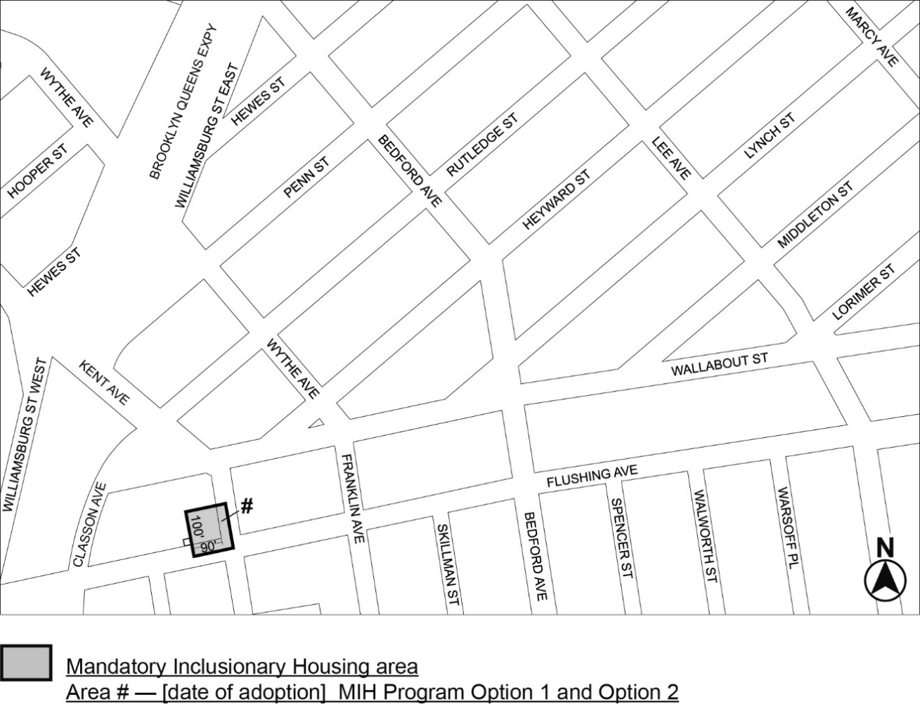

Portion of Community District 1, Brooklyn

* * *
Adopted.

Office of the City Clerk,}
The City of New York,} ss.:

I hereby certify that the foregoing is a true copy of a Resolution passed by The Council of The City of New York on _________, 2025, on file in this office.

.....................................................
City Clerk, Clerk of The Council

