THE COUNCIL OF THE CITY OF NEW YORK
RESOLUTION NO. 568

Resolution approving the decision of the City Planning Commission on ULURP No. N 260170 ZRR, for a Zoning text amendment (L.U. No. 99).

By Council Members Riley and Louis
WHEREAS, Economic Development Opportunity Zone Fund 1 LLC, filed an application pursuant to Section 201 of the New York City Charter, for an amendment of the Zoning Resolution of the City of New York, amending the Appendix to Article XII, Chapter 8 (Special St. George District) and APPENDIX F for the purpose of establishing a Mandatory Inclusionary Housing Area, which in conjunction with the related action would facilitate the development of a new 14-story mixed-use residential building with community facility space located at 198, 204, and 208 Richmond Terrace in St. George, Borough of Staten Island, Community District 1 (ULURP No. N 260170 ZRR) (the "Application");
WHEREAS, the City Planning Commission filed with the Council on June 9, 2026 its decision dated May 13, 2026 (the "Decision") on the Application;
WHEREAS, the Application is related to application C 260169 ZMR (L.U. No. 98), a zoning map amendment to change R6 and R6/C2-2 zoning districts to an R7-3/C2-4 zoning district;
WHEREAS, the Decision is subject to review and action by the Council pursuant to Section 197-d of the City Charter;
WHEREAS, upon due notice, the Council held a public hearing on the Decision and Application on June 17, 2026;
WHEREAS, the Council has considered the land use and other policy issues relating to the Decision and Application; and
WHEREAS, the Council has considered the relevant environmental issues, including the Type II Memorandum issued on December 15, 2025 pursuant to the City’s Green Fast Track for Housing process (CEQR No. 26DCP061R), which includes an (E) designation (E-864) to avoid the potential for significant adverse impacts related to hazardous materials, air quality, and noise (the “Type II Memorandum”).
RESOLVED:
The Council finds that the action described herein will have no significant impact on the environment as set forth in the (E) Designation (E-864) and Type II Memorandum.
Pursuant to Section 197-d of the New York City Charter and the Decision and Application, the environmental determination and consideration described in the report, N 260170 ZRR, incorporated by reference herein, and the record before the Council, the Council approves the Decision of the City Planning Commission.
The Zoning Resolution of the City of New York, effective as of December 15, 1961, and as subsequently amended, is further amended as follows:
Matter underlined is new, to be added;
Matter struck out is to be deleted;
Matter within # # is defined in Section 12-10;
* * * indicates where unchanged text appears in the Zoning Resolution
* * *

ARTICLE XII
SPECIAL PURPOSE DISTRICTS

Chapter 8 – Special St. George District (SG)

Appendix – Special St. George District Plan

Map 1 – Special St. George District and Subdistricts [date of adoption]
[EXISTING MAP]
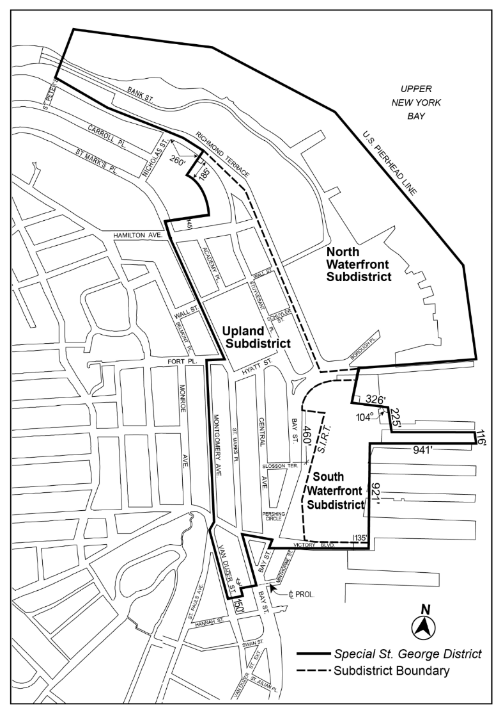

[PROPOSED MAP]
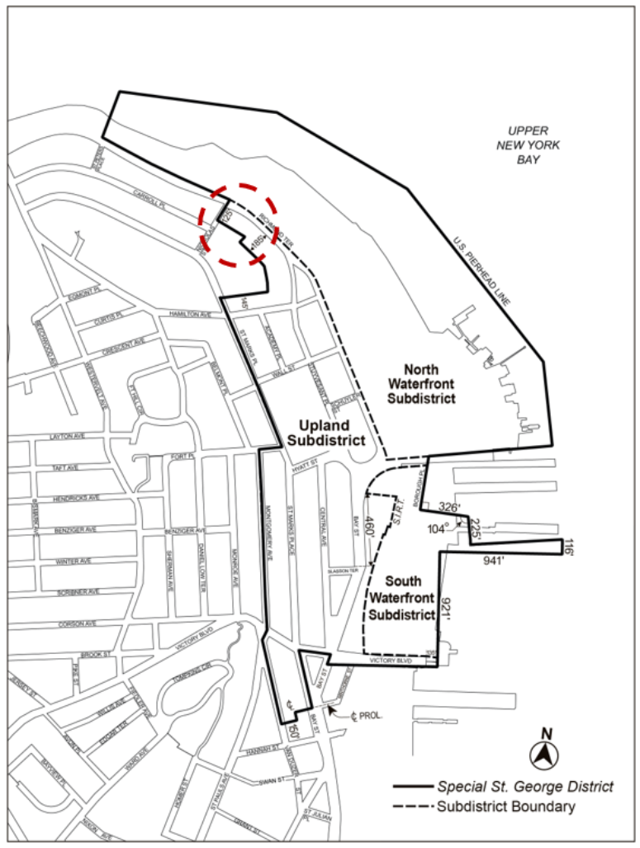

Map 2 – Commercial Streets [date of adoption]
[EXISTING MAP]
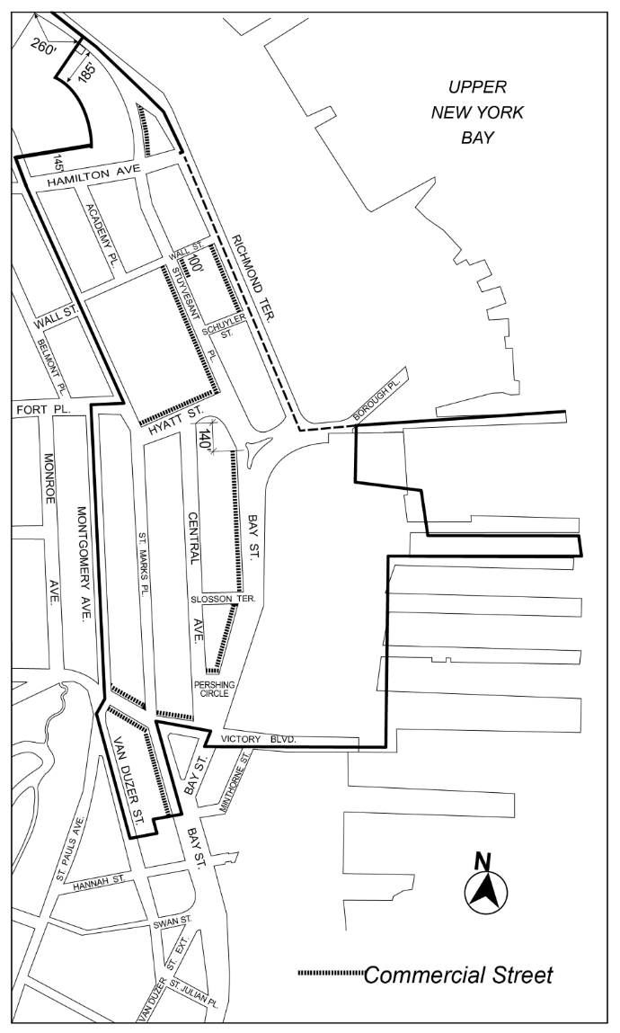

[PROPOSED MAP]
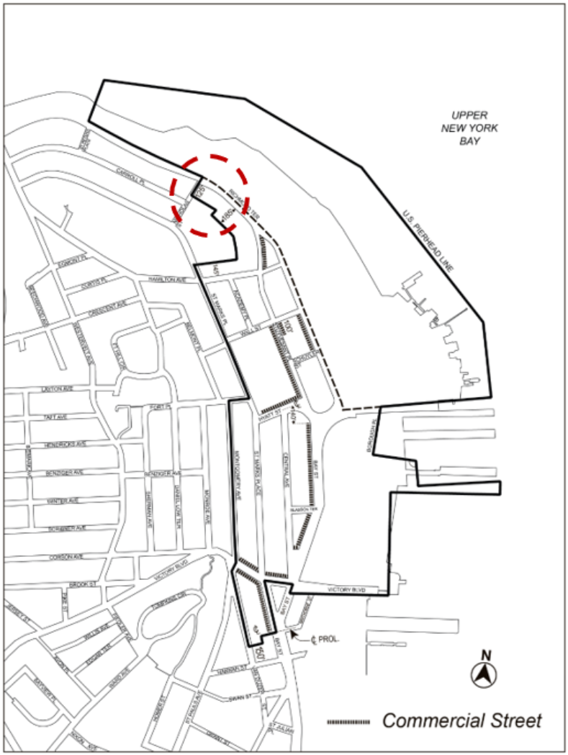

Map 3 – Minimum and Maximum Base Heights [date of adoption]
[EXISTING MAP]
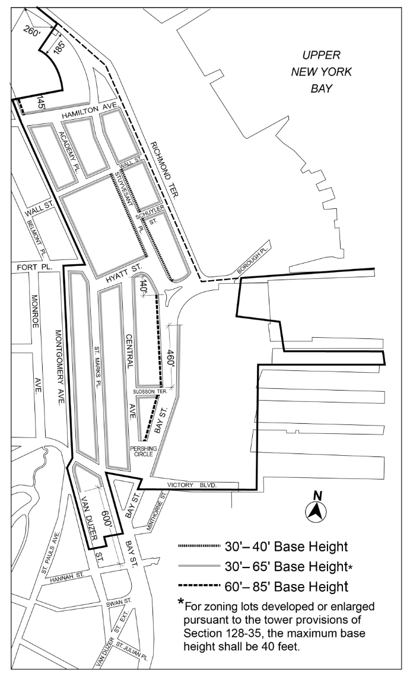

[PROPOSED MAP]
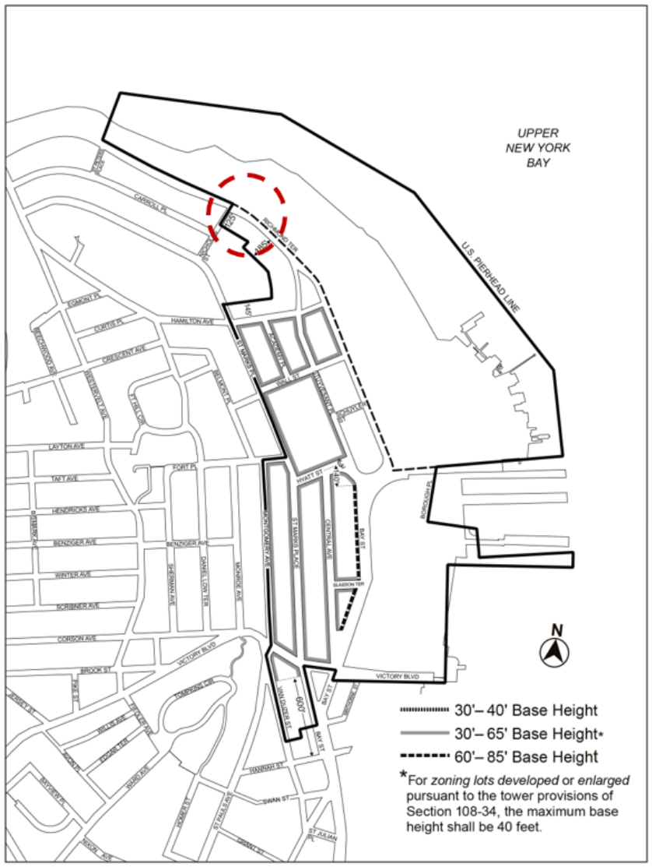

Map 4 – Tower Restriction Areas [date of adoption]
[EXISTING MAP]
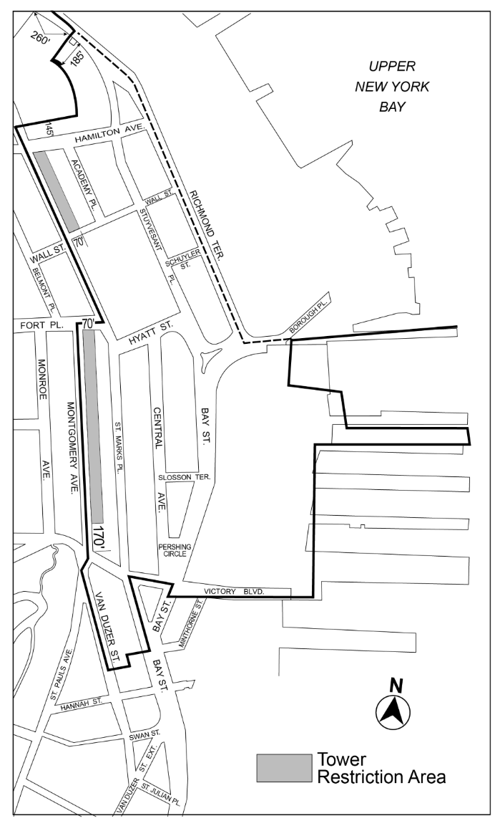

[PROPOSED MAP]
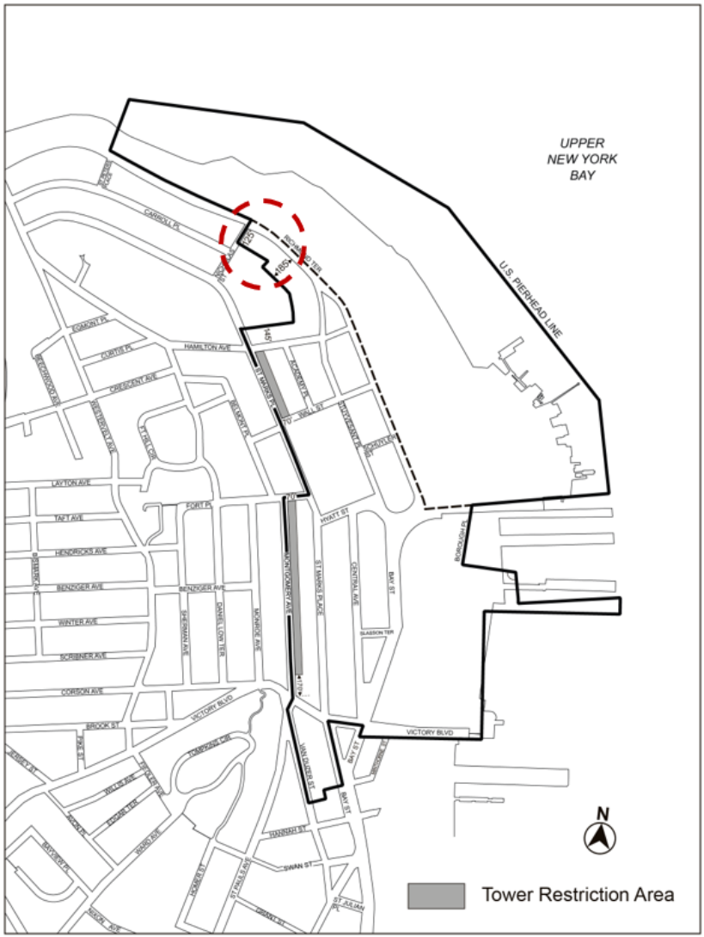

Map 5 – Visual Corridors and Parcels [date of adoption]
[EXISTING MAP]
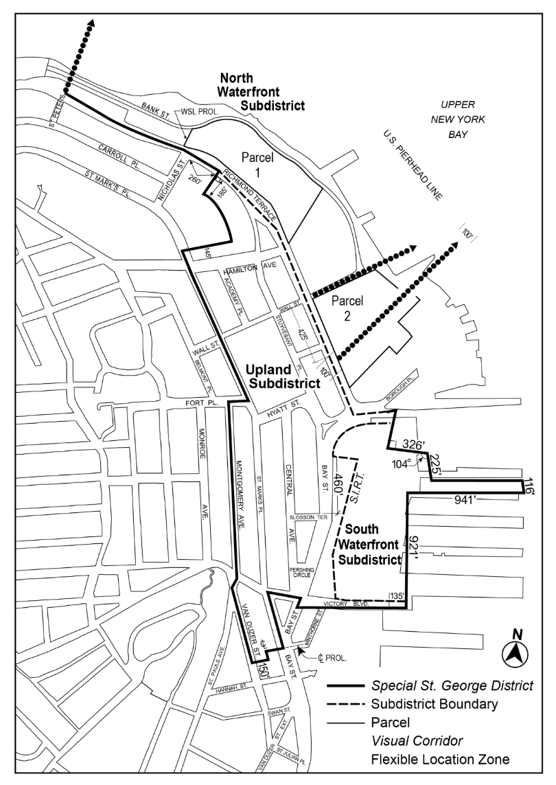

[PROPOSED MAP]
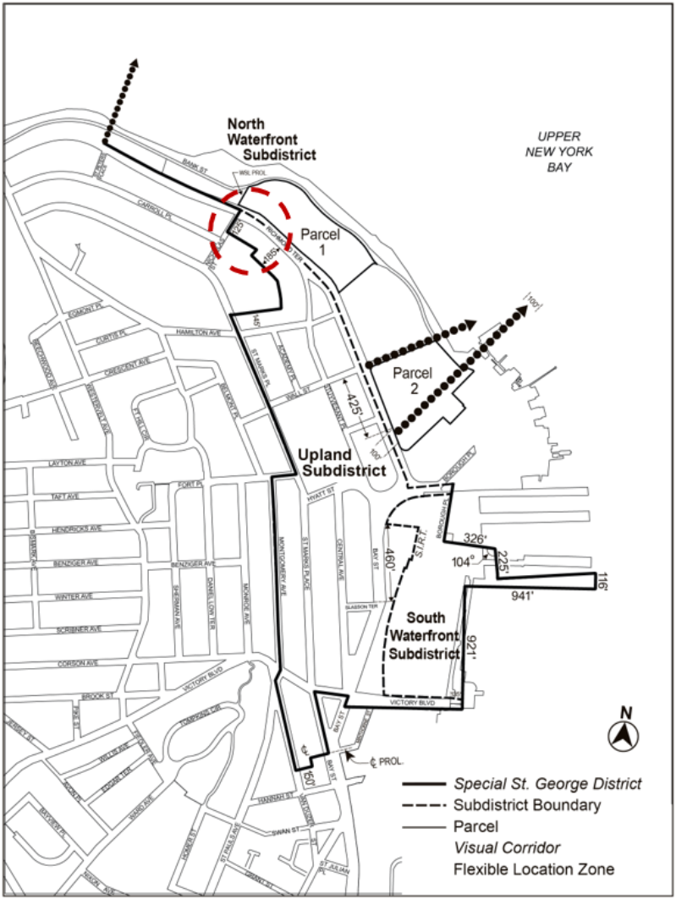

* * *

APPENDIX F
Mandatory Inclusionary Housing Areas and former Inclusionary Housing Designated Areas

* * *

STATEN ISLAND

Staten Island Community District 1

* * *

Map 3 – [date of adoption]
[EXISTING MAP]
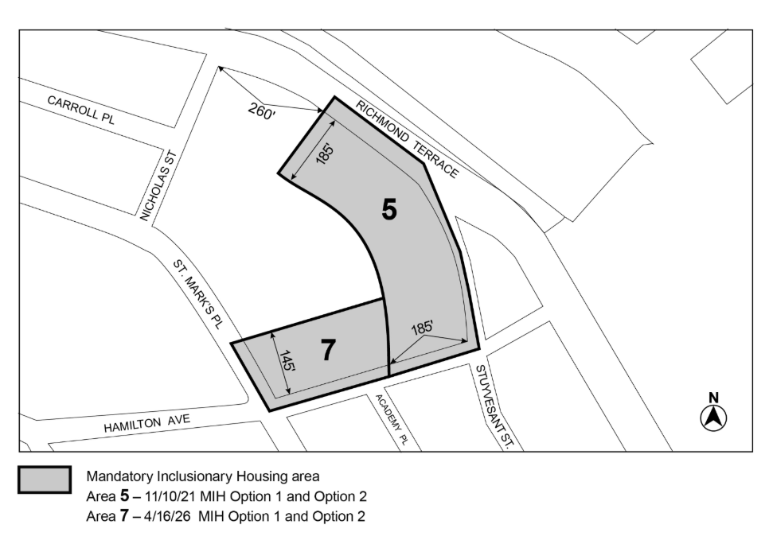

[PROPOSED MAP]
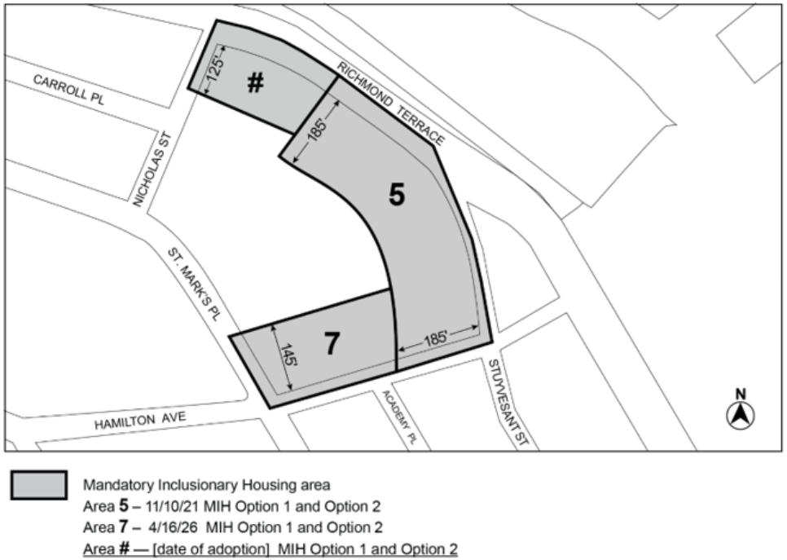

Portion of Community District 1, Staten Island

* * *

Adopted.

Office of the City Clerk, }
The City of New York, } ss.:

I hereby certify that the foregoing is a true copy of a Resolution passed by The Council of The City of New York on ______________, on file in this office.

.....................................................
City Clerk, Clerk of The Council

