THE COUNCIL OF THE CITY OF NEW YORK
RESOLUTION NO. 367

Resolution approving the decision of the City Planning Commission on Application No. N 140274 ZRQ, for an amendment of the Zoning Resolution of the City of New York, relating to Article XI, Chapter 7, to enlarge the Special Long Island City Mixed Use District and to modify certain provisions related to sidewalk cafes and to expand the boundary of the Hunters Point Subdistrict of the Special Long Island City Mixed Use District, Borough of Queens (L.U. No. 99).

By Council Members Greenfield and Weprin

WHEREAS, the City Planning Commission filed with the Council on June 13, 2014 its decision dated June 11, 2014 (the "Decision"), pursuant to Section 201 of the New York City Charter, regarding an application submitted by Hunters Point 49, LLC, for an amendment of the text of the Zoning Resolution of the City of New York, relating to Article XI, Chapter 7, to enlarge the Special Long Island City Mixed Use District (“LIC”), to expand the boundary of the Hunters Point Subdistrict of the Special Long Island City Mixed Use District and to modify certain provisions related to sidewalk cafés (Application No. N 140274 ZRQ), Borough of Queens (the "Application");

WHEREAS, the Application is related to application C 140275 ZMQ (L.U. No. 98), an amendment to the Zoning Map, changing from M1-4 to M1-5/R7X and to establish the LIC District on Block 61, Lot 50 and portions of Lots 5 and 55 and Block 72, a portion of Lot 1;

WHEREAS, the Decision is subject to review and action by the Council pursuant to Section 197-d(b)(1) of the New York City Charter;
WHEREAS, upon due notice, the Council held a public hearing on the Decision and Application on July 21, 2014;

WHEREAS, the Council has considered the land use implications and other policy issues relating to the Decision and Application; and

WHEREAS, the Council has considered the relevant environmental issues including the negative declaration (CEQR No. 14DCP066Q) dated February 18, 2014, which is subject to the conditions of CEQR Declaration E-335 for air quality impacts (the “Negative Declaration”);

RESOLVED:

The Council finds that the action described herein will have no significant impact on the environment as set forth in the Negative Declaration.

Pursuant to Sections 197-d and 200 of the City Charter and on the basis of the Decision and Application, and based on the environmental determination and consideration described in this report, N 140274 ZRQ, incorporated by reference herein, the Council approves the Decision.

The Zoning Resolution of the City of New York, effective as of December 15, 1961, and as subsequently amended, is further amended as follows:

Matter Underlined is new, to be added;
Matter in Strikeout is old, to be deleted;
Matter within # # is defined in Section 12-10;
* * * indicate where unchanged text appears in the Zoning Resolution

* * *

District and Subdistricts
Map to be Deleted

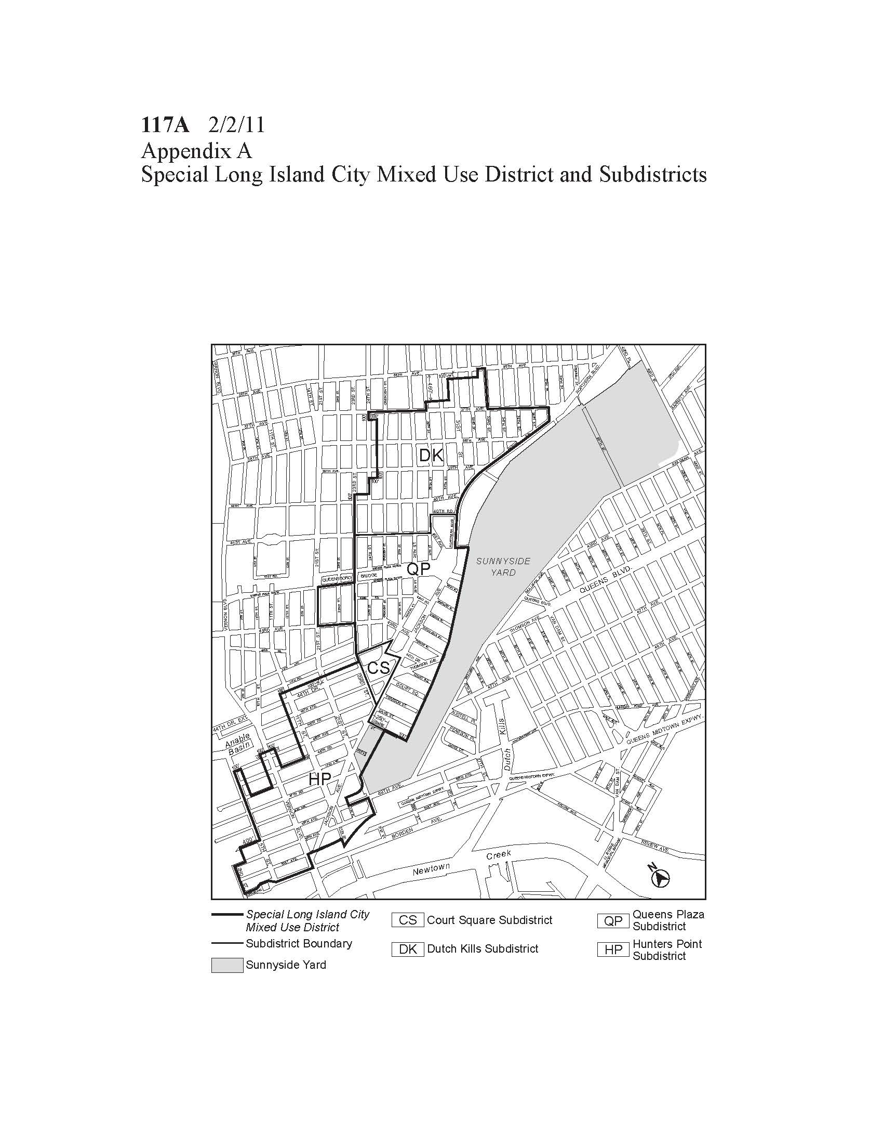
District and Subdistricts
Map to be Added

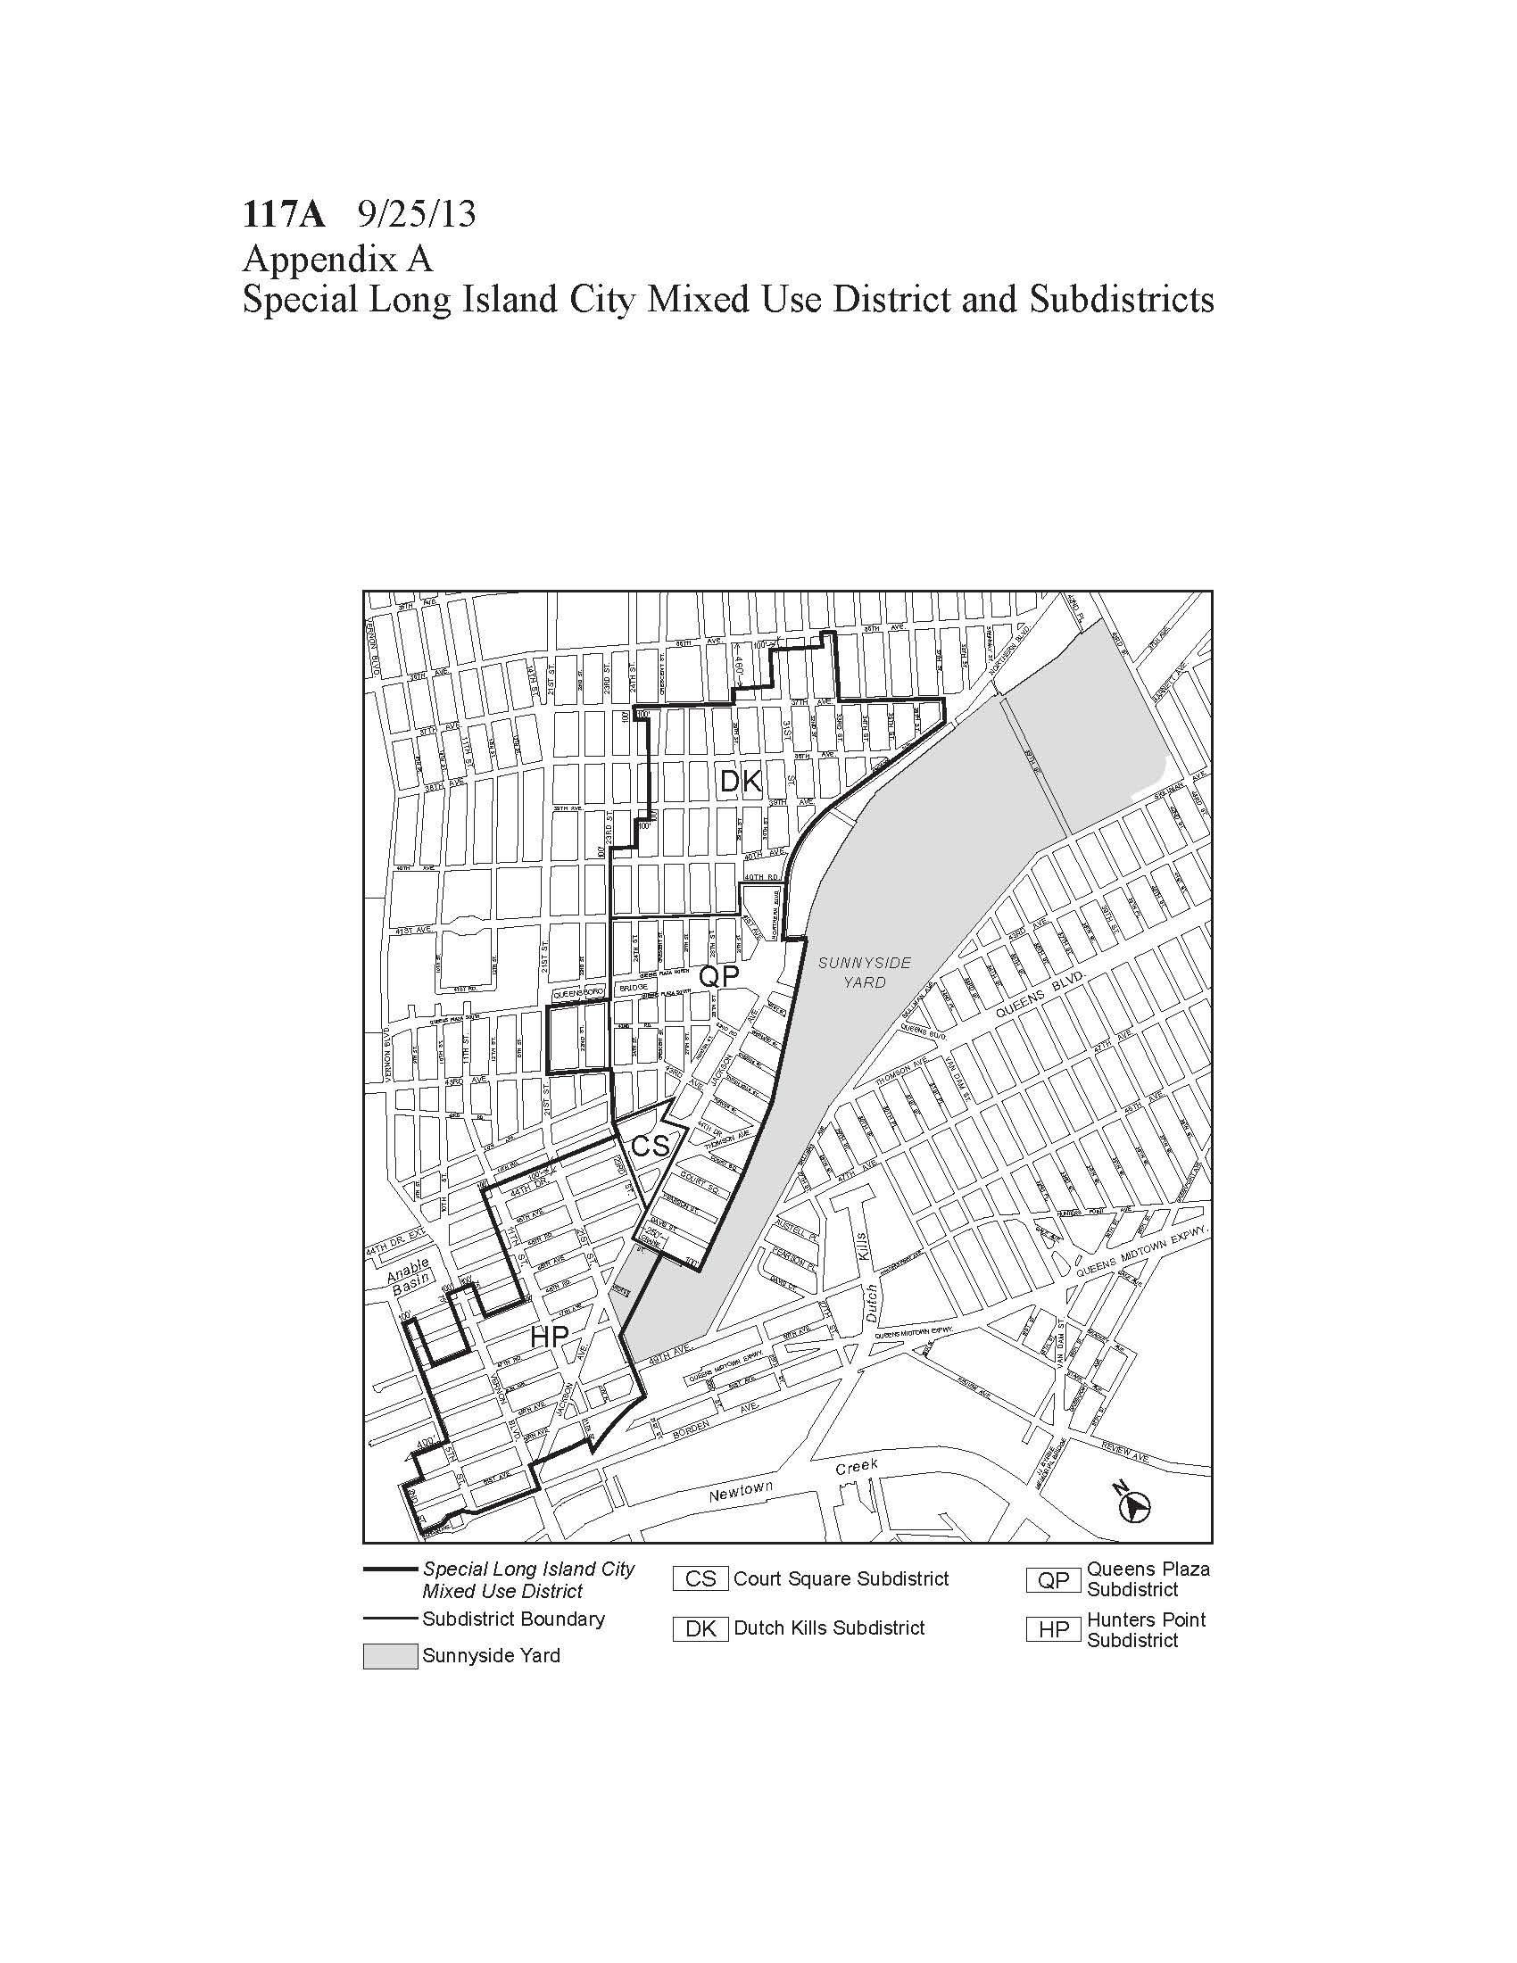
Permitted Sidewalk Café Locations
Map to be Deleted

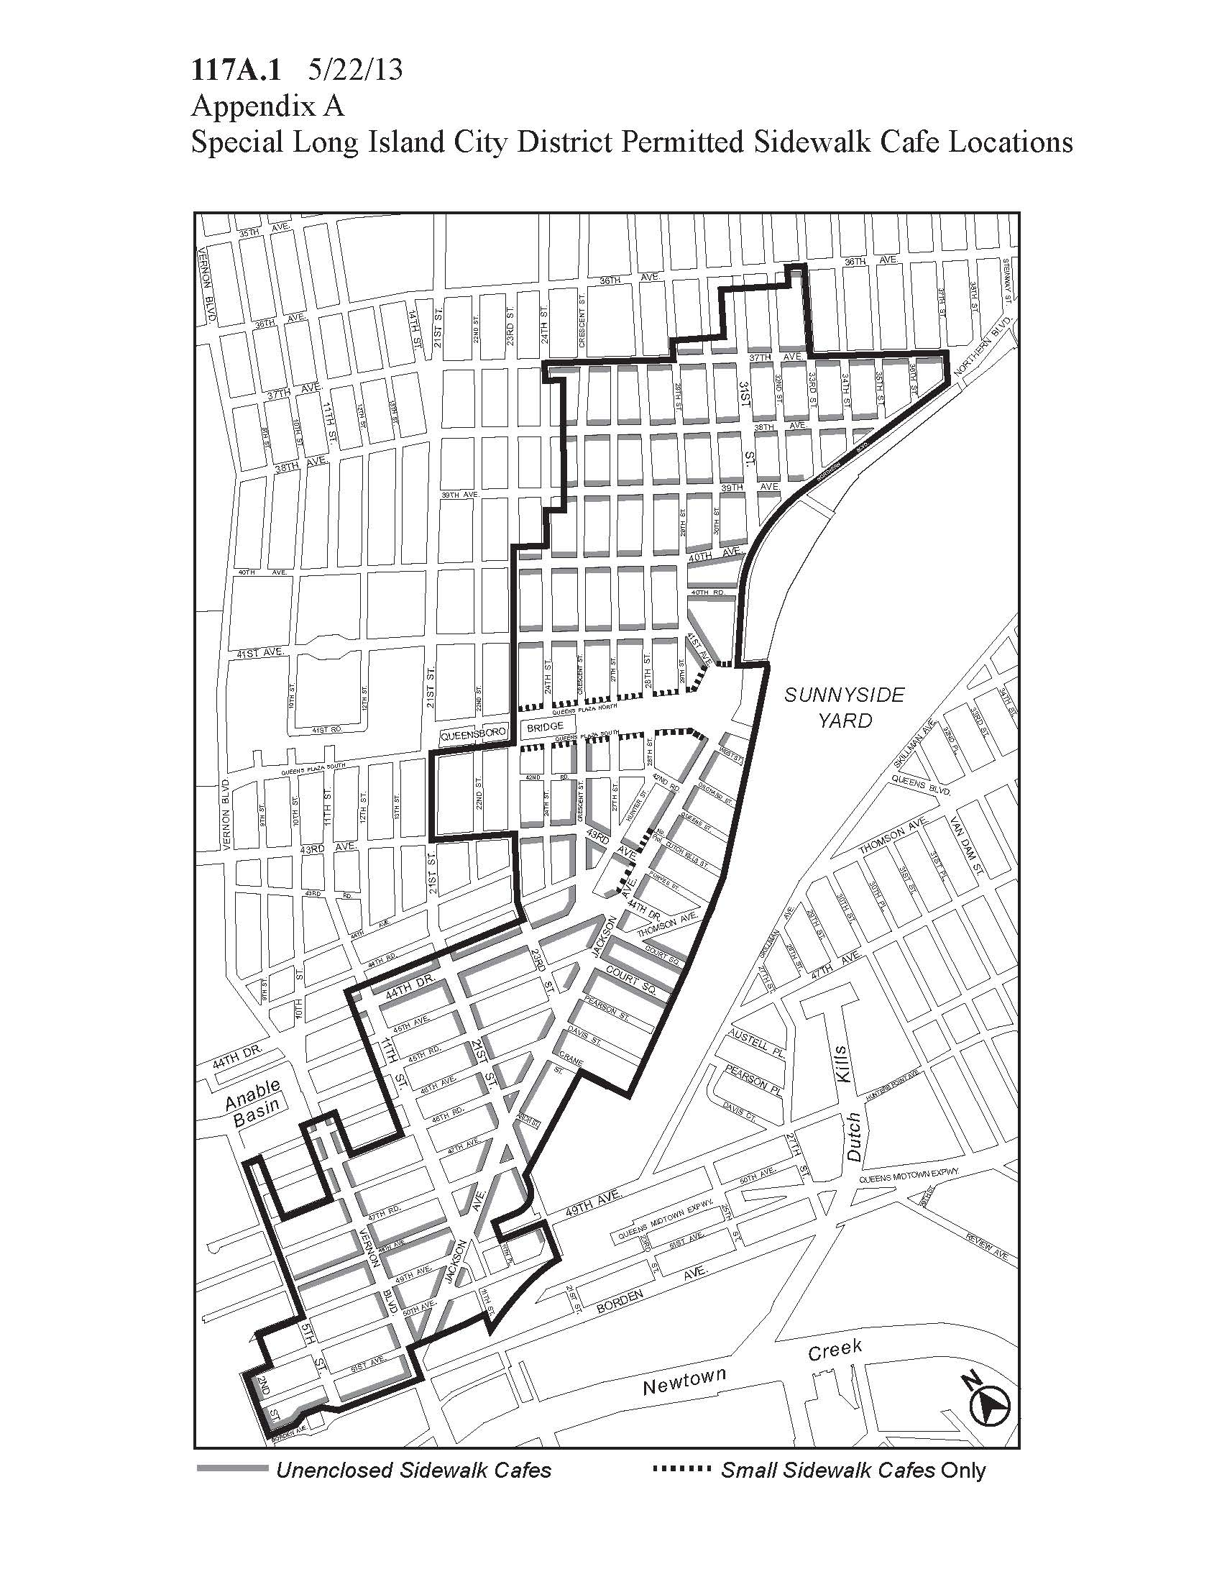

Permitted Sidewalk Café Locations
Map to be Added

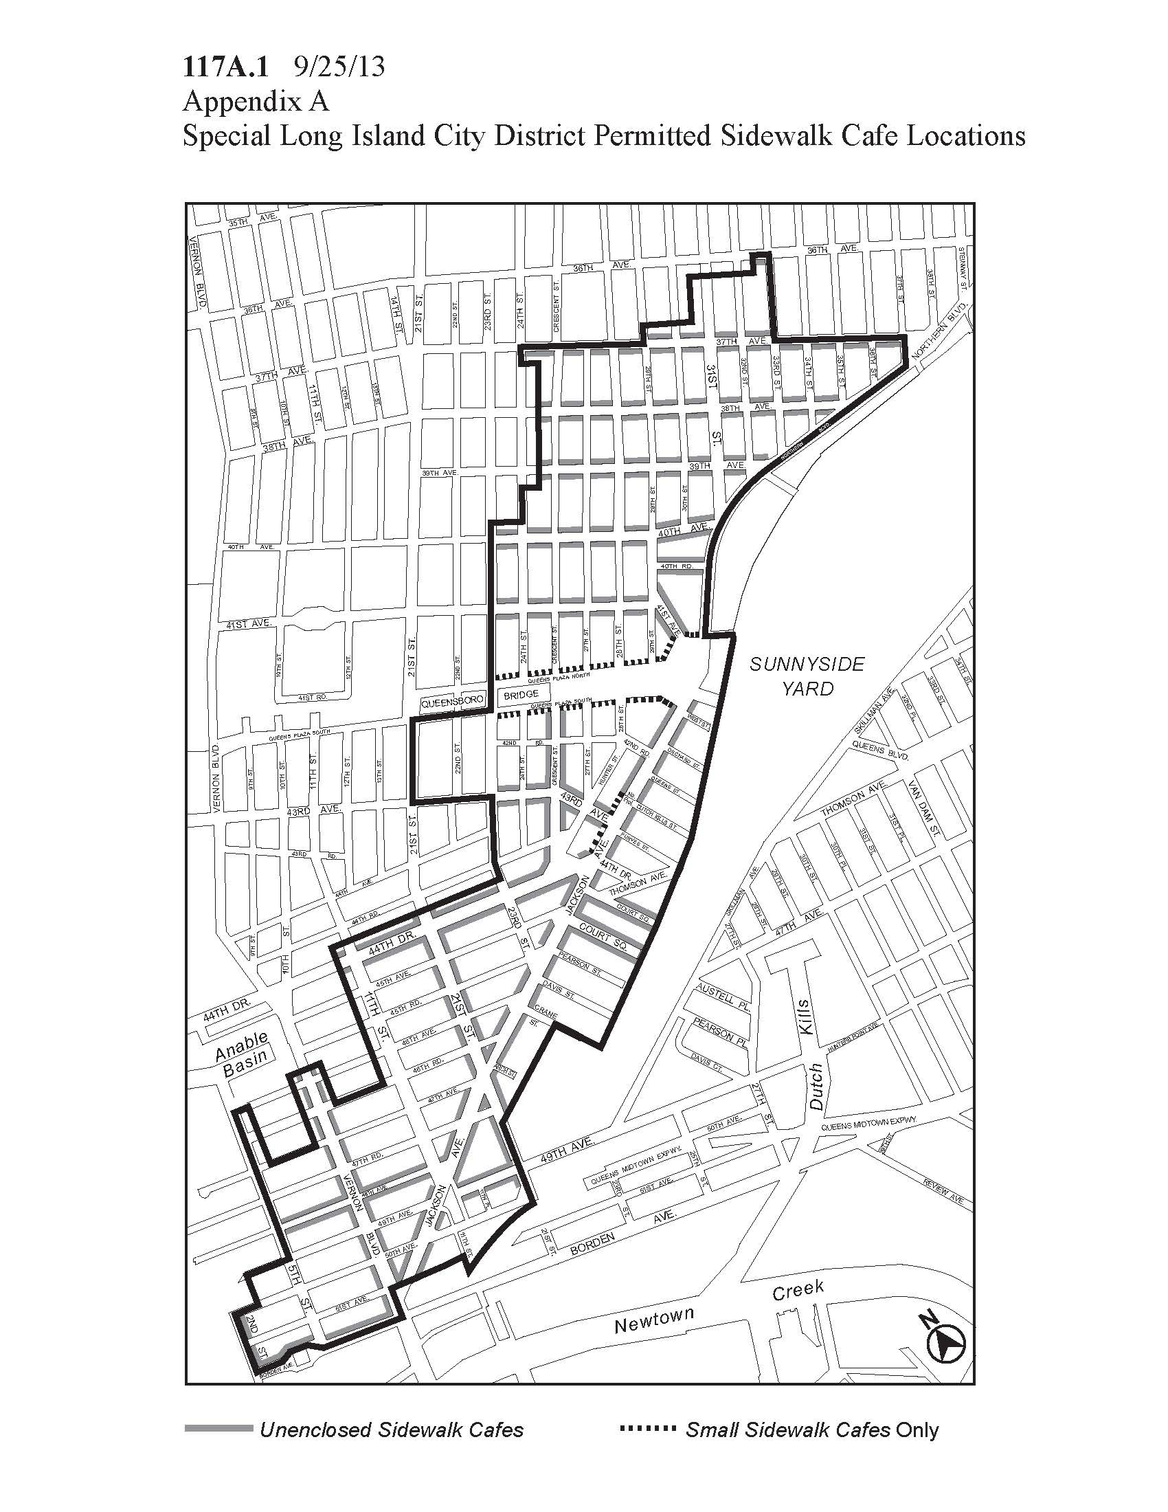
Adopted.
Office of the City Clerk, }
The City of New York, } ss.:

I hereby certify that the foregoing is a true copy of a Resolution passed by The Council of The City of New York on July 24, 2014, on file in this office.

.....…….........................................
City Clerk, Clerk of The Council

