THE COUNCIL OF THE CITY OF NEW YORK
RESOLUTION NO. 1494

Resolution approving with modifications the decision of the City Planning Commission on Application No. N 200104 ZRQ, for an amendment of the text of the Zoning Resolution (Pre. L.U. No. 690).

By Council Members Salamanca and Moya

WHEREAS, Tuchman Associates, LLC, filed an application pursuant to Section 201 of the New York City Charter, for an amendment of the text of the Zoning Resolution of the City of New York, modifying Appendix F for the purpose of establishing a Mandatory Inclusionary Housing area utilizing Options 1 and 2, which in conjunction with the related action would facilitate the development of a new building with community facility and residential uses at 110-40 Saultell Avenue in the Corona neighborhood of Queens, Community District 4 (ULURP No. N 200104 ZRQ), (the “Application”);

WHEREAS, the City Planning Commission filed with the Council on October 9, 2020, its decision dated October 7, 2020 (the "Decision") on the Application;

WHEREAS, the Application is related to application C 200103 ZMQ (Pre. L.U. No. 689), a zoning map amendment changing from an R6B District to an R6 District;

WHEREAS, the Decision is subject to review and action by the Council pursuant to Section 197-d of the City Charter;

WHEREAS, upon due notice, the Council held a public hearing on the Decision and Application on October 22, 2020;

WHEREAS, the Council has considered the land use implications and other policy issues relating to the Decision and Application; and

WHEREAS, the Council has considered the relevant environmental issues, including the negative declaration issued December 16, 2019 (CEQR No. 20DCP010Q), which includes an (E) designation to avoid the potential for significant adverse impacts related to hazardous materials, air quality, and noise, and (E-558) (the “Negative Declaration”).

RESOLVED:

The Council finds that the action described herein will have no significant impact on the environment as set forth in the (E) Designation (E-558) and Negative Declaration.

Pursuant to Sections 197-d and 200 of the City Charter and on the basis of the Decision and Application, and based on the environmental determination and consideration described in the report, N 200104 ZRQ, incorporated by reference herein, and the record before the Council, the Council approves the Decision of the City Planning Commission with the following modifications:

Matter underlined is new, to be added;
Matter struck out is to be deleted;
Matter within # # is defined in Section 12-10;
Matter double struck out is old, deleted by the City Council;
Matter double-underlined is new, added by the City Council
* * * indicates where unchanged text appears in the Zoning Resolution.

* * *

APPENDIX F
Inclusionary Housing Designated Areas and Mandatory Inclusionary Housing Areas

* * *

QUEENS

* * *

Queens Community District 4

Map 1 - [date of adoption]

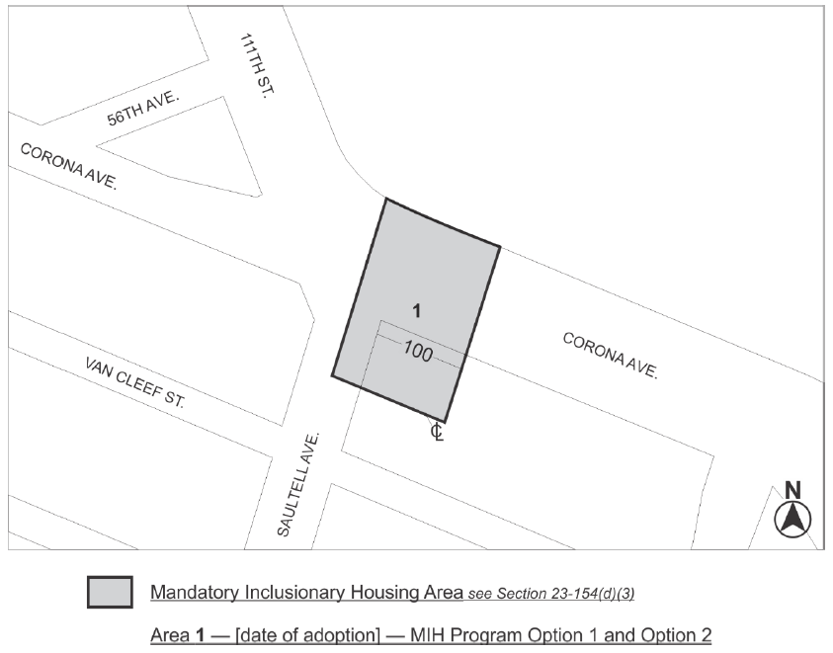

Area 1 – [date of adoption] – MIH Program Option 1 and Option 2
Portion of Community District 4, Queens

* * *

Adopted.

Office of the City Clerk,}
The City of New York,} ss.:

I hereby certify that the foregoing is a true copy of a Resolution passed by The Council of The City of New York on __________, 2020, on file in this office.

.....................................................
City Clerk, Clerk of The Council

