THE COUNCIL OF THE CITY OF NEW YORK
RESOLUTION NO. 866

Resolution approving the decision of the City Planning Commission on Application No.
N 240251 ZRQ, for an amendment of the text of the Zoning Resolution (L.U. No. 270).

By Council Members Salamanca, Riley and Mealy

WHEREAS, QBM Properties, LLC, filed an application pursuant to Section 201 of the New York City Charter, for an amendment of the text of the Zoning Resolution of the City of New York, modifying APPENDIX F for the purpose of establishing a Mandatory Inclusionary Housing area, which in conjunction with the related action would facilitate the development of a new 17-story mixed-use building containing ground-floor commercial space and approximately 216 dwelling units, of which 54 would be income-restricted, located at 102-51 Queens Boulevard in the Forest Hills neighborhood, Borough of Queens, Community District 6 (ULURP No. N 240251 ZRQ), (the “Application”);

WHEREAS, the City Planning Commission filed with the Council on March 14, 2025, its decision dated March 5, 2025 (the "Decision") on the Application;

WHEREAS, the Application is related to application C 240250 ZMQ (L.U. No. 269), a zoning map amendment to change an R7-1/C1-2 zoning district to R8X/C2-4 and R7-1 zoning districts;

WHEREAS, the Decision is subject to review and action by the Council pursuant to Section 197-d of the City Charter;

WHEREAS, upon due notice, the Council held a public hearing on the Decision and Application on April 17, 2025;

WHEREAS, the Council has considered the land use implications and other policy issues relating to the Decision and Application; and

WHEREAS, the Council has considered the relevant environmental issues, including the Negative Declaration issued on September 23, 2024 (CEQR No. 24DCP107Q), which includes an (E) designation to avoid the potential for significant adverse impacts related to hazardous materials, air quality, and noise (E-780) (the “Negative Declaration”).

RESOLVED:

The Council finds that the action described herein will have no significant impact on the environment as set forth in the (E) Designation (E-780) and Negative Declaration.

Pursuant to Sections 197-d and 200 of the City Charter and on the basis of the Decision and Application, the environmental determination and consideration described in the report, N 240251 ZRQ, incorporated by reference herein, the record before the Council, and the Council approves the Decision of the City Planning Commission.

Matter underlined is new, to be added;
Matter struck out is to be deleted;
Matter within # # is defined in Section 12-10;
* * * indicates where unchanged text appears in the Zoning Resolution

* * *

APPENDIX F

Mandatory Inclusionary Housing Areas and former Inclusionary Housing Designated Areas

* * *

QUEENS
* * *

Queens Community District 6

* * *
Map 4 – [date of adoption]
[EXISTING MAP]
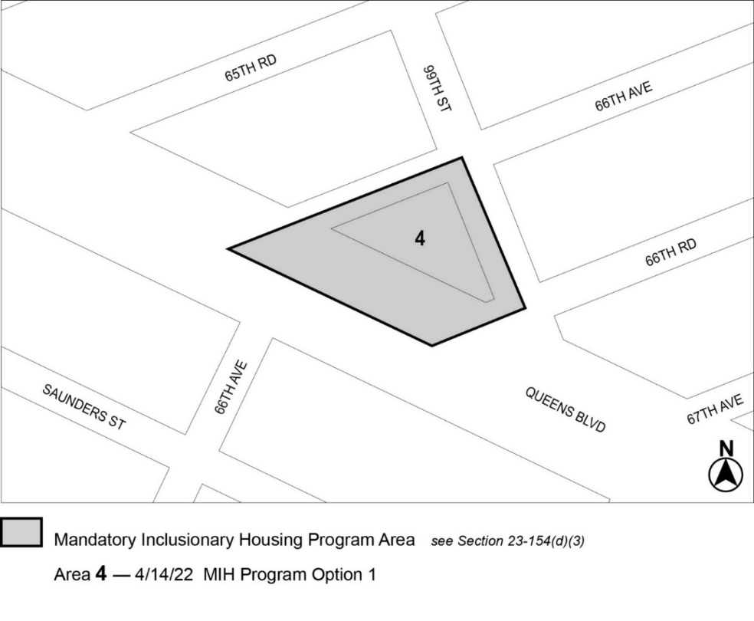

Map 5 – (7/14/22)
[EXISTING MAP]
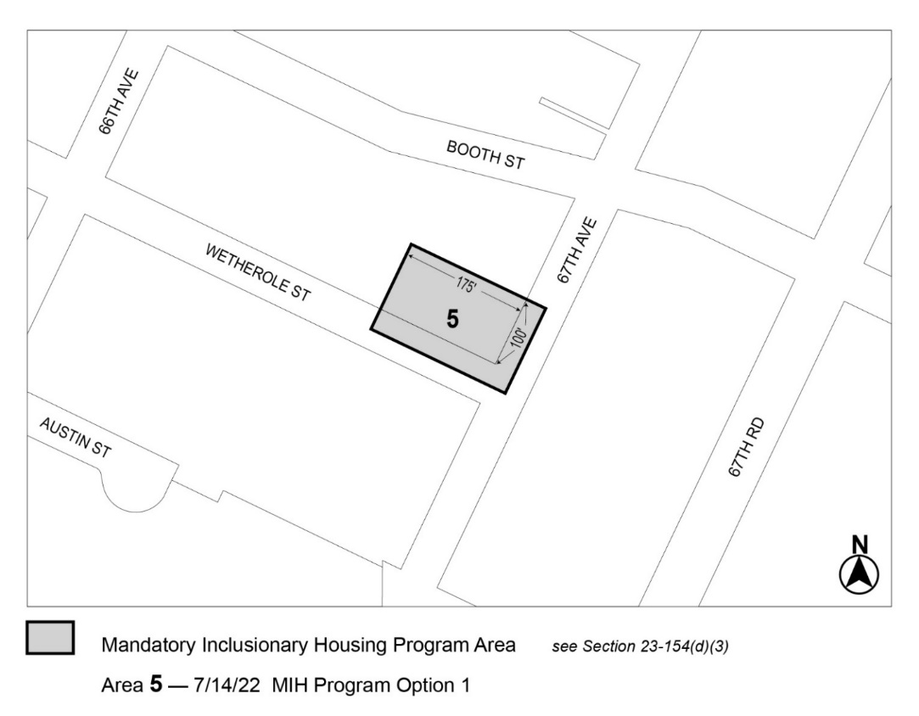

[PROPOSED MAP]
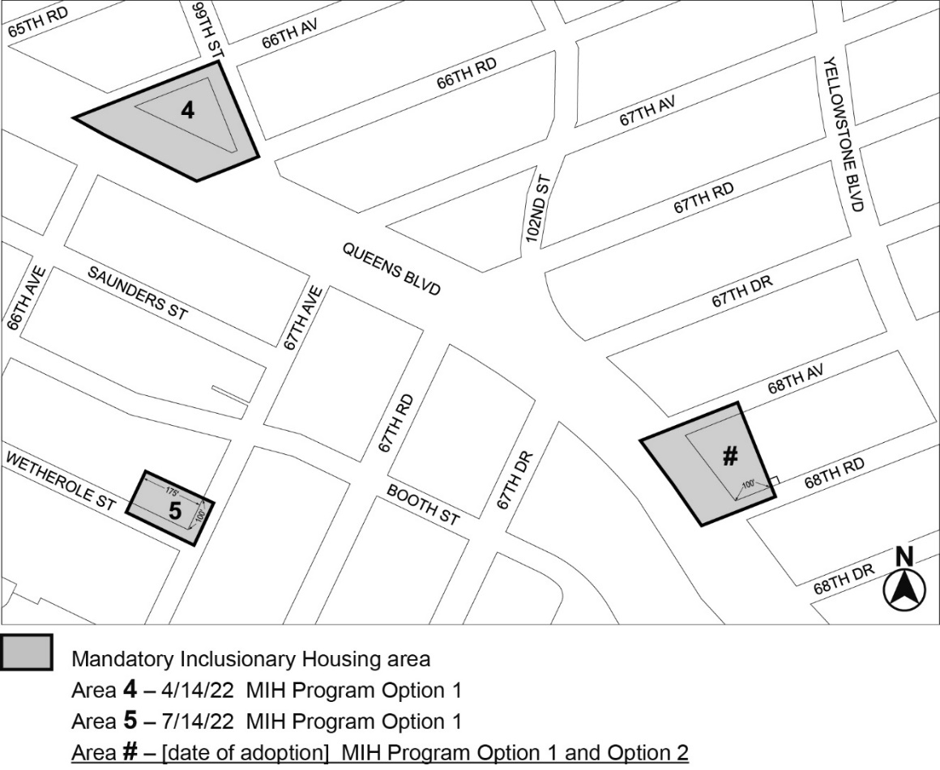

Portion of Community District 6, Queens

* * *
Adopted.

Office of the City Clerk,}
The City of New York, } ss.:

I hereby certify that the foregoing is a true copy of a Resolution passed by The Council of The City of New York on May 1, 2025, on file in this office.

.....................................................
City Clerk, Clerk of The Council

