Committee Staff
Austin Malone, Legislative Counsel
Natasha Bynum, Legislative Counsel
Sierra Townsend, Legislative Counsel
Ricky Chawla, Senior Legislative Policy Analyst
Andrew Bourne, Legislative Policy Analyst
Tanveer Singh, Financial Analyst

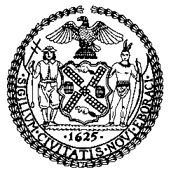

The New York City Council
Andrea Vazquez, Legislative Director

Committee Report of the Infrastructure Division
Brad Reid, Deputy Director

Committee on Environmental Protection, Resiliency and Waterfronts
Hon. James F. Gennaro, Chair

February 28, 2025

Oversight – Air Quality and Last Mile Deliveries

Int. No. 107 By Council Members Avilés, Cabán, Restler, Gutiérrez, Won, Hanif, Bottcher, Hudson, Nurse, Narcisse, Abreu, Ayala, Brewer, Gennaro, Sanchez, Ossé, Rivera, Hanks, Williams, Menin, Marte, Brannan, Salaam, Farías, Schulman, Krishnan, Joseph, Brooks-Powers, Powers, De La Rosa, Ung, Louis, Salamanca, Banks, Lee, Zhuang, Riley, Moya, Feliz, Dinowitz and Holden (by request of the Brooklyn Borough President)

Title: A Local Law to amend the administrative code of the city of New York, in relation to air quality monitoring at designated “heavy use” thoroughfares

Administrative Code: Adds new section 24-154.1

Int. No. 1130 By Council Members Avilés, Brooks-Powers, Restler, Cabán, Williams, Krishnan and Louis (in conjunction with the Brooklyn Borough President)

Title: A Local Law to amend the administrative code of the city of New York, in relation to the regulation of indirect sources of air pollution

Administrative Code: Adds new sections 24-191 and 24-192

- Introduction

On February 28, 2025, the Committee on Environmental Protection, Resiliency, and Waterfronts (the Committee), chaired by Council Member James F. Gennaro, will hold a hearing on air quality and last mile deliveries. The Committee will also hear Int. No. 107, sponsored by Council Member Alexa Avilés, in relation to air quality monitoring at designated “heavy use” thoroughfares, and Int. No. 1130, sponsored by Council Member Avilés, in relation to the regulation of indirect sources of air pollution. The Committee welcomes testimony from the Department of Environmental Protection (DEP) and interested members of the public.
- Background

Criteria Air Pollutants

Gasoline- and diesel-powered motor vehicles produce criteria air pollutants that can cause respiratory issues. Exposure to these pollutants can result in symptoms such as coughing, chest tightness, and aggravation of asthma symptoms. Children may be particularly vulnerable to the effects of exposure to airborne pollutants because they consume more air per unit of body size compared to adults, are more likely to be active outdoors during peak traffic hours, tend to play closer to the ground where particulate matter concentrations are highest, and because the membrane barriers in their respiratory tract are not fully developed.
Vehicle exhaust contains five of the six criteria air pollutants monitored by the U.S. Environmental Protection Agency: particulate matter (PM), ozone, nitrogen oxides (NOx), sulfur dioxide (SO2), and carbon monoxide. As of December 31, 2024, the New York, northern New Jersey, and Long Island region is in serious nonattainment for ozone pollution, which means that ozone concentrations are between 33% and 50% higher than recommended levels. The region is in attainment for the five other criteria pollutants.
Medium- and heavy-duty trucks contribute an outsized amount of pollution relative to the number of such vehicles. Nationally, such vehicles represent less than 10% of vehicles on the road but account for more than 60% of NOx and fine particulate matter (PM2.5) emissions. Heavy-duty diesel trucks with engine model years older than 2007, the year the U.S. Environmental Protection Agency tightened its emissions standards, are especially polluting. In New York City, up to 83% of emissions from heavy-duty diesel trucks are attributable to pre-2007 engine model year vehicles according to analysis conducted by The Real Urban Emissions Initiative.
Air Quality Monitoring

The New York City Community Air Survey (NYCCAS), administered by the Department of Health and Mental Hygiene (DOHMH) in collaboration with Queens College of the City University of New York, has collected data on air quality since 2009. The program deploys air quality monitors for two weeks during each season (i.e., spring, summer, fall, and winter) at nearly 100 sites citywide. Concentrations of NOx, PM2.5, and black carbon are measured throughout the year, concentrations of ozone are only measured in the summer, and SO2 is only measured in the winter. Approximately 80% of these monitoring sites were selected to capture a diversity of air quality environments and are located across neighborhoods with varying relevant characteristics, such as the densities of traffic and buildings. The remaining 20% of sites were selected to ensure that potentially high-emissions locations, including Hunts Point Market and the Port Authority Bus Terminal, are represented in NYCCAS analysis. Additionally, NYCCAS has deployed eight monitors that measure PM2.5 in real time at fixed locations throughout the year, in order to measure changes in air quality based on time of day and local pollution sources, such as heavy-duty trucks. NYCCAS monitors are deployed 10 to 12 feet above street level on public light and utility poles to ensure that measured air quality reflects that experienced by pedestrians.
NYCCAS has found that overall air quality has improved since the program began, with citywide PM2.5 down 46%; nitrogen dioxide (NO2) down 41%; nitric oxide (NO) down 58%; and sulfur dioxide (SO2) down 97% between 2009 and 2022. However, ozone levels have not trended downward, and New York City experienced higher levels in 2023 than in any other year since recording began in 2009. NYCCAS predicts that ozone concentrations may increase in the coming years as average temperatures climb due to climate change, as ozone is produced when NOx and volatile organic compounds react to sunlight and heat. Data from the eight real-time NYCCAS air quality monitors suggest that factors such as daily changes in traffic volume and weather patterns can occasionally raise PM2.5 concentrations to harmful levels, even in neighborhoods with generally good air quality.
The New York State Department of Environmental Conservation (DEC) also measures air quality in New York City. DEC operates more than 50 air quality monitors throughout New York State, of which approximately 13 are located in the City. Air quality measurements gathered by DEC are reported to the U.S. Environmental Protection Agency and inform the federal AirNow Air Quality Index (AQI) forecast. DEC also produces AQI forecasts for each of the eight Air Quality Health Advisory Regions in New York State. DEC monitors are located on top of buildings, where concentrations of pollution from vehicle traffic may be lower than at street level. Real time air quality data gathered by these monitors are available on DEC’s website.
According to the 2023 PlaNYC report, DEP aims to develop a new air quality monitoring program by 2024. The report states that NYCCAS tracks changes in air quality over time but was not designed to detect impacts from a specific source of pollution, such as an individual factory or construction site. A new air quality monitoring program that aims to monitor these hyper-local sources of pollution could inform DEP’s mitigation efforts and help to ensure compliance with the New York City Air Pollution Control Code. However, it is unclear if such a program was developed by the stated deadline.
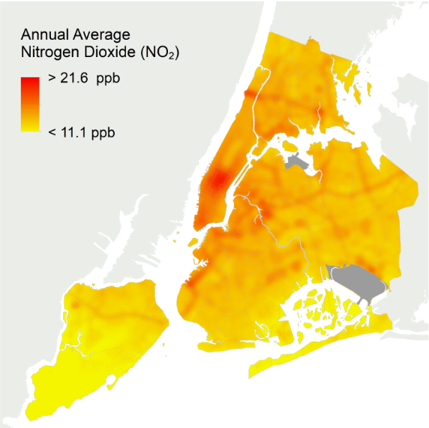
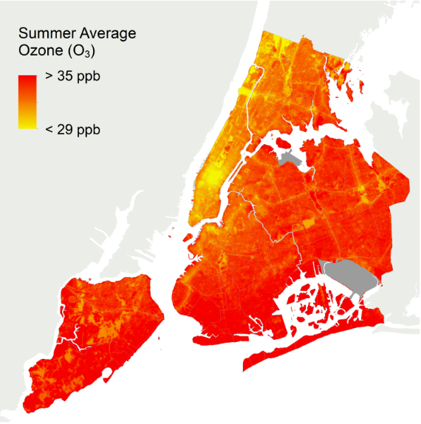
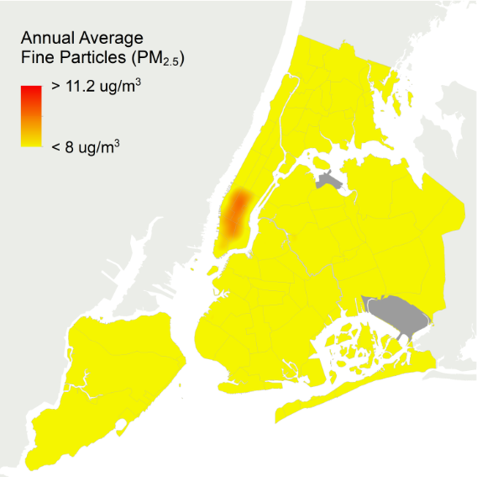
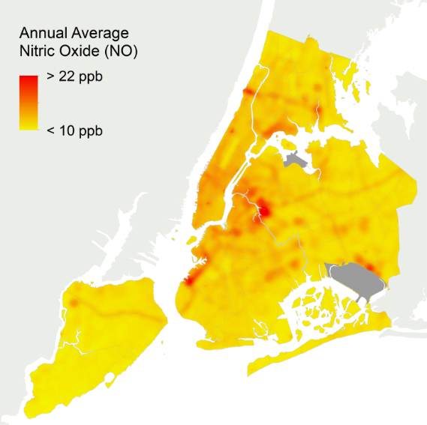
Chart A: 2022 Concentrations of NOx, Ozone, and PM2.5 in NYC
Four maps displaying average concentrations of NO2, NO, ozone, and PM2.5 in 2022 as measured by NYCCAS. Concentrations of NO and NO2 spike in certain areas of the City, particularly industrial areas. Summer ozone concentrations are high throughout New York City except in midtown Manhattan. PM2.5 concentrations are high in downtown and midtown Manhattan but low elsewhere.
Proliferation of Last-Mile Delivery Warehouses
For more than a decade, e-commerce sales in the United States have grown rapidly, and are projected to continue growing. New York City is no exception to this economic shift. In the five boroughs, the rise of e-commerce substantially increased freight volumes and delivery vehicles. As of 2021, approximately 80% of deliveries in New York City went directly to residential customers, with over 80% of New Yorkers receiving a package delivery at least once a week. The New York Metropolitan Transportation Council’s 2017 ”Regional Freight Plan 2018-2045” predicted New York City and its surrounding roadways would see approximately 537 million tons of truck-transported freight in 2045—a 67% increase from the roughly 322 million tons transported by trucks in New York City in 2012. Since this prediction, the New York City Department of Transportation estimated that truck-transported freight traffic over the Hudson River had already increased by 50% as of January 2020. This shift toward e-commerce and the resultant demand for faster deliveries has resulted in the proliferation of e-commerce warehouses, also known as last-mile facilities, throughout New York City.
Last-mile facilities are warehouses and transfer stations in which products and small parcels are stored and sorted in preparation for their delivery from the facility directly to end consumers. There are several factors that make last-mile facilities distinct from traditional warehouses. Unlike traditional warehouses, last-mile facilities are often sited in or around densely populated areas and urban centers. Last-mile facilities also see more activity than a traditional storage warehouse with higher numbers of truck trips, 24/7 operating times, and larger square footage to accommodate higher volumes of products and parcels. Generally, last-mile facilities are able to generate up to 1,000 vehicle trips in and out per day. While the increased truck traffic—including medium- and heavy-duty diesel trucks—often contribute to noise pollution, traffic congestion, and polluted air in the areas surrounding a last-mile facility, the impacts to surrounding air quality can vary by facility.
As of 2023, at least 45 existing and planned last-mile facilities were identified in New York City, mainly in the outer boroughs. These last-mile warehouses are often sited in and around Environmental Justice communities. Of the known existing and planned last-mile facilities, 68% are sited within a New York City Environmental Justice Advisory Board-designated Environmental Justice Area (“EJ Area”)—a geographic area that has experienced disproportionately negative impacts of environmental pollution, identified using New York State‘s Disadvantaged Communities criteria. All facilities but six are sited within a quarter-mile of an EJ Area. Many of these facilities are clustered in and around the neighborhoods of Sunset Park, Red Hook, East New York, and Newtown Creek, all of which contain census tracts designated as EJ Areas. Demographic data provides further evidence of the disproportionate burden of last-mile facilities in New York City. Across the five boroughs, the odds of living within a half-mile of a warehouse are increased by 17% for Black residents; 13% for Hispanic/Latinx residents; and 19% for low-income residents.
Communities of color and low-income communities in New York City—where last-mile facilities are largely sited—are already disproportionately subject to the public health burdens of air pollution. Communities of color in New York City are subject to as much as 15% more PM2.5 pollution from diesel tricks than mostly white communities. Further, adverse health outcomes related to such pollution, such as air pollutant-related hospital visits, occur more in low-income communities and communities of color in New York City.

Chart B: Last-Mile Facilities and Environmental Justice Areas in NYC
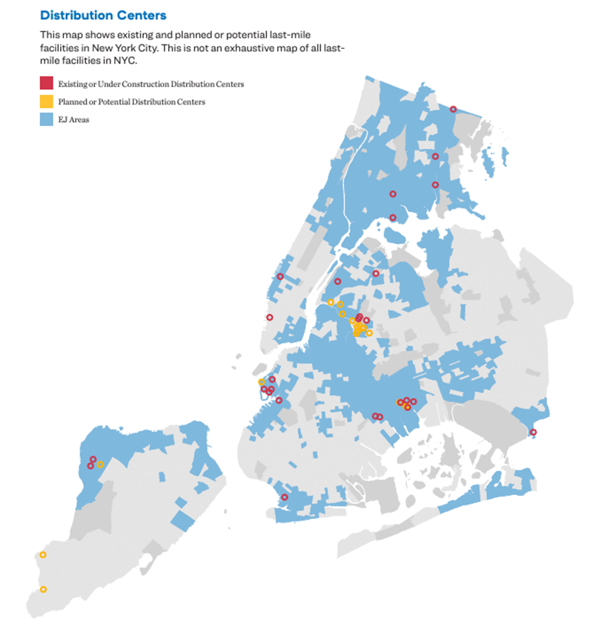
Chart B shows a map showing existing or planned last-mile facilities in New York City, and New York City’s “EJ Areas.” The map does not include an exhaustive list of existing or planned last-mile facilities.

Emissions Reduction Strategies

In December of 2021, the New York City Economic Development Corporation (EDC) and the New York City Department of Transportation (DOT) published a plan outlining ongoing efforts and potential future strategies to reduce emissions associated with the City’s freight transportation activities. Titled “Delivering Green: A vision for a sustainable freight network serving New York City,” the plan laid out key goals aimed at making local freight activities more sustainable: increasing the efficiency of last mile distribution, greening the last mile, creating a culture of compliance, and shifting freight transport from roads to waterways and to rail.
The final leg of a package’s route to its end destination is often referred to as the last mile. In the City, last mile deliveries can be complicated by traffic congestion and insufficient curb space for offloading, which encourages double parking, further hindering the efficient flow of traffic, and exacerbating congestion, which costs residents time and money and negatively affects local air quality. Initiatives aimed at increasing the efficiency of last mile deliveries include:
- Expanding DOT’s off-hours delivery program, which provides technical assistance to program enrollees seeking to shift delivery activities from high traffic peak hours to less congested off hours between 7 p.m. and 6 a.m.;
- Seeking federal funding for research into the feasibility of urban consolidation centers, which are facilities that receive goods from multiple distributers in order to consolidate those goods onto fewer trucks for a more streamlined delivery process; and
- A proposed expansion of the neighborhood loading zone program, which reserves curbside space for delivery vehicles, from 1,150 locations as of December 2021, to 1,500 locations by 2040.
The diesel-powered trucks used for many last-mile deliveries are a significant source of PM2.5 emissions. In the New York City region, approximately 27% of PM2.5 emissions are attributable to heavy-duty vehicles, with PM2.5 emissions from traffic sources estimated to contribute to 320 premature deaths and 870 emergency department visits and hospitalizations annually. Initiatives aimed at shifting deliveries from diesel trucks to zero- or lower-emissions vehicles include:
- A cargo bicycle pilot program, which allows enrolled companies to use bicycles to load and unload at designated cargo bike corrals and wherever commercial vehicles are allowed to do so at no cost. Each cargo bike is estimated to generate an annual CO2 reduction of approximately 7 tons, equivalent to more than 100 trees planted;
- Joint efforts between DOT and EDC to expand multimodal freight operations at underutilized landings capable of supporting transfers between waterway transport networks and cargo bicycles;
- Electrification initiatives like expanding the network of electric vehicle (EV) charging infrastructure, and funding the replacement of diesel-powered refrigerated trucks with electric and hybrid powered units; and
- Expansion of DOT’s Clean Trucks Program, which provides rebates for replacing older diesel trucks with new all-electric, EPA emission-compliant alternative fuel vehicles, or diesel vehicles, provided that vehicles and applicants meet specific criteria related to age and class of vehicles being replaced, new vehicles purchased, and applicants operating or being located within 0.5 miles of an approved industrial business zone.
Shifting the transport of good from roads to New York City’s waterways can reduce congestion, minimize the negative effects of overweight trucks on city infrastructure, and reduce transport associated pollution, as moving goods by water generally produces fewer emissions per ton mile traveled compared to road transport. While local waterways were heavily utilized for the transport of goods around the City in the past, policy decisions that prioritized moving goods via truck have led to the City’s maritime transport infrastructure falling out of use. Initiatives to revive the City’s marine transport infrastructure include:
- Seeking federal funding to modernize the South Brooklyn Marine Terminal by building heavy-duty platforms with cranes to move heavy cargo, and building shore power connections to allow vessels to turn off engines while docked;
- Seeking federal funding to reconstruct the Red Hook Piers, which were constructed over 50 years ago with wooden piles and cannot be utilized in their current condition;
- Identifying City-owned waterfront assets that can be activated for use as last mile distribution centers; and
- Exploring the feasibility of intra-harbor services for transporting truck trailers and shipping containers between New Jersey and New York.
According to the American Association of Railroads, rail freight is the most efficient way of moving goods over land, with trains requiring only a single gallon of fuel to move 1 ton of goods nearly 500 miles. Because a single rail car can carry the equivalent of 3-4 truckloads of freight, one train has the potential to remove more than 300 trucks from the road. A significant factor limiting the utilization of rail freight transport in the City is the shortage of locations at which goods can be moved from rail cars to be distributed to end customers. To address this limitation, the City intends to seek federal funding to support the expansion of freight car lines and transfer facilities via the following initiatives:
- Improving access to the rail yards in the Sunset Park Industrial Business Zone by potentially converting First and Second Avenue to one-way streets, and updating signage, curb configurations, and signaling to improve rail and traffic flow;
- Constructing new transload facilities to facilitate the movement of goods from rail lines to last mile delivery vehicles, increasing utilization of the Bay Ridge Cut, and identifying new opportunities to build out the City’s rail freight network; and
- Modernizing the Arthur Kill Bridge, which connects Staten Island and New Jersey’s rail networks, and is the only rail line in the City capable of accommodating double stack trains, by renovating mechanical, structural and electrical systems to ensure continued functionality.

Indirect Source Review
Warehouses pose a unique regulatory problem because most of their emissions come not from the facilities themselves but from mobile sources, like delivery trucks, that travel to and from the facilities. While warehouses do generate emissions from within their own walls, these pale in comparison to their transportation-related emissions. Direct emissions from warehouses and similar buildings account for just 13% of the logistics sector’s carbon emissions; transportation is responsible for the remaining 87%, with road freight comprising the bulk of that share. In New York State, warehouses of 100,000 square feet or larger are estimated to generate around 171,000 truck trips per day.
Warehouses and other facilities that attract mobile sources of air pollution are known collectively as indirect sources. Other examples include office buildings, shopping centers, housing developments, and parking garages.
Regulating emissions from indirect sources
Regulations that target mobile source emissions by regulating indirect sources are known as indirect source review or indirect source rules. Under indirect source review, warehouses or other indirect sources are held responsible for emissions generated by vehicles that drive to and from their facilities, and they are required to reduce such emissions by implementing various air pollution control measures. This shifting of responsibility is intended to incentivize large facilities like warehouses to invest in zero-emission infrastructure and encourage their contractors and partners to do the same.
The federal government has explicitly authorized states to adopt indirect source review programs. Such programs refer to the facility-by-facility review of new or modified indirect sources, including measures to curb attraction of mobile sources where emissions would contribute to nonattainment under the Clean Air Act. If a state incorporates an indirect source review program into its State Implementation Plan (SIP), which outlines how the state will bring its air quality control regions into compliance with federal air quality standards, the program becomes federally enforceable by the EPA.
Indirect source review in action: a look at California
Currently, California is the only state that has implemented indirect source review. It has two programs in place: one that applies generally to new indirect sources, and one that targets warehouses specifically. Both have been incorporated into California’s SIP and are federally enforceable. These programs are widely studied and often used as models for programs that are proposed in other areas.
The older of the programs, which has been in place in the San Joaquin Valley Air Pollution District since 2005, is a general indirect source rule that applies to nearly all new developments. While it does not specifically target warehouses, it captures them along with other residential, medical, commercial, industrial, and transportation developments that exceed a specified threshold size. Each covered facility must submit an application identifying clean air measures that it will implement in order to meet specified emissions reductions targets for NOx and PM. If a facility cannot or will not implement sufficient clean air measures, it must instead pay a fee that the district will use to fund off-site emissions reduction projects, in addition to an administrative fee. Since it was implemented, the program has avoided over 22,000 tons of NOx and PM emissions through on-site clean air measures at new developments subject to the rule, as well as reduced NOx and PM emissions by another 7,600 tons through off-site mitigation projects funded by the program.
The more recent of the programs was promulgated by the South Coast Air Quality Management District in 2021. Unlike the San Joaquin Valley program, this one applies only to warehouses of 100,000 square feet or more. It also uses a phased implementation approach: warehouses 250,000 square feet or larger were subject to the rule in 2022, with the rule expanding to cover warehouses 150,000 square feet or larger in 2023, and warehouses 100,000 square feet or larger in 2024.
The central component of the program is a point system called Warehouse Actions and Investments to Reduce Emissions (WAIRE), pursuant to which warehouses must earn points to offset their annual number of truck trips by completing actions from a set menu of clean air measures. The menu includes such measures as the purchase or use of zero-emission vehicles, the installation or use of zero-emission charging infrastructure, and the installation or use of onsite solar panels. In lieu of selecting measures from the menu, a warehouse owner or operator may submit a custom emissions reduction plan for approval by the district. If a facility cannot or will not earn the requisite number of points, it may pay a mitigation fee to make up the difference. WAIRE points may not be transferred except in limited circumstances, including: between warehouses operated by the same entity within the same compliance period, from one compliance period to subsequent compliance periods for the same warehouse, and between a warehouse facility or land owner and any warehouse operator at the same site.
In addition to complying with the point system, facilities must satisfy reporting requirements. Each covered warehouse must provide an initial report, followed by annual WAIRE reports, with data on truck trips, WAIRE menu items selected, and other site information. Covered facilities must also pay an administrative fee.
The WAIRE program has seen relative success thus far, though data is not yet complete. In 2023, projects implemented through the program reduced NOx emissions by as much as 0.86 tons per day. The South Coast Air Quality Management District estimates that NOx emissions reductions could reach 2.95 tons per day by 2030, depending on which menu options are implemented. The program has also led to a higher number of zero-emission vehicle deployments in the district in its first three years than California’s statewide voucher program for zero-emission heavy-duty trucks and buses did during its first three years.
Early reporting also reveals that warehouses are earning a surplus of points under the program; those that have submitted their first annual report have earned, in aggregate, about four times as many points as they were required to. Furthermore, across the first two compliance periods only five percent of required points have been purchased through the mitigation fee program, indicating that warehouses are finding it feasible to comply with the program’s requirements. However, one of the largest challenges faced by the program is compliance. Just 41% of potential covered warehouses in Phase 1 and 28% of covered warehouses in Phase 2 submitted the required annual WAIRE report in 2023.
Despite this challenge, WAIRE has inspired other regulators to pursue similar programs. A bill modeled after WAIRE has been introduced in New York State and is discussed in greater detail below. Similar programs are also being considered in Illinois, New Jersey, and Colorado.
Bringing indirect source review to New York
New York State is considering a bill, A.1718/S.2127A, which was passed by the New York State Senate and is in committee in the New York State Assembly, that would establish an indirect source review program. The bill would cover certain heavy distribution warehouses, including fulfillment centers, parcel hubs, and parcel sorting facilities, that are at least 50,000 square feet. It would also apply to facilities of any size that are owned or operated by an entity that, in aggregate, owns or operates at least 500,000 square feet of heavy distribution warehouse space in the state. This is larger in scope than the South Coast program, as it reaches smaller warehouses. The details of the program are left largely up to DEC.
- Legislation
Int. No. 107

This bill would require DEP to designate heavy-use thoroughfares in every borough and install street level air monitors at a minimum at two major intersections on every designated heavy-use thoroughfare and at every park or playground adjacent to a heavy use thoroughfare. The bill would define a heavy-use thoroughfare as a road that receives more vehicle traffic than the median level of traffic for all NYC roads. The bill would also require the issuance of a report to the NYC Mayor and to the Speaker of the NYC Council containing the results of the air quality monitoring of designated heavy-use thoroughfares and recreational areas. Where the results of the air quality monitoring indicate that levels of any regulated air contaminant constitute a violation of an existing standard, DEP, along with DOT and the Department of Education, would be required to implement mitigation measures that reduce exposure risks.
This bill would take effect 90 days after it becomes law.

Int. No. 1130
This bill would require DEP to promulgate an indirect source rule to reduce emissions attributable to the use of indirect sources, such as warehouses or other structures that attract mobile sources of air pollution, such as vehicles. The indirect source rule would regulate warehouses with an area 50,000 square feet or larger, as well as any other indirect sources, as determined by DEP.
This bill would take effect 180 days after it becomes law, except that DEP shall take such measures as are necessary for the implementation of this local law, including the promulgation of rules, before such date.
Int. No. 107

By Council Members Avilés, Cabán, Restler, Gutiérrez, Won, Hanif, Bottcher, Hudson, Nurse, Narcisse, Abreu, Ayala, Brewer, Gennaro, Sanchez, Ossé, Rivera, Hanks, Williams, Menin, Marte, Brannan, Salaam, Farías, Schulman, Krishnan, Joseph, Brooks-Powers, Powers, De La Rosa, Ung, Louis, Salamanca, Banks, Lee, Zhuang, Riley, Moya, Feliz, Dinowitz and Holden (by request of the Brooklyn Borough President)

A Local Law to amend the administrative code of the city of New York, in relation to air quality monitoring at designated “heavy use” thoroughfares

Be it enacted by the Council as follows:

Section 1. Subchapter 6 of chapter 1 of title 24 of the administrative code of the city of New York is amended by adding a new section 24-154.1 to read as follows:
§ 24-154.1 Heavy use thoroughfares. (a) Definitions. For purposes of this subdivision the following terms shall have the following meanings:
(1) “Heavy use thoroughfare.” The term “heavy use thoroughfare” means any highway, roadway or other traffic corridor that has traffic volume greater than the fiftieth percentile of the average New York city roadway corridors or has traffic in excess of 100,000 vehicles on an annual basis. Designation of heavy use thoroughfares shall be based upon verifiable use and traffic volume data obtained from transportation planning agencies including, but not limited to, the New York metropolitan transportation council, the department of transportation and the New York state department of transportation.
(2) “Recreational area.” The term “recreational area” means any park, playground, ball field and school playground that abuts a heavy use thoroughfare.
(3) "Regulated air contaminant." The term “regulated air contaminant” means oxides of nitrogen, volatile organic compounds, sulfur dioxide, particulate matter, carbon monoxide, carbon dioxide, polycyclic aromatic hydrocarbons or any other air contaminant for which a national ambient air quality standard has been promulgated, or any air contaminant that is regulated under section 112 of the clean air act of 1963, as amended.
(4) “At risk populations.” The term “at risk populations” means persons 16 years of age or younger, persons who are pregnant, persons 60 years of age or older, and persons with weakened immune systems.
(b) No later than December 30, 2022, the department shall designate heavy use thoroughfares in every borough.
(c) No later than December 30, 2023, the department shall install street level air monitors at a minimum at two major intersections on every designated heavy use thoroughfare and at every recreational area.
(d) No later than December 30, 2024, and annually thereafter, the department shall issue a report to the mayor and to the speaker of the council containing the results of the air quality monitoring of designated heavy use thoroughfares. Such report shall also be posted on the department’s website.
(e) The department along with the department of transportation and the department of education shall collaboratively identify, develop and implement mitigation measures that significantly reduce or eliminate short-term and long term exposure risks where the results of the air quality monitoring on heavy use thoroughfares:
(1) Indicate that levels of any regulated air contaminant constitute a violation of an existing standard for that regulated air contaminant; or
(2) Indicate that levels of any regulated air contaminant contribute to an actual or potential danger to public health or the environment, based upon the most recent research available, including by presenting a health risk to at-risk populations.
§3. This local law shall take effect 90 days after it becomes law.

Session 13
LS 8254
1/18/24

Session 12
SS
LS 8254
6/1/22 4:26 p.m.

[Page Intentionally Left Blank]

Int. No. 1130

By Council Members Avilés, Brooks-Powers, Restler, Cabán, Williams, Krishnan and Louis (in conjunction with the Brooklyn Borough President)

A Local Law to amend the administrative code of the city of New York, in relation to the regulation of indirect sources of air pollution

Be it enacted by the Council as follows:

Section 1. Chapter 1 of title 24 of the administrative code of the city of New York is amended by adding a new subchapter 10 to read as follows:
Subchapter 10
INDIRECT SOURCE RULE
§ 24-191 Definitions. For the purposes of this subchapter, the following terms have the following meanings:
Indirect source. The term “indirect source” means a facility, building, structure, installation, real property, road, or highway which attracts, or may attract, mobile sources of air pollution.
Indirect source rule. The term “indirect source rule” means a regulation of indirect sources that aims to reduce emissions from mobile sources of air pollution that interact with such indirect sources.
Mobile source of air pollution. The term “mobile source of air pollution” mean vehicles, engines, and equipment that generate air pollution and that move, or can be moved.
Qualifying warehouse. The term “qualifying warehouse” means a warehouse that is 50,000 square feet or greater.
Warehouse. The term “warehouse” means a fulfillment center, a facility whose primary purpose is storage and distribution of goods to consumers either directly or through a last mile facility; or a last mile facility whose primary purpose is processing or redistributing goods for delivery directly to consumers; or a parcel sorting facility whose primary purpose is sorting or redistributing goods from a fulfillment center to a last mile facility.
§ 24-192 Indirect source rule. a. The commissioner shall promulgate an indirect source rule. Such rule shall apply to all operators of qualifying warehouses and any other indirect sources the commissioner deems appropriate.
b. In promulgating the indirect source rule, the commissioner shall consider a variety of measures including, but not limited to:
1. Requiring indirect sources to implement air pollution mitigation plans approved by the commissioner;
2. Regulating times or methods of delivery to or from indirect sources;
3. Establishing incentives for indirect sources to take actions specified by the commissioner that mitigate air pollution; and
4. Establishing penalties for violations of the indirect source rule.
§ 2. This local law takes effect 180 days after it becomes law, except that the commissioner of environmental protection shall take such measures as are necessary for the implementation of this local law, including the promulgation of rules, before such date.

EH
LS #8937/12504/14948
11/25/2024 1:15 PM

“What Kinds of Harmful Health Effects Can Ozone Cause?”, California Air Resources Board, available at: https://ww2.arb.ca.gov/resources/fact-sheets/health-effects-ozone
D’Anguilli A., “Severe Urban Outdoor Air Pollution and Children’s Structural and Functional Brain Development, From Evidence to Precautionary Strategic Action”, Frontiers in Public Health, April, 2018, available at: https://www.frontiersin.org/articles/10.3389/fpubh.2018.00095/full
“Cars, Trucks, Buses and Air Pollution”, Union of Concerned Scientists, Sept 15, 2023, available at: https://www.ucsusa.org/resources/cars-trucks-buses-and-air-pollution
“8-Hour Ozone (2015) Designated Area/State Information”, U.S. EPA Green Book, December 31, 2024, available at: https://www3.epa.gov/airquality/greenbook/jbtc.html
“National Ambient Air Quality Standards for Ozone”, U.S. Environmental Protection Agency, Federal Register, October 26, 2015, available at: https://www.federalregister.gov/documents/2015/10/26/2015-26594/national-ambient-air-quality-standards-for-ozone
“Summary Nonattainment Area Population Exposure Report”, U.S. EPA Green Book, December 31, 2024, available at: https://www3.epa.gov/airquality/greenbook/popexp.html
Lowell and Culkin, “Medium- & Heavy-Duty Vehicles,” Environmental Defense Fund, available at: https://www.edf.org/sites/default/files/documents/EDFMHDVEVFeasibilityReport22jul21.pdf, pg. 4
Meyer and Dallmann, “Air quality and health impacts of diesel truck emissions in New York City and policy implications,” The Real Urban Emissions Initiative, available at: https://theicct.org/wp-content/uploads/2022/04/true-diesel-trucks-nyc-apr22.pdf, pg. 3
“NYCCAS Report: 2008 – 2022,” NYC Environment and Health Data Portal, available at: https://a816-dohbesp.nyc.gov/IndicatorPublic/data-features/nyccas/
Id.
Id.
Id.
Id.
Id.
Id.
Id.
“Air quality,” NYC Environment and Health Data Portal, available at: https://a816-dohbesp.nyc.gov/IndicatorPublic/data-explorer/air-quality/?id=2027#display=trend
“NYCCAS Report: 2008 – 2022,” supra 9.
“Air quality,” supra 16.
“NYS’ Program to Track Air Quality,” NYS DEC, available at: https://dec.ny.gov/environmental-protection/air-quality/monitoring; “Air Monitoring Website,” NYS DEC, available at: http://www.nyaqinow.net/.
“NYS’ Program to Track Air Quality,” supra 19; “AirNow,” U.S. EPA, available at: https://www.airnow.gov/?city=New%20York&state=NY&country=USA.
“Today’s Air Quality Index (AQI) Forecast for New York State,” NYS DEC, available at: https://extapps.dec.ny.gov/cfmx/extapps/aqi/aqi_forecast.cfm.
“NYCCAS Report: 2008 – 2022,” supra 9.
“Air Monitoring Website,” supra 19.
“PlaNYC Getting Sustainability Done,” New York City, April 20, 2023, available at: https://climate.cityofnewyork.us/wp-content/uploads/2023/06/PlaNYC-2023-Full-Report.pdf, pg. 61.
Id.
“NYCCAS Report: 2008 – 2022,” supra 9.
“Quarterly Retail E-Commerce Sales: 3rd Quarter 2024,” U.S. Department of Commerce, Nov 19, 2024, available at: https://www.census.gov/retail/mrts/www/data/pdf/ec_current.pdf; “Delivering Green: A Vision for a Sustainable Freight Network Serving New York City,” New York City Economic Development Corporation and New York City Department of Transportation, Dec 2021, available at: https://www.nyc.gov/html/dot/downloads/pdf/freight-vision-plan-delivering-green.pdf, pg. 1.
“Delivering New York: A Smart Truck Management Plan for New York City,” New York City Department of Transportation, May 2021, available at: https://www.nyc.gov/html/dot/downloads/pdf/smart-truck-management-plan.pdf, pg. 3.
“Microhubs Pilot: Manhattan Community Board 8,” New York City Department of Transportation, Sept 4, 2024, available at: https://www.nyc.gov/html/dot/downloads/pdf/microhubs-pilot-mn-cb8-sept2024.pdf, pg. 4.
“Regional Freight Plan 2018-2045,” New York Metropolitan Transportation Council, 2017, available at: https://www.nymtc.org/Portals/0/Pdf/RTP/Plan%202045%20Final%20Documents/Plan%202045%20Individual%20Appendices/Appendix%208_Regional%20Freight%20Plan.pdf, pg. 2-24 tbl.2.3.
“Delivering Green,” supra 28.
“EJNYC: A Study of Environmental Justice Issues in New York City,” New York City Office of Climate & Environmental Justice, 2024, available at: https://climate.cityofnewyork.us/wp-content/uploads/2024/04/EJNYC_Report_FIN_20240424.pdf, pgs. 86-88.
Id., at pg. 88.
Id.; see also “Fact Sheet: Amending Regulations on Last-Mile Warehouses is critical to Achieving New York City’s Environmental Justice and Racial Equity Goals,” Earthjustice, 2023, available at: https://earthjustice.org/wp-content/uploads/2023_last_mile_fact_sheet_en_final_1_1.pdf, pg. 1.
“Hidden and In Plain Sight: Impacts of E-Commerce in Massachusetts,” Metropolitan Area Planning Council, (2021), available at: https://www.mapc.org/wp-content/uploads/2021/02/Feb2021-Ecommerce-Report.pdf, pg. 26, citing Dion Sorrentino, “New Industrial Revolution – Disruption 2020, Vol. 1., No. 14,” Colliers International, June 16, 2020.
Bex Allen, et. al., “E-Commerce & Last-Mile Warehouses in NYC,” April 20, 2021, available at: https://storymaps.arcgis.com/stories/a58b514593cc47078568213d3a41d549.
“EJNYC: A Study of Environmental Justice Issues in New York City,” supra 3, pg. 88.
Id., pg. 87.
Id., pg. 88.
Id., pg. 5-6.
Id., pg. 88.
Id. See also “Fact Sheet,” supra 35, pg. 2.
“EJNYC Full Data Explorer,” New York City Mayor’s Office of Climate and Environmental Justice, (last accessed Jan 16, 2024), available at: https://experience.arcgis.com/experience/6a3da7b920f248af961554bdf01d668b/page/Data-Explorer/.
“Warehouse Boom Places Unequal Health Burden on New York Communities,” Environmental Defense Fund, Jan 18, 2023, available at: https://globalcleanair.org/wp-content/blogs.dir/95/files//EDF-NY-Warehouse-Boom-Report-1-18-23.pdf, pg. 3.
“EJNYC: A Study of Environmental Justice Issues in New York City,” supra 3, pg. 77.
“Air Quality and Health Impacts of Diesel Truck Emissions in New York City and Policy Implications,” supra 8, pg. 5-7.
“EJNYC: A Study of Environmental Justice Issues in New York City,” supra 3, pg. 77.
Id., pg. 87.
“Delivering Green: A Vision for a Sustainable Freight Network Serving New York City,” New York City Economic Development Corporation and New York City Department of Transportation, Dec 2021, available at: https://www.nyc.gov/html/dot/downloads/pdf/freight-vision-plan-delivering-green.pdf,
Id, pg. 1.
Id, pg. 3.
Id, pg. 4.
“Delivering Green: A Vision for a Sustainable Freight Network Serving New York City,” New York City Economic Development Corporation and New York City Department of Transportation, Dec 2021, available at: https://www.nyc.gov/html/dot/downloads/pdf/freight-vision-plan-delivering-green.pdf, pg. 6.
Iyad Khierbeck et al, The contribution of motor vehicle emissions to ambient fine particulate matter public health impacts in New York City: a health burden assessment, Environmental Health, August 26, 2016, https://ehjournal.biomedcentral.com/articles/10.1186/s12940-016-0172-6
Supra note 54, pgs. 6-7.
NYC Clean Trucks Program FAQ. https://www.nycctp.com/faqs/
Furhana Husani. Blue HighwaysL A New Path for Urban Freight: Waterfront Alliance. November 21, 2024. https://waterfrontalliance.org/2024/11/21/blue-highways-a-new-path-for-urban-freight/
NYC EDC, NYC DOT. Delivering Green: A vision for a sustainable freight network serving New York City. December, 2021. https://www.nyc.gov/html/dot/downloads/pdf/freight-vision-plan-delivering-green.pdf, pg. 11
Id, pgs. 11-12.
Association of American Railroads. Freight Rail and Climate Change. https://www.aar.org/issue/freight-rail-climate-change/
Union Pacific. 12 train facts you may not know. https://www.up.com/customers/track-record/tr030822-12-train-facts-you-might-not-know.htm
NYC EDC, NYC DOT. Delivering Green: A vision for a sustainable freight network serving New York City. December, 2021. https://www.nyc.gov/html/dot/downloads/pdf/freight-vision-plan-delivering-green.pdf, pg. 14
Id, pg. 15
Warehouses’ direct emissions arise from energy consumption for heating, cooling, lighting, and other on-site uses. U.S. Energy Information Administration, Commercial Buildings Energy Consumption Survey, 2018, https://www.eia.gov/consumption/commercial/pba/warehouse-and-storage.php#:~:text=Energy%20use%20in%20warehouse%20and,0.1%20MBtu%20per%20square%20foot). Warehouse construction is also responsible for emissions; the upfront embodied greenhouse gas cost of a core and shell industrial building can be as high as seven years of operational emissions. John Caulfield, A new study presses for measuring embodied carbon in industrial buildings, Building Design + Construction, June 20, 2023, https://www.bdcnetwork.com/home/news/55154505/a-new-study-presses-for-measuring-embodied-carbon-in-industrial-buildings.
World Economic Forum, Supply Chain Decarbonization: The Role of Logistics and Transport in Reducing Supply Chain Carbon Emissions, 2009, https://www3.weforum.org/docs/WEF_LT_SupplyChainDecarbonization_Report_2009.pdf, at 8, 20.
Environmental Defense Fund, Warehouse Boom Places Unequal Health Burden on New York Communities, https://globalcleanair.org/wp-content/blogs.dir/95/files/EDF-NY-Warehouse-Boom-Report-1-18-23.pdf, at 1.
42 U.S.C. § 7410(a)(5)(A)(i).
42 U.S.C. § 7410(a)(5)(D).
42 U.S.C. § 7407(a).
42 U.S.C. § 7410(a)(5)(A)(i).
89 Fed. Reg. 73568, Air Plan Approval; California; South Coast Air Quality Management District, Sept. 11, 2024, https://www.federalregister.gov/documents/2024/09/11/2024-20349/air-plan-approval-california-south-coast-air-quality-management-district#:~:text=The%20EPA%20is%20approving%20SCAQMD,%E2%80%9D)%20as%20a%20SIP%20strengthening; 86 Fed. Reg. 33542, Air Plan Approval; California; San Joaquin Valley Unified Air Pollution Control District, Jun. 25, 2021, https://www.federalregister.gov/documents/2021/06/25/2021-13448/air-plan-approval-california-san-joaquin-valley-unified-air-pollution-control-district#:~:text=This%20revision%20strengthens%20the%20current%20SIP%2Dapproved%20rule.,will%20become%20federally%20enforceable%20under%20the%20CAA.
District Rule 9510, San Joaquin Valley Air Pollution Control District, adopted Dec. 15, 2005, https://ww2.valleyair.org/media/cjlnn0u1/r9510-a.pdf.
Id.
Id.
Id.
District Rule 3180, San Joaquin Valley Air Pollution Control District, adopted Dec. 15, 2005, https://ww2.valleyair.org/media/aw1fdlj4/rule-3180.pdf.
San Joaquin Valley Air Pollution Control District, 2024 Annual Report on the District’s Indirect Source Review Program, December 19, 2024, https://ww2.valleyair.org/media/shmpiyrd/final-isr-annual-report-2024.pdf, at 2, 9-10.
District Rule 2305, South Coast Air Quality Management District, adopted May 7, 2021, https://www.aqmd.gov/docs/default-source/rule-book/reg-xxiii/r2305.pdf?sfvrsn=15.
Id. The District has recently proposed a complementary indirect source review program that would target freight rail yards. District Proposed Rule 2306, South Coast Air Quality Management District, https://www.aqmd.gov/home/rules-compliance/rules/scaqmd-rule-book/proposed-rules/rule-2306.
Id.
District Rule 2305, South Coast Air Quality Management District, adopted May 7, 2021, https://www.aqmd.gov/docs/default-source/rule-book/reg-xxiii/r2305.pdf?sfvrsn=15.
Id.
Id.
Id.
Id.
Id.
District Rule 316, South Coast Air Quality Management District, adopted May 7, 2021, https://www.aqmd.gov/docs/default-source/rule-book/reg-iii/r316.pdf?sfvrsn=9#:~:text=This%20administrative%20fee%20shall%20be,the%20mitigation%20fee%20is%20paid.
South Coast Air Quality Management District, WAIRE Program Annual Report, Oct. 2024, https://www.aqmd.gov/docs/default-source/Agendas/Mobile-Source/msc-agenda-101824.pdf, at 26.
South Coast Air Quality Management District, Final Socioeconomic Impact Assessment for Proposed Rule 2305, May 2021, http://www.aqmd.gov/docs/default-source/Agendas/Governing-Board/2021/2021-May7-027.pdf, at 47.
Id.; See California HVIP, Voucher Map and Data, https://californiahvip.org/impact/#deployed-vehicle-mapping-tool.
South Coast Air Quality Management District, WAIRE Program Annual Report, Oct. 2024, https://www.aqmd.gov/docs/default-source/Agendas/Mobile-Source/msc-agenda-101824.pdf, at 19.
Id. at 22.
Id. at 41.
See HB5013, 103rd Illinois General Assembly, https://www.ilga.gov/legislation/fulltext.asp?DocName=&SessionId=112&GA=103&DocTypeId=HB&DocNum=5013&GAID=17&LegID=152973&SpecSess=&Session=.
See SB3546, 221st New Jersey Legislature, https://legiscan.com/NJ/text/S3546/id/3020894/New_Jersey-2024-S3546-Introduced.html.
See Memo re: GHG Resolution and Indirect Sources to Air Quality Control Commission members from Jana Milford, Jul. 12, 2024, https://raqc.egnyte.com/dl/0S9rwV3Kvv/IndirectSources_AQCC_Memo.pdf_.
A01718, N.Y. State Assembly, https://nyassembly.gov/leg/?bn=A01718&term=2023&Actions=Y&Memo=Y&Text=Y#jump_to_Actions.
Id.
Id.

