THE COUNCIL OF THE CITY OF NEW YORK
RESOLUTION NO. 911

Resolution approving the decision of the City Planning Commission on Application No. N 180529 ZRQ, for an amendment of the text of the Zoning Resolution (L.U. No. 403).

By Council Members Salamanca, Jr. and Moya

WHEREAS, the City Planning Commission filed with the Council on April 12, 2019 its decision dated April 10, 2019 (the "Decision"), on the application submitted by Ashley Young, LLC, and John Young Associates, LLC, pursuant to Section 201 of the New York City Charter, for an amendment of the text of the Zoning Resolution of the City of New York, modifying Appendix F for the purpose of establishing a Mandatory Inclusionary Housing area utilizing Option 2 in Queens, Community District 1 (Application No. N 180529 ZRQ), (the "Application");

WHEREAS, the Application is related to application C 180530 ZMQ (L.U. No. 404), a zoning map amendment to change from C8-1, R6B, and R5 zoning districts to R7X/C2-4 and R6B/C2-4;

WHEREAS, the Decision is subject to review and action by the Council pursuant to Section 197-d of the City Charter;
WHEREAS, upon due notice, the Council held a public hearing on the Decision and Application on May 2, 2019;

WHEREAS, the Council has considered the land use implications and other policy issues relating to the Decision and Application; and

WHEREAS, the Council has considered the relevant environmental issues, including the Revised Negative Declaration issued April 10th, 2019, which supersedes the Negative Declaration issued November 13th, 2018, and Revised Environmental Assessment Statement issued April 5th, 2019 (CEQR No. 19DCP003Q) which include an (E) designation to avoid the potential for significant adverse impacts related to hazardous materials, air quality, and noise (the “E” Designation (E-509));

RESOLVED:

The Council finds that the action described herein will have no significant impact on the environment as set forth in the (E) Designation (E-509) and Revised Negative Declaration.

Pursuant to Sections 197-d and 200 of the City Charter and on the basis of the Decision and Application, and based on the environmental determination and consideration described in the report, N 180529 ZRQ, incorporated by reference herein, and the record before the Council, the Council approves the Decision of the City Planning Commission.

Matter underlined is new, to be added;
Matter struck out is to be deleted;
Matter within # # is defined in Section 12-10;
* * * indicates where unchanged text appears in the Zoning Resolution.

* * *

APPENDIX F
Inclusionary Housing Designated Areas and Mandatory Inclusionary Housing Areas

* * *

QUEENS
* * *

Queens Community District 1

* * *
Map 5 - [date of adoption]

[PROPOSED MAP]

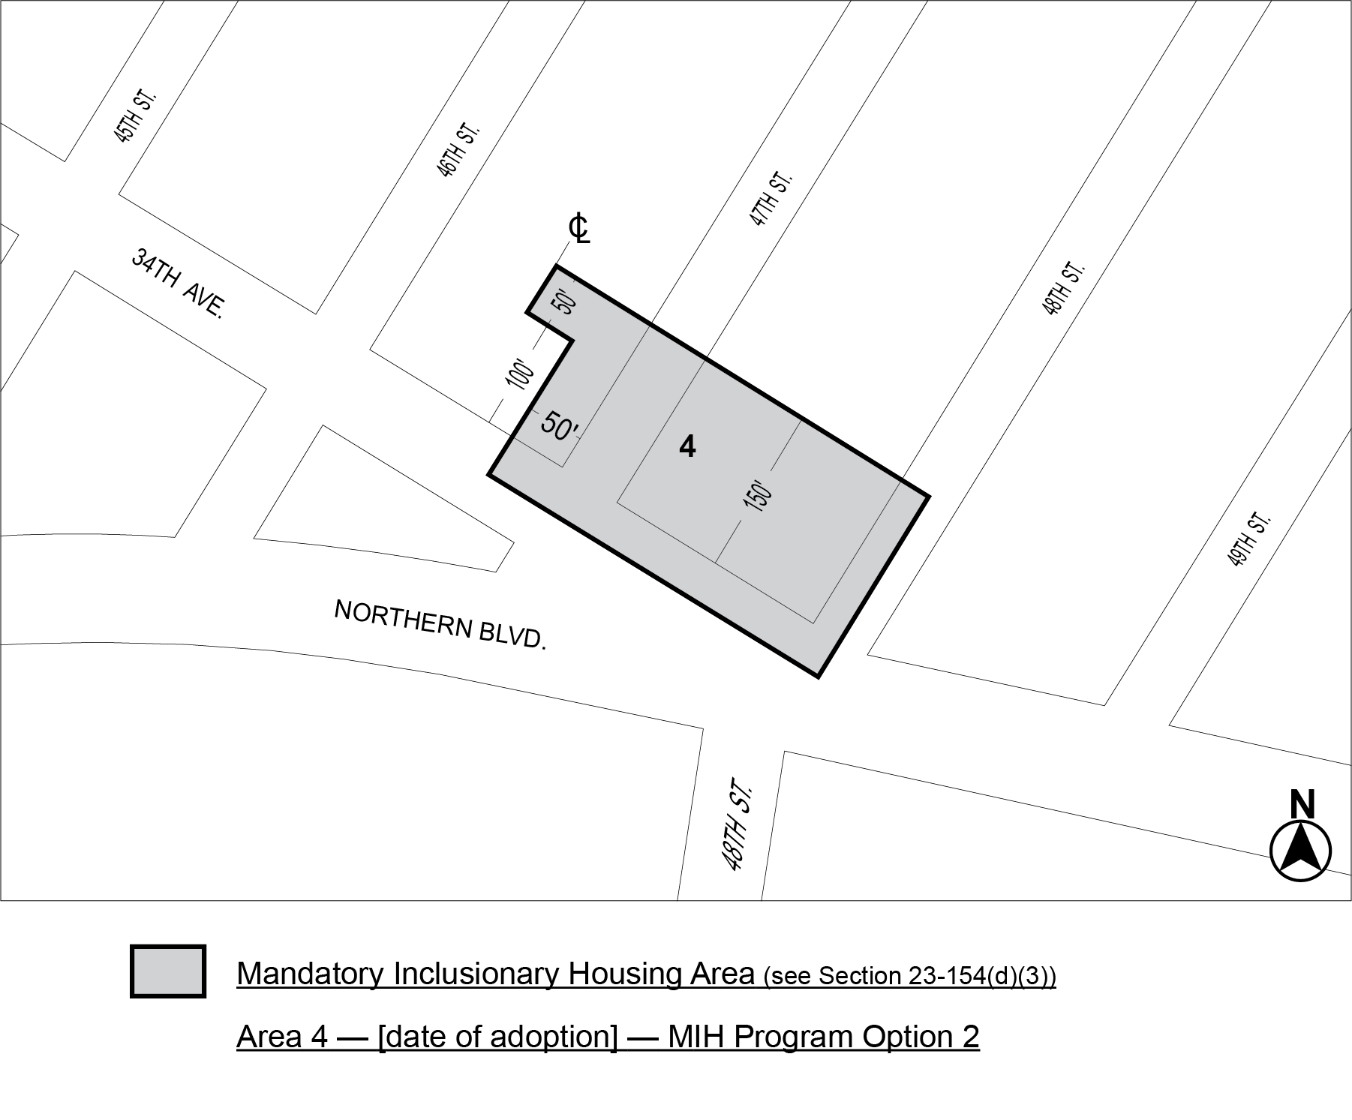
Portion of Community District 1, Queens

* * *

Adopted.

Office of the City Clerk, }
The City of New York, } ss.:

I hereby certify that the foregoing is a true copy of a Resolution passed by The Council of The City of New York on May 29, 2019, on file in this office.

.....…….........................................
City Clerk, Clerk of The Council

