THE COUNCIL OF THE CITY OF NEW YORK
RESOLUTION NO. 837

Resolution approving the decision of the City Planning Commission on Application No. N 190083 ZRK, for an amendment of the text of the Zoning Resolution (L.U. No. 370).

By Council Members Salamanca and Moya

WHEREAS, the City Planning Commission filed with the Council on March 8, 2019 its decision dated February 27, 2019 (the "Decision"), on the application submitted by North 13 Holdings, LLC, pursuant to Section 201 of the New York City Charter, for an amendment of the text of the Zoning Resolution of the City of New York, adding an Industrial Business Incentive Area to Article VII, Chapter 4 (Special Permits by the City Planning Commission), which in conjunction with the related actions would facilitate the construction of a new seven-story, 110-foot-high, 59,986-square-foot mixed-use development at 103 North 13th Street in the Williamsburg neighborhood of Brooklyn Community District 1, (Application No. N 190083 ZRK), (the "Application");

WHEREAS, the Application is related to applications C 190084 ZSK (L.U. No. 371), a special permit by pursuant to ZR Section 74-962 to increase the maximum permitted floor area ratio of Section 43-12 and C 190085 ZSK (L.U. No. 372), a special permit pursuant to ZR Section 74-963 to modify the off-street parking requirements of Section 44-20 and the loading berth requirements of Section 44-50;

WHEREAS, the Decision is subject to review and action by the Council pursuant to Section 197-d(b)(1) of the City Charter;

WHEREAS, upon due notice, the Council held a public hearing on the Decision and Application on March 19, 2019;

WHEREAS, the Council has considered the land use implications and other policy issues relating to the Decision and Application; and

WHEREAS, the Council has considered the relevant environmental issues, including the negative declaration issued October 15th, 2018 (CEQR No. 18DCP182K), which included (E) designations to avoid the potential for significant adverse impacts related to air quality or noise (E-507) (the “Negative Declaration”);

RESOLVED:

The Council finds that the action described herein will have no significant impact on the
environment as set forth in the (E) Designation (E-507) and Negative Declaration.

Pursuant to Section 200 of the City Charter and on the basis of the Decision and Application, and based on the environmental determination and consideration described in the report, N 190083 ZRK, incorporated by reference herein, and the record before the Council, the Council approves the Decision of the City Planning Commission.

Matter underlined is new, to be added;
Matter struckout is to be deleted;
Matter within # # is defined in Section 12-10;
*** indicates where unchanged text appears in the Zoning Resolution.

Article VII: Administration

Chapter 4
Special Permits by the City Planning Commission

* * *
74-96
Modification of Use, Bulk, Parking and Loading Regulations in Industrial Business Incentive Areas

For #developments# or #enlargements# on #zoning lots# located within any Industrial Business Incentive Area specified on the map in this Section, the City Planning Commission may increase the maximum permitted #floor area ratio# and modify the #use#, #bulk# and #public plaza# regulations as set forth in Section 74-962 (Floor area increase and public plaza modifications in Industrial Business Incentive Areas). The Commission may also modify parking and loading requirements for such #developments# or #enlargements# pursuant to Section 74-963 (Parking and loading modifications in Industrial Business Incentive Areas).

For #developments# or #enlargements# receiving a #floor area# increase pursuant to this Section, Section 43-20 (YARD REGULATIONS), inclusive, shall be modified as follows: #rear yard# regulations shall not apply to any #development# or #enlargement# on a #through lot#.

Map of Industrial Business Incentive Areas specified:

Community District 1, Borough of Brooklyn: The block bounded by North 12th Street, Kent Avenue, North 13th Street and Wythe Avenue

[PROPOSED MAP]

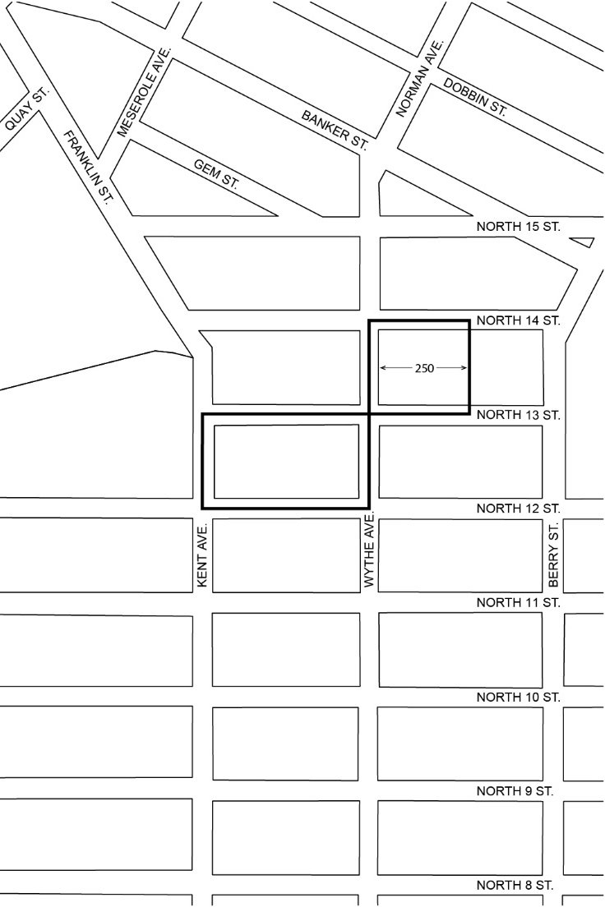

Industrial Business Incentive Area

Portion of Community District 1, Borough of Brooklyn

* * *

Adopted.

Office of the City Clerk, }
The City of New York, } ss.:

I hereby certify that the foregoing is a true copy of a Resolution passed by The Council of The City of New York on April 9, 2019, on file in this office.

..……........................................... City Clerk, Clerk of The Council

