THE COUNCIL OF THE CITY OF NEW YORK
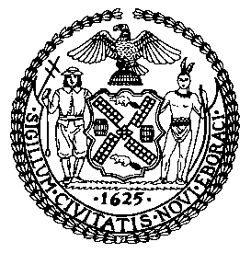

OFFICE OF THE GENERAL COUNSEL
Jason Otano, General Counsel

COMMITTEE REPORT OF THE
COMMITTEE ON RULES, PRIVILEGES AND ELECTIONS
Hon. Brad Lander, Chairperson

November 30, 2017

Council Chambers at City Hall
New York, NY 10007

Preconsidered Res. No. 1740

SUBJECT:
Resolution approving changes in Membership to certain Standing Committees.
ANALYSIS: Before the Committee for its consideration are proposed changes to the membership of certain Standing Committees.

By Council Member Lander:
RESOLVED, That pursuant to Rules 7.00 and 7.20 of the Rules of the Council, the Council does hereby consent to the following changes in Membership to certain Standing Committees.

STANDING COMMITTEES

CONTRACTS
Adams

ECONOMIC DEVELOPMENT
Adams

GENERAL WELFARE
Adams

MENTAL HEALTH, DEVELOPMENTAL DISABILITY, ALCOHOLISM, SUBSTANCE ABUSE AND DISABILITY SERVICES
Adams

SMALL BUSINESS
Adams

