THE COUNCIL OF THE CITY OF NEW YORK
RESOLUTION NO. 907

Resolution approving the decision of the City Planning Commission on Application No.
N 240295 ZRK, for an amendment of the text of the Zoning Resolution (L.U. No. 282).

By Council Members Salamanca and Riley

WHEREAS, Neptune Avenue Commercial, LLC, filed an application pursuant to Section 201 of the New York City Charter, for an amendment of the text of the Zoning Resolution of the City of New York to amend Article XII, Chapter 3 (Special Mixed Use District) and APPENDIX F to establish a Mandatory Inclusionary Housing area, which in conjunction with the related action would facilitate the development of a new 18-story, approximately 161,500 square-foot mixed-use building containing approximately 141,417 square feet of residential space with 145 dwelling units, approximately 37 of which would be permanently income-restricted per the Mandatory Inclusionary Housing (MIH) program, as well as approximately 20,100 square feet of ground floor commercial space. The development would be located at 2201-2227 Neptune Avenue in the Coney Island neighborhood of Brooklyn, Community District 13 (the “Application”);

WHEREAS, the City Planning Commission filed with the Council on April 21, 2025, its decision dated April 9, 2025 (the "Decision") on the Application;

WHEREAS, the Application is related to application C 240294 ZMK (L.U. No. 281), a zoning map amendment to change an M1-2 zoning district to an M1-5/R7-3 (MX-26) mixed-use zoning district;

WHEREAS, the Decision is subject to review and action by the Council pursuant to Section 197-d of the City Charter;

WHEREAS, upon due notice, the Council held a public hearing on the Decision and Application on April 23, 2025;

WHEREAS, the Council has considered the land use implications and other policy issues relating to the Decision and Application; and

WHEREAS, the Council has considered the relevant environmental issues, including the Negative Declaration issued on November 15, 2024 (CEQR No. 24DCP108K), which includes an (E) designation to avoid the potential for significant adverse impacts related to hazardous materials and air quality (E-816) (the “Negative Declaration”).

RESOLVED:

The Council finds that the action described herein will have no significant impact on the environment as set forth in the Negative Declaration.

Pursuant to Sections 197-d and 200 of the City Charter and on the basis of the Decision and Application, the environmental determination and consideration described in the report, N 240295 ZRK, incorporated by reference herein, and the record before the Council, the Council approves the Decision of the City Planning Commission.

Matter underlined is new, to be added;
Matter struck out is to be deleted;
Matter within # # is defined in Section 12-10;
* * * indicates where unchanged text appears in the Zoning Resolution

* * *

ARTICLE XII
SPECIAL PURPOSE DISTRICTS

Chapter 3
Special Mixed Use District

* * *

123-90
SPECIAL MIXED USE DISTRICTS SPECIFIED

* * *

#Special Mixed Use District# - 25:

Gowanus, Brooklyn

The #Special Mixed Use District# - 25 is established in Gowanus in Brooklyn as indicated on the #zoning maps#.

#Special Mixed Use District# - 26:

Coney Island, Brooklyn

The #Special Mixed Use District# - 26 is established in Coney Island in Brooklyn as indicated on the #zoning maps#.

* * *

APPENDIX F
Mandatory Inclusionary Housing Areas and former Inclusionary Housing Designated Areas

* * *

BROOKLYN

* * *

Brooklyn Community District 13

Map 1 – [date of adoption]

[EXISTING MAP]

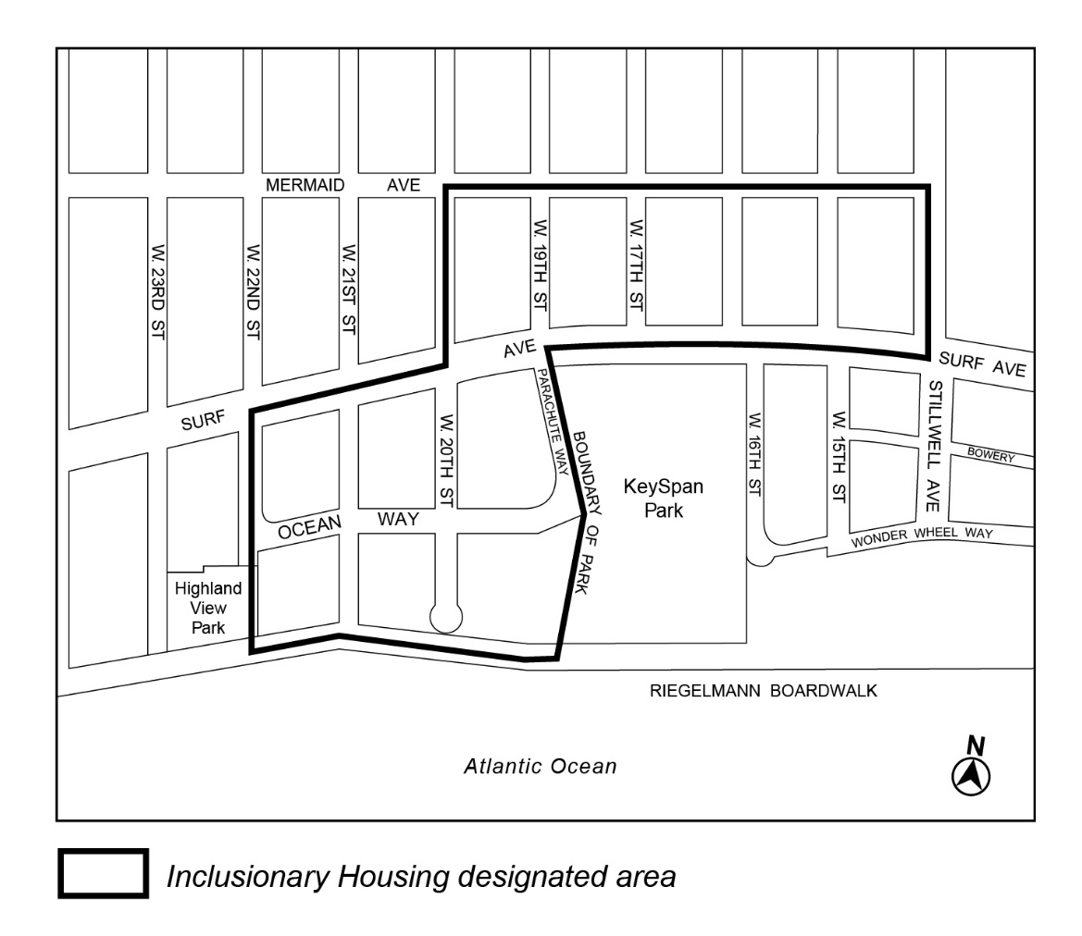

Map 2 – (3/22/18)

[EXISTING MAP]

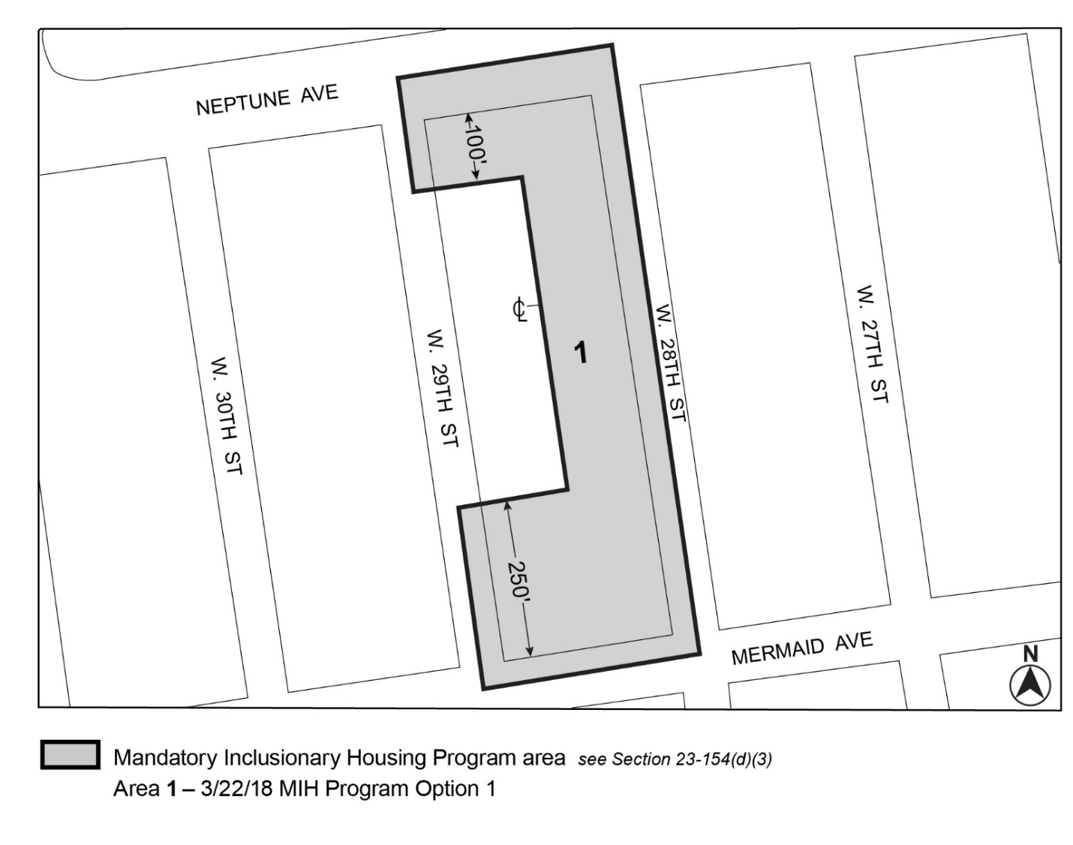

[PROPOSED MAP]

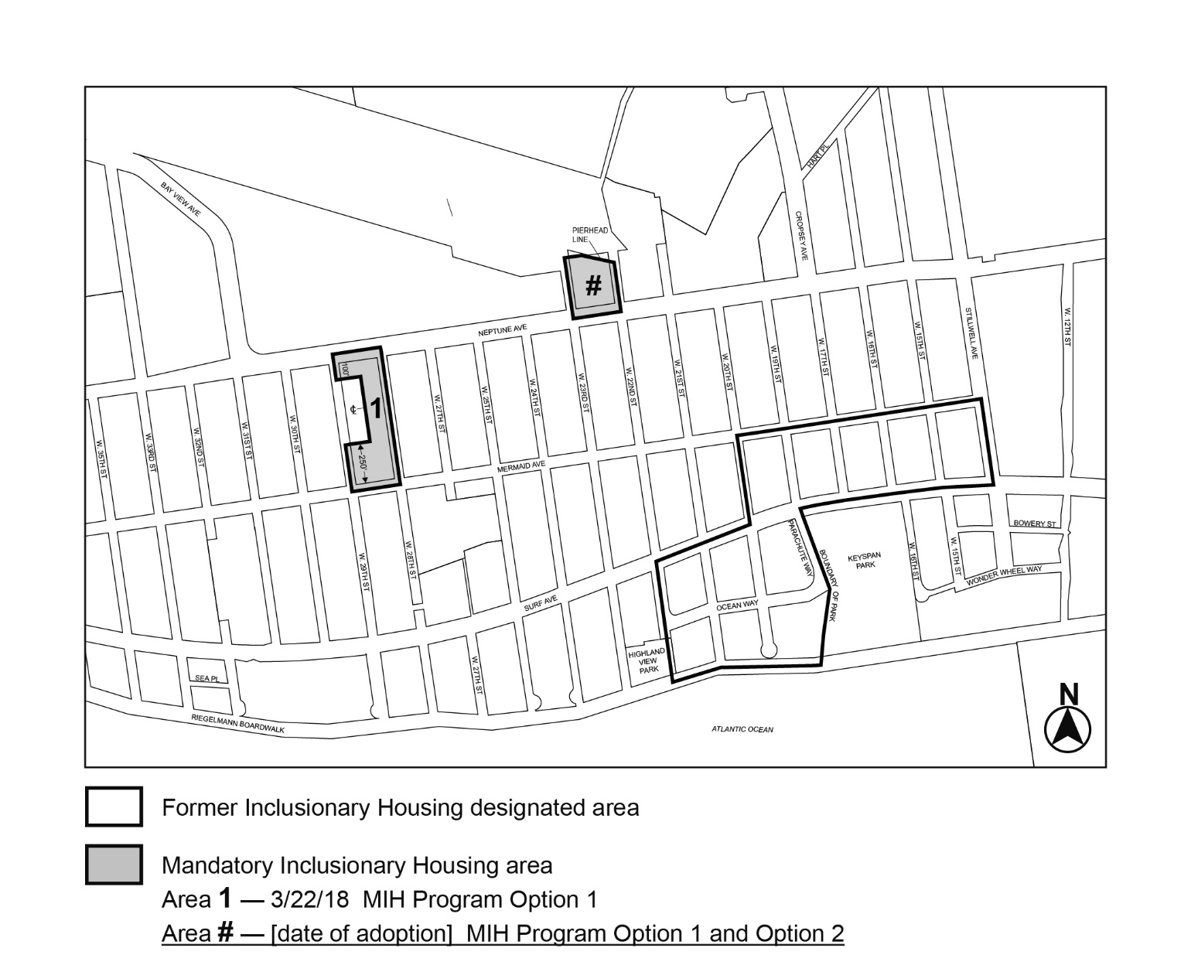

Portion of Community District 13, Brooklyn

* * *

Adopted.

Office of the City Clerk,}
The City of New York,} ss.:

I hereby certify that the foregoing is a true copy of a Resolution passed by The Council of The City of New York on _________, 2025, on file in this office.

.....................................................
City Clerk, Clerk of The Council

