Committee on Public Safety:
Daniel Ades, Senior Legislative Counsel
Casie Addison, Senior Policy Analyst

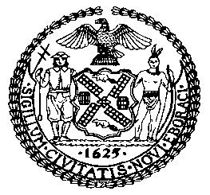

THE COUNCIL OF THE CITY OF NEW YORK
BRIEFING PAPER AND COMMITTEE REPORT OF THE
GOVERNMENTAL AFFAIRS DIVISION
Jeffrey Baker, Legislative Director
Brian Crow, Deputy Director, Justice Division

COMMITTEE ON PUBLIC SAFETY
Hon. Donovan Richards, Chair

November 19, 2018

Oversight: Preventing Hate Crimes in NYC

INT. NO. 1234 By Council Member Levine

TITLE: A Local Law to amend the New York city charter, in relation to creating an office for the prevention of hate crimes

NEW YORK CITY CHARTER: Adds new section 20-F

PRECONS. INT. NO. By Council Members Deutsch and Richards

TITLE: A Local Law to amend the New York city charter, in relation to requiring educational outreach within the office of prevention of hate crimes.

NEW YORK CITY CHARTER: Amends section 20-F

- INTRODUCTION
On November 19, 2018, the Committee on Public Safety, chaired by Council Member Donovan Richards, will hold an oversight hearing related to the prevention of hate crimes in New York City. The Committee will also hear Introduction Number 1234 (Int. No. 1234), a local law to amend the New York City Charter, in relation to creating an office for the prevention of hate crimes and Preconsidered Introduction No. __, a local law to amend the New York City Charter, in relation to requiring educational outreach within the office of prevention of hate crimes. Those expected to testify include representatives of the NYPD and various advocates, stakeholders, and members of the public.
- BACKGROUND
In New York State, hate crimes are not defined as distinct penal law offenses. Instead, certain specified conduct that constitutes a penal law offense is designated a hate crime when the act is committed or the victim is selected because of a belief or perception regarding the race, color, national origin, ancestry, gender, religion, religious practice, age, disability or sexual orientation of a person. A hate crime designation raises the level of the offense category, resulting in significantly higher potential jail sentence. For example, a person who commits assault in the second degree because he believes the victim to be Jewish has committed assault in the second Degree as a hate crime. While assault in the second degree is normally classified as a D violent felony punishable by a maximum of 7 years in prison, assault in the second degree as a hate crime is a class C violent felony and is punishable by a maximum of 15 years in prison. The list of 39 felonies and 13 misdemeanors that can be charged as hate crimes is attached as Appendix A.
Offenses that are charged as hate crimes do not always result in hate crime convictions. Part of the difficulty in establishing that a crime is motivated by bias is that offensive or discriminatory language may be used in the course of a crime or dispute that leads to a crime, even if the actions or the dispute did not originate from a belief about the victim. Out of 400 hate crime arrests that resulted in convictions and were reported to the New York State Division of Criminal Justice Services from 2012-2016, 123 resulted in convictions for hate crimes and 277 resulted in convictions for non-hate crimes.
Nevertheless, New York State Law deems crimes committed because of bias against members of the groups listed above as more serious in nature than other crimes, and there are thus important law enforcement interests in preventing these kinds of crimes.
- FIRST AMENDMENT PROTECTIONS OF HATE SPEECH
The constitutional protections of an individual’s right to voice his or her views, no matter how offensive or distasteful, are fundamental. However, they also limit the legal measures governments can utilize to prohibit hate speech. The U.S. Supreme Court has repeatedly upheld First Amendment protections in cases of offensive speech, even when that speech includes statements that are perceived as vague threats against certain groups of individuals. In 1969, the Court protected a Ku Klux Klan member’s hateful speech directed toward African Americans and set forth the principle that “constitutional guarantees of free speech and free press do not permit a State to forbid or proscribe advocacy of the use of force or of law violation except where such advocacy is directed to inciting or producing imminent lawless action and is likely to incite or produce such action”. In 1977, the Court upheld an appellate court decision allowing Neo-Nazis to march through Skokie, Illinois, a substantially Jewish town where Holocaust survivors lived. In 1992, the Court overturned the conviction of a teenager convicted of burning a cross on the law of an African American family’s home.
However, the First Amendment is not absolute. Speech that is likely to incite imminent violence is not protected, and conduct that is criminal is not made less criminal because the perpetrator expressed opinions that are otherwise protected under the First Amendment. One year after its decision overturning the conviction for cross burning in R.A.V. v. City of St. Paul, the Supreme Court upheld a Minnesota law similar to New York’s hate crime statute, which punishes hate crimes more harshly than comparable crimes that are not motivated by bias. The Court ruled that even though hate speech on its own cannot be criminalized, society may deem crimes motivated by bias to be more damaging to victims and society than other offenses and worthy of more severe punishment.
- NYPD’S HATE CRIME TASK FORCE
The NYPD’s Hate Crime Task Force, formally known as the Bias Incident Investigative Unit, is a dedicated citywide team of investigators who are responsible for investigating all hate crimes and related incidents. The Unit is part of the Special Victims Division. Patrol Officers responding to the scene of crimes that may be the result of bias refer these cases to the Hate Crime Task Force. According to the Patrol Guide, the Commanding Officer of the Task Force then determines how an investigation of the incident should proceed. The investigation may be conducted wholly by the Task Force or precinct detectives or may be a joint investigation between the two. Pursuant to the guidelines in the Patrol Guide, officers investigating incidents of bias should include personal contact with the victims of the alleged bias incident. Investigators must make a determination of whether the incident was in fact bias motivated and issue a report within 10 days. Throughout this process, reports on the progress of the bias incident investigation are recorded on the following forms: Complaint Follow Up (PD313-081), Complaint Report (PD313-152), Complaint Report Worksheet (PD313-152A), and Unusual Occurrence Report (PD370-152).
The Hate Crime Task Force is also required to compile reports on bias related incidents and use this data to conduct analyses designed to assist the Department and the City in coordinating an appropriate response to these incidents.
- RECENT HATE CRIME TRENDS
Several reports have shown a spike in hate crimes both nationally and locally. According to the Federal Bureau of Investigation’s (FBI) Uniform Crime Reporting Program, the number of hate crime incidents reported in 2017 increased by 17% from the year prior. The Uniform Crime Reporting Program’s Hate Crime Statistics report is comprised of incidents reported to the federal government by law enforcement agencies. In 2017, law enforcement agencies reported 7,175 hate crimes incidents compared to 6,121 in 2016. The 2017 incidents encompassed 8,437 total offenses and involved 8,825 victims. While the total number of reported hate crimes grew, so did the number of law enforcement agencies reporting hate crime data. According to the FBI, nearly 1,000 law enforcement agencies contributed information related to hate crimes that had `not the year before. The FBI has reported an increase in hate crimes consistently for the past 3 years, with a 5% increase between 2015 and 2016.
Of the 8,828 victims of hate crimes in 2017, 59.65% were targeted based on their race/ethnicity, 20.6% were victimized because of bias against religion, and 15.8% were targeted because of bias against their perceived sexuality. Of the 5,060 victims of racial bias hate crimes, nearly 50% were victims of anti-Black or African American bias. Similarly, of the 1,749 victims of anti-religious hate crimes, 58.1% were victims of crimes motivated by anti-Jewish bias.
The NYPD is required to report hate crime complaints and arrests pursuant to Local Law 130 of 2016. These data show that local trends mirror those at the national level. In 2017, 325 hate crimes were reported to the NYPD, of which 135 arrests were made, a slight decrease from 333 reported hate crimes in 2016. Of reported hate crimes in 2017, 46.46% were motivated by anti-Jewish bias. The number of anti-Jewish hate crime complaints is consistently much higher than all other bias motivations.
The following charts are based on NYPD data that is posted online. It is crucial to note that these statistics reflect the number of complaints made to the NYPD rather than the number of hate crimes that actually occurred. In addition, there are some discrepancies between the quarterly reports and the annual totals that may suggest the quarterly data contains duplicate entries or incidents that were incorrectly tabulated as hate crimes and later corrected.

Complaints
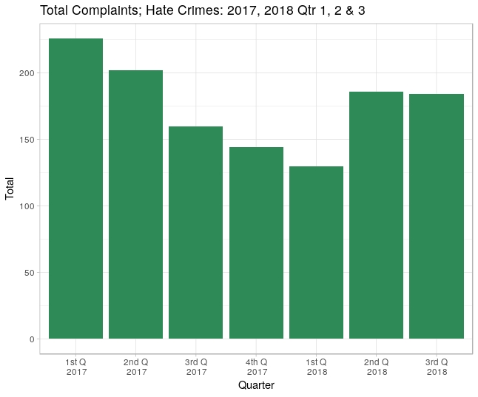
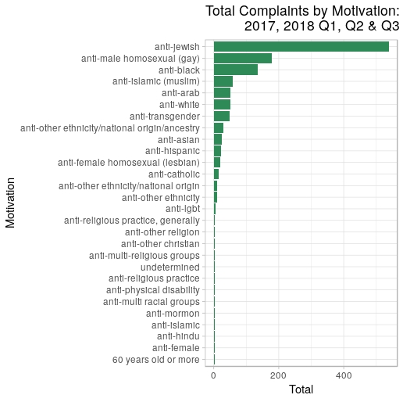

Arrests
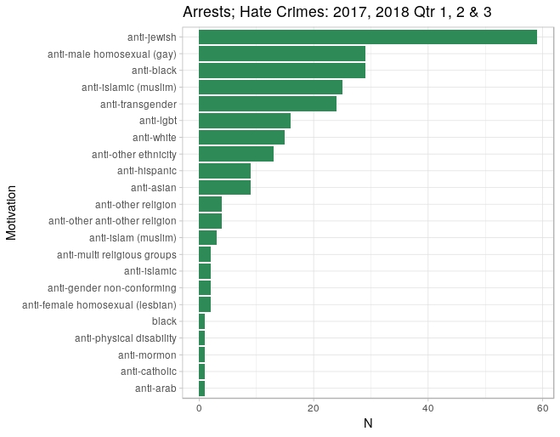
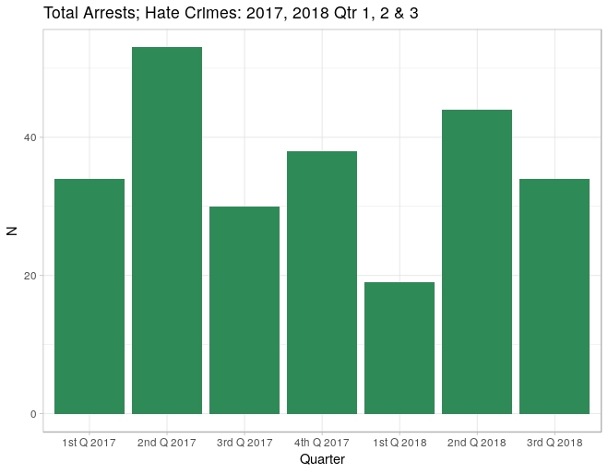

- RECENT NOTABLE INCIDENTS IN NEW YORK CITY
The rise in hate crimes in New York City has had particular effects on certain communities, leading to growing fears and concerns about safety, specifically in the years following the 2016 presidential election. Anti-Jewish hate crimes and sentiments have made up a significant proportion of reported crimes in the City, accounting for nearly half of reported crimes so far this year. According to the New York Times, there have been four times as many crimes motivated by bias against Jews as compared to crimes motivated by bias against Black/African Americans.
Several notable anti-Jewish hate crimes and sentiments have occurred around the City. Last month alone, within a few days, a graffiti swastika along with “KKK” was found on a police/fire call box on the Upper West Side in Manhattan, and two Orthodox Jewish men were attacked on the street in a Hasidic Jewish neighborhood in Brooklyn. Days before Halloween, swastikas appeared at a popular trick-or-treating area in Brooklyn Heights. In early November, a get-out-the-vote event was cancelled at a Brooklyn synagogue after anti-Semitic graffiti was discovered on the temple’s walls, just days following the mass shooting at a synagogue in Pittsburgh. Other anti-Semitic hate crimes were reported that same weekend, as surveillance footage showed a group of teenagers throwing a metal pipe through a window during a service at the Congregation Aveni Aish Volkin in Bedford Stuyvesant, Brooklyn.
While anti-Jewish bias hate crimes represent a large share of reported crimes in the City, crimes against protected identities are generally on the rise. On October 31, 2018 the African Burial Ground Monument, which contain 15,000 remains of enslaved persons in Lower Manhattan, was defaced with racist slurs, as a vandal wrote “Kill N-ggers” on a plaque. In early November, Ann Marie Washington, a black woman was punched and stabbed on a subway platform in Brooklyn, while her assailant yelled expletives at her. In September of this year, two gay men were attacked in Brooklyn after leaving a bar in Williamsburg. According to the police department the assailant uttered anti-gay slurs before injuring both men, rendering them unconscious.
In October, the Metropolitan Republican Club in Manhattan hosted Gavin McInnes, the founder of the ‘Proud Boys’, a right-wing organization with ties to white supremacist groups, leading to a series of brawls and arrests. The event highlighted the ongoing conflict of identifying the harmful nature of hate speech and holding those accountable while protecting the right to free speech.
- ISSUES AND CONCERNS
In a proudly diverse community such as New York City, the rise of hate speech has unique and profound consequences. The instinct to condemn and punish those who spread hateful ideology is often at odds with civil liberties concerns over free speech. The city is also home to a substantial Jewish population, the second largest in the world after Israel, which has been the target the largest percentage of hate crimes, a trend that has only increased recently. In addition, the recent shooting at the Tree of Life Synagogue in Pittsburgh has made a notable impact on the Jewish community here in New York, stoking fears that such an attack could be carried out here, and even prompting some elected officials to advocate for licensed firearm owners to carry their weapons to religious services. Other elected officials including the Mayor of Pittsburgh and Mayor DeBlasio, have opposed the notion that more guns are the solution, and images of the NYPD’s counterterrorism Unit standing outside synagogues may send the wrong signal about what it means to be living in a democratic society, and especially in New York City.
There are also practical considerations when relying on law enforcement measures to mitigate the harmful impact of hateful actions toward minority groups. The fine line between hate crime and hate speech is difficult for lawyers to determine, and even more challenging for patrol officers who may not be well versed in blurry legal definitions. The hearing will explore the method for referring cases to the Hate Crimes Task Force, and the standards employed for deciding whether certain conduct constitutes a hate crime or merely offensive speech. Because only recent data is available online, the hearing will also seek to connect recent trends to the time period prior to the election of President Trump, which has been linked to an increase in hateful rhetoric. The hearing will also explore preventative measures the NYPD can take in advance of events that are likely to incite conflict and protests.

- ANALYSIS OF INT. NO. 1234
Section 1 of Int. No. 1234 would add a new section 20-F to the New York City Charter and would require the mayor to establish an office for the prevention of hate crimes in the executive office of the mayor or within another office of the mayor. The office would be headed by a coordinator, whose duties would be to advise and assist the mayor in the planning and implementation of a coordinated response to hate crimes among the agencies involved in the prevention, awareness, investigation, prosecution and impact on communities of hate crimes; review the budget requests of all agencies for programs related to hate crimes; report on the activities of the office, the areas in the city that are vulnerable to hate crimes, the security concerns of neighborhoods, schools, and houses of worship, the efficacy of available resources for victims of hate crimes, and statistics on hate crime complaints within the city; study the effectiveness of safety plans and resources available for victims in vulnerable communities; and serve as a liaison for the city with providers of victim services.
Section 2 of Int. No. 1234 would have this bill take effect 9 months after it becomes law.

- ANALYSIS OF PRECONS. INT. NO.__(COUNCIL MEMBERS DEUTSCH AND RICHARDS)
Section 1 of this bill would amend section 20-F of the New York City Charter, as added by Int. No. 1234, to require the coordinator of the office of hate crimes prevention to establish a division of educational outreach on the impact and effects of hate crimes, including measures to achieve greater tolerance and understanding, and coordination with relevant city agencies, interfaith organizations, community groups, and civil rights groups.
Section 2 of this bill would amend Paragraph 4 of subdivision b of section 20-F of the New York City Charter to require the coordinator of the office to prevent hate crimes to also report on the populations which the division of educational outreach addressed, the types of programs created or provided by the division, and any other outreach, education, and prevention efforts made by the division.
Section 3 of this bill would have it take effect on the same day as Int. No. 1234.

Int. No. 1234

By Council Member Levine

A LOCAL LAW

T
o amend the New York city charter, in relation to creating an office for the prevention of hate crimes

Be it enacted by the Council as follows:

Section 1. Chapter 1 of the New York city charter is amended by adding a new section 20-F to read as follows:
§ 20-F Office for the prevention of hate crimes. a. The mayor shall establish an office for the prevention of hate crimes. Such office may, but need not, be established in the executive office of the mayor and may be established as a separate office or within any other office of the mayor or within any department the head of which is appointed by the mayor. Such office shall be headed by a coordinator who shall be appointed by the mayor or the head of such department. For the purposes of this section only, “coordinator” shall mean the coordinator of the office for the prevention of hate crimes.
b. Powers and duties. The coordinator shall have the power and the duty to:
1. Advise and assist the mayor in planning and implementing for coordination and cooperation among agencies under the jurisdiction of the mayor that are involved in prevention, awareness, investigation and prosecution, and impact on communities of hate crimes.
2. Create and implement a coordinated system for the city’s response to hate crimes. Such system shall, in conjunction with the New York city commission on human rights’ bias response teams, the police department, and any relevant agency or office, coordinate responses to hate crime allegations.
3. Review the budget requests of all agencies for programs related to hate crimes, and recommend to the mayor budget priorities among such.
4. Prepare and submit to the mayor and the council and post conspicuously on the city’s website by January 30 of each year an annual report of the activities of the office, regarding the prevalence of hate crimes during the previous calendar year and the availability of services to address the impact of these crimes. Such report shall include but need not be limited to the following information: (i) identification of areas or populations within the city that are particularly vulnerable to hate crimes, (ii) an assessment of the security concerns and needs of city neighborhoods, schools, and houses of religious worship, (iii) identification and assessment of the efficacy of counseling and resources for victims of hate crimes, and (iv) collation of city, state and federal statistics on hate crime complaints and prosecutions within the city, including incidents by offense, bias motivation, and demographic characteristics such as age and gender of offenders.
5. Study the effectiveness of, and make recommendations with respect to, the expansion of safety plans for neighborhoods and institutions that are particularly vulnerable to hate crimes, and the resources available for victims.
6. Serve as liaison for the city with providers of victim services, community groups, and other relevant nongovernmental entities and assist in the coordination among such entities on reporting and responding to allegations of hate crimes, to ensure that city residents have access to relevant services after hate crime events.
7. Perform other duties as the mayor may assign.
§2. This local law takes effect 9 months after it becomes law.
LS # 3942
MKW
11/7/18

Preconsidered Int. No.

By Council Members Deutsch and Richards

A LOCAL LAW

T
o amend the New York city charter, in relation to requiring educational outreach within the office of prevention of hate crimes

Be it enacted by the Council as follows:

Section 1. Section 20-F of the New York city charter, as added by a local law for the year 2018 amending the New York city charter, relating to creating the office for the prevention of hate crimes, is amended by adding a new subdivision c to read as follows:
c. The coordinator shall establish a division of educational outreach. The division shall have the power and the duty to:
1. Ensure, by such means as necessary, including coordination with relevant city agencies and interfaith organizations, community groups, and human rights and civil rights groups, the provision of effective outreach and education on the impact and effects of hate crimes, including measures necessary to achieve greater tolerance and understanding, and including the use of law enforcement where appropriate.
2. In cooperation with the department of education, create a K-12 curriculum addressing issues related to hate crimes.3. Perform other duties as the mayor may assign.
§ 2. Paragraph 4 of subdivision b of section 20-F of the New York city charter, as added by a local law for the year 2018 amending the New York city charter, relating to creating the office for the prevention of hate crimes, is amended to read as follows:
4. Prepare and submit to the mayor and the council and post conspicuously on the city’s website by January 30 of each year an annual report of the activities of the office, including the prevalence of hate crimes during the previous calendar year and the availability of services to address the impact of these crimes. Such report shall include but need not be limited to the following information: (i) identification of areas or populations within the city that are particularly vulnerable to hate crimes, (ii) an assessment of the security concerns and needs of city neighborhoods, schools, and houses of religious worship, (iii) identification and assessment of the efficacy of counseling and resources for victims of hate crimes, [and] (iv) collation of city, state and federal statistics on hate crime complaints and prosecutions within the city, including incidents by offense, bias motivation, and demographic characteristics such as age and gender of offenders, (v) the populations to which the division of educational outreach addressed, (vi) the types of programs created or provided by the division of educational outreach and the names of the providers of such programs, and (vii) any other outreach, education, and prevention efforts made by the division of educational outreach.
§ 3. This local law takes effect on the same date that a local law for the year 2018 amending the New York city charter, relating to creating the office for the prevention of hate crimes, takes effect.
LS # 8664
MKW
11/9/18

APPENDIX A:
Specified Offenses Eligible for Hate Crime Designation
Penal Law Section | Offense
120.00 | Assault in the Third Degree
120.05 | Assault in the second degree
120.10 | Assault in the first degree
120.12 | Aggravated assault upon a person less than eleven years old)
120.13 | Menacing in the first degree
120.14 | Menacing in the second degree
120.15 | Menacing in the third degree
120.25 | Reckless endangerment in the first degree
121.12 | Strangulation in the second degree
121.13 | Strangulation in the first degree
125.15 (1) | Manslaughter in the second degree
125.25 | Murder in the second degree
120.50 | Stalking in the third degree
120.55 | Stalking in the second degree
120.60 | Stalking in the first degree
130.35 (1) | Rape in the first degree
130.50 (1) | Criminal sexual act in the first degree
130.65 (1) | Sexual abuse in the first degree
130.70 (1)(a) | Aggravated sexual abuse in the first degree
135.05 | Unlawful imprisonment in the second degree
135.10 | Unlawful imprisonment in the first degree
135.20 | Kidnapping in the second degree
135.25 | Kidnapping in the first degree
135.60 | Coercion in the second degree
135.65 | Coercion in the first degree
140.10 | Criminal trespass in the third degree
140.15 | Criminal trespass in the second degree
140.17 | Criminal trespass in the first degree
140.20 | Burglary in the third degree
140.25 | Burglary in the second degree
140.30 | Burglary in the first degree
145.00 | Criminal mischief in the fourth degree
145.05 | Criminal mischief in the third degree
145.10 | Criminal mischief in the second degree
145.12 | Criminal mischief in the first degree
150.05 | Arson in the fourth degree
150.10 | Arson in the third degree
150.15 | Arson in the second degree
150.20 | Arson in the first degree
155.25 | Petit larceny
155.30 | Grand larceny in the fourth degree
155.35 | Grand larceny in the third degree
155.40 | Grand larceny in the second degree
155.42 | Grand larceny in the first degree
160.05 | Robbery in the third degree
160.10 | Robbery in the second degree
160.15 | Robbery in the first degree
240.25 | Harassment in the first degree
240.30 (1), (2),(4) | Aggravated harassment in the second degree

N.Y. Penal Law §§ 485.05, 485.15
N.Y. Penal Law § 485.10
http://www.criminaljustice.ny.gov/crimnet/ojsa/hate-crime-in-nys-2016-annual-report.pdf
Brandenburg v. Ohio, 395 U.S. 444 (1969)
National Socialist Party of America v. Village of Skokie, 432 U.S. 43 (1977)
R.A.V. v. City of St. Paul, 505 U.S. 377 (1992)
Wisconsin v. Mitchell, 508 U.S. 476 (1993)
The Official Website of the New York City Police Department “Hate Crimes/Bias Incidents” available at https://www1.nyc.gov/site/nypd/services/law-enforcement/hate-crimes.page
The Official Website of the New York City Police Department “Hate Crimes/Bias Incident” available at https://www1.nyc.gov/site/nypd/services/law-enforcement/hate-crimes.page
See NYPD Patrol Guide “Bias Motivated Incidents” Section: Complaints Procedure No. 207-10 available at https://www1.nyc.gov/assets/ccrb/downloads/pdf/investigations_pdf/pg207-10-bias-motivated-incidents.pdf
See NYPD Patrol Guide “Bias Motivated Incidents” Section: Complaints Procedure No. 207-10 available at https://www1.nyc.gov/assets/ccrb/downloads/pdf/investigations_pdf/pg207-10-bias-motivated-incidents.pdf
See NYPD Patrol Guide “Bias Motivated Incidents” Section: Complaints Procedure No. 207-10 available at https://www1.nyc.gov/assets/ccrb/downloads/pdf/investigations_pdf/pg207-10-bias-motivated-incidents.pdf
See NYPD Patrol Guide “Bias Motivated Incidents” Section: Complaints Procedure No. 207-10 available at https://www1.nyc.gov/assets/ccrb/downloads/pdf/investigations_pdf/pg207-10-bias-motivated-incidents.pdf
See NYPD Patrol Guide “Bias Motivated Incidents” Section: Complaints Procedure No. 207-10 available at https://www1.nyc.gov/assets/ccrb/downloads/pdf/investigations_pdf/pg207-10-bias-motivated-incidents.pdf
See NYPD Patrol Guide “Bias Motivated Incidents” Section: Complaints Procedure No. 207-10 available at https://www.fbi.gov/news/pressrel/press-releases/fbi-releases-2017-hate-crime-statistics
See NYPD Patrol Guide “Bias Motivated Incidents” Section: Complaints Procedure No. 207-10 available at https://www.fbi.gov/news/pressrel/press-releases/fbi-releases-2017-hate-crime-statistics
“FBI Releases 2017 Hate Crime Statistics” Federal Bureau of Investigations November 13, 2018 available at https://www.fbi.gov/news/pressrel/press-releases/fbi-releases-2017-hate-crime-statistics
See “2017 Hate Crime Statistics – Victim Data” Federal Bureau of Investigations available at https://ucr.fbi.gov/hate-crime/2017/topic-pages/victims
See NYPD Patrol Guide “Bias Motivated Incidents” Section: Complaints Procedure No. 207-10 available at https://www.fbi.gov/news/stories/2017-hate-crime-statistics-released-111318
See NYPD Patrol Guide “Bias Motivated Incidents” Section: Complaints Procedure No. 207-10 available at https://ucr.fbi.gov/hate-crime/2017/topic-pages/victims
See NYPD Patrol Guide “Bias Motivated Incidents” Section: Complaints Procedure No. 207-10 available at https://ucr.fbi.gov/hate-crime/2017/topic-pages/victims
The Official Website of the New York City Police Department “Hate Crimes Reports” https://www1.nyc.gov/site/nypd/stats/reports-analysis/hate-crimes.page
Weiss, Murray “Hate Crimes Jump 30 Percent in 2016, NYPD Stats Show” DNA Info New York November 16, 2016 available at https://www.dnainfo.com/new-york/20161116/civic-center/nypd-hate-crime-statistics-2016-2015/
Bellafante, Ginia “Is It Safe to Be Jewish in New York” New York Times October 31, 2018 available at https://www.nytimes.com/2018/10/31/nyregion/jewish-bias-safety-nyc.html
Bellafante, Ginia “Is It Safe to Be Jewish in New York” New York Times October 31, 2018 available at https://www.nytimes.com/2018/10/31/nyregion/jewish-bias-safety-nyc.html
Rashbaum, William and Winston, Ali “Ilana Glazer Event at Synagogue Is Canceled After Anti-Semitic Graffiti Is Found” New York Times November 2, 2018 available at https://www.nytimes.com/2018/11/02/nyregion/broad-city-jewish-synagogue-anti-semitism.html?rref=collection%2Fsectioncollection%2Fnyregion&action=click&contentCollection=nyregion&region=rank&module=inline&version=highlights&contentPlacement=2&pgtype=sectionfront
Roberston, Campball “11 Killed in Synagogue Massacre; Supsect Charged With 29 Counts” New York Times October 27, 2018 available at https://www.nytimes.com/2018/10/27/us/active-shooter-pittsburgh-synagogue-shooting.html?module=inline
Offenhartz, Jake “De Blasio, Cuomo Accused of Indifference After Racist Graffiti Discovered At African Burial Ground Monument” Gothamist November 5, 2018 available at http://gothamist.com/2018/11/05/african_burial_ground_monument.php
Watkins, Ali “Racist Slur Defaces African Burial Ground Monument in Lower Manhattan” New York Times November 2, 2018 available at https://www.nytimes.com/2018/11/02/nyregion/african-burial-ground-monument-racial-slur.html
Whaley, Natelege “The Stabbing of Ann Marie Washington Should Call Attention to Hate Crimes in Public Spaces” Mic November 13, 2018 available at https://mic.com/articles/192427/the-stabbing-of-ann-marie-washington-should-call-attention-to-rising-hate-crimes-in-public-spaces#.pYK7BVIy3
Fitzsimmons, Tim “Police hunt for suspect in alleged anti-gay attack in Brooklyn” NBC News September 24, 2018 available at https://www.nbcnews.com/feature/nbc-out/police-hunt-suspect-alleged-anti-gay-attack-brooklyn-n912681
Goldmacher, Shane “Fight Breaks Out Near Republican Club After Visit by Gavin McInnes, Police Say” New York Times October 12, 2018 available at https://www.nytimes.com/2018/10/12/nyregion/gavin-mcinnes-republican-club-vandalized.html?module=inline
https://www.nytimes.com/2018/10/28/nyregion/eric-adams-brooklyn-guns.html

